**Application Form**

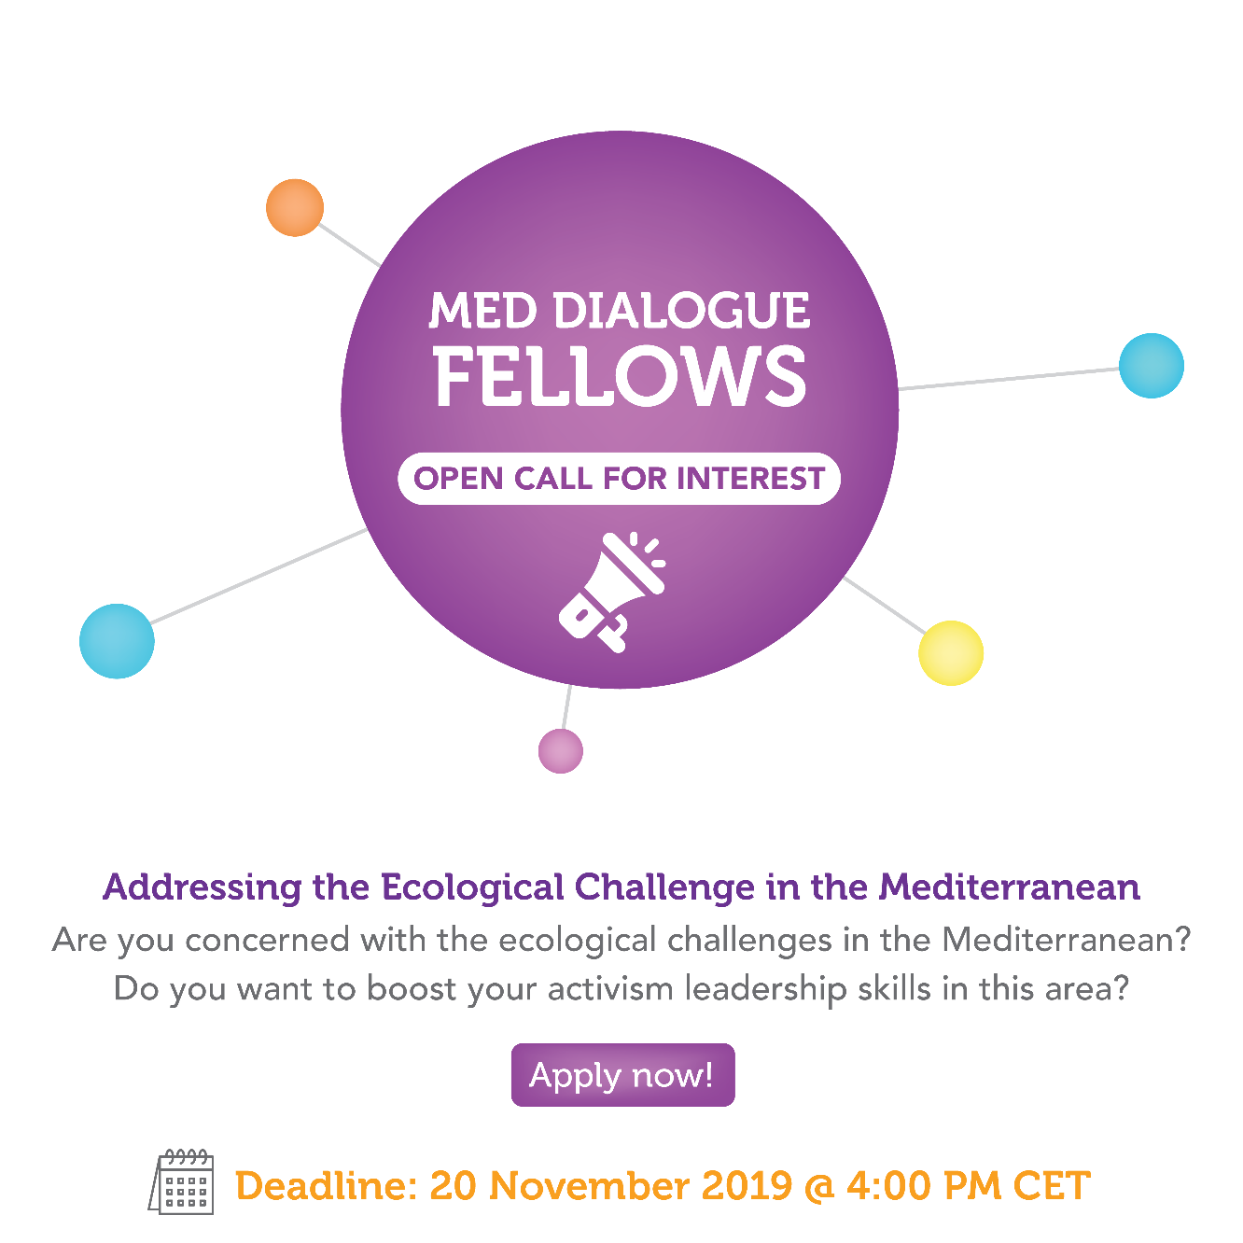

1. **Personal information**

|  |  |  |
| --- | --- | --- |
|  | **Title:** | □ Mr. □ Mrs. |
| **1.1** | **First Name:** |  |
| **1.2** | **Last Name:** |  |
| **1.3** | **Contact phone No:** |  |
| **1.4** | **Email Address:** |  |
| **1.5** | **Residential Address:** | Apt No:  Street:  District:  City/town:  Postal code:  Country: |
| **1.6** | **Country of Citizenship:** | Indicate the country of your citizenship |
| **1.7** | **Gender:** | Male □  Female □ |
| **1.8** | **Date of Birth (DD/MM/YYYY):** | (______/_______/__________) |
| **1.9** | **Language skills:** | Indicate competence on a scale of A1 to C2 (<http://europass.cedefop.europa.eu/sites/default/files/cefr-en.pdf>):   |  |  |  |  | | --- | --- | --- | --- | | Language | Reading | Speaking | Writing | |  |  |  |  | |  |  |  |  | |  |  |  |  | |  |  |  |  | |

1. **Relevant experience** (In this section, you can use 1500 characters per question, spaces included)

|  |  |  |
| --- | --- | --- |
| **2.1** | **Provide the name and address of the organisation(s) you are associated with (if any):** |  |
| **2.2** | **Your position/Job title (if applicable):** |  |
| **2.3** | **Are you a founder of the organisation?** | Yes □ No □ |
| **2.4** | **Employment or involvement status in the organisation(s):** | Please tick as applicable  **□** Full time  □ Part time  □ Other, please specify |
| **2.5** | **Is the Board or management of your organisation aware of your interest in this Call programme?** | **Yes □ No □** |
| **2.6** | **For how many years have you been involved in CSOs taking a leading role in your community or volunteering in one form or another? For the definition of CSO, check the Call’s Guidelines.** | □ 0 - 2 years  □ 2 - 5 years  □ 6 - 8 years  □ over 8 years |
| **2.7** | **For how long have you been engaged in addressing ecological challenges, nature conservation, or climate change?** | □ 0 - 2 years  □ 2 - 5 years  □ 6 - 8 years  □ over 8 years |
| **2.8** | **Please describe an important ecological project or relevant advocacy action to which you have participated, and that you are proud of as a leader of your organisation or community** |  |

1. **Motivation** (In this section, you can use 1000 characters per question, spaces included)

|  |  |  |
| --- | --- | --- |
| **3.1** | **Describe three key personal objectives or goals that you want to achieve through you participation in this activity** | 1.  2.  3. |
| **3.2** | **Briefly describe how and why your participation in this programme would be beneficial to you and your future involvement in your community / organisation:** |  |

1. **Proposal for a common action**

**Please do not forget to fill the form for your Project idea for a common action**

1. **Additional information**

|  |  |  |
| --- | --- | --- |
| **5.1** | **Would you require a mentorship for the implementation of your local action in the framework of the common action?**  **If so, explain in which areas of expertise and why you think you’d need it.** | **Yes □ No □**  If yes, please describe: |
| **5.2** | **Please provide your recent Curriculum Vitae/resume:** | Please include your CV below or attach it to your application |

1. **Applicant declaration:**

The applicant, in the context of the present call Med Dialogue Fellows, hereby declares that:

* She/ he meets the eligibility criteria specified in the call;
* She /he has the capacity to carry out with his/her associated organisation(s) the proposed common action in his/her community, including the relevant professional competences and qualifications;
* She/he would be directly responsible for the preparation, management and implementation of the common action in his/her community;
* She /he would be in the position to start the common action implementation within the requested timeframe

Signature: _____________________________

Date: _______________________