- Dissemination of climate change knowledge through awareness-raising campaigns targeting the youth, civil society, stakeholders and policymakers;
- Establishment of a National and two States’ waste baselines as well as emissions profile associated with sustainable capacity building on best practices.



Urban Neigbourhood in Abuja : A row of houses adorn

the roof tops with solar panels to cut energy costs.(2020)

Project Team
The Conseil Santé Consortium, a French agency specialising in international health, social protection, and climate change adaptation and mitigation is leading the SOFRECO, CITEPA and FACTOR outfits in providing technical assistance for the project´s implementation.

The Technical Assistance Team, supported by local partners: NEST and CENRAD, is responsible for providing advice and expertise, in collaboration with relevant stakeholders (private sector, civil societies, academia, national and sub-national governments).

The specific areas are in line with the programme’s scope and include institutional development and coordination, institutional strengthening, capacity building, planning, budgeting and financing.
The NCCRP also builds capacity at the Federal and State levels as well as supporting service management while monitoring progress against set performance indicators.

Timeline
The NCCRP is expected to last forty-eight months.
(From 20 January 2020 to 19 January 2024).

About the Programme
Following the ratification of the Paris Agreement in 2017, Nigeria committed itself to conditionally reduce its greenhouse gases (GHGs) emissions by 45% in 2030 in line with its Nationally Determined Contribution (NDC) pledge.

To support Nigeria’s mitigation efforts, the European Union, under its Global Public Goods and Challenges Thematic Programmes, is funding the Nigerian Climate Change Response Programme (NCCRP).
In addition, the NCCRP contributes to the country’s progressive achievement of Sustainable Development Goal (SDG) 13 on “climate action”. It also promotes progress towards goals 7 “affordable and clean energy” and 5 “gender equality”.
The Conseil Santé Consortium in collaboration with the Department of Climate Change, Federal Ministry of Environment is implementing the NCCRP.
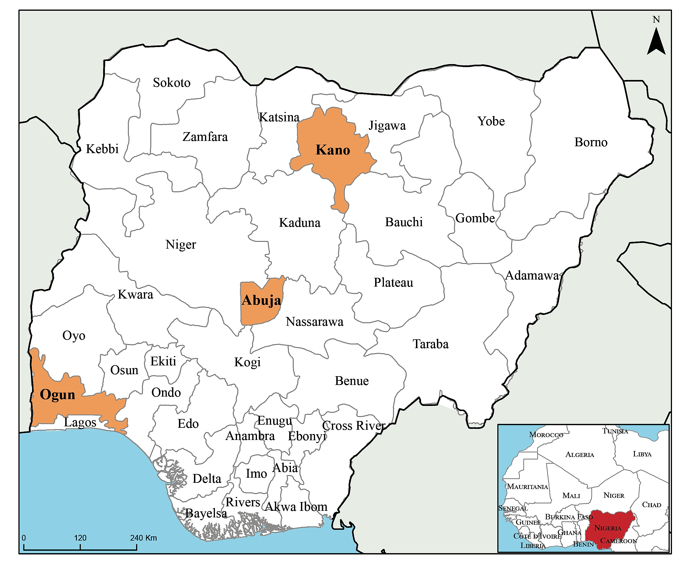
NCCRP Intervention Areas

Programme Goals
The implementation of the NCCRP is intended to:
- Implement mitigation measures;
- Enhance national capacity to adapt to climate change;
- Raise the profile of climate change-related science, technology and research and development;
- Increase public awareness and involve private sector participation; and
- Strengthen national institutions and mechanisms for climate change governance.

Scope
The following expected results are well in line with the difficulties identified in reaching Nigeria UNFCCC’s goals:
- Establishment of the MRV framework and the implementation of sustainable sectoral MRV systems for waste and energy;

Kayode Egbeleye 2020
Kayode EGBELEYE

