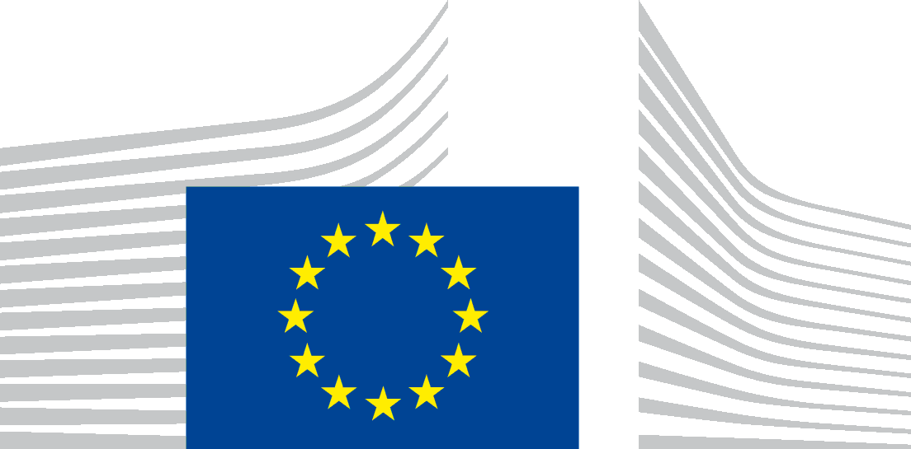 | EUROPEAN COMMISSION  DIRECTORATE-GENERAL FOR INTERNATIONAL COOPERATION AND DEVELOPMENT  International Cooperation and Development Policy  Civil Society Organisations, Foundations
CSO consultation on the Thematic Civil Society Programme

Template for the collection of written inputs

Please send your contributions to the EUROPEAID-A5@ec.europa.eu email address by 10 December 2020 the latest.

- How can we better detect and respond to changes in civic space in partner countries and better engage to strengthen an enabling environment for civil society?

  - What short and long-term modalities could be used on country level, regionally and globally?

  - What other actors beyond CSOs should be engaged to strengthen and protect civic space?

- How do we best build capacity in CSOs, in partner countries and globally, to empower civil society, both as an actor of governance and as a development partner?

  - How can we increase capacity of CSOs in partner countries to further their participation in policy dialogue and contribution to reducing inequalities?

  - Is the FPA framework a good modality to strengthen regional and global networks and the capacity of local members?

- How can the existing EC instruments to engage with civil society can be improved?

  - How can we develop the PFD platform, including the future digital format, to ensure an inclusive and effective policy dialogue, making sure that civil society is consulted appropriately and that the voices of women, youth, minorities and marginalised groups are heard?

  - How can the Roadmaps better create complementarity between thematic and geographic programmes and between EU and Member States initiatives? How can civil society be better mainstreamed in the new cooperation priorities at country level?

  - How can we make the DEAR Programme respond to global challenges in a more strategic and focused way in order to increase its impact?

