Communication notice for immediate release

Med Dialogue Leaders’ Common action:
Mediterranean Innovators for Solidarity
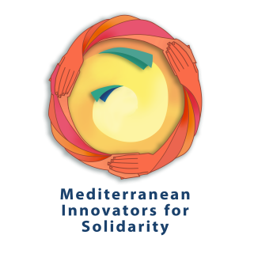
Wednesday, January 20th, 2021

Thirty young civil society leaders launch the “Mediterranean Innovators for Solidarity” campaign, comprising of initiatives taking place simultaneously in the Southern Mediterranean between 15 - 31 January 2021, with the aim to raise awareness on social and solidarity economy. This Common action - developed and supported by the EU-funded “Med Dialogue for Rights and Equality Programme” – will take place in 10 Arab countries: Algeria, Egypt, Jordan, Lebanon, Libya, Mauritania, Morocco, Palestine, Tunisia, and Syria.

Designed by young leaders through a process of debate and capacity building on social and solidarity economy challenges across the Mediterranean, on the occasion of an online Bootcamp on “Entrepreneurship for social and solidarity economy” held in October 2020, this Common action includes a range of different types of activity, both online and offline: from entrepreneurship initiatives to training sessions, from local advocacy events to public sensitization conferences, from thematic documentary films to social economy incubators. Its main objective is to promote solidarity in the young leaders’ own communities, while highlighting what social and solidarity economy can offer in terms of new ideas and opportunities.

“Mediterranean Innovators for Solidarity” embodies the far-reaching power of youth, when they move as one “critical mass” to address common policy challenges across the Mediterranean region. Accordingly, this Common Action promotes principles and best practices of social and solidarity economy, and highlights solidarity as a vector for a new culture of entrepreneurship and social and environmental responsibility, to overcome the economic crisis in this time of pandemic “- notes Gianluca Solera, Team Leader of the Med Dialogue for Rights and Equality Programme.

Med Dialogue for Rights and Equality is a 3-year (2019 – 2022) EU-funded Technical Assistance regional Programme with the overall objective to strengthen the role of CSOs active at the regional scale, in building sustainable development, regional cohesion and social resilience, as well as in influencing policy-making in the Southern Neighborhood and the Euro-Mediterranean Space.

For more information, please contact: gianluca.solera@particip.com, Med Dialogue for Rights and Equality team leader.

Click on the following to get more information about this action:
- Common action descriptions
- Facebook post
- Twitter post
- Hashtag : #Med_innov4solid
Follow us on: FB, YouTube, TW, and Instagram

