DRAFT June 4, 2012
  World Bank | 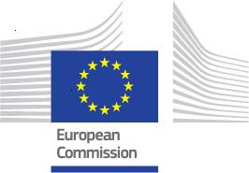 | 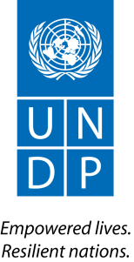 | 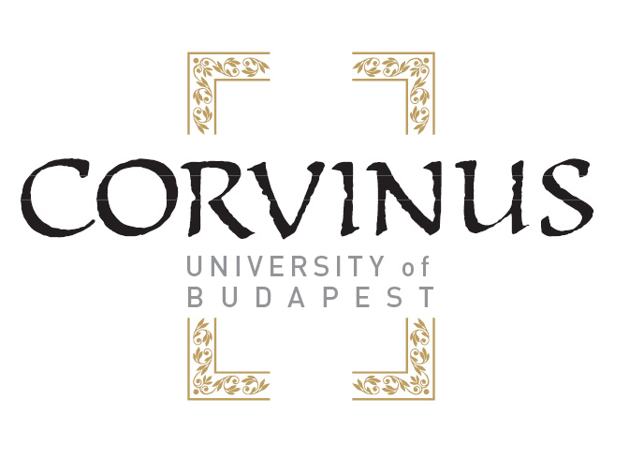

Building Capacity of Emerging European Donors: Assessing Existing Practices and Needs
Technical workshop
jointly organized by WBI, UNDP and European Commission in partnership with the Corvinus University of Budapest
June 13-14, 2012, Budapest, Hungary

Workshop Objectives:
This technical workshop is aimed at: (i) taking stock of the past capacity development efforts of emerging European donors, with support from different bilateral and multilateral institutions, (ii) identifying capacity gaps that may still exist, (iii) presenting various available learning programs and approaches, and (iv) developing a coordinated approach to further knowledge and learning programs by WBI, UNDP and European Commission with the view to enhance capacities of emerging European donors as global development partners.

Workshop Participants:
Government officials from EU12 member countries, Croatia and Turkey representing Ministries in charge of development cooperation agenda and ODA agencies, major NGOs, knowledge institutions and think-tanks involved in provision of capacity building, WB and WBI, UNDP and European Commission.

Workshop Agenda:

Day 1: June 13, 2012
9:30 – 10:00 am Welcome and Setting the Stage (Moderator - Balázs Szent-Iványi, Corvinus University)
- Mihály Görög, Corvinus University of Budapest, Vice-Rector
- Xavier Devictor, WB, Country Manager for Poland and Baltic States
- Daniel Hanspach, UNDP, Emerging Donors Policy Specialist
- Sharon Zarb, European Commission

Introductions by participants

10:00 am – 11:00 pm Session 1: Existing Practices in building capacity of emerging donors
(Moderator/Panel Facilitator: Renate Hahlen, European Commission)
- Assessment Study Findings and Recommendations by Balázs Szent-Iványi , Corvinus University (20 min)
- Panel discussion: Reflections from the government representatives (40 min):
  - Karolina Zelent-Smigrodzka, Poland MFA
  - Kaili Terras, Estonia MFA
  - Doina Doroftei, Romania MFA
  - Vassil Petkov, Bulgaria MFA
  - Milan Konrad, Czech Republic MFA
  - Ádám Kirchknopf , Hungary MFA;
  - Marcela Hanusova, Slovakia MFA;
  - Tomas Irnius, Lithuania, MFA.

11:00 – 11:15 am Coffee Break

11:15 am – 12:30 pm Session 1 - continued: Existing Practices in building capacity of emerging donors
(Moderator/Panel facilitator: András Tétényi, Corvinus University);
- Panel discussion: Providers of capacity building about existing practices (45 min):
  - Tatyana Leonova and Julia Komagaeva, WB
  - Daniel Hanspach and Dmitry Mariyasin ,UNDP
  - Sharon Zarb, European Commission
  - David Leong, USAID
- Questions and Answers: open floor (30 min)

12:30 – 1:30 pm Lunch

1:30 – 3:00 pm Session 2: Development Cooperation Practices – How development assistance is being organized in participating countries – what works and what does not work:
(Moderator/Panel Facilitator: Daniel Hanspach, UNDP)
- Country Presentations and Panel Discussion:
  - Jan Hofmokl, Poland MFA
  - Ayşe Örün, TIKA
  - Maria Erla Marelsdottir, Iceland MFA
  - Ádám Kirchknopf , Hungary MFA
  - Peter Tomasek, Slovak Aid

3:00 – 3:15 pm Coffee Break

3:15 – 5:00 pm Session 2 – continued: Development Cooperation Practices
(Moderator/Panel Facilitator: Tatyana Leonova, WBI):
- Panel Discussion: Engagement with different stakeholders – contracting out Development Assistance projects to third parties (60 min):
  - Petra Krylova, Czech Republic Palacky Universitet
  - Pawel Baginski, Poland GDRG and Batory Foundation
  - Adela Rusu, Romania NGDO Platform – FOND
  - Urska Zrinski, Slovenia Center for Excellence in Finance
  - Gyorgyi Ujszaszi, Hungary Association of NGOS for Development and Aid
  - Zuzana Sladkova, Belgium CONCORD
- Questions and Answers: open floor (45 min)

7:00 – 10:00 pm Welcome Dinner
___________________________

Day 2: June 14, 2012
9:30 – 10:30 am Session 3: Way forward towards a coordinated program of enhancing capacity
of emerging European donors
(Facilitators: Tatyana Leonova, WBI; Sharon Zarb, European Commission,
Dmitry Mariyasin, UNDP):
- Identified Capacity gaps – Recap from the First Day by Balázs Szent-Iványi, Corvinus University (15 min);
- Breakout session: Small Group work – specifying demands and looking for approaches: 3 - 4 groups looking for answers to provided questions (45 min):
  - Programming and Project Management Skills:
    - enhancing technical skills: M&E, results monitoring, etc
    - communications and outreach
  - Institutional organization of DA
  - Building Human Potential for Development Cooperation (development studies and curricula, partnership for e-learning curriculum, HR schemes);
  - Development aid knowledge exchange;
  - Enhanced Donor Coordination
    - Enhancing coordination among emerging donors and joint programs to recipient countries
    - Trilateral Cooperation

10:30- 10:45 am Coffee Break
10:45 am – 12:30 pm Session 4: Way forward towards a coordinated program of enhancing capacity of emerging European donors – Program Building Blocks and Who can do What? (Moderator: András Tétényi, Corvinus University)
- Reporting back from the Breakout Groups with recommendations ( 45 min)
- Open floor: Countries’ feedback and expectations (60 min)
12:30 – 1:00 pm Wrap up, next steps and Good Bye:
Tatyana Leonova, WBI; Sharon Zarb, European Commission; Dmitry Mariyasin, UNDP.
1:00 – 2:00 pm Lunch

Guidelines for the panelists and discussants:

Workshop Agenda:

Day 1: June 13, 2012

10:00 am – 11:00 pm Session 1(1): Existing Practices in building capacity of emerging donors
- Panel discussion: Reflections from the government representatives:
Objective:
Perceive overall feedback from European emerging donors regarding capacity building efforts undertaken up to date.
Expectations from panelists:
The panelists are expected to provide overall reflections on the past capacity building activities including: i) appropriateness and demand - supply balance with respect to specific country needs; ii) strengths and weaknesses of the received technical support; iii) existing capacity gaps; etc.
  - Karolina Zelent-Smigrodzka, Poland MFA;
  - Kaili Terras, Estonia MFA;
  - Doina Doroftei, Romania MFA;
  - Vassil Petkov, Bulgaria MFA;
  - Milan Konrad, Czech Republic MFA;
  - Ádám Kirchknopf , Hungary MFA;
  - Marcela Hanusova, Slovakia MFA;
  - Tomas Irnius, Lithuania, MFA.

11:15 am – 12:30 pm Session 1(2): Existing Practices in building capacity of emerging donors – continued;
- Panel discussion: Providers of capacity building about existing practices:
Objective:
Reflect on the report/presentation and present available capacity building approaches and instruments;
Expectations from panelists:
The panelists are expected to reflect on available capacity building approaches and share observations of the rendered capacity building support to emerging donors covering: i) key lessons learnt; ii) main pitfalls; iii)challenges ahead; etc
  - Tatyana Leonova and Julia Komagaeva, WB;
  - Daniel Hanspach and Dmitry Mariyasin ,UNDP;
  - Renate Hahlen and Sharon Zarb, European Commission;
  - David Leong, USAID

1:30 – 3:00 pm Session 2(1): Development Cooperation Practices – How development assistance is being organized in participating countries – what works and what does not work:
- Country Presentations and Panel Discussion:
Objective:
Perceive current development assistance cooperation practices and organizational set-up.
Expectations from panelists:
The panelists are expected to make 7 - 10 minutes country presentations covering major aspects of national development cooperation systems set-up. Open floor discussion is to follow to reflect what works and does not work in development assistance cooperation.
  - Maria Erla Marelsdottir, Iceland MFA;
  - Michal Pastvinsky, Czech Republic ODA Agency;
  - Jan Hofmokl, Poland MFA;
  - Ayşe Örün, TIKA;
  - Ádám Kirchknopf , Hungary MFA;
  - Peter Tomasek, Slovak Aid;
  - Natali Lulic, Croatia, MFA;
  - Maya Schembri, Malta, MFA

3:15 – 5:00 pm Session 2(2): Development Cooperation Practices – continued;
- Panel Discussion: Engagement with different stakeholders – contracting out Development Assistance projects to third parties:
Objective:
Perceive existing practices and level of cooperation among key national development assistance stakeholders.
Expectations from panelists:
The panelists are expected to share their experience of cooperation in development assistance projects with respect to: i) key areas of engagement; ii) institutional arrangements; iii) expectations and needs. Open floor discussion is to follow soliciting feedback from Government representatives.
  - Petra Krylova, Czech Republic Palacky Universitet;
  - Pawel Baginski, Poland GDRG and Batory Foundation;
  - Adela Rusu, Romania NGDO Platform – FOND;
  - Urska Zrinski, Slovenia Center for Excellence in Finance;
  - Gyorgyi Ujszaszi, Hungary Association of NGOS for Development and Aid;
  - Zuzana Sladkova, Belgium CONCORD

Using power point presentation is optional

