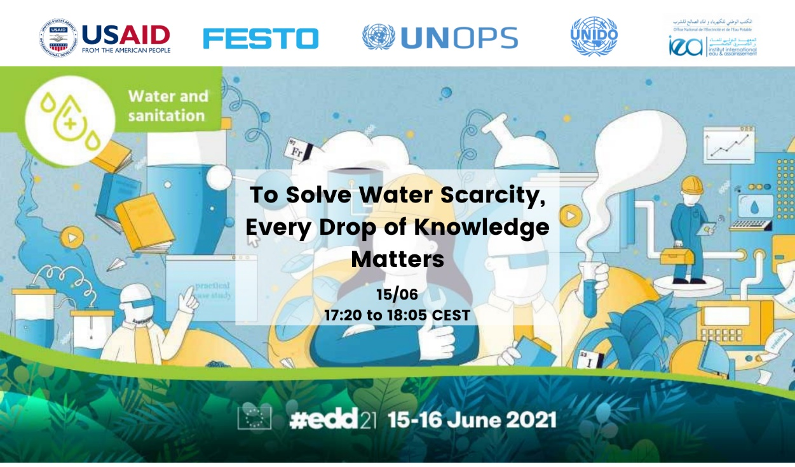
Dear colleagues,
The United Nations Industrial Development Organisation (UNIDO), Festo Didactic, USAID, UNOPS and the Moroccan National Office for Drinking Water cordially invite you to join the webinar on
“To Solve Water Scarcity, Every Drop of Knowledge Matters. Innovative, Sustainable, and Scalable Solutions in the MENA Region”
at the European Development Days 2021 on June 15 at 5:20pm (CEST/Brussels time).
Join the discussion with our speakers from UNIDO, USAID, Festo Didactic, UNOPS and the Moroccan National Office for Drinking Water sharing their experiences about the implementation of innovative solutions to water challenges in the MENA region through inter alia technical skills development, private sector engagement, sustainable infrastructure development, technology transfer and digitalisation.
We are looking forward to your participation and questions! To participate at any EDD event, kindly register for an account with the EDDs HERE.
For more information visit the EDD event page HERE. The session will take place in both English and French with running translation.
For questions, please contact Lisa-Maria Nossek: L.Nossek@unido.org
This webinar will be recorded for external use.

