Coral bleaching and coastal hazard forecasting service

This document has been circulated to UNESCO-IOC, WIOMSA, ICPAC, GMES Africa/BRAGMA.

The coral bleaching component of this system has been developed by CORDIO East Africa and operational since 2007, and has been evaluated for accuracy in two stages – up to 2010 (Obura et al, in review) and up to 2012 (Obura & Gamoyo, in prep.). In a project funded by the Western Indian Ocean Marine Science Association and in collaboration with the Kenya Meteorological Department (KMD), the International Union for the Conservation of Nature (IUCN), and the University of Cape Town (UCT), we have undertaken trials to broaden the approach to identify the key climate hazards to which coastal communities are vulnerable (extreme rain and wind events, drought), and develop tools to also generate useful forecasts for these (dry/wet spells, extreme wind/rain/drought).

This document gives some background on how this system could be expanded and rolled out at a regional level, and including the following key components.
- Consolidation of coral bleaching forecasting with pilot components on dry/wet spells, extreme wind/rain/drought;
- improved stakeholder involvement and ground reporting stations, to provide confirmations of forecasted events that allows improving the skill of the system;
- integration with regional and distant climate information service providers (GHACOF/ICPAC, SARCOF and SWIOCOF)
- integration at national levels with meteorological departments and disaster response networks.

The relevance of this forecasting system to coastal communities and economies of the region is high, and has been discussed at the following regional fora.
- Thirty Second Greater Horn of Africa Climate Outlook Forum (GHACOF 32): 29 – 31 August 2012, Zanzibar, Tanzania
- GMES & Africa Workshop on Marine and Coastal Areas, 9-10th October 2012, Mombasa - Kenya
- Western Indian Ocean Marine Science Association (WIOMSA), Inception And Partnership Building Meeting, 24-25 October, 2012 Mombasa, Kenya.

These meetings provide a guiding regional framework and partners for building up this system, as an example of a needs-oriented collaborative climate forecasting system suited to the African context, and that could be replicated in other social and environmental contexts on the continent.

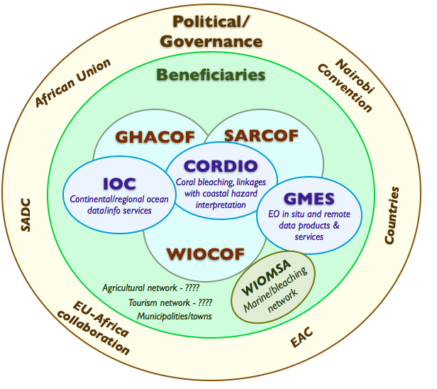
The region of focus is defined by marine and coastal dynamics, and covers the Western Indian Ocean, including mainland East Africa and the Indian Ocean island states in the SW Indian Ocean.
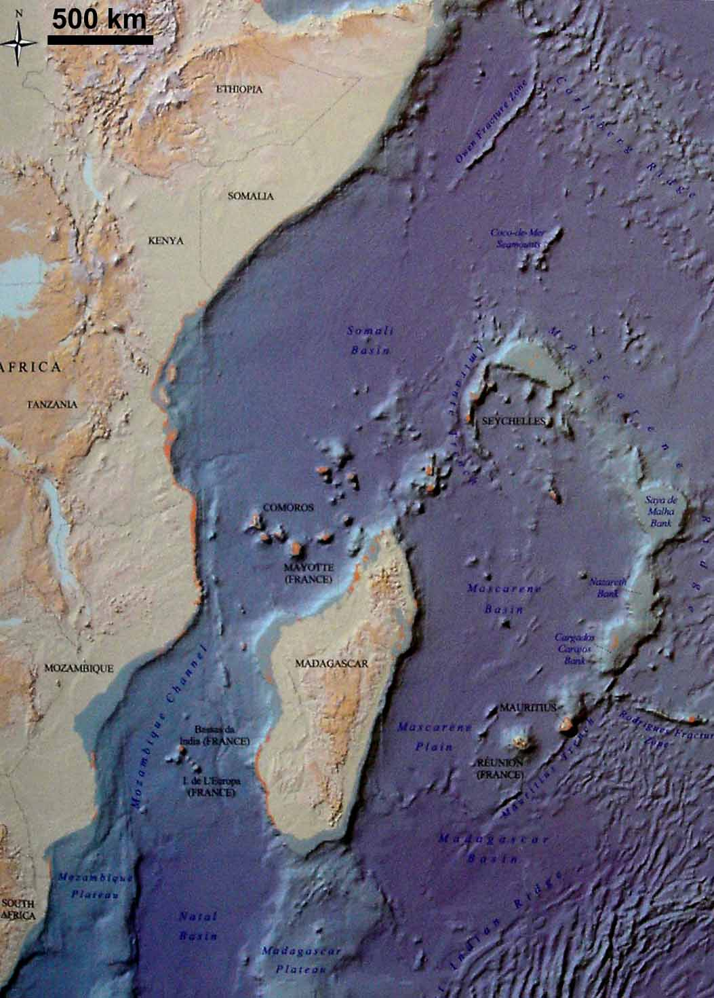

The table below adds additional detail, following the outline of the GMES Africa marine and coastal workshop

2.2 An African Forecast System and Disaster Early Warning System
- 2.2.1 What forecast and disaster-early-warning systems do already exist?
Description  The coral bleaching forecast/early warning system uses global temperature, ENSO and IOD data/models/outputs to determine the overall risk of coral bleaching in the local summer season (Jan-May each year), followed by SST-derived datasets focused on corals (Coral Watch, NOAA) and other weather-related sources (clouds, cyclones, etc) to develop 2-week update forecasts of bleaching risk. 5 subregions of the WIO appear optimal for forecasting, based on SST/marine climate zones within the region.  Rainfall events (dry/wet spells) have been analyzed in relation to SST/ENSO/IOD signals providing a foundation for building up rainfall forecasting ability (Tanzania), along with statistical modeling/forecasting for short term forecasts (Kenya). |  | Actions  Short term  Support the rollout of the bleaching warning system so that it is integrated with regional EO and climate information systems for access to datasets and communicating the forecasts to different regional/international audiences (regional)  Support trials of a wet/dry spell and extreme wind event forecasting system emphasizing the information base needed (regional) and forecasts in some selected trial countries (national).  Medium term  Scoping and project development to integrate such a user-oriented/collaborative forecasting system at regional levels with relevant downscaling to meet diverse national and local needs
- 2.2.2 What would be the benefits of a forecast and disaster-early-warning system at an Africa-wide scale against more national/ regional systems?
Because the marine systems determine coastal climate, a regional focus determined by marine/maritime provinces is essential. Continent-wide action would add value where it can integrate and link different regional efforts together for larger scale data use/interpretation, lessons sharing, etc. |  |  | Medium term
- 2.2.3 What information and analyses and in which from would need to be provided to by an African forecast and disaster- early-information system and to which authorities and institutions in your Country?
The form of the information can be in simple risk/alert levels (e.g. 1, 2, 3) and/or the higher/lower than normal terciles as used in ICPAC climate alerts. This can then be further interpreted, or guidelines given to the receiving instiutions, on how to interpret these for stakeholders. | Relevant institutions in a country would include: disaster/response offices/networks, media (print, radio, TV), fisheries and agriculture departments and extension systems, fisheries and agriculture stakeholder/community group associations, coastal towns/municipalities, police stations, schools, tourism associations/operators/hotels
- 2.2.4 Which are your Country’s current partner organisations (IO,RO,REC,etc.),programmes and projects supporting existing, or the development of new forecast and disaster-early-warning systems and does this support include networking aspects (targets)?
At present, these actions have not been supported nationally, so this needs to be built up.
- 2.2.5 Which regional or international organisations, programmes or projects would you identify/suggest for intermediate technical and financial support to such a forecast and disaster-early-warning system?
For providing support to this system, the African/regional economic fora should eventually support this, as the benefits to coastal economies in avoided costs/lost income will be substantial. In the short term however, funding through the international mechanisms, such as EU and bilateral programmes, or through the service contracts of the international EO data. Further, technical support and collaboration could be obtained through climate cooperation programmes of national/international agencies such as the Hadley Climate Center, etc.

