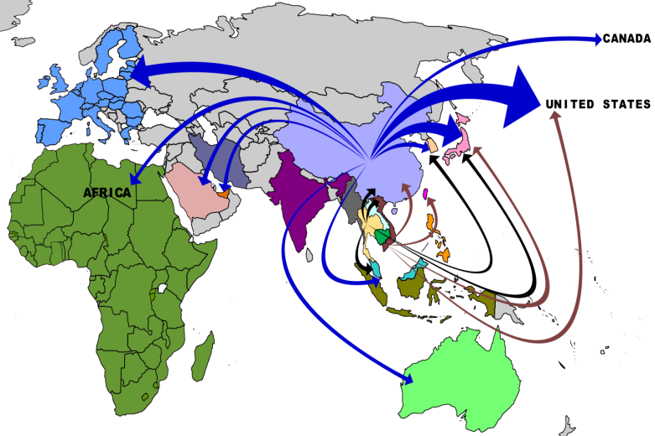
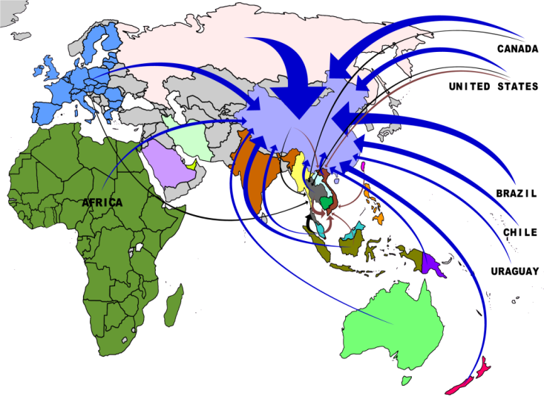

Options for engagement in FLEGT dialogue with China

To support China’s role in improving
global forest governance and management

Table of Contents

INTRODUCTION 3
1. OBJECTIVES FOR FLEGT ENGAGEMENT WITH CHINA 4
2. SETTING THE SCENE 5
3. CHINESE POLICIES TO ADDRESS ILLEGAL LOGGING 11
4. FLEGT RELATED COOPERATION BY THE EU AND EU MS 12
5. SIX LEVERAGE POINTS FOR CHANGE AND POSSIBLE ACTIONS 13
6. THE KEY RISKS IN IMPLEMENTING THIS VISION 18

INTRODUCTION

The international effort to improve forest governance and combat illegal logging and related trade, including the implementation of the EU FLEGT Action Plan, cannot be successful without the involvement of China.

In 2009 the EU (represented by DG ENV) and the People’s Republic of China (represented by the State Forestry Administration) agreed on a Bilateral Coordination Mechanism (BCM) on FLEG (Annex 1). The BCM meets annually; its next meeting is scheduled for Brussels in January 2013.
Although it is a BCM on FLEG, the main aim is to exchange FLEGT related information and coordinate activities.
The BCM is also tasked to explore opportunities for the EU and China to develop a shared approach towards legality verification schemes for timber and timber products implemented by timber exporting countries including in the context of FLEGT VPAs. It aims to bring substance to the EU-China FLEGT cooperation.
All FLEGT support activities of EFI in China are guided by the EU – China BCM. The European Forest Institute’s Regional Support Programme for EU FLEGT Action Plan in Asia is the only EC mechanism to support the BCM.

1. OBJECTIVES FOR FLEGT ENGAGEMENT WITH CHINA

- To enlist Chinese commerce to leverage change in timber exporting countries, and in FLEGT VPA countries in particular, in favour of good governance, poverty eradication and improved forest management.

This can be achieved by ensuring that demand for legal timber and timber products in discriminating consumer countries (EU, US, Australia) feeds through Chinese trading and processing operations to suppliers in timber producing countries in Asia, Africa and Latin America.

- As a result of 1 above, to encourage and leverage change in legality and sustainability standards on the fast growing domestic Chinese market.
This requires credible legality verification at the point of export based on control of the long and complex domestic supply chains in China that includes a broad variety of timber sources from all over the world and domestically produced timber (usually, timber is imported as a log or sawn timber and is exported as a composite multi species product without sufficient legality documentation).

- The scope of the work is to support the Chinese understanding of FLEGT and VPAs, and its linkages with market requirements from the EU and other consumer countries in the Asia Pacific.

2. SETTING THE SCENE
The People’s Republic of China has become one of the world’s leading economies and ranks among the world’s most significant processing and trading hubs for timber and wood products. China’s main export markets are the US, the EU and Japan, which absorbed about 50% of China’s timber and wood product exports.

Figure 1 : Where are China’s exports going?
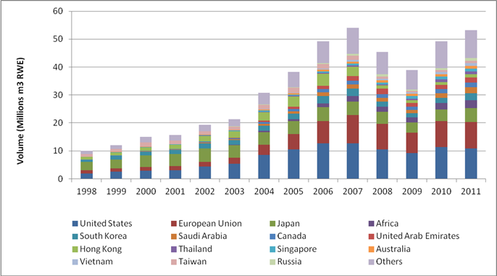
Sources of Data: China's Customs, compiled by Forest Trends.

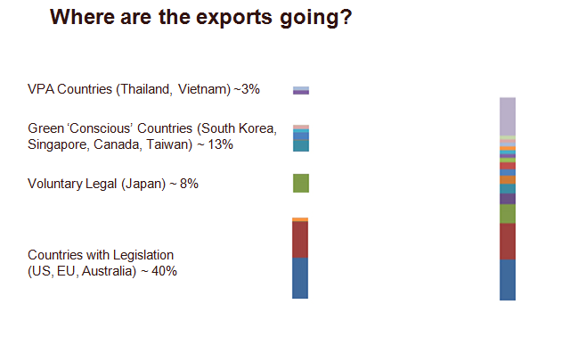These consumer markets increasingly require proof that timber products have been manufactured using legally harvested timber. The combined demand for exports and China’s rapidly growing domestic consumption outpace the country’s domestic timber production by a large margin, resulting in a steadily widening supply gap and continued dependence on imports of unprocessed logs and semi-finished wood products.
Figure 2 :Breakdown of ‘environmentally sensitive markets’ in China’s 2011 exports
Figure 3: Rise of Chinese domestic consumption
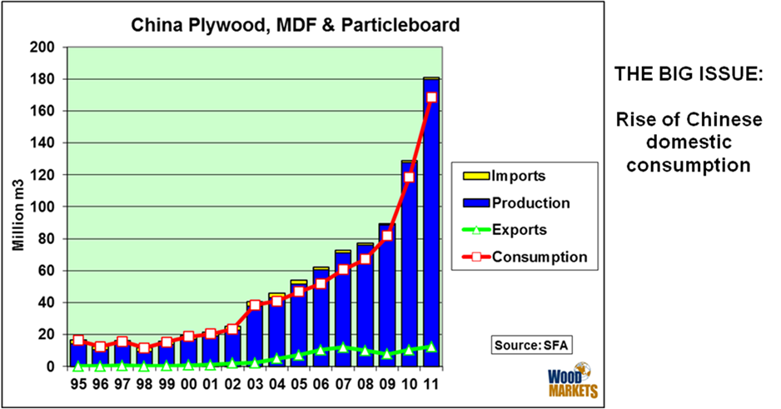
These are sourced from a wide range of countries, including developing and transition countries in Eurasia/North Asia, Southeast Asia, Africa and Latin America and include all VPA countries (annex 2). China encourages overseas investment by Chinese enterprises in the timber sector.
Figure 4 : China Timber Supply and Consumption
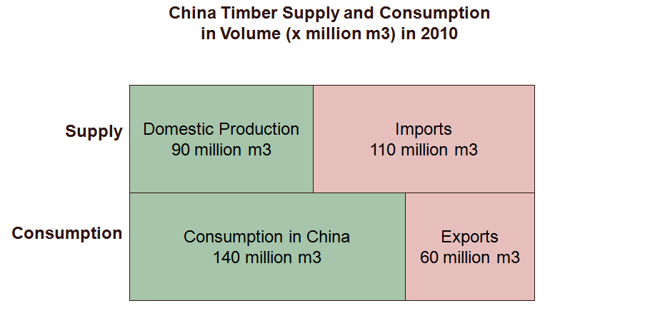
Chinese timber product imports account for more than 50% of its supply. Many developing and transition countries supplying Chinese industries face significant forest governance challenges, including a high incidence of illegal logging and related crime and corruption, high rates of deforestation and forest degradation, and the resultant adverse impacts in terms of GHG-emissions, loss of biodiversity, deterioration of rural livelihoods, and land use disputes. Challenges of this kind inhibit sustainable forest management and endanger global public goods.
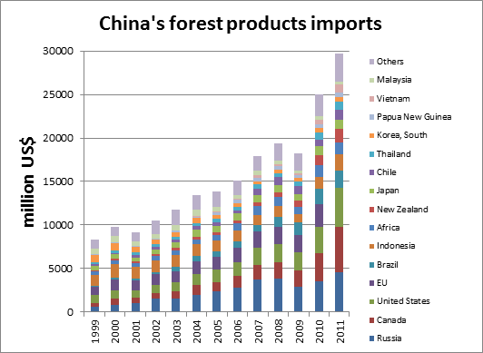
Sources of Data: China's Customs, compiled by Forest Trends.

Figure 5 : China’s Forest Products Imports

The big issue is the rise of the domestic consumption in China, drawing wood from nearly every country that has a forest left. China is facing a huge timber deficit, even with their domestic plantation-sourced timber, which comprises most of their raw material needs. There is going to be a long-term societal demand for more and more timber including high risk woods.

Figure 6: OECD projection of size of middle class by 2030

The circles are the size of the current and expected middle class, by region. The green circles are current (2009) middle class size. Europe is the largest. The biggest circle (expansion of the green circle) is expected size of the middle class by 2030. Asia Pacific will be huge.

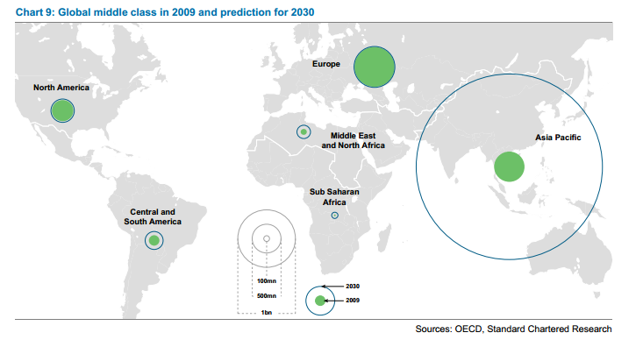

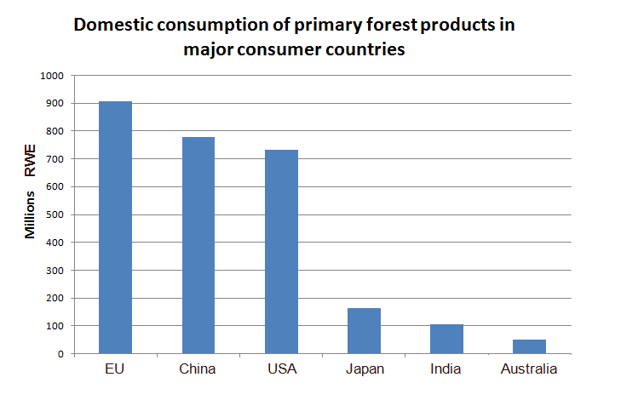Figure 7: Domestic consumption of primary forest products in major consumer countries

China’s fast-growing domestic market will make up for any weakness in their export market.

3. CHINESE POLICIES TO ADDRESS ILLEGAL LOGGING
China is increasingly aware of the changing market requirements in its main export markets and the reputational risks associated with its global forest investment footprint, but likewise of possible implications in terms of continued market access for Chinese timber and wood products industries and traders. Challenges include, inter alia, the need for credible legality verification and timber tracking along complex supply chains, enhanced accountably of foreign investors to adopt best management practices, and the alignment of measures taken by Chinese authorities and market stakeholders with new regulatory requirements of target markets. China faces a growing need to meet new legislation imposed by international markets and to demonstrate sustainable management of Chinese foreign investment.
Responding to these challenges, China has launched a number of initiatives and guidelines aimed at sustainable forest management in China, an ambitious domestic land tenure policy, investments in domestic village based forestry, implementing low risk forestry, supporting carbon build up, and the promotion of trade in legal timber and sustainable overseas forest investment. More information can be found in annex 3, 4 and 5 discussing PEFC in China, Chain of Custody (CoC) certification in China and China’s Timber Legality Verification System (CTLVS).
Regarding the guidelines for Chinese operators overseas, more work is needed to ensure actual implementation and application of these policies to govern the responsible behaviours of Chinese operators.

4. FLEGT RELATED COOPERATION BY THE EU AND EU MS
So far our BCM support work has been modest. To make an impact, FLEGT support work in China requires an effective BCM, a mandate from the EU and China to work on the implementation of the BCM activities and a presence on the ground. Currently these conditions are not sufficiently met.
The main EU MS active in China is the UK. Under the auspices of the UK China Sustainable Development Dialogue the cooperation started drafting a Chinese Timber Legality Verification System. Initial work was concluded in May 2012. The UK works closely with the BCM. EFI works closely with DFID.
Germany has supported a FLEGT related workshops in China, some support work on forest certification, but the bulk of the support was focussed on introducing SFM techniques in State Forest Farms as well as collectively and individually managed forests. The cooperation in this area has stopped.

5. SIX LEVERAGE POINTS FOR CHANGE AND POSSIBLE ACTIONS

- Chinese exporters to sensitive markets. Increase awareness of new and developing market requirements for timber, how to meet that demand and what needs to be done to comply. Associations exporting timber products have an improved understanding of FLEGT and its practical implications for trading timber

Possible Actions:
- Continue with EFI Capacity-Building Training & Training for Trainers Project contracted to Chinese Academy of Forestry to improve awareness on FLEGT;
- Co-organise events on trade in legal timber with international partners (private sector, government, civil society);
- Disseminate reliable information in every possible way;
- Co-organise joint legality training workshops with like-minded partners;
- Share and discuss experiences and best practices on Procurement Policies, setting up of Common Information Window/Clearing House Mechanism;
- Develop buyers’ guides/contribute inputs to Information Clearing House for consuming country importers;
- Support information sharing and awareness-raising workshops, including through the Clearing House Mechanism;
- Support Stakeholder Dialogue;
- Continue with awareness-raising through providing the timber trade press (journals, magazines, newsletters and web-information) with FLEGT-related information written in industry-friendly language;
- Targeted information dissemination to Chinese timber trade associations such as the China Wood Products Distribution Association;
- Improve understanding on the role of China as a responsible consumer in the world timber trade;
- Co-organise ETTF International Trade Forum to align responsible sourcing of timber by industry associations around the world;
- Coordinate messages and integrate FLEGT into activities initiated by APEC, APFNet, ASEAN + 3 (Japan, China, Korea); ITTO, AFoCO, RECOFTC, RRI, FAO, LEAF, RAFT etc.
- Buyers of Chinese timber products. Strengthen the alliance of like- minded consumer countries in cooperating with China on legal timber. In particular the buyers with an interest in verified legal timber products, see Figure XXX. Support the harmonisation of legality requirements from the major consumer countries (EU, US, Australia, Japan, South Korea, and the VPA countries, Thailand and Vietnam).

Possible Actions:
- Support the EU in coordinating with countries that have FLEGT related MoUs with China (Japan-China; Australia-China, Japan- China, US-China, Indonesia-China. Japan-South Korea-China). Individually, these MoUs cover only a modest amount of export, but together they cover about 70% of the export value of timber products. Coordination is essential;
- Support in particular the coordination and harmonisation of viewpoints and messages between consuming countries, with a focus on the buyers in these countries. What is it that they want from China and the exporting countries behind China?
- Coordinate messages at APEC, APFNet, ASEAN + 3 (Japan, China, Korea); ITTO, AFoCO.

- Domestic supply chain in China. Identifying best practices. Improved tracking and tracing of timber flows in country. China is not ready for the EUTR. Providing documented proof of legality for all timber which has passed through so many hands is going to be difficult. Increased understanding of domestic tenure and forest management reform processes as well as national programmes and how they can be utilized to implement FLEGT.

Possible Actions:
- Support the DFID initiatives on timber tracking under the FGMC programme;
- Conduct a timber flow study between the point of import and export for key timber products in China;
- Stimulate a generic chain-of-custody system that integrates PEFC, FSC and FLEGT and other COC’s;
- Identify and spread best practises in supply chain management to support systems within China to meet the new requirements, awareness raising, sharing lessons learned from outside China or other sectors within China;
- Dialogue with Government on the development of documentation and tracking systems that inform on the origin of imported wood;
- Collaborate with relevant organizations including FAO, RRI, RECOFTC, DFID and the SFA to maximize results from China’s forest tenure reform process.

4. Chinese importers of timber. Chinese companies importing timber that might end up in export of timber products to sensitive markets. . Importers basically have to mirror or replicate the same due diligence requirements as buyers from sensitive markets. Associations importing timber products have an improved understanding of FLEGT and its practical implications for trading timber

Possible Actions:
- Understanding the way Chinese businesses operate overseas through investor associations (kongsi);
- Identify points of leverage likely to result in advocacy and awareness raising;
- Training, capacity building, translating responsible purchasing policies.

5. Supplier countries to China. Increase demand for FLEGT licensed timber and certified and verified legal timber, including increased dialogue between China and VPA countries in Asia and Africa. Provide understanding of the legality standards in the supplier countries for China so that it meets Chinese export markets demand and discriminates against illegal timber.

Possible Actions:

- Sensitise foreign investors to adopt best management practices, and the alignment of measures taken by Chinese authorities and market stakeholders with new regulatory requirements of target markets;
- Relate Chinese stakeholders with – the African VPA country stakeholders;
- Co-organize workshop and findings in a publication on China- Africa commodity trade flow studies, conducted by institutions like ICRAF, CIFOR, IIED highlighting the timber trade;

- Participate, co-organise and contribute to FLEGT related events organised by development partners (GIZ, DFID, EU Member States);
- Support B2B dialogues between China and its supplier countries, support civil society and private sector to attend regional FLEGT-related events.

6. Land border areas. Border areas with the Russian Far East in the North East (timber coming across the border from the Russian Far East generally has a poor legality reputation), and with Myanmar and Laos in the West, see Figure XXX, bordering VPA countries.

Possible Actions:

- Conduct a study to understand the China (Yunnan) – Myanmar timber trade;
- Coordinate activities with VPA Dialogue Partner countries (Myanmar & Laos);
- Conduct a study to understand the cross border China-Russian Far East timber trade from the Chinese perspective;
- Coordinate activities between China and the RFE, in particular with the implementing partners of the new EU funded World Bank ENA FLEG programme.

Figure 8 : Border areas hotspots
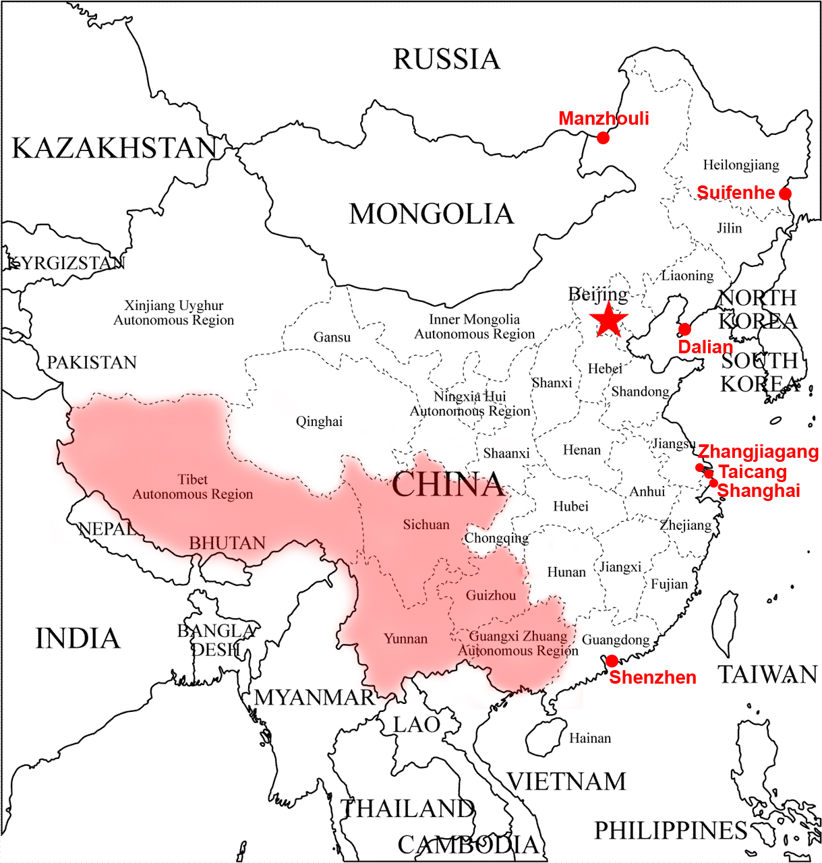

6. THE KEY RISKS IN IMPLEMENTING THIS VISION

- A closing window of opportunity: China not only imports timber for re-exportation but is rapidly becoming an end market in its own right. This reduces the influence of discerning consumer markets and points to a closing window of opportunity for change.

- The urgency of tracking and tracing: Much of Chinese timber destined for the export market is derived from unknown sources and acquired through the spot-market. Without a major drive to improve the tracking and tracing of timber within the vast Chinese processing industry, Chinese demand for timber cannot be used to leverage change in supplying countries.

- Limited EU influence over Chinese domestic forestry situation and timber production: In the absence of VPA negotiations with China the EU has very limited insight into and influence over the way in which domestic timber in China is produced.

- An economic downturn in China forces government to relax measures that encourage responsible trading

ANNEX 1
-
EU - China Bilateral Coordination Mechanism on Forest Law Enforcement and Governance

ANNEX 2
-
China’s Forest Products Imports from VPA Countries

Sources of Data: China's Customs, compiled by Forest Trends Sources of Data: China's Customs, compiled by Forest Trends.

Sources of Data: China's Customs, compiled by Forest Trends. Sources of Data: China's Customs, compiled by Forest Trends.

Sources of Data: China's Customs, compiled by Forest Trends. Sources of Data: China's Customs, compiled by Forest Trends.

Sources of Data: China's Customs, compiled by Forest Trends. Sources of Data: China's Customs, compiled by Forest Trends.

Sources of Data: China's Customs, compiled by Forest Trends. Sources of Data: China's Customs, compiled by Forest Trends.

Sources of Data: China's Customs, compiled by Forest Trends. Sources of Data: China's Customs, compiled by Forest Trends.

Sources of Data: China's Customs, compiled by Forest Trends. Sources of Data: China's Customs, compiled by Forest Trends.

Sources of Data: China's Customs, compiled by Forest Trends.

ANNEX 3
-
PEFC in China
PEFC in China

The PEFC China Initiative was formally launched in October of 2007 in Beijing, China.

The main aims of the PEFC China Initiative:
- Support and promote sustainable forest management in China;
- Increase the market awareness of PEFC forest certification scheme;
- Promote PEFC Chain of custody (CoC) as a market access tool;
- Strengthen the cooperation with Chinese forestry and forest products industry;
- Offer information service and technical support about PEFC forest certification.

November 2010, China Forest Certification Council (CFCC) with support of the China State Forestry Administration (SFA) applied for PEFC membership in 2011 and officially became a PEFC member in 2011 August.

By joining PEFC, CFCC has fulfilled an important prerequisite for applying for PEFC endorsement and is optimistic that PEFC endorsement in attainable by early 2013. Up to October 2012, there is no forest management certification in China, while around 170 CoC have been certificated by PFEC. It is expected that the number of COC and the area of forest management certification could increase significantly after the CFCC gets endorsement from PEFC.

ANNEX 4
-
Chain of Custody (CoC) Certification in China
Chain of Custody (CoC) certification in China

In the Chinese forest products market, there are three kinds of Chain of Custody (CoC): Forest stewardship Council (FSC)-CoC, Programme for the Endorsement of Forest Certification schemes (PEFC)-CoC and China Forest Certification Scheme (CFCS)-CoC.

From 2002, the China State Forestry Administration (SFA) started to research and develop its “China Forest Certification Scheme” (CFCS).

In September 2007, the CFCS with 9 principles, 45 Criteria and 118 indicators and a Forest Certification-Chain of Custody was issued by the SFA. January 2008, the “China Forest Certification Implementation Rules” was issued by the China Certification and Accreditation Administration Committee, which formally established the China Forest Certification Scheme. In 2009, the first forest certification body was established, the Zhonglin Tianhe (Beijing) Forest Certification Center.

FSC is supported by World Wildlife Fund (WWF) which started to launch relevant activities to publicise and promote forest certification in China from 1996. In May 2001, the working group of China forest certification was established in Beijing with the support of WWF. In March 2006, the FSC China office was officially opened in Beijing.
Up to the end of October of 2012, there are 2263 FSC-Chain of Custody certificates in Mainland China (source of information : FSC China), and the number would be 2759 if the Special Administrative District of Hong Kong is counted too. There are 170 PEFC-Chain of Custody certificates, while there are only 2 China Forest Certification Scheme (CFCS)-Chain of Custody certificates.

ANNEX 5
-
China Timber Legality Verification Scheme (CTLVS)
China Timber Legality Verification Scheme (CTLVS)

The objective of the scheme is to provide a suitable approach to meet the new timber legality requirements of international markets, especially the US Lacey Act Amendment and EU Timber Regulation, based on China’s domestic timber management and control system. The draft CTLVS provides a theoretical framework for China, but it still requires further development and detail.

Domestically produced timber could be fully qualified as verified legal timber by China’s three-permit system. This system includes a forest harvesting permit, a timber shipment permit and a timber processing permit. There are two verification schemes that will be implemented for imported timber under this scheme:

- Government-guiding timber verification scheme with bilateral agreements signed with agreement countries (CGTVS)
- Sector association guiding voluntary timber verification scheme established with non-agreement countries (CATVS)

Both the CGTVS and the CATVS require China-authorized organizations to issue timber legality certificates. The Chinese customs office will check the certificates when Chinese companies export their timber products. A wood tracking system is needed for both schemes once timber products enter the country.

There are still many challenges to be overcome in the progress of implementing the CTLVS. The next step is testing and demonstrating work. For this, it is planned to choose a processing company from South China as the pilot sample, and imported tropical timber could be the main target for the testing stage in the further work plan.

On the 16th of November 2012, the launch ceremony of the verification pilot of the Chinese Timber Legality Verification Scheme and the Implementation Regulation of Chinese Timber Legality Verification Scheme will be held during the 2nd International Forest Products Trade Forum by Chinese National Forest Products Industry Association. This is considered a milestone in the development of the CTLVS.

