***Inscription of Creole Cultures to the Intangible Cultural Heritage of UNESCO***

This initiative is part of the process involving States proposing to include elements of their heritage on the World Heritage List. Its aim is to make Creole communities aware of their heritage and to share their values ​​with the peoples of the world.

It all started **in February 2018** with the launch of the group "Creoles cultures / Kiltir Kreol / Cultures Créoles" , devoted to the theme "Developing a knowledge base on heritage', on LinkedIn (<https://www.linkedin.com/groups/8259466>

The initiative was also presented to the participants of the 16th International Conference of Creole Studies, Mahé (Seychelles), **28 October - 2 November 2018**,

at the INTERNATIONAL CONFERENCE "Small companies in a globalized world: lessons learned from Seychelles" at UniSey **from 6 to 8 March 2019**, during which the **Declaration of ‘Anse Royale’** was signed.

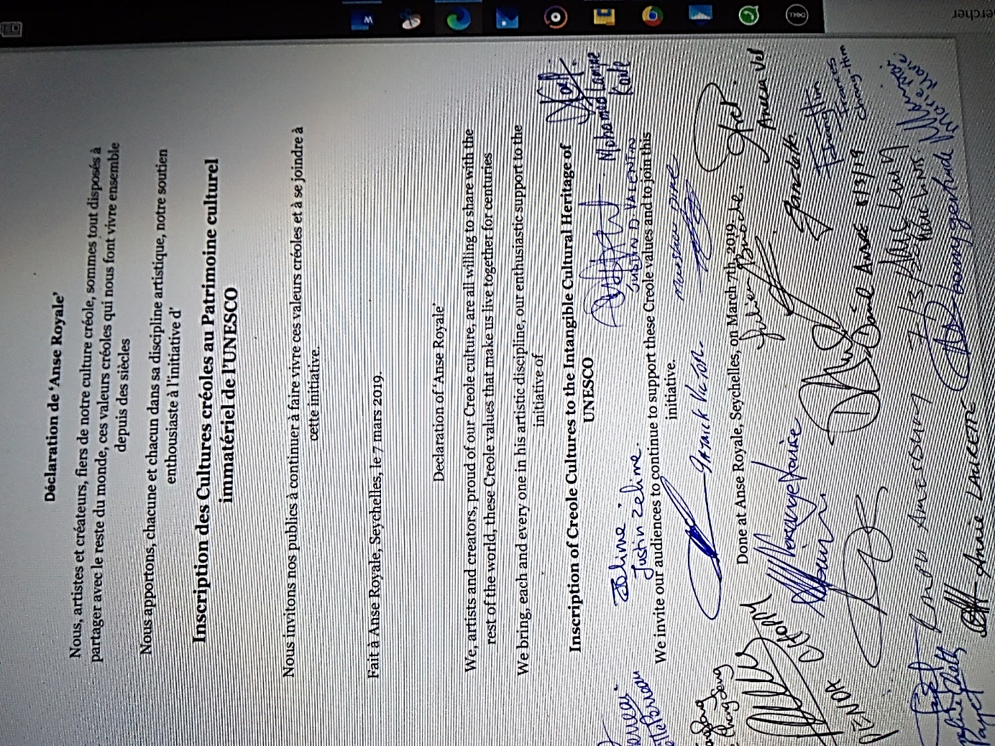

and at the Dominica Country Conference 2019, **August 15 & 16, 2019,** at UWI Open Campus Dominica Road Elmshall Roseau, Dominica.

<https://fr.slideshare.net/MarcLINTS/pp-dominica-2019-edited>

**Throughout 2019**, artists and cultural professionals, as creators and mediators, were made aware of the promotion of the heritage of Creole cultures to their audiences.

**At the end of 2019**, the Group “Creoles cultures / Kiltir Kreol / Cultures Créoles"  
has also been installed on the site

<https://europa.eu/capacity4dev/creoles-cultures-kiltir-kreol-cultures-cr-oles>

Capacity4dev is the European Commission’s knowledge sharing platform for development cooperation where you can share, learn and collaborate with over 25,000 members.

**In early 2020**, Marc LINTS led a mission to prepare activities related to the twinning of capitals, Praia for Cape Verde and Victoria for Seychelles, on the island of

Santiago. Beyond twinning, this mission also relates to cultural cooperation and international Creole cooperation, it provides concerts during the **Kriol Jazz Festival** and interventions at meetings of the **Atlantic Music Expo**.

The planned Seychellois delegation consists of David André, Mayor of Victoria, Lydia Charlie, Executive Director at the Town Hall, Patrick Victor, Honorary Cultural Ambassador of Seychelles and musicians from the Metis Group, and also Marc Lints. Initially organized for Easter 2020, it is reported in 2022 given the ongoing pandemic.

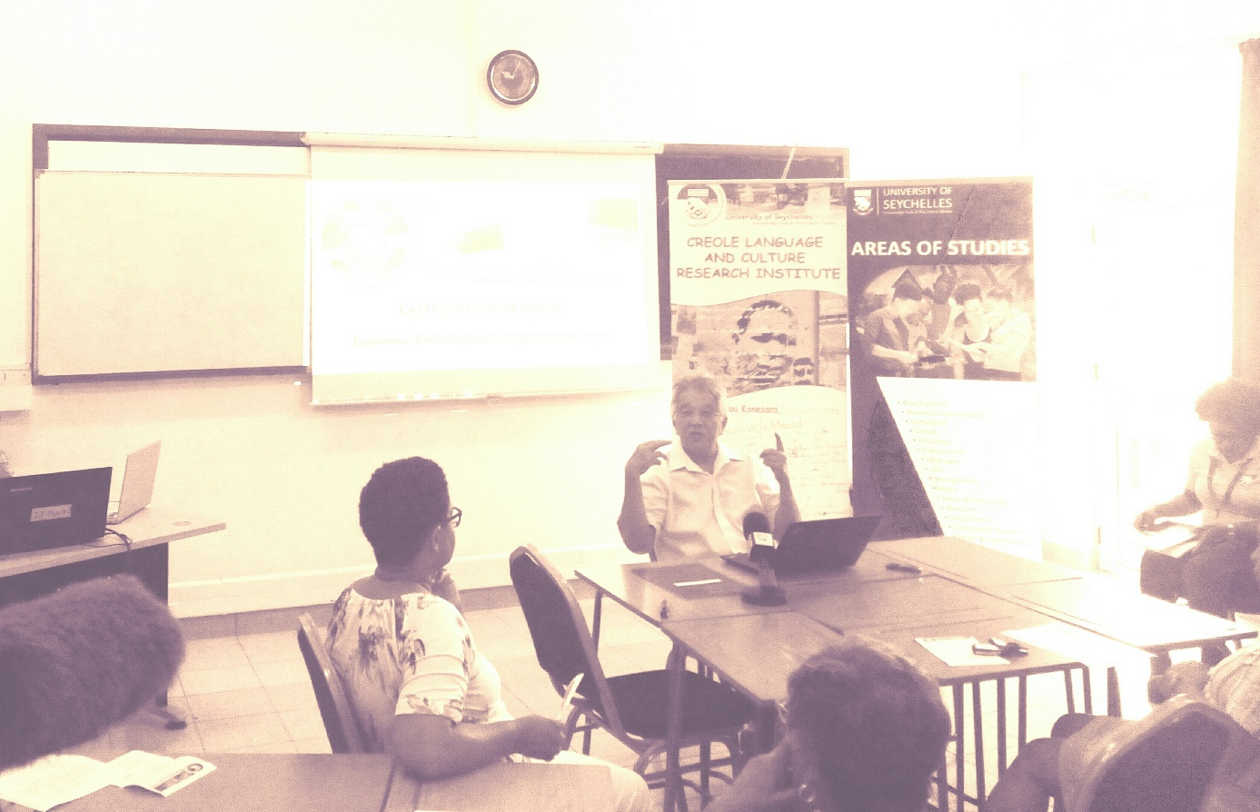

In 2020, Presentation at the VALER KREOL Workshop - VIV ANSANM

Propoze by Lenstiti Resers for Lalang ek Kiltir Kreol takes place on **28 Fevriye, Liniversite Sesel, 2020.**

<https://www.slideshare.net/MarcLINTS/pp-clcri-2020-en-230283668>

Reports have been published on the Group sites :

[**Creoles cultures / Kiltir Kreol / Cultures créoles**](https://www.linkedin.com/groups/8259466)

<https://www.linkedin.com/groups/8259466>

<https://europa.eu/capacity4dev/creoles-cultures-kiltir-kreol-cultures-cr-oles> <https://culturexchange.eu/group/25/stream>

And the Initiative is invited **to MASA 2020**, to be presented and to share cultural cooperation projects between the Creole worlds of the Indian Ocean, the Atlantic and the Caribbean. (A vast program to which the African continent is intimately linked). MASA 2020, from March 7 to 14 in Abidjan (Côte d´Ivoire) <http://www.fr.masa.ci/>

<https://www.slideshare.net/MarcLINTS/pp-masa-2020-fr-230301475>

Following the creation of the site **CultureXchange**

* A knowledge and skills sharing platform and a match-making tool, supporting a vibrant professional community dedicated to culture and creative industries in the EU partner countries. This project is funded by the European Union and implemented with the support of the OACPS ( [**ORGANISATION OF AFRICAN, CARIBBEAN AND PACIFIC STATES**](http://www.acp.int/fr/content/organisation-african-caribbean-and-pacific-states-hosts-extraordinary-intersessional-summit-)**)**

Installation of the Group on:<https://culturexchange.eu/group/25/stream>

**End of 2020 and spring 2021**, preparations for the organization of the event "Les Rencontres creoles de" at EDD21 https://eudevdays.eu/ in Brussels.

This event in the heart of the European Union virtually brings together creators, artists, poets, literary artists, academics, gastronomes ... in short, active people, from "Creole" cultures concerned with sharing, transmissions and exchanges. It involves

A musical co-creation by artists bringing together

For the Caribbean,

Aurelio Martinez from Garifuna (Belize, Guatemala, Honduras, Nicaragua), Omar Sosa, Cuba,

For the Indian Ocean,

Gilbert Pounia from Reunion, Eric Triton from Mauritius, David André and Patrick Victor from Seychelles

and for the Atlantic,

Mario Lucio from Cape Verde,

A conference entitled ON CREOLIZATION

Gathering around Mario Lucio Sousa, the speakers

Carlos Vaz (Guiné Bissau), Camile Queiroz (Brazil), Erol Josué (Haiti), Jorge Rui Martins (Portugal), Percy Yip Tong (Mauritius), Frédérique Ménant (France), Elisa Lucinda (Brazil), Catarina Isabel Matins (Moçambique) -Portugal).

A workshop to reflect on human values

Reflections workshop prepared by Penda Choppy, at the start of the 'Creole values' workshop held at UniSey on February 28, 2020 and fed by proposals concerning 'European' values developed by Pietro De Matteis and 'Sufi' values by Faouzi Skali

**April 2021**, the Organization of African, Caribbean and Pacific States (OACPS), approached as co-organizer with BOZAR, informs us that: “the Secretariat of the OACPS cannot yet decide on the participation of the Program. ACP-EU Culture at EDD21, post posing then ‘The Creole Meetings of Brussels’ in the year 2022.

**May 2021**, the health situation having improved in Portugal, the organizers of "IMATERIAL" announce a first "limited" version of the festival to EVORA to which Marc Lints is invited to participate in the conference program for the

Presentation of the Initiative Inscription of Creole Cultures in the Intangible Cultural Heritage of UNESCO

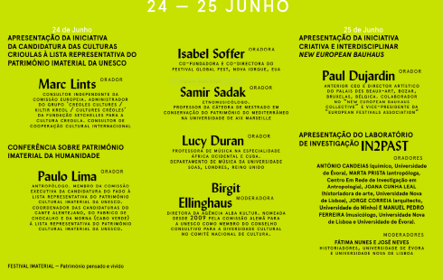

Marc Lints a presenta a Iniciativa de Candidatura das Culturas Crioulas no Património Cultural Imaterial da UNESCO, falando-nos dos vários projectos em curso de cooperação cultural entre os povos crioulos do Oceano Índico, do Atlântico e das Caraíbas. A iniciativa respeita a uma proposta dirigida a estas comunidades crioulas, no sentido de inscrever os seus legados nas listas oficiais do Património Imaterial, apelando, em paralelo, à preservação de práticas artísticas concretas e à sensibilização de artistas e instituições para a promoção das suas culturas.

MARC LINTS Consultor independente da Comissão Europeia; Administrador do grupo Creoles cultures / Kiltir Kreiol / Cultures créoles da Fundação Seychelles para a Cultura Crioula

https://www.slideshare.net/MarcLINTS/pp-evora-2021-en10193-249953229

On this occasion, I communicated :

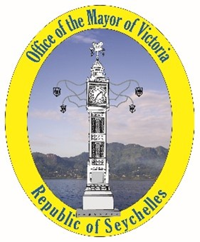

As Mayor of Victoria, Capital of Seychelles, responsible for the creation of the "National Institute for Culture, Heritage and the Arts of Seychelles",

I organize, surrounded by my collaborators,

**The "Creole Encounters"**

**At Victoria**

**November 1-2, 2021**



This event in the capital of the Seychelles will bring together creators, artists, poets, literaries, academics, gastronomes ... in short, active people, from "Creole" cultures concerned with sharing, transmissions and exchanges.

It will take place after the 36th Seychelles Kreol Festival, in which the guests of the Meetings will participate. Indeed, they will be invited to share the Seychellois Creole life by staying "with the locals" in the "districts" according to artistic affinities. They will participate in cultural activities organized by the inhabitants in their "territories", before reaching the capital at the end of the week.

It involves

**A musical co-creation**

**A festival of audiovisual creations**

**A workshop to reflect on human values**

**A workshop to reflect on the place of women, children and minorities in Creole life**

**A conference entitled Falando de crioulização**

**An exhibition "Musical Heritage of the Indian Ocean"**

(S) David André

And **on September 30**, the press release is issued :

*Following the evolution of the world health situation and its consequences on the economy of Seychelles, David André, Mayor of Victoria, in charge by President Wavel Ramkalawan, of Culture at the Government of Seychelles and as such initiator of the Creole Meetings de Victoria, asked me to inform you that this event is postponed until the end of October 2022. In the meantime, the Seychelles team continues the preparation and remains open to any participation*.

In parallel, the participation of Seychelles in the 2nd edition of **the Luanda Biennale**, in Angola, is envisaged from July 2021 and unfortunately, given the degradation of the sanitary conditions in this part of Africa, Seychelles decided to participate only in a virtual way, via a "National Pavilion" https://www.unesco.org/biennaleluanda/2021/fr/pavilions

The conference proposal was articulated in three parts:

1. Presentation of the initiative to inscribe Creole Cultures on the UNESCO Intangible Cultural Heritage List, as presented in Seychelles (2019), Dominica (2019) and Portugal (2021), by Marc LINTS.

2. Presentation of the Concept of the "National Institute for Culture, Heritage and Arts of Seychelles", by David André.

3. Presentation of the Manifesto FALANDO DE crioulização, by Mario Lucio Sousa.

It thus responded to theme 1 of the Biennale:

The contribution of arts, culture and heritage to peace and is part of the common approach of the Creole States, the majority of which are members of the OACPS, to the recognition of their cultures by UNESCO, as theorised in the document "**Kreolitude":** Kreolitude is resolutely turned towards the future in order to contribute through its experience to the construction of a better world. The aim is therefore to identify the values that have enabled people from the four corners of the world, the Creole peoples, to establish a society of peace, respectful of its cultural differences, harmoniously mixed, even if imperfect because it is becoming daily.

On 28 October **EUROPEANA** publishes Creole culture movement: Kreolitude, a version illustrated with documents from its collection. : https://www.europeana.eu/fr/blog/creole-culture-movement-kreolitude?fbclid=IwAR14rwN3jMdfbxlPfy-a5Befl_uSajP4SL3yHEyYD8Va_2SvUhT0jGlwHFw

Follows the "expanded" version on YouScribe : <https://www.youscribe.com/catalogue/documents/actualite-et-debat-de-societe/actualite-evenements/mouvement-cultures-creoles-3252267?ni=1>

**November 2021**, the IOMMa in Reunion Island, invites a delegation from Seychelles to participate in its work:

Mr David André, Secretary General - National Institute for Culture, Heritage and the Arts

Mrs Miera Savy, International Cooperation Advisor - National Institute for Culture

Mr Marc Lints, Consultant

And on 3 December, we received this bad news:

*Dear Seychellois delegation,*

*Due to the new health restrictions imposed on us, it is impossible to receive travellers from Mauritius and South Africa. All travellers from the Indian Ocean are now subject to a 10 day isolation on arrival in Reunion, we are unable to bring you to us. It is a great sadness and heartbreak for us not to be able to welcome you (and all the delegations from the Indian Ocean) to this 2021 edition of the IOMMa. We thank you for your support and will come back to you later to define together the axes of cooperation.*

**December** Moutya was added to UNESCO's list of intangible heritage on December 15th and the Secretary General of the Seychelles Institute of Culture, Heritage and the Arts, David Andre, said :  
"For our traditional dance, it shows how valuable our heritage is, but now we must work hard to ensure that our Moutya gets the place it deserves, especially among the youth, so that it can continue to be enjoyed for generations to come," said Andre.  
In his statement to mark the occasion, the Seychelles' President Wavel Ramkalawan said that December 15th will be marked as an important date in the history of the island nation.

https://www.youtube.com/watch?v=o26q5td5q8E