EUROPEAN COMMISSION  DIRECTORATE-GENERAL FOR INTERNATIONAL COOPERATION AND DEVELOPMENT | EUROPEAN EXTERNAL ACTION SERVICE
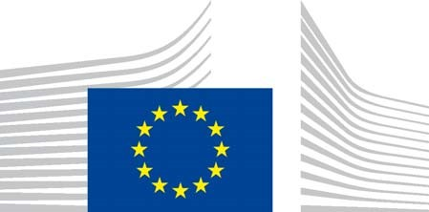 | 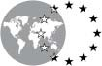
The Director-General | Secretary General

Gender Action Plan III – 2021-2025
UGANDA - Country Level Implementation Plan (CLIP)
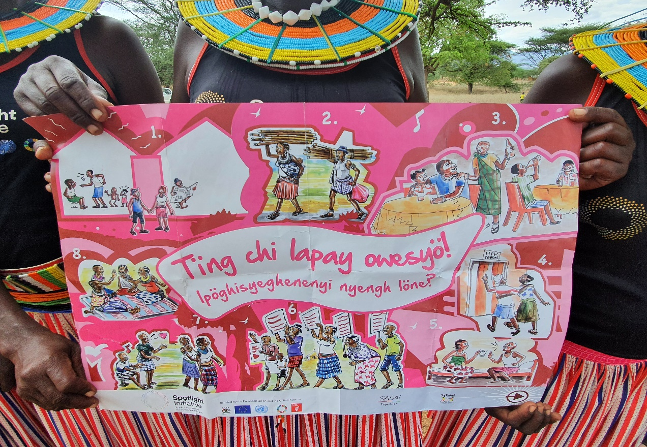
- Context for EU action gender equality and women’s empowerment in the country
Uganda’s vision 2040 is a transformed society where Ugandans aspire for a future in which men and women are accorded equal opportunity to participate in development. This is further strengthened in the National Development Plan (NDP) III which sets out Uganda’s vision of a transformed society from a peasant economy to a modern and prosperous one by 2040. In addition, the Government of Uganda has strengthened its commitment to realize equal opportunities in planning and budgeting through the Public Finance Management Act (PFMA) 2015 that mandates all sectors, Ministries, Departments and Agencies (MDAs) and local governments to plan and budget in a gender and equity responsive manner to be issued with a certificate of compliance. The recently passed sexual offences bill (2019) has specific provision for sex-related offences that have hitherto remained inappropriately addressed and on the increase despite the existence of other related laws. However, it falls short on international human rights standards in its current form and there are calls for its revision before being assented to by the President.

Uganda has a progressive legal and policy framework to support gender equality and women’s empowerment (GEWE). The Constitution prohibits all forms of discrimination against women and provides for the protection and promotion of women’s rights. Other specific laws relating to GEWE include the Domestic Violence Act (2010), the Prohibition of Female Genital Mutilation Act (2009); and the Prevention of Human Trafficking Act (2009), which outlaws customs that violate women’s and girls’ right to personal dignity and bodily integrity and the Children Act (amendment, 2016). These laws provide a legal framework for the empowerment of women and girls and for addressing barriers that negatively affect women’s status in society. Laws also provide for the building of women’s capacity to participate in governance structures with equal rights and as beneficiaries of good governance dividends. At the international level, Uganda has ratified the Convention on the Elimination of All Forms of Discrimination against Women (CEDAW), the Maputo Protocol and the Goma Declaration on Eradicating Sexual Violence and Ending Impunity in the Great Lakes Region. Uganda has also developed its 3rd National Action Plan on Women, Peace and Security 2020-2025.

Although much has been achieved especially on the legal and policy framework for GEWE, there still exists a significant gap between laws and policies on one hand and reality on women’s and girls’ lives on the other. There are reported high rates of gender-based violence; e.g. 56% of women reported having experienced physical violence at some point in their lives, and 22% of women aged 15 – 49 years have experienced sexual violence. The COVID-19 pandemic has exacerbated the situation with increased cases of SGBV, early pregnancies and cases of defilement against girls and children especially as a result of closure of schools and lockdown. Rape or defilement is the third most common case reported to the police while conviction rates remain low. There is unequal division of unpaid care and domestic work, and discrimination in public office remain significant barriers to gender equality in Uganda. Shocks, climate change and disasters continue to have a disproportionate effect on women and children. Uganda has made strides in improving access to sexual and reproductive health services.

The situation of women and girls is further complicated by the existence of post conflict situations in parts of the country, localised conflicts related to the extraction of natural resources and the influx of refugees from neighbouring countries.

- Selected thematic areas of engagement and objectives

The CLIP is closely linked to the 2021-2027 multi-annual indicative programme (MIP), the Human Rights and Democracy Country Strategy (HRDCS) 2021-2024 and the 2021-2027 Civil Society Roadmap. Gender equality is a cross-cutting and prominent themes in all three strategic documents.

The 2021–2025 CLIP will focus on the following five key thematic policy areas of the GAP III: (i) ensuring freedom from all forms of gender-based violence, (ii) promoting sexual and reproductive health and rights, (iii) promoting economic and social rights and empowering girls and women, (iv) advancing equal participation and leadership, and (v) integrating women, peace and security agenda. The selection builds on priorities and lessons learnt from the GAP II implementation and is aligned with the MIP priorities. The above objectives will be achieved through specific actions such as the EU-UN Spotlight initiative, support to adolescent girls education and support to civil society. Political and policy dialogue with the government and partnerships with EU Member States as part of the Team Europe initiative on demography and social inclusion and with the private sector such as the Sustainable Business for Uganda Platform (SB4U) will also contribute to the achievement of the CLIP objectives. The EU Delegation will also pursue a greater engagement with faith-based organisations which play an essential role in shaping norms in the country as well as with youth-based organisations.

Priority area I- Ensuring freedom from all forms of gender-based violence
Overall objective- Women and girls are free from all forms of gender-based violence (priority areas 3 of the MIP, priority 3 of the HRDCS).

Despite positive trends in legislation and actions to eliminate GBV in Uganda, women continue to be subject to various forms of abuse and violence, including physical, sexual, emotional and economic abuse. The impact of COVID-19 lockdown and school closures has worsened the situation. The EU in Uganda intends to use a transformative approach and also increase men and boys’ engagement as champions of change. The specific objectives under this priority are:
  - Women and girls are protected from all forms of gender-based violence through legislation and effective enforcement.
  - Women, men, girls and boys are agents of change regarding discriminatory social norms, gender stereotypes.
  - Promote the provision of medical, psycho-social, legal and safety support to victims/survivors of conflict-related sexual and/or SGBV.
  - Women and girls are protected from SGBV in humanitarian (refugees and those displaced) crisis situations.
  - Women’s rights organisations, women human rights defenders (WHRDs), social movements and other civil society organisations are influential in ending GBV.

Priority area II- Promoting sexual and reproductive health and rights
Overall objective – To enable women and girls access universal health and enjoy their health and sexual and reproductive rights (priority area 3 of the MIP, priority 1 of the HRDCS).

Sexual and Reproductive Health and Rights (SRHR) still remains a contentious issue in Uganda. There is limited access to information and services on SRHR to many women and girls. Many girls are married before age of eighteen and teenage pregnancy still remains a major concern. The National Sexuality Education Framework was launched and is being disseminated. The lower secondary curriculum has been revised to integrate sexuality education infused across all subjects. Key challenges for continued engagement regards quality of sexual education intervention by government and restrictive implementation environment for partners especially from traditional religious institutions. There are limited family planning services and the majority of women cannot make free and informed decision about their sexual and reproductive health. The specific objectives under this priority are:

  - Women and girls have improved access to quality sexual and reproductive health care and services.
  - Comprehensive sexuality education fully integrated within the education curriculum.

Priority area III- Promoting economic and social rights and empowering women and girls
Overall objective- To facilitate girls and women empowerment through education, sustainable growth and increased access to jobs (priorities 2 and 3 of the MIP, priorities 1 and 4 of the HRDCS).

Despite a policy of universal access to education, completion rates in primary school are low, with just a third of students completing primary education. At secondary level, completion rates are even lower, especially for girls who experience additional barriers including gender-based violence in schools. The vicious circle of girls’ low education and high unplanned (teenage) pregnancy rates, further entrenched by patriarchal attitudes, hampers the achievement of other social and economic rights and is directly linked to the major demographic challenge of the country. Furthermore, women and girls continue to be denied access to means of production like land and capital, yet they take the biggest burden in care and production especially at household level. According to UNHS 2016/2017, only 22.4% of women have opportunities in modern wage employment compared to 36.6% of men. The COVID-19 pandemic has seen many vulnerable women out of the small options of survival they had to fend for their families. The specific objectives under this priority are:

  - Increased access to education for adolescent girls through scholarships and WASH facilities in schools
  - Increased access of women to decent work, especially in non-traditional sectors of science, technology and ICT

Priority area IV- Advancing equal participation and leadership
Overall objective – Women and men participate equally in decision-making process at all levels and women take on leadership roles (priorities 3 of the MIP, priorities 3 of the HRDCS)

Uganda has made progress in increasing opportunities for women participation through inclusive policies with an increase in number of women in decision-making positions. For example, the number of women representation in parliament increased from 131 in the 9th parliament (2011- 2016) to 160 in the 11th parliament (2016-2021). Women representation at the various local government levels was reported at 41%. However, this progress has not translated to improved welfare in the lives of majority women. The specific objectives under this priority are:

  - Support women’s organisations working for gender equality and rights
  - Equitable social norms, attitudes and behaviours promoting equal participation and leadership at all levels through civic education, media, education and culture

Priority area V- Integrating women, peace and security
Overall objective – Integrating women, peace and security agenda in conflict prevention and resolution mechanisms (priority 3 of the MIP, ECHO humanitarian aid)

Uganda hosts the highest number of refugees in Africa and is a signatory to UNSCR 1325 that calls for protection of women and girls from SGBV in emergency and humanitarian situations, and their increased participation at all levels of decision-making. The 3rd National Action Plan (NAP) III on Women, Peace and Security (WPS) was adopted by the government in March 2021. This priority area is linked to Priority II of the HRDCS, which aims to promote land and environmental rights, areas which often give rise to conflicts which disproportionately impact women. The specific objectives under this priority are:

  - Strengthen consultative mechanisms on conflict-related issues with grassroots women activists and CSOs in conflict-related settings
  - Promote and strengthen the rule of law and criminal justice system through transitional and restorative justice to end impunity for perpetrators of SGBV crimes.
  - Promote the provision of medical, psycho-social, legal and safety support to all victims/survivors of conflict-related sexual and/or gender-based violence/SGBV.

- Targeted actions supporting gender equality and women’s empowerment

Action | Link to MIP and HRDCS priorities and to Team Europe Initiatives (TEI) | GAP III Objective | Rationale/Expected result | Indicators
SGBV- SRHR (building on the EU-UN spotlight) | MIP: Democratic governance and social inclusion  HRDCS: SRHR as part of right to education  TEI on demography and social inclusion (under development) | Ensuring freedom from all forms of GBV  Promoting sexual and reproductive health and rights | Women and girls continue to face SGBV  Women and girls who experience SGBV have access to essential services and protection  Women and girls fully enjoy their SRHR | - Number of individuals benefitting from EU-funded programmes to counter SGBV  - Extent to which comprehensive sexuality education is integrated in education curriculum  - Number of women of reproductive age using modern contraction methods with EU support
Education for adolescent girls | MIP: Democratic governance and social inclusion  HRDCS: Right to education  TEI on demography and social inclusion (under development) | Strengthening economic and social rights and empowering girls and women | Reduction in gender disparities in enrolment, progression and retention around the transition between primary and secondary levels | - Number of adolescent girls enrolled in education with EU support
Support to civil society | MIP: Democratic governance and social inclusion  HRDCS: Civic and political space | Women and men participate equally in decision-making process at all levels and women take on leadership roles | Enhancement, inclusion and contribution of women in development processes and policy dialogues at all governance levels  Women and men are agents of change regarding discriminatory social norms and gender stereo-types | - Number of women’s organisations supported

- Engage in dialogue for gender equality and women empowerment
The EU Delegation will engage in regular dialogue on the issue of gender equality and women empowerment at policy and political levels. This dialogue will also take place in the context of the implementation of the MIP, the HRDCS and the civil society roadmap. Interlocutors will include the government and relevant ministries (e.g. gender, education, finance), civil society organisations (e.g. human rights defenders, women’s and faith-based organisations) and the private sector on women economic empowerment and gender aspects of the human rights and business agenda. The EU can also play a convening role by bringing together diverse groups of stakeholders to engage in dialogue on issues falling under the CLIP. Cooperation with the UN agencies present in Uganda, in particular in the context of the EU-UN Spotlight initiative, will continue.

- Outreach and other communication / public diplomacy activities

Gender will be mainstreamed in international days falling under the responsibility of the EU Delegation. Visibility around actions targeting specifically women and girls (e.g. EU-UN Spotlight initiative, adolescent girls’ education, support to women’s organisations and civil society organisations with a strong focus on gender) will be promoted. The annual EU Human Rights Defenders Award is also an avenue for recognition of women human rights defenders.

- Technical Facility and/or financial resources allocated to support GAP III implementation

Implementation of the GAP III CLIP will be supported by ongoing actions and the new MIP, in particular priority areas 2 (sustainable and inclusive growth and jobs) and 3 (democratic governance and social inclusion). Notably, it is estimated that under priority 3 of the MIP, 70% of the funding will be allocated to gender, including two G-2 actions; one on GBV/SRHR building on the ongoing EU-UN Spotlight initiative and a new action to support adolescent girls education. Both actions will be part of the TEI on demography and social inclusion (under development). Furthermore, support to civil society will continue to have a significant component on gender including the Civil Society in Uganda Support Programme and its successor (under preparation), the Democratic Governance Facility and its possible successor and EIDHR grants.
Thematic expertise may also be mobilised through the technical facility to conduct analyses and /or mainstream gender in new actions

Date: …………………………………………………………………………………….

Signature by Head of Delegation: ……………………………………………………………………

Public Finance Management Act (2015)
The Sexual Offences Bill (2019)- Uganda Women Parliamentary Association (UWOPA) Policy brief
National report on the implementation of the Beijing Declaration and Platform of Action for Uganda, June 2019
Uganda Country Gender Analysis Report (2016- 2020)
Uganda Demographic and Household Survey (UDHS) 2016
Police annual crime report 2019
Voluntary national report on the implementation of the 2030 agenda for sustainable development- June 2020
Under this objective, the CLIP will align with the EU’s support to civil society under the Civil Society Roadmap, and the EU’s efforts to safeguard civic space under Priority 3 of the HRDCS. The EU will also pay specific attention to protecting and raising the profile of women human rights defenders (WHRD).
Right to education and greater human rights compliance by businesses in Uganda, including through raising the voices of women in dialogue on business and human rights
A matrix and analysis of gender equality laws and policies in Uganda, published by Makerere University Gender Equality Project in partnership with University Forum on Governance with support from Democratic Governance Facility (DGF) – 2019 P.10
Civic and political space
National report on the implementation of the Beijing declaration and platform for action - 2019
Ibid

