

|  |  |
| --- | --- |
| European Commission Framework Contract SIEA 2018 | |
| EUROPEAID/138778/DH/SER/MULTI  Lot I: Sustainable management of natural resources and resilience  Contract Reference n° 2020 / 419864 Version 1  Elaboration of the Country Environmental Profile (CEP) of South Sudan  EuropeAid/138778/DH/SER/multi  South Sudan Country Environmental Profile Report  Submission Date: 06/05/2022 | |
|  | **SOGEROM CONSORTIUM**  ***Implementing Partners*** |
| This project is funded by European Union |  |



|  |  |
| --- | --- |
| **Assignment Title** | Elaboration of the Country Environmental Profile (CEP) of South Sudan |
| **Report Title** | South Sudan Country Environmental profile |
| **Period Covered** | 25/10/2021 to 06/05/2022 |
| **Document Version** | 06/05/2022 |
| **Status** | Final |
| **Date of Submission** | 06/05/2022 |
| **Contracting Authority** | EUD South Sudan |
| **Task Manager** | Sergio Rejado Albaina |
| **FWC Contractor** | SOGEROM |
| **Assignment Manager** | Antonin Braho |

**Prepared by:**

|  |  |
| --- | --- |
| **Team Leader** | Jerome Courboules |
| **Team Member** | Martin Dramani |

*This report was prepared with financial assistance from the Commission of the European Communities. The views expressed are those of the consultant and do not necessarily represent any official view of the Commission or the Government of South Sudan.*

**TABLE OF CONTENTS**

TABLE OF CONTENTS 3

LIST OF FIGURES 6

LIST OF TABLES 7

ACRONYMS 8

EXECUTIVE SUMMARY 11

1 CHAPTER ONE: SOUTH SUDAN CONTEXT 14

1.1 Geography/Physical Environment 14

1.1.1 Topography 14

1.1.2 Hydrology 15

1.1.3 Geology 15

1.1.4 Ecosystems 16

Montane and lowland forests 16

Low-rainfall savannah woodlands 16

High-rainfall savannah woodlands 16

Savannah woodlands recently derived from rain forests 16

Grasslands 16

Semi-desert 17

Wetlands and marshes 17

Degraded forest/agriculture ecosystems 17

1.2 Socio-economic environment 17

1.2.1 Economy 17

1.2.2 Population 18

1.2.3 Poverty 18

1.2.4 Education 19

1.2.5 Health 19

1.3 Climate change 20

1.3.1 Current climate 20

1.3.2 Observed climate variability and changes 20

1.3.3 Projected changes 21

1.3.4 Effects of climate change 22

1.3.5 The challenge of climate information availability and accessibility 23

2 State of the environment, trends, and pressures 25

2.1 Main ecosystems 25

2.1.1 Montane forests 25

2.1.2 Lowland forests 26

2.1.3 Woodland savannah 26

2.1.4 Grassland savannah 26

2.1.5 Flood plains 27

2.1.6 Wetlands and marshes 27

2.1.7 Rivers 28

2.1.8 Semi-arid region 28

2.1.9 Degraded forest/agriculture ecosystem 29

2.1.10 Irrigated agriculture 29

**Comparison between non irrigated and irrigated lands** 30

2.2 Forests 30

Certification schemes 32

2.3 Biodiversity 32

Genetic diversity (UNEP MoEF, 2018b) 33

2.4 Protected areas and forest reserves 34

2.4.1 Protected areas challenges 35

2.5 Pressures on the environment 36

2.5.1 Deforestation 37

2.5.2 Poaching 40

2.5.3 Pressure on land 41

2.5.4 Grazing competition 42

2.5.5 Water pollution 43

2.5.6 Oil pollution 43

2.5.7 Wetland drainage 44

2.5.8 Overfishing 44

2.5.9 Invasive species 45

2.5.10 Sedimentation 45

2.5.11 Mining 45

2.5.12 Climate change 46

2.5.13 Water 46

2.5.14 Expansion of the desert 47

2.5.15 Disaster Risk Reduction (DRR) 47

2.5.16 Conflict and environment 48

3 Environmental and climate change policy and institutional framework 49

3.1 Environmental and climate change policies and legislations 49

3.1.1 Legislation 49

3.1.2 Strategies, policies, and plans 51

3.2 International agreements and processes 54

3.2.1 Multi-lateral environmental agreements 54

REDD/REDD+ 55

3.3 Institutional framework 55

3.3.1 Environment 55

3.3.2 Climate change 56

3.3.3 Others 56

3.3.4 NGOs and development partners 57

3.4 Institutional challenges 58

4 Integration of environmental and climate change concerns into key policies and sectors 60

4.1 Mainstreaming in national development plans 60

4.2 Mainstreaming at sector level 61

4.3 Mainstreaming in institutions and governmental agencies 62

4.4 Mitigation 64

4.5 Adaptation 64

4.6 Recommendation for mainstreaming climate change 65

5 Elements of external aid 66

5.1 Main EU support actions 66

5.1.1 GMES and Africa 66

5.2 Support by other international organisations 66

6 Conclusions and recommendations 69

6.1 Conclusions 69

6.1.1 Environment and habitat degradation 69

6.1.2 Climate change 70

6.1.3 Cross-cutting issues 71

6.2 Recommendations 73

6.2.1 Environment 73

6.2.2 Climate change 75

6.2.3 Water resources 75

6.2.4 Agriculture 76

6.2.5 Institutional framework 76

6.2.6 Cross cutting issues 77

6.2.7 International synergies 77

7 References 78

**LIST OF FIGURES**

Figure 1: South Sudan topography 14

Figure 2: South Sudan Hydrographic network 15

Figure 3: South Sudan geological map 15

Figure 4: South Sudan land cover 16

Figure 5: County population estimates 2020 18

Figure 6: South Sudan poverty headcount % 18

Figure 7: South Sudan average annual rainfall, 1950 - 2000 20

Figure 8: Projected changes in temperature, 1960 - 2039 21

Figure 9: Projected changes in precipitations, 1960 - 2039 21

Figure 10: South Sudan simplified land cover 25

Figure 11: South Sudan Hydrographic network and wetlands 28

Figure 12: Comparison between non irrigated and irrigated lands 30

Figure 13: Mount Lotukei forest cover changes, 1985 - 2018 31

Figure 14: South Sudan protected areas 34

Figure 15: Main causes of deforestation 37

Figure 16: Consequences of deforestation 40

Figure 17: Livelihoods zones (source FEWS NET, 2013) 42

Figure 18: Oil exploration and exploitation sites 43

Figure 19: International Funding in Agriculture and Environment Sectors 67

**LIST OF TABLES**

Table 1: List of Protected Areas in South Sudan 34

Table 2: Environment Recommendations 74

Table 3: Climate Change Recommendations 75

Table 4: Water Resources Recommendations 75

Table 5: Agriculture Recommendations 76

Table 6: Institutional Framework Recommendations 76

Table 7: Cross Cutting Issues Recommendations 77

Table 8: Recommendations Concerning International Synergies 77

**ACRONYMS**

|  |  |
| --- | --- |
| AMESD | African Monitoring of the Environment for Sustainable Development |
| AU | African Union |
| BRACED | Building Resilience and Adaptation to Climate Extremes and Disasters |
| CAMP | Comprehensive Agricultural Development Master Plan |
| CAR | Central African Republic |
| CBD | Convention on Biological Diversity |
| CEP | Country Environmental Profile |
| CHI | Computational Hydraulics International |
| CIDA | Canadian International Development Agency |
| CITES | Convention on International Trade in Endangered Species |
| CMS | Convention on the Conservation of Migratory Species of Wild Animals |
| DDR | Disaster Risk Reduction |
| DRC | Democratic Republic of the Congo |
| EA | Environmental Audits |
| EIA | Environmental Impact Assessment |
| EO | Earth Observation |
| EPI | Environmental Performance Index |
| E-RAISE | Expansion of Rural Agricultural Inputs Supply and Extension Services |
| ESA | European Space Agency |
| ESAs | Environmentally Sensitive Areas |
| ETC | Equatoria Teak Company Limited |
| EU | European Union |
| EUD | European Union Delegation |
| EUMETSAT | European Organisation for the Exploitation of Meteorological Satellites |
| FAA | Foreign Assistance Act |
| FAO | Food and Agriculture Organisation of the United Nations |
| FCDO | Foreign, Commonwealth & Development Office |
| FEDIS | Farm Enterprise Development through Inputs and Services |
| FFI | Fauna and Flora International |
| FORESITE | Food Security & Resilience in Transitioning Environments |
| FSC | Forest Stewardship Council |
| GDP | Gross Domestic Product |
| GEF | Global Environment Facility |
| GHG | Green House Gas |
| GIZ | Gesellshaft für Internationale Zusammenarbeit |
| GMES & Africa | Global Monitoring for Environment and Security and Africa |
| GoSS | Government of South Sudan |
| GPAA | Greater Pibor Administrative Area |
| ICPAC | IGAD Climate Prediction and Applications Centre |
| ICRAF | International Council for Research in Agroforestry |
| ICRC | International Committee of the Red Cross |
| IDMP | Irrigation Development Master Plan |
| IFAD | International Fund for Agriculture and Development |
| IGAD | Intergovernmental Authority on Development |
| INC | Initial National Communication |
| INDC | Intended Nationally Determined Contribution |
| IP | Implementation Partner |
| IPCC | Intergovernmental Panel on Climate Change |
| IR | Inception Report |
| IRC | International Rescue Committee |
| IWRM | Integrated Water Resources Management |
| JICA | Japan International Corporation Agency |
| LDN | Land Degradation Neutrality |
| MAFCRD | Ministry of Agriculture, Forestry, Cooperative and Rural Development |
| MAFS | Ministry of Agriculture and Food Security |
| MEDIWR | Ministry of Electricity, Dams, Irrigation and Water Resources |
| MESA | Monitoring of the Environment and Security in Africa |
| MFA | Ministry for Foreign Affairs of Finland |
| MHADM | Ministry of Humanitarian Affairs and Disaster Management |
| MLFI | Ministry of Livestock and Fisheries Industry |
| MoAF | Ministry of Agriculture and Forestry |
| MoEF | Ministry of Environment and Forestry |
| MoFEP | Ministry of Finance and Economic Planning |
| MoFP | Ministry of Finance and Planning |
| MWCT | Ministry of Wildlife Conservation and Tourism |
| NAPA | National Adaptation Programme of Action |
| NBI | Nile Basin Initiative |
| NBSAP | National Biodiversity Strategy and Action Plan |
| NCSA | National Capacity Self-Assessment |
| NDCs | Nationally Determined Contributions |
| NDS | National Development Strategy |
| NGO | Non-Governmental Organisation |
| NGOs | Non-Governmental Organisations |
| NPA | Norwegian People’s Aid |
| NRC | Norwegian Refugee Council |
| NRMG | Natural Resource Management Group |
| NTFPs | Non-Timber Forest Products |
| OECD | Organisation for Economic Co-operation and Development |
| PAs | Protected Areas |
| PERS | Productivity Enhancement and Resilience Strengthening |
| PES | Payments for Ecosystem Services |
| PLEP 2 | Pastoral Livelihoods and Education |
| PUMA | Preparation for the Use of Meteosat Second Generation in Africa |
| REDD+ | Reduce Emissions from Deforestation and Forest Degradation |
| SALPI | Sustainable Agriculture and Livestock Production Initiative |
| SNMI | Sustainable Nitrogen Management Index |
| SoEOR | State of Environment and Outlook Report |
| SSDP | South Sudan Development Plan |
| SSEC | South Sudan Electricity Corporation |
| SSMD | South Sudan Meteorological Department |
| SSRGUN | Strengthening Smallholders’ Resilience in Greater Upper Nile |
| TGoNU | Transitional Government of National Unity |
| UNEA | United Nations Environment Assembly |
| UKAID | United Kingdom Agency for International Development |
| UNCCD | United Nations Convention on Combating Desertification |
| UNDP | United Nations Development Programme |
| UNEA | United Nations Environment Agency |
| UNEP | United Nations Environment Programme |
| UNFCCC | United Nations Framework Convention on Climate Change |
| UNIDO | United Nations Industrial Development Organization |
| UNOPS | United Nations Office for Project Services |
| USAID | United States Agency for International Development |
| WCS | Wildlife Conservation Society |
| WFP | World Food Programme |
| WHC | World Heritage Convention |
| WISER | Weather and Climate Information Services for Africa |
| WLS | Wildlife Services |
| WMO | World meteorological Organization |
| ZOA | international relief and recovery organisation |
| 2SCALE | Toward Sustainable Clusters in Agribusiness through Learning in Entrepreneurship |

EXECUTIVE SUMMARY

South Sudan is covered by mainly semi-arid grassland and shrubland corresponding to a tropical climate. Almost ninety-six percent (96%) of total land areas of the country’s 658,842 km2 falls entirely within the Nile River Basin in East-Central Africa, making South Sudan one of the richest agricultural areas in Africa, endowed with extensive grasslands, wetlands, and tropical forests combined with mineral, timber, and energy resources. Yet, and in spite of its wealth innatural resources, South Sudan remains one of the least developed countries in the world. The country is characterized by a high incidence of poverty, particularly in rural areas with social indicators of the country rated very low in addition to poor essential infrastructures, such as feeder, intra-, and inter-state truck roads.

The majority of the population and institutions of South Sudan are experiencing severe negative effects of a climate variability in the form of floods and droughts. The country experienced three (3) consecutive years of extensive flooding. At the time of writing this report, the 2021 floods had not receded and were likely to still be present when the 2022 rainy season began. The 2021 floods were intensive, and discrete flooding occurred from May till November 2021. Following the floods, an estimated number of more than 835,000 people across 8 states were affected, making the year 2021 as one of the worst in the 60 years history of flooding for South Sudan’s (Africa News, 2021), Jonglei, Unity, and Upper Niles. These states remain the worst impacted states, with 80% of the total cumulative number of affected people. The situation is particularly bad in Jonglei State, where 305,000 people are affected, followed by Unity (220,000 affected) and Upper Nile (141,000 affected). The flooding has caused severe hardship in affected communities. Infrastructures such as houses, nutrition and health facilities, water sources, schools, and markets were submerged, and affected persons lost access to essential services, eroding their coping mechanisms and exacerbating their vulnerability. People in some affected areas have reported no access to safe water, increasing the risk of waterborne diseases (Africa News, 2021).

In general terms, the country are experiencing substantially warmer and drier weather, and the combined effects of these is leading to increasing evaporation and more droughts. Several studies have reported clear evidence of desertification advancing in the southern part of the country due to declining rainfalls (Hanadi K. Ahmed and Essam Warrag, 2005) and massive deforestation. These occurrences are causing significant changes in the vegetation cover in most parts of the country, particularly in the northern part of South Sudan. Almost all the country’s population, who exclusively depend on agriculture for their livelihoods, are suffering from frequent floods, drought, diseases, and food insecurity caused mainly, by the degradation of the environment, which is being aggravated by the climate variability.

The combined effect of droughts and floods is decreasing agricultural productivity, upon which the majority of the population depends for their livelihoods. In addition to these climatic catastrophes, the over 50 years of recurring civil wars in South Sudan have displaced a considerable number of people. The displaced persons and some of the host communities have all been relying on humanitarian relief assistance to meet their basic needs. This situation has encouraged national dependency upon imported goods and services from the neighboring countries and beyond. Unless communities and institutions of South Sudan are assisted to adapt to these environmental and climatic changes and their impacts, the on-going climate change challenges will continue to exacerbate South Sudan’s already fragile humanitarian situations, and will continue to contribute to the existing tensions and communal conflicts.

Ecosystems challenges including encroachment, uncontrolled urban expansion, wildlife poaching, wildfires, deforestation due to unregulated charcoal production, and pollution from extractive industries (oil and minerals) are the main causes of degradation of environments and ecosystems in South Sudan. The natural resilience to extreme climate events, normally provided by healthy ecosystems, is seriously degraded and the increased occurrence of catastrophic flooding events is undoubtedly aggravated by deforestation. In general, the conservation status of both ecosystems and animal/plant species is extremely poor. Apparently, little or close to nothing is being done to sustainably manage and maintain the ecological services being provided by these ecosystems under the current systems. In the absence of actions from the relevant governmental institutions and their key development partners, the existence of many wildlife and ecosystems such as montane forest, lowland forest, and swamps is seriously threatened to the point that they are at serious risk of extinction.

Currently, there are existing policies and legal frameworks for the environment and climate change, which are mostlyfounded principally upon the Transitional Constitution of the Republic of South Sudan. Previous important strategic plans include the South Sudan Development Plan 2011-2013, which was extended to 2018 with attention to mainstreaming environmental issues. These policies, legislations, and Strategic Plans have been developed strategically to provide better guidance to institutions tasked with managing the country’s environment and natural resources. However, most of these legislations and policies have either remained in draft form or are shelved awaiting approval by the legislative assembly. Some legal instruments (such as the National Environmental Policy 2015-2025 and the Draft Wildlife Conservation and Protected Areas Bill 2015) have a direct bearing on environmental protection. However, due to limited inclusion of environment and climate change considerations, important legal documents such as the Petroleum and Mining Acts have the potential to indirectly and negatively affect the country’s biodiversity and environment.

Operationally, with the bulk of the revenue from oil being spent in security-related sectors, key institutions (like the Ministry of Environment and Forestry) have been grossly underfunded, thus leading to lack of strong, effective institutions for managing environmental assets in the country. In response to this matter, the European Union and many other development partners, including UN Agencies, have been supporting resilience-related programs, streamlining environmental protection to the extent possible. However, the environmental challenges facing South Sudan institutions have, not been targeted strategically because of the absence of clear Government strategies and policies that could guide investments and programming.

In general, it is fair to conclude that South Sudan governmental responses to the sustainable management of natural resources and environmental protection have remained weak, inadequate, or non-existent, due to the limited investments in the sector and inadequate budget, equipment, and capacity at governmental offices. In addition, the years of recurring conflicts have also led to significant weakening of the institutional bodies mandated with managing the country’s environmental and natural resources. There are, therefore, environmental and climate change concerns that are critical parameters to be taken into account when developing and implementing the country’s development support programmes and projects.

As the EU and its member states move towards the new joint programming phase (2021-2027), there is a need to clearly document the state of affairs with regard to the environmental sector and climate change in South Sudan in order to ensure sustainable management of the natural resource base, whilst at the same time formulating strategic investments that serve to the merger of development objectives with environmental objectives, in accordance to the Green Deal Agenda. In December 2019, the EU adopted the ambitious Green Deal, with associated sector strategies (protection of biodiversity, “farm to fork'', sustainable agriculture, clean and renewable energies, sustainable industry, construction, sustainable mobility, zero pollution, and climate action). The crosscutting nature of the European Green Deal and its external dimension mean that issues concerning nature protection, climate action, and sustainable development must be reflected in any future bilateral programming in South Sudan.

Considering that the government responses to management of the environment and its natural resources are weakened by the years of conflicts and limited operational capacities, and considering a green and resilient economy (including issues such as food security, jobs for youth, diversification of the economy, climate change, and natural resources management) as one of the three priority sectors for the EU cooperation with South Sudan for the 2021-27 period, the EU Delegation to South Sudan has elaborated this first Country Environmental Profile (CEP) to identify and assess key environmental and climate change issues facing South Sudan. To the extent possible, this CEP describes the key linkages between the environment and development challenges in the country, including climate change and poverty reduction, building an information baseline to tilt political dialogue and cooperation between South Sudan and the EU on key areas of common concern.

This CEP seeks to draw conclusions and also make key recommendations (in chapter 6) to address environmental and climate change concerns and the major causes of deforestation and habitat degradation in the following areas:

1. Biodiversity (protected areas management)
2. Climate change
3. Energy
4. Environment and habitat degradation,
5. Disasters risk reduction and management
6. Climate-smart agriculture
7. Environmental policy and legislative frameworks
8. Cross-cutting issues including gender considerations
9. Environmental data and information
10. Regional and international aid
11. Projects.

These recommendations are in line with the implementation of the Sustainable Development Agenda 2030, aligned with the EU Commission Green Deal Agenda and the transition to a green economy. Taking advantage of the relative stability brought by the 2018 peace, the EU and other international organizations can assist the people and government of South Sudan by providing targeted financial and technical assistance to implement the above stated recommendations.

The South Sudan’s CEP was developed through a wider multi-stakeholder and multi-sectoral consultation process spread over a period of three (3) months, involving two national consultation workshops, four state level mini-workshops, and field visits to four representative states in the country (experiencing severe floods, droughts, deforestation, wildlife poaching, wetlands and land degradation, etc.). The information and data contained in the CEP were reviewed and validated in a national validation workshop attended by all the relevant stakeholders in the respective Government institutions, EUD, other donors, UN agencies, NGOs, etc.

# CHAPTER ONE: SOUTH SUDAN CONTEXT

## Geography/Physical Environment

### Topography

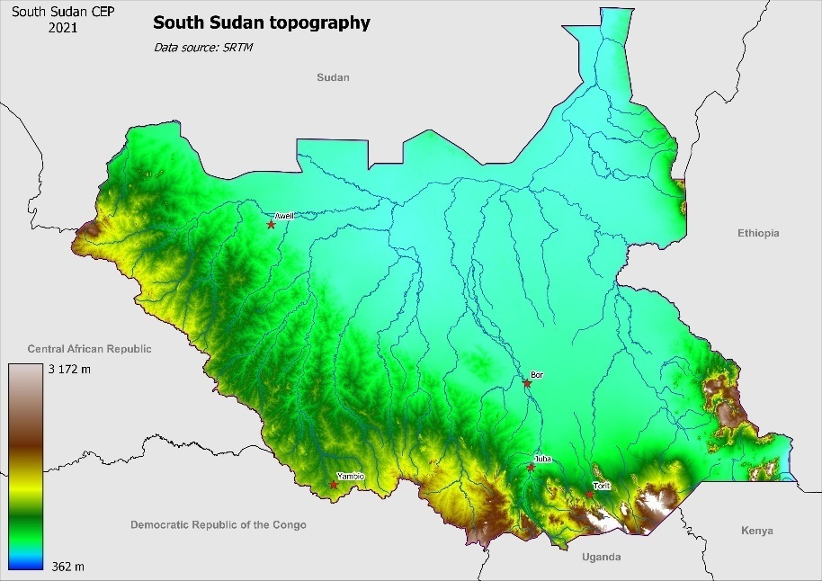South Sudan is a landlocked east-central African nation, which shares borders with Kenya, Sudan, Ethiopia, Uganda, the Democratic Republic of Congo (DRC), and the Central African Republic (CAR). South Sudan covers an area of 645,964 km2, stretched within the tropical zone between latitudes 3°N and 13°N and longitudes 24°E and 36°E.

Altitude varies from 600 to 3,187m above sea level. The lowest point of the country is in the extreme north of Upper Nile State. The highest point is located in the south of the country, in Eastern Equatoria State, along the border with Uganda, where lies the Imatong Mountain Range, with peaks exceeding 3,000 meters (including the country’s highest peak, Mount Kinyeti, at 3,187 m).

**Figure 1: South Sudan topography**

The Ironstone Plateau, running South-East to North-West along the boundaries of DRC, CAR, and Uganda, is another large elevated portion of the country. The Ironstone land slopes gently to the north, with a relatively flat relief made of hills dissected by numerous valleys. Other highlands lie along the Ethiopian border to the east of the country.

### Hydrology

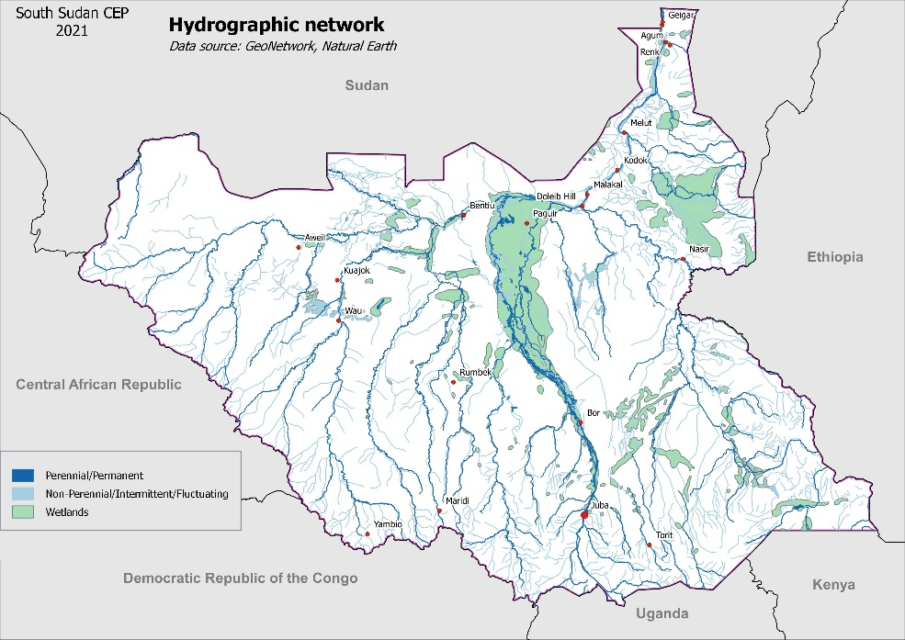The White Nile River (Bahr el Jebel) is the dominating geophysical feature. It flows from South to North through the country. It is joined by its major tributaries, the Bahr el-Ghazal, the Bahr el-Zeraf, the Sobat and the Adar in the northern part of South Sudan.

The Sudd (means “the barrier” in Arabic) region dominates the centre of the country. This large swampy area is one of the largest freshwater ecosystems (wetland) in the world, with an area of approximately 57,000 km2.

**Figure 2: South Sudan Hydrographic network**

During the wet season, and depending on inflowing water, the Sudd may extend to 130,000 km2, covering almost 20% of country’s entire surface. In 2006, the Sudd was classified as a Wetland of International Importance, Ramsar site (UNESCO, 2021).

### Geology

Precambrian igneous and metamorphic rocks form 40% of South Sudan foundations and underlie the country’s geological units.

During the Pan-African orogeny in the Neoproterozoic and the extensional tectonics of the Mesozoic, thick sedimentary sequences were deposited in rift basins that carry important oil deposits.

**Figure 3: South Sudan geological map**

The Second Sudanese Civil War, which led to South Sudan’s independence in 2011, was partially driven by the discovery of these oil fields in 1975. Oil exploitation occurs in the Northern part of the country.

Outside oil, South Sudan has numerous underexploited mineral resources such as gold, copper, cobalt, zinc, iron, marble, limestone, and dolomite.

### Ecosystems

South Sudan is covered by vast and diverse natural forests and woodlands, which are estimated to cover about 32% (i.e., 207,422 km2) of the South Sudan area. Moreover, large zones of natural habitats, such as the forested savannah, swamps, grasslands, etc. remain untouched because of their remoteness and lack of access. The absence of roads (which is regarded by some as a sign of underdevelopment) is in this case the best protection for natural environment and wildlife. These characteristics grant South Sudan with a unique potential in East Africa for the protection and conservation of the biodiversity, wildlife, and ecosystems.

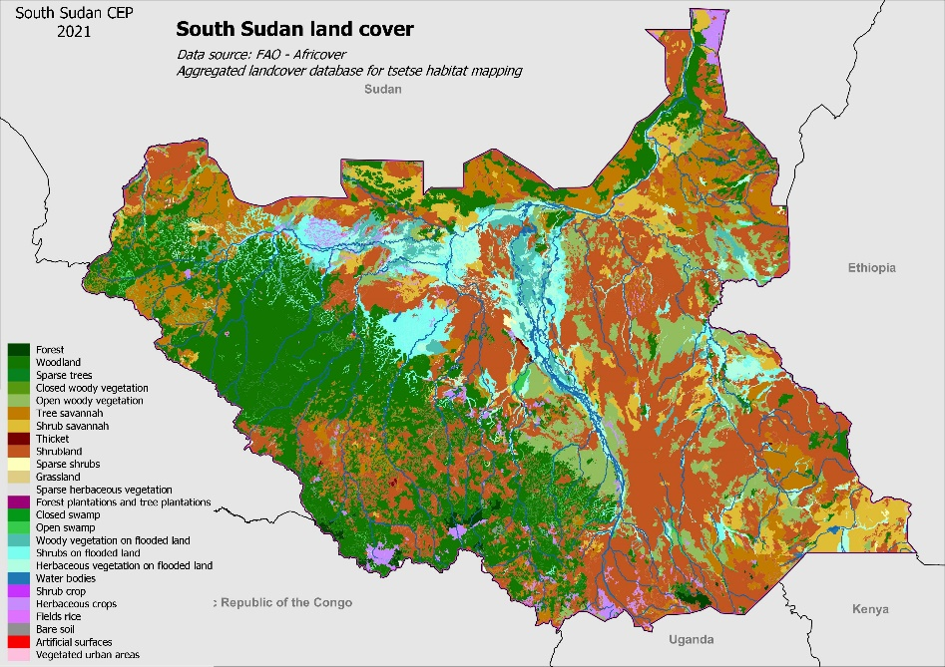The main ecosystems are the followings:

* Montane forest,
* Lowland forest,
* Woodland savannah,
* Grassland savannah,
* Flood plain,
* Wetlands and marshes,
* Rivers,
* Semi-arid region,
* Agro-ecosystem.

**Figure 4: South Sudan land cover**

**Montane and lowland forests**

While montane forests are found in south-eastern parts of South Sudan (in Eastern Equatoria state, notably on the Imatong Mountains, Jebel Gumbiri, Dongotona, and the Loti mountains), the lowland forests are limited to a few scattered small areas in the southwest on the foothills of the Imatong Mountains, on the Aloma Plateau near Yei, the Azza Forest in Maridi County, and the Yambio area.

**Low-rainfall savannah woodlands**

Low-rainfall Savannah woodlands cover a small part of the country in the northern part of Upper Nile state.

**High-rainfall savannah woodlands**

High-rainfall Savannah woodlands cover most of the country with the exceptions of the floodplain around the Nile River, the Montane region, and the desert area at the south-eastern tip of South Sudan. Western Bahr el-Ghazal and Western Equatoria together contain about 56% of the total forest cover (UNEP & MoEF, 2015) (all types combined) in the country.

**Savannah woodlands recently derived from rain forests**

Savannah woodlands, recently derived from rain forest are localised along the Congo border in high rainfall areas (>1,300mm). These rainforests have been degraded by human activities over years and becoming gradually an open forest ecosystem with few remaining trees.

**Grasslands**

Grasslands account for about 23% of the land cover of South Sudan, with the Upper Nile, Jonglei, Eastern Equatoria, and Unity states accounting for about two-thirds of the grasslands in the country.

**Semi-desert**

The semi-desert area is located in the extreme southeast tip of the country. The poor ground cover is composed of patches of short open grasslands with acacia bush-land. The average annual rainfall in the area is low, around 300 to 500 mm.

**Wetlands and marshes**

The Sudd Wetland is recognized under the Ramsar Convention as a Wetland of International Importance and is one of the world’s largest wetlands averaging 57,000 km2, but can double this size (up to 130,000 km2) depending on the discharge from Lake Albert.

**Degraded forest/agriculture ecosystems**

In South Sudan, the most common agricultural practices include small, hand-cultivation at household level, mixed rain-fed agriculture, livestock grazing, and pastoralism. The farmers use small fields often derived from the destruction of natural forested areas, by opening the forest cover for cultivation, and through the traditional slash and burn practice.

## Socio-economic environment

### Economy

South Sudan is, in term of GDP per capita, the richest country in East Africa, with oil exports accounting for 70% and 64% of GDP in 2010 and 2011, respectively (MAFS & JICA, 2015). The oil sector is the main economic driver, generating 98% of government revenues, with estimated oil production of 62.1 million barrels in FY2019/20 (World Bank, 2021).

Despite its natural endowment, the country remains one of the least developed in the world, with a high poverty incidence (particularly in rural areas), low social indicators, and virtually non-existent infrastructures. Seventy-eight percent (78%) of households depend on crop farming or animal husbandry as their primary source of income. The rampant poverty in South Sudan is an important driver for environment degradation and climate change vulnerability (UNEP, 2018).

The agriculture sector is characterised by small, hand-cultivating household units, belonging to larger family aggregations and practising different combinations of rain-fed agriculture, livestock grazing and pastoralism, wild food harvesting, and fishing (UNEP, 2018). Eighty-one % (81%) of them cultivate land, 74% own livestock, and 22% engage in fishing. These populations rely heavily on natural resources and ecosystems services for food, energy (firewood and charcoal), fibre, and construction material.

Despite an increased agricultural production over the past few years, food insecurity persists with exceptionally high food prices limiting access to food for a large segment of the population. In total over 8.3 million people in South Sudan were estimated to be in need of humanitarian assistance in 2021 (World Bank, 2021). In addition to the recurring food insecurity, the displacement of people because of war, famine, droughts, and floods leaves scores of people relying on humanitarian relief assistance to meet their daily livelihood needs.

The above-mentioned situation is more exasperating as the South Sudan has an enormous potential for agriculture with an estimated 70% and 90% of the country’s area as suitable for agriculture (UNEP, 2018).

In addition to oil, South Sudan has abundant and largely unexploited natural resources, including minerals, precious metals, water, fertile land, hardwood timber, Gum Arabic, and honey.

### Population

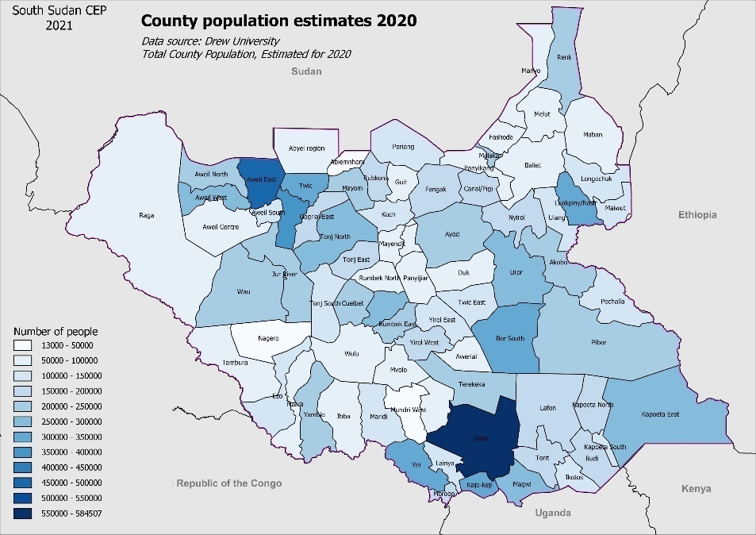By becoming a sovereign state, independent from Sudan in 2011, South Sudan is the world’s newest nation and Africa’s 55th country. It is also one of the least densely populated countries in Sub-Saharan Africa, with an average density of 13 people/km2.

The current population of South Sudan is 11,372,180 as at November 2021, based on Worldometer elaboration of the latest United Nations data (Worldometer, 2021). Only 24.6 % of the population are urban whereas the median age in South Sudan is 19.0 years. It is expected that the population of South Sudan will be approximately 20 million by 2050 (Reliefweb, 2019).

**Figure 5: County population estimates 2020**

### Poverty

Barely two years after the creation of the Republic of South Sudan, precisely in December 2013, armed conflict broke out in the country, resulting in economic decline and an increase in disease incidences and hunger. This conflict forced millions of people to flee their homes and left millions displaced inside the country (UNHCR, 2019). In total almost 2.3 million South Sudanese have fled to neighbouring countries and 1.87 million remain internally displaced in South Sudan due to violent conflict throughout the country (UNHCR, 2020)

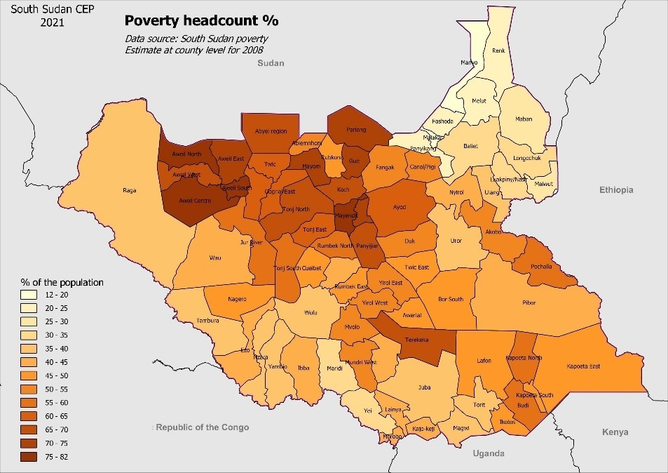Insecurity, lack of basic services, and unresolved housing, land, and property issues prevented people from returning home in large numbers. In 2021, nearly 8.3 million people in South Sudan were estimated to be in need of humanitarian assistance (UNOCHA, 2019).

The recent heightened episodes of drought, flood, and global oil price fluctuations have increased the vulnerability of the South Sudan economy to climate change and communal-related conflict incidences.

**Figure 6: South Sudan poverty headcount %**

Several reports and informants consulted during the preparation of this CEP indicated that poverty is one of the main drivers for environment degradation in South Sudan. Natural resource products may be mentioned as one of the limited available options, while being at the same time the last resort source of income for the poorest fraction of the population.

The high rate of poverty in South Sudan is being reflected directly, and indirectly; in the reduction of the density of natural resources in and around the urban centres and refugee settlements of the country, where the need for natural resources products such as wood, charcoal, fibres, plants, nuts, etc., are relatively high.

The depletion and unsustainable over-exploitation of natural resources weaken ecosystem services and the protection naturally provided by forest and vegetation cover, exposing more and more of the South Sudanese populations and economy to the effects of climate change.

Since illegal logging, tree cutting for firewood and charcoal production, poaching, and bush fires are mainly driven by rampant poverty in South Sudan, it is therefore important to emphasise that addressing environmental issues in the country will not be achieved without fighting poverty.

### Education

In South Sudan more than 70% of the country’s population above the age of 15 is illiterate and the majority of those in this age bracket are women. It is also estimated that about 2.8 million children are out-of-school. South Sudan female illiteracy ranks among the highest in the world with fewer than one % (1%) of girls completing primary education and also with only one schoolchild in four being a girl (UNICEF, 2021a).

Like poverty, illiteracy has a considerable impact on the state of environment, especially since the local population depends heavily on natural resources for their subsistence. It should be noted the critical role played by ecosystem services to people’s livelihoods and mitigation of climate change, which requires a minimum knowledge that can normally be obtained through formal education.

### Health

Access to basic health services and care in South Sudan is very challenging, with a deficient public health system, lack of health infrastructures, and a limited number of health workers. Thus, health indicators are amongst the worst in the world (UNOCHA, 2021), with a child mortality rate of 78 deaths per 1,000 live births (UNICEF, 2021b).

The deficiency of the health system is a serious source of concern in South Sudan, especially knowing that 60% of recently emerging human diseases, including Ebola (with outbreaks in South Sudan in 1976, 1979, and 2004) (WHO, 2021), COVID 19, HIV-1, and pandemic influenza, originate from animals. The increasing pressures of zoonoses, which are infectious diseases of animals that can be naturally transmitted to humans, have their roots in many causes (Waithaka Mwangi et al., 2016). Amongst others, the natural habitats destruction, create new contacts opportunities between humans and wildlife. In South Sudan, these conditions are met with the regular consumption of bush meat by a great proportion of the rural and urban population and the natural habitat destruction.

To address this situation in a holistic manner, the One Health concept has been developed which addresses the three parts of the problem: human health, animal health, and environmental health. Developed initially as a response to the Ebola outbreak in West Africa, the One Health concept is the best coordinated response that could be implemented in South Sudan.

## Climate change

### Current climate

The climate of South Sudan ranges from Tropical Semi-Humid (with a short rainy season in the north) to Tropical Wet-Dry and Tropical Rainy climates (with progressively longer wet seasons in the south) (UNEP & MoEF, 2016). South Sudan has two major rainfall regimes: unimodal in the North and bimodal in the southern part of the country, both of them amounting to approximately 1 billion m3 of rain annually.

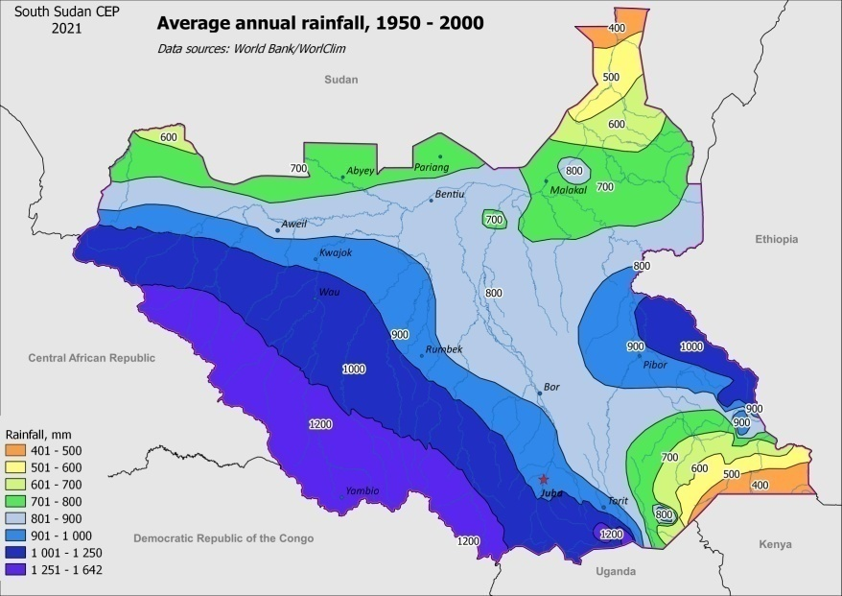The northern unimodal rainfall regime has a six-month wet season from May to October. The southern part of the country has a bimodal rainfall regime with high rainfall for 7-8 months a year, which ranges from 500-600 mm to 1,500 mm annually, with a maximum (up to 2,200mm) in mountainous areas of Western Equatoria and highland parts of Eastern Equatoria.

The exception to this South/North regime is the south-eastern tip of Eastern Equatoria, which has a quasi-desert climate and receives only 200 mm per year.

Average annual temperatures are between 18 °C and 30 °C, with the coldest temperatures in elevated areas.

**Figure 7: South Sudan average annual rainfall, 1950 - 2000**

Extreme temperatures can exceed 35°C, notably during the dry season from January to April. Most of the annual rainfall occurs during the “long-rain season” between June and September, during which relatively heavy and steady rains are usually common.

### Observed climate variability and changes

South Sudan is currently experiencing considerable variations in rainfall from year to year and from location to location within the same year.

Above or below normal rainfall (across the country or in a certain region) can cause widespread localised droughts and floods. Flash floods often occur when the Nile River and its tributaries overflow during the months of August and September (USAID, 2013). The year 2021 represents the third year in a row of extreme flooding from Jonglei State in the central belt to the Upper Nile, all the way to the Sudanese border.

Although it is premature to speak of climate change (which refers to change of state of climate system over a period of a minimum of 30 years), this tendency of increased extreme weather events has considerable impacts on the life of local communities and institutions.

### Projected changes

#### Temperature

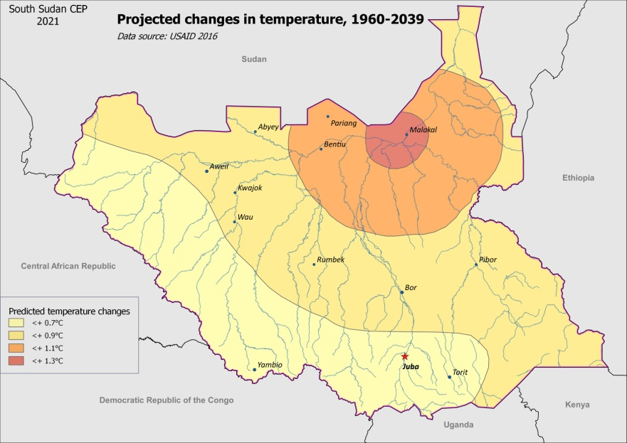Over the past 30 years, South Sudan has been among the most rapidly warming locations on the globe; historical records show that the mean annual temperature has increased by 1.3°C to 1.5°C for the period 1951-2000 (when in the same period of time, mean annual precipitation has decreased by 41 mm per month) (C. Funk et al., 2011).

The adjacent, Figure 8 shows the projected changes in temperatures in South Sudan (1960-2039).

Figure 8 shows warming in South Sudan as successive southward advances of average temperatures. The spatial pattern of warming corresponds (broadly) with the areas associated with reduced precipitation. The conclusion is therefore that South Sudan is becoming drier and hotter (WMO, 2011).

**Figure 8: Projected changes in temperature, 1960 - 2039**

#### Change in mean annual rainfall

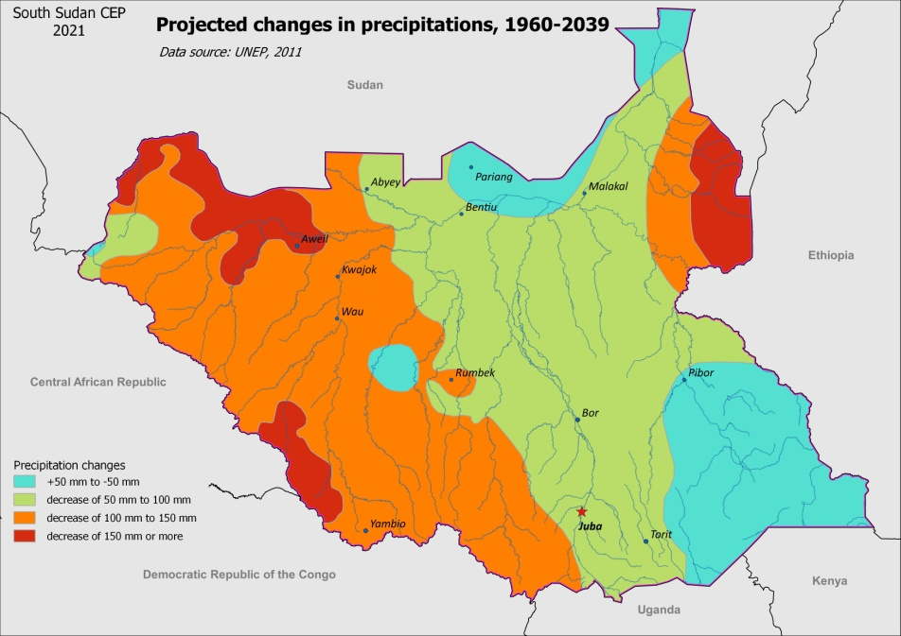There is no general consensus about rainfall changes over the last decades, but according to the climate analysis of the Famine Early Warning Network, much of South Sudan has experienced a 10-20% decrease in long rains since the mid-1970s (Ministry of Foreign Affairs of Netherlands, 2018).

According to this dataset, the region that “normally” received 500 mm or more of rain has contracted, increasingly exposing populations in Upper Nile, Jonglei, and Eastern Equatoria to rainfall deficits.

**Figure 9: Projected changes in precipitations, 1960 - 2039**

In addition to the 30-year trend of declining precipitations, there is evidence that variability in the amount and timing of rainfall will increase from year to year (World Bank, 2020).

Figure 9 shows the projected changes in precipitations (smoothed time series of 1960-2009 rainfall).

#### Change in rainfall patterns

Large year-to-year variability in precipitation has been observed during the last decade, often shifting from 50% lower than average rainfall in one year, to 50 % higher than the average the next year. Irregular delays in the start of the rainy season and early cessation result in the overall shortening of the season and the unpredictability of harvest outcome for a large majority of the South Sudan population who depend on it.

### Effects of climate change

The key manifestations of climate change in South Sudan include, but are not limited to, increased occurrences of the two extremes: **drought** and **floods**. Since the 1960s, droughts have become more frequent and widespread in South Sudan: in 2015 an El Niño event was accompanied with severe drought in the country.

In 2017, extreme flooding led to the displacement of approximately 100,000 people (USAID, 2019). In October 2021, it was estimated that more than 623,000 people in 8 states (Jonglei, Unity, Upper Nile, Warrap, Northern Bahr el Ghazal, Western Bahr el Ghazal, Lakes, and Central Equatoria), were affected by the successive episodes of flooding in 2019, 2020, and 2021.

#### Climate impacts on food production

Rainfall is one of the main climatic determinants of food production in South Sudan and good rainfall years result often in good agricultural harvests, and hence in high food production. Grains and cereals are the main staple in the country. These crops are sensitive to changes in rainfall, and almost 70% of the variability in their production can be influenced by variations in rainfall (WFP, 2014).

In South Sudan, extreme events such as flood and drought are associated with destruction of harvest, livestock, and habitat. They limit poor people’s physical access to markets and basic services, while increasing poverty and food insecurity.

#### Climate impacts on livelihoods

Like in many other parts of the world, food security is highly sensitive to climatic trends, particularly in the most vulnerable areas of South Sudan. Agro-pastoralist and agricultural households, depend heavily on climate pattern. Decline of seasonal rainfall or its poor distribution, often result in reduction of seasonal food production and this consequently forces households to depend on humanitarian food assistance or purchase food for consumption. In addition, climate-induced food price volatility requires households to spend more of their income on food.

It is likely that the climate change will exacerbate livelihood vulnerabilities and food insecurity trends in the most at-risk areas. Efforts to reduce the adverse impacts of climate change on food security in South Sudan should therefore prioritize these livelihood zones.

#### Climate impacts on security

The scarcity of resources due to drought and/or floods could lead to heightened inter-communal conflict over the use and/or access to natural resources such as water, grazing lands, wood, etc. Livestock losses associated with the climate-related factors can exacerbate rivalries, increasing the risk of cattle raiding, which can trigger retaliations, fuelling communal conflicts and subsequent displacement of people (Norwegian Institute of International Affairs, 2021).

#### Climate impact on temperatures

High temperature impacts will be amplifying the effects of drought: an observed warming of more than 1°C is equivalent to 10-20% reduction in rainfall through increased evaporation.

#### Climate change impact on water availability

Most of South Sudan is covered by the Bahr el-Ghazal, the Nile, and the Sobat River catchments that join near Malakal to form the White Nile. In contrast to the Nile, the Sobat and Bahr el Ghazal catchments have a strong seasonal character.

Research on the lakes and the Bahr el-Ghazal basins suggest that an increase of 2°C in temperature might cause the natural flow to fall to 50% of the current average in these two sub-basins (Ministry of Foreign Affairs of the Netherlands, 2018). Unreliable rainfall and rising temperatures are likely to have a negative impact on the Sudd, which is a very important source of fish and natural resources for the surrounding local population. The basin is also a carbon sink and a wetland of global biodiversity importance.

#### Climate impact on displacement of people

Unpredictable annual rainfall patterns and extreme weather conditions, such as floods and droughts affect pastoral mobility and agricultural production. These changes may also exacerbate tensions between herdsmen and farmers, often in connection with access to land, grazing, and water, and lead to temporary displacement or longer-term migration (Cedric H. de Coning et al., 2021).

#### Climate impact on gender

Women and girls in South Sudan are the primary food providers for their families. The consequences of climate change events such as drought and floods, together with environmental degradation, have strong negative impacts on the availability of and women’s access to natural resources such as firewood, leafy vegetables, fruits, roots, and tubers. Despite their critical role in the exploitation and the processing of natural resources, women have limited property rights to ensure their access to land and forests.

While degradation of the forest ecosystem has had an impact on communities in general, women have suffered more than their male counterparts. Women have comparatively fewer employment opportunities in the collection, production, and sale of timber, wood, charcoal, and other forest products. This gender disparity in access to and utilisation of natural resources from forests and elsewhere is a major factor contributing to the rising poverty among women (UNEP & MoEF, 2015).

### The challenge of climate information availability and accessibility

Prior knowledge and close monitoring of weather conditions are vital in guiding agricultural planning and operations, such as land preparation, pest management, and selection of crop varieties and livestock practices that are appropriate for the local conditions (FAO, 2015).

In 2015, FAO supported the rehabilitation of meteorological stations. However, the gaps in climate information still remain crucial in South Sudan with regard to records of reliable data. Without accurate and current data, it is impossible to assess details on the changes in climate and their corresponding trends.

Apart from FAO’s efforts at building capacity to enable South Sudan address its challenge of lack of information and data, the Global Monitoring for Environment and Security and Africa (“GMES and Africa” (African Union, 2021) , a joint programme of the European Commission and the African Union Commission) aims at strengthening and developing infrastructure and knowledge for the exploitation of Earth Observation data (space and in-situ) technologies and services supporting environmental policies for sustainable development in Africa.

The GMES and Africa is being implemented by 12 Consortia involving 144 institutions in 45 African countries, covering the whole continent, and works in close cooperation with the European Space Agency (ESA), Copernicus, and EUMETSAT (EU4Oceanobs, 2021). GMES and Africa in 2017–2021 improved upon the infrastructure (by providing two (2) receiving stations per country) and capacities enhanced by earlier projects such as PUMA (Preparation for the use of Meteosat second generation in Africa, 2001–2005), AMESD (African Monitoring of Environment and Sustainable Development, 2007-2011), and MESA (Monitoring of the Environment and Security in Africa, 2013-2017) by ensuring the continuity of support over a long period of time.

In South Sudan, the PUMA station is located in South Sudan Meteorological Service, and the MESA station is located in the Ministry of Environment, Directorate of Forestry. The station is currently not working and the national authorities are looking for a solution to fix it soon (J. Courboules, 2021).

In July 2021, ICPAC (the GMES and Africa regional implementing centre for East Africa) launched a regional public multi-hazard monitoring system (Disaster Operations Centre - DOC) to track and monitor drought, climate change, pests, locust, heavy rainfall, floods, and Food Insecurity in the East Africa region. It is recommended to exploit the opportunities offered by GMES and Africa, notably in terms of early warning systems.

# State of the environment, trends, and pressures

This chapter provides a short introduction about ecosystems of South Sudan. Threats to the environment, their origins, and their impacts, as well as the effects of climate change are described in the second part of this chapter.

## Main ecosystems

South Sudan is bestowed with an opulent natural environment including a large variety of ecosystems, an immense assortment of flora and fauna species and an unknown biological and genetic diversity that is yet to be discovered. It is home to the Sudd swamp, one of the world’s largest tropical wetlands, and to one of the greatest circular migrations of wildlife on the planet (UNEP, 2018).

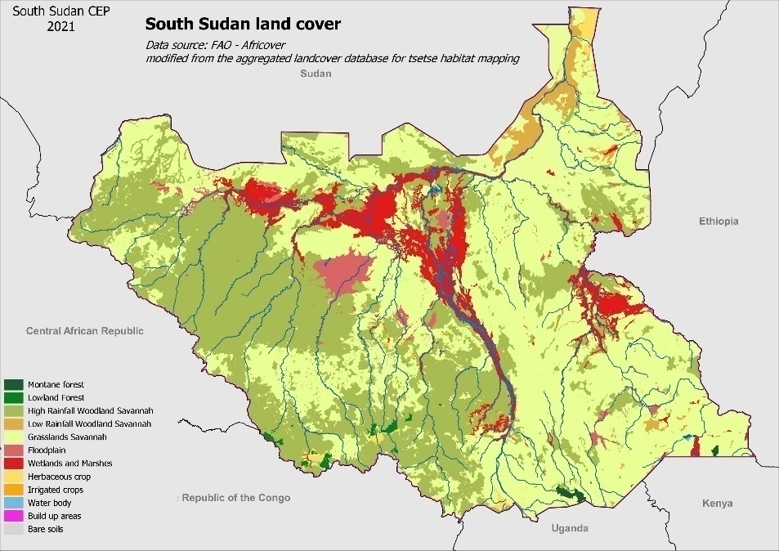The South Sudan main ecosystems could be divided into the following categories:

* Montane forest,
* Lowland forest,
* Woodland savannah,
* Grassland savannah,
* Flood plain,
* Wetlands and marshes,
* Rivers,
* Semi-arid region,
* Degraded forest-agriculture ecosystem.

**Figure 10: South Sudan simplified land cover**

Figure 10 is a simplified version of the land cover using the map developed by FAO/Africover, showing the main broad ecosystems in South Sudan.

### Montane forests

Montane forests are found in the Imatong Mountains, Mt Didinga (Lotukei), Jebel Gumbiri, Dongotona and the Acholis in the south-eastern parts of the country in Eastern Equatoria state. The highest spot is Mt. Kinyetti in the Imatong range with an altitude of 3,187m ASL.

The Montane vegetation is dominated by species of Vernonia (*Vernonia sp*.), Hagenia (*Hagenia abyssinica*), Albizia (*Albizia sp*.), *Podocarpus milanjianus* and Erica (*Erica sp*.), forming zones from the grasslands (Afro-Montane), to the Afro-Alpine dominated by Erica shrub thicket. Inhabiting the forest are mammals including forest ungulates such as bushpig (*Potamochoerus larvatus*), bushbuck (*Tragelaphus scriptus*), Harvey’s duiker (*Cephalophus harveyi*), blue duiker (*Cephalophus monticola*), buffalo (*Syncerus caffer)*, primates like the black and white colobus (*Colobus guereza*) (UNEP & MoEF, 2015), olive baboon (*Papio anubis*), red-tailed monkey (*Cercopithecus ascanius*), blue monkey (*Cercopithecus mitis*), Oustalet's red colobus (*Piliocolobus oustaleti*), and common chimpanzee (*Pan troglodytes*) (Primate Watching, 2021).

These montane forests are amongst the richest biodiversity hotspots in Africa and hosts ecosystems that are not comparable to anywhere else in the region. These forests are home to many endemics and possibly unique species, although scientists are yet to study the region’s species (Karimeh Moukaddem, 2011) and their distinctiveness and peculiarities.

### Lowland forests

The lowland forests are the northernmost extension of the Congo basin forests and are rich in forest plants and animal biodiversity. In South Sudan, lowland forests are limited to a few scattered but small areas in the southwest near the CAR, the DRC, the Ugandan borders and the foothills of the Imatong Mountains, the Aloma Plateau near Yei, the Azza Forest in Maridi County, and the Yambio area (UNEP & MoEF, 2015). The area receives an annual rainfall averaging at 1,600 mm.

Several forest species of mammals have been known to have existed in the region, but their current status is unknown and their presence has to be confirmed. These lowland forests shelter probably African forest elephants (*Loxodonta cyclotis*) migrating across the border of the CAR and DRC. Other species likely to be found in the lowland forests are chimpanzees (*Pan troglodytes*), bongo (*Tragelaphus eurycerus*), African forest buffalo (*Syncerus caffer nanus*), and giant forest hog (*Hylochoerus meinertzhageni*) (UNEP & MoEF, 2018b).

### Woodland savannah

Woodland savannah is the largest ecological region in South Sudan and is divided into two categories:

* the low-rainfall woodland savannah, and
* the high-rainfall savannah woodlands.

The low rainfall woodland savannah is present only in the northern part of the Upper Nile state and it covers about 2.9 % of the total land area of the country. This type of forest cover has been largely sacrificed to agricultural development and is today largely fragmented and threatened by farming development in the area.

The high rainfall woodland savannah is the largest ecosystem in South Sudan, covering 52.6 % of the South Sudan territory (UNEP & MoEF, 2016). Woodland savannah stretches semi-diagonally from the north-western borders of South Sudan with Northern Sudan along the CAR, DRC, and Ugandan borders in Western and Central Equatoria to Magwi County in Eastern Equatoria. This region, lying primarily on the Ironstone Plateau and the Green Belt of South Sudan, also shelters mixed patches of lowland forest to the west, and grassland savannah and floodplains to the east, in addition to woodland savannah.

Common large mammals of the wooded savannah include savannah elephant (Loxodonta africana), hippopotamus (*Hippopotamus amphibius*), waterbuck (*Kobus ellipsiprymnus*), giraffe (*Giraffa camelopardalis*), bushbuck (*Tragelaphus scriptus*), Oribi (*Ourebia ourebi*), duikers (*Cephalophus sp*.), Uganda kob (*Kobus kob thomasi*), warthogs (*Phacochoerus africanus*), hartebeest (*Alcelaphus buselaphus lewel*), giant eland (*Taurotragus derbianus*), buffalo (*Syncerus caffer*); various species of primates such as patas monkey (*Erythrocebus patas*), olive baboon (*Papio anubis*), grivet (*Chlorocebus aethiops*), and tantalus monkey (*Chlorocebus tantalus*); and carnivores as lion (*Panthera leo*), leopard (*Panthera pardus*), cheetah (*Acinonyx jubatus*), African wild dog (*Lycaon pictus*), spotted hyena (*Crocuta crocuta*), and golden jackal (*Canis aureus*) (UNEP & MoEF, 2015).

### Grassland savannah

Grasslands account for about 23% of the land cover, with Upper Nile, Jonglei, Eastern Equatoria, and Unity states accounting for about two-thirds of the grasslands in the country.

The grassland savannah habitat is a contiguous area, covering northern, eastern, and south-eastern parts of South Sudan’s floodplain. It is characterized by open short grasslands with scattered trees and shrubs. The dominant woody vegetation here includes species of Acacia, Balanites and Combretum. Dominant perennial grasses include Hyperrhenia, Andropogon, Panicum, and several other species.

Various species of mammals inhabiting this region include some globally threatened ones such as the cheetah (*Acynonix jubatus*), African wild dog (*Lycaon pictus*), lion (*Panthera leo*), African savannah elephant (*Loxodonta africana*), and leopard (*Panthera pardus*) (UNEP & MoEF, 2015).

A massive migration of white-eared kob (*Kobus kob leucotis*) and tiang (*Damaliscus lunatus tiang*) occurs in grasslands and floodplain habitats. The protected Areas of Boma National Park, Badingilo National Park, and Kidepo Game Reserve partially cover these wildlife migration corridors.

### Flood plains

The floodplain is constituted by seasonally flooded plains, which extend around the Sudd swamps and on both sides of the White Nile, and covers an estimated area of 112,700 km2. These floodplains provide habitat and grazing areas for large herds of large mammals. Among the most abundant species found here are the tiang (*Damaliscus lunatus tiang*), the Nile lechwe (*Kobus megaceros*), and the Mongalla gazelle (*Eudorcas albonotata*). These antelope species use the relatively undisturbed habitats of the floodplains, grasslands, and the Sudd swamps. Areas designated for protection within the floodplain ecological region include Shambe National Park and Zeraf and Meshra Game Reserves (UNEP & MoEF, 2015).

### Wetlands and marshes

There are several large swamp and marshy areas in South Sudan and the Sudd is considered as the most important.

The Sudd wetland, with an estimated area of approximately 57,000 km2 represents one of the largest freshwater ecosystems in the world. The extent of the Sudd wetlands is highly variable. it depends largely on the seasons and years, respectively. In the wet season, the size of the wetland increases up to 90,000 km² and gradually decreases to about 42,000 km² depending on high seasonal flood (UNESCO, 2021). The Sudd plays the role of a giant hydrological regulator, filter, and sanitation system of the entire Nile River Basin System.

The Sudd is an important hotspot for biodiversity and a wetland of international interest. It was declared a Ramsar site number 1622 on 5 June 2006.

The Sudd swamp is a complex of channels and open water bodies that was recently, heavily clogged by mats of floating vegetation and bordered by papyrus (*Cyperus papyrus*). The cattail *Typha dominguensis* represents the dominant vegetation, covering about three quarters of the total swamp.

There is also the infestation by invasive alien plant species, such as the water hyacinth *Eichornia crassipes* and the fern *Azolla filiculoides*, which affect the swamp’s wealth and biodiversity by forming a continuous floating ‘mat’ over channels and lakes.

The Sudd swamp is known to support a multitude of fish species, and a rich and diverse macro-invertebrate fauna. Major mammalian species inhabiting the region include threatened species like hippopotamus (*Hippopotamus amphibious*), near-threatened species such as sitatunga (*Tragelaphus spekii*) and mostly endemic species like the Nile lechwe (*Kobus megaceros*). The swamp is frequented by African savannah elephants (*Loxodonta africana*), buffalos (*Syncerus caffer*), and several other species of mammals. The Sudd ecosystems also harbour the Nile crocodile (*Crocodylus niloticus*), African rock python (Py*thon sebae*), other species of snakes and amphibians, and notably the re-discovered Nubian Flapshell Turtle (*Cyclanorbis elegans*), which until 2018 was believed to be extinct (Benansio et al., 2018).

The region is also rich with resident and migratory birdlife and is listed as an Important Bird Area (IBA) by Birdlife International with over 470 documented species.

*Toich* are areas that get seasonally flooded by spilled-water from rivers and where the soil retains sufficient moisture throughout the dry season to support grasses. *Toich* belongs to the Sudd ecosystem and plays an important and critical role by providing grazing areas for wildlife and pastoral livestock during the dry season.

### Rivers

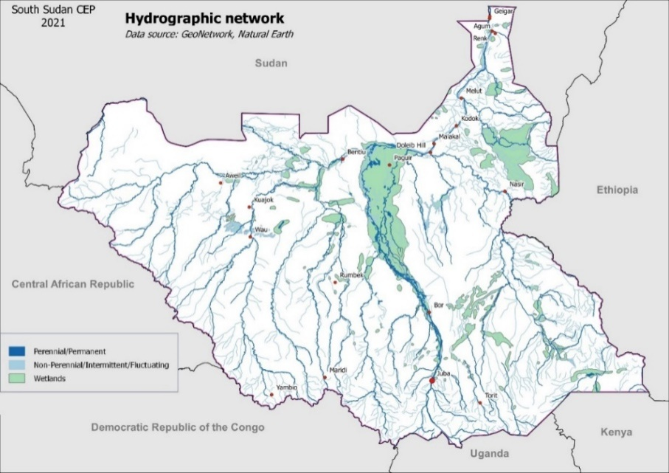When we talk about rivers of South Sudan, we generally associate these with the Sudd because of its overwhelming presence. Rivers in South Sudan are not limited to those that flow to the Sudd as South Sudan is endowed with numerous rivers.

The Nile (Bahr el-Jebel) winds through the Fulla rapids before passing through Juba, the capital of South Sudan and then enters the Sudan plain and the vast swamp of the Sudd. It eventually makes its way to Lake No, where it merges with the Bahr el-Ghazal and forms the White Nile.

**Figure 11: South Sudan Hydrographic network and wetlands**

A branch river called Bahr el-Zeraf flows out of the Bahr el Jebel through the Sudd and finally re-joins the White Nile close to Tondiak. Another, the Jur River/Sue River flows from the South (Yambio) to the North (Wangkei) to join the Bahr el-Ghazal. Bahr el-Ghazal, which translates as “sea of gazelles”, is the main western tributary of the Nile. It is 716 kilometres long, flowing from West to East, through the Sudd wetlands to Lake No, where it joins the White Nile (Fortune of Africa, 2021).

It is important to note that, but for the RAMSAR convention targeting the preservation of the Sudd, nothing will have existed today to protect the large areas of the ecosystems, similar to what has been done for marine areas. This has made Lake No to be proposed as a Nature Conservation Area and also falling under the category of Terrestrial Protected Areas.

With the South Sudan population predicted to increase in the future, the exploitation of resources bestowed by the rivers will be a more and more important source of livelihoods, and if this prediction happens as projected it will most likely lead to the decline and/or the destruction of these resources.

To keep the exploitation of these resources at a sustainable level, it is, therefore essential to protect relatively large areas of the swamp and rivers to allow fish stocks to regenerate. Such protected areas need to be designed with the support of the local communities and fishermen and, above all, the management of river resources must be a responsibility of the local communities, including the protection of replenishment zones. There are numerous examples of traditional management of marine resources by local communities could be found around the world that could inspire the implementation of a network of protected segments of rivers, large or small, in South Sudan.

### Semi-arid region

The semi-desert areas of South Sudan are located in the extreme south-eastern part of the country and around the Ilemi Triangle in Eastern Equatoria state (UNEP & MoEF, 2018b). This region, which is characterised by a low rainfall, averaging 300 to 500 mm annually, favours the growth of patches of short open grasslands with acacia bushland. The ground cover is generally poor and depends on annual rainfall, which is unpredictable.

Wildlife found in this region includes East African oryx (*Oryx beisa*), Grant’s gazelle (*Gazelle grantii*), and Kirk’s dikdik (*Madoqui kirkii*). No protected areas (PAs) in this region have been designated for protection. However, the presence of Oryx, an endangered species, has been confirmed in recent surveys by WCS, thus, making the region important enough to be provided with protection/conservation status of PAS (UNEP & MoEF, 2018b).

### Degraded forest/agriculture ecosystem

In South Sudan, the agriculture sector covers only 3.8 % of the country’s area and is represented, mostly by small, hand-cultivating household units, mixing rain-fed agriculture, livestock grazing and pastoralism. These small fields often derive from the degradation of natural forested areas, notably by opening the forest cover for cultivation and the traditional slash and burn practice. A practice that renders a great majority of fields to be cultivated periodically rather than continuously.

There are no stable (eco)systems here because the areas are under the influence of human activities and the ecological services they avail to the local communities, depend strictly on the way these areas are managed.

Based on the situation at hand, one domain where immense progress could be achieved, will certainly be that of improved farming practices on cultivated areas by expanding the concepts of agro-forestry and climate-smart agriculture, which develop hedging, mix crops with trees to protect against soil erosion, diversify production, and maintain biodiversity.

### Irrigated agriculture

South Sudanese agriculture is entirely rainfall-dependant, but there is a great potential of irrigated agriculture (for crop, livestock and aquaculture) productions development. The great advantage of irrigation is that productivity does not depend on rainfall and is, in a way, climate change resilient.

To illustrate this irrigation potential and climate resilient crops, the following images illustrate two areas (same scale) just separated by approximately 150 km and identical in terms of climate and rainfall. The left image (Google Earth image) shows the area of Renk in Upper Nile. Sorghum, sesame, and other crops are cultivated on rain-fed fields.

This type of cultivation is totally dependent on rainfall. The IPCC climate change projections predict increasing temperatures and a reduction of rainfall, particularly significant in the Upper Nile region of South Sudan. The agriculture production in this zone will very probably be negatively impacted in a very near future.

**Comparison between non irrigated and irrigated lands**

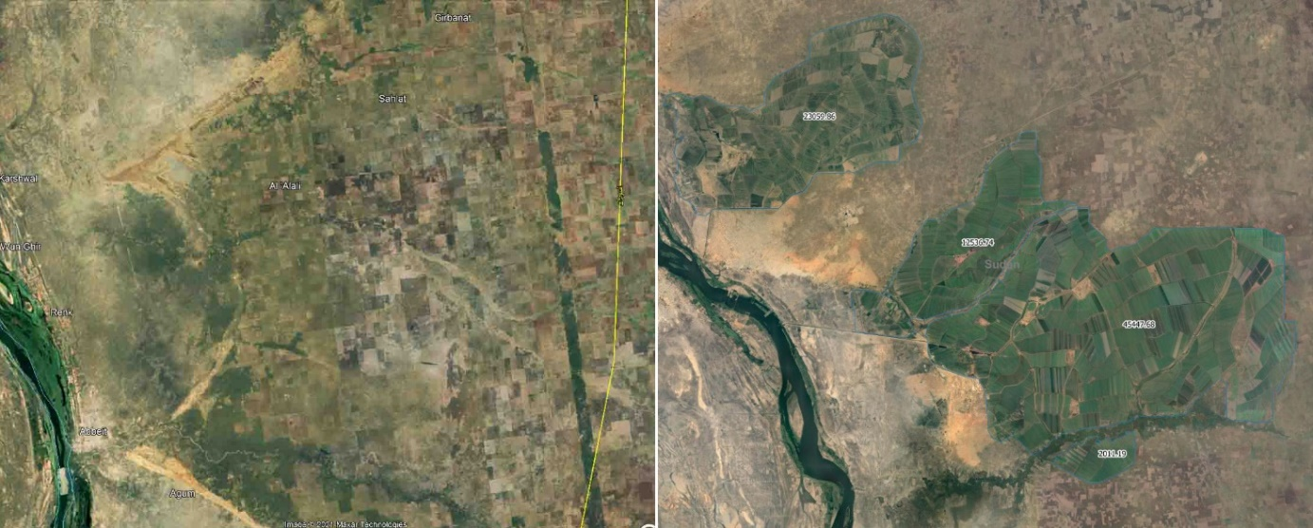

**Figure 12: Comparison between non irrigated and irrigated lands**

**Left: Renk (South Sudan) Right: Asalaya & Sifeiya (Republic of Sudan)**

The right image illustrates irrigated areas close to two small towns of Asalaya and Sifeiya, in Sudan. The green fields on this image represent more than 83,000ha of irrigated fields, of which the productivity does not depend on rainfall, and is less vulnerable to the climate change effects.

## Forests

Forests and woodlands represent nearly a third of South Sudan’s land area. 16.57% of the country’s land is currently designated as protected areas, a majority of them concerning forest habitats. Forest timber and non-timber resources are used for food, timber, firewood, building material, and energy, supplying 80% of the country’s energy needs (Pius Zebhe Yanda, 2019).

South Sudan, formally and informally, exports a wide range of timber products to international markets. Many non-timber forest products such as Shea nuts, gum Arabic, and honey are harvested for local consumption, with a good potential for international markets.

Despite the huge potential of these forests and their NTFPs, they are poorly managed, thus leading to deforestation, degradation, and depletion of natural resources.

Montane forests are located in the eastern and Southern parts of the country, and are shrinking at an accelerated rate, to such an extent that they could well disappear within a few decades. Extraction of timber, especially the high value Podocarpus (at the higher altitudes) and mahogany (at the lower elevations) is leading to serious deforestation (USAID, 2014).

Within the forest area, the comparison of time-series of satellite images shows that local farming communities continue to move up the slopes, opening the land for cultivation and reaching an altitude of 2,300m. The consequences of this expansion upslope include increased soil erosion, potential flash floods, and amplified sedimentation and siltation of downstream rivers.

Illegal logging, charcoal making, poor governance, and lack of agreement regarding ownership of forest and of forest resources lead to a situation where montane forests are only preserved by the steepness of their slopes and the difficulties to access the remaining stands of trees. The actual rate of deforestation, not only of montane forest, but of all dense forest formations, is such that it (should it continue) could lead to a near total loss of forest cover within 50 years (MoAF, 2012).

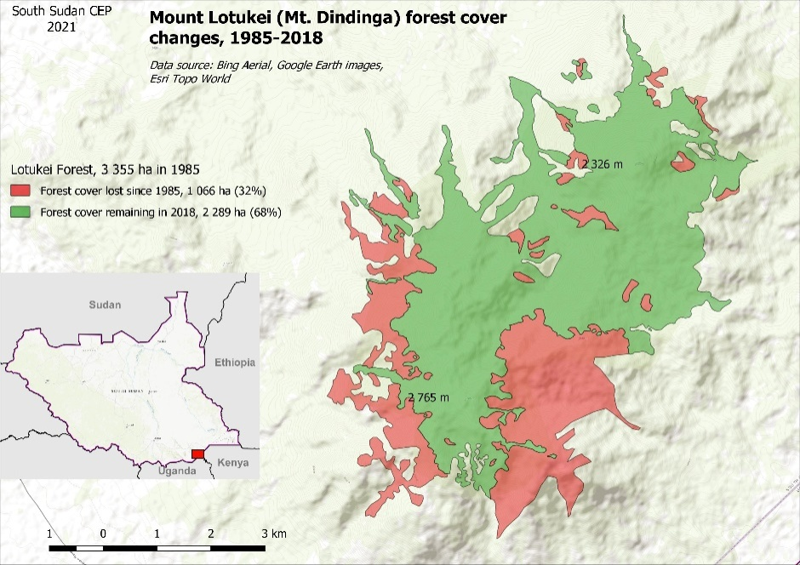For example, the Dongotona lost two-thirds of its forest cover between 1986 to 2011, and the area was by then projected to be cleared of all vegetation by 2020. Temporal analysis of a series of satellite images, covering the Imatong Mountains and the surroundings, show that many smear reliefs have totally cleared of forest cover in the last 36 years.

Figure 13 shows the result of a rapid assessment of the evolution of the forest cover of Mt. Lotukei (Mt. Dindinga) over the last 36 years.

**Figure 13: Mount Lotukei forest cover changes, 1985 - 2018**

Mt. Lotukei is located very close to the South Sudan border with Uganda, less than 100 km at the east of the Imatong Mountains. Satellite images acquired in 1985 and 2018 over the Mt Lotukei allows drawing forest contours at these two dates. The result speaks for itself and over 36 years the forest cover has lost 1,066ha, more than one third (32%) of its initial surface.

Moreover, the analysis of the succession of satellite images available in this area shows that, until 1998, the forest cover losses were limited to smaller encroachment at the slope bottom. After this date, the deforestation rate sped up resulting in the large patch of deforestation (580 ha) at the South East of the Mt Lotukei, which was cleared very quickly between 2000 and 2002.

Action to preserve the last remaining cover of montane forest has become an urgent matter. If nothing is really done on-to-the-field (rangers, control, and law enforcement) these unique ecosystems will totally disappear in a few years or decades.

Dense lowland forests, forming limited areas distributed along the southern part of the country, are also subject to intense deforestation, and are threatened by illegal logging, encroachment, and slash-and-burn practices. The untouched and fertile soils on which the lowland forests are rooted make them a prime target for industrial large-scale plantations of oil palm, teak, and coffee. This phenomenon is not unique to South Sudan but is found all over the world: lowland forests tend to be the first forest formations to disappear.

In South Sudan, some forest areas are still protected by their remoteness and the absence of access roads, but this does not mean that they will continue to remain safe indefinitely. It is therefore suggested that the use of natural resources the ecosystem provides to local communities should be regulated to ensure its sustainability for future generations. Attention should also be paid at protecting some of the remaining patches of lowland forests, if only to preserve their unique biodiversity potential in South Sudan. As for montane forests, the deforestation rate of lowland forests could lead to a total disappearance within 50 years.

Woodland savannah is the most important forest formation and covers approximately 52.6 % of the South Sudan territory. Threats to woodland savannah are numerous and range from illegal logging and the gathering of construction materials to charcoal making. Hunting has also negative impacts on the woodland savannah ecosystem.

Woodland savannah is an open canopy ecosystem, which makes it particularly vulnerable to bush fires, notably at the peak of the dry season in January/February. Bush fires are part of the normal life-cycle of woodland savannah, and, as such, it has limited impact on the ecosystem as a whole. This assertion is true if bushfires occur on a natural basis of one fire every one or two years.

Today, the traditional practice of shifting cultivation and setting fire to dry bushes to rejuvenate grazing areas has increased considerably the occurrence of fires. In addition, fire is used by hunters to push wild animals to traps, nets, or waiting hunters. Yet, the fires do not stop as one would wish. Key informants, consulted during field mission conducted for preparation of this CEP, said that dozens of hectares of woodland savannah are often burnt to hunt a single antelope or bush rat.

The likelihood of addressing the prevailing degrading situation appears to be remote at least in the nearest future. With the projected doubling of the South Sudan population in 2050, pressure over environmental resources will continue to increase and this will most probably be worsened by the expected impact of climate change.

There are no reliable estimates of forest loss and annual deforestation rates in South Sudan. However, a study conducted by the World Agroforestry Centre (ICRAF) in 2006, revealed the extensive conversion of forest and woodlands to grasslands, pasture, and rain-fed agriculture in selected sites between 1973 and 2005, and a total of 40% loss of forest cover (UNEP, 2018).

More information is needed before extrapolating figures obtained on selected sites to the entire South Sudan country. Larges zones of South Sudan, notably on the western part of the country are still totally devoid of traces of human activities because of their remoteness and the absence of access roads and tracks.

**Certification schemes**

Forest certification has not yet become a norm in South Sudan.

The major concessionary in South Sudan has been the Equatoria Teak Company Limited (ETC). ETC has a 32-year, renewable concession on a total area of 18,640 hectares (186.4 km2) for five land blocks near Nzara, Western Equatoria. ETC was temporarily granted certification for its concessions in South Sudan which has since been revoked due to a controversy with regard to this certification (Aly Verjee, 2013). To date, ETC is looking for Forest Stewardship Council (FSC) certification and carbon credit programs.

In the absence of a certification scheme for high-value timber found in South Sudan, there is a high likelihood that illegal logging will escalate. GoSS, through the MoEF, needs to urgently put in place sound policies and regulations on the exploitation of forest resources, in addition to ensuring that timber harvested from the South Sudan is certified (USAID, 2014).

## Biodiversity

South Sudan is gifted with a wide range of habitats, some of which still present large portions devoid of any human presence and impact, supporting a very rich diversity of both animals and plant species. Nonetheless, its African forest elephant (*Loxodonta africana*) population has dramatically declined and emblematic species such as black rhinoceros (*Diceros bicornis*) and white rhinoceros (*Ceratotherium simum*) are believed to be extinct, even if there is still hope that they took shelter in the most remote regions of the country.

Some of the endemic fauna species in the country include the Nile lechwe (*Kobus megaceros*), Hoogstral's striped grass mouse (*Lemniscomys hoogstraali*), Nile sitatunga (*Tragelaphus spekii)*, and a recently discovered African climbing mouse (*Dendromus ruppi*). South Sudan is known to be the only African country sheltering both species of eland: the common eland (*Taurotragus oryx*) and the Derby’s (giant) eland (*Taurotragus derbianus*) (UNEP & MoEF, 2015).

There are wildlife migrations across the eastern grassland savannahs and floodplains of Jonglei and Eastern Equatoria States that stretch into the neighbouring Gambella region of Ethiopia and can be compared, in number and importance, to the Serengeti migration. The white-eared kob (*Kobus kob leucotis*), tiang (*Damaliscus lunatus tiang*), Mongalla gazelle (*Eudorcas albonotata*), and Bohor reedbuck (*Redunca redunca*) represent one of the greatest animal migrations and wildlife spectacles of the world. This is an invaluable natural resource for South Sudan and the rest of the world and could in future be a major tourist attraction once stability returns to the country (Philip Ayuen Dot, 2020). The world’s largest populations of shoebill (*Balaeniceps rex*) and black-crowned crane (*Balearica pavonina*) occur in the Sudd wetland. While South Sudan shares many of its fauna species with her neighbours to the south and west, other species like the Nile lechwe (*Kobus megaceros*) and the white-eared kob (*Kobus kob leucotis)* are endemic to South Sudan and Ethiopia (UNEP & MoEF, 2015).

Reptiles endemic to South Sudan include the Torit gracile blind snake (*Letheobia toritensis*) and the Mount Kinyeti chameleon (*Trioceros kinetensis*). Freshwater fishes known exclusively from South Sudan include *Barbus tongaensis* and *Labeo tongaensis* (UNEP & MoEF, 2018a).

For plant species, Imatong Forest is a major biodiversity hotspot supporting over 2,000 vascular plants and 500 bird species, and is one of the largest intact Podocarpus forest in Africa. Endemic flora of South Sudan includes *Chloroselast aposana* and *Lepidochrysops nigritia*, *Aloe diolii*, *Aloe macleayi*, the cycad *Encephalartos mackenziei*, *Chlorophytum superpositum*, *Scilla chlorantha*, and *Panicum bambusiculme*. Wild Arabica coffee (*Coffea arabica*) grows in the forests of the Boma Plateau and Imatong Mountains.

**Genetic diversity** (UNEP MoEF, 2018b)

Genetic characterisation of wild and domestic species in South Sudan is currently almost non-existent. Plant genetic resources range from little known indigenous wild fruits and vegetables, forages, medicinal plants, and indigenous staples like millet and sorghum, to introduced crops such as maize.

The loss of genetic diversity may be rapid in South Sudan and many species may be declining, particularly for plant varieties (even if they are not yet extinct) without any documented information. Some of the world’s rare and indigenous crop varieties such as finger millet and sorghum are an important part of the traditional farming system. Of more immediate importance is the loss of within indigenous crop species, which South Sudan may prioritize in its effort to combat food insecurity in the country.

The expansion of exotic crops, driven by market forces (higher yields, but increased vulnerability to pests and adverse climatic conditions), will result in genetic uniformity threatening the indigenous crop genetic diversity.

## Protected areas and forest reserves

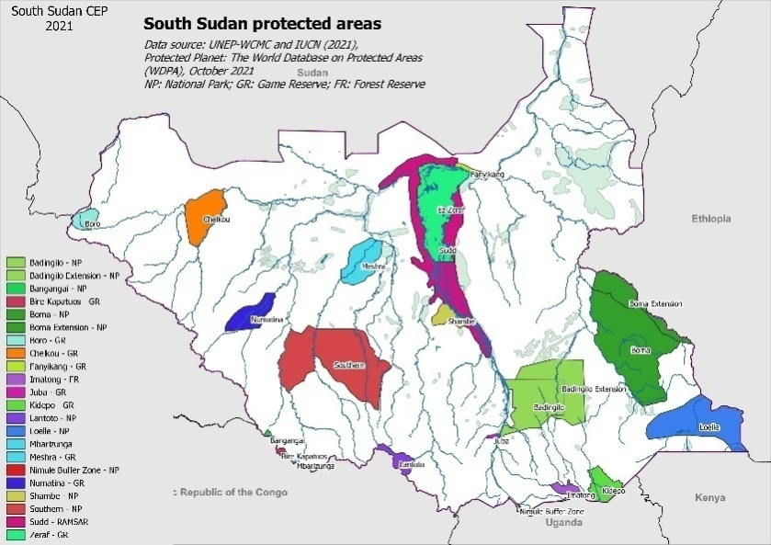South Sudan has the largest virgin savannah in Africa. In 2010, the Wildlife Conservation Society reported sighting one of the largest antelope’s migrations of the world, comprising 1.2 million white-eared kobs (*Kobus kob leucotis*), Mongalla gazelles (*Eudorcas albonotata*), and tiang (*Damaliscus lunatus tiang*), rivalling the Serengeti migrations.

The adjacent Figure 14 shows the protected areas of South Sudan, according to the IUCN, UNDP, 2021, World Database on Protected Areas provided by Protected Planet (2021 version), a joint project between UNEP and the IUCN.

**Figure 14: South Sudan protected areas**

In addition to antelopes, there are around 4,000 African savannah elephants (*Loxodonta africana*) and other species such as giraffes (*Giraffa camelopardalis*), buffaloes (*Syncerus caffer*), the endemic Nile lechwe (*Kobus megaceros*) and carnivores such as lions (*Panthera leo*), leopards (*Panthera pardus*), and African wild dogs (*Lycaon pictus*). It was also observed that some species had been decimated during the civil war, such as plains zebra (*Equus quagga*) and buffalo (*Syncerus caffer*) (Home Wiki, 2020).

The richness of the avian fauna has already been mentioned while describing the wetlands where a large population of birds find shelter in the floodplains, swamps, and grasslands. Among these birds are the black-crowned crane (*Balearica pavonina*), the pink-backed pelican (*Pelecanus rufescens*), the cattle egret (*Bubulcus ibis*), and the marabu stork (*Leptoptilos crumenifer*).

In order to effectively protect the biodiversity and species that abound in South Sudan, the most efficient way is to create and enforce the conservation of wildlife habitats. In South Sudan, there are three types of protected areas: National Parks, Game Reserves, and Forest Reserves. The Sudd wetland is a Ramsar site, which is an international classification (UNEP, 2018).

There are twenty (20) designated protected areas representing 16.57% of South Sudan total land area, amounting to 107,087 km2. In addition, three (3) National parks are proposed (Badingilo extension, Boma extension, and Loelle), amounting for 23,724 km2. The gazetting of these three additional areas would increase the surface of protected lands to 121,774 km2, or 18,85% of the country’s surface.

**Table 1: List of Protected Areas in South Sudan**

| **Name** | **Year** | **Status** | **Habitat** | **Area km²** | **State(s)** |
| --- | --- | --- | --- | --- | --- |
| Bandingilo | 1986 | National Park | Grassland and woodland savannah | 9 008 | Central & Eastern Equatoria |
| Badingilo Extension (Ashana, Bandingaru) | 1939 | National Park | Woodland savannah, grassland and floodplains | 7 800 | Central Equatoria |
| Bangangai | 1939 | National Park | Lowland forest, woodland and open glades | 201 | Western Equatoria |
| Bire Kpatuos | 1939 | Game reserve | Lowland forest, woodland and open glades | 227 | Western Equatoria |
| Boma | 1986 | National Park | Woodland savannah, grassland & riverine woodland | 20 032 | Jonglei |
| Boma Extension | 0 | National Park | Woodland savannah, grassland & riverine woodland | 4 957 | Jonglei |
| Boro | 1986 | Game reserve | Woodland and tree savannah | 1 496 | Western Bahr el Ghazal |
| Chelkou | 1939 | Game reserve | Woodland and tree savannah | 5 289 | Western & southern Bahr Gel Ghazal |
| Fanyikang | 0 | Game reserve | Wetlands, toich grassland, wooded savannah and floodplains | 477 | Upper Nile |
| Imatong | 1952 | Forest Reserve | Montane forest | 1 171 | Eastern Equatoria |
| Juba | 1939 | Game reserve | Woodland and tree savannah | 177 | Central Equatoria |
| Kidepo | 1975 | Game reserve | Woodland and tree savannah | 2 892 | Eastern Equatoria |
| Lantoto | 1986 | National Park | Woodland, forest and open glades | 1 550 | Central Equatoria |
| Loelle | 0 | National Park | Tree savannah and desert | 11 171 | Eastern Equatoria |
| Mbarizunga | 1939 | Game reserve | Lowland forest, woodland and open glades | 180 | Western Equatoria |
| Meshra | 1986 | Game reserve | Woodland, wooded savannah | 4 421 | Warrap, Lakes |
| Nimule | 1954 | National Park | Wooded savannah, Nile River | 55 | Eastern & Central Equatoria |
| Numatina | 1939 | Game reserve | Woodland and wooded savannah | 3 428 | Western Bahr el Ghazal |
| Shambe | 1985 | National Park | Woodland & wooded savannah, grassland and floodplains | 1 755 | Lakes |
| Southern | 1939 | National Park | Woodland and wooded savannah, bush land, small grasslands, riverine woodland, inselbergs | 19 245 | Lakes, Warrap, Western Equatoria, Western Bahr el Ghazal |
| Sudd | 2006 | Not reported | Ramsar Site, Wetland of International Importance | 15 258 | Unity |
| Zeraf | 1939 | Game reserve | Wetlands, toich grassland, wooded savannah and floodplains | 10 984 | Jonglei E, Upper Nile, Unity |

*Source: Adapted from South Sudan NBSAP 2018 and IUCN, 2009* (ProtectedPlanet.net, 2021)

### Protected areas challenges

Limited human, technical, institutional, and infrastructure assets are dedicated to protected area (PAs) management. The basic institutional and infrastructural capacities built during the establishment of the PAs were largely destroyed by the civil war.

Moreover, most of these protected areas are only what is called “paper parks”, and the demarcation of the protected area boundaries never underwent a consultation process with local populations and stakeholders. In addition, a large majority of the administration dealing with wildlife management is staffed with untrained personnel, lack of capacity and equipment, while most policies dealing with protected areas are inadequate, outdated, or still in draft format.

Today’s protected areas challenges could be summarised as follows (Fortune of Africa, 2020):

* Lack of laws and weak institutions to regulate the wildlife sector in the country;
* Habitat destruction, disturbance through park encroachment, and habitat degradation stand as main challenges;
* Considerable competition for grazing areas and water, while agricultural expansion is done at the expense of the savannah land areas and wildlife habitats;
* Widespread ownership of firearms across the country is one of the major challenges to the conservation of biodiversity, and specially megafauna, as they facilitate poaching and exacerbate the effects of competition for natural resources (grazing grounds and water) between humans and wildlife;
* Poaching and trafficking of bushmeat and other wildlife products are themselves another key challenge facing the wildlife sector in South Sudan;
* Protected areas, created on paper, never underwent a consultation process with local stakeholders and boundaries were never demarcated;
* Inadequate enabling environment and capacity for wildlife management at all levels of government;
* Data deficiencies on plant diversity, avifauna, reptiles, amphibians, fisheries, etc.;
* Lack of effective management to secure wildlife borders and ensure sustainable resource management: Boma and Bandingalo park limits do not adequately protect species’ migration patterns;
* Oil companies are moving into the upper White Nile, logging companies are negotiating contracts to exploit the rich teak forests;
* Inadequate funds to put in place the necessary infrastructure;
* Government departments suffer from shortages of facilities, material, and skilled personnel.

## Pressures on the environment

Most of the South Sudanese population lives close to the natural environment, directly depending on natural resources provided by forests and woodlands for fuel, food, and building materials. They depend also on the land for growing their crops, pastures for their livestock, and clean water sources for household needs. These ecosystem goods and services constitute the foundation of South Sudan’s socioeconomic development (IFAD, 2020).

Damaging one’s surrounding natural environment and ecosystems is very much like damaging one’s own source for energy, food, material, and income. Some populations, notably in South Sudan, do not have much choice when it comes to survival, but to rely heavily on natural resources for food and income, leading in the long term to the destruction of these resources. Fighting poverty and supporting these fragile populations are therefore *“sine qua non”* short term responses to an urgent situation.

Apart from short term responses, environmental awareness and knowledge (alternative sources of income, agro-forestry, etc.) are the key for a long-term and durable changes in environment-related behaviour of populations. In achieving these, the natural resources management be done in close cooperation and with participation from local communities. Poor forest resource governance and the lack of agreement regarding ownership of forest and natural resources are aggravating factors to environmental degradation in South Sudan. Therefore, laws to protect the environment need to be endorsed, explained to the population, and thereby enforced.

Without firm actions of the government of South Sudan in addressing poverty, lack of education, and law enforcement, the threats endangering the very permanence of the ecosystem will not be abated by themselves, especially within the context of climate change, which points to expected escalation of intensity/frequency of drought/floods episodes.

### Deforestation

Deforestation is the major driver of environmental degradation all over the World. In Africa, deforestation driven by population growth, unsustainable land management practices and climate change has been particularly impacting on fragile livelihoods of Sahel countries, resulting in food and water shortages, conflicts over declining natural resources, mass unemployment and forced migration.

Community leaders and political stakeholders have taken stock of the problem and developed the Great Green Wall initiative regrouping 20 countries (South Sudan is not yet part of this initiative, although it has expressed interest in participating), aiming at developing a green belt of 8 0000 km stretching from Senegal in the West to Djibouti in the East. South Sudan should quickly become an active member of the Great Green Wall initiative, both for the direct benefits and for the tremendous potential in terms of education and communication.

In South Sudan, deforestation has many causes, but a large majority originates in the country’s rampant poverty and lack of environmental awareness.

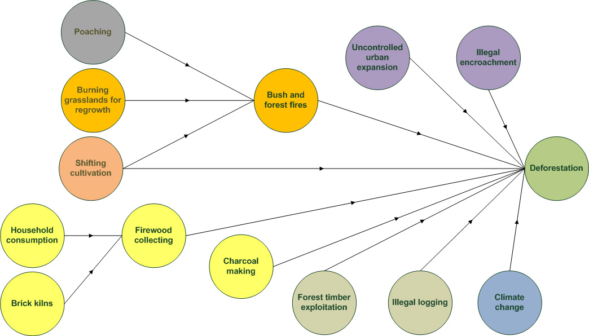The figure 15 illustrates the different human activities leading to deforestation.

**Figure 15: Main causes of deforestation**

#### Firewood and charcoal

The production of charcoal requires large quantities of wood and the activity is one of the significant causes of deforestation in South Sudan.

Firewood and charcoal account for over 80% of all wood used in South Sudan. In 2009, 62% of rural and 39% of urban households used firewood as a source of energy. It is also heavily used in a few key informal industries, especially brick-making and bakeries. An estimated 108,000 tonnes of charcoal were consumed in the country in 2009, 79% of which was consumed in urban areas and the rest in rural areas (UNEP, 2018).

Making charcoal, although illegal, is one of the main options available for the poor to generate income. Other than having simple tools, no license is needed for one to engage in charcoal production in South Sudan. Moreover, there is a widespread perception amongst local populations that the forests belongs “to nobody”.

In addition to local consumption, charcoal making became a small-scale business in some parts of South Sudan. It is estimated that approximately 60,000 bags of charcoal are exported from Renk County each year, representing 2,700 hectares of deforested land. Since more charcoal may have been exported unregistered or illegally, the real figure is likely much higher (U. C. Jha, 2014).

Today, there is no realistic and immediate alternative to the use of firewood and wood charcoal for domestic uses in South Sudan. Gas, biogas, and solar energy offer possibilities, but cannot compete with charcoal when it comes to availability and low cost. In terms of energy production and distribution for domestic use, everything remains to be done in South Sudan to providing an opportunity to push forward green energies and environment friendly solutions.

It will take time before an alternative energy solution is used by a large majority of the population in South Sudan. In the meantime, it is probably better to regulate, organise, and manage charcoal production in a (more) sustainable way, rather than trying to prohibit it. The first management step could be the distribution of charcoal making licenses, conditioned to the completion of training on environmental awareness, improved charcoal kiln techniques, tree planting and marketing of the product to get a better return on investment.

#### Bush fires

Bushfire is one of the most important threats to forest, woodland savannah, and grassland ecosystems. The amplitude of the phenomenon is alarming. When flying close to populated areas of Northern and Western Bahr al-Ghazal at the beginning of the dry season, smoke and burning savannah is visible everywhere. This is a repeated event year after year (old burned areas are still visible). The following are the main factors triggering the practicing of bushfire in South Sudan:

* It is a common practice amongst pastoral communities and small-scale farmers to set fire to grass to rejuvenate grazing areas and “clear” the land of bushes were pests and people could hide.
* The traditional practice of shifting cultivation is another factor encouraging the use of bushfires, notably in wooded lands.
* Poaching is an increasing activity reaching the level of well organised local business. In an open space such as grasslands, fire represents an easy way to push wild animals to traps, nets or hunters. Today, the increase of poaching activity comes with a parallel increasing of the occurrence of bushfires.

During the dry season, wildfires have a very strong impact on vegetation and wildlife, not only for iconic species such as large mammals, but also with regard to destroying invertebrates, reptiles, and insects which are essential for the good functioning of entire ecosystems. Wildfires also affect the ecology of the forest, vegetation strata, and the re-growth capacity through destruction of seed banks. Observations made in Tanzania and other parts of the world, indicate that the presence of large herds of wildlife feeding on grass reduce considerably the occurrence of wildfires by removing a large part of the vegetation cover and, thus, preventing the fire propagation (Ricardo Martin Holdo et al., 2009).

#### Shifting cultivation

Shifting cultivation and opening forest areas for cultivation are also an important cause of deforestation in South Sudan.

It is estimated that the country has lost 40% of its forests over the last 50 years, and deforestation is still ongoing. Communities use destructive forms of agriculture such as burning and clearing forests to grow low-intensity maize and other food crops. Cultivated land is expected to increase proportionally due to population growth as well as anticipated agricultural mechanization following improved national security (Pius Zebhe Yanda, 2019).

#### Agriculture expansion

By some estimates, between 70% and 90% of the country’s total area (of roughly 645,954 km2) is suitable for agriculture, about half of which is classified as prime agricultural land. In 2012, it was thought that only about 4% of the total land area was being cultivated (UNEP, 2018).

This huge agriculture potential should be developed in the coming years in order to accommodate food security concerns in South Sudan. Unless sustainable methods of agriculture such as climate-smart agriculture are applied, development will be done at the expense of the natural environment and forest cover. Yet, it could and should be done with a careful development planning, preserving potential for all activities such as agriculture, soil and watershed preservation, and biodiversity protection.

#### Plantations

In South Sudan, commercial plantations are under developed and account only for 0.1% of the total forested area (UNEP, 2018). Most of South Sudan tree plantations concern teak, and they are considered as the oldest in Africa. A majority of the mature trees standing today are between 35 and 50 years old.

Nevertheless, there is a recognised potential for coffee, tea (on highlands), and oil palm. The actual impact of plantation onto the forest cover is limited today, but it could change rapidly if investors decide to finance the expansion of this activity without proper regulations, and in an unsustainable manner.

Regulation should be written and enforced to regulate this activity and ensure, notably, that companies harvesting wood in plantations re-plant young trees as it is the usual practice in this type of concession to private sector operators. Some of the unfortunate stories heard during field visits for preparation of the South Sudan CEP consist of stories about companies leaving in a hurry after harvesting trees, and never replanting a single tree in replacement.

#### Consequences of deforestation

In the same way as there are many drivers of deforestation, the consequences of deforestation are also multiple.

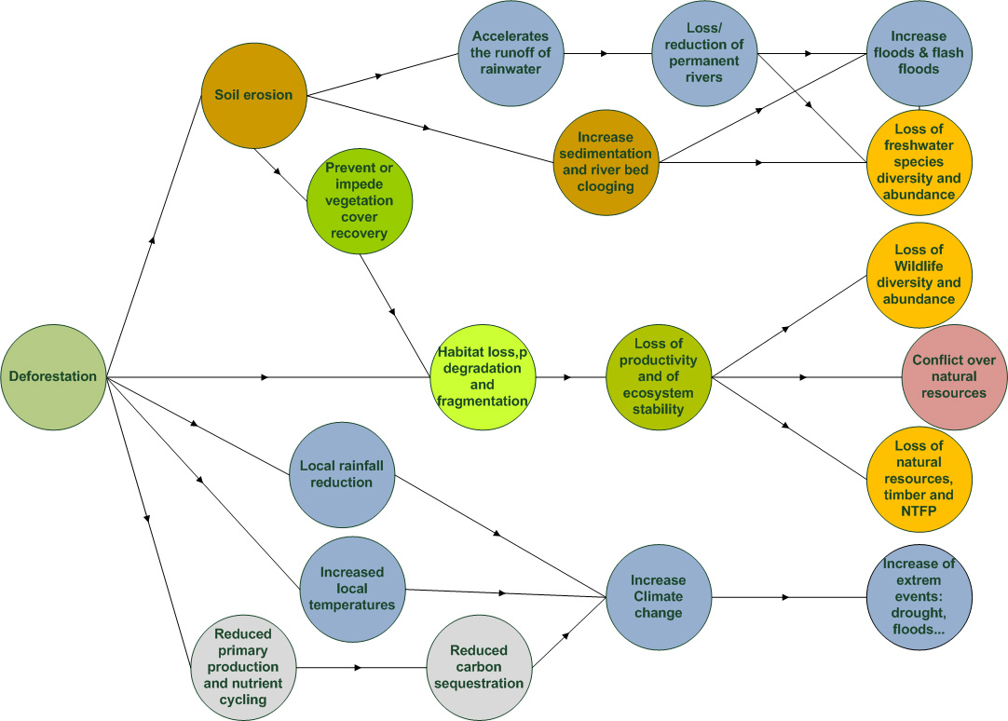

**Figure 16: Consequences of deforestation**

Figure 16 shows that deforestation has not only strong negative impacts on wildlife, habitats, and biodiversity, but is also considerably aggravating climate change impacts at the local, regional, and global levels.

Forested areas play an important role in the modification of the localised climate through evapotranspiration and their capacity to absorb solar radiation through an important thermal inertia, thus reducing local temperature and increasing the quantity of precipitations.

On the other hand, deforestation leads to bare mineral soils and/or reduced vegetation cover (bushes rather than forest), which have little or no thermal inertia, releasing directly the absorbed solar radiation into the atmosphere, which in turn results into the warming of the air and soil temperature and reduced soil moisture at local and regional levels.

A “positive feedback” process is therefore unchained: the more deforestation of an area, the more the local or surrounding climate will change, and these changes will impact negatively the remaining forest covers and degrade its resilience capacity.

When started, lots of effort and investments will be necessary to stop and reverse this process. This is why it is critical to address environmental issues as soon as possible and protect areas to preserve the country’s recovering capacity. In this process, education is paramount, if not the only tool available to change people’s mindset in order to built-up sustainable use of natural resources, which is understood/appreciated rather than being imposed on South Sudan populations.

### Poaching

In East and Central Africa, South Sudan and Uganda act as critical waypoints for elephant tusks, pangolin scales, hippo teeth, and other wildlife products. Elephants face continued and expanded threats in South Sudan. South Sudan’s elephant population dropped from 80,000 in the late 1960s to about 10,000 in 2000 and less than 5,000 in 2016. ([Keith Somerville](https://theconversation.com/profiles/keith-somerville-275605), 2016). The WCS aerial survey conducted in 2015-2016 (WCS, 2017) reported only 730 elephants in the surveyed area, which let expect an overall elephant population of about 2,500 for the entire country (Christina Russo, 2014). Giraffe population have been also reduced from some 13,000 in the early 1980’s to only hundreds remaining now and at risk of local extinction (WCS, 2017). Along with elephants and giraffes, other species at greatest risk include the Nile lechwe (*Kobus megaceros*) and tiang (*Damaliscus lunatus tiang*); the latter is one of the main targets of poachers (Casey Michael, 2014).

Nonetheless, one of the main assets of South Sudan are its immense wilderness areas and recent aerial and ground surveys by WCS in 2019, have revealed that important numbers of migrating antelopes, elephant, Nubian giraffe, eland, oryx and lions remain in the Boma-Bandingilo Landscape (WCS, 2019).

Juba is a well-known hub for ivory traffic (Shipping Position, 2016) where tons of ivory transit every year. Poachers target not only ivory and high-value wildlife products, but also bush meat and large herds of animals attract poachers even from bordering countries to supply the international market.

Those charged with preventing poaching (park ranger forces) are under-staffed, under-equipped, and under-paid.

In South Sudan, proliferation of small arms after the conflict has given poachers an easy access to large mammals, which in turn leads to the development of small-scale organised business around bush meat marketing. Butchering and processing large mammals such as elephant or buffalo, needs a minimum of organisation and workforce. Marketing large quantities of bushmeat needs to be organized. However, the lack of control from local governmental and/or the possibility to move through international boundaries without being controlled encourages this practice.

In South Sudan, poaching is not only done by organised groups, but hunting also played and continues to play an important role in human survival, providing one of the cheap sources of animal protein. Many wildlife species have thus been hunted for their meat by local populations all over South Sudan.

Generally, resident species such as giraffe (*Giraffa camelopardalis)*, African savannah elephants (*Loxodonta africana)*, roan antelope (*Hippotragus equinus*), and buffalo (*Syncerus caffer*) suffer more than the migratory species, such as white-eared kob (*Kobus kob leucotis*) and Mongalla gazelle (*Eudorcas albonotata*).

Wildlife-based ecotourism has a great potential as a source of revenue for local community development, but this ability may be lost forever if the wildlife populations are not immediately secured (UNEP, 2018).

In some parts of South Sudan, poison extracted from the smashed root (rotenone) of a plant is used to catch fish in streams and rivers (probably not in the White Nile due to the volume of water carried by this river). Although fishing is not illegal in South Sudan, this method is very destructive, indiscriminately killing all fish, both adults and juveniles, and other forms of water life (invertebrates, insects, etc.), while only a small fraction of killed fish is recovered.

### Pressure on land

South Sudan has an abundance of relatively flat land. However, land degradation is a critical issue throughout South Sudan, including areas with the highest rainfall. Various forms of land degradations are manifested in de-vegetation and species change, loss of soil fertility, and the physical loss of soil through erosion as a result of overgrazing, cutting trees for firewood and charcoal, and climate change. The land in rural areas of South Sudan is held under customary rights and managed collectively by local communities. This is in line with the 2011 Transitional Constitution of South Sudan, which states that land belongs to the community. However, it is not clear who makes decisions about land, and who is entitled to it even in most of the rural areas. With the exception of Juba and state capitals, there is no documentation or records of land owners, users, or demarcation. Customary decision-making regarding the agreement to lease land are more often made by chiefs or elders of land-owning families, excluding women, youth, and members of non-land-owning families.

In an agrarian society such as South Sudan, with more than 80% of people living in rural areas and dependent upon agriculture and pastoralism for their livelihoods, the land is the critical resource for economic development, livelihood security, and sustainable natural resource management. This underscores the importance of tenure assessments, and supporting the institutional framework for land use and governance, which have major implications for other natural resource policies and management arrangements.

### Grazing competition

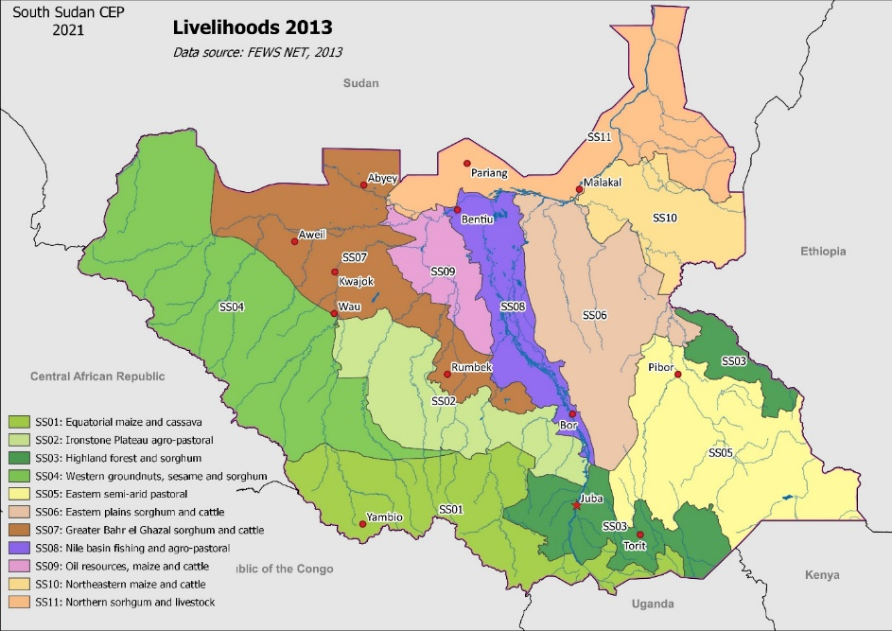Livestock grazing is an important and extensive land use system in South Sudan, largely practiced in the Sudd floodplains, the ironstone plateau, the central hills, and the South-Eastern plains.

The figure 17 shows that livestock raising is an important component in most of livelihood zones in South Sudan (SS05, SS06, SS07, SS08, SS09, SS10 and SS11). Even in SS01, SS02, SS03 and SS04 where cattle raising is not a major lifestyle element, competition and conflicts occur between farmers and pastoralists (UNEP, 2018).

**Figure 17: Livelihoods zones (source FEWS NET, 2013)**

In grasslands dominated by pastoral populations, vast herds of livestock often come in competition with wildlife for grazing areas. This competition over natural resources seriously threatens the existence of large mammals and ungulate wildlife (Benjamin-Fink Nicole, 2019).

In many parts of South Sudan, the traditional routes adopted by people tend to compact soils and overtime, result in some grass and shrub species disappearing from the range. Because of large herds kept in the above-mentioned areas, overgrazing is now visible in some areas, especially during the dry season and around watering points along cattle routes to Toich (Pius Zebhe Yanda, 2019).

During drought periods, livestock keepers in those areas move their herds from drought-prone areas to areas with better conditions, including forests in search for water and pastures. The high livestock population contributes to land degradation through overgrazing due to poor range conditions during such period. Waste pollution

Pollution by human waste and refuse is a widespread problem in South Sudan. Pollution affects land, rivers, and swamp ecosystems alike, especially those closer to large urban centres.

In many parts of South Sudan, the absence of treatment of used water, especially downstream of large urban centres, makes the water quality incompatible with human consumption. Lack of water treatment has left too many poor people with no choice but to drink unclean water, which can cause serious illnesses such as cholera, diarrhoea, dysentery, typhoid fever, and polio.

Pollution by plastics and, especially, plastic bottles has become a real threat notably downstream from Juba. Floating plastic bottles could be seen covering large areas of open waters, especially in the calmest meanders of the rivers. This provides a perfect substratum for bacteria development, reducing water oxygenation and attenuating the solar light. If nothing is done in the coming decade, the Sudd will not be any more composed of papyrus and cattails, but of plastic bottles.

### Water pollution

Access to clean drinking water in the country remains low, with roughly 41% of the population having access to safe drinking water, and only 11% having access to improved sanitation facilities (USAID, 2021). In most parts of the country, boreholes and rivers are the means by which most of the water is supplied for drinking and domestic uses, watering livestock, irrigation of vegetable gardens, etc. These water sources mentioned above are susceptible to pollution from sewage effluents, which are washed by surface run-offs into boreholes, streams, and rivers. Currently, there is no properly-established sewage treatment in South Sudan. It is common practice to discharge untreated sewage directly in and around river banks, which can easily be washed into the rivers. As oil export is the largest economic sector activity in South Sudan, it accounts between 70% to 64% of the country’s GDP (AfDB Group, 2019b). Considering the above, there is an urgency for other sources of income in order to avoid shortcuts in the oil production activity that does not fully protect the environment from pollution, which currently is the norm rather than exception. Examples include produced water and oil spills, amongst others, all of which are exacerbated due to flooding in the rainy season (UNEP, 2018).

### Oil pollution

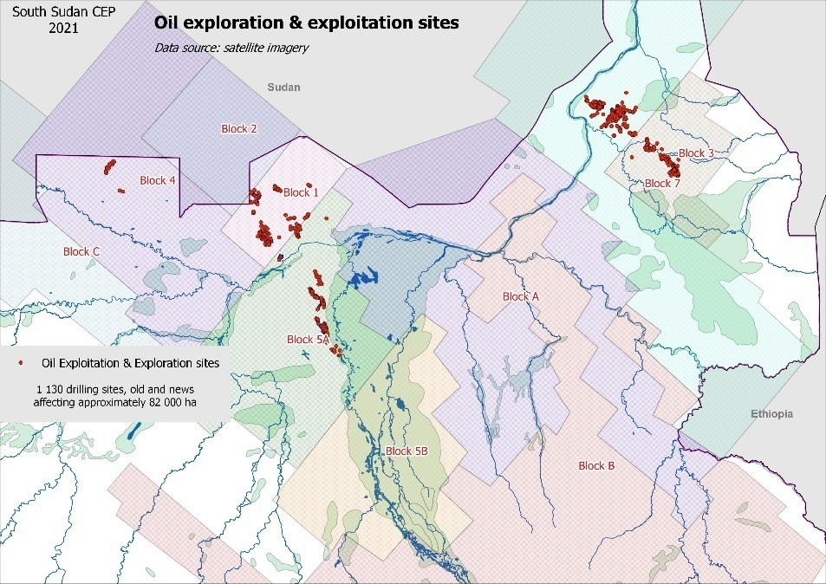Oil exploitation contributes to 98% of government revenues, and around 70% (2010) to 64% (2011) of its GDP. Oil extraction sites are almost entirely controlled by several local and international companies including Malaysia’s Petronas, India’s ONGC Videsh, and the China National Petroleum Corporation (Sihle Qekeleshe, 2020). Oil exploitation and exploration will only cease when the oil fields run out, and one should not expect big changes in the way in which these companies conduct their business, and in particular their insensitivity to environmental issues. Due to the limited required capacity and facilities and the urgent need for the financial resources generated from oil production, it is very unlikely to expect from the government of South Sudan to address environmental concerns associated with oil production in the nearest future.

Figure 18 shows a count of current exploitation drilling sites and related oil fields realised in 2021.

**Figure 18: Oil exploration and exploitation sites**

Like in any parts of the world, pollution caused by oil exploitation and exploration activities in South Sudan is also associated with the chemicals used for drilling and petrol extraction. Chemical pollution can only be detected when the deleterious effects become clearly visible.

Considering the existing legislative frameworks and economic condition of South Sudan, it is likely that oil pollution will continue to increase in the coming years, and little is likely to be done to counter the power and interests of oil conglomerates in the country.

Drilling sites as well as oil companies’ processing facilities in South Sudan can easily be interpreted from high-resolution satellite images (figure 17). Using this technique, 1,130 drilling sites (active and inactive) have been counted. From these data it may be estimated that oil exploitation affects approximately 82,000ha of land in the country. This estimation is probably higher if we take into account the road network developed to access the various exploitation/exploration sites.

Several reports published by public and private institutions indicate that numerous complaints have been raised by local South Sudanese communities living around oil exploitation sites on the poisoning of livestock and health/sickness of people. Apparently, nothing or little is being done to address these concerns.

Knowing that oil pollution is very difficult to fight and to clean in an intricate environment such as swamps, it would be fair to conclude that the development of these activities is associated with very serious threats for the health of local populations in the flood plain and the swamp ecosystems.

### Wetland drainage

The Jonglei Canal project was launched and stopped in the 1980s due to civil war in Sudan (CHI, 2018). If completed, the Jonglei canal would have diverted 3.5-4.8 x 109 m³ of water per year, an increase of around 5 -7% of Sudan and Egypt's current water supply (Wikipedia encyclopedia, 2021. The Jonglei Canal was the result of a planning approach that totally ignored and neglected environmental and local populations’ concerns, and pursued only profits through the development of irrigated cultivation downstream. The point is that the canal “benefits” would be shared by Egypt and Sudan, while the expected damages would exclusively fall on South Sudan. The concept of the Jonglei Canal gives little or no consideration to the ability of the Sudd swamp to act as carbon sink and as sponge and regulator of floodwaters.

Completing the Jonglei Canal would have provoked an environmental and social catastrophe, including the destruction and/or the deterioration of thousands of hectares of natural habitat, endangering innumerable wildlife, the interruption of wildlife migration pathways, the collapse of fisheries, the drying of floodplains and of grazing lands, the drop of groundwater levels, and the reduction of rainfall in the whole region (thanks to the Sudd’s role as a regulator of the regional weather patterns). In addition, the drying up of the Sudd would make the area more prone to wildfires with possible consequence of a massive release of the carbon stored in the swamp ecosystems.

### Overfishing

In many parts of South Sudan overfishing is already a reality close to large urban centres, where fish are heavily exploited, and fishermen need a few hours in a paddle boat to reach the fishing grounds (FAO, 2021). There is little data concerning fish stocks in the White Nile. Considering the vastness of the surface area occupied by the river systems, its complexity, and the difficulties to access its most remote parts, we could assume that, large fish stocks still exist in the South Sudan rivers. Although currently considered to be abundant, there is a strong need to properly protect and manage fish stocks. From a management point of view, it is better to take measures to protect a natural resource when it exists in good condition. The design and implementation of protected areas along the White Nile and major rivers in South Sudan should be done in close cooperation with the local population, in order to allow fish stocks to prosper and recover from exploitation in non-protected areas.

### Invasive species

In larger parts of the river ecosystem in South Sudan, invasive species such as the water hyacinth *Eichornia crassipes* and the fern *Azolla filiculoides* form dense mats thus reducing the photosynthesis and oxygen diffusion rates, deteriorating the environment of submerged plants and algae. Under these mats, the decayed parts of these plants create an anaerobic environment which, accompanied by the lack of light penetration, results in the degradation of drinking water quality and lack of oxygen.

In dry lands, the Mesquite tree (*Prosopis juliflora*) has been reported in Eastern Equatoria by interviewees during the CEP preparation field surveys. This invasive species is known to, literally, take over the indigenous vegetation, especially in low and sandy areas. In those parts of the country the original and diversified habitat is replaced, at the end of a monospecific cover, losing much of its biodiversity by preventing the germination and rising of other species. Even if its leaves could be eaten by livestock (as well as the fruits) and could be used for charcoal making, they form dense and spiky barriers difficult to cross.

In the tropical forests of Western Equatoria state, the devil weed *Chromolaena odorata* (Babatiru, a Noxious Weed native to North, Central, and South America) prospers in the degraded forest areas. It is one of the world’s worst 100 invasive species. *Chromolaena odorata* forms dense strands preventing the establishment of other species, both due to competition and allelopathic effects. When dry, *C. odorata* becomes a fuel, which may promote wild bushfires. *C. odorata* may also cause skin conditions and asthma to allergy-prone persons. It is a major weed in plantations and croplands, including plantations of rubber, oil palm, coffee, and forestry plantations (Global Invasive Species Database, 2021).

### Sedimentation

The key informants of South Sudan CEP reported that climate change is already being experienced in South Sudan. It is affecting rain patterns, generating violent rain episodes. These torrential rains entangle in a vicious cycle with deforestation, which does not allow the slopes to retain water, causing rivers to evolve more frequent torrential flow regime, which in turn increases river bank erosion, downstream turbidity, and sedimentation. The informants in the places visited reported that, time after time, sediments are deposited in major riverbeds, raising up the river bottom, slowing the water flow, and thereby creating the perfect conditions for more frequent and more important flood episodes.

### Mining

In South Sudan the current mining efforts are at an artisanal level and have been ongoing since about the 1940s. There is little data on threats to the environment that is caused by these activities.

It is estimated that the country’s artisanal gold mining activities take place in about 25 counties and it involve more than 60,000 miners. Most artisanal mining consists of panning for alluvial gold in streams, but in some places, miners dig deeper tunnels to extract the soil, which is then panned in water to sift the gold. In Budi and Kapoeta Counties (in Eastern Equatoria State) this method is employed more frequently than in the mining sites in Central Equatoria State. The gold found in all sites is of good quality and mostly coarse-grained, meaning that no mercury or cyanide is required for extraction and purification (UNEP, 2018), which is good news for the local population’s health, the water quality and the environment.

South Sudan also has copper, iron, and bauxite mining activities, as well as very large quantities of resources of clays, gravel, and sand for building materials.

### Climate change

Some of the most striking impacts related to climate change and environmental degradation with regard to South Sudan’s water, soil, forests, biodiversity, agriculture, and fisheries include but are not limited to the following (UNDP & MoEF, 2011):

* The drying up of permanent rivers resulting in seasonal rivers, reduction of water tables in boreholes, and the delay and shortening of the rainy season;
* Increased soil degradation due to water erosion, wind erosion, and fire, with and as a consequence of increased sedimentation in river beds;
* Accelerating deforestation due to wood being collected for fuel, charcoal production, livestock, agriculture, bricks kilns, and collection of construction materials;
* Increased vulnerability of wildlife populations already being depleted by poaching and war related hunting, with a limited possibility of recovery in many areas;
* Lower agricultural revenues per hectare due to unpredictable rains, output losses due to poor post-harvests management, and soil degradation;
* Competition for drinking water between human and livestock and habitat degradation for livestock and wildlife due to vegetation degradation and desertification (in the north and south-east of the country);
* Loss of fish species and reduction of fish size as a result of rivers becoming increasingly seasonal.

### Water

South Sudan has a twofold relationship with water: either there is not enough and drought episodes set in, or there is too much and floods follow suit. This is the case of the episodes of flooding that the country has experienced in the last three years.

Today, it is not possible to affirm that recent flood and drought episodes experienced by South Sudan are due to climate change. Nonetheless, the IPCC (IPCC, 2021) report states; “It is likely that human influence contributed to the pattern of observed precipitation changes since the mid-20th century”, which means that, yes, it is “likely” that human activities have contributed to these floods/droughts.

This likelihood is not 100%, but what we know from the works of the IPCC is that it is likely that the number of extreme climatic events will increase in the future. Unfortunately for the country, droughts and floods will be part of the future of South Sudan and the high probability of such events should be considered in all planning and development projects.

#### Floods

If natural ecosystems such as swamps and floodplains adapt to river level variations, this is not the case for adjacent areas of bush or woodland savannah.

There is no data on the effects of floods on wildlife and flora, but it is almost certain that a large number of animals and plants are negatively impacted by the floods. The key informants met during field visits for the preparation of the South Sudan CEP, have reported an increasing number of dead trees and livestock in the areas that have been repetitively flooded. The fact that mature trees died from flooding indicate a noticeable change in the water cycle of inundation, and this occurrence might very likely be due to climate change.

It has been observed in Bor Town and other flood-prone areas of South Sudan that roads have been constructed to act as a dyke. Much of such infrastructure could prevent flooding river swelling to reach certain areas, but the dyke could also retain water in case of heavy rains because of the absence of culverts. Thus, it would be eventually better to be able to control the water flow rather than block it.

#### Droughts

Areas prone to drought are widely used by agro-pastoral communities in South Sudan and such events affect both livestock and wildlife. A large number of wild ungulates generally migrate to areas less affected, but this option is not possible for all species and drought will raise competition between livestock and wildlife for water and fodder, which generally will hardly turn advantageous for biodiversity. One solution would be the promotion of rain water harvesting techniques and the development of small reservoirs and water storage for smallholder farming (Jean Payen et al., 2012).

### Expansion of the desert

There is no data on this specific threat, but in Eastern Equatoria it is common to hear that the desert advances several kilometres northward every year, as a consequence of climate change. Scientific studies and researches should be done to confirm or inform this assertion.

### Disaster Risk Reduction (DRR)

According to several reports (including those published by the national Ministry of Humanitarian Affairs and Disasters Management Strategic Plan of 2018-2020), South Sudan communities are at risk from a variety of hazards that cause a range of disasters:

1. weather and climatic hazards including floods, droughts, lightning, etc.;
2. environmental hazards; pest infestations, wildfires, livestock disease;
3. ecological hazards including deforestation, and pollution; and
4. epidemic hazards: HIV/AIDS, cholera, malaria, typhoid, etc.

South Sudan has been particularly affected by droughts and floods. For example, the country experienced extensive flooding in 2021, with discrete flooding events occurring from May until November. It was estimated that more than 835,000 people across 8 states (Jonglei, Unity, Upper Nile, Warrap, Northern Bahr el Ghazal, Western Bahr el Ghazal, Lakes, and Central Equatoria) were impacted by these floods, making 2021 one of the worst floods in 60 years in South Sudan’s history (Richard Davies, 2021). Jonglei, Unity, and Upper Nile remain the worst impacted states, with some 80 per cent of the total cumulative number of affected people. The situation is particularly worst in Jonglei State, where 305,000 persons are affected, followed by Unity (220,000 affected) and Upper Nile (141,000 affected). Flooding has caused severe hardship in affected communities. Infrastructures such as houses, nutrition and health facilities, water sources, schools, and markets are submerged, affecting people’s access to essential services, eroding their coping mechanisms and exacerbating vulnerability. People in some affected areas have reportedly no access to safe water, increasing the risk of waterborne diseases (Richard Davies, 2021).

Baseline environmental, political, and economic conditions have created this vulnerability to disasters. However, climate change is projected to exacerbate the intensity, frequency, and duration of these events. The increased incidence and intensity of extreme climate events (particularly flooding) is projected to continue and will result in damage to the country’s essential infrastructure, including transportation infrastructure. This will undermine economic development, reduce access of rural households to markets and trade, and drive urbanisation(Ministry of Foreign Affairs of Netherlands, 2018). Moreover, climate change has also impacted economic activity in the country, particularly in the agriculture sector, further limiting the adaptive capacity of communities impacted by extreme climate events, hence exacerbating existing vulnerabilities (MHADM, 2018).

Responding to the above, the GoSS has developed its first disaster risk management policy, the Ministry of Humanitarian Affairs and Disaster Management (MHADM) Strategic Plan (2018–2020) to show its commitment to implementing the Sendai Framework for Disaster Risk Reduction (2015–2030). The Sendai Framework was designed to align with other 2030 Agenda Agreements including, *inter alia*, the Paris Agreement on Climate Change and the Sustainable Development Goals (SDGs) (UNDRR, 2021).

### Conflict and environment

South Sudan attained its independence from Sudan in July 2011, after more than 50 years of protracted armed conflict that disrupted the development of two sovereign nations (Sudan and South Sudan). The direct and indirect effects of the conflict include large numbers of displaced persons, continuing food insecurity, disruption to social services, and increased poverty, all of which have a negative impact on the environment and natural resources of the country.

The relative peace in South Sudan following independence was short-lived due to internal conflict erupting in 2013 and again in 2016. This conflict subsided in late 2018 with the signing of apower-sharing agreement between the government and rebel factions. However, South Sudan continues to experience internal conflicts and instabilitydue to:

1. presence of armed militia;
2. increased possession of small arms among civilians;
3. ethnic rivalries;
4. breakdown of cultural norms;
5. political disagreements;
6. lack of economic opportunities; and
7. community disputes over cattle and access to natural resources (grazing land). (JICA, 2017).

The on-and-off internal conflicts exacerbaterampant poverty, hinder human development, and damage already poor infrastructure, with governance institutions further experiencing limited institutional coordination, macroeconomic challenges, corruption, and power struggles affecting environmental resources of the new nation (AfDB Group, 2019a).

For example, the above-mentioned challenges had led to populations of antelope, white-eared kob (*Kobus kob leucotis*) have been hunted for meat to feed the population as other sources of protein (beef, small ruminants) have either become more expensive or unavailable due to forced changes in migration patterns. Elephant and other wildlife products are sold for cash into a ready market. From the Wildlife Conservation Society aerial surveys conducted in 2015-2016 (WCS, 2017), it is estimated that the initial elephant population of 75,000 in the 1870’s has been reduced to a mere 2,500, which means that 97% of the South Sudanese African savannah elephant (*Loxodonta africana*) population has been lost due to poaching (UNEP, 2018).

Conflict-accelerated deforestation has been reported by interviewers during CEP field visits: during times of conflict, people naturally avoid insecure areas, thereby concentrating charcoal production in accessible places and further intensifying land degradation around urban centres. Although accurate data were not readily available, it was reported that teak and mahogany are lumbered selectively to convert to cash to support the conflict and these resources are illegally exported to the regional and international markets. Armed conflict has also forced herdsmen to abstain from following traditional and preferred migration routes. Therefore, cattle are either concentrated on non-productive land (causing overgrazing) or forced onto pastures where there are no pre-existing relationships between farmers and herdsmen (leading to new sources of conflict).

# Environmental and climate change policy and institutional framework

## Environmental and climate change policies and legislations

After attaining its independence in 2011, South Sudan made some progress in drafting policies and laws to facilitate sustainable development in South Sudan. However, most of these policies and legislative frameworks are either in draft form or approved but not implemented due to several factors, including (among others) inadequate institutional, human, and financial resources.

Currently, a good number of approved policies and legislations have expired and the government lacks the resources required to initiate the process of review and renewal of related documents.

Numerous challenges (including the internal armed conflicts of 2013 and 2016) have often dragged government priorities to short-term humanitarian needs, with the risk of considering the vision towards sustainable development as illusive. If the current environmental and climate change situations in the country are to improve in the nearest future, South Sudan and its development partners will need to change their priorities and invest significant resources in finalizing, approving, and then implementing sustainable development policies. Taking the advantage of the relative stability brought by the 2018 peace agreement, EUD and other international organizations can assist the people and government of South Sudan by providing targeted financial and technical expertise to move the process forward.

This chapter provides a brief information on some relevant legislative and policy frameworks developed and those being developed to address environmental and climate change challenges in South Sudan.

### Legislation

A number of legislative documents have been enacted to protect and manage the country’s environment and natural resources for sustainable development of South Sudan. Among them are:

**Transitional Constitution of the Republic of South Sudan, 2011**: It provides the legal framework for developing and enacting policies and legislation to protect and manage the country’s environment and natural resources. Articles 41 & 46 of the Interim Constitution confer the obligations of protecting the environment to every person, as well as the right to a well-protected and well-managed environment for present and future generations.

**Draft Environmental Protection and Management Bill, 2014**: It provides a good legal framework to protect the environment and to promote sustainable development in the country. The bill promotes public participation and inclusion of environmental considerations into development activities, as well as resolution and management of conflicts related to the use of natural resources and the environment. The document also provides for the preparation of a national environmental action plan, notably designing Environmentally Sensitive Areas (ESAs) for the protection of the habitat of environmentally threatened species.

**Draft Wildlife Conservation and Protected Areas Bill, 2015:** This bill is not approved yet. Drafted under the guidance of South Sudan Wildlife Service (SSWS) and technical and funding support from Wildlife Conservation Society (WCS) in South Sudan, it has excellent provisions to support the sustainable management and conservation of South Sudan’s natural heritage and wildlife through establishment and management of protected areas.

**Draft Water Bill, 2015:** This bill is not approved yet. When approved and implemented, it will ensure that all the people of the Republic of South Sudan, including poor and vulnerable groups, have access to basic water and sanitation of acceptable quality and quantity. The bill supports efforts to manage floods and droughts and mitigate water-related disasters. It encourages local and private resource mobilisation and external project financing that supplements and complements public investment in water resource development and management.

**Draft Forest Bill, 2009:** When approved, this bill will support implementation of the the Forest Policy, which is already approved by the National Cabinet. The bill includes excellent articles to protect and manage issues associated with all forests, forest reserves, and woodlands in the country. It provides a governance structure for all the forests, sustainable forest management standards, certification schemes, and complaint and appeal mechanisms.

**Petroleum Act, 2012:** This act is approved. It requires that Environmental and Social Impact Assessments to be undertaken by oil contractors in compliance with international standards to:

1. determine environmental and social damage, and
2. establish the costs of repair and compensation.

Irrespective of the provisions in this law, unfortunately the government institutions charged with the implementation of this act are under constrains by various challenges that include financial and human capacity to effectively implement the law.

**Mining Act, 2012:** This act created favorable investment opportunities permitting foreign entities to explore the country’s minerals. It also provides a framework for the management of mining sector that is consistent with international standards, including environmental protection guidelines.

**Land Act, 2009:** The Land Act prescribes that land may be acquired, held, and transferred through customary, freehold, and leasehold tenure. All citizens hold freehold titles to their lands. Non-citizens may acquire leasehold for specific periods but may not possess land in freehold. The Act addresses land tenure security, transparency, and accountability, resource-based conflicts, and gender bias and discrimination. It also addresses the need for social and environmental impact assessment for planned projects. However, the Land Act does not completely align with the Transitional Constitution in the area of land ownership.

**Ministry of Livestock and Fisheries:** The following bills are under review in the national Ministry of Livestock and Fisheries;

1. National Livestock Development Policy (Review), 2021;
2. National Fisheries Policy (review), 2021;
3. National Aquaculture Development Strategy (review), 2021;
4. National Rangeland Management Strategy (draft), 2021;
5. Meat Control and Slaughter House Bill, 2020;
6. Rangeland and Grass Fire Bill, 2020;
7. Hide & Skins and Leather Processing Bill, 2020;
8. Livestock Bill, 2020;
9. Animal Welfare Bill, 2020;
10. Fisheries and Aquaculture Bill, 2020;
11. Veterinary Council Bill, 2019;
12. Animal Diseases and Pest Control Bill, 2019;
13. Livestock and Livestock Products Marketing Bill, 2020.

### Strategies, policies, and plans

Other provisions put in place are:

**National Environment Policy, 2015–2025:** Currently, this is the leading policy regulating the use and protection of environmental resources in South Sudan. The key strategic objectives of this policy include:

1. to promote the green economy and create more jobs for the youth to reduce poverty in the country;
2. support climate change adaptation and mitigation interventions;
3. the implementation and enforcement of international and national environmental regulations; and
4. the mobilisation of financial resources for environmental programmes.

**The Draft South Sudan Vision 2040**: The Vision foresees government initiatives and investments in agriculture to achieve food security, advancing the role of women, and promoting partnerships between local and foreign investors that invest in development that substantially increases resource ownership and management by citizens. The Vision also envisages that the government will adopt appropriate measures to limit pollution that may result from rapid industrialisation and to foster sustainable environmental management.

**National Disaster Risk Management Policy, 2016:** Envisages the Government of South Sudan’s promotion of resilient communities that are able to manage the hazards they face, to respond to disasters, and reduce their impact in the Republic of South Sudan. The policy commits the government to the formulation and implementation of policies and programmes to coordinate disaster risk management and humanitarian assistance, and to ensure that disaster risk reduction is mainstreamed into the national development planning process at all levels.

**Disaster Management Policy and its accompanying Master Plan, 2015-2030**: Provides for capacity-building for disaster risk reduction (local conflicts, civil wars, droughts, and floods).

**Water Resources Management Policy Framework, 2011:** This document promotes sustainable management of quantity, quality, and reliability of available water resources in order to maximise social and economic benefits, while ensuring long term environmental sustainability. The policy prioritizes among others the following:

1. freshwater protection and pollution prevention and mitigation;
2. floods and drought monitoring and disaster mitigation;
3. proactive and innovative research into impacts of climate change and variability on water resources; and
4. identification of all possible sources of financing for WRM activities.

**Food Security Policy, 2012**: This is one of the key national policies to support food security. It includes policy measures and strategies meant to mitigate the adverse effects and impacts from climate change in the medium- and long-term. These include the development of community adaptive capacity for climate change through the development of crops that can resist droughts and floods. This document is currently being updated with support of the European Union.

**Agricultural Sector Policy Framework, 2012–2017**: Its main objective is to increase of agricultural productivity to improve food security and contribute to economic growth and environmental sustainability. The framework also aims at enhancing measures to mitigate the adverse effects and impacts from climate change in the medium- and long-term. It also provides for the protection of plants, seed management, and the development of plant genetic resources conservation programme and a bio-safety framework.

**Policy on Agriculture and Livestock Extension Services, 2012**: This policy is currently under review by the national Ministry of Livestock and Fisheries. It aims at transforming the traditional farming and livestock systems into competitive and profitable agricultural systems, in order to achieve food security, wealth creation, and national economic growth.

**Fisheries Policy, 2012:** It provides a foundation for a fisheries management framework in order to maximize production, avoid overfishing, prevent destruction of wetlands, and promote their conservation.

**Draft Wildlife Conservation and Protected Area Policy, 2012:** It acknowledges climate change as a global reality with serious implications for natural ecosystems and wildlife resources. The policy calls for designing coping strategies to address the impacts of climate change on habitats and populations of wildlife species. It guides on the sustainable management and utilization of wildlife resources including land, water, fauna, and flora for the benefit of the people of South Sudan.

**South Sudan Tourism Policy, 2012:** It recognizes that tourism development in National Parks and Game Reserves shall adhere to provisions of the General Management Plans developed according to the Wildlife Conservation and Protected Area Policy and related legislation, regulations, and guidelines.

**Harmonized Forest Policy, 2015:** The policy aims at ensuring a sufficient and sustained forest resource base and flow of forest goods and services to support livelihoods and socio-economic development for the present generation without compromising these endowments for future generations. The policy addresses important tenure issues around the country’s forests and articulates forest ownership and institutional management boundaries. The policy designates previous Central Forest Reserves as National Forest Reserves to be managed by central government, and State Forest Reserves to be overseen by state governments, and allows for formalizing tenure and co-management arrangements for communities for forests on community lands.

**South Sudan Development Plan (SSDP):** The plan initially covered the period 2011–2013 but was extended to 2016 in 2013. Again, due to the conflict in the country, a follow-up was not introduced until November 2018, when the Ministry of Finance and Planning tabled the **National Development Strategy (NDS)** for the period 2018–2021 (MoFP, 2018). Although the NDS includes the natural environment as one of four cross-cutting focus areas identified (UNICEF, 2020), it does not explicitly mention climate change, but rather focuses on pollution. South Sudan’s NDS reports Climate Action (SDG Goal #13) ranked second to last (16th of 17 goals).

**National Petroleum Policy, 2013:** It aims for environmental protection through different measures such as environmental and social impact assessments, environmental audits, and environmental management plans.

**Mining Policy, 2012:** Like most practices anywhere, mining in South Sudan, if started on large scale, can impact directly all land-based resource uses including agriculture, livestock, fisheries, wildlife, tourism, and forestry, as well water resources through pollution, diversion, and groundwater contamination. The existing policy provides a regulatory framework aimed at ensuring that mining operations are conducted in a socially and environmentally responsible manner, minimizing the harmful impacts and ensuring that the interests of local communities are fully considered and protected.

**Ministry of Animal Resources and Fisheries Policy Framework and Strategic Plan, 2012–2016:** It promotes best animal husbandry practices to reduce environmental degradation and support sustainable rangeland management practices.

**Comprehensive Agriculture Master Plan (CAMP), 2015–2040:** This is a roadmap for the agriculture development in South Sudan. It encourages sustainable agriculture in terms of crop husbandry, animal husbandry, forestry management, fisheries development, water resources, and the development of irrigation schemes, dams, and hydro-electricity production. The CAMP identifies the potential of different products across the country, priority programmes/projects and the resources required to implement them.

**Irrigation Development Master Plan (IDMP)** (MEDIWR, 2015)

The Irrigation Development Master Plan (IDMP) Framework is a comprehensive programmatic approach to address policy, institutional, capacity development and infrastructure issues and requirements of the agriculture sector resources across the country without jeopardising the needs of other sectors or stakeholders. The overarching goal of IDMP is “to achieve sustainable irrigated agriculture and other productive uses, thereby improving food security and resilience, reducing poverty, and contributing to economic growth and development”. Consistent with CAMP development themes and time horizons, the IDMP set and defined its strategic goals in three (3) phases, as: “1) to promote irrigated agriculture and other productive uses”; “2) to expand irrigated areas and improve productivity”; and “3) to ensure efficient and sustainable irrigation management” in the short term, medium term and long term respectively.

**National Seeds Policy, 2011:** As sustainable increases in crop productivity and output depend to a large extent on utilization of high yielding varieties, which in turn requires an effective seed supply system that enables farmers to easily access quality seeds, South Sudan draft Seeds policy, therefore aims to improve agricultural productivity and household income and reduce food insecurity through adequate, timely, and sustainable supplies of well-adapted, high-quality seeds. This document is currently being updated with support of the European Union.

**Proposed Land Policy, 2019:** It addresses issues such as population displacements due to civil wars, natural disasters, land-rights conflicts, and conflicts over pastures and water points. The Policy encourages the sustainable management of land-based resources used in common, including forests, pasture lands, and water resources, through collaborative planning and management initiatives. It also recognizes the land needs of low-income groups and advocates for provision of basic infrastructure services to all.

**National Adaptation Programme of Action (NAPA)** (UNEP & MoEF, 2016)**, 2016**: It specifies the key guiding principles and identifies 28 projects to address the most immediate and urgent adaptation needs of climate-affected and vulnerable communities in South Sudan.

**National Biodiversity Strategy and Action Plan** (**NBSAP), 2018–2027**: It establishes a framework for biodiversity conservation that fulfils South Sudan’s obligation to the United Nations Convention on Biological Diversity (CBD), while at the same time boosting economic prosperity and social development. The NBSAP provides guidance for the sustainable use and benefit sharing of South Sudan’s abundant natural resources and addresses several identified threats to the environment and biodiversity, including climate change.

**Humanitarian Affairs and Disaster Management (MHADM) Strategic Plan, 2018-2020:** It provides support to the fulfillment of South Sudan’s commitment to implement the Sendai Framework for Disaster Risk Reduction. The Plan is a holistic approach coupling disaster risk reduction and climate change vulnerability reduction. Among others, the two key relevant strategic objectives include:

1. Mobilising financial resources, and

2. Raising disaster awareness and preparedness through hazard vulnerability reduction, including droughts and floods, which are identified as a natural hazard in the MHADM Strategic Plan.

**Land Degradation Neutrality (LDN) Strategy, 2019:** It provides an overview of the current state of land degradation in South Sudan and facilitate the mainstreaming of LDN into national policies and strategies. The LDN Strategy provides guidance for the identification, development, and the implementation of appropriate related projects. Several targets are identified, some of which indirectly contribute to climate change mitigation, including ending the conversion of forests and wetlands for other land-use (by 2030), and expanding forest cover 20% by 2030 as compared to 2015 indicator values. The achievement of these targets will contribute to climate change mitigation by providing carbon sequestration benefits.

**Nationally Determined Contributions** (**NDCs) 2020:** It develops over 13 sectoral strategies mitigation and adaptation interventions. The priority sectors identified include:

1. Agriculture and Livestock;
2. Infrastructure (construction and buildings);
3. Disaster Risk Management;
4. Forestry, Biodiversity and Ecosystems;
5. Electricity, Gas and Water;
6. Fishing;
7. Health;
8. Industries;
9. Mining and Quarrying;
10. Petroleum, Chemicals and Non-metallic Minerals Products;
11. Tourism;
12. Transport; and
13. Waste.

## International agreements and processes

### Multi-lateral environmental agreements

South Sudan has acceded to and is implementing obligations on the key international environmental conventions including the United Nations Framework Convention on Climate Change (UNFCCC, 1992), the United Nations Convention on Biological Diversity (CBD, 1992), the United Nations Convention to Combat Desertification (UNCCD, 1994), the Convention on Wetlands of International Importance, Ramsar Convention (UNEP & MOEF, 2018a) and the World Heritage Convention (UNESCO, 2016). The country also signed the instrument of Paris agreement in September 2017.

However, the country has not yet ratified the Kyoto Protocol under the UNFCCC. The following are others key environmental treaties and conventions to which the Government of South Sudan is not a party:

1. Stockholm Convention on Persistent Organic Pollutants (2004);
2. Bamako Convention on the Ban of the Import into Africa and the Control of Transboundary Movement and Management of Hazardous Wastes in Africa (1998);
3. Convention on the International Trade in Threatened and Endangered Species of Wild Fauna and Flora (CITES, 1973);
4. Montreal Protocol on Substances that Deplete the Ozone Layer (1987);
5. Convention on the Conservation of Migratory Species of Wild Animals (CMS, 1979).

In 2013, South Sudan joined membership of the GEF, becoming its 183rd Member. Since then, the GEF provided financial support to tackle climate change, environmental, and biodiversity loss issues. Two national focal points were nominated and endorsed by the GEF. From 2014, the GEF started to offer funds to the country to implement enabling activity projects, namely:

* the NAPA in Response to Climate Change;
* the NBSAP to fulfill its commitments under CBD;
* the National Capacity Self-Assessment for Global Environmental Management;
* the Initial National Communication (INC) to UNFCCC;
* the 2018 National Report to UNCCD.

The following line ministries were designed to serve as focal point for multilateral environmental agreements the country accedes to:

1. The national Ministry of Environment and Forestry is the focal institution for:
2. United Nations Framework Convention on Climate Change (UNFCCC), acceded to in 2014.
3. Convention on Biological Diversity (CBD), acceded to in 2014.
4. Ramsar Convention on wetlands international importance in 2006.
5. Paris Agreement for which South Sudan developed and submitted its INDC in 2015 and NDC in 2021.
6. The national Ministry of Wildlife Conservation and Tourism appointed in January 1995 a focal point for the Convention on International Trade in Endangered Species of Wild Fauna and Flora (CITES), although it is not a party to this convention.
7. The national Ministry of Agriculture and Food Security is the focal institution for United Nations Convention to Combat Desertification (UNCCD), acceded to in 2014.

**REDD/REDD+**

With a forest cover at 207,422 km2 or about 32% of the total land area (as per the latest inventory (USAID, 2014), South Sudan is among the top eleven most forested countries in Africa. Although commercial plantations are negligible (about 0.1% of the total forested area), the country’s favourable climate, soils, and low population density provides potential for extending plantations considerably (MoAF, 2015).

South Sudan began engaging with REDD following its independence in 2011. However, the progress has been slow and frequently interrupted by armed conflict of 2013 and 2016. Despite setbacks, a Stakeholder Mapping and Capacity Needs Assessment was undertaken in 2015. The African Development Bank has also provided financial assistance, which helped establish a monitoring and evaluation system, a REDD+ Safeguard strategy, scoped work on a Monitoring Reporting and Verification system as well as supporting the efforts of a Good Governance officer seated in the Ministry of Environment and Forestry. Irrespective of the persistent budget constraints, there are on-going efforts to improve activities, including plans to improve survey and inventories, build a national REDD+ strategy, and support forest-related training centres, such as Kegulu Forestry Training Center in Yei River County. In some states, in-kind payment to local communities (i.e., through school programmes for example) are supported by companies profiting from the nearby concessions. Payments for Ecosystem Services (PESs) do not yet exist.

## Institutional framework

South Sudan has a federal government structure, which consists of three levels: national, state, and local. The legislations and policies of the countryare formulated at the national level, and are implemented at the state/sub-national and local level through structures called County, Payam, and Boma. All the above-mentioned government structures are assigned different roles for protection and management of environmental resources. Below there are listed some relevant institutions and their respective roles and responsibilities in environmental conservation.

### Environment

The **Ministry of Environment and Forestry** is the lead institution responsible for formulation of policies, regulations and plans for environment, forest, and biodiversity protection and management in South Sudan. The Ministry of Environment and Forestry is also the technical and operational focal point for international environmental conventions and treaties.

The **Ministry of Energy and Dams** is the regulatory body in the power sector, responsible for development of electricity sector policies and regulations in South Sudan. It looks after implementation of plans, strategies and projects in electricity generation, distribution, transmission, and dams for irrigation.

The **Ministry of Wildlife Conservation and Tourism** manages protected areas in South Sudan (national parks and game reserves) at all levels of the government and in general protects, conserves, and manages wildlife and biodiversity through the **South Sudan Wildlife Service**.

The **Ministry of Water Resources and Irrigation** is responsible for water resource management in South Sudan, looking after management of rivers, watersheds, and water supply.

The **Ministry of Agriculture and Food Security** is responsible for enhancing the agricultural productivity with the aim to improve food security, drive economic growth, and facilitate and encourage sustainable development towards improved livelihoods.

The **Ministry of Livestock and Fisheries** is charged with livestock and fishery development policies. The ministry’s roles include preparing and enforcing regulations and guidelines related to livestock disease tracking and control, and ensuring safety of food of animal origin.

The **Ministry of Petroleum** is responsible for formulating necessary legislation and regulation for the management and development of South Sudan’s oil and gas sector. The ministry is also responsible for supplying petroleum products for power generation.

The **Ministry of Mining** is responsible to develop and implement policies, regulations and legal frameworks for development and sustainable management of mineral resources in South Sudan.

The **Ministry of General Education and Instruction** is mandated to develop policies and regulations with the aim of providing basic education to all children, eradicate illiteracy, improve status of women, and provide equitable access to learning opportunities for all South Sudanese people. This Ministry plays an essential role in environmental awareness raising and education, which is the only way to ensure the long-term success of conservation measures.

**Ministry of Gender, Child, and Social Welfare** is responsible for developing and implementing policies that promote gender equality, social inclusion and justice, and safeguarding rights of women, children and other vulnerable groups. Women are the first users of natural resources contributing to household economy. They are also the first to be impacted by environmental degradation.

### Climate change

The **South Sudan Meteorological Department** operates under the **Ministry of Transport** (as part of the South Sudan Civil Aviation Authority) to provide meteorological (weather and climate) aeronautical information for air navigation and socio-economic development of the country, and to save lives and property from extreme weather events.

The **Ministry of Humanitarian Affairs and Disaster Management** is responsible for developing policy and decision-making on disaster risk reduction at national level. It is mandated to supervise all humanitarian works in South Sudan.

The **Ministry of Housing, Land, and Urban development** is the national-level institution responsible for land governance, land use planning, and urban development in South Sudan.

The **Ministry of Roads and Bridges** is responsible for carrying out research related to roads and developing affordable, efficient, and safe road transportation infrastructure in the country.

### Others

The **South Sudan Electricity Corporation (SSEC)** is the only electricity utility, responsible for the generation, transmission, distribution, and sales of electrical energy to consumers in Juba, Malakal, and Wau. SSEC is an implementing body of the **Ministry of Electricity and Dams,** which is also responsible for the execution of ministry policies and strategies.

The **Ministry of Transport,** including the **South Sudan Road Authority** and the **South Sudan Civil Aviation Authority**, is responsible for overall transport sector policy and regulation, as well as as administration of all modes of transportation – road, rail, air, and river.

The **Ministry of Finance and Planning** is responsible for developing South Sudan’s finance policies including public finance management, tax and revenue collection, procurement, and other legislation. It is also responsible for allocating financial resources to government agencies, thus enabling them to implement sectoral plans and policies

The **National Bureau of Statistics** is responsible for collecting and analysing national-level economic, social, and demographic statistics in South Sudan.

The **Ministry of Defence and Veteran Affairs** is responsible to defend and protect citizens, maintain peace and sustain conditions that enable stability, unity, and economic growth of the country. The ministry is also responsible for helping civilian authorities in cases of emergency and natural disasters.

The **Ministry of Justice and Constitutional Affairs** is responsible for representing the South Sudanese government in legal matters, drafting statutory laws, informing the general public regarding any legal frameworks/documents, and overseeing the judiciary related professions in South Sudan.

The **South Sudan Land Commission** is responsible for developing and coordinating policies such as the Land Act and other legal frameworks related to land, land governance, and land rights within the country.

The **Ministry of Interior** is responsible for law enforcement and maintenance of order in South Sudan.

### NGOs and development partners

The **United Nations Agencies**. Several United Nations Agencies are involved in climate change activities in South Sudan at different levels. These include the Food and Agricultural Organization of the United Nations (FAO), the United Nations Development Program (UNDP), the World Food Programme (WFP), and the United Nations Environment Agency (UNEA-UNEP). Key activities being supported by the UN-based institutions include food aid, peace building (which is key in climate change programmes), forestry management, REDD+, and water resources management. These institutions are well endowed in terms of finances, human capacity, and infrastructure. They constitute an important network of partners to be involved in climate change adaptation and mitigation. UNDP has recently completed an institutional and stakeholder mapping exercise on which this assessment has built. The UN agencies have well spelt out mandates and have mainstreamed climate change into their programs and activities.

**The Wildlife Conservation Society (WCS)** has the mandate to support the administration and management of South Sudan’s protected area network, in partnership with the Ministry of Wildlife Conservation and Tourism and other interested institutions. This includes much of the country’s national park estate and includes law enforcement activities as well. WCS additionally works outside of the formally protected areas in a landscape-based approach, addressing critical ecosystem services to broader region, including hydrological cycling and Green House Gases (GHG) sequestration.

Their 2015-16 aerial survey covered the areas (17,934 km2) of Boma, Badingilo, Nimule, Southern, and Shambe National Parks, and the proposed Loelle protected area confirmed a minimum of 730 elephants in the surveyed zone.

**Fauna and Flora International (FFI)** provides support to the South Sudan Ministry of Wildlife Conservation and Tourism (MWCT), encompassing the Wildlife Service (WLS), and local communities through technical expertise and direct funding for the improved conservation management of three of the country’s protected areas (PAs) in Western Equatoria State. Specifically, areas such as Southern National Park and Lantoto National Park constitute large tracts of forest and woodland and are critical to the well-being of millions of people as well as for biodiversity.

**Norwegian People’s Aid** have a long history of involvement in South Sudan, a robust network of community-based leaders and have worked on climate change issues in South Sudan previously with a focus on community-based natural resources management. For example, NPA, in partnership with UNEP conducted pilot activities on community-based natural resource mapping in 2013 in Lainya and Ikwoto Counties of South Sudan. This important exercise builds capacity for community-based forest resources assessment and holds some lessons learned for piloting climate change considerations in the management of natural resources and food security improvement strategies. In particular, NPA has been identified in REDD+ activities given their involvement in capacity needs assessment.

**The Sudd Institute** aims to significantly improve the quality, impact, and accountability of local, national, and international policy and decision-making in South Sudan. As South Sudan embarks on critical state of nation building and development initiatives, the Institute was established to help ensure that decisions result in positive change and are founded on credible evidence.

In line with its mandate, the Institute provides evidence and analytical views on environment, climate change, and natural resource management. The Sudd Institute is a part of a consortium of actors known as the BRACED Consortium (BRACED, 2017), focusing on climate change adaptation and mitigation in South Sudan, funded by FCDO. This is therefore an important strategic partner in any initiatives on mainstreaming climate change considerations into national and state level programmes and strategies. The Institute is well facilitated with the required capacity (financial, technical, and capital) to support climate change initiatives.

## Institutional challenges

Most of the institutions of South Sudan face huge developmental challenges due to decades of political instability, poverty, and chronic food insecurity, all of which are being exacerbated by environmental degradation and climate change.

The formation of the Transitional Government of National Unity (TGoNU) in March 2020 offered a renewed hope to the people of South Sudan. With the 2018 peace agreement, there is a new impetus to diversify the economy (from oil) and take full advantage of economic opportunities presented by the untapped environmental assets. However, overall, Government responses to the environmental challenges facing the country remain weak. The recurring political crisis and conflict have been a major impediment to good governance that otherwise could ensure the productive and sustainable use of the country's natural resources whilst at the same time protecting the environmental resources base.

With the bulk of the revenue from oil being spent in security-related investments, key institutions like the Ministry of Environment and Forestry have been grossly underfunded, leading to lack of strong, effective institutions for peacefully managing environmental assets in the country. In response to this matter, the European Union and many other development partners, including UN Agencies, have been supporting the resilience of various national stakeholders with targeted interventions, and also addressing sustainable management of natural resources and, to the extent possible, environmental protection. The environmental challenges facing South Sudan institutions have, however, not been targeted strategically due to the absence of clear Government strategies and policies that could guide investment and programming in the sector.

Reports from the Directorate of Environment and Forestry further show that the years of conflict coupled with poor budgetary allocations have led to significant institutional weakness to even carry out various assessments and inventory of the country’s environmental and natural resources. Overall, there is no updated data to regularly feed into the state of the environment in South Sudan and most of the policies and regulatory frameworks that were developed following independence are now outdated and not consistent with the current context. In spite of the fact that South Sudan is a signatory to the United Nations Framework Convention on Climate Change (UNFCCC), the Convention on Biological Diversity (CBD), and the UN Convention to Combat Desertification (UNCCD), there are virtually limited or no institutional frameworks to accomplish environmental and climate-change commitments (UNEP, 2018).

In the short period since independence, South Sudan has developed several legislative and policy frameworks that incorporate environmental issues. However, several of these laws and policies remain in draft form or are awaiting approval by the legislative assembly. Although most of the South Sudanese institutions recognize sustainable economic development based on sound environmental management as a priority, the near complete absence of environmental governance and financial resources is the main challenge to address the issues of over-exploitation and development-induced damage to environmental resources.

Integration of environmental and climate change policies, legislation considerations, and actions into the national development frameworks also remains one of the significant challenges of national government. For example, the requirements for effective implementation of provisions of the three Rio conventions exceed the current human, institutional, and financial resources and capacities available in South Sudan. There is also a potential risk of overlapping and redundant efforts and resources from different lines ministries and development partners.

Other key institutional challenges facing the Republic of South Sudan are the weak and inadequate coordination mechanisms between the national, state, and local levels of Government as well as poor resource allocation and accountability, which are significant challenges to institutional capacity and environmental governance. There is also limited public awareness on environmental policies, laws, and environmental protection and management in general. This is in addition to the failure by some of the key public and private institutions to recognise the value and importance of fragile ecosystems and protected areas.

A number of institutions of South Sudan are still suffering from the impact of prolonged periods of war, which have promoted corruption and illegal activities of poaching and logging. During periods of armed conflict, civilian communities and combatants alike fed on wildlife and other natural resources for survival, which in several areas resulted in uncontrolled hunting and over-exploitation during the extended periods of war.

Considering that South Sudan only achieved its sovereign status in 2011, and has fallen back to instability, it is not surprising that coherent governance structures, and adequate integration of policies and actions, top the list of institutional challenges. Therefore, there is arguably a considerable need for strengthening various government tiers as well as other relevant actors including the ones in the private sector. Any effort, be it locally, nationally or internationally to support environmental issues in South Sudan must address the above capacity gaps necessary to respond to climate change issues.

Others key gaps identified were those related to the knowledge and technologies, include the following (Hezron Mogaka, 2018):

* Limited planning skills driven by the inadequacy of technical staff;
* Lack of land use plans to guide various investments based on specific land resources and driven by their respective comparative advantage;
* Inadequate GIS skills training and application skills at all levels;
* South Sudan institutions largely lack the right technologies in land assessment, land appraisal, predictions of weather patterns, and weather forecasting;
* Poor resources inventory to aid in planning;
* Insufficient system of robust monitoring, evaluation, and learning frameworks.

# Integration of environmental and climate change concerns into key policies and sectors

## Mainstreaming in national development plans

Since gaining its independence from Sudan in 2011, the Government of the Republic of South Sudan has been formulating and implementing a number of relevant national laws and policies to assist the country in managing its environmental and natural resources. Nevertheless, most of these legislative and policy frameworks do not adequately integrate provisions for addressing climate change issues. A brief analysis of some of the existing bills/laws and policies relevant to environment and climate change is presented below:

**The Transitional Constitution of the Republic of South Sudan (2011)** is the supreme legal framework of South Sudan. The constitutionindirectly addresses climate change through Section 41, which commits the GoSS to protecting the natural environment through measures that: “(a) prevent pollution and ecological degradation; (b) promote conservation; and (c) promote ecologically sustainable development and the sustainable use of natural resources while supporting economic and social development”. Despite the absence of a direct reference to climate change the inclusion of Section 41 indirectly establishes a legal foundation for climate change policies and legislation.

**The South Sudan Vision 2040** was developed in 2011 and embodies a global vision for the country’s national development planning frameworks. Although the Vision 2040 does not make explicit reference to climate change, its goals and targets are aligned with the Sustainable Development Goals. Nevertheless, it secures the natural environment conservation by requiring “environmental friendliness and sustainable utilisation of the natural resources” as a guiding socio-economic principle. Moreover, the need for policies promoting conservation of the environment is recognised and article 2.5 states: “the physical environment in South Sudan has been degraded for decades by the continuous use of wood as fuel for cooking, and seasonal burning of forests by pastoralists with the aim of regenerating pastures for their herds. These mal-practices are a direct consequence of the increasing demand for charcoal in towns and the traditional system of animal husbandry practiced by our pastoralists”.

**The South Sudan Development Plan 2011-2013 (later extended until2018)**, is another national framework which provides a roadmap for the future of South Sudanese people, setting out priorities and the actions necessary to achieve rapid, inclusive, and sustainable development. In addition, this plan considers mainstreaming environmental protection within multiple sectors, and it specifically calls for natural resources to be protected from significant adverse environmental impacts (MoFEP, 2013).

**The National Development Strategy (NDS, 2018–2021).** The government of South Sudan, through the Ministry of Finance and Planning, facilitated the drafting and launch of the National Development Strategy (NDS) in 2018 in order to ensure a common vision amongst public institutions, development partners, and civil society. As a national strategy document, the strategy was formulated to guide national investment and development actions. As it was the case with the first South Sudan development plan (SSDP) 2011-13, which was extended to 2016 -2018, the implementation of the NDS faced many challenges due to conflict, and little progress has been made towards the attainment of set targets. Currently the Ministry of Finance and Planning is leading the review, update, and extension of the NDS beyond 2021. It is important to note that although the NDS recognizes development sectors such as agriculture, health, infrastructures, etc. as directly impacted by climate change, there is no direct mention of these impacts, or any proposed climate change mitigation and/or adaptation objectives. This absence limits the applicability of NDS framework, and point rather to the necessity of directly addressing climate change issues in the Ministry’s operations.

**South Sudan’s Nationally Determined Contributions (NDC, 2021)** emphasised investment in climate-resilient agricultural practices as a necessary intervention to improve people’s livelihoods and resilience to climate change (UNDP & MoEF, 2021a). The document also identifies promoting environmental sustainability, climate resilient communities, and appropriate land use as critical enablers that will complement the eight strategic priorities of the National Development Strategy (NDS), 2018-2021**.**

**South Sudan’s first National Adaptation Plan (NAP) 2021** was developed to guide efforts from a national level, down to communities and households. This Plan envisions mainstreaming adaptation planning within South Sudan’s development planning across different government line ministries and building climate resilient communities. It was also prepared to ensure climate-centric development for long-term resilience and interruption of the poverty cycle.

The three priority pillars of the NAP include:

1. Building climate-resilient communities;
2. Building a climate-resilient economy and development trajectory; and
3. Building a climate-resilient environment and ecosystems.

The document recognizes the agricultural sector as having the largest potential for growth as a result of the country’s underutilised arable land: at present, only 5% of arable land in South Sudan is being used. The document concluded that development of this sector is expected to reduce food insecurity and rural poverty at the household level (UNDP & MoEF, 2021b).

## Mainstreaming at sector level

Over the years, South Sudanese institutions mandated to manage the country’s vast natural and environmental resources have designed a number of sectoral policies, legislation, and strategic plans to guide sustainable development process of the new nation. While most of legal instruments such as the National Environmental Policy 2015-2025 and the Draft Wildlife Conservation and Protected Areas Bill 2015 have a direct bearing on conservation of biodiversity, the Petroleum Act, Mining Act, and others in various sectors have the potential to influence indirectly the country’s biodiversity and environment.

Currently, South Sudan has no stand-alone policy, law, or strategy on climate change. However, climate change issues are mentioned in the Policy on Food Security (2012), the Fisheries Policy (2012-2017), the Forestry Policy (2013), and the Draft Policy on Wildlife Conservation and Protected Areas (2012). However, the National Environmental Policy 2015-2025 is currently the only policy that adequately addresses the issues of climate change. In addition, climate change issues are also covered in Environmental Bills drafted to regulate the exploitation of natural resources and all forms of socio-economic development in the country. When implemented, the policy and bill will address the drivers of environmental degradation and contribute to the mitigation of climate change, while ushering the country towards a path of environmentally sustainable development (Nhial Tiitmamer, 2015).

**The 2009 Land Act** contains clauses promoting climate change resilience. The Land Act is supposed to enhance land tenure security through survey, demarcation, and registration, but these articles have barely been implemented.

Wetland’s conservation is mainstreamed in the **National Environmental Policy** and in the **Environment Protection Bill of South Sudan**. With regard to protected areas, South Sudan currently has eight National Parks and ten Game Reserves, one Ramsar Site (the Sudd) and several Forest Reserves. The Protected Areas of South Sudan cover about 16,57 % of the terrestrial areas of the country, which is higher than the African average estimated at 9% (USAID 2014).

**The National Adaptation Programme of Actions** (NAPA) to climate change (Published in 2016), emerged from the multilateral discussions on adaptation measures within the UN Framework Convention on Climate Change (UNFCCC). South Sudan’s NAPA therefore specifies five priority activities for effective climate change adaptation across the five identified priority thematic areas, namely:

1. Environment;
2. Water Resources;
3. Agriculture;
4. Disaster Risk Reduction; and
5. Policy and Institutional Framework (UNEP & MoEF, 2016).

As climate change impacts could severely undermine economic growth in South Sudan, the NAPA represents an important opportunity for the formulation and implementation of policies on climate change adaptation that are vital for sustainable development of the country.

**The Agriculture Sector Policy Framework (2012-2017)**: The agriculture sector across African landscapes is the single most important driver of environmental degradation, forest degradation and loss, and land and soil degradation. The Republic of South Sudan is no exception. For example, despite the fact that Climate Smart Agriculture is a recognised tool for climate change mitigation and attenuation, there is a total absence of this approach in the CAMP. Moreover, there is an opportunity for prioritising agricultural intensification on lands already under agriculture, rather than expanding into forestlands and biodiversity sensitive ecosystems. Application of modern technologies, the development of irrigation, the use of certified planting materials, the development of agricultural products value chain and marketing, are potential and viable paths for improving the resilience of the agricultural sector to climate change.

**The Comprehensive Agriculture Master Plan** (CAMP) was developed between 2012 and 2015 in a coordinated manner by the former Ministry of Agriculture, Forestry, Cooperative and Rural Development (MAFCRD), the former Ministry of Livestock and Fisheries industry (MLFI), the former Ministry of Electricity, Dams, Irrigation and Water Resources (MEDIWR), development partners and members of the civil society organizations, with the technical assistance of Japan International Corporation Agency (JICA). CAMP's primary focus is to achieve the overarching agriculture sector development objective, namely food security for all the people of the Republic of South Sudan enjoying an improved quality of life and environment. Presently, climate change considerations in the CAMP are limited to the forestry sector, and the mainstreaming of climate change considerations into forest resources and value-chain management practices have been identified as one of six overarching opportunities in the forestry sector.

**The Irrigation Development Master Plan (IDMP) 2015** was developed to complement the CAMP, with the technical assistance of Japan International Corporation Agency (JICA). The rationale of the IDMP builds upon the recognition of the impact of climate change (increased frequency and intensity of erratic rainfall, flooding and droughts) on agricultural production. Irrigated agriculture does not depend on rainfall and is, in this way, climate change-resilient. The IDMP supports the development of irrigation infrastructure to address the inevitable climatic and seasonal changes and to ensure reliable access to water for both smallholder and commercial farmers.

## Mainstreaming in institutions and governmental agencies

**The Ministry of Agriculture and Food Security** (MoAF) is an essential institution in leading the mainstreaming of climate change consideration activities into South Sudan’s development trajectory. As the Ministry in charge of the sector most vulnerable to climate change, it has the potential of being an essential driver in stimulating a resilient system to reduce climate-induced risks to the millions of South Sudan people who depend on agriculture for their sustenance.

The Ministry’s mandate provides opportunities to promote climate-smart agriculture, use of certified seeds and other planting materials, up-scaling of irrigated agriculture, and targeted capacity development.

However, the Ministry lacks the capacity to transform the sector without injuring the natural resource capital. At the national level, there is an inadequate capacity to steer climate change responsive initiatives, including policy and legislation. At the regional level, the issue is even worse, having a situation where the Ministry is scantly staffed. The Ministry at both levels, needs capacity support, both technical and financial, and investment in both physical infrastructure and staff capacity building (Hezron Mogaka, 2018).

**The Ministry of Environment and Forestry**’s core mandate is to increase the mainstreaming of environmental management concerns into the country’s planning and development trajectory. Specific key mandates include the development of Environmental Impact Assessment (EIA) Guidelines, Environmental Audits (EA), Environmental Enforcement, Waste Management, Environmental Compliance and Enforcement, and Forestry Management. The Ministry is well structured and developed at the national level with two directorates: Environment and Forestry. The Directorate of Environment is the focal point for the Convention on Biological Diversity and UNFCCC while the Directorate of Forestry is the Focal Point for REDD+ (Hezron Mogaka, 2018).

However, it appears that there is an inadequate collaboration between the Directorates on the specific mandates of climate change. In addition, the necessary legislation to support the Ministry’s activities has remained at the bill stage for too long. For example, the Forest Bill (2009) and Environmental Protection Bill (2010) are still pending for approval in the Ministry of Justice and Constitutional Affairs.

In the emerging structures of South Sudan, the Ministry of Petroleum and the Ministry of the Interior have taken precedence over all other Ministries and environmental interests have not been considered key strategic concerns. In addition, the Ministry has little data on the current status of forest and the evolution of forest resources.

**The Ministry of Livestock and Fisheries** is charged with development and implementation of livestock and fishery policies. The ministry’s roles include preparing and enforcing regulations and guidelines related to livestock disease tracking and control, and ensuring safety of food of animal origin. The Ministry developed a fairly comprehensive Animal Resources Sector Policy and Strategic Plan 2006-2011 which had guided the development of the sector throughout the CPA period. The above plan did not adequately take into account developments in the land sector particularly as they relate to clarifying and securing land tenure for livestock producers. The policy provides very little discussion of wildlife-livestock interactions, although it does note that the expansion of Game Reserves and National Parks is one of the issues affecting livestock access to rangelands in some parts of the country.

Currently, the Ministry with support from development partners such as FAO is reviewing several bills and policies including the following; i) National Livestock Development Policy, 2021; (ii) National Fisheries Policy, 2021; (iii) National Aquaculture Development Strategy, 2021; (iv) National Rangeland Management Strategy , 2021; (v) Meat Control and Slaughter House Bill, 2020; (vi) Fisheries and Aquaculture Bill, 2020; (vii) Animal Diseases and Pest Control Bill, 2019; (viii) Livestock and Livestock Products Marketing Bill, 2020, etc. However, it appears the Ministry is lacking adequate funding and technical resources to complete the reviews in timely manner.

**The Natural Resource Management Group** (NRMG) currently dormant, is an important cross-institutional group, originally composed of an Executive Committee with the Undersecretaries of seven ministries and one commission: Ministry of Agriculture and Fisheries, the Ministry of Environment and Forestry, the Ministry of Interior, the Ministry of Wildlife Conservation and Tourism, the Ministry of Livestock and Fisheries Resources, the Ministry of Electricity, Water and Dams, the Ministry of Physical Infrastructure, the Ministry of Petroleum and Mining, and the Land Commission. Despite the obvious importance of this institutional group, NRMG existence has never been formalised as an institution, and thus has not been supported by budgetary allocations.

**The Ministry of Petroleum** is one of the most influential ministries within the Government structure, given its financial contribution of more than 90% of the South Sudan total income through oil production and exportation. The land use sector in South Sudan is ultimately directly influenced through the decisions of the Ministry of Petroleum. Other extractive industries such as gold mining and other land uses have similar impacts on land use decisions, and the associated emissions of those decisions (Hezron Mogaka, 2018). However, the Ministry does not contain a climate change unit, or even tacitly acknowledge climate change impacts in neither its establishing act nor its operational mandate.

**The South Sudan Meteorological Department** (SSMD), which is actually under the Ministry of Transport, has the potential to be a strategic partner with the Ministry of Environment and Forestry in providing relevant climate data. But, the SSMD suffers from an extensive lack of capacity in most climate information including, data collection, analyses, forecasting, and dissemination, as well as complete lack of necessary infrastructure. For example, only three (3) out of the forty-three (43) of the pre-war data reporting stations are currently operating.

**The Ministry of Wildlife Conservation and Tourism**. This is an important Ministry regarding climate change adaptation and mitigation. Wildlife resources are part of the wider ecosystem network that should be protected to enhance the country’s resilience towards emerging climate change (Hezron Mogaka, 2018). The protected areas network represents a significant part of South Sudan’s surface, amounting to 107,0871 km2 (16.57% of the country’s area). Therefore, the proper management of these means that they represent key climate change adaptation and mitigation options.

**The Ministry of Energy and Dams** is a potential source of GHG emissions but also solely depends on the ecosystem services originating from water towers or catchment areas. These areas as are under serious threat from encroaching settlements and agriculture. Predictions on climate change over the next 30-50 years indicate that the Eastern Africa region (including South Sudan) is likely to experience changes in rainfall patterns. Too less or too much water could lead to the destruction of water management infrastructures. However, the Ministry of Energy’s mandate currently does not contain any statements on climate change and its impacts on water resources. There is a significant challenge for aligning climate change considerations and in particular increased precipitation or prolonged droughts while planning for an increased energy production in the medium and long-term development perspective of the country (Hezron Mogaka, 2018).

## Mitigation

South Sudan is working to employ clean technologies to realize low-carbon, climate-resilient development. Current GHG-emission estimates are not available. In its INDC, the country commits to undertake a national GHG-inventory to allow assessment for mitigation potential and to quantify emission reductions. South Sudan prioritizes three sectors for low carbon development:

1. the energy sector is to increase the use of clean and carbon-neutral energy,
2. the forest sector will declare 20% of the country’s natural forest as reserve forests and start reforestation by planting of 20 million trees over the next 10 years, and
3. the transport sector will establish emission standards for vehicles.

## Adaptation

A sectoral approach was adopted for the INDC with priority actions based on observed adverse effects of climate change on these sectors:

* Agriculture and livestock: build upon traditional knowledge and support communities through climate-smart agriculture, livestock improvement, enhance productivity of fishery sector; promote water harvesting and soil erosion control;
* Health: conduct comprehensive vulnerability assessments to inform actions on improving early warning systems for climate related disease outbreaks, building public hospitals, etc.
* Adapting vulnerable communities to climate change: improving access to water, enhancing food security through the introduction of climate-smart agriculture and irrigation, gender inclusive adaptation interventions, creating buffer zones, and relocating vulnerable communities from flood-prone areas.
* Forests, biodiversity, and ecosystems: promoting agro-forestry practices; afforestation of 20 million trees over a ten-year period; reducing deforestation by establishing forest reserves, conservancies, and protected areas; enforcing environmental regulations; establishing water points for wildlife; and increasing awareness of local communities on climate change and environmental protection.
* Infrastructure: improving wastewater treatment; mainstreaming climate change adaptation criteria into development plans.
* Institutional and policy actions: capacity building and mainstreaming climate change concerns into all sectors; providing relevant data develop early warning systems.

## Recommendation for mainstreaming climate change

Mainstreaming climate change considerations requires strong, adequately funded, and coordinated institutions ready to learn (Hezron Mogaka, 2018). The recommendations that the team of consultants would like to share with national and international stakeholders for considerations would be as follows:

* The Government and Ministries to fast-track the approval of pending bills and policies touching on natural resources, environment, and agriculture;
* The Government and relevant Ministries to consider revising the existing policies and acts to reflect emerging issues notably climate change;
* The Ministry of Environment and Forestry to consider reactivating the Steering Group or Committee on natural resources to promote coordination of climate change issues as well as sustainable management of natural resources;
* The Government to embark on resource inventory to inform planning and policy formulation including livestock, wildlife, forestry, and water among others;
* The Government to set agro-advisory centres across the major ecosystems to provide the necessary information on weather patterns and forecasts;
* The Government and the Ministry of Environment and Forestry to support exposure missions to Tanzania, Kenya, Uganda, Rwanda, and Ethiopia for bench-marking on mainstreaming climate change considerations in the strategic planning processes;
* The government should reinforce coordination mechanisms between the central government and state governments on programme implementation, resource allocation, and accountability.

# Elements of external aid

## Main EU support actions

Since 2014, the Directorate-General for International Partnerships of the European Commission has made more than €173 million development support available to respond to the humanitarian crisis in the country, covering among others the provision of food support, clean water and sanitation/health (with the aim of reducing mortality due to waterborne diseases).

EU interventions in South Sudan (2012-2021) are principally associated with three main sectors: Agriculture and Livelihoods, Rural Infrastructure, and Environmental protection sectors.

The list of EU projects (active as per December 2021) with additional details is given in Appendix 1.5 to this document.

### GMES and Africa

To this list of project specifics for South Sudan, we can add the Pan African programmes of MESA/GMES and Africa, which cover South Sudan.

GMES and Africa is implemented by 12 Consortia involving 144 institutions in 45 African countries, covering the whole continent. The programme develops two services on i) Natural and Water and ii) Marine and Coastal Resources involving exclusively African thematic and scientific institutions, and in cooperation with European partners including Earth observation providers European Space Agency (ESA), Copernicus, JRC, and EUMETSAT.

ICPAC (IGAD Climate Prediction and Applications Centre) is a climate centre accredited by the World Meteorological Organization that provides Climate Services to 11 East African Countries. ICPAC also hosts GMES and Africa, which supports East African countries to use Earth Observation (EO) data and technologies to monitor natural resources and food security.

The benefits South Sudan could expect by reinforcing its participation to these programmes have already been discussed in the Climate change chapter.

## Support by other international organisations

There is broad international assistance in South Sudan from various countries around the world (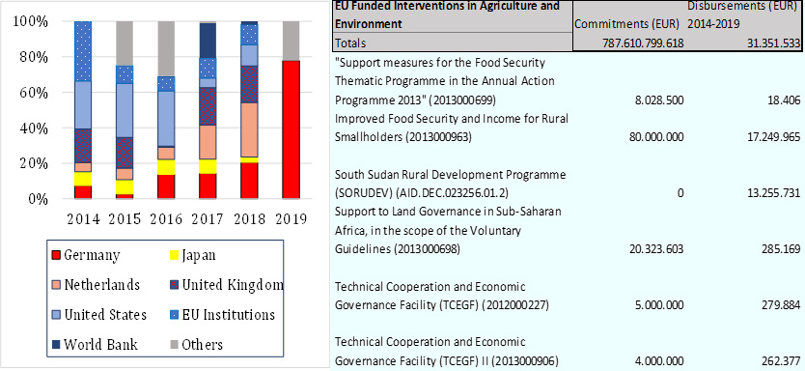including the EU), as shown in Figure 19.

**Figure 19: International Funding in Agriculture and Environment Sectors**

***(Source: EU Aid Explorer and CRS OECD Database 2021)***

Often these investments are focused upon agriculture and rural development investments, as shown in the commitments and disbursements from the EU for the period from 2014 to 2019.

There is broad international assistance in South Sudan from various countries around the world:

* The **Global Environment Facility** (GEF) through UNEP and other UN agencies funded Enabling Activity Projects for preparation of the following strategies, reports, and nation plans, such as NAPA (2016), NBSAP (2018), NCSA Report and Plan (2017), INDC (2015), INC (2018), UNCCD 2018 National Report. GEF also provided funding support for preparation of Land Degradation Neutrality (LDN) Strategy and Target (2019) to: i) provide an overview of the current state of land degradation in South Sudan, Development of the South Sudan LDN Targets, ii) cease the conversion of forests and wetlands for other land-use purposes by 2030, etc. Through UNDP, GEF supported South Sudan’s National Adaptation Plan (2020) to provide a baseline of existing climate change impacts and vulnerabilities, and identifies priority climate change adaption needs and associated projects to address these requirements.
* **The Foreign, Commonwealth & Development Office** (FCDO), through UNEP, funded the preparation of the South Sudan’s First State of the Environment and Outlook report in 2018, to provide a benchmark for the assessment and inventory of South Sudan’s natural resources, with particular emphasis on the impact of climate change and natural hazards on natural resources. FCDO also funded Weather and Climate Information Services for Africa (WISER) to reduce impact of weather and climate shocks in South Sudan through the enhanced provision and uptake of weather and climate information services for decision making in South Sudan by the priority sectors.
* **The Japanese International Cooperation Agency** (JICA) has contributed in several environmental supports in South Sudan, including; the Comprehensive Agriculture Master Plan (CAMP, 2015–2040) and Irrigation Development Master Plan (IDMP, 2015-2040). Its activities, among others, address the projected impacts of climate change on agriculture, livelihoods, and food security in South Sudan. JICA also supported the Irrigation Development Master Plan (IDMP, 2015) to achieve sustainable irrigated agriculture and the other productive uses of water, thereby improving food and nutrition security, enhancing resilience, reducing poverty, and contributing to economic growth and sustainable development.
* **The US Agency for International Development** (USAID) supported the Biodiversity and Tropical Forestry (FAA 118/119) (USAID, 2020) assessment which analysed direct environmental threats and their drivers (i.e., root causes) as the means for identifying actions necessary for biodiversity and tropical forest conservation. This assessment described biodiversity, forests, ecosystems, key environmental trends, and potential impacts of development, the state of protected areas and natural resource management, the value and economic potential of biodiversity and forests, etc.
* **The Netherlands Ministry of Foreign Affairs** supported, among others, the development of several projects, including an Integrated Water Resources Management (IWRM) approach and related capacity building; enhancing the agricultural sector through seed provision and agricultural value chain development; and expanding transport infrastructure. The Netherlands Ministry of Foreign Affairs support the implementation of the “Towards Strategic Clusters in Agribusiness through Learning in Entrepreneurship” (2SCALE) programme in South Sudan. This programme is designed to help rural smallholders to move from subsistence farming, through a sustainable improvement in productivity and quality, leading to marketable surpluses to increase family incomes.
* The Government is collaborating with a number of partners, including the **World Bank**, **Egyptian government**, and the **Intergovernmental Authority on Development** (IGAD) to build the capacity for hydrological monitoring in the country.
* South Sudan is a member of the **Nile Basin Initiative** (NBI), which is a regional body of nine countries working together to address water issues in the Nile Basin. NBI activities help build resilience to climate change in the Nile Basin through: 1) using variability in river flows as one way of understanding climate change impacts and planning how to respond to these impacts, and (2) developing this understanding and putting it into use. Through this initiative, the member countries are currently working to establish a regional hydro-meteorological system.

The ‘NBI Strategy 2017-2027’ identifies priority areas for transboundary water resource management and development, including, inter alia, strengthened water governance, climate change resilience, enhanced food and water security, and hydropower development. Other transboundary policies include:

* NBI Basin Sustainability Framework;
* NBI Gender Mainstreaming Policy and Strategy;
* Climate Change Strategy;
* Information Disclosure Policy;
* Environment and Social Policy;
* Communication and Stakeholder Engagement Strategy 2018–2023;
* Strategy for Management of Environmental Flows in the Nile Basin;
* Wetland Management Strategy.
* Other partners supporting implementation of climate change and environmental projects include: **The African Union** (AU); **Adaptation Fund**; **Canadian International Development Agency** (CIDA); **Ministry for Foreign Affairs of Finland** (MFA); **Norwegian Embassy**; **International Fund for Agriculture and Development** (IFAD), **United Nations Food and Agriculture Organization** (FAO), **World Food Programme** (WFP), **United Nations Environment Agency** (UNEA-UNEP), **Alliance for Green Agriculture in Africa**, IGAD **Climate Prediction and Applications Centre** (ICPAC), **International Committee of the Red Cross** (ICRC), **Sudd Institute**, **United Nations Industrial Development Organization** (UNIDO), etc.

# Conclusions and recommendations

## Conclusions

Environmental and climate change concerns are numerous in South Sudan.

### Environment and habitat degradation

South Sudan is one of the least densely populated countries in East Africa. **Forests and woodlands** make up nearly a third of South Sudan’s land area, and 16.57% of the country’s land is designated to be protected areas and forest reserves. Forest timber and non-timber resources are used for food, timber, fibres, medicines, and building materials, supplying 80% of the county’s energy through firewood and charcoal. Despite the low population, immigration and natural population growth have resulted in an increased demand for firewood, charcoal, as well as land for agricultural and residential purposes, leading to serious land and environment degradation at the proximity of populated places.

The rate of deforestation is accelerating through uncontrolled and unmanaged illegal logging, slash and burn shifting cultivation, firewood and charcoal production, agricultural land opening, settlement expansion and wild fires. Deforestation and habitat degradation have decreased the ability of woodland and forest ecosystems to provide important goods (such as non-timber forest products) and services (such as water provision) to rural communities, and to buffer these communities against climate change impacts. By degrading and/or destroying habitats, deforestation influence negatively the biodiversity and wildlife conservation in South Sudan.While large patches of woodland savannah remain untouched, montane and lowland tropical forest are on the brink of extinction. Conservative measures should be taken to preserve these unique biodiversity spots in South Sudan.

**Savannah and grasslands** cover respectively 52% and 23% of the South Sudan territory, hosting vast herds of mammals according to a WCS survey in 2007, which make savannah and grasslands the most important ecosystems in the country. However, grasslands and wooded savannah are regularly set on fire to either ease land clearing, rejuvenate grass for livestock, or to push wildlife to nets and traps. These repetitive fire actions degrade soils, increase soil erosion, destroy biodiversity, and reduce the recovering capacity of the ecosystem. The only immediate and feasible remedy to reverse these trends is strengthening education and environmental awareness raising targeting farmers and agropastoral communities. The carbon released in the atmosphere contributes to climate change at global and regional levels.

**Protected areas** are today the most effective tool for protecting biodiversity and species abundance and enforce the conservation of wildlife habitat. South Sudan, is reported to have 121,774 km2of existing and proposed protected areas, which represents about 16.57% of the country’s area. The World Database of Protected Areas lists 19 national-level protected areas as well as the Sudd, a Ramsar Site designed as Wetland of International Importance. However, most of these protected areas are existing on “paper” but are not enforced in the field. The lack of governmental budget for this sector is preventing the efficient management of the protected areas and this is, in turn, causing degradation of habitats and steady disappearing of the important wildlife species.

In addition, wildlife and protected area management in South Sudan are strongly impaired by the lack of data and information, with the last large-scale surveys dating back 2015-2016 by WCS. In order to improve protected area effectiveness in the near future, more information is needed (particularly in the GIS domain). Park staff competencies regarding data collection and processing should also be improved.

**Agriculture** in South Sudan is represented largely by small, hand-cultivating household units, mixing rain-fed agriculture, livestock grazing, and pastoralism. Most of these small-scale agricultural activities depend on the degradation of natural forested areas. However, this CEP study observed a huge margin for improving environmental conditions and ecosystem services to benefit local communities in these agricultural areas. Some of the existing and applicable techniques recommended are agro-forestry, hedging, livelihood diversification, and the introduction of new and/or more productive crops and improved varieties. The implementation of these methods and techniques should take into consideration the beneficiary’s participation, and the development of local community ownership concerning the sustainable exploitation of natural resources, NTFPs, and the preservation of ecosystem services.

### Climate change

Climate change is a reality in South Sudan. While the IPCC report states that past human activities are “likely” to contribute to the changes of climate patterns, it appears the last rows of repetitive episodes of droughts and floods experienced by South Sudan are undoubtedly the consequences of a mix between climate change, natural hazards, and anthropogenic influences (notably deforestation), all of which impacts river flow, increases soil erosion, and contributes to riverbed sedimentation.

All projections agree that South Sudan will become warmer by 2060, with lower temperature increases occurring in the south-western part of the country. These warming projections range from 1.5°C to 3.1°C during August to between 1.1°C and 2.1°C during January (UNEP & MoEF, 2016).

While there are no consensus projections on the future change in rainfall, the current increased variability (in terms of onset, duration, and total amount) is likely to continue. Rainfall variability is high in the semi-arid northern and eastern parts of the country. Changes in climatic patterns (both long-term and seasonal) have, and will continue to have, a detrimental effect on South Sudanese livelihoods. These impacts are particularly severe for rural populations, which depend heavily on climate-sensitive activities such as seasonal and daily agricultural labour, rain-fed crop sales, livestock, and fishing.

The expected changes in climate are likely to lead to more droughts and floods, which are becoming increasingly more severe. These changes will affect agriculture and natural resources, which are the main livelihood sources of more than 80% of the South Sudanese population. Unless strong mitigation and adaptation measures are developed and implemented by the South Sudan Government, climate change will continue to decrease agriculture production, increase food insecurity and consequently have negative impacts for South Sudan’s socioeconomic development.

Some of the most striking impacts observed linked to climate change and environmental degradation on water, soil, forests, biodiversity, agriculture, and fisheries include (UNDP & MoEF, 2011):

* The drying up of permanent rivers resulting in seasonal rivers, the reduction of water tables in boreholes, and the delay and shortening of rainy seasons;
* Increased soil degradation due to water erosion, wind erosion, and fire;
* Accelerating deforestation due to wood being collected for fuel, charcoal production, livestock, agriculture, bricks, and collection of construction materials;
* Increase vulnerability of wildlife populations already depleted by related hunting with a limited possibility of recovery in many areas;
* Lower agricultural revenues per hectare due to unpredictable rains and soil degradation;
* Competition for drinking water between people and livestock and habitat degradation for livestock and wildlife due to vegetation degradation and desertification (in the north and south-east of South Sudan);
* Loss of fish species and reduction of fish size as a result of rivers becoming increasingly seasonal.

**Disaster risk reduction and management**: Currently, there is no effectively functional disaster reduction and management body in South Sudan. Nevertheless, the potential for a rapid deployment of a Disaster Risk Unit already exists in South Sudan, through the GMES and Africa running programme and the technical support of ICPAC regional implementation centre. Two stations are already deployed in South Sudan: the MESA station is located in the Ministry of Environment and Forestry, Directorate of Forestry, and The PUMA station is located in South Sudan Meteorological Department (SSMD).

**Infrastructure:** In Jonglei state, dykes/roads are built to prevent flooding originating from river swelling. The dyke/road starting from Bor is supposed to reach Malakal, 350 km up North (in a straight line), but this infrastructure poses two questions:

1. has an environmental impact assessment been conducted prior making these dykes, which will prevent thousands of hectares of natural environment to be periodically flooded?

2. while building a dyke to prevent flooding originating from river swelling is the correct thing to do, many field reports stated, however, that flood could also be the result of heavy rains – in this case the risk is that the dyke will block the water and prevent it to be drained into the river, keeping large flooded areas. Building a dyke with culverts, which could be opened or closed according to circumstances, would have been a better option and more cost efficient if planned from the beginning.

### Cross-cutting issues

**Education** and environmental awareness-raising are the most important tools to preserve the environment and they must be addressed as a priority. Awareness creation and raising programmes, both through traditional school systems and stand-alone programmes, should address production and consumption practices and patterns that are sustainable. Such programmes should be broad in their messaging, targeting, for example, energy use through improved cooking stoves as well as improved lighting options. South Sudan should move toward policy options that favour an increase of solar energy use by many citizens as well as low emission lighting. Water consumption and conservation should be a part of every student’s upbringing, as well as practices for vegetable raising and marketing, which are found in many school systems (UNEP, 2018).

**Poverty** is widespread, particularly in the rural areas, which are home to more than 6.9 million people (AfDB Group, 2019a). Approximately 51% of South Sudan’s population lives below the national consumption poverty line and are living on an equivalent of less than US$ 1 per day. Over 75% of households are dependent on crop farming or animal husbandry as their primary source of livelihood. It has been observed that poverty is an important driver of environmental degradation, because the poorer fraction of the population relies heavily on natural resources for subsidence. Internal displaced and refugee camps in South Sudan that shelter great numbers of people, show high levels of environmental degradation and depletion of natural resources in a wide perimeter around the camp. Charcoal making is also a widespread activity for majority South Sudanese people including civil servants and armed forces who lack access to other and less environmental damaging sources of income.

**Gender**. Climate change will continue to have a greater impact on women than men. In South Sudan, women are traditionally responsible for household duties, cultivating land, and collecting water and firewood and other materials for domestic use. These natural resources are already heavily degraded around populated places, and the predicted consequences of climate change will further damage these natural resources and, thus, negatively affect women’s livelihoods.

The consequences of a decrease in availability of such resources will require South Sudanese women and girls to spend more time travelling to gather drinking water, firewood, and natural resources. Therefore, they will have less time for other income-generating activities. Furthermore, in South Sudan, women have less capacity and financial resources to adapt to climate change impacts. Currently, the literacy rate among men is more than double that among women, whilst the gender parity index indicates that girls are dropping out of the school system much earlier than boys (UNEP & MoEF, 2016).

Poverty levels are also higher among female-headed households: 57% of the population living in female-headed households are poor compared to 48% in male-headed households. Climate change will exacerbate these disparities and further restrict the socio-economic development and empowerment of women in South Sudan. Gender equality is therefore recognised as an important issue in South Sudan and should be integrated into the design and implementation of all adaptation projects (UNEP & MoEF, 2016).

**Energy**: Firewood and charcoal are the most-used sources of energy in South Sudan with 62% of rural and 39% of urban households using firewood as source of energy in 2009. Combined with rapid population growth, high levels of poverty and urbanization, the reliance upon wood is leading to the overexploitation of forest resources and extensive deforestation (UNEP & MoEF, 2016).

Currently, there are no realistic alternative energy technologies available in South Sudan (and many parts of the World) to replace charcoal. There are few existing technical solutions (solar, wind, gas, biogas, etc.), but communities lack the capacity and the budget to implement these technologies.

In addition to charcoal, there is also a growing demand for fuel wood and brick-making, which is accelerating the deforestation rate. Charcoal-making is an attractive economic activity, which is done outside any legal framework, often without legal agreement from landowners and with very minimum or complete absence of benefit-sharing with local communities.

In the absence of simple and cheap replacement solutions, it would be more efficient to control and manage this activity through:

1. A system of licenses delivered upon completing training on: 1) environmental awareness, 2) improved charcoal kiln techniques, 3) tree planting in a long-term business perspective, and 4) marketing of the product to get a better return on investment.
2. The promotion of improved stoves reducing the firewood consumption by approximately 40%, is a promising approach to be widely developed and supported to reduce significantly the level of deforestation in South Sudan.

**Water** is a real concern in South Sudan because there is a great variation in water availability in the country. Depending of the geographic location of the country, an area could have less water (droughts) or too much (floods). Since agriculture and livestock development need a better management of water resources it is recommended that South Sudan should implement water harvesting techniques such as small dams to address imbalances. These techniques have successfully been used for centuries in some countries (India, Sri Lanka, Bangladesh, etc.) and they could be probably imported with some adjustments to fit South Sudan context.

**Infrastructure,** and notably roads, are important for the development of the South Sudan economy and population displacements. Road construction has a direct impact on the environment, but the most negative impact is to give a better access to natural resources that were preserved naturally by their remoteness. All over the World, illegal encroachment, poaching, wildfires happen along roads and opened tracks. Education and environmental awareness targeting local communities should be associated systematically with road construction.

**Pollution** is a rising concern in South Sudan. Waste management does not exist and unfavourable weather conditions, combined with population growth, increase the discharge of wastewater effluent and solid waste into watercourses, further damaging already deteriorating water resources. Examples of such sources of pollution include: oil spills, sewage disposal, solid waste (e.g., plastic waste in rivers and stream in major cities of South Sudan), and acid rain from usage of diesel generators all over the country.

**Lack of data**: In South Sudan there is a very important need for accurate data at national level with regard to environmental concerns and climate change. On climate change aspects, it is important for South Sudan relevant institutions such as SSMD and Ministry of Environment and Forestry to strengthen their existing relationships with ICPAC through the GMES & Africa programme. The same programme provides access to high resolution satellite imagery from COPERNICUS, which are suitable for land cover and land use mapping at regional scale.

**Lack of environmental/climate change indicators**. The 2020 **Environmental Performance Index** (EPI) provides a data-driven summary of the state of sustainability around the world. Using 32 performance indicators across eleven (11) issue categories, the EPI ranks 180 countries on environmental health and ecosystem vitality. These indicators provide a gauge at a national scale of how close countries are to established environmental policy targets. Unfortunately, South Sudan (as Sudan) is absent from the list of concerned countries. The **World Bank database** provide information about South Sudan and notably the CO2 emission (metric ton per capita) but from a general point of view, these data are sparse and fragmented. The **Sustainable Nitrogen Management Index** (SNMI) seeks to balance efficient application of nitrogen fertilizer with maximum crop yields as a measure of the environmental performance of agricultural production. Again, South Sudan (and Sudan) is absent from the list of concerned countries. The **Sustainable Development Report** (formerly the SDG Index & Dashboards) is the first worldwide study to assess where each country stands with regard to achieving the Sustainable Development Goals. In the last report South Sudan is ranked 165 on 166 with a score of 43,66 (Sachs J.et al. 2020), which is a very low performance. The **OECD key environmental indicators** record and updates are limited to 30 states, mostly developed countries. In the global context of climate change, it is regrettable that the most negatively affected countries by climate change are absent of this listing.

## Recommendations

The CEP has made recommendations in key selected areas mentioned below to address environmental and climate change concerns and major causes of deforestation and habitat degradationin the context of development of new cooperation programmes and actions with South Sudan. The recommendations are in line with the implementation of the Sustainable Development Agenda 2030, aligned with the EU Commission Green Deal Agenda and the transition to a green economy as much as possible to the relevant national documents published recently in South Sudan including but not limited to the following:

1. The National Biodiversity Strategy and Action Plan 2018-2027;
2. The South Sudan State of the Environment (2018);
3. South Sudan Climate Vulnerability Profile (2019);
4. South Sudan initial communication to the UNFCCC (2018);
5. South Sudan National Adaptation Plan (2021);
6. National Adaptation Programme of Actions (NAPA) to climate change, etc.

### Environment

Ecosystem services and resources supplied by the natural environment and by forests constitute important sources of livelihoods for rural communities in South Sudan. These goods and services could contribute up to 75% of household incomes and include water provision, non-timber forest products (NTFPs), and charcoal. There is a direct and strong link between environment and climate change. Effectively, an environment in good state, providing abundant free ecosystem services, is the best protection humanity has to prevent the deleterious effects of climate change. With these concepts in mind, the following recommendations aim to preserve and/or restore ecosystem services while promoting a sustainable use of natural resources and a long-term sustainable development of human activities.

Conflict sensitivity should be mainstreamed in the implementation actions of the recommendations below.

**Table 2: Environment Recommendations**

| **Recommendations** | **S/M/L\*** |
| --- | --- |
| Promote measures for reducing deforestation – which include reforestation, agroforestry, hedging, and the use of energy-saving technologies, such as improved wood/charcoal stoves, biogas and solar-powered systems, management of the charcoal production. | S |
| Promote measures for biodiversity and habitat protection through the extension of protected areas to encompass migratory routes, the addition of new protected areas, and the reinforcement of the protection of near extinct ecosystems such as Montane Forest and lowland forest. | S |
| Promote the set-up of Transboundary Wildlife Management agreements to build trust and cooperation between South Sudan and its neighbours such as Uganda, Ethiopia, Kenya, CAR, and the DRC to prevent conflicts over natural resources, share skills and resources, learn from different countries’ experiences, and manage wildlife on a landscape scale where it crosses international boundaries. | M |
| Promote and support the design of protected areas along the largest rivers in South Sudan in order to protect fish resources and aquatic wildlife. | S |
| Promote measures to reduce and prevent poaching and wildlife trafficking. | S |
| Promote a strong integration of local communities into every project/programme dealing with environmental and climate change concerns. | S |
| Promote local communities’ ownership and management of natural resources and water. | S |
| Promote the development of fire management plans including awareness raising, to prevent wildfires during drought periods. | S |
| Promote land use planning, management, and the definition of special areas according to uses and livelihood systems to prevent conflicts over natural resources, e.g., between farmers, agropastoral communities, and wildlife. | S |
| Promote the development of waste collection, treatment, and recycling. | S |
| Promote and support landscape restoration and ecosystem-based adaptation. This includes applying principles for wetland use and promoting projects aimed at maintaining genetic diversity. | M |
| Promote the control/destruction of invasive species and support the development of techniques for recycling their biomass; among others: babatiru (*Chromolaena odorata*), water hyacinth (*Eichornia crassipes*), *Azolla filiculoides*, Mesquite tree (*Prosopis juliflora*), etc. | L |
| Support the monitoring of the situation of environmental resources (including assessment of the current forest cover) and their overall evolution, allowing for alerts on the consequences of potential degradation due to overexploitation, pollution, encroachment, wildfires, etc. | L |

***NB: S - short-term, M - medium – term, L - Long-term***

### Climate change

**Table 3: Climate Change Recommendations**

|  |  |
| --- | --- |
| **Recommendations** | **S/M/L\*** |
| Establish and build flood and drought strategic response capacity (information and communication, implementation of decision chain through county, state, and national levels, human and technical means, pre-defined shelter area on upper ground, etc.) |  |
| Support the development of agencies and policies dealing with disaster risk reduction and early warning systems for drought, famine, floods, etc. Strengthen SSMD, and increase cooperation with ICPAC. | S |
| Promote the building of a credible baseline data starting with the major environmental assets and climate change. | S |
| Improve knowledge on climate change and on the state of environment. | S |
| Promote the development of infrastructures allowing to control water flow in flood prone areas (such as dykes with culvert, which allows to control water flow rather than blocking it definitively). | M |
| Promote the reactivation of GMES & Africa and the strengthening of cooperation with ICPAC implementing centre on early warning, meteorological data and weather forecast aspects. | L |

***NB: S - short-term, M - medium – term, L - Long-term***

### Water resources

**Table 4: Water Resources Recommendations**

| **Recommendations** | **S/M/L\*** |
| --- | --- |
| Build institutional capacity in water resource management, planning and governance at the national, county, and state levels. | S |
| Promote rain water harvesting techniques and the development of small reservoirs and water storage for smallholder farming. | S |
| Promote and support laws protecting water resources from pollution and overexploitation. | M |
| Promote sustainable and equitable access to water resources to offset climate induced changes. | M |
| Promote the implementation of water reservoirs along migratory routes for wildlife and/or livestock. | M |
| Promote and support the sustainable management and conservation of wetlands in South Sudan. | L |
| Support the protection and the restoration of watersheds so that they continue to contribute to ecosystem services and improve resilience against climate change. | L |

***NB: S - short-term, M - medium – term, L - Long-term***

### Agriculture

**Table 5: Agriculture Recommendations**

|  |  |
| --- | --- |
| **Recommendations** | **S/M/L\*** |
| Promote sustainable land management practices, such as climate-smart agriculture, agro-forestry, conservation agriculture, and holistic planned grazing. | S |
| Promote the development of community-based fishing cooperatives to exploit fish stocks in a sustainable way. | S |
| Improve access to better seeds and varieties of crops, fruits, and plants (e.g., drought-tolerant, flood-resistant, early-maturing, disease-resistant, and adapted to local agroecological zones), and techniques through extension services support. | S |
| Improve access to markets and enhance product value chains for agriculture and fisheries products. | S |
| Facilitate people’s access to credit and financial systems to stimulate socioeconomic development and enhance households’ capacity to mitigate climate change impacts. | S |
| Establish and/or strengthen appropriate fishery policies, laws, and institutions to regulate fish catches, including traditional fishing regulations, such as fishing restrictions that allow for the replenishment and maintenance of ecological balance in rivers and wetlands. | M |
| Promote the development of aquaculture (away from riverine areas to avoid the introduction of exotic species, which could turn to be invasive). | M |
| Promote and support the diversification of sources of income and livelihoods through the development of sustainable exploitation of NTFP, honey, gum Arabic, shea tree, etc. | M |
| Promote the expansion of irrigated agriculture (for crop and livestock production, aquaculture) to improve the agriculture production resilience to climate change, offer employment opportunities, and improve local sources of income. | M |
| Promote the protection of the biodiversity and the genetic resources of traditional and indigenous cultivars threatened by modern agriculture practices of genetically engineered crop species. | M |

***NB: S - short-term, M - medium – term, L - Long-term***

### Institutional framework

**Table 6: Institutional Framework Recommendations**

| **Recommendations** | **S/M/L\*** |
| --- | --- |
| Support the strengthening of capacity building on environmental and climate change issues into relevant institutions. This should include establishing environmental and climate change focal points and units in concerned government ministries and agencies. | S |
| Promote a systematic review of environmental legislation and policies, supporting and update for climate change mainstreaming, and easing the process of draft finalisation, adoption, and implementation. | S |
| Promote improved coordination and cooperation between National-, state-, and county-level regarding environmental and climate change concerns. | S |
| Support the mobilisation of climate finance (international sources, domestic public and private sources, and carbon finance) for climate change mitigation/adaptation purposes. | S |
| Support the principle of sustainable benefits sharing in the case of operations dealing with natural resources, notably in the extractive/mining sector and land acquisition (plantations). | S |
| Systematically study the opportunity to launch a Strategic Environmental Assessment for each focal sector to be supported by the EU: education, food security, youth employment, ecosystems, and biodiversity, being the more important sectors. | S |
| Support the systematic implementation of environmental and social impact assessments before undertaking any major infrastructure developments such as inter-states truck roads to reduce negative effects on local populations, natural resources and wildlife. | M |
| Promote the mainstreaming of climate change and environmental concerns and adaptation in planning and budgeting at the national, state and county levels. | M |

***NB: S - short-term, M - medium – term, L - Long-term***

### Cross cutting issues

**Table 7: Cross Cutting Issues Recommendations**

|  |  |
| --- | --- |
| **Recommendations** | **S/M/L\*** |
| Promote and support systematic consideration of gender aspects in all projects and programmes addressing environmental and climate change concerns, women being the most affected by environmental degradation and climate change. | S |
| Promote environmental and climate change education and awareness raising in South Sudan population and support the introduction of environment and climate change as part of the formal primary and secondary school curricula. | M |

***NB: S - short-term, M - medium – term, L - Long-term***

### International synergies

**Table 8: Recommendations Concerning International Synergies**

|  |  |
| --- | --- |
| **Recommendations** | **S/M/L\*** |
| Promote long-term support (rather than project-based mechanisms) and local initiatives, based upon a strong participation of local communities and reinforcing national/state/county frameworks. | S |
| Support the participation of South Sudan in international climate and environmental fora, including accession to CITES and CMS. | S |
| Promote the cooperation between donors and international agencies regarding environmental and climate change matters. | S |
| Support South Sudan involvement and cooperation at regional level, enhancing synergies and benefits from shared experience in natural resources management and regional centres of climate/early warning expertise such as the services provided by ICPAC. | L |

***NB: S - short-term, M - medium – term, L - Long-term***

# References

|  |
| --- |
| **AfDB Group (2019a)**. Republic of South Sudan Update of the Extended Interim Country Strategy Paper (CSP) 2012–2018 to December 2021 and 2018 Country Portfolio and Performance Review. |
| **AfDB Group (2019b)**. Proposed Strategic Water Supply and Sanitation Improvement Project, 2019 |
| **Africa News (2021)**. South Sudan – Over 800,000 Affected by Worst Flooding in 60 Years. From: https://floodlist.com/africa/south-sudan-floods-update-december-2021 |
| **African Union (2021)**. GMES And Africa. From: https://au.int/GMESAfrica/background |
| **Aly Verjee (2013).** Is all well in the teak forests of South Sudan? From: https://africanarguments.org/2013/03/is-all-well-in-the-teak-forests-of-south-sudan-by-aly-verjee/ |
| **Benansio et al. (2018)**. Rediscovery of the Nubian Flapshell Turtle (*Cyclanorbis elegans*) in South Sudan. |
| **Benjamin-Fink Nicole (2019).** An Assessment of the Human-Wildlife Conflict across Africa, from: http://dx.doi.org/10.5772/intechopen.82793 |
| **BRACED (2017)**. Building Climate Resilience in Fragile Contexts: Key Findings of BRACED Research in South Sudan, Improving Resilience to Climate Change in South Sudan |
| **Casey Michael (2014).** Fighting in South Sudan putting the country's elephants, giraffes at risk, from: https://www.cbsnews.com/news/fighting-in-south-sudan-putting-countrys-elephants-giraffes-at-risk/ |
| **CBD (1992).** United Nations Convention on Biological Diversity, from: https://www.cbd.int/doc/legal/cbd-en.pdf |
| **C. Funk et al (2011)**. A Climate Trend Analysis of Sudan. From: https://www.researchgate.net/publication/259841875_A_Climate_Trend_Analysis_of_Sudan |
| **Cedric H. de Coning et al. (2021)**. Climate, Peace and Security Fact Sheet: South Sudan. |
| **CHI (2018)**. Jonglei Canal Project Under Potential Developments in the Upper Nile States. From: https://www.chijournal.org/C448 |
| **CITES (1973).** Convention on International Trade in Endangered Species of Wild Fauna and Flora, from: https://cites.org/eng/disc/text.php |
| **Christina Russo (2014).** New Doubts About Whether Elephants Can Survive South Sudan's Civil War, from: https://www.nationalgeographic.com/adventure/article/141208-south-sudan-elephant-census-conservation-animals |
| **Hezron Mogaka (2018)**. Comprehensive Report on Policy and Institutional Analysis. |
| **EU4Oceanobs (2021)**. GMES and Africa Programme |
| **FAO (2015)**. Gathering weather data to provide early warning on climate. From: https://www.fao.org/resilience/news-events/detail/en/c/282695/ |
| **FAO (2021)**. FAO in action, Stories, South Sudan. Improving catches and reducing post-harvest losses for fishing communities in Bor South through knowledge. From: https://www.fao.org/emergencies/fao-in-action/stories/stories-detail/en/c/1416218/ |
| **Fortune of Africa (2020)**. Wildlife subsector challenges in South Sudan. From: https://fortuneofafrica.com/southsudan/wildlife-subsector-challenges-in-south-sudan/ |
| **Fortune of Africa (2021)**. Rivers in South Sudan. From: https://fortuneofafrica.com/southsudan/rivers-in-south-sudan/ |
| **Global Invasive Species Database (2021).** Species profile: *Chromolaena odorata*, From: http://www.iucngisd.org/gisd/species.php?sc=47 |
| **Hanadi K. Ahmed and Essam Warrag (2005)**. Sudan Vegetation cover assessment using NOAA-AVHRR data for the period between 1982-1999. From: http://api.uofk.edu:8080/api/core/bitstreams/61721d47-eba9-4a37-a3d2-7f15acfddf46/content |
| **Home Wiki (2020)**. Protected areas of South Sudan. From: https://second.wiki/wiki/c381reas_protegidas_de_sudc3a1n_del_sur |
| **IFAD (2020)**. South Sudan Livelihoods Resilience Programme. |
| **IPCC (2021)**. Climate Change 2021. The Physical Science Basis |
| **J. Courboules (2021)**. ICPAC personal communication |
| **Jean Payen et al. (2012)**. Small reservoirs and water storage for smallholder farming. |
| **Keith Somerville (2016).** South Sudan’s humanitarian crisis: wildlife is also in the firing line. https://theconversation.com/south-sudans-humanitarian-crisis-wildlife-is-also-in-the-firing-line-63064 |
| **MEDIWR. (2015).** The Republic of South Sudan Project for Irrigation Development Master Plan (IDMP) in the Republic of South Sudan, Final Report, (Annexes, Part I). Ministry of Electricity, Dams,  Irrigation and Water Resources (MEDIWR), from: https://openjicareport.jica.go.jp/pdf/12249181.pdf |
| **JICA (2017)**. Country Gender Profile, Republic of South Sudan. From: https://land.igad.int/index.php/documents-1/countries/south-sudan/gender-5/981-country-gender-profile-republic-of-south-sudan-2017/file |
| **Karimeh Moukaddem (2011)**. South Sudan’s tropical forest fast disappearing. From: https://news.mongabay.com/2011/06/south-sudans-tropical-forests-fast-disappearing/ |
| **MAFS & JICA (2015)**. South Sudan Comprehensive Agricultural Development Master Plan. |
| **MHADM (2018)**. Ministry of Humanitarian Affairs and Disaster Management Strategic Plan 2018–2020. |
| **Ministry of Foreign Affairs of Netherlands (2018)**. South Sudan Climate Change Profile. |
| **MoAF (2012)**. South Sudan Forest Policy. |
| **MoAF (2015)**. REDD+ Volume 1 Stakeholder mapping and Capacity Needs Assessment Report. |
| **MoFEP (2013)**. South Sudan Development Plan 2011-2013. From: http://www.grss-mof.org/wp-content/uploads/2013/08/RSS_SSDP.pdf |
| **MoFP (2018)**. South Sudan National Development Strategy: Consolidate Peace and Stabilise the Economy. |
| **Nhial Tiitmamer (2015)**. Assessment of Policy and Institutional Responses to Climate Change and Environmental Disaster Risks in South Sudan. (Juba, South Sudan, Sudd Institute). |
| **Norwegian Institute of International Affairs (2021)**. Climate, Peace, and Security Fact Sheet: South Sudan. |
| **Philip Ayuen Dot (2020)**. Why South Sudan should strive to protect and preserve her natural biodiversity. From: https://ssnewsnow.com/opinion-why-south-sudan-should-strive-to-protect-and-preserve-her-natural-biodiversity/ |
| **Pius Zebhe Yanda (2019)**. Analysis of Drivers of Deforestation and Forest Degradation. |
| **Primate Watching (2021)**. South Sudan list of species. From: https://www.primatewatching.com/south-sudan |
| **ProtectedPlanet.net (2021)**. World Database on Protected Areas. From: https://www.protectedplanet.net/en |
| **Ricardo Martin Holdo et al. (2009)**. Grazers, browsers, and fire influence the extent and spatial pattern of tree cover in the Serengeti. |
| **Richard Davies (2021)**. South Sudan – Over 800,000 Affected by Worst Flooding in 60 Years. From: https://floodlist.com/africa/south-sudan-floods-update-december-2021 |
| **Sachs J.et al. (2020)**. The Sustainable Development Goals and COVID-19. Sustainable Development Report 2020. Cambridge: Cambridge University Press |
| **Shipping Position (2016)**. South Sudan Seizes Half Ton of Ivory Amid Smuggling Worries. From: https://shippingposition.com.ng/south-sudan-seizes-half-ton-of-ivory-amid-smuggling-worries/ |
| **Sihle Qekeleshe 2020.** Energy Capital & Power. Meet South Sudan’s Oil Operators. From: https://energycapitalpower.com/meet-south-sudans-oil-operators/ |
| **U. C. Jha (2014)**. Armed Conflicts and Environmental Damages. |
| **UNCCD (1994).** United Nations Convention to Combat Desertification (UNCCD, 1994), from https://catalogue.unccd.int/936_UNCCD_Convention_ENG.pdf |
| **UNDP & MoEF (2011)**. South Sudan Environmental Impacts, Risks and Opportunities Assessment. |
| **UNDP & MoEF (2021a)**. South Sudan's Second Nationally Determined Contribution. From: https://www4.unfccc.int/sites/ndcstaging/PublishedDocuments/South%20Sudan%20First/South%20Sudan%20Intended%20Nationally%20Determined%20%20%20%20Contribution.pdf |
| **UNDP & MoEF (2021b)**. First national adaptation plan for climate change. From: https://unfccc.int/sites/default/files/resource/South-Sudan-First-NAP%20.pdf |
| **UNDRR (2021)**. What is the Sendai Framework for Disaster Risk Reduction? From: https://www.undrr.org/implementing-sendai-framework/what-sendai-framework |
| **UNEP (2018)**. South Sudan First State of Environment and Outlook Report. From: https://www.unep.org/resources/report/south-sudan-first-state-environment-and-outlook-report-2018 |
| **UNEP & MoEF (2015)**. Fifth National Report to the Convention on Biodiversity. From: https://www.cbd.int/doc/world/ss/ss-nr-05-en.pdf |
| **UNEP MoEF (2016)**. South Sudan National Adaptation Programme of Actions (NAPA) to climate change. From: https://wedocs.unep.org/bitstream/handle/20.500.11822/17757/SouthSudan_NAPA_Nov2016.pdf?sequence=1&amp%3BisAllowed= |
| **UNEP & MoEF (2018a)**. South Sudan Initial National Communication to the United Nations Framework Convention on Climate Change. From: https://unfccc.int/sites/default/files/resource/South%20Sudan%20INC.pdf |
| **UNEP & MoEF (2018b)**. South Sudan National Biodiversity Strategy and Action Plan 2018-2027. From: https://www.cbd.int/doc/world/ss/ss-nbsap-01-en.pdf |
| **UNESCO (2016**). South Sudan ratifies the World Heritage Convention. From: https://whc.unesco.org/en/news/1513 |
| **UNESCO (2021)**. Sudd Wetland, tentative list. From: https://whc.unesco.org/en/tentativelists/6276/ |
| **UNFCCC (1992).** United Nation Framework Convention on Climate Change, from:https://unfccc.int/resource/docs/convkp/conveng.pdf |
| **UNHCR (2019)**. UNHCR South Sudan Factsheet. From: https://reliefweb.int/report/south-sudan/unhcr-south-sudan-factsheet-september-2019 |
| **UNHCR (2020)**. The South Sudan refugee crisis explained. From: https://www.unrefugees.org/news/south-sudan-refugee-crisis-explained/ |
| **UNICEF (2020)**. The situation of Children and Women in South Sudan |
| **UNICEF (2021a)**. The situation of children and women in South Sudan (2018–2020) |
| U**NICEF (2021b)**. South Sudan, Health. From: https://www.unicef.org/southsudan/what-we-do/health |
| **UNOCHA (2021)**. South Sudan - Health indicators. From: https://data.humdata.org/dataset/who-data-for-south-sudan |
| **UNOCHA (2019)**. South Sudan Humanitarian Needs Overview 2021. From: https://reliefweb.int/report/south-sudan/south-sudan-humanitarian-needs-overview-2021-january-2021 |
| **USAID (2013)**. South Sudan climate vulnerability profile. From: https://www.climatelinks.org/sites/default/files/asset/document/south_sudan_climate_vulnerability_profile_jan2013.pdf |
| **USAID (2014)**. South Sudan Tropical Forests and Biological Diversity Assessment, Phase 1: Pre-field FAA 118 119 desk assessment. |
| **USAID (2019)**. South Sudan Climate Vulnerability Profile. |
| **USAID (2021)**. Global Waters Org. South Sudan Overview. From: https://www.globalwaters.org/wherewework/africa/south-sudan |
| **USAID (2020).** Biodiversity and Tropical Forest (118/119) Analyses, from: https://www.usaid.gov/environmental-procedures/biodiversity-tropical-forest-analyses |
| **Waithaka Mwangi et al. (2016)**. One Health: Addressing Global Challenges at the Nexus of Human, Animal, and Environmental Health. From: https://www.ncbi.nlm.nih.gov/pmc/articles/PMC5025119/#sec001title |
| **WCS (2017).** South Sudan Wildlife Surviving Civil War, but Poaching and Trafficking Threats Increase, from: https://newsroom.wcs.org/News-Releases/articleType/ArticleView/articleId/10089/South-Sudan-Wildlife-Surviving-Civil-War-but-Poaching-and-Trafficking-Threats-Increase.aspx |
| **WCS (2019).** Key Wildlife Populations Remaining in South Sudan Despite Five and a Half Years of Armed Conflict, from: https://newsroom.wcs.org/News-Releases/articleType/ArticleView/articleId/12506/Key-Wildlife-Populations-Remaining-in-South-Sudan-Despite-Five-and-a-Half-Years-of-Armed-Conflict.aspx |
| **WFP (2014)**. Climate risk and food security in South Sudan. |
| **WHC (1972). T**he World Heritage Convention, from: https://whc.unesco.org/archive/convention-en.pdf |
| **WHO (2021).** Ebola virus disease. From: https://www.who.int/news-room/fact-sheets/detail/ebola-virus-disease |
| **Wikipedia encyclopedia (2021)**. Jonglei Canal. From: https://en.wikipedia.org/wiki/Jonglei_Canal |
| **WMO (2011)**. Drier and warmer season forecast across Eastern Africa. From: https://public.wmo.int/en/media/news/drier-and-warmer-season-forecast-across-eastern-africa |
| **World Bank (2021)**. The World Bank in South Sudan, Overview. From: https://www.worldbank.org/en/country/southsudan/overview#1 |
| **World Bank 2020.** Climate Change Knowledge Portal. From: https://climateknowledgeportal.worldbank.org/country/south-sudan/climate-data-historical |
| **Worldometer (2021)**. South Sudan Population. From: https://www.worldometers.info/world-population/south-sudan-population/ |