Inscription of Creole Cultures to the Intangible Cultural Heritage of UNESCO

This initiative (*1) is part of the process involving States proposing to include elements of their heritage on the World Heritage List. Its aim is to make Creole communities aware of their heritage and to share their values ​​with the peoples of the world.
It all started in February 2018 with the launch of the group "Creoles cultures / Kiltir Kreol / Cultures Créoles", devoted to the theme "Developing a knowledge base on heritage', on LinkedIn (https://www.linkedin.com/groups/8259466
The initiative was also presented to the participants of the 16th International Conference of Creole Studies, Mahé (Seychelles), 28 October - 2 November 2018,
at the INTERNATIONAL CONFERENCE "Small companies in a globalized world: lessons learned from Seychelles" at UniSey from 6 to 8 March 2019, during which the Declaration of ‘Anse Royale’ was signed.
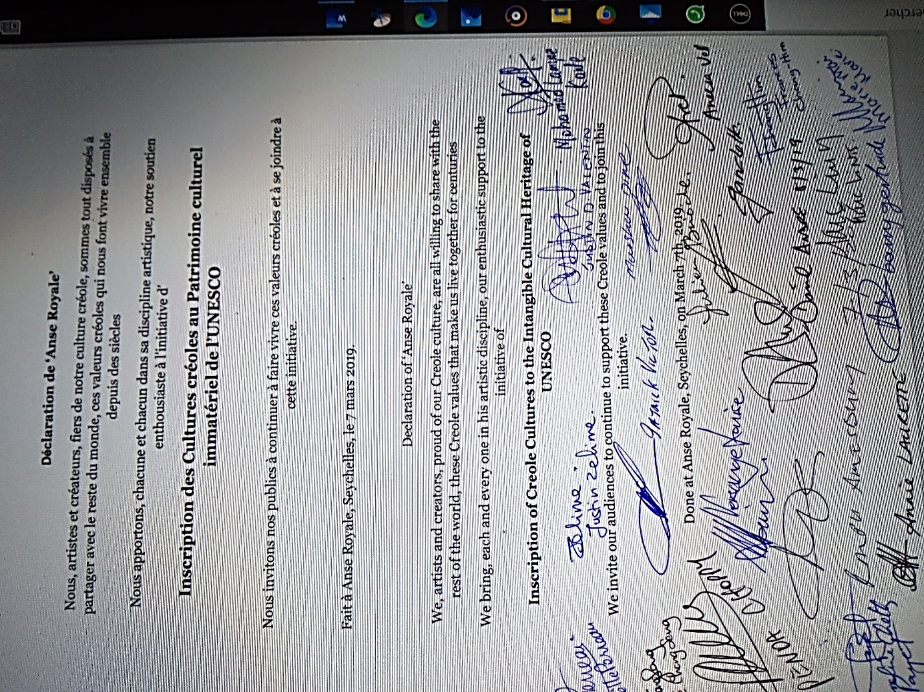
- 1 https://www.youscribe.com/catalogue/documents/actualite-et-debat-de-societe/debats-et-polemiques/inscription-of-creole-cultures-to-the-intangible-cultural-heritage-3334337?ni=1
and at the Dominica Country Conference 2019, August 15 & 16, 2019, at UWI Open Campus Dominica Road Elmshall Roseau, Dominica.
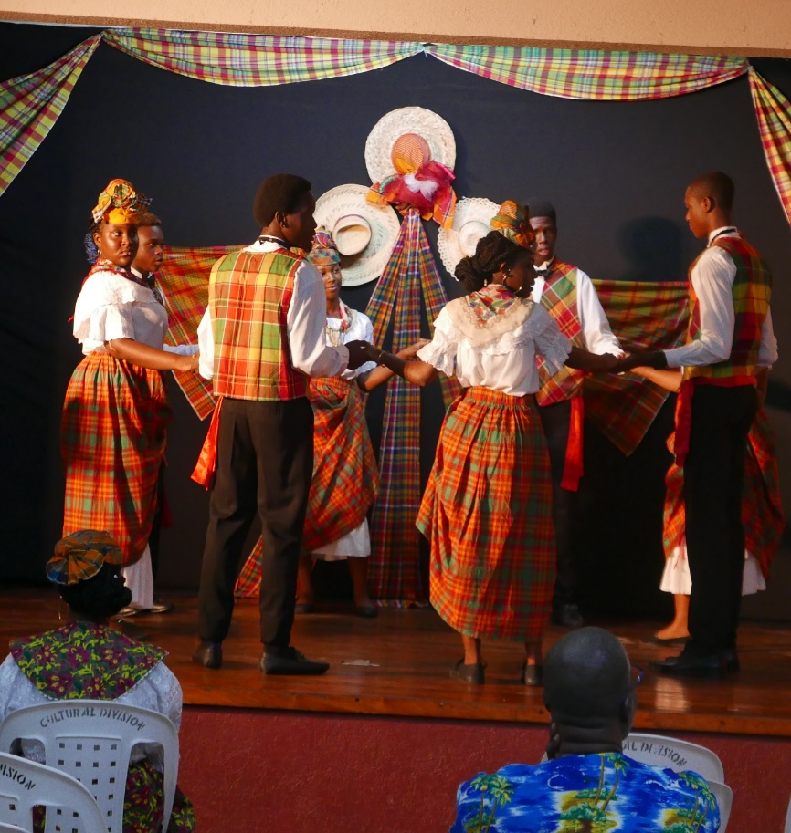
https://fr.slideshare.net/MarcLINTS/pp-dominica-2019-edited

https://slidetodoc.com/inscription-des-cultures-croles-au-patrimoine-culturel-immatriel/

Throughout 2019, artists and cultural professionals, as creators and mediators, were made aware of the promotion of the heritage of Creole cultures to their audiences.
At the end of 2019, the Group “Creoles cultures / Kiltir Kreol / Cultures Créoles"
has also been installed on the site
https://europa.eu/capacity4dev/creoles-cultures-kiltir-kreol-cultures-cr-oles
Capacity4dev is the European Commission’s knowledge sharing platform for development cooperation where you can share, learn and collaborate with over 25,000 members.

In early 2020, Marc LINTS led a mission to prepare activities related to the twinning of capitals, Praia for Cape Verde and Victoria for Seychelles, on the island of
Santiago. Beyond twinning, this mission also relates to cultural cooperation and international Creole cooperation, it provides concerts during the Kriol Jazz Festival and interventions at meetings of the Atlantic Music Expo.
The planned Seychellois delegation consists of David André, Mayor of Victoria, Lydia Charlie, Executive Director at the Town Hall, Patrick Victor, Honorary Cultural Ambassador of Seychelles and musicians from the Metis Group, and also Marc Lints. Initially organized for Easter 2020, it is reported in 2022 given the ongoing pandemic.

In 2020, Presentation at the VALER KREOL Workshop - VIV ANSANM
Propoze by Lenstiti Resers for Lalang ek Kiltir Kreol takes place on 28 Fevriye, Liniversite Sesel, 2020.
https://www.slideshare.net/MarcLINTS/pp-clcri-2020-en-230283668
Reports have been published on the Group sites :

Creoles cultures / Kiltir Kreol / Cultures créoles
https://www.linkedin.com/groups/8259466
https://europa.eu/capacity4dev/creoles-cultures-kiltir-kreol-cultures-cr-oles https://culturexchange.eu/group/25/stream
And the Initiative is invited to MASA 2020, to be presented and to share cultural cooperation projects between the Creole worlds of the Indian Ocean, the Atlantic and the Caribbean. (A vast program to which the African continent is intimately linked). MASA 2020, from March 7 to 14 in Abidjan (Côte d´Ivoire) http://www.fr.masa.ci/
https://www.slideshare.net/MarcLINTS/pp-masa-2020-fr-230301475

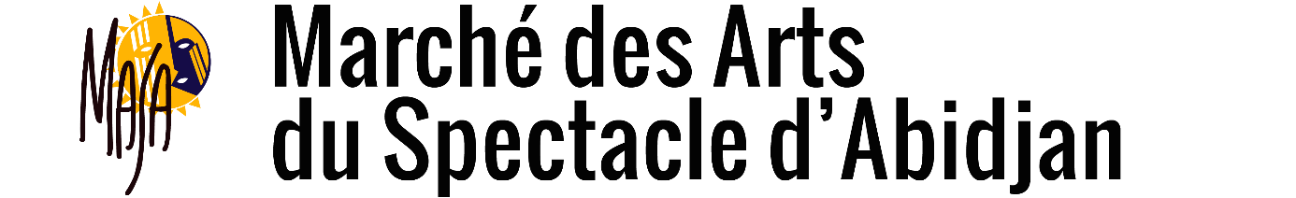

Following the creation of the site CultureXchange

- A knowledge and skills sharing platform and a match-making tool, supporting a vibrant professional community dedicated to culture and creative industries in the EU partner countries. This project is funded by the European Union and implemented with the support of the OACPS ( ORGANISATION OF AFRICAN, CARIBBEAN AND PACIFIC STATES )
Installation of the Group on:https://culturexchange.eu/group/25/stream

End of 2020 and spring 2021, preparations for the organization of the event "Les Rencontres creoles de" at EDD21 https://eudevdays.eu/ in Brussels.
This event in the heart of the European Union virtually brings together creators, artists, poets, literary artists, academics, gastronomes ... in short, active people, from "Creole" cultures concerned with sharing, transmissions and exchanges. It involves
A musical co-creation by artists bringing together For the Caribbean, Aurelio Martinez from Garifuna (Belize, Guatemala, Honduras, Nicaragua), Omar Sosa, Cuba, For the Indian Ocean, Gilbert Pounia from Reunion, Eric Triton from Mauritius, David André and Patrick Victor from Seychelles and for the Atlantic, Mario Lucio from Cape Verde,
A conference entitled ON CREOLIZATION
Gathering around Mario Lucio Sousa, the speakers
Carlos Vaz (Guiné Bissau), Camile Queiroz (Brazil), Erol Josué (Haiti), Jorge Rui Martins (Portugal), Percy Yip Tong (Mauritius), Frédérique Ménant (France), Elisa Lucinda (Brazil), Catarina Isabel Matins (Moçambique) -Portugal).
A workshop to reflect on human values
Reflections workshop prepared by Penda Choppy, at the start of the 'Creole values' workshop held at UniSey on February 28, 2020 and fed by proposals concerning 'European' values developed by Pietro De Matteis and 'Sufi' values by Faouzi Skali

April 2021, the Organization of African, Caribbean and Pacific States (OACPS), approached as co-organizer with BOZAR, informs us that: “the Secretariat of the OACPS cannot yet decide on the participation of the Program. ACP-EU Culture at EDD21, post posing then ‘The Creole Meetings of Brussels’ in the year 2022.
May 2021, the health situation having improved in Portugal, the organizers of "IMATERIAL" announce a first "limited" version of the festival to EVORA to which Marc Lints is invited to participate in the conference program for the
Presentation of the Initiative Inscription of Creole Cultures in the Intangible Cultural Heritage of UNESCO
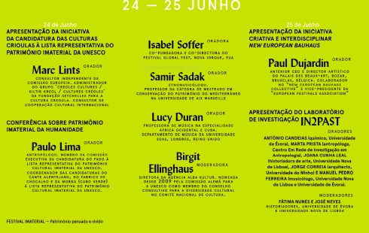
Marc Lints a presenta a Iniciativa de Candidatura das Culturas Crioulas no Património Cultural Imaterial da UNESCO, falando-nos dos vários projectos em curso de cooperação cultural entre os povos crioulos do Oceano Índico, do Atlântico e das Caraíbas. A iniciativa respeita a uma proposta dirigida a estas comunidades crioulas, no sentido de inscrever os seus legados nas listas oficiais do Património Imaterial, apelando, em paralelo, à preservação de práticas artísticas concretas e à sensibilização de artistas e instituições para a promoção das suas culturas.
MARC LINTS Consultor independente da Comissão Europeia; Administrador do grupo Creoles cultures / Kiltir Kreiol / Cultures créoles da Fundação Seychelles para a Cultura Crioula
https://www.slideshare.net/MarcLINTS/pp-evora-2021-en10193-249953229
On this occasion, I communicated :
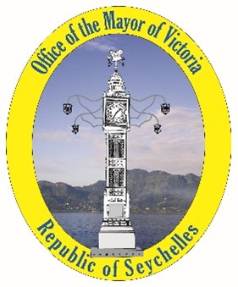
As Mayor of Victoria, Capital of Seychelles, responsible for the creation of the "National Institute for Culture, Heritage and the Arts of Seychelles",
I organize, surrounded by my collaborators,
The "Creole Encounters"
At Victoria
November 1-2, 2021
This event in the capital of the Seychelles will bring together creators, artists, poets, literaries, academics, gastronomes ... in short, active people, from "Creole" cultures concerned with sharing, transmissions and exchanges.
It will take place after the 36th Seychelles Kreol Festival, in which the guests of the Meetings will participate. Indeed, they will be invited to share the Seychellois Creole life by staying "with the locals" in the "districts" according to artistic affinities. They will participate in cultural activities organized by the inhabitants in their "territories", before reaching the capital at the end of the week.
It involves
A musical co-creation
A festival of audiovisual creations
A workshop to reflect on human values
A workshop to reflect on the place of women, children and minorities in Creole life
A conference entitled Falando de crioulização
An exhibition "Musical Heritage of the Indian Ocean"
(S) David André
And on September 30, the press release is issued :
Following the evolution of the world health situation and its consequences on the economy of Seychelles, David André, Mayor of Victoria, in charge by President Wavel Ramkalawan, of Culture at the Government of Seychelles and as such initiator of the Creole Meetings de Victoria, asked me to inform you that this event is postponed until the end of October 2022. In the meantime, the Seychelles team continues the preparation and remains open to any participation.
In parallel, the participation of Seychelles in the 2nd edition of the Luanda Biennale, in Angola, is envisaged from July 2021 and unfortunately, given the degradation of the sanitary conditions in this part of Africa, Seychelles decided to participate only in a virtual way, via a "National Pavilion" https://www.unesco.org/biennaleluanda/2021/fr/pavilions
The conference proposal was articulated in three parts:
1. Presentation of the initiative to inscribe Creole Cultures on the UNESCO Intangible Cultural Heritage List, as presented in Seychelles (2019), Dominica (2019) and Portugal (2021), by Marc LINTS.
2. Presentation of the Concept of the "National Institute for Culture, Heritage and Arts of Seychelles", by David André.
3. Presentation of the Manifesto FALANDO DE crioulização, by Mario Lucio Sousa.
It thus responded to theme 1 of the Biennale:
The contribution of arts, culture and heritage to peace and is part of the common approach of the Creole States, the majority of which are members of the OACPS, to the recognition of their cultures by UNESCO, as theorised in the document "Kreolitude": Kreolitude is resolutely turned towards the future in order to contribute through its experience to the construction of a better world. The aim is therefore to identify the values that have enabled people from the four corners of the world, the Creole peoples, to establish a society of peace, respectful of its cultural differences, harmoniously mixed, even if imperfect because it is becoming daily.
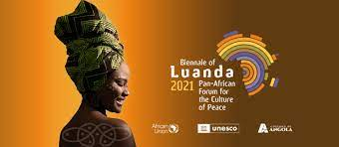

On 28 October EUROPEANA publishes Creole culture movement: Kreolitude, a version illustrated with documents from its collection. : https://www.europeana.eu/fr/blog/creole-culture-movement-kreolitude?fbclid=IwAR14rwN3jMdfbxlPfy-a5Befl_uSajP4SL3yHEyYD8Va_2SvUhT0jGlwHFwFollows the "expanded" version on YouScribe : https://www.youscribe.com/catalogue/documents/actualite-et-debat-de-societe/actualite-evenements/mouvement-cultures-creoles-3252267?ni=1
November 2021, the IOMMa in Reunion Island, invites a delegation from Seychelles to participate in its work:
Mr David André, Secretary General - National Institute for Culture, Heritage and the Arts
Mrs Miera Savy, International Cooperation Advisor - National Institute for Culture
Mr Marc Lints, Consultant
And on 3 December, we received this bad news:
Dear Seychellois delegation,
Due to the new health restrictions imposed on us, it is impossible to receive travellers from Mauritius and South Africa. All travellers from the Indian Ocean are now subject to a 10 day isolation on arrival in Reunion, we are unable to bring you to us. It is a great sadness and heartbreak for us not to be able to welcome you (and all the delegations from the Indian Ocean) to this 2021 edition of the IOMMa. We thank you for your support and will come back to you later to define together the axes of cooperation.
December Moutya was added to UNESCO's list of intangible heritage on December 15th and the Secretary General of the Seychelles Institute of Culture, Heritage and the Arts, David Andre, said :
"For our traditional dance, it shows how valuable our heritage is, but now we must work hard to ensure that our Moutya gets the place it deserves, especially among the youth, so that it can continue to be enjoyed for generations to come," said Andre.
In his statement to mark the occasion, the Seychelles' President Wavel Ramkalawan said that December 15th will be marked as an important date in the history of the island nation.
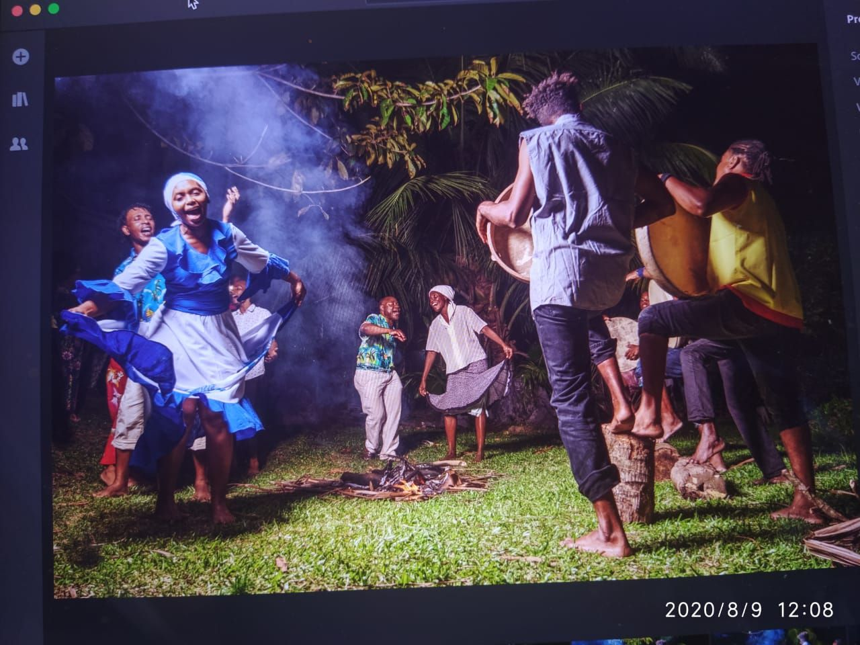
https://www.youtube.com/watch?v=o26q5td5q8E

2022
Cape Verde, January 21, at the Presidency
The President of the Republic will be godfather and spokesperson for the worldwide movement of the candidacy of Creolization and Creole cultures to World Heritage. The invitation made today (21) by the Movement's Coordinator was promptly accepted by José Maria Neves, who intends to hold a World Summit of Creole countries, nations and regions in Cape Verde.
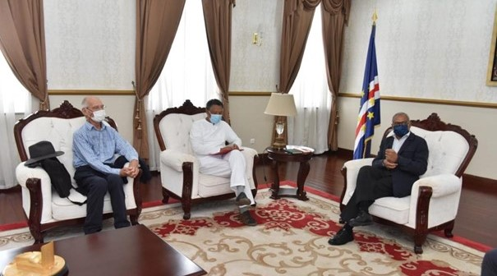

O Presidente da República vai ser padrinho e porta voz do movimento mundial da candidatura da crioulização e das culturas crioulas a património Mundial. O convite feito hoje (21) pelo Coordenador do Movimento foi prontamente aceite por José Maria Neves, que pretende realizar em Cabo Verde, uma Cimeira Mundial dos países, nações e regiões crioulas. https://www.tcv.cv/noticia/noticia-details?id=9043
We are invited to IOMMA 22 in La Réunion from May 29 to June 5, 2022
David ANDRE, Secretary General of the Seychelles National Institute for Culture, Heritage and the Arts and Mayor of Victoria
Patrick VICTOR, Cultural Ambassador
Marc LINTS, Consultant in the Office of the Secretary General
David André will speak on June 2 during the session
Conférence / Conference Pays de l’Océan Indien, situation et perspectives / Indian Ocean countries, status and perspectives 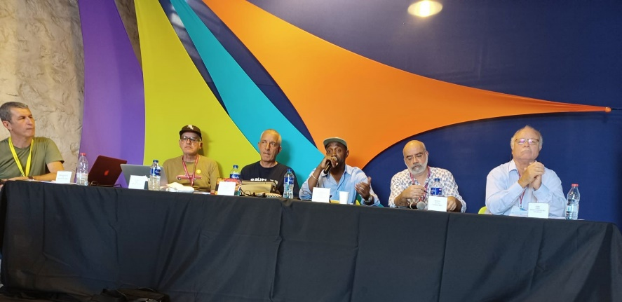

PR reclama papel ativo de Cabo Verde na realização da Cimeira do Futuro da UN 21/09/2022 https://presidencia.cv/arquivo/7479
O Chefe de Estado de Cabo Verde, Dr. José Maria Pereira Neves, ao intervir na 77ª Sessão da Assembleia Geral das Nações Unidas, começou por saudar a realização da Cimeira do Futuro, promovida pela ONU e a realizar-se em 2023, com vista a um novo consenso global sobre o destino do Planeta, assim como o papel ativo de Cabo Verde na realização de tal certame.
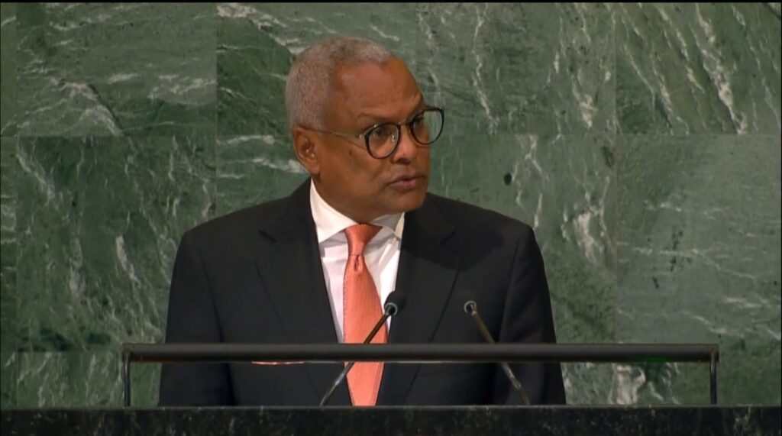

Igualmente, reafirmou a pertença do País enquanto Pequeno Estado Insular em Desenvolvimento, mas com ambição em tornar-se, a breve trecho, num Pequeno Estado Insular Desenvolvido.
Assumiu-se como um dos porta-vozes do Continente Africano, sublinhando a necessidade da preservação do Património Natural e Cultural da África e da promoção da justiça climática e da equidade no Continente. Reiterou a importância do movimento mundial de candidatura da crioulização e das culturas crioulas a Património Universal, de que é Padrinho, fazendo jus ao facto de ser o Chefe de Estado da Nação crioula mais ancestral do mundo.
The Head of State of Cape Verde, Dr. José Maria Pereira Neves, speaking at the 77th Session of the United Nations General Assembly, began by welcoming the Future Summit, promoted by the UN and to be held in 2023, with a view to a new global consensus on the fate of the planet, as well as Cape Verde's active role in holding the event.
He also reaffirmed the country's status as a Small Island Developing State, but with the ambition of becoming a Small Island Developing State in the near future.
He assumed himself as one of the spokespersons for the African Continent, stressing the need to preserve Africa's Natural and Cultural Heritage and to promote climate justice and equity on the Continent. He reiterated the importance of the world movement for the candidacy of Creolization and Creole cultures as Universal Heritage, of which he is Godfather, doing justice to the fact that he is the Head of State of the most ancestral Creole Nation in the world.

https://www.youtube.com/watch?v=SirZVXPSUhs&ab_channel=FestivalIMATERIAL

Imaterial est avec AGENDA CULTURAL ' ÉVORA et Évora 2027, Cidade Candidata CEC à Évora.
No dia 3 de Outubro, Mário Lúcio de Sousa apresenta o MANIFESTO A CRIOULIZAÇÃO, UMA POÉTICA DE PARTILHA PARA MULTIPLICAR no Ciclo de Conferências do Festival Imaterial. O músico, escritor e pensador essencial da cultura cabo-verdiana, defende que as evidências antropológicas apontam que todos os povos e todos os indivíduos são crioulos.
O Imaterial é um projeto com organização da Câmara Municipal de Évora/DCP, cidade candidata a Capital Europeia da Cultura em 2027, em parceria com a Fundação Inatel e direção artística de Carlos Seixas

On October 3, Mário Lúcio de Sousa presents MANIFESTO A CRIOULIZATION, UMA POÉTICA DE PARTILHA PARA MULTIPLICAR (THE POETIC OF SHARING TO MULTIPLY) at the Imaterial Festival Conference Cycle. The musician, writer and essential thinker of Cape Verdean culture, argues that anthropological evidence points out that all peoples and all individuals are Creole.
Imaterial is a project organized by the Municipality of Évora/DCP, candidate city for European Capital of Culture in 2027, in partnership with Inatel Foundation and artistic direction by Carlos Seixas

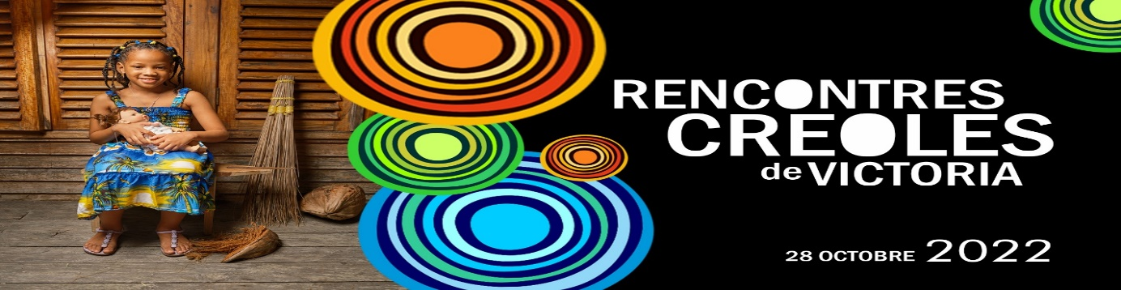
The Victoria Creole Encounters were initiated as an extension of the recognition of 'Victoria as the Capital of the Creole World' as an opportune moment to examine the persistent traumas and identity conflicts of the Creole world today and to recognise and celebrate its positive aspects.
This event in the capital of the Seychelles intends to bring together creators, decision-makers, artists: poets - literary - musicians, academics, gastronomes... simply active people, passionate about 'Creole' cultures and above all concerned with sharing, transmission and exchange. It will take place on 28 October 2022, International Creole Day, during the Seychelles Kreol Festival, a festive, cultural and academic moment dedicated to the sharing and transmission of Creole traditions and values.
These Meetings are organised within the framework of a project for the inscription of Creole Cultures in the Intangible Cultural Heritage of UNESCO. This project is sponsored by the President of the Republic of Cape Verde, His Excellency Mr José Maria Neves, who has announced his intention to organise a world summit of Creole countries, nations and regions in Cape Verde in 2024.
PROGRAMME
MORNING
09.00 Official speech by Mr David ANDRE, Secretary General of the National Institute for Culture, Heritage and the Arts
General presentation on Creole values by Mrs Christine PEJAKOVIC, Researcher and PhD student at UNISEY
Interventions
1. Literary explanation of the song 'Lasezon Kreol in refleri' by Mr Joseph SAMY, Musician - author - composer and journalist, Chevalier de l'Ordre des Arts et des Lettres
2. Space of identity in Guadeloupe by Mr Felix LUREL, Academic and President of the Council of Culture, Education and Environment of the Guadeloupe Region
3. Solidarity between Creole women in the Indian Ocean by Mrs Lourdes BOZELLE, Member of the association Femmes Entrepreneur Rodrigues Région Est
4. The ontological and epistemic tolerance of a Creole religion: Haitian voodoo by Professor Dr Obrillant DAMUS, socio-anthropologist, linguist, pedagogue and President of the League for Research on Indigenous Education - Haiti
5. Creole Values by Prisheela MOTTEE, President of the Raise Brave Girls - Mauritius
6. The Creole Garden by Mrs. Penda CHOPPY, Researcher and Director of Studies and Research on Language and Culture - UNISEY
7. Creole values in the Seychelles society by Mrs Jenita LAPORTE, Member of the Fondasyon Kiltirel Seselwa
8. The importance of transmission in culture by Mr Michel SAVY, Poet and Member of the Leritaz Takamaka Association
9. Creole values, shared human values by Mr Ansley CONSTANCE, Pedagogue passionate about the preservation and promotion of the Creole culture of La Digue
AFTERNOON - THEME "CREOLISATION
13.30 Official speech by Mrs. Patricia PROFIL, Regional Councillor in charge of regional cooperation in sports and culture - Reunion Island
General presentation on Creolisation by Mr Rudy ALBINA, Academic and territorial civil servant from Guadeloupe
Interventions
1. Bilingual Creole-French literacy as an educational success for Creole-speaking children by Mrs Laurence DALEAU-GAUVIN, Agrégée in Creole language, Doctor in linguistics, researcher associated with the Research Laboratory on Creole and Francophone Spaces - University of Reunion
2. The introduction of the Creole language in the Rodrigues School and the design of a Creole dictionary by Mr Augustin John WINSLEY, Creole teacher in Rodrigues
3. Linguistic planning in official bodies: the legitimacy of the Creole language by Mrs Flora BEN DAVID, Executive Director of the Creole Academy of Seychelles
4. Guadeloupe the 7 rhythms of Gwo Ka by Mr Jimmy BASSIEN, Founder of the Lakou Veranda Music School
5. Oral traditions in the Seychelles by Mrs Berthilda WALTER, Director of Intangible Heritage at the Seychelles National Institute for Culture, Heritage and the Arts
6. The place of Creole poetry in Seychellois society by Ms Graciana MARIE, a young French teacher in Seychelles
7. Haute-taille: an example of cultural creolisation in Martinique by Mr David KHATILE, Director of a cultural centre and member of an artists' collective - Martinique
8. Moutya as a vehicle of transmission and transformation by Mr Shamad JAPHA, a young French teacher in the Seychelles
9. Big Drum Nation" by Mr Marcus Trevor MCINTOSH, nephew of WINSTON FLEARY - activist of the Creole culture who made the recognition of the Creole memory and culture called "Big Drum Nation" in the island of Carriacou in GRENADES
10. Moutya, a documentary by the HERITAGE SECTION of the Seychelles National Institute for Culture, Heritage and the Arts
https://www.facebook.com/watch/?v=458566066377789&extid=NS-UNK-UNK-UNK-AN_GK0T-GK1C&ref=sharing
https://www.nation.sc/articles/15616/-rencontres-croles-de-victoria-

