## ANNEX A.1: DAS 2020-2021 errors analysis

The Declaration of Assurance (DAS) is an annual exercise conducted by the European Court of Auditors (ECA) and aims to give an opinion on the legality and regularity of the accounts. The ECA extracts its sample from the payments and clearings made during the current year. In 2021, 140 transactions were selected for the EDF and 14 for the General Budget. More information on the DAS exercise procedure and timing can be retrieved from the INTPA intranet [DAS Audits (europa.eu)](https://myintracomm.ec.europa.eu/dg/INTPA/audit-and-control/european-court-of-auditors/Pages/das-audits.aspx)

The DAS errors by type of error and Risk Control System (RCS) for the years 2020 and 2021 are presented in table 1 below.

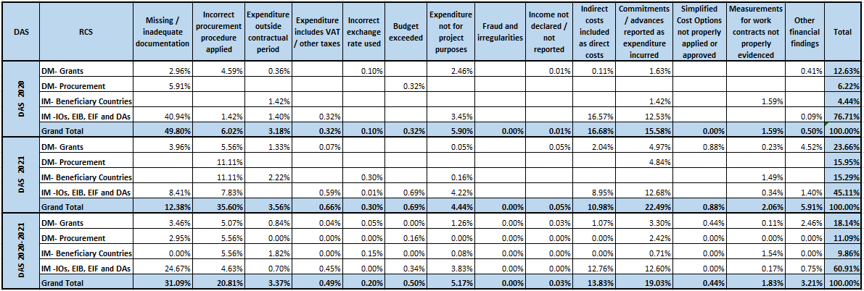

Table 1: DAS errors by error type and RCS

As presented in figure 1, the most common error is due to missing or inadequate documentation provided and constitutes 31.09% of the total error rate. The errors identified based on public procurement and award decision errors follow with a 20.81% error rate. More specifically, these errors are based on public procurement procedures that were not properly applied, award decisions that were not sufficiently justified, and other procedural errors in general. The third most important type of error (19.03%) concerns commitments and advances reported as expenditures incurred. The indirect costs declared as direct, such as staff uplift, also represent a quite significant proportion of errors and amount to 13.83% of the total error. Lastly, the errors identified due to expenditures incurred not for project purposes and outside the contractual period may be less frequent but still significant, representing 5.17% and 3.37% of the total error rate, respectively.

Moreover, the analysis by RCS shows (figure 2) that the majority of all types of errors, with a 60.91% error rate, fall under indirect management with International Organizations. Far below with an 18.14% error rate follow the errors identified in grants managed under direct management, while errors observed in procurement procedures managed under direct management and indirect management with beneficiary countries follow with just 11.09% and 9.86%, respectively.

## ANNEX A.2: RER 2020-2021 errors analysis

The Residual Error Study (RER) is an important exercise which measures the effectiveness of our internal control system and a building block of the Director-General’s assurance. Unlike the DAS, the sample is extracted from contracts closed in the period September (t-1) to August (t), where (t) is the reporting year, and aims to detect errors that have escaped the control system. The RER is carried out by an external auditor. For the 2021 RER study, 353 transactions were selected. The RER methodology, manual and final reports can be retrieved from <https://myintracomm.ec.europa.eu/dg/INTPA/audit-and-control/residual-error-rate/Pages/index.aspx>.

The RER errors by type of error and Risk Control System (RCS) for the years 2020 and 2021 are presented in table 2 below.

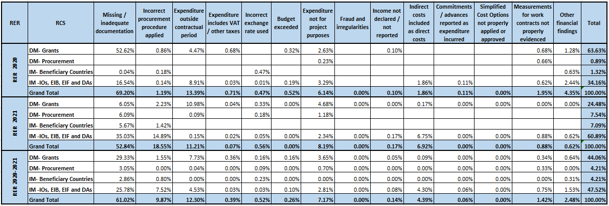

Table 2: RER errors by error type and RCS

As presented in figure 3, the most common error concerns missing or inadequate documentation provided and constitutes 61.02% of the total error rate. The errors identified based on expenses incurred outside the contractual period follow with a 12.30% error rate. The third greater type of error (9.87%) concerns public procurement and award decision errors. More specifically, these errors are based on public procurement procedures that were not properly applied, award decisions that were not sufficiently justified, and other procedural errors in general. The expenditures not for project purposes also constitute a quite significant proportion of errors and represent 7.17% of the total error. Lastly, the errors identified due to indirect costs declared as direct, such as staff uplift, may be less frequent but still significant, representing 4.39% of the total error rate.

Moreover, the analysis by RCS shows (figure 4) that the majority of all types of errors are identified both in indirect management with International Organizations and grants managed under direct management, with 47.52% and 44.06% error rates, respectively. Far below with a 4.21% error rate follow the errors observed in procurement procedures managed under direct management and indirect management with beneficiary countries.

## ANNEX A.3: DAS & RER errors analysis combined

The DAS and RER errors by type of error and Risk Control System (RCS) for the years 2020 and 2021 are presented in table 3 below.

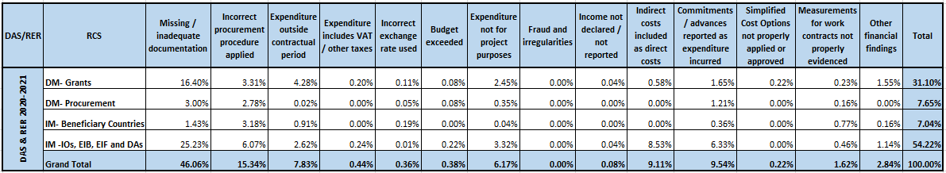

Table 3: DAS & RER errors by error type and RCS

As presented in figure 5, the most common error concerns missing or inadequate documentation provided and constitutes 46.06% of the total error rate. The errors identified based on public procurement and award decision errors follow with a 15.34% error rate. More specifically, these errors are based on public procurement procedures that were not properly applied, award decisions that were not sufficiently justified, and other procedural errors in general. The third greater type of error (9.54%) concerns commitments and advances reported as expenditures incurred. The indirect costs declared as direct, such as staff uplift, also constitute a quite significant proportion of errors and represent 9.11% of the total error. Lastly, the errors identified due to expenditures incurred outside the contractual period and not being part of project purposes may be less frequent but still significant, representing 7.83% and 6.17% of the total error rate, respectively.

Moreover, the analysis by RCS shows (figure 6) that the majority of all types of errors, with a 54.22% error rate, are found in indirect management with International Organizations. Far below with a 31.10% error rate follow the errors identified in grants managed under direct management, while errors observed in procurement procedures managed under direct management and indirect management with beneficiary countries follow with just 7.65% and 7.04%, respectively.

## ANNEX A.4: Frequent errors examples

Some representative examples of the most frequent errors are the following:

1. Missing/inadequate documentation:

* The hit cost item, "Documentary Crew Subsistence", amounting to EUR 12 032, was part of the incidental expenditure budgeted and charged to the project. The auditors received supporting documents for hotel and travel allowances justifying expenditure for an amount of EUR 7 041 and did not receive proofs of expenditure for the difference (12 032-7041), EUR 4991. The transaction was affected by a 41,48% quantifiable error.
* The hit cost item corresponded to the salary of an expert for an amount of EUR 7533. The contract was signed on 15/08/2019 and had a duration of 20 days. The auditors did not received essential supporting documents to prove the payment of the amount of EUR 7 533, e.g. copies of bank statements. In the absence of essential supporting documents and in line with the requirements of article 18.1 of the General Conditions the costs are considered ineligible. The cost item was affected by a 100% quantifiable error.
* In a transaction out of the 10 hit cost items, supporting documents were provided only for one, resulting in 9 quantifiable errors of 100% and an ineligible amount of EUR 204.361,64

1. Public procurement procedure not properly applied/ Procedural errors/ Award decision not sufficiently justified:

* The set of procurement procedure documents received by the auditors did not include the minutes specified in the beneficiary’s manual. These minutes should summarise the evaluation of the administrative and technical sections of the offers (including the technical evaluation of each member of the evaluation committee). The beneficiary did not comply with its own procurement manual. As a result it was not possible to verify that the procurement procedure has been carried out properly. Thus, the error was 100% quantifiable.
* The service contract to which the Hit payment related required a competitive procurement procedure under the beneficiary’s rules. The beneficiary proceeded with signing a contract directly without competitive procedure for practical reasons. Consequently, the direct procurement procedure was not carried as per beneficiary’s procurement rules. The related costs were not considered as eligible. The item is affected by 100% quantifiable error.
* A contract was awarded to a bidder without previously informing the other bidders and without respecting the standstill period between the notification of the award and the contract’s signature (PRAG art. 2.10.1). Moreover, one offer was disqualified with the reasoning that the financial offer was abnormally low (around 19% less than the provisional budget), while this offer should have been selected according to the “best value for money” criterion. Lastly, the awarding authority used the “conflict of interest” as an evaluation criterion to retract points from a tender’s technical offer instead of rejecting the offer according to paragraph 2.5.4.4 of the PRAG. This was 100% error.

1. Commitments or advances declared as expenditure incurred:

* The beneficiary of the audited transaction signed a contract with a Construction firm. An advance payment of 15% of the original contract price was paid. The audited expenditure of one hit item corresponded to this advance payment for construction works (EU share rounded to 85%) of EUR. The beneficiary did not provide essential supporting evidence to demonstrate that, at the time of the clearing, it had incurred expenses of the amount declared. The hit item was affected by a 100%.
* The hit item concerned a payment of 30% advance on Works contracts awarded for the construction of a hospital building. The advance was reported as costs of the reporting period. No proof of any expenditure actually incurred by the sub-contractor was provided. The hit item was affected by a 100%.
* The sampled cost item was included in the list of expenditure request submitted to the Commission. When requesting supporting documents the beneficiary replied that the budget for this cost item was not used - no expenditure incurred. In this transaction, 3 out of the 10 sampled items were relevant to budgeted amounts that did not incur. Each of the three items was affected by 100%.

1. Indirect costs declared as direct:

* An ICRU (Improved Cost Recovery Uplift) administrative cost for IT security in the local office was included as direct costs for an amount of 4.8% of a monthly salary. Since this cost does not concern an actual expenditure item but a system-generated posting known as “ICRU” (a percentage charge levied on salary costs of project personnel to cover costs of IT, security and office occupancy), it was incorrectly reported as a direct cost instead of an indirect one according to the General and Special Conditions of the Delegation Agreement. These costs were ineligible
* The beneficiary applied a standard cost methodology to its salary expenses including those for long-term contractual experts. The standard cost methodology was developed to ensure that departments have no financial incentive to discriminate in the selection of employees on the basis of nationality, family circumstance, and/or benefit entitlements. Standard cost consists of two components for long-term contractual experts; Component one is the actual salary of the expert. Component two is a benefit mark-up ratio that is calculated annually. The methodology behind the mark-up was explained in detail and documented. However, the actual documentation/financial statements proving these figures was not available. The mark up costs were ineligible.
* The selected cost hit represented in part staff costs, which were charged to the project as a percentage uplift applied to monthly salary costs. Major elements of these were: installation allowance payments, repatriation grant funding, after service medical cost funding, home leave and education travel cost payments. The uplift percentage was calculated to offset, during the year in course, payment of these entitlements to the staff and other such charges made during the year. The uplift amounts charged to the project do not correspond to the actual costs of the given staff member, but rather represent an estimate of average organization-wide payroll related costs. As such, at the individual level, these costs were not charged in the proportion actually incurred during the implementation period of the specific agreement. Moreover, they were not identifiable and substantiated by supporting documents and therefore do not comply with the definition of direct eligible costs. These costs were ineligible.

1. Expenses outside the contractual period:

* A training workshop took place from 13 to 18 January 2020, while the implementation period of the action according to its Special conditions was from 10/09/2014 to 09/01/2020. Therefore, the training workshop cost was considered ineligible since the expenditure had been incurred outside the action's implementation period.

1. Expenditure not for project purposes:

* A member of a beneficiary’s staff worked on two different projects during a 15 working days mission. 2 of the 15 days were spent working on the audited contract, and the other 13 days were spent on another assignment. The expenditure incurred during these 15 days has been correctly apportioned between these two separate tasks. However, an additional expenditure, which was incurred on various allowances, was charged entirely to the audited contract rather than being split between the two separate tasks. Therefore, the 13/15 of this amount was considered ineligible since it was referring to expenditure not for project purposes.

## ANNEX A.5: Recommendations to avoid frequent errors

Concrete steps towards the elimination of the most frequent errors identified should be taken. Below you can find a non-exhaustive list of some simple recommendations:

* All contractors and partners need to maintain supporting documents as described in the terms and conditions. Where possible, electronic copies should also be kept by the delegations and financial units.
* All procedures must be in line with the applicable rules. The criteria set should be clear and all the steps of the procedure should be properly documented and filed.
* The new checklists that came into force in June 2021 stipulate that the amount of clearing should include only costs incurred. If this distinction is not clear in the financial report, formal written confirmation from the contractor should be requested that the expenditure incurred does not include advances and/or commitments. Many instructions have been communicated on this subject including the latest Ares(2020)6546643 of 10/11/2020.
* Draw the attention of beneficiaries and external auditors to the contractual period and to the fact that only expenses relevant to each project should be reported.
* When filing in the checklists for payments and clearings, make sure that you have evidence/confirmation that the correct exchange rate is used, that no ineligible VAT is included etc.
* Directorate R is working on long-term solutions such as simplified cost options for eliminating the indirect costs declared as direct type of error.
* Quick follow up and launch of recoveries of the established errors (excluding extrapolated amounts) could help increasing awareness among partners.