Training material for Homestay/Lodge operators

The Homestay & small lodge operator curriculum and training material are one of the several skills building products developed by the EC funded High Impact Tourism Training for Jobs & Income programme (HITT) to support informal workers and potential workers from the tourism sector of Nepal to enhance their productivity and professionalism, and increase their employability and income opportunities.

We are pleased to share with you the training materials developed to train Homestay & small lodge operators. The training material for Homestay & small lodge operator consists of 8 elements:
- A Trainer’s Manual
- A Trainer’s Guide
- 3 Flip Files
- A CD detailing the content of the Trainer’s Kit
- 2 Learner’s hand-outs.

The content of the Homestay & small lodge operator material is described in details here below.

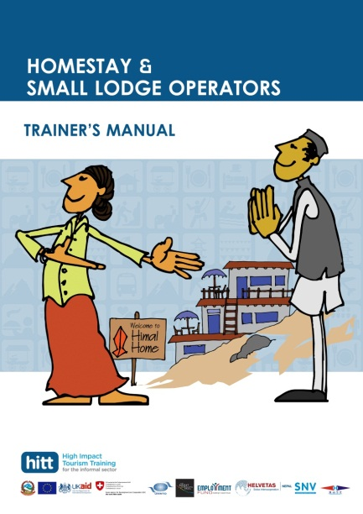 | Trainer’s Manual  The Trainer’s Manual is the central tool of the trainer, and provides all information required for the trainer to prepare his course. Its comprehensive index enables easy access to the different topics and activities during the training.  The manual contains:  - A description of the course (requirements, organisation, duration, detailed training programme, course objectives, assessment)  - All content to be taught during the course (separated into 3 modules)  - Detailed descriptions of teaching activities (including a description of resources required and reference to other tools, flip files, etc.)  - Quizzes to assess the knowledge of participants  A good knowledge of the Trainer’s Manual is essential to be able to deliver the training.  http://www.hitt-initiative.org/downloads/HITT-%20Trainer's%20Manual.pdf
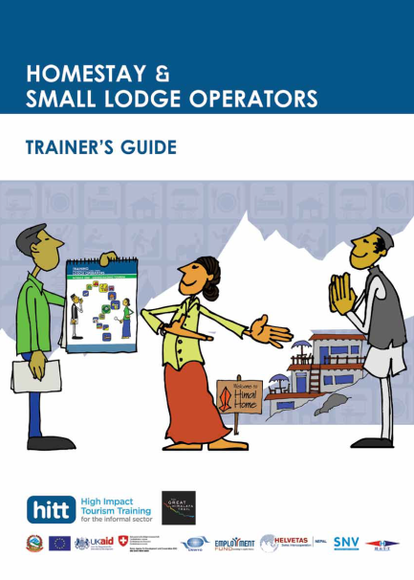 | Trainer’s Guide  The Trainer’s Guide is a simplified version of the Trainer’s Manual. It is a guide to be used during the training, and essentially contains a description of activities. It also contains the titles of all topics to be taught in order to guide the trainer during the course.  http://www.hitt-initiative.org/downloads/HITT-Trainer's%20Guide.pdf
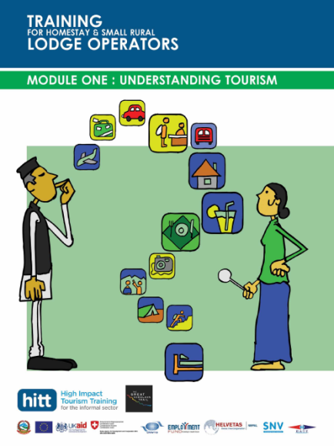 | Flip File: Module 1 – Understanding Tourism  The flip file Module 1 is an interactive teaching tool to be used to deliver the first module of the training course. On the front, it contains illustrations in A2 format to be used for specific activities mentioned in the Trainers’ Guide (and Trainer’s Manual). On the back, it contains prompts and reminders of activities and content to be taught, as well as teaching tips to help the trainer during the course.  http://www.hitt-initiative.org/downloads/HITT-Flip-File-module1.pdf
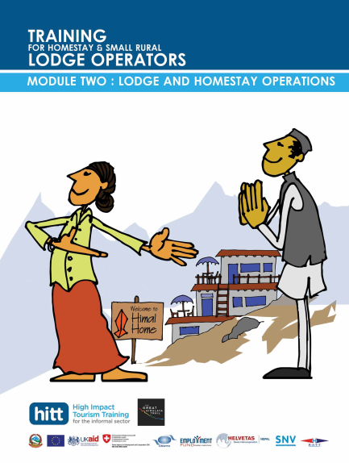 | Flip File: Module 2 – Lodge and Homestay Operations  The flip file Module 2 is an interactive teaching tool to be used to deliver the second module of the training course. On the front, it contains illustrations in A2 format to be used for specific activities mentioned in the Trainers’ Guide (and Trainer’s Manual). On the back, it contains prompts and reminders of activities and content to be taught, as well as teaching tips to help the trainer during the course.  This tool is to be used with the Learner’s handbook on Housekeeping tips, to which it frequently refers.  http://www.hitt-initiative.org/downloads/HITT-Flip-File-module2.pdf
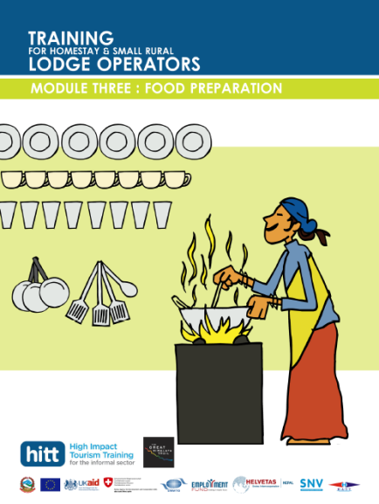 | Flip File: Module 3 – Food Preparation  The flip file Module 3 is a teaching tool to be used to deliver the third module of the training course. On the front, it contains illustrations in A2 format to be used for specific activities mentioned in the Trainers’ Guide (and Trainer’s Manual). On the back, it contains prompts and reminders of activities and content to be taught, as well as teaching tips to help the trainer during the course.  This tool is to be used with the Learner’s handbook Cooking for Happy Guest, to which it frequently refers.  http://www.hitt-initiative.org/downloads/HITT-Flip-File-module3.pdf
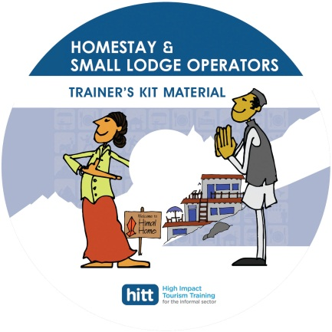 | The CD: Trainer’s Kit Material  The CD lists all resources required to teach the course, classified per activity number. It contains hand-outs and images to be printed for the course, and picture of objects that the trainer will need in order to be able to deliver the course.  The CD is to be used by the trainer to make his own training kit.  If you want the resources in this CD, please contact HITT Nepal.
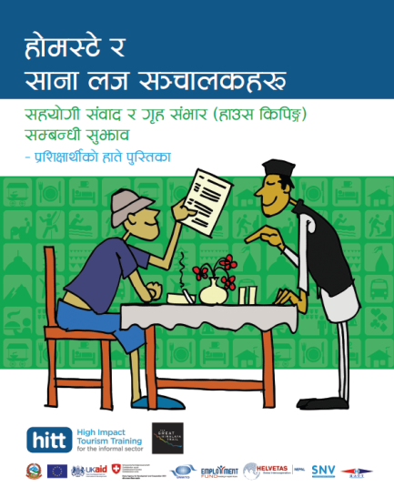 | Friendly Conversation and Housekeeping Tips – A Handbook for Learners  This handbook is to be distributed to learners during the training and kept as a reference after the training. It contains essential information to be taught during the training, and to which the learner can refer to while working in a lodge or homestay. It is made in a friendly format and durable material, and can be used as a communication tool by lodge/homestay operators as well as by guests.  Note: handbooks are also available in English.  http://www.hitt-initiative.org/downloads/HITT%20Friendly-Conversation&Housekeeping-Tip
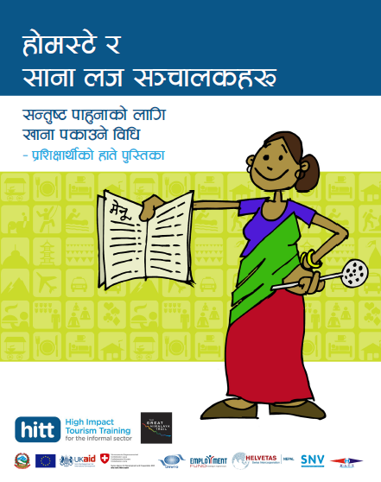 | Cooking for Happy Guests – A Handbook for Learners  This handbook is to be distributed to learners during the training and kept as a reference after the training. It contains essential information to be taught during the training and cooking recipes to which the learner can refer to while working in a lodge or homestay. It is made in a friendly format and durable material and is spirally bound in order to be easily used during cooking.  Note: handbooks are also available in English.  Download Nepali version

