Country-led environmental and climate change mainstreaming (specialist course)

Handout for participants

---

MODULE 10
Synthesis – Mainstreaming framework and tools

MODULE 10 – Synthesis

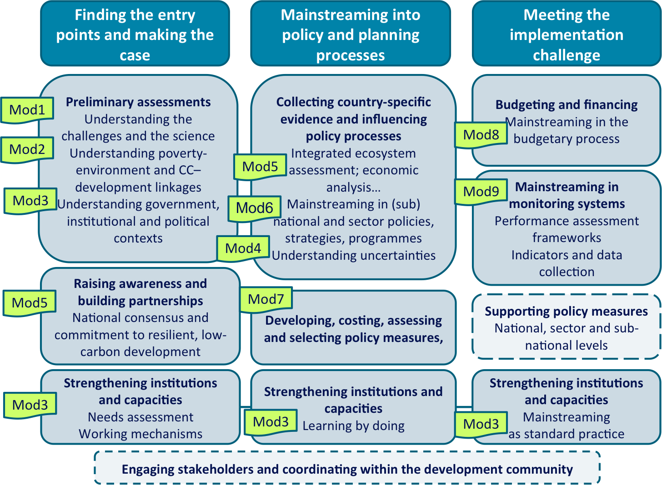
Adapted from: UNDP-UNEP (2009) Mainstreaming Poverty-Environment Linkages into Development Planning:
A Handbook for Practitioners. Figure 3.1, p. 15.

Module title | Key tools
Module 1 – Understanding the basics: environmental challenges and climate change science | No specific ‘tool’ – See materials provided in handout
Module 2 – Understanding environment-climate change-development linkages | * Millennium Ecosystem Assessment (2005) ‘Conceptual framework of interactions between ecosystem services, human well-being and poverty reduction, and drivers of change’
Module 3 – Mainstreaming and strengthening institutions and capacities | * Mainstreaming framework  * National capacity self-assessment (NCSA)  * Stakeholder analysis  * Setting up of working mechanisms  * Complementary activities supporting learning-by-doing:  - Formal training  - Exchange visits  - On-the-job learning  - Lesson learning and dissemination
Module 4 – Understanding and planning under uncertainty | * Adaptive management  * Scenario-based planning
Module 5 – Raising awareness and building partnerships | * Integrated ecosystems assessment  * Vulnerability and adaptation assessment  * Macro and meso economic analysis  * Demonstration or pilot projects  * Communication and advocacy strategy
Module 6 – Mainstreaming in national, sector and sub-national policies, strategies and programmes | * Strategic Environmental Assessment screening  * EuropeAid’s Climate change sector scripts  * Climate risk screening  * Climate risk assessment  * Strategic environmental assessment (SEA) (including lighter forms of such assessments)  * Also (see Module 5):  - Integrated ecosystems assessment  - Vulnerability and adaptation assessment  - Macro and meso economic analysis  - Demonstration or pilot projects  - Communication and advocacy strategy
Module 7 – Costing, assessing and selecting options and measures | * Cost-benefit analysis (CBA)  * Cost-effectiveness analysis (CEA)  * Multi-criteria analysis (MCA)
Module 8 – Mainstreaming in the budgetary process | * Public expenditure review (PER)  * Public environmental expenditure review (PEER)  * Climate Public Expenditure and Institutional Review (CPEIR)  * Also (see Modules 6 and 7):  - SEA screening (as a pre-requisite for the financing of measures by the capital expenditure budget)  - Climate risk screening (as a pre-requisite for the financing of measures by the capital expenditure budget)  - Cost-benefit and cost-effectiveness analysis (supporting the costing of measures to be budgeted)  - Multi-criteria analysis (for prioritising measures to be budgeted)
Module 9 – Mainstreaming in monitoring systems | * Performance assessment framework (PAF) – Milestones, indicators and targets (to be integrated into the wider development monitoring system)

