location, date

**Title**

***Chapeau with key information (2-4 sentences)***

Main text with quotes.

**General information on the event** could be found at:

**For more information please contact:** Name, title&organisation, e-mail. , tel. .: +38 (..) …

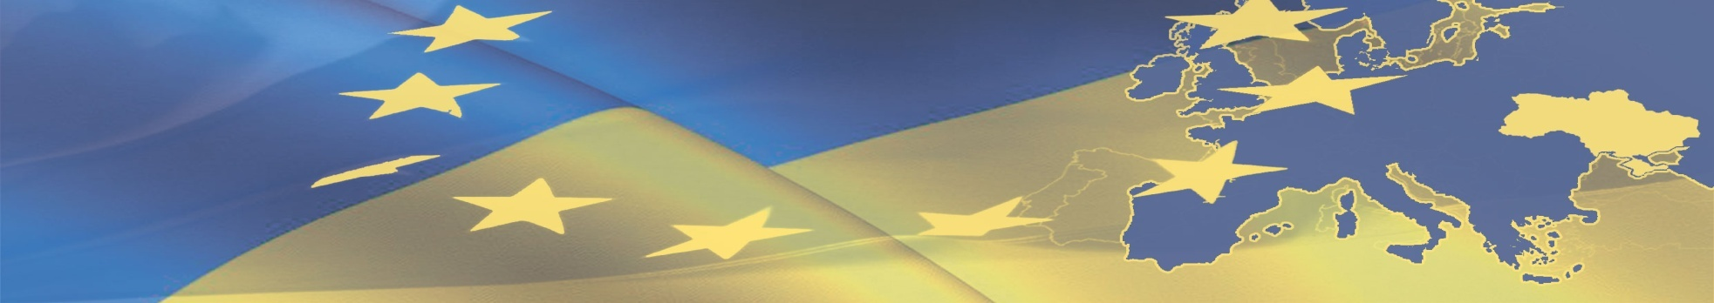

**PRESS RELEASE**

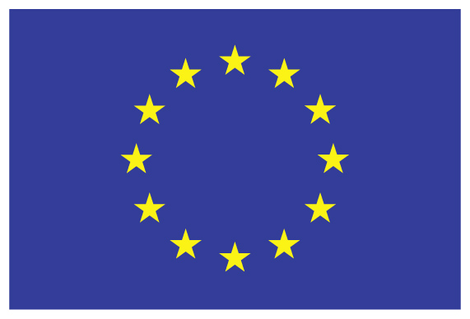

The European Union is made up of 28 countries and the people of those countries. It is a unique political and economic partnership founded on the values of respect for human dignity, freedom, equality, the rule of law and human rights. Over more than fifty years we have created a zone of peace, democracy, stability and prosperity on our continent while maintaining cultural diversity, tolerance and individual freedoms. The EU looks to share its values and achievements with neighbouring countries and peoples and those farther afield.

**Delegation of the European Union to Ukraine**

Address:

101 Volodymyrska Street

01033 Kyiv, Ukraine

Tel: +38 044 39 08 010

Fax: +38 044 39 08 015

A project implemented

By the Contractor

Address:

Tel:

Fax: