
…at the…
Inter-Agency Workshop
on Strengthening Cooperation in
Fragile and Conflict-Affected Countries

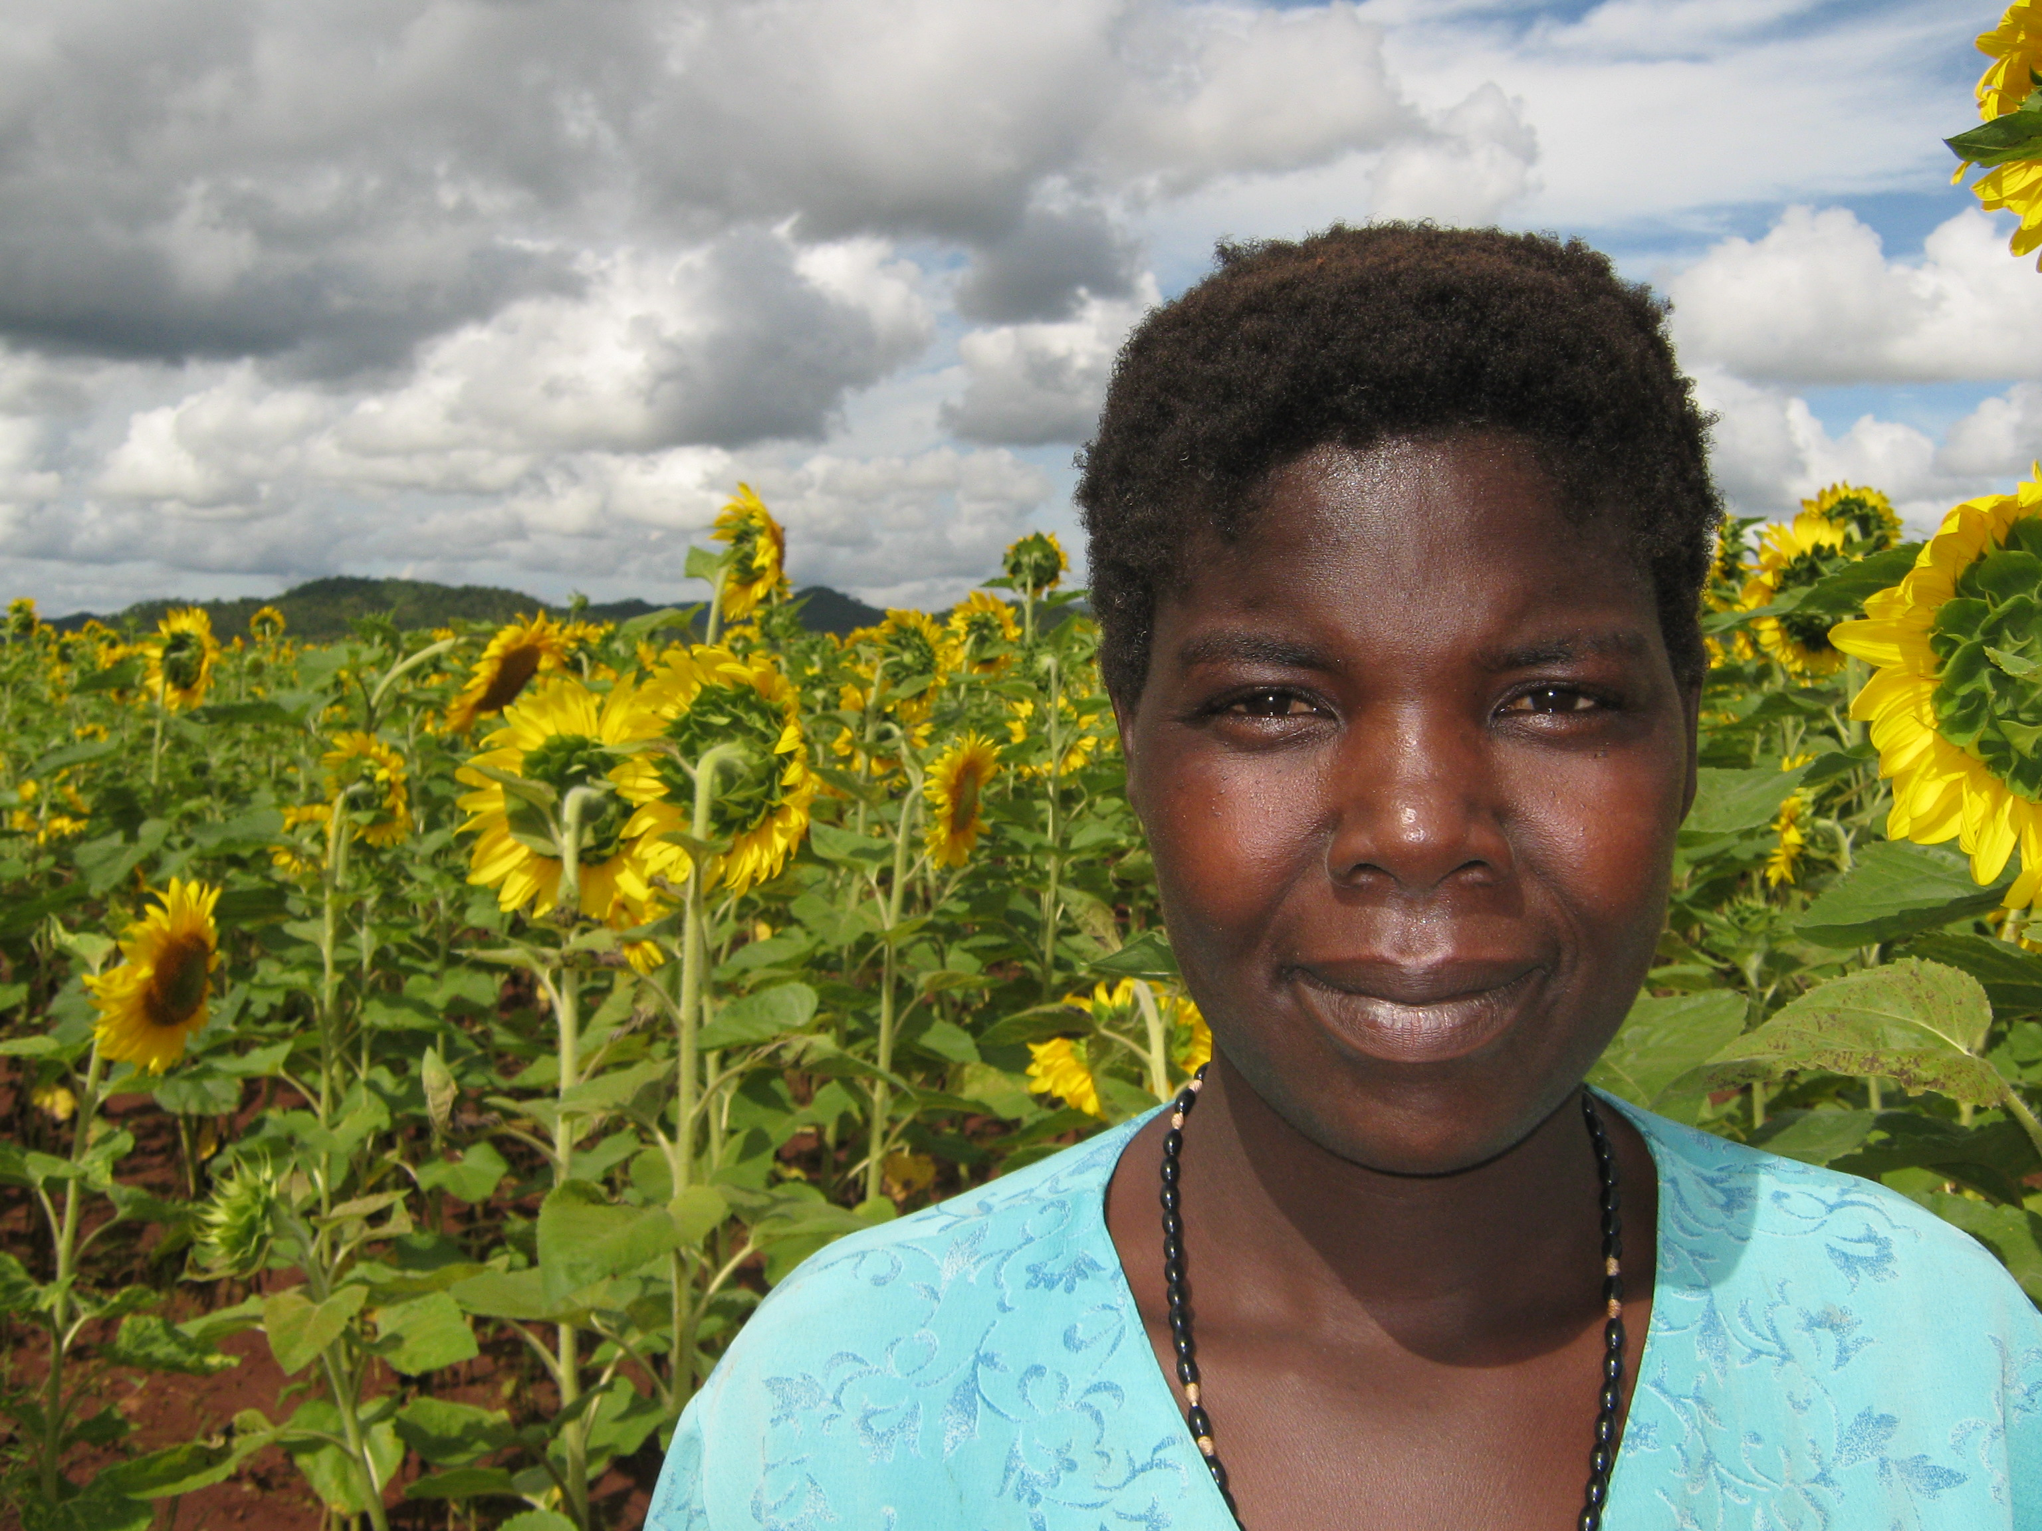

> Core Course on Fragility, Security and Development <
SEPTEMBER 9 -13, 2013
Hoover Francqui Conference Room, Level -1
Boulevard du Régent 40, 1000 Brussels, Belgium


