

Global Forum Summary

Using Country Systems to Manage Climate Change Finance

A Global Forum Facilitated by
the Partnership for Action on
Climate Change Finance and
Effective Development Co-operation

2-3 December 2013
Incheon, Republic of Korea

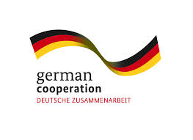
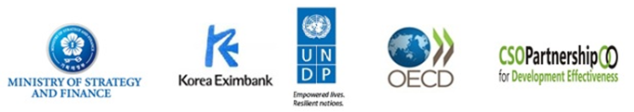


Organised by: With financial support by:

Summary
Over 150 participants, from 24 countries, from Ministries of Finance, Planning and Environment from Africa, Asia Pacific, Latin America and the Middle East met in Incheon, Korea on 2nd & 3rd December 2013 with development partners, civil society and representatives from the UNFCC and Green Climate Fund for the Global Forum on Using Country Systems to Manage Climate Change Finance. The Forum was co-organized by the UNDP and Government of Korea, OECD and the Civil Society Partnership for Development Effectiveness (CPDE), and co-financed by the governments of Korea, Sweden, Germany and the EU’s Global Climate Change Alliance.
Country systems were defined broadly to include national and local systems for planning, policy coordination and implementation, budgeting and financial management, procurement and monitoring and evaluation. Climate finance was defined based on a country-led definition of climate expenditures both from domestic and international sources, and both public and private sources. The benefits of using country systems to guide and manage climate finance were greater ownership, reduced duplication, domestic transparency and accountability, and greater opportunity for transformational change and mainstreaming to achieved desired development goals. The challenges for use of country systems included political, institutional and fiduciary issues.
The Global Forum reviewed country experiences with the use of country systems to manage climate finance, including opportunities, innovations and challenges and concluded that:
- Strong political leadership at the national level and country ownership at the highest possible level is important.
- Aligning climate change strategy formulation with national development plans and results can help in developing more comprehensive climate responses.
- Prioritisation of climate change programmes and investments continues to be a challenge for many countries.
- The ability to clearly track climate spend through the budget and other extra-budgetary systems (e.g., funds, projects) is important.
- Public climate finance is being disbursed through a growing number of modalities including programmatic support which is often a modality preferred by partner governments
- There is urgent need for capacity building support for new institutional frameworks and public financial management to attract, guide, and manage climate finance.
- There is need to strengthen the mechanisms for measuring the impact and results of climate policy and finance, particularly for the most vulnerable countries and segments of the population.
- The role of local government in channelling climate finance is key, but is not receiving enough attention.
- More effective use of climate finance requires strengthening engagement with a broad range of stakeholders, and providing transparency and accountability mechanisms.
- Understanding the political economy in each country is important for identifying the incentives of various stakeholders and unlocking effective action.
- Harnessing private investment through fiscal and other government policy is key to achieving transformation.
- Country-led regional dialogues on the use of country systems for climate finance are a valuable mechanism that supports South-South-North exchange and peer review and mutual learning. .
The Global Forum shared with the Green Climate Fund (GCF) Executive Director the need for the GCF business model to:
- Recognize and build upon existing country systems to manage finance, including the role of the ministries of finance in managing the budget process.
- Provide formal support to develop and strengthen country readiness to absorb climate finance through country systems, including support for co-ordination and public financial management.
- Promote a programmatic approach covering both adaptation and mitigation.
- Ensure transparency and accountability of its own operations.
- Create an enabling environment for the private sector, including through changes in government policies and incentives.

The GCF Director encouraged countries to view the GCF as a fund that could drive transformational change through the provision of additional catalytic finance. She supported the whole-of-government or multi-sectoral approaches currently being piloted by many countries. She stressed that countries needed to be strategic in their choice of institutions for National Designated Authorities and National Implementing Entities for the GCF and select institutions with a proven track record.
The Global Forum reviewed a draft framework for dialogue and learning lessons on the use of country systems to manage climate finance, which covers themes on the definition of public climate change finance at the country level, assessment of results, predictability, public finance management, accountability, transparency, gender equity, enabling environments and fiscal policies and measures. Such a framework could be useful to take forward dialogue through the Partnership for Action on Climate Change and Effective Development Co-operation, as well as to other global processes such as the UNFCCC GCF. It could be useful, for example, to strengthen country readiness for climate finance and in taking forward mutual learning through the Global Partnership for Effective Development Co-operation.
It was agreed that there is scope to replicate the successful Latin American model for regional dialogues and lesson learning on public climate change finance and use of country systems. The goal of regional dialogue is to strengthen learning, knowledge and action through the sharing of country experience at regional level. These should build on the regional and the sub-regional forums already convened in Africa, Asia-Pacific, the Pacific Islands and Latin America,
Partners agreed to further develop and work together to implement a common work plan and an active strategy to engage all relevant stakeholders.

Introduction
The Forum was one of a series of meetings in the “Climate Finance Week” in Incheon, which included the Korean President’s launching of the Secretariat for the Green Climate Fund (GCF). The Forum brought together officials from Ministries of Finance, Planning and Environment as well as local government and parliamentarians representing 24 countries. It included a wide range of development partners, including multilateral and bilateral development agencies, UN and other international agencies, representatives of the UNFCCC and the GCF secretariat, researchers and representatives of civil society organizations.
This was the second Global Forum organized by the Partnership for Action on Climate Change Finance and Effective Development Cooperation. The forum built on the 2012 global event focused on Climate Public Expenditure and Institutional Reviews (CPEIRs) which are designed to help Ministries of Finance, Environment and Planning assess how national budgets and institutional frameworks are configured to respond to climate change.
This year, the 2013 Global Forum in Korea focused on the use and quality of country systems for managing climate change finance, and addressed the following questions:
- How is climate change finance interacting with national development plans and making use of country systems?
- How have countries and their development partners strengthened the capacity of country systems to access and manage climate change finance?
- How can we review progress to support national climate change policy and planning as an integral part of national development plans and on the use and quality of country systems to manage climate finance?
- What can development partners do to ensure coherence, transparency and predictability for support to partner countries?
The Forum also provided a platform for countries to engage with global policy processes such as the UNFCCC through the newly launched GCF Secretariat and the Global Partnership for Effective Development Co-operation (GPEDC).
In setting the context for the Forum, an opening panel of representatives from the organizing committee (Government of Korea, OECD, IBON and UNDP) provided clarity on how the two main issues - climate finance and country systems - are defined. The Forum broadly defined country systems as including those designed and used for planning, for policy coordination and implementation, for budgeting and financial management, for procurement, and for monitoring and evaluation (of both the finance but also the results of the programmes being financed). The systems may operate at national, sub-national or local level. The benefits of using country systems for managing climate finance include:
- Improves ownership over results of financing which will promote the sustainable management of resources in the future.
- Reduces duplication and transaction costs by strengthening a country’s own systems instead of parallel ones.
- Strengthens domestic accountability and accountability over climate finances.
- Promotes economic transformation in the transition to a climate resilient, low emission economy by linking to the core planning and budgeting processes.
- Promotes mainstreaming of climate change considerations into sector and local plans and budgets.
Presentations also highlighted the various challenges when using country systems which may deter use:
- Political: external funders may lose control over their strategic objectives.
- Programmatic: results may emerge slowly.
- Institutional: domestic controls may be too weak.
- Environmental: regulation to avoid negative environmental effects might be insufficient.
- Fiduciary: funds may not be allocated for their intended purposes.

Managing climate finance through country systems – where appropriate - is in line with the Partnership for Action on Climate Change Finance and Effective Development Co-operation which seeks to strengthen linkages between climate finance and countries’ planning, budgeting and public financial management systems.
The Forum reflected on the diverse country-led definitions of climate finance noting that sources of climate change finance could be public or private, domestic as well as international.
- Many countries that have undertaken Climate Public Expenditure and Institutional Reviews (CPEIRs) show that significant domestic public finance (between 0.5 - 7 % of GDP) is already being allocated towards climate-related expenditures. The Forum highlighted that each country has a different approach to managing climate finance. Many countries are also taking forward innovations that integrate climate finance into country systems and taking a whole-of-government approach to managing climate finance. Climate finance and the budget cycle were highlighted as an approach to managing climate finance (see diagram below).
- International climate finance also provides financing in many countries: total bilateral climate change-related aid commitments reached USD 21.2 billion per year in 2010-11 (OECD 2013). A sub-set of climate-related aid finance is included and counted towards Fast Start Finance (FSF) commitments, over 2010-12, but climate-related aid may also be broader than FSF. It was highlighted, particularly by civil society representatives that future pledges of international climate finance need to be met and the Green Climate Fund needs to be swiftly capitalised.

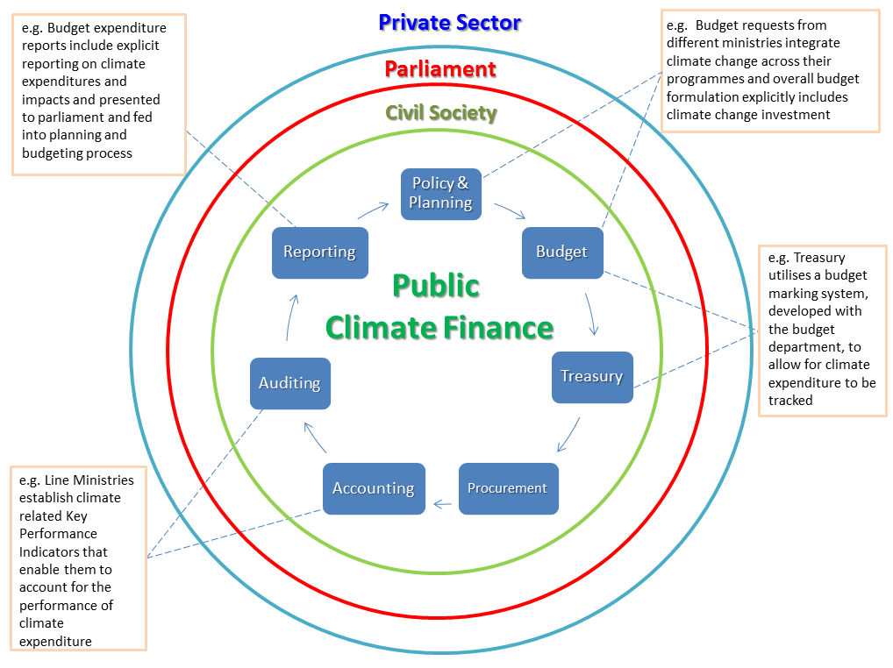

A video, produced by UNDP, outlining a whole-of-government approach to managing climate finance was shown and can be accessed here.

Country experiences in using country systems to manage climate finance
The Forum was an opportunity to learn about country experiences and the specific tools and processes that could be undertaken to increase use and strengthen country systems to manage climate finance. The forum held peer-to-peer discussions where countries exchanged lessons on their overall systems for managing climate finance and discussed the opportunities and challenges for strengthening these systems and better managing climate finance at the country level. Parallel sessions on specific innovations in the use and strengthening of country systems focused discussion on specific country systems, and the innovations that have been piloted. Below are the common themes and lessons from the various sessions.
- Strong political leadership at the national level and country ownership at the highest possible level is important in order for climate finance to be utilized most effectively. Representatives from Nepal demonstrated that strong political will is needed to drive the policy and institutional reforms necessary for mainstreaming and prioritizing climate relevant actions. Strong national ownership also includes forging cross-ministerial partnerships in country. For example the forum learnt that in Lebanon, the Ministry of Finance (MoF) has become a core partner in national energy and environment initiatives including those related to climate finance. This has been done through institutional co-operation on climate change, including establishing official representation of MoF in the National Council for the Environment (2012) and the Climate Change Coordination Unit at the Ministry of Environment (MoE) (2013) and by jointly recruiting an economist, jointly based at MoE and MoF, who is dedicated to supporting climate change mainstreaming and studying fiscal incentives (2013). Thailand is strengthening ownership at the sector level by working through flagship programmes in the Ministry of Agriculture.

- Aligning climate change strategy formulation with national development plans and results can help in developing more comprehensive climate responses. Many countries have now developed either national, sectoral or local plans or strategies on addressing climate change. In general these strategies use national development strategies as anchors to guide climate-related reform agendas. However more is needed to truly integrate climate policies with national systems in terms of monitoring and alignment with the national budget process. Examples from Bangladesh, which has strong national planning, and Cambodia, with a more sectoral focus, showcased the different approaches to climate strategy formulation. These examples revealed how in both cases strategic alignment with development plans has helped to drive national dialogue on climate change and strengthened programming of climate finance.

- Prioritisation of climate change programmes and investments continues to be a challenge for many countries. Once national strategies and action plans are in place, many countries are finding it difficult to prioritise these actions to convert them into budgets and implementation plans. This is both because of the political imperative to act broadly and comprehensively in the immediate and mid-term and also because of the complicated institutional frameworks for management of climate finance. Tools for moving from plans to budgets and implementation were showcased by Vietnam, which is reviewing its legal framework to support formulation of action plans and priority projects for climate change and green growth strategies, and Cambodia, which has developed criteria for prioritization of climate expenditures based on effectiveness, co-benefits and feasibility.

- The ability to clearly track climate spend through the budget and other extra-budgetary systems (e.g., funds, projects) is important for planning and budgeting purposes and also for broader transparency and accountability. The Forum acknowledged the need for mutual accountability between donor and recipient countries and recognized the value of the budget tracking tools being developed in countries such as Nepal and Indonesia, which are starting to develop budget markers for climate finance. The European Commission (EC) shared its approach to track climate finance, which is based on OECD methodology (“Rio markers”) and is already used for tracking official development finance by OECD donors. The presentation on an OECD-led review of stakeholder perspectives, entitled ‘What enables effective international climate finance in the context of development co-operation’, highlighted that the high priority and needs of donors to track climate finance may imply that general budget support, in the absence of climate specific budget codes, is not considered a feasible modality for climate change support. A presentation from the International Budget Partnership highlighted how general efforts to improve budget transparency and accountability could benefit climate finance and that lessons can be learnt from general budget experience. The presentation shared high level principles from the Global Initiative for Fiscal Transparency (GIFT) that could be applied to the governance of climate finance, and insights from experiences from the Open Budget Survey, which has been run in 100 countries over the past four years and measures public access to budget information, the extent of public participation opportunities and the strength of formal oversight institutions.

- Public climate finance is being disbursed through a growing number of modalities, including programmatic support, which is often a modality preferred by partner governments. Some development partners, such as the European Union are providing climate change related budget support (eg in Samoa and Mauritius); others are supporting National Climate Funds and many are supporting project activities. Each financing modality has pros and cons for addressing climate change. However, a better understanding of these modalities may encourage more effective choices. Countries such as Samoa has climate related budget support for the water sector, while Mauritius has climate related programmatic support linked to performance-based budgeting. The forum reflected on the considerable challenge of balancing the immediate urgency for scaling up climate actions and climate finance versus the need to build capacity and readiness in the longer term. The Panelist from the World Bank mentioned a number of different modalities that the Bank uses including traditional investment lending, policy-based budget support, advisory services and carbon financing tools and highlighted the WB’s strong alignment with country systems, but noted the need for continued capacity building support for many countries. The panelist from UK DFID provided insights into how the UK’s rapid rollout of its International Climate Fund resulted in a portfolio that is dominated by projects which may have a useful role in learning, provided they are properly evaluated and monitored and indicated that they are now pursuing more programmatic approaches.

- There is urgent need for capacity building support for the new institutional frameworks and public financial management required to attract, guide and manage climate finance. The Forum noted that certain countries need specific institutional support for country access to and readiness to absorb climate finance. This includes improved public financial management to address fiduciary issues to strengthen country systems to manage public climate finance and strengthened enabling environments in-country to harness and guide private resources. Cross-government climate finance working groups have been set up in several countries such as Bangladesh and Cambodia. Several Ministries of Finance are setting up specific climate-related units to access and manage climate finance. India’s Ministry of Finance has a Climate Finance unit and Samoa’s Ministry of Finance has recently set up a Climate Resilience unit.

- There is need to strengthen the mechanisms for measuring the impact and results of climate policy and finance, particularly for the most vulnerable countries and populations. The Forum noted that it is a challenge in a number of countries to monitor and track results of climate actions. There is a need to strengthen local systems for learning. Presentations by Transparency International outlined the many gaps in institutional frameworks for monitoring policy impacts and for broader civil society participation. Tracking policy impacts was closely linked with the issue of ensuring that climate finance reaches local government and that it is allocated and spent effectively in the first place.

- The role of local government in channelling climate finance is key, but is not receiving enough attention. Most developing countries are primarily concerned with and developing adaptation projects, responsibility for which often lies with sub-national or local governments. Understanding climate change and, particularly, capacity to act on it, are also often weak at the level of local government. One possible model for supporting local government to cover the incremental costs of adaptation through the Local Climate Adaptive Living Facility or LoCAL mechanism developed by UN Capital Development Fund. In Nepal the National Adaptation Plan for Action set a target that 80% of climate finance resources should be spent at the local (village/municipal) level and this commitment has already triggered greater attention to the local level and promoting community engagement.

- More effective use of climate finance requires strengthening engagement with a broad range of stakeholders, and providing transparency and accountability mechanisms. The Forum emphasized the role of Parliament and engagement with CSOs. There is a great demand for more transparency on climate finance both domestically and internationally. Transparency International highlighted some of the good practices in this regard including the National General Climate Change Law in Mexico, the CSO Transparency initiative in Peru and the role of the national planning council in developing the consolidated database of donor and government-financed projects in the Maldives. Representatives from Uganda shared the experiences with the Parliamentarian Task Force and highlighted the important role of parliament as a national oversight body which could strengthen the governance of climate finance through country systems. The Forum noted that the media has a role to play in disseminating information and helping to ‘mature’ national climate change dialogue and bringing stakeholders together. Academia may also continue to generate lessons and evidence on programmatic approaches that have been proven to work in the medium to long term.

Understanding the political economy in each country is important for identifying the incentives of various stakeholders and unlocking effective action. Some groups discussed the need for continued efforts to build awareness across a range of stakeholders around national climate change issues and on how to use climate finance more effectively and to support a whole-of-government approach. Building on the one day workshop on “Governance Challenges in Climate Change Finance – Understanding the Political Economy” (jointly hosted by UNDP and GIZ) which took place one day prior to the Global Forum, partner countries and development partners both highlighted the challenges of understanding the political economy of specific countries and organisations. This understanding plays an important part in driving policy implementations particularly around extra budgetary climate funds which may be in the interests of certain Ministries. Bangladesh and DFID provided such examples. Global funds, such as the Climate Investment Funds in Bangladesh and in Nepal have been reviewed using political economy analyses to understand the factors that shape decisions in use of climate finance at the national level. Transparency International – Bangladesh highlighted the challenges of understanding the political economy in any country and then using this to drive policy implementation, particularly around extra budgetary climate funds. CSO representatives also highlighted concerns with the political economy of climate finance and need to consider the most effective channels for delivering climate finance.
- Harnessing private investment through fiscal and other government policy is key to achieving transformation. Many participants noted the need to attract private climate finance for both mitigation and adaptation and noted that for adaptation, this is still a relatively new and challenging area. More needs to be done to identify appropriate programmes for private sector involvement and also in terms of communicating with the private sector in a language they understand and can relate to. Korea’s Exim Bank shared their experiences in leveraging private sector investment through green bonds and export credit facilities for renewable energy and to high-tech energy efficiency projects. KPMG also shared their experiences in leveraging private sector finance for climate investment and noted that knowledge and risk sharing between public and private stakeholders was important when structuring financing arrangements. CSO representatives highlighted the need for attention to ensure that public funding delivers public good benefits rather than being diverted to support private gain.

- Country-led regional dialogue on the use of country systems for climate finance is a valuable mechanism that supports South-South-North exchange, peer review and mutual learning. A presentation from Honduras highlighted the importance of regional-level, as well as inter-regional dialogues, in strengthening national capacity and ownership and as a means to build common negotiating positions, e.g. for the UNFCCC. The Forum saw this Latin American initiative as having potential to be replicated in other regions as a basis for more structured South-South-North learning building on initial regional forums in Africa and in Asia-Pacific that have been held in past years and on work in the Pacific Islands (see below).

Taking forward a framework for lesson learning on the use of country systems to manage climate change finance
The Forum discussed a draft framework to support cross-country and cross-regional learning and dialogue regarding efforts to strengthen and use country systems to manage climate change finance. The draft framework builds on a broad definition of country systems as national government procedures, going beyond financial management to incorporate strategic planning, prioritisation and policy implementation, as well as various mechanisms to strengthen accountability, build engagement and trust. Some regions already have country level assessment frameworks such as the Pacific region, which issued a Pacific Climate Finance Assessment Framework; this framework supports such dialogue and action and many countries are taking forward assessments. There is also a regional platform for dialogue in Latin America and in Africa. Participants suggested that whilst a common framework to guide dialogue and learning across countries and regions might be useful, it would be important not to duplicate regional, sub-regional or country level initiatives for assessing country systems but to draw from these on-going processes.

Participants recognised the usefulness of having a framework for learning and dialogue but cautioned against establishing targets and indicators for assessment as a blue print for taking forward work at country level, since there were many differences between countries and the objective was not to become prescriptive. The Forum agreed that further work was needed to refine a draft framework such that it would add value and build on other initiatives. The aim could be to produce a more strategic tool to guide regional dialogue and learning.
The UNFCCC Secretariat recognised that such a framework could in particular guide lesson learning and capacity building support to achieve climate finance readiness perhaps in associatioin with Green Climate Fund. Further, one participant from the Global Partnership for Effective Development Co-operation (GPEDC) recognised the potential for such a framework to support evidence-based dialogue as part of the on-going efforts more generally within the GPDEC to strengthen the use of country systems in the management of development finance.
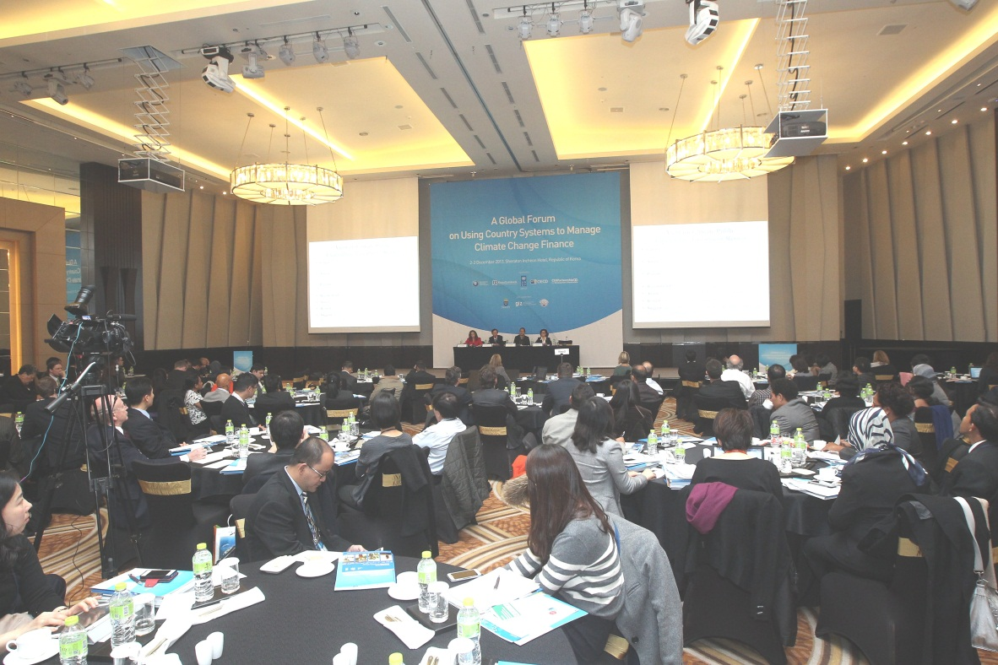

Table 1: Elements of the Draft Framework for Lesson Learning on Use of Country Systems to Manage Climate Finance

Theme | Questions
Defining public climate change finance | How is public climate change finance defined at the country level?
Results focused | Are national climate change policies translated into national development programs? And is there a feedback loop between impacts and policy? Are these policies leading to poverty reduction?
Predictability | Is public climate change finance spent in line with the planned budget?
Public finance management | Are country PFM and procurement systems being strengthened for the delivery of climate finance?
Accountability | Do the legislature and the supreme audit institution scrutinize government financial performance, including performance against climate change-related objectives?
Transparency | What ways exist to promote transparency of public climate change finance delivery in an accessible format?
Gender equity | Is gender equality a consideration in the management of public climate change finance?
Enabling environment | How does government enable the contribution of civil society and the private sector to climate compatible development? How does civil society engage with this process?
Fiscal Measures | How does government fiscal policy relate to the national response to climate change?

Next steps for the development of a framework for learning on use of country systems to manage climate finance
The Forum acknowledged the need to continue refining the framework and identified the following next steps
- The framework could be further developed and refined with the early involvement of a number of participating countries and based on feedback received during the Global Forum. This could include incorporating additional questions around how climate finance is addressing inequality and social issues generally (e.g., gender, cohesion, health), what partnerships are emerging in country and in regions as a result of efforts to strengthen country systems, and whether reform of country systems would result in transformational impacts.

- Evidence and lessons learned from this framework could seek to inform the proposed readiness and preparatory activities of the Green Climate Fund and use the momentum created around its launch. This should be explored with the GCF Secretariat.

- A work plan should be developed that would include, among other issues: (i) how to engage with other relevant initiatives: e.g. the Effective Institutions Platform and regional dialogues bodies on public climate finance such as the System for Integration of Central America and early results from the regional dialogue platforms noted above; and (ii) develop outreach and communication strategies in different languages.

It was also highlighted that there would be value to further develop regional dialogue platforms for continued lesson learning and exchange between countries on use of country systems. This could include using this framework at other future regional and global forums as a means to structure dialogue and lesson learning across regions on good practice in managing public climate change finance.


Messages for Green Climate Fund (GCF)
The Forum discussed what needs to be done at country and international level, including by governments and development partners, to strengthen country systems to access and manage international climate finance including by the Green Climate Fund. The following key points emerged from group breakout sessions and were presented to and discussed with Ms Hela Cheikhrouhou, Green Climate Fund Executive Director on the need for the GCF business model to:
.
- Recognize and build upon existing country systems to manage finance including the role of the Ministry of Finance in managing the budget process:
  - The GCF could provide support for accreditation processes for National Designated Authorities (NDA) and National Implementing Entities including recognition of the role of Ministries of Finance and actions within the national budget cycle
  - Countries are already taking steps to improve country systems through co-coordination and accountability and the GCF can usefully build on this experience
  - The GCF needs to develop simplified procedures to access funds through existing country systems

- Provide formal support for country readiness to absorb climate finance through country systems including co-ordination and public financial management
  - Support for public financial management can include strengthening accountability and audit systems
  - Supporting countries to undertake comprehensive risk assessments for country systems in order to create mutual understanding of how to manage risks
  - Supporting the development of inventory databases for better monitoring, Reporting and Verification (MRV)
  - Developing a comprehensive check-list with specific actions and conditions that indicate readiness for countries to absorb additional resources

- Promote a programmatic approach covering both adaptation and mitigation
  - The Forum proposed that the GCF business model could promote a programmatic approach and not scattered projects
  - This programmatic approach would benefit from linking to a countries’ own planning and budgeting processes
  - The Forum stressed that adaptation and mitigation were both important and there was a need to prioritize areas investments in both the short and long-term
  - The Forum stressed the issues of climate-induced migration and human rights should also be addressed by the GCF

- Ensure transparency and accountability of its own operations through dissemination of GCF procedures to all countries and having clear definitions on what constitutes climate activities as well as clear criteria and guidance on how to access funds and avoiding duplication. The GCF should also establish clear accountability mechanisms including the establishment of governance requirements (e.g. including grievance redressing mechanisms) on implementing partners, and establishing an independent watchdog to monitor GCF under the UNFCCC. The GCF will also need to coordinate with existing international climate funds to provide harmonized financing. Coordination with other agencies and funds will also reduce confusion for countries. It also includes being clear about national ownership for example if there are international intermediaries, national governments should explicitly participate in project preparation.

- Create an enabling environment for the private sector, including changes in government policies and incentives: This could include creation of an innovation fund (or private sector support facility) to provide seed money for business/technology start-ups and capacity building. This could include providing trainings and tools to private sector (particularly the banking and insurance sectors) on climate relevant products and services. The GCF will also need to also establish governance structures that help it to engage with civil society and encourage more community participation.
Ms Cheikhrouhou welcomed the Forum’s messages and noted that the GCF governing document and all GCF deliberations and decisions are a matter of public record and could be accessed on line. It is the GCF’s position to continue to ensure full transparency in the decision making, design and implementation of the Fund. She also noted that a distinguishing feature of the GCF was the balanced representation of all countries on the GCF Board with 24 members, half or which are non-Annex 1 countries. She stressed that countries could continue to engage with the GCF through representation of the relevant Board members and pointed out that the next Board meeting would be held in February 2014. This will give countries another opportunity to engage. She highlighted that the national communiqués to the UNFCCC are also opportunities for influencing the design and work of the GCF.
The GCF Director encouraged countries to view the GCF as a fund that could drive transformational change through provision of additional catalytic finance. She supported the whole-of-government or multi-sectoral approaches currently being piloted by many countries. She stressed that countries needed to be strategic in their choice of institutions for National Designated Authorities and National Implementing Entities for the GCF and select institutions with a proven track record.

She also indicated that in order to be transformational, countries should also be very clear about the type of readiness support that could realistically be delivered in the short term, particularly around development of transformational policies and around setting up effective public-private partnerships etc. She underlined that the GCF is seeing private sector engagement as an opportunity rather than a challenge and will continue to be pro-active in leveraging the private sector and to this end has already set up a private sector advisory group. She concluded by agreeing that transparency was key and reported that the launch of the GCF Secretariat will be an opportunity to step up efforts on raising global awareness of the Fund, its structure and operations.

Forum Conclusions
The Forum concluded by recognizing the importance of sustaining the global dialogue on use of country systems to manage domestic and international climate finance through the ongoing Partnership on Climate Change Finance and Effective Development Co-operation. It was considered that multi-stakeholder dialogues are useful and more can be done to continue to jointly engage with global policy processes, such as the Global Partnership for Effective Development Co-operation and the UNFCCC, as well as the GCF. A key challenge is to support country readiness for climate finance through the enhancement of enabling environments and policy frameworks to facilitate the mobilization and effective deployment of climate finance. .
It was agreed that there is scope to replicate the successful Latin American model for regional dialogues and lesson learning on public climate change finance and use of country systems so as to strengthen learning, knowledge and action through the sharing of country experience.
Partners agreed to further develop and work together to implement a common work plan and an active strategy to engage all relevant stakeholders.
A list of participants with photos (Who’s Who) is available here. All Forum presentations can be accessed here.

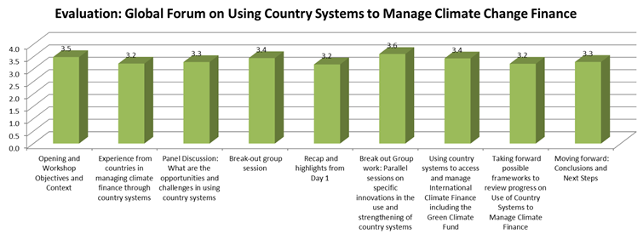
Annex 1- Global Forum Evaluation Feedback (0= not useful, 4= very useful)

Annex 2– Final Agenda

Annex 2- Global Forum Agenda
Day 1
Time | Sessions
8.30-9.00 | Registration
9.00 – 9.15 | Opening by the Government of Korea  - Mr. Sung-Soo Eun, Deputy Minister, Ministry of Finance, Korea  Introduction to the meeting by UNDP  - Mr. Gordon Johnson, Environment and Energy Practice Team Leader, UNDP Asia Pacific Regional Centre
9.15 – 10.30 | Session 1: Workshop Objectives and Context  Chair: MOSF Korea – Dr. Moonjoong Tcha, Special Advisor to the Minister  This session will introduce the workshop and provide clarity as to how the two main issues - climate finance and country systems - are defined  - Global Forum objectives – Mr Paul Steele, UNDP Asia Pacific Regional Centre  - What is the Busan Partnership for Action on Climate Change Finance and Development Effectiveness? – Ms. Tetet Lauron, Civil Society Partnership for Development Effectiveness  - What are country systems and why do they matter? Ms Sara Fyson, OECD  - What is climate change finance? Mr. Tom Beloe, UNDP Asia Pacific Regional Centre  - Short video, UNDP
10.30-11.00 | Break
11.00-12.30 | Session 2: Experience from countries in managing climate finance through country systems  Chair: Ms. Lidia Fromm, Hon Deputy Minister, Honduras  This session will provide a platform for selected countries from different regions to present their experiences and innovations in strengthening and using country systems to manage climate finance including donor linkages.  - Asia country examples Viet Nam: Dr. Pham Hoang Mai, Ministry of Planning and Investment  - Pacific country examples Samoa: Ms. Litara Taulealo, Ministry of Finance  - Arab states examples Lebanon: Ms. Lea Hakim, Ministry of Finance  Discussion in plenary
12.30-13.30 | Lunch
13.30-14.30 | Session 2 (continued): Experience in managing climate finance through country systems  Chair: Jan Corfee-Morlot, OECD  - European Union experience- Ms Simona Constantin, European Commission  - UK experience - Mr. Malcolm Smart, DFID  - World Bank experience - Mr. Christophe Crepin, World Bank  Discussion in plenary
14.30-15.00 | Break
15.00- 16.30 | Session 3 – Panel Discussion: What are the opportunities and challenges in using country systems?  Chair: Ms Ulrika Akesson, Sweden  The objective of this session is to provide an overview of different practices across use of country systems for managing climate change finance. The presenters will be asked to focus on particular country systems, and reflect on the relationship between use and quality. The respondent will address some of the challenges raised by the presenters.  - Case 1: Overview of Country Systems for Climate Finance (Dr. Neil Bird, Overseas Development Institute)  - Case 2: Survey of development co-operation practitioners on “what enables effective climate finance?” (Ms Stephanie Ockenden, OECD)  - Respondent : Partner country (David Ebong, Uganda)  - Respondent 2 Development co-operation provider (Steve Pierce, USAID)  - Respondent 3: Civil Society Organisation (Isaac Shapiro, International Budget Partnership)  Discussion in plenary
16.30-18.00 | Session 4: Break-out group session: Peer to peer review by countries of their overall systems for managing climate finance and opportunities and challenges for strengthening these systems and better managing climate finance at the country level  The objective of this session is to enable participants from countries to group together and discuss what can be done at the country level to strengthen and use country systems to manage a response to climate change:  - How do countries currently manage domestic and international finance to address climate change?  - What challenges/opportunities exist in using country systems?  - What is and can be done to strengthen use of country systems to manage climate finance?  Development partners and regional / international organisations to select as observers.
18.00 | Close of Day 1
18.15 | Reception (hosted by KEXIM, Mr. Seop Shim, Senior Executive Director)

Day 2
Time | Sessions
8.45-9.30 | Session 5: Recap and highlights from Day 1  Gallery walk: This session will enable all the participants to have an overview of the type of issues that the different groups from Day 1 raised.  Recap: MOSF Korea - Mr. Kwang-Chul Ji, Head of Development Cooperation
9.30-11.30  (coffee breaks will be served at the breakout groups) | Session 6: Break out Group work: Parallel sessions on specific innovations in the use and strengthening of country systems  The objective of each discussion during this session will be to focus on specific country systems, and understand the innovations that have been piloted to increase the use and quality of country systems.  Topics:  - Strategy formulation and climate change prioritizing areas for climate action and funding, linkages to development priorities including poverty reduction  - Delivering climate finance through sector and/or subnational planning, programmes and budgeting systems  - Fiscal and other policies and using public climate finance to leverage private investment  - Modalities for funding: blending international climate finance with domestic climate finance through different funding modalities  - Monitoring : Tracking quantity and quality of climate expenditure, accountability and transparency
11.30 – 12.30  (coffee breaks will be served at the breakout groups) | Session 6 (Continued): Break out groups continued: Accessing and managing international climate finance including the Green Climate Fund.  The same groups continue with a discussion on what needs to be done at country and international levels, by governments and their development partners to strengthen country systems to access and manage international climate finance including the Green Climate Fund:  - What do governments need to do with their country systems to access and manage international climate finance?  - What do international funds, including the Green Climate Fund need to do to support countries to access and manage international climate finance through their country systems?
12.30-13.30 | Lunch
13.30-15.00 | Session 7: Using country systems to access and manage International Climate Finance including the Green Climate Fund.  Chair: Pradeep Kurukulasuriya, UNDP  Break-out groups Report back to the plenary  Respondents: Ms Hela Cheikhrouhou, Green Climate Fund Executive Director
15.00-15.30 | Break
15.30-17.00 | Session 8: Taking forward possible frameworks to review progress on Use of Country Systems to Manage Climate Finance  Chair: Ms Lidia Fromm, Hon Deputy Minister, Honduras  The objective of this session is to identify potential frameworks to review progress and potential ways to integrate frameworks with on-going country, regional, and global processes.  - Possible framework to review progress on use of country systems to manage climate finance and how it can be taken forward – Neil Bird, ODI  - Potential role of and links to international processes under the UNFCCC - Mr Yolando Velasco, UNFCCC  - Potential role of and links to international processes under the Busan process - Steve Pierce, USAID  Discussion in plenary
17.00-17.30 | Session 9: Moving forward: Conclusions and Next Steps  Chair: Mr. Paul Steele, UNDP  The objective of the session is also to agree on the way forward, and agree on key actions required by different stakeholders.  Closing remarks:  - Mr. Manfred Konukiewitz, Germany, GCF Board Member and Co-Chair  - Mr. Taeyong Yoon, Director-General, MOSF Korea  - Mr. Abhishek Acharya, Ministry of Finance, India  - Ms. Tetet Lauron, Civil Society Partnership for Development Effectiveness
17.30 | Close

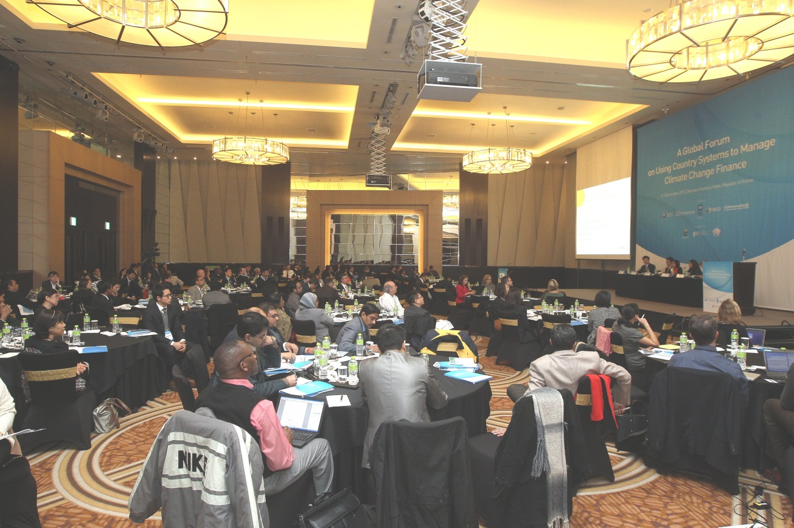

These CPEIRs have been undertaken now in Bangladesh, Cambodia, Indonesia, Nepal, Samoa and Thailand and CPEIRs are also underway or planned in China, Fiji, India, Pakistan and Vietnam. Similar studies have been conducted in Tanzania and Uganda. Many governments are interested in following up on the recommendations of the CPEIRs and assessing how country systems more broadly can be strengthened and leveraged to improve the effectiveness of national climate change responses.

