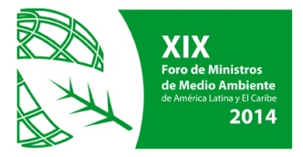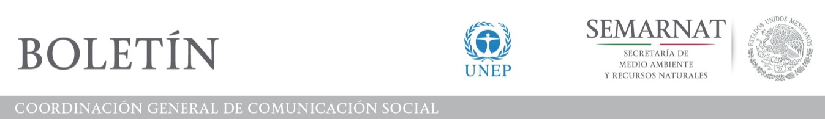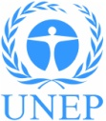

**Latin American and Caribbean Environment Ministers Seize the Opportunity to Prepare to Exert Global Environmental Leadership**

**Ministerial Forum Approves Ambitious Set of Decisions to Advance Sustainable Development in the Region and Offer Support to Peru and Ecuador as Hosts of Crucial UN Conferences**

*15 March 2014. Los Cabos, Mexico.* The high-level political dialogue of Latin American and Caribbean Environment Ministers and international experts produced an agreement to advance a regional cooperation framework on the global sustainable development agenda, climate change, biodiversity, chemicals, waste, Small Island Developing States (SIDS), among other crucial areas of action.

Acknowledging the need and opportunities for global-scale leadership by this region for the world´s environment, through the Los Cabos Declaration, the Ministers confirmed the Forum of Ministers of the Environment of Latin America and the Caribbean as one of the most relevant spaces for political and policy dialogue to establish and identify regional priorities. In preparation for the Upcoming United Nations Environment Assembly (UNEA) of the United Nations Environment Programme, the Ministers reiterated the importance of strengthening UNEP´s regional and subregional offices.

The 19th Meeting of the Forum, convened in Los Cabos, Baja California Sur, Mexico, offered its support to Peru in its capacity as President of the 20th session of the Conference of the Parties (COP 20) of the United Nations Framework Convention on Climate Change (UNFCCC), to be held in Lima in December, and recognized the importance of ratifying the Amendment to the Kyoto Protocol as soon as possible.

The Ministers of the Environment of the region also offered their support to Ecuador as President of the XI Meeting of the Conference of the Parties of the Migratory Species Convention, to be held in Quito, from 1 to 9 November.

“We have completely achieved the targets that we had set,” stressed the Secretary of Environment and Natural Resources of Mexico, Juan José Guerra Abud, on the closing day of the meeting. “Mexico takes over the Chairmanship of this Forum for the next two years. We want the region to be very active in environmental issues. It is an opinion that must be taken into account. Mexico will be an appropriate speaker to convey the opinion of this region at all international fora,” he added.

Achim Steiner, United Nations Under-Secretary General and Executive Director of the United Nations Environment Programme (UNEP), expressed his gratitude to Secretary Juan José Guerra Abud and the Government and people of Mexico for having organized an “exceptional meeting, with an ambitious set of regional perspectives and with a level of participation that made it a special forum, bringing together the leaders of the region on the environment and attracting an unprecedented number of representatives and experts from the international community who are engaged in work on the environment and sustainable development in Latin America and the Caribbean.”

In attendance were ministers, vice ministers and experts from 27 countries in the region, in addition to experts from 15 international agencies and global and regional leaders in the fields discussed during the meeting’s ministerial dialogues.

**Decisions to advance sustainable development**

The Environment Ministers of Latin America and the Caribbean convened in Los Cabos endorsed a set of decisions to advance sustainable and inclusive development in the region.

The Forum adopted the Regional Plan of Action on Atmospheric Pollution as a guide for the development of national action plans that emphasize technical exchange, capacity building and design alternatives to reduce air pollution. The Forum also encouraged governments to identify the economic resources needed for the sustainability of the air quality monitoring networks. The ministers called upon the United Nations to support governments in the development of epidemiological studies in relation to health damages associated to air pollution in the region.

The Forum reiterated the support of Latin America and the Caribbean to the 10 Year Framework on Programmes on Sustainable Consumption and Production Patterns (10YFP) and to maintain a leading role in its implementation. It also confirmed its interest in participating in the first five 10YFP Programmes (consumer information, sustainable lifestyles and education, sustainable public procurement, sustainable buildings and construction and sustainable tourism), while requesting the consideration of additional programmes for Small and Medium Enterprises and on integrated sustainable waste management. It also agreed to promote the inclusion of sustainable consumption and production (SCP) as an essential element of the Sustainable Development Goals (SDGs) and the post-2015 development agenda, with the support of UNEP. In addition, a decision was made to prioritise the development and harmonization of SCP indicators.

A decision was made to consolidate a Network of Youth and Children for Sustainability in Latin America and the Caribbean. The regional environmental leaders also requested UNEP to develop the 2014-2016 workplan for the Environmental Training Network of Latin America and the Caribbean, promoting environmental education through innovative technologies and fostering the participation of universities of the region in UNEP’s Global University Partnership on Environment for Sustainablilty (GUPES).

In regard to the Latin American and Caribbean Initiative for Sustainable Development (ILAC), the ministers decided to support the development of indicators that provide information on the links between different priority areas of the initiative, encouraged the development of environmental information systems on platforms accessible to the public and promoting the involvement of Ministries of Environment and Statistical Offices in the process of establishing Sustainable Development Goals.

The environmental authorities of the region reaffirmed their commitment to work towards achieving full implementation in Latin America and the Caribbean of Principle 10 of the Rio Declaration on access to information, public participation and justice in environmental matters.

UNEP was asked to support governments within the region in the development of work programmes to foster the sound management of chemicals and waste. The ministers also identified specific cooperation actions aiming to facilitate the implementation of the Minamata Convention on Mercury and reiterated the importance of mobilizing the necessary financial resources to strengthen global, regional and national efforts in order to comply with international instruments related to chemicals and waste.

The Forum decided to urge Member States to prioritize undertaking South-South cooperation activities with the Caribbean Small Island Developing States (SIDS) and to call upon the UN system to support national and regional programmes, projects and activities being undertaken in support of Caribbean SIDS in priority areas such as climate change, biodiversity, land degradation and water resources management that are critical to the long term development of these countries.

**The complete declaration, decisions, final report and other documents of the 19th Meeting of the Forum of Ministers of the Environment of Latin America and the Caribbean are available at:** [**http://www.pnuma.org/forodeministros/19-mexico/documentos.htm**](http://www.pnuma.org/forodeministros/19-mexico/documentos.htm)

**For more information, please contact:**

Alejandro Laguna. Information Officer. UNEP. Regional Office for Latin America and the Caribbean. Email: [alex.laguna@unep.org](mailto:alex.laguna@unep.org)

Diana Aspiros Heras. Information Director. Secretariat of Environment and Natural Resources (SEMARNAT) of Mexico. Email: [diana.aspiros@semarnat.gob.mx](mailto:diana.aspiros@semarnat.gob.mx) Phone: 0445549406354