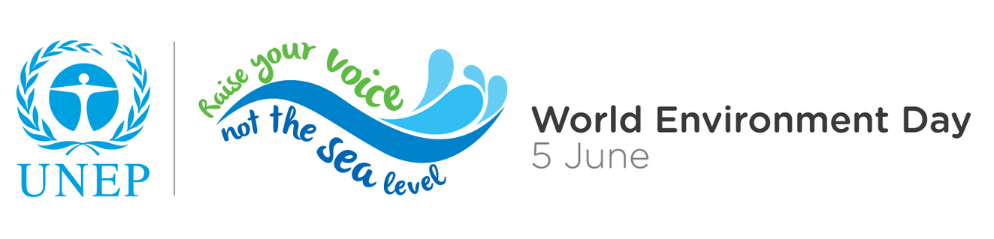
"Planet Earth is our shared island, let us join forces to protect it."—UN Secretary-General Ban Ki-moon

This Year’s World Environment Day Theme:
- World Environment Day (WED) is the United Nations’ principal vehicle for encouraging worldwide awareness and action for the environment. World Environment Day 2014 falls during the International Year of Small Island Developing States, declared by the United Nations General Assembly to raise awareness of the special needs of this diverse coalition as part of the global discussion on how to achieve a sustainable future for all. –UN Secretary-General Ban Ki-moon

Why Small Island Developing States?
- The world’s small island nations are collectively home to more than 63 million people.
- SIDS contribute little to the problem of climate change yet they are especially vulnerable to the changing climate due to their small size, narrow resource base, susceptibility to natural hazards, low economic resilience, and limited for mitigating and adapting to the effects of climate change. –UNEP Executive Director Achim Steiner
What can you do to combat climate change? “Raise your voice, not the sea level”

- “You can contribute to this movement by joining us, in Barbados or wherever you are in the world, in celebrating World Environment Day and raising your voice to encourage action.” –UNEP Executive Director Achim Steiner.
- You can raise your voice no matter where you are—even in Brussels! Cities consume more than 75% of the world's natural resources; use 60-80% of the world's energy, and are responsible for 75% of its carbon emissions. And with approximately 50% of the world’s population now living in cities, billions of these voices can be raised for climate change!
- From Brussels to Barbados, we are all directly affected by climate change. You can do your part by keeping Brussels a sustainable, green city through your everyday actions.
- By taking on the WED Challenge, you can take action right now in your city! Take on these challenges:
  - Power down: When you save energy—by switching to compact fluorescents, biking or walking, going hybrid or carpooling, you reduce fossil fuels -- coal, oil and gas-- the greatest source of human carbon dioxide output. – Actor Don Cheadle
  - Reduce your footprint: Food waste in landfills is one of the biggest contributors of the harmful gases that cause global warming, causing sea levels to rise, threatening small islands, and low lying cities around the world. Managing your meals smartly, storing food, using leftovers, buying imperfect vegetables, and encouraging your supermarkets and restaurants to cut their food waste all. –Model Gisele Bundchen
  - Be informed: Being more informed and by doing business with companies that have demonstrated their commitment to these issues. We can plant more trees, grow more kitchen gardens and just think more carefully about how the decisions we make impact our one and only Planet Earth. –Actor Ian Somerhalder
  - Purge Plastics: Plastics end up in the garbage or the ocean where they live FOREVER—adding to landfills and killing marine life. Stock up on reusable bags and find alternative water sources to avoid plastic bottles. If you have to use plastic, make sure you reuse or recycle! –Footballer Yaya Toure

UNEP (2013) City-Level Decoupling: Urban resource flows and the governance of infrastructure transitions. A Report of the Working Group on Cities of the International Resource Panel. Swilling M., Robinson B., Marvin S. and Hodson M. Join the WED Challenge at www.unep.org/wed/wedchallenge/

