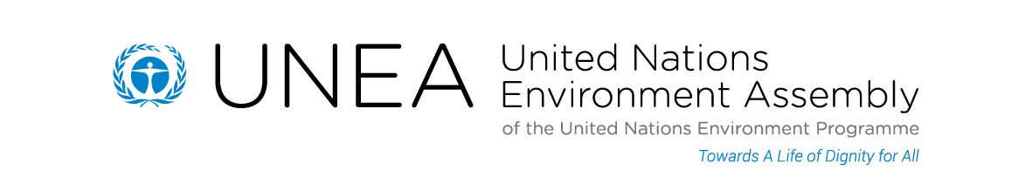

Media Fact Sheet

United Nations Environment Assembly

The Authoritative Voice on the Global Environment

Key Messages

- UN Secretary-General Ban Ki-moon and the President of the UN General Assembly will participate in the high-level segment of the first ever United Nations Environment Assembly (UNEA) on 23 June 2014 in Nairobi.
- UNEA represents the highest level global platform for environmental policy making.
- UNEA aims to catalyse international action on issues ranging from the management of life-threatening chemicals to animal poaching and beyond.
- UNEA has universal membership which allows all UN Member States, Observer States and other stakeholders to gather together for the first time to decide on concrete actions to address key environmental challenges.
- UNEA reports annually to the UN General Assembly through the UN Economic and Social Council (ECOSOC).
- The two main themes for the high-level segment of UNEA are the Sustainable Development Goals (SDGs), including sustainable consumption and production, and the illegal trade in wildlife.
________________________________________

Functions of UNEA

UNEA, with its universal membership, provides the world’s environment ministers, for the first time, with an assembly at which they can define international action on the environment.

UNEA can invite the UN General Assembly to draft resolutions for adoption by the General Assembly for UN-wide action.

UNEA reports annually to the UN General Assembly through the UN Economic and Social Council (ECOSOC).

The following are the specific functions of UNEA:

- Promote international cooperation and, where appropriate, policies in the field of the environment;
- Provide policy guidance for the direction and coordination of the UN’s work on the environment;
- Review the world’s environmental situation in order to ensure that emerging global environmental problems are given appropriate and adequate consideration by Governments;
- Promote the exchange of environmental knowledge and information and, as appropriate, the environmental work of the United Nations;
- Continuously review the impact of national and international environmental policies and measures on developing countries, and ensure that environmental projects are compatible with the development plans and priorities of those countries; and
- Annually review and approve the utilization of the financial resources of the Environment Fund.

About the inaugural UNEA - June 2014

The first UN Environment Assembly will convene in Nairobi, Kenya, from 23 to 27 June 2014. This marks a historic milestone in UNEP’s 43-year history and is open to attendance by all UN Member and Observer States. UNEA also provides for the active participation of major groups and stakeholders.

UN Secretary-General Mr. Ban Ki-moon, the President of the UN General Assembly, Ministers of Environment and Foreign Affairs and Chief Executives of a number of international organisations and heads of international convention secretariats are set to attend the newly-established UNEA that will bring together over 1,200 high-level participants from government, business and civil society.

At UNEA - under the slogan A Life of Dignity for All - Ministers and international leaders will gather to discuss two key sustainable development and environmental topics of current international concern, namely:

• Sustainable Development Goals (SDGs), including sustainable consumption and production.

• The illegal trade in wildlife to address the escalation in poaching and surge in related environmental crime.

To complement the Ministerial discussions, UNEA will also see the convening of two Symposia that address two key aspects of environmental sustainability, namely:

• The environmental rule of law through the gathering of leading representatives of the international judicial community, including Chief Justices, Attorney Generals and Judges;

• And secondly, the role of Finance in the Green Economy by bringing to Nairobi and UNEA the leaders from the world of business, finance and industry.

UNEA 2014 will also define the future of UNEP for the next few decades.

The UNEA inaugural session is a new building block to global governance. It charts a new course in the way the international community addresses environmental sustainability challenges.

Significance of UNEA

The universal nature of UNEA demonstrates that environmental sustainability is a universal agenda, and that the international community recognizes that challenges are best addressed when the world joins forces to address the environmental dimension of sustainable development.

UNEA will play an integral role in ensuring a life of dignity for all, in a world in which no one is left behind.

UNEA symbolizes the commitment by world leaders at Rio+20 to strengthen and upgrade UNEP as “the leading global environmental authority that sets the global environmental agenda, that promotes the coherent implementation of the environmental dimension of sustainable development within the United Nations system and that serves as an authoritative advocate for the global environment.”

