**Project Name**: Development Aid Support Mechanism

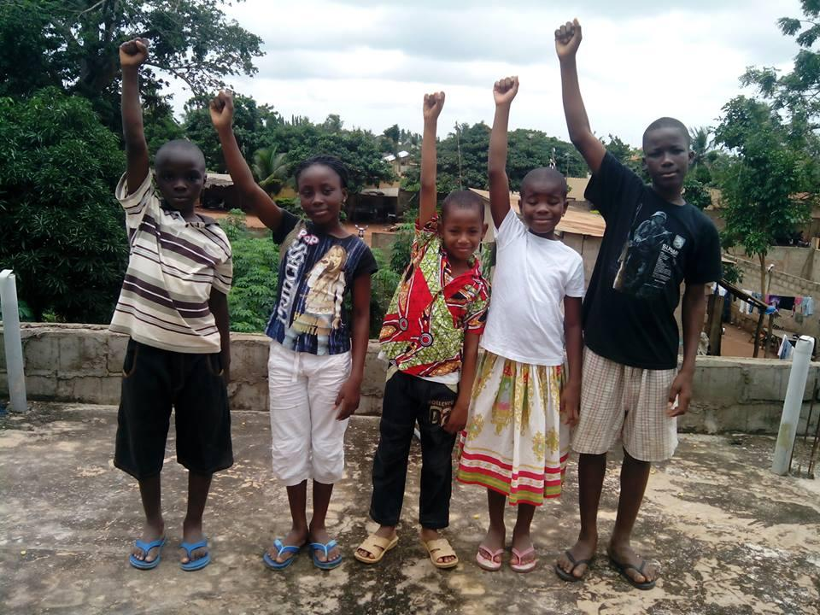

**Project Description**

The “Development Aid Support Mechanism” is a project launched by the NGO "[KFDWB"](http://www.developmentaidsupport.org/) to contribute to the support and improvement of the results of [Millennium Development Goals](http://www.un.org/millenniumgoals/) (MDGs) and forthcoming [Sustainable Development Goals](http://sustainabledevelopment.un.org/) (SDGs) that address the challenges of economic development, social inclusion, environmental sustainability, and good governance. In brief, the project aims to provide a global Social Service Support that improves the results of Millennium Development Goals (MDGs) and forthcoming Sustainable Development Goals (SDGs).

<--break-->

**The Objective of the Project**

The objective of this project is to assist the efforts of Development Organizations, NGOs, Foundations, local governments, Donators, Charity Organizations, private and public institutions etc. to identify current development issues and development best practices on the ground on real time in helping local communities know and understand which human development challenges and/or frustrations they are facing each day, and make these information and knowledge universally accessible via a central database and useful to development organizations and local and national responsible bodies in order to highlight and alleviate the problems at a community level to reach the Millennium Development Goals (MDGs) and the forthcoming Sustainable Development Goals (SDGs) in each corner of the globe.

**The Goals of the Project**

1. To achieve a worldwide network of volunteers who act as the eyes and ears for communities who require development aid assistance.
2. To provide development organizations and local and national responsible bodies with updated information on critical development issues at the community level.
3. To assist with the identification of potential economic, social and environmental development issues and simple best practices in each corner worldwide.
4. To assist development organizations, NGOs, local populations, and local governments as well as the private sector for more effective management and investment in social, economic and environmental problems worldwide.

**The expected Outcome**

To enhance positively the efforts of development agencies, NGOs, private and public institutions and local and central governments a long term when they are receiving  accurate information, knowledge and feedback in real time for better decision making and timely intervention.

To develop  a suitable social mechanism support worldwide that connects a global audience to necessary resources while providing a central global support system to make development issues and best practices available to all, and to translate the available goals, data, information and knowledge into sustainable local best practices via networking.

To mobilize, encourage and engage local citizens without distinction in sustainable development activities to address their own daily human development challenges and frustrations by reporting, and/or raising a ticket about the economic, social and environmental problems they are facing so that human development engagements, interventions, researches and resources must be efficiency targeted and focused.

To access to a central global coordinated database that has accurate information and knowledge, and a reporting system on the ground for effective decision making interventions.

To evaluate and monitor the human development progress on the ground.

More information at: <http://developmentaidsupport.org>

**References:**

[1] [http://www.developmentaidsuppo](http://goog_1334013185)[rt.org](http://rt.org)

[2] <http://www.ngojobs.at/ngos/583>

[3] <http://en.wikipedia.org/wiki/User:KFDWB>

[4] <http://capacity4dev.ec.europa.eu/aid-Support>