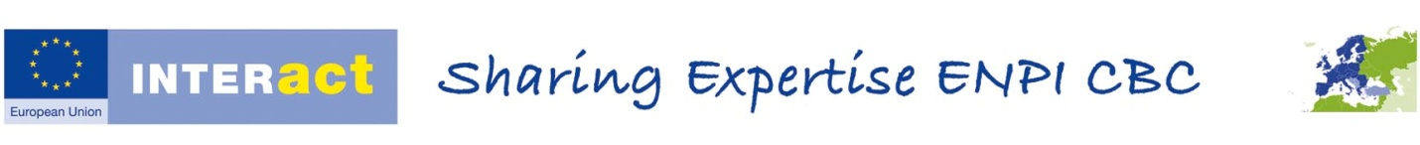

**WORKSHOP 07C08, OPEN DAYS 2014 - ENI CBC (EUROPEAN NEIGHBOURHOOD INSTRUMENT CROSS BORDER COOPERATION): PROMOTING COOPERATION AT THE EU’S EXTERNAL BORDER**

***AGENDA***

**14.30 - 14.50: I**ntroduction to ENPI CBC/ENI CBC and to the panel by Ms. Bodil Persson, DG DEVCO, European Commission.

**14.50 - 15.10:** Presentation of MEDGENERATION project (funded under the ENPI CBC MED Progamme) by Mr.Mathias Fillon, Project Manager, ANIMA Investment Network, France.

**15.20 - 15.40:** Presentation of the RescOp project (funded under the ENPI CBC South East Finland – Russia Programme) by Mr.Floris Goerlandt, Researcher, Aalto University, Finland.

**15.40 - 16.00:** Presentation of the Not for Sale - Say stop to human trafficking project (funded under the ENPI CBC Romania-Ukraine-Republic of Moldova Programme) by Ms.Raluca Francu, Project Manager, Save the Children Organisation, Romania.

**16.00 – 16.45 :** Questions/answers and wider discussion on ENPI CBC/ENI CBC moderated by Mr.Carlos Bolaños, Team Leader, INTERACT ENPI.

**16.45 – 17.00:** Summary and conclusions of the workshop.