
Agribusiness forum: enhancing regional trade and
adding value to Caribbean agrifood products

Organised by CTA and IICA

The Flamboyant Hotel, St. George, Grenada, 16-18 November 2014

This Briefing is linked to the Brussels Briefings organized by the CTA, the European Commission (DG DEVCO), the ACP Group and Concord every two months on key issues related to agriculture in ACP countries
http://brusselsbriefings.net

- Context

Although Caribbean countries have differences in terms of size, population, social and economic conditions, infrastructure and standard of living, they have many common disadvantages such as small size, a narrow resource base, excessive import dependence, high transport and communication costs, high population density.

Furthermore, low levels of FDI into the agricultural sector and the lack of accessibility to services that are critical to agricultural development such as finance, infrastructure, business development services, insurance and research, all hamper agricultural growth and diversification. Another notable source of vulnerability for agriculture concerns climate change and natural disasters, which have a devastating effect on crops and plantations.

Tourism is the life-blood of many Caribbean economies. Relative to its size, the island-states of the Caribbean are more dependent on income from tourism than that of any other part of the world. The figures are staggering and deserve attention, the estimated tourism participation in GDP in 2012 was 27% in Jamaica, 39% in Saint Lucia and in Barbados, 48% in The Bahamas, and 77% in Antigua and Barbuda, to name few good examples.

The Caribbean region has secured its position on the tourism map with luxury hotels, all-inclusive resorts and cruise ship arrivals in millions, but too often the financial benefits do not trickle down to the islands themselves in terms of local employment. The term Agritourism includes a variety of strategies, from large international hotels sourcing their products from local farmers, through the revival of indigenous culinary and medicinal culture, to marketing initiatives that highlight the region’s unique products and heritage.

There is a need to strengthen tourism-agriculture linkages and develop a strong local and regional market for agricultural products serving the tourism sector.

A key dimension in the potential for agriculture to support sustainable economic growth in Caribbean countries is its strong capacity to develop links with other sectors, including smart, innovative sectors. In its assessment of sustainable agricultural initiatives in the Caribbean, Compete Caribbean identifies “links with smart sectors” as one of the assessment criterion of a sustainable agricultural venture. These linkages could involve:
  - establishing innovative links with culinary and agro-tourism, or with naturalists and ecologists interested to engage in farming activities with their explorations;
  - creating closer collaboration with private sector development and the application of appropriate technologies that simplify processing and provide power while at the same time minimizing fossil fuel consumption;
  - applying alternate water and waste management systems;
  - linking research to policy that place an emphasis on communicating and further developing the results in the field with the engagement of communities;
  - integrating information and communication technologies (ICTs) in all aspects of farming and marketing, data and record keeping, integration of data systems and the use of GIS systems to overlay farm structure and natural resources surveys;
  - collaborating with education systems and applied learning – targeting in particular curriculum development and applied farming for youth and adults.

- Promoting regional trade and agribusiness in the Caribbean

Many countries in the Caribbean are highly dependent on imported food and agricultural products, and therefore very susceptible to changes in world food prices. Across the Caribbean, the potential of agriculture, and especially value-added products, could be further developed and greater investments made in the sector. As a result, it would be easier to attract youth and further develop farming activity in rural areas, have stronger linkages along the value chain and closer relations between key actors such as farmers, processors, supermarkets, restaurants and hotel groups.
Changes in global markets and loss of preferential market access for traditional products such as sugar, bananas, rice, have caused further marginalization of some Caribbean countries, putting them under increased pressure.
Most of Caribbean countries are still dependent of a few export products while potential for regional trade is underscored. The links between the two productive sectors agriculture and tourism seems a natural way to increase trade and business development in fresh and processed products as well as promote a greater use or local products. This would create economic opportunities which benefit rural communities and enhance sustainable development of the islands.

Structure of CARICOM Economies (2010)
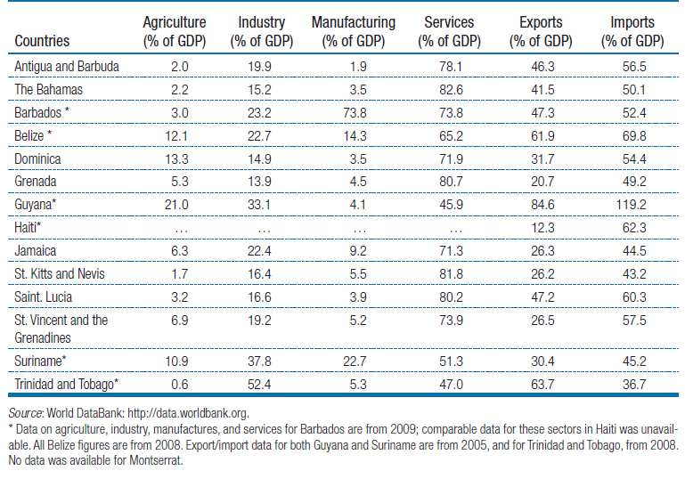
Linking agriculture to the tourism industry which brings millions of visitors every year to the islands can also generate other benefits in terms of entrepreneurship in rural areas, regional and international investment, and increased resilience of smallholders. The link to patrimony, identity and culture, traditional knowledge and cuisine could be enhanced.

- Adding value to agricultural products

Certification in the agricultural industry involves the establishment of voluntary or mandatory standards, often backed by a public or private sector instrument or institution, in order to provide consumer guarantee that certain pre-specified standards have been met for a specific product. Certifications vary from the most stringent to the most flexible, and including initiatives such as organic labelling, fair trade or equitable labelling and other such schemes.

There are numerous benefits which have been argued in favour of certification and labelling as forms of value addition for the agricultural sectors of Small Island Developing States (SIDS), not least the fact that there are a range of schemes which can suit the needs of specific producers or commodities and also the demands of the consumer in the importing country such as origin-linked products and geographical indications..

Bananas and sugar, both fundamental agricultural commodities for many SIDS, provide an example of the scope for labelling and certification, whereby up to 90% of banana producers in the Windward Islands for example, have a fair trade certification.

Although eco-labelling standards challenge market access for exports from poor and vulnerable economies, there is evidence that eco-labelling can also be an avenue for gaining access to niche markets in which a premium price is paid for ‘green’ products. For some producers, eco-labelling can present an opportunity to add value to existing products, expand reach in existing markets, or maintain market share in a competitive environment through product differentiation and therefore provide these exporters with potential to enhance their export earnings.

Beyond fair trade, agricultural producers in ACP SIDS are becoming more ambitious in seeking premiums for their goods, and as a result, there is an increase in the number of organic producers. Dominica’s Organic Island Initiative focuses on development and implementation of a 10-year programme of action to establish the country as an ‘Organic Island’ and wellness tourism destination. The initiative aims to ‘coalesce the food, the activities, the eco-tourism and agro-tourism opportunities into a high end unspoilt image of the country’ (Government of the Commonwealth of Dominica et al., 2006).

Premium products should not only be considered for the export market. A recent study into Dominica’s potential as an “Organic Island” involved a survey whose results showed that Dominican consumers were on average willing to pay 17.5 % more for organic, and 12 % more for locally grown, produce. This study was undertaken in the context of Dominica’s intention to totally eliminate chemical inputs into national agricultural production by 2015. Other Caribbean governments have not pursued the potential for organic agriculture with the same enthusiasm as Dominica, notwithstanding substantial private sector and civil society intervention in favour of government action on the issue.

- The opportunities offered by agritourism

Agribusiness-tourism linkages areperhaps one of the most promising avenues for diversification and trade growth for the agricultural sector in the Caribbean as shown by successes across countries in the region. By integrating these two economic activities agritourism also presents opportunities for stronger collaboration to address areas of vulnerability that affect both sectors, such as climate change, environmental degradation, lack of private sector finance, changes in consumer habits and spending and limited economies of scale.
High quality food, every day of the year, is essential to hotels, lodges and resorts. Often the food purchasing bill of a tourism site is large in the context of the local economy, but surprisingly little is spent locally, even when farmers are nearby. The challenges of shifting food-sourcing to local farmers are considerable, yet if it can be done in a way that meets commercial needs and customer tastes, this is one way in which tourism operations can significantly increase their contribution to local economic development. Common problems of sourcing products locally are well known – inadequate quality, reliability, or volume of produce, exacerbated by poor transport and lack of communication and information between supplier and purchaser.

The Farmers Programme initiated and supported by the Sandals Group in the Caribbean is a good example whereby a private sector entity focuses on all three categories by becoming engaged in a) channelling and creating demand for local products among its staff and customers; b) supporting the supply side to deliver quality and quantity required; and c) establishing workable communication structures between supply and demand through the Rural Agricultural Development Authority (RADA) and Continuing Education Program in Agricultural Technology (CEPAT).

- Promoting agribusiness and private sector development through agritourism

Building upon previous work of IICA and CTA and developing recommendations made at the agritourism investment seminar held at the Caribbean Week of Agriculture in October 2013 in Guyana, it was proposed to hold and agribusiness forum which highlights successes in strengthening links between agriculture and tourism industries.

Objectives:
- Analyse the drivers of success through analysing some successful business models
- Identify further opportunities for linking small-scale farmers to the tourism industry in the Caribbean and increase market linkages
- Generate ideas for a regional project on sustainable sourcing by the tourism industry / supermarkets from small-scale farmers.

The two day meeting will analyse and discuss a few selected successes in linking agriculture and tourism industry for improved market access and regional trade. The key players these successes will be invited. The drivers of success and their replicability will be analysed.

Participants:
30-40 participants

- Government officials, private sector (hotel industry, farmer’s organizations, finance providers, certification bodies, supermarkets, chefs, cooperation agencies and development partners.

Content:

- Short overview of the tourism sector in the region and its linkages with agriculture
- Main findings of the IICA/CTA/CTO study
- Group presentation (3-4 speakers) for each of the 3 to 4 cases highlighting their role and contribution to success stories. Each business model success will have a presentation by the various agrifood chain actors
- Conditions for replicability and upscaling
- Policy implications
- Needed investments and potential partners

Follow-up:

- This will feed into the first regional agribusiness/agritourism forum in 2015.
- Strong linkages will be made with the World Food Expo to be held in Milano, Italy, in 2015. Private sector representatives from the Caribbean will be invited to participate.

UNEP. 2008. Climate Change in the Caribbean and the Challenge of Adaptation. Regional Office for Latin America and the Caribbean
Edghill, Michael W. Tourism and the Caribbean Economy. Caribbean Journal, September 30, 2013
Tandon, N. (2013) Compete Caribbean. Sustainable agricultural initiatives in the Caribbean: Realities from the field?? Does it ends here? It seems editor and country missing.
Dankers, C. (2004) FAO Environmental and Social Standards, Certification and Labelling for Cash Crops
Commonwealth Trade Digest June 2010 Fairtrade, the Windward Islands and The Changing EU Banana Regime
Ibid.
Boys, K., Willis, D., and Carpio, C. Consumer willingness to pay for organic and locally grown produce on Dominica: insights into the potential for an ‘‘Organic Island’’. Journal of Environ Dev Sustain (2014)
Tandon, N. (2013) Compete Caribbean. Sustainable agricultural initiatives in the Caribbean: Realities from the field.
Ibid

