EVD Preparedness Strengthening Team
Draft report

Mali Country Visit
20 - 24 October 2014

Contents
Executive Summary 2
Introduction 4
Country Visit Objectives 4
Country Visit Team 4
Activities 4
Strengths and weaknesses 8
Key areas for improvement for MoH 9
Conclusions and next steps 11
Annexes 13
A: Mission Team 13
B: List of Mali Committees for EVD Planning and response 14
C: Strengths and weaknesses (Francais) 15
D: Areas for Improvement 17
E: Suggested EOC / IMS structure 19
F: Checklist results 20
G: Table top exercise results 27
H: Simulation exercise 29
Actions attendues de la Simulation 29
Rapport de l’exercice de simulation au centre hospitalier Gabriel Touré 33

Executive Summary
As recently demonstrated in Mali, the evolving Ebola Virus Disease (EVD) situation poses a considerable risk to countries in close geographic proximity to those seeing intense and widespread transmission. With adequate levels of preparation, such introductions can be contained before they develop into large outbreaks. WHO, and partners including CDC, is currently deploying international Preparedness Strengthening Teams (PST) to help unaffected countries build upon their existing preparedness work and planning.
The immediate objective of this visit was to urgently ensure that Mali is as operationally ready as possible to effectively and safely detect, investigate and report potential EVD cases and to mount an effective response that will prevent a larger outbreak from developing. During the Country Visit, Mali confirmed its first case of EVD. The joint team to Strengthen Mali EVD Preparedness was composed Mali’s Ministry of Health, WHO, CDC, INSPQ, John Hopkins University and other partners.
Following technical working group meetings, field visits, a table top exercise and a hospital based simulation. Key strengths and weaknesses were identified and specific areas for improvement were proposed to the Ministry of Health.
Key recommendations to the Ministry of Health include:
- Coordination
- Establish an operational system for coordination of technical teams under a command and control structure.
- Establish an Emergency Operations Centre (EOC) with a functional organigram to coordinate technical operations and implement preparedness and response activities.
- Establish technical teams by Ministerial decision or decree, nominate official focal points with operational decision making authority and nominate team members with clear terms of reference.
For the Incident Management Structure (IMS) / EOC:
- Integrate all required human resources for preparedness and response under the EOC structure and chain of command.
- Strengthen technical capacities and reinforce human resources within the EOC structure.
- Ensure logistic support is available to the technical teams (including sampling equipment, IPC, transport, infrastructure, telecommunications etc).

- Budget
- Update the detailed budget of the contingency plan and IMS/EOC structure.
- Present the budgetary deficit to partners for financial support.
- Preposition operations funds at the field level.

- Surveillance
- Establish and strengthen a call centre for the management of functioning hotlines 24h/24h.
- Enhance community surveillance and sensitization for rapid detection of suspect EVD cases.
- Create a data management team within the EOC with a standard database and tools for data collection.

- Infection Prevention and Control
- Accelerate the establishment of minimum standards for infection control (standard precautions) in all health care facilities in Mali.
- Develop and implement specific EVD SOPs for IPC in all health centres and hospitals.

- Rapid Response Teams (RRTs)
- Strengthen the membership of the national Rapid Response Team.
- Establish RRTs at the regional and district level where necessary.

- Case Management

Ebola Treatment Centres:
- Increase the number of ETCs (2 in Bamako and one in each region), and urgently:
  - Complete the two centres in Bamako (CVD-CNAM, hôpital du Mali) and operationalise within international standards;
  - Establish ETCs in Kayes and Sikasso.

Observation sites:
- Reorient the current isolation sites to become temporary observation sites or holding centres prior to transfer to regional or national ETCs.
- Establish two-bed observation rooms in each district referral centre (CSREF) with required infection control and case management resources.

Safe and dignified burials:
- Establish teams responsible for the conduct of safe burials using WHO norms.

- Contact tracing
  - Develop SOPs for the identification and follow-up of contacts.
  - Conduct training for community focal points for conduct tracing
  - Decentralise contact tracing teams.

- Social Mobilisation
- Integrate community-based health staff (‘relais communitaires’) in the detection of cases in the community.
- Sensitize all Malians about basic Ebola signs and symptoms and risk of transmission; use sensitization activities to dispel myths and misconceptions

- Laboratory
- List all laboratory technicians who are trained on procedures for confirming the presence of Ebola virus.
- Strengthen procedures for the transport of samples under triple packaging.

- Points of Entry
- Strengthen procedures and means for the transporting suspect cases from Points of Entry to observation centres or ETCs.

Introduction

Given the evolving Ebola Virus Disease (EVD) situation, there is a considerable risk of cases appearing in currently unaffected countries. With adequate levels of preparation, such introductions can be contained before they develop into large outbreaks. WHO is currently deploying international Preparedness Strengthening Teams (PST) to help unaffected countries build upon their existing preparedness work and planning. The CDC has also started planning similar activities for unaffected countries and had planned to send a team to Mali for the week of October 20-24. These preparedness visits The PST visits focus on supporting countries in developing their operational readiness for EVD to the greatest degree possible.

These PST visits are just one part of a larger group of activities to prepare all countries for the potential introduction of EVD.

Country Visit Objectives

The immediate objective of this visit was to urgently ensure that Mali is as operationally ready as possible to effectively and safely detect, investigate and report potential EVD cases and to mount an effective response that will prevent a larger outbreak from developing. The visit identified necessary next steps required to strengthen preparedness over a period of 30, 60 and 90 days (the EVD Action Plan, Annex 1).

Country Visit Team

The joint team to Strengthen Mali EVD Preparedness was composed Mali’s Ministry of Health, WHO, CDC, INSPQ, John Hopkins University and other partners.

Activities
Day 1
Team briefing by WR Mali (Dr Fall) |  | WHO Mali |  |  | Introduction of team and briefing on Mali context, and preparedness measures taken by Mali supported by WHO
Agreement on Mission Objectives with Minister of Health |  | Ministry of Health |  |  | Initial mission objectives set out by WR, HE Minister of Health, the Secretary General of Health, CDC, and INSPQ.  The team provided a contextual briefing on the WHO response, Emergency Committee Recommendations for preparedness, the Brazzaville Meeting, and current UNMEER establishment.  The Consolidate Preparedness checklist was shared and introduced.
Meeting with MoH and partners to discuss the Current Situation in Mali for EVD Preparedness |  | WHO Mali |  |  | Meeting attended by MoH, Mission Team, UN agencies (WFP), and NGOs.  Technical leads from MoH presented the current status of preparedness in Mali in four technical areas:  - Surveillance, alert and response  - Rapid Response Teams  - Contact Tracing  - Laboratory  - Social mobilisation.  Overall challenges in preparedness were identified in each of the areas.  Discussions on the set-up and scope of the simulation exercise.
Technical Working Group break out groups |  | WHO Mali |  |  | The working groups were introduced to the Preparedness Checklist and broke into 3 sub-groups to address specific gaps, needs and priority areas across: Surveillance, rapid response teams, contact tracing, social mobilization, case management, safe burials, and infection prevention and control.  Human resource gaps, logistic challenges and a need for further training were identified as cross-cutting needs in the country.  Thematic discussions were used to define the scope of the simulation exercises to be held on Wednesday and Thursday.
Day 2
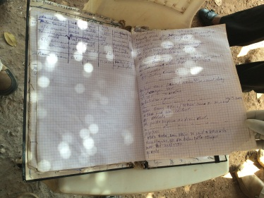  Visit to border post between Mali and Guinea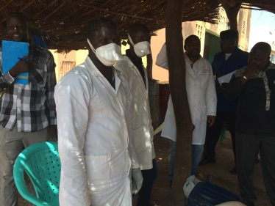 |  |  |  | Kouremale (Health District of Kangaba) | A MOH-WHO-CDC team travelled one of the 10 districts currently implementing enhanced surveillance activities at Points of Entry. Kouremale is a town (pop. Approx. 5000) with the international border between Mali-Guinea running through its centre.  The team met with 2 health teams at the Mali border post and 1 health team at the Guinea post; the team were briefed on the screening procedures in place and on the criteria used for conducting further examinations for some travellers; case definitions; PPE availability; the management of suspect cases; and the transmission of surveillance data from the border post to the national levels.
Visit of the Community Health Centre and the Isolation Site for suspected and confirmed EVD cases  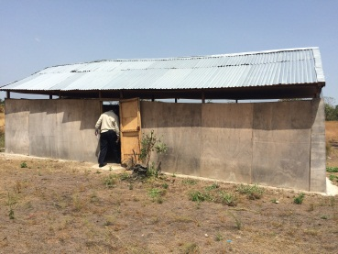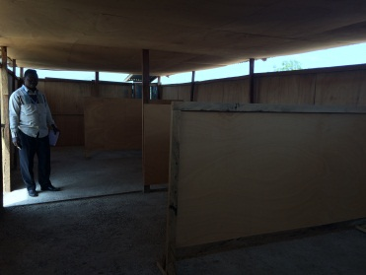 |  |  |  | Kouremale (Health District of Kangaba) | The MOH-WHO-CDC team met with the staff of the local health centre and with representatives from the district referral centre. Routine surveillance measures; EVD case definitions; and procedures for the management and clinical care of suspected or confirmed EVD patients were discussed.  The team visited the local isolation site (constructed outside the village, not in close proximity of a HCF). The site had no running water or electricity and would provide only very basic shelter for patients.  3 tents, one of which had an open and well ventilated would be used to isolate patients while laboratory testing took place. On confirmation of a case, the referral to the national isolation centre was not clear.  Patient management would be carried out by the National RRT and reference health centre staff at the district level.
Visit of the prospective National ETC at Centre National de la lutte contre la maladie (CNAM) |  |  |  | CNAM | The MOH-WHO-CDC team visited a possible ETC in Bamako at the CNAM hospital. The ETC would have 24 beds, and would be managed by the RRT. Currently it is still under rehabilitation. 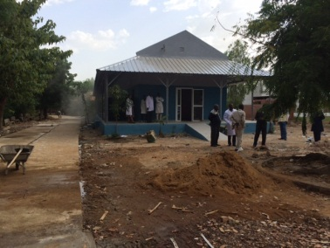
Preparations for EVD Exercise |  |  |  | WHO Mali | 1. Contact list and Invitation letter from WR and ministry of health to partners and ministry staff completed.  2. Exercise agenda finalised  3. Aim and objectives identified  4. Facilitation, players, observers and documentation roles identified.  5. Discussion presentation completed  Exercise logistics to be finalised tomorrow morning.
Technical Working Groups (cont.) |  |  |  | WHO Mali | Feedback and recommendations for preparedness checklist on coordination completed with input from MOH and other partners completed.
Visit to the National Public Health Laboratory |  |  |  | INRSP Laboratory | Visit by WHO-CDC to National Lab to discuss EVD preparedness and Contact tracing (INRSP designated by MOH to be responsible for that aspect of the response)
Day 3
Team briefing with MoH on findings of field visit |  |  | WHO Mali |  | Mission team presented the overall findings of the previous day’s field visit to the border town Kouremale.
Preparation of the Table top exercise and the following field exercise |  |  | WHO Mali |  | Team agreed on the scope of both exercises. The table top exercise scenarios would draw out expected actions in the areas of detection, points of entry, case management, laboratory, contact tracing, social mobilisation and coordination. The expected actions would be reported and used to evaluate the practical exercise the following day.  The location for the field simulation was established; the Gabriel Toure Hospital in Bamako.  A communications plan for the exercise was also developed.
EVD Table Top Exercise  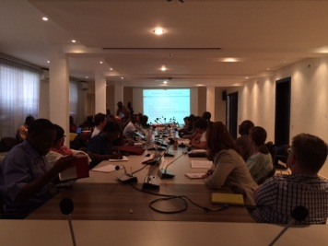 |  |  | WHO Mali |  | The INSPQ exercise team ran a table top exercise involving WHO, CDC, MOH authorities (including the Serefo Laboratory who is processing specimens from suspect EVD cases) and international partners including OCHA, IFRC, Mali Red cross, UNICEF, USAID, WFP, and MSF.  The exercise covered 2 scenarios, one at a point of entry and the other at a district reference health centre. The exercise addressed strengths and weaknesses at the national, regional and district levels.
Visit to Gabriel Toure Hospital in Bamako |  |  | GTH Bamako |  | The Director of the hospital was briefed on the simulation exercise to be held tomorrow.
Day 4
Pre-simulation briefing |  |  | WHO Mali |  | Outline of the rules of the exercise, presentation of the scenario, and selection of the exercise team.
Field Simulation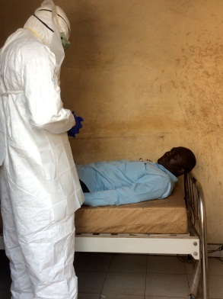 |  |  | Hopital Gabriel Toure |  | Field exercise on the detection, case management (including IPC) and communication. Team included MOH, CDC, John Hopkins and WHO.  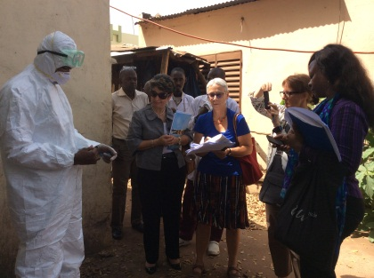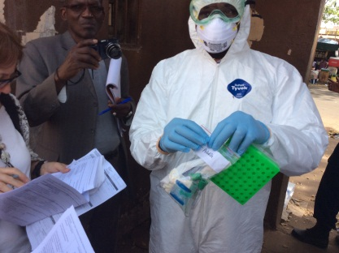
Simulation evaluation |  |  | WHO Mali |  | Hot wash evaluation of the hospital (See Annexes)
On 23 October 2014: first case of Ebola Virus Disease confirmed in Kayes, Mali in a 2 year old girl with travel history to Guinea
Day 5
Ministerial debriefing |  |  | MoH |  | Final briefing on strengths and weaknesses of Mali, and high level recommendations.
PROTECT training for inter-agency staff |  |  | WHO Mali |  | Rapid training of WHO Country Office, MoH, and partner agencies using the PROTECT training materials prior to departure to Kayes, where first confirmed Ebola case was identified.
EVD Task Force Meeting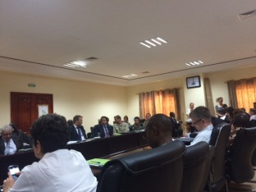 |  |  | WHO Mali |  | Minister of Health and WHO chaired a meeting of the EVD Task Force. Discussion on the confirmed case detected in Kayes, Mali.
Finalisation of Action Plan and Mission report |  |  | WHO Mali |  | Costing of the action plan and incorporation into the National Contingency Plan for EVD.

Strengths and weaknesses

 | Strengths | Weaknesses
Coordination | - The existence of strategic and political coordination structures (see Annex)  - The existance of an EVD Task Force;  - Regular meetings at national and regional levels;  - Mechanisms to transfer funds to local levels | - No operational emergency structure;  - Fragmentation of roles between government institutions with no clear integrating structure;  - No formalisation of technical roles and responsibilities
Surveillance | - Case definition exists;  - Mechanisms for sharing epidemiologic data exist;  - Training on surveillance using the case definition has taken place;  - Enhances surveillance at points of entry | - Case definition not available in all health centres;  - Private health care facilities are not covered in current contingency plans  - Community based surveillance strategies are not yet implemented.
Rapid Response Teams | - The team leader of the Rapid response team is named;  - The team has been successfully mobilised tested for all suspect EVD cases (25) | - Lack of human resources (more RRTs required);  - Members of the RRT are not clearly identified;  - Lack of coordination with other technical teams
Social Mobilisation | - A dedicated public health institution exists for social mobilisation;  - Many community / cultural organisations are active nationally and locally;  - Communication materials have been produced and shared | - No designated focal point or spokesperson within high level committees;  - Lack of thematic sub-groups or activities;  - Lack of focus on community violence witnessed during Preparedness.  - Strategy for communications with limited scope focusing only on general prevention messages, but no plan for response to Ebola outbreak.
Infection prevention and control | - PPE exists in country and has been distributed;  - Hand washing facilities exist at points of entry | - Health workers are not familiar with basic IPC;  - IPC is currently not considered in isolation sites;  - Prepositioning of material not complete.
Case management | - Ebola Treatment Centre is under construction (12 – 20 beds) | - Currently no ETCs exist within the country;  - Lack of capacity for clinical management or safe burials;  - Lack of clarity on who is responsible for case management
Laboratory | - A P3 laboratory exists and has been used to process samples from suspect cases;  - Laboratory technicians have been trained;  - Laboratory equipment available | - Sample packaging has not been distributed  - A lack of transport means for sample shipment within the country
Points of entry | - Enhanced surveillance at points of entry in 33 locations;  - Sites exist to hold suspect cases near the borders;  - Screening mechanisms are functioning | - Isolation sites do not meet international standards;  - No transportation means are available for the transportation of suspect cases to the isolation sites.
Budget | - A costed contingency plan exists;  - Mechanism for transferring funds to the field exists;  - Partners are willing to contribute to costs | - Resource mobilisation challenges exists with the MoH  - Insufficient funds available at the regional / local levels.
Logistics |  | - A further assessment of logistics capabilities and capacities in country

Key areas for improvement for MoH
- Coordination
- Establish an operational system for coordination of technical teams under a command and control structure.
- Establish an Emergency Operations Centre (EOC) with a functional organigram to coordinate technical operations and implement preparedness and response activities.
- Establish technical teams by Ministerial decision or decree, nominate official focal points with operational decision making authority and nominate team members with clear terms of reference.
For the Incident Management Structure (IMS) / EOC:
- Integrate all required human resources for preparedness and response under the EOC structure and chain of command.
- Strengthen technical capacities and reinforce human resources within the EOC structure.
- Ensure logistic support is available to the technical teams (including sampling equipment, IPC, transport, infrastructure, telecommunications etc).
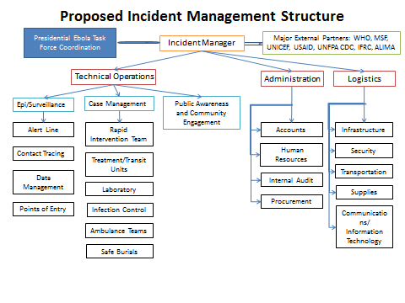
- Budget
- Update the detailed budget of the contingency plan and IMS/EOC structure.
- Present the budgetary deficit to partners for financial support.
- Preposition operations funds at the field level.

- Surveillance
- Establish and strengthen a call centre for the management of functioning hotlines 24h/24h.
- Enhance community surveillance and sensitization for rapid detection of suspect EVD cases.
- Create a data management team within the EOC with a standard database and tools for data collection.

- Infection Prevention and Control
- Accelerate the establishment of minimum standards for infection control (standard precautions) in all health care facilities in Mali.
- Develop and implement specific EVD SOPs for IPC in all health centres and hospitals.

- Rapid Response Teams (RRTs)
- Strengthen the membership of the national Rapid Response Team.
- Establish RRTs at the regional and district level where necessary.

- Case Management

Ebola Treatment Centres:
- Increase the number of ETCs (2 in Bamako and one in each region), and urgently:
  - Complete the two centres in Bamako (CVD-CNAM, hôpital du Mali) and operationalise within international standards;
  - Establish ETCs in Kayes and Sikasso.

Observation sites:
- Reorient the current isolation sites to become temporary observation sites or holding centres prior to transfer to regional or national ETCs.
- Establish two-bed observation rooms in each district referral centre (CSREF) with required infection control and case management resources.

Safe and dignified burials:
- Establish teams responsible for the conduct of safe burials using WHO norms.

- Contact tracing
  - Develop SOPs for the identification and follow-up of contacts.
  - Conduct training for community focal points for conduct tracing
  - Decentralise contact tracing teams.

- Social Mobilisation
- Integrate community-based health staff (‘relais communitaires’) in the detection of cases in the community.
- Sensitize all Malians about basic Ebola signs and symptoms and risk of transmission; use sensitization activities to dispel myths and misconceptions

- Laboratory
- List all laboratory technicians who are trained on procedures for confirming the presence of Ebola virus.
- Strengthen procedures for the transport of samples under triple packaging.

- Points of Entry
- Strengthen procedures and means for the transporting suspect cases from Points of Entry to observation centres or ETCs.

Conclusions and next steps
In conjunction with the Ministry of Health and local partners in Mali, WHO, CDC and international partners will facilitate the implementation of the National EVD Action plan by:
- Providing immediate and longer term technical support to Mali to achieve 30, 60 and 90-day goals through follow-up visits by technical experts specifically in the field of IPC, clinical management, and surveillance.
- Finalise and cost the operational Action Plan for strengthening preparedness and response under the National Contingency Plan.
- Develop and implement a comprehensive training plan for national, regional and local levels, with WHO reference materials and tools.
- Engage extensively with the UN Country Team to support and monitor the progress made across the technical fields.
- Provide logistic support for preparedness and response operations required at the country level.

Annexes

Annex A: Mission Team
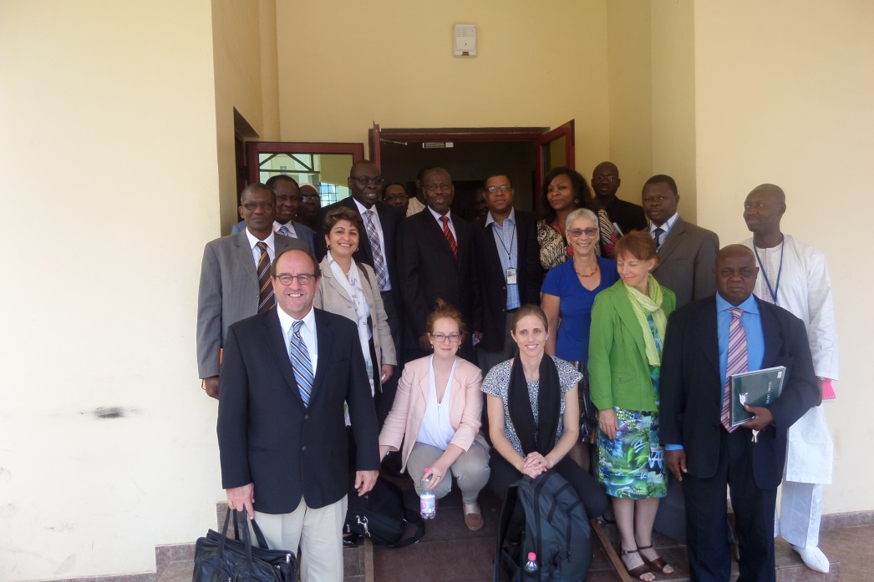
INSPQ (Institut National de Santé Publique du Québec) | Alain POIRIER  Lucie LEMIEUX  Anne FORTIN
CDC-USA | Rana HAJJEH  Jennifer HARRIS
John Hopkins University | Amiata KABA
WHO | HQ  Stella CHUNGONG (Mission Lead)  Catherine SMALLWOOD  Paul COX  Jean Christophe AZE  AFRO  Adama BERTHE  Vincent SODJINOU  WCO  Ibrahima-Soce FALL (WHO Representative)  Cheik Oumar COULIBALY

Annex B: List of Mali Committees for EVD Planning and response

- Comité de coordination des activités de prévention et de prise en charge de la MVE (16 réunions) présidé par le Ministre de la Santé
- Comité interministériel permanent de gestion des Epidémies (5 réunions) présidé par le Ministre de la santé
- Comités permanents régionaux et locaux de gestion des épidémies présidé par les Gouverneurs de région et les préfets

Annex C: Strengths and weaknesses (Francais)

 | Forces | Points à améliorer
Coordination | - Existence Comité interministériel au niveau politique  - Existence d’un task force;  - Organisation régulière des réunions;  - Mobilisation initiales de ressources financières locales | - Absence d’un centre opérationnel d’urgence;  - Fragmentation des attributions entre plusieurs structures avec absence de mécanisme de travail en équipe;  - Non formalisation de l’existence des structures techniques;
Surveillance épidémiologique | - Existence des définition de cas;  - Circuit d’information fonctionnel;  - Disponibilité des ressources humaines formées;  - Contrôle au niveau des frontières | - Non disponibilité des définition de cas dans toutes les formations sanitaires;  - Non prise en compte des acteurs du privé dans les sessions de formation déjà réalisées
Equipes de Réponse Rapide | - Existence d’un responsable de l’équipe d’intervention rapide;  - Gestion de cas suspects par le responsable de l’équipe d’intervention rapide | - Insuffisance de ressources humaines;  - Absence de nomination formelle des membres de l’EIR;  - Difficulté à travailler avec les autres structures techniques en charge des volets
Mobilisation sociale / Engagement communautaire | - Existence d’une structure nationale dédiée a la mobilisation sociale / engagement communautaire;  - Existence d’associations structurées et décentralisées des acteurs communautaires;  - Elaboration de matériels et supports de communication | - Non désignation d’un porte parole au sein de la commission;  - Absence de sous commissions thématiques;  - Messages non encore adaptés aux déterminants des violences observées lors de la gestion des alertes
Prévention et lutte contre les infections | - Disponibilité d’équipements de protection individuelle;  - Existence de points de lavage des mains aux cordons sanitaires | - Agents de santé non formés sur les mesures de prévention de l’infection;  - Absence de points dans les sites de transit des cas suspects;  - Non pré positionnement du matériel dans les sites
Prise en charge des cas | - Existence de centres de traitements en cours de constructions | - Insuffisance numérique et qualitative des centres de traitement;  - Acteurs non formés sur la prise en charge des cas et sur les enterrements sécurisés;  - Non identification formelle des équipes dédiées à la prise en charge des cas
Laboratoire | - Existence d’un laboratoire du niveau P3;  - Existence de techniciens de laboratoire formés;  - Existence de kits labo | - Non pré positionnement des kits Labo;  - Absence de moyens des transport des échantillons au niveau régional et périphérique
Capacités aux Points d’entrée | - Existence de 33 cordons sanitaires;  - Existence de centres de transit au niveau des frontières;  - Dépistage effectif des malades au niveau des points d’entrée | - Non conformité aux normes des centres de transit;  - Absence de moyens de transport des cas suspects
Budget global pour l’épidémie | - Existence d’un plan de contingence budgétisé;  - Création d’une régie spéciale pour faciliter les décaissements;  - Disponibilité de l’appui des partenaires | - Difficulté de mobilisation des fonds;  - Insuffisant pré positionnement des fonds dans les régions et les districts

Annex D: Areas for Improvement

Principaux points d’amélioration pour la Maladie du Virus Ebola (MVE) au Mali
Mission conjointe OMS-CDC-INSPQ auprès du Mali
- Coordination
- Créer un système de coordination opérationnelle des différentes équipes techniques sous la responsabilité du chef d’équipe de réponse.
- Créer un centre des opérations d’urgences (COU) avec un organigramme fonctionnel pour assurer la coordination technique et le suivi régulier de la mise en œuvre des interventions.
- Formaliser la création des équipes techniques (sous-comités techniques) par la prise des arrêtés / décisions de nomination officielle des points focaux (avec pouvoir de décision opérationnelle) et des membres et leurs attributions/termes de référence.
A l’endroit du centre opérationnel d’urgence
- Intégrer toutes les ressources humaines disponibles dans le dispositif de préparation et de réponse sous la coordination du chef de file.
- Renforcer les capacités des ressources humaines (par thématique selon les attributions).
- Assurer les moyens logistiques pour les équipes techniques (équipements de prélèvements et prévention de l’infection, transports, infrastructure, télécommunications, ordinateurs etc.).

- Budget global
- Actualiser le budget détaillé par composante du plan de contingence en y incluant le centre opérationnel d’urgence.
- Présenter le gap budgétaire aux partenaires pour financement.
- Pré positionner les fonds opérationnels pour faciliter le travail des équipes sur le terrain.

- Surveillance épidémiologique
- Créer et renforcer un centre d’appels pour l’exploitation des lignes vertes qui fonctionnent 24h sur 24.
- Renforcer la surveillance communautaire pour la détection des cas suspects de la maladie a virus Ebola.
- Mettre en place une équipe de gestion des données au niveau du centre opérationnel d’urgence avec une base de données et des outils de collecte et de suivi.

- Prévention et contrôle des infections
- Accélérer la mise en place du minimum standard pour la prévention des infections dans toutes les structures de soins du pays.
- Développer et mettre en œuvre les procédures opérationnelles standards pour la prévention et le contrôle de l’infection de la MVE dans tous les centres de santé.

- Les équipes d’intervention rapide
- Renforcer la constitution de l’équipe d’intervention rapide du niveau national.
- Mettre en place des équipes d’intervention rapide au niveau des régions et des districts sanitaires.

- Prise en charge des cas

Centres de traitement :
- Augmenter le nombre de centres de traitement des cas (2 à Bamako et un centre dans chaque région) et de façon urgente :
- Finaliser rapidement les deux centres de traitement de Bamako (CNAM, hôpital du Mali) et les opérationnaliser selon les normes internationales.
- Mettre en place dans les meilleurs délais des centres de traitement des cas a Kayes et Sikasso.

Sites d’observation :
- Transformer les centres d’isolement actuels en centres de transit ou d’attente de transfert vers les centres de traitement nationaux ou régionaux et les équiper du minimum nécessaire pour les soins et la prévention de l’infection.
- Prévoir dans chaque CSREF une salle d’observation (de deux lits) des cas suspects éventuels avec le minimum requis pour les soins et la prévention de l’infection.

Inhumation sécuritaire :
- Mettre en place des équipes chargés des enterrements sécurisés et dignes selon les normes de l’OMS.

- Identification et suivi des contacts
- Développer les procédures opérationnelles standards pour l’identification et le suivi des contacts.
- Décentraliser les équipes d’identification et de suivi des contacts.

- Mobilisation sociale et engagement des communautés
- Impliquer les mobilisateurs / relais dans la sensibilisation et la détection des cas au niveau communautaire.

- Activités du Laboratoire
- Elaborer une liste des techniciens de laboratoire formés dans le cadre de la lutte contre la maladie a virus Ebola.
- Affiner le dispositif de transport des échantillons.

- Dépistage aux points d’entrée
- Renforcer le processus de transport des cas suspects des points d’entrée vers les centres de transit ou de prise en charge.

Annex E: Suggested EOC / IMS structure
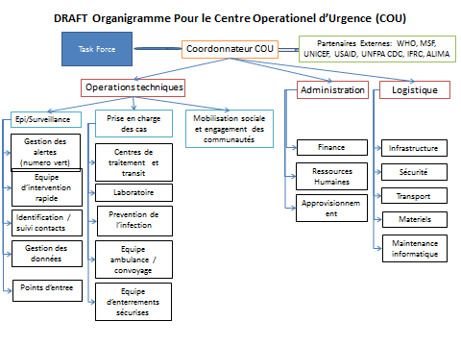

Annex F: Checklist results

Component 1 – Overall coordination
 | Tasks | Within | Y/N.
1.1 | Emergency & epidemic committees / Ebola Task Force (ETF)  Existence of multisectoral, functional, Ebola Task Force (ETF) / Committee and technical subcommittees at national and district levels; Pre-existing emergency / epidemic committee transitioned into an ETF  Membership to the ETF at national and sub-national level in “at risk” districts reviewed and updated, and every one informed  of the roles and responsibility  Technical sub-committees of the ETF with focal points and clear mandate constituted  Existence of clear TOR of ETF and technical sub-committees  Established procedures for command & control, coordination mechanisms, clearance of key technical and information products  Country UN office is coordinating donor support at the country level  Review of current policy and legislative frameworks to ensure that they will provide the authorization for the preparedness measures (including financing) that are proposed | 30 days | Y
1.2 | Emergency Operations Centre (EOC)/ Incident Management Structure (IMS):  Establish nationally to cover areas of low and high population density  Identify, train and designate Incident Manager and Operations Manager  Demonstrate success during drills  Establish personnel at the subnational level for localized EOC/IMS coordination and management  Develop plans for communication channels within EOC/IMS and between EOC/IMS and the public  Clearly assign communication responsibilities to specific EOC/IMS roles | 30 days | N

Component 2 – Rapid Response Team
 | Tasks | Within (days) | Yes/No
2.1 | Identify and assign members of the teams | 30 | Y/N
2.2 | Train medical staff on EVD RRT | 30 | Y
2.3 | Train medical staff using WHO-AFRO modules applied in Liberia, including mock ETC | 30 | N
2.4 | Identify a space in an existing health facility and turn it into a fully functioning ETC | 30 | Y
2.5 | Map potential health facilities at the district level that can be turned into ETCs at short notice | 30 | N
2.6 | Identify and train community volunteers in the community | 60 | N
2.7 | Train the epidemiologists in subnational RRT as part of the second level 24h/7 hotline service | 60 | N
2.8 | Ensure that there is no cash-flow problem and a contract-facilitation mechanism | 60 | N
2.9 | In the absence of an EVD case in the country after 60 days, conduct at least one simulation exercise to maintain capacity | 90 | N

Component 3 – Public awareness and community engagement
 | Tasks | Within (days) | Yes/No
3.1 | Develop or adapt, review, translate into local languages and disseminate targeted messages for media, health care workers, local and traditional leaders, churches, schools, traditional healers and other community stakeholders | 30 | Y
3.2 | Identify and engage influential/key actors/mobilisers, such as religious leaders, politicians, traditional healers, and media in urban and rural areas | 30 | Y
3.3 | Map out public communication capacities and & expertise within health and other sectors | 30 | Y
3.4 | Identify and establish mechanisms for engagement with national networks for social mobilization | 30 | Y
3.5 | Identify established functional communication coordination mechanism involving all government sectors and other stakeholders (including civil society organisations and communities) | 30 | Y (NGO)
3.6 | Establish coordination mechanism for engaging with the community (involving the traditional leaders, relevant sectors in a bottom-up approach) | 30 | Y (NGO)
3.7 | Establish coordination mechanism for engaging with partners (e.g. NGOs) | 30 | Y
3.8 | Draw up a roster with clear roles and responsibilities for internal and external communications and spokespersons | 30 | N
3.9 | Establish functional and timely procedures for review, validation and clearance of information products | 30 | Y
3.10 | Identify and train spokespersons and communication team | 30 | N
3.11 | Develop a comprehensive strategy, plan and budget for engaging with the media and public (including a scaled-up approach) | 30 | Y
3.12 | Establish a system for rumour monitoring, investigation and response | 30 | N
3.13 | Establish a plan for reviewing, revising and monitoring impact of communication strategy | 30 | Y
3.14 | Identify critical communication networks (TV, radio, social media, SMS, story tellers, theatre) and plan for use in appropriate languages | 30 | Y
3.15 | Establish media monitoring mechanisms with appropriate tools | 30 | Y/N

Component 4 – Infection Prevention and Control
 | Tasks | Within days | Yes/No
4.1 | Provide health facilities with basic hygiene, sanitation, disinfection/protective equipment and posters. Priority should be given to hospitals; then health centres in high risk areas (started in 30 days and to cover priority districts in 60 days) | 30 – 60 | Y
4.2 | Increase the general awareness about hygiene and how to effectively implement infection prevention and control (started in 30 days and completed in 60 days for priority districts) | 30 – 60 | N
4.3 | Identify health facilities for setting up basic isolation units (2 beds) for suspected cases in all major hospitals and all border points (ideally regional and district hospitals) | 30 | N
4.4 | Establish a compensation and benefits package for health care workers (HCWs) for:  - remuneration and motivation for high-risk assignment;  - in case of infection and death | 60 | N

Component 5 – Case management
5a) Ebola Treatment Centre (ETC)
 | Tasks | Within (days) | Yes/No
5a.1 | Set up at least one facility with trained staff, adequate supplies, ready to provide care to a patient or cluster of patients with suspected EVD. This facility should cater for 15 patients initially. | 30 | N
5a.2 | Equip and adequately train ambulance teams to transport suspect EVD cases | 30 | N
5a.3 | Identify health facilities at district level that can be turned into an ETC at short notice | 30 | N
5a.4 | Identify health facilities at local level that can be turned into an ETC at short notice | 60 | N

5b) Safe burials
 | Tasks | Within (days) | Yes/No
5b.1 | Develop SOPs for safe burials and decontamination | 30 | Y
5b.2 | Identify appropriate secured burial ground with agreement of the community | 30 | Y
5b.3 | Train burial team (8 people) | 30 | N
5b.4 | Ensure that a dedicated transportation process is in place to bury human remains safely | 30 | N

Component 6 – Epidemiological Surveillance
 | Tasks | Within (days) | Y/N
6.1 | Establish a 24/7 hotline with escalation facilities with medically trained staff | 30 | Y
6.2 | Train the hotline staff on case identification and management of communication with potential cases | 30 | Y
6.3 | Provide guidance (case investigation forms, standard case definitions to all countries) | 30 | Y
6.4 | All countries to test existing IDSR systems for Ebola, identify gaps and start implementation of corrective actions where necessary | 30 | N
6.5 | Establish immediate lines of reporting for suspect cases, clear responsibility for such actions | 30 | Y
6.6 | Identify human resources for community surveillance (community HCWs, Red Cross/Crescent volunteers, NGOs, midwives, healer, leaders etc.) | 30 | N
6.7 | Provide Technical Assistance and training to address the still existing gaps in IDSR | 60 | N
6.8 | Distribute case definitions to all provincial, district levels and healthcare facilities; provide training on the case definition | 60 | Y/N
6.9 | Disseminate simplified case-definitions for community use | 60 | Y

Component 7 – Contact Tracing
 | Tasks | Within (days) | Yes/No
7.1 | Train the teams at both national and subnational levels from RRTs and ToT on contact tracing and data management | 30 | Y
7.2 | Provide UNMEER with list of required equipment and materials for contact tracing at National and sub-national levels | 30 | N
7.3 | Train staff at district level on contact tracing | 60 | N
7.4 | Train staff at sub district and community level on contact tracing | 90 | N

Component 8 – Laboratory
 | Tasks | Within (days) | Yes/No
8.1 | For each district, identify laboratory responsible for analysis and /or specimen handling of biological samples and mode of transport for samples | 30 | Y
8.2 | Stand-by arrangements and agreements with WHO Collaborating Centres for confirmatory testing in place | 30 | Y
8.3 | Stand-by arrangements and agreements with relevant air-lines to ship samples from suspected cases to WHO collaborating Centres in place | 30 | Y
8.4 | Availability of resources to facilitate transportation and shipment of specimens | 30 | Y
8.5 | Existence of protocol for:  - sample collection;  - referral and shipment of specimens from suspect EVD cases to designated laboratory for confirmation at national and sub-national public health laboratories | 30 | Y
8.6 | Laboratory personnel trained on procedures for specimen collection, packaging, labelling, referral & shipment, including handling of infectious substances | 30 | N

Component 9 – Capacities at Points of Entry
 | Tasks | W. | Y/N
9.1 | Identify PoE teams to cover 24/7, to assist travellers and ensure correct isolation if required | 30 | Y
9.2 | Deliver identified supplies (9 PPE full sets at each PoE Medical equipment to survey cases 3 Infrared Hand held Thermometers, 1 Scanner, 2 Observation room/ 2 Health facilities and supplies for safe isolation and observation of suspect cases if possible separation room, if not, a separated area. Depending on the geographical location, 1 Ambulance) to PoEs. Every PoE needs to have either a separation room of a dedicated area for holding suspected cases | 30 | Y/N
9.3 | Train staff on IPC (Training of Trainers) | 30 | Y
9.4 | Identify “holding” center/area | 30 | Y
9.5 | Ensure that a health emergency contingency plan is in place at high risk PoE (ports, airports, and ground crossings) | 30 | Y
9.6 | Equip and appropriately staff sites for health assessments and management of suspected ill travellers at all PoE | 30 | Y
9.7 | Avail SoPs to identify, manage and refer suspected ill patients from PoE to designated hospitals /isolation facility | 30 | Y
9.8 | Review and test current communication system between health authorities and conveyance operators at PoE, and national health surveillance systems | 30 | N
9.9 | Sensitize public health authorities at PoE to EVD, review their roles and processes for handling, reporting and for referral of suspected cases of EVD | 30 | Y
9.10 | Avail SOP for implementing exit screening in the event of a confirmed EVD outbreak | 30 | N
9.11 | Review systems and procedures for implementation of health measures related to IPC | 30 | N

Component 10 – Overall budget for outbreak
 | Tasks | Within (days) | Yes/No
10.1 | Define operational budget for activities (communication, enhanced surveillance, investigation, etc.), pre-epidemic detection and for the preliminary response | 30 | Y
10.2 | Identify funding sources, including allocation of domestic resources and mechanisms to raise additional resources when necessary, has been put in place and is known | 30 | Y
10.3 | Develop templates for resource mobilization and for country and donor reporting, including mechanisms to monitor and track implementation | 30 | Y
10.4 | Establish easily accessible contingency funds for immediate response to outbreak of EVD at national and other appropriate sites | 30 | Y
10.5 | Identify the process to transfer money from central level to local emergency use | 30 | Y

Annex G: Table top exercise results

Évaluation de la discussion sur le scénario et améliorations suggérées
De façon générale, la discussion préparatoire à la simulation terrain a généré beaucoup d’intérêt et de commentaires malgré que les réponses au scénario présenté pour stimuler la discussion sur les composantes du plan de préparation et de réponse provenaient d’une poignée d’intervenants. En effet, nous ne retrouvions pas des équipes pour toutes les composantes de la “checklist” de l’OMS. Le temps prévu ne nous a pas permis de discuter tous les éléments du scénario.
Un fiche de rétroaction a permis de dégager les points principaux à partir de questions ouvertes sur les enjeux relevés et les besoins d’amélioration. Les réponses ont été regroupées dans le tableau qui suit selon les composantes de la checklist.
Composantes | Points d’amélioration | /25
Coordination | Le point le plus souvent mentionné par les répondants. Surtout sous l’angle du besoin, mais également avec des suggestions de clarifier les responsables, de renforcer le comité de gestion des maladies infectieuses, et de créer un COU. Quelques participants ont mentionné percevoir une résistance des autorités à admettre les lacunes ou même un manque de volonté politique | 13
Unité de réponse rapide | Sans nécessairement nommer l’unité plusieurs participants indiquent un besoin d’améliorer ou de clarifier la détection des cas, la question des prélèvements et de leur acheminement aux laboratoires | 9
Communication et Mobilisation sociale | Plusieurs suggestions d’augmenter les activités de communication en général, celles entourant les cas suspects. La gestion des rumeurs et le besoin de transparence ont été également mentionnés | 11
Prévention et contrôle des infections | Les conditions et la localisation des sites d’isolement méritent d’être améliorées selon plusieurs | 12
Gestion des cas | La prise en charge des cas confirmés doit être améliorée pour plusieurs et quelqu’un mentionnent au niveau des CSRef | 10
Gestion des enterrements | Besoin d’amélioration avec implication de la communauté | 3
Surveillance épidémiologique | La surveillance n’est pas ressortie | 0
Recherche de contacts | Des améliorations sont attendues notamment en matière de formation | 10
Laboratoire | Une seule mention | 1
Points d’entrée |  | 4
Autres thèmes | Le rehaussement du nombre de ressources humaines, de leur formation, des équipements, de ressources financières, de l’eau et des déchets sont également mentionnés | 4,3,3,3,2,1,1

Par ailleurs, des commentaires généraux ont été mentionnés. La discussion, son animation, la mission et le besoin d’autres simulations ont été évoqués par 5 participants, alors que deux personnes critiquent les palabres déjà entendus et réclament de passer à l’action.
La fiche d’évaluation de la discussion aussi appelée “simulation de table” comportait des questions d’appréciation sur l’atteinte du but établi, sur la qualité des discussions et l’utilité des leçons. L’accord avec les trois énoncés retrouvés dans le prochain tableau était supérieur à 95%.
Contenu | Fortement d’accord | D’accord | En désaccord | Fortement désaccord
1. La discussion a atteint le but établi. | 25% | 71% | 4%
2. Les scénarios et les questions ont donné lieu à de bonnes discussions. | 36% | 64%
3. Le travail a permis de soulever d’importantes questions et de tirer des leçons utiles. | 40% | 56% | 4%

Annex H: Simulation exercise

Actions attendues de la Simulation
ASPECT | MESURE PRÉVUE | PAR QUI | QUAND
État de préparation à l’importation de cas d’Ebola | Au poste douanier, le cordon sanitaire a été mis en place. Une équipe sanitaire (2 agents de santé pour chaque cordon sanitaire) est en place avec un thermomètre infra-rouge. Tous les voyageurs sont vérifiés. | 2 agents de santé dans chaque cordon sanitaire
 | 33 cordons sanitaires, 17 sites d’isolement
 | Directives disponibles : de définition de cas, de liste des passagers, des dispositifs d’intervention d’urgence. Les directives ont été distribués à tous les cordons sanitaires  Formation : réalisée auprès des agents de santé | Direction nationale de santé
 | Le véhicule est immobilisé. L’Équipe d’intervention rapide est appelée. Les autres passagers sont maintenus sur place jusqu’à la réception des résultats. Si les passagers refusent de rester. La police est appelée.
 | Le patient est amené à :  Unité d’évaluation et si répond à la définition de patient suspect;  Unité d’isolement | Agents de santé
 | L’autobus est désinfecté. Les agents de santé font la désinfection. | Agents de santé
 | Les bagages sont conservés dans un endroit. Pas de directive pour les bagages. «On n’y touche pas durant la période d’attente».
 | Poste douanier : latrines publiques. Elles sont désinfectées régulièrement | Agents de la douane
Notification | Il existe un système de communication vers le médecin-chef du district (selon la hiérachie).
Coordination et communication interne | Dès qu’un patient est suspect, la communication est faite vers le médecin-chef et vers l’équipe d’intervention rapide, simultanément. | Agents sanitaires | 1 numéro bleu (équipe de garde Dr Sow)
 | Les numéros verts : La ligne Orange ne fonctionne pas toujours (problème technique qui doit réparer par les opérateurs). La ligne Malitel fonctionne bien.  Il n’y a pas de couverture 24/7 de la igne verte. Il faut développer un centre d’appel. |  | 2 numéros verts (médecins de garde de la direction nationale de la santé)
 | Il n’existe pas de stratégie de communication pour les patients, pour le personnel. Il y a une stigmatisation des patients et du personnel.
 | Des affiches ont été distribuées dans les CSComm, CSRef. Pas des cliniques privées. Pour l’information de masse seulement.
Prise en charge du patient | Au cordon sanitaire : les agents sanitaires font l’évaluation, puis téléphone l’équipe d’intervention d’urgence.
 | Au CSRef : Les bureaux d’accueil sont informés des directives. Ils doivent appelés la ligne verte.  Les premiers cas n’ont pas été gérés selon les normes.  Dr Sow. Dès que le personnel craint Ebola, il fuit. Et l’équipe d’intervention d’urgence est appelée. | Direction nationale de la santé
 | Les unités d’isolement (cordon sanitaire).  1er plan. Quatre tentes. Chaque tente correspondant à une fonction : habillage, personnel, cas suspects, cas confirmés.  Plans suivants. Trois tentes ou cabanes. 6 investissements importants pour des sites d’isolement. | Direction nationale de la santé
 | Formation centres de santé : Il n’y a pas de personnel dédié. Il n’y a pas de formation spécifique pour Ebola.  67% ne connaissent pas les pratiques de base.  La division hygiène et salubrité de la direction nationale de la santé est responsable de la formation des agents sanitaires pour la PCI. Il existe un traité technique pour la PCI, des modules de formation, un guide du formateur et une participation à la semaine de l’hygiène des mains. Non-spécifique pour Ebola. | Direction nationale de la santé - Division hygiène et salubrité.

Combien de structures d’isolement sont prévues? Outre le CNAM et les unités près de frontières.

Besoin d’eau dans les unités d’isolement. CNAM OK

Sécurité des patients. Il faut augmenter la sécurité.

Plan B. L’Hôpital du Mali. Advenant le cas où il y aurait plus de patients qui dépasse la capacité du CNAM.
 | Gestion des corps. Il y a un besoin de mettre en place des équipes d’enterrement. Les techniciens sanitaires seraient responsables des enterrements. Certains techniciens sanitaires ont été formés.  Des «sprayers» doivent être identifiés et formés. | Direction nationale de santé
Santé publique
Recherche de contacts | L’équipe d’intervention rapide contacte l’INRSP avec une liste de contacts. L’INRSP souhaite vérifier la liste de l’équipe d’intervention rapide. La concertation est difficile. «pas de réponse de l’équipe d’intervention rapide» «l’équipe d’intervention rapide est une seule personne».  La directrice fait le suivi des cas. Les patients ne souhaitent pas de visite. Ils ne souhaitent pas non plus faire eux-mêmes les visites à une clinique de peur d’être stigmatisés.  Il n’y pas eu de formation de suivi des contacts. | INRSP  Croix-Rouge pourrait apporter un soutien (ce qui est fait dans d’autres pays)
Transport | Le transport du patient et des prélèvements est fait par l’équipe d’intervention rapide. Les transporteurs portent l’EPP. Une désinfection des véhicules est faites.  À la douane, le transport s’improvise. Il n’y a pas d’ambulance.  Il est prévu que le transport se ferait par ambulance vers le centre de traitement de l’Ebola CNAM).
EPP
Décontamination – éléments à prendre en considération | Il n’y a pas d’équipe de décontamination (à la douane, dans les unités d’isolement, au centre de traitement, des corps etc.) – sprayer.
Communications – médias et public | Les communications médiatiques. La nouvelle part très vite à tous les niveaux : politique, administratif, population. Pas de porte-parole établi.
 | Un plan de communication et plusieurs stratégies de communication existent et sont annexés au plan de contingence.  Des centaines de radios ont été distribuées. | Ministre de la santé informe la population
 | On mise sur les relais communautaires et leaders religieux pour la communication à la population.
Labos | Les prélèvements SEREFO.
Financement | Aucune discussion à ce sujet
Coordination | La formalisation de la structure de coordination, comités techniques est important. Il y a un besoin de centre de commandement.  Du point de vue technique | Comité interministériel  Préfets, coordonnateurs des régions
Suivis

Rapport de l’exercice de simulation au centre hospitalier Gabriel Touré
Au centre hospitalier Gabriel Touré
- Accueil et evaluation
Le patient arrive en taxi au centre hospitalier Gabriel Touré. Des affiches sont présentes dans la salle d’attente pour que ceux-ci informe la réception de la présence de symptômes de fièvre ou de toux. Le patient accepte de porter un masque et de s’installer dans une section distincte de la salle d’attente.

L’infirmier voit le patient, puis le médecin de service.

Réponse attendue |  | Indicateurs⁽¹⁾ | Observation
Évaluer le patient rapidement  Hygiène des mains  Mesures générales :  - Ne pas serrer la main  - Maintenir une distance d’au moins 1 mètre entre l’interviewer et l’interviewé  - EPI non indiqué si personne asymptomatique (sans fièvre, diarrhée, vomissements ou saignements), si la distance est maintenue et s’il n’y a pas de contact avec l’environnement  - Des solutions hydro-alcooliques et les techniques d’hygiène des mains sont disponibles et appliquées par les interviewers |  | Application des mesures générales | Satisfaisant  Directive établie dans centre hospitalier de ne pas serrer la main.  Maintien d’une distance d’au moins 1 mètre.  Constats :  Aucune affiche présente à l’accueil.  Lavabo non fonctionnel. Aucun savon. Aucune solution hydro-alcoolique par l’hôpital. Fourniture individuelle.  Recommandations :  S’assurer de rendre disponible des lavabos fonctionnels dans les aires d’accueil. S’assurer de la disponibilité par le centre hospitalier de savon. S’assurer de la disponibilité par le centre hospitalier de solutions hydro-alcooliques.
Questionnaire :  Symptômes significatifs : Fièvre, céphalées, myalgie, toux, mal de gorge, douleurs abdominales, vomissements, diarrhées, hémorragies  Facteurs d’exposition : contacts significatifs dans une région à risque |  |  | Satisfaisant  Constats :  Les symptômes ont été sollicités.  Cependant, il n’y a pas eu de question sur la nature de l’exposition : à Conakry, mais aucune investigation sur les contacts avec des patients atteints d’une maladie à virus Ebola.  Recommandations :  Rendre disponible à l’accueil (tous les accès possibles du centre hospitalier: urgence, consultation générale, obstétrique, pédiatrie etc.) la directive et la définition de cas. Former le personnel d’accueil pour tous les accès du centre hospitalier.
Si le patient répond à la définition de cas suspect :  EPI : masque, gants, blouse imperméable (sur medical scrubs), matériel à usage unique ou dédié  Toilette (ou chaise d’aisance) est dédiée  Limitation des visiteurs et aux personnes qui entrent dans la pièce  Registre des entrées dans la pièce |  | Connaissance des mesures, spécifiquement de la méthode de revêtement et retrait de l’EPI  Séances de formation | Satisfaisant  L’EPI est disponible (N=10)  L’habillage s’est fait avec l’aide d’une seconde personne. L’ordre de l’habillage a été respecté avec l’aide d’un tableau fourni dans la boîte de l’EPI.  Les visites sont limitées. Par exemple, on demanderait à la conjointe de visiter son mari de loin accompagné par le médecin.  Nb de séances de formation : Aucune  Constats :  Le patient a été amené sur pied accompagné par le médecin, puisque sa condition clinique le permettait. Ceci n’était pas prévu dans le scénario, ce qui a créé de la confusion. Le scénario a été adapté : 1) le patient devient malade dans la pièce d’isolement et 2) le personnel doit porter l’EPI.  Le personnel a revêtit l’EPI à deux endroits : les 2 infirmières dans une salle à part et le vêtement médecin près de la pièce d’isolement.  Aucun affichage sur les mesures de prévention et de contrôle des infections sur la porte.  Habillage : Difficile. Pas de «médical scrub». Aucune hygiène des mains (pas de lavabo, pas de solution hydro-alcoolique).  Déshabillage : Très difficile. Multiples erreurs dans l’ordre du déshabillage et dans la contamination. Aucune technique de retrait des gants. Aucune hygiène des mains.  L’EPI est placé dans la boîte de carton de USAID. Il est trop petit (combinaison biologique, gants). On nous rapporte que tous les EPI ont la même grandeur. L’étiquette de grandeur de l’EPI est placée à l’intérieur de la combinaison biologique, conséquemment difficilement visible à moins de rendre accessible une armoire avec un rangement en fonction des tailles (small, medium, larde, Y-large) .  Aucun matériel dédié dans la pièce d’isolement. Technique de désinfection inconnue par le médecin. Le médecin rapporte qu’il mettrait son stéthoscope dans un gant pour éviter le contact direct avec le patient. Aucun contenant piquant-tranchant. Aucun contenant pour la gestion des déchets.  Une toilette et un lavabo est présent au fond de la pièce d’isolement pour le patient.  La pièce d’isolement est définitivement trop petite pour assurer une prise en charge sécuritaire pour les travailleurs de la santé. Il n’y a pas de place prévue à la sortie pour l’hygiène des mains (pas de lavabo, pas de solution hydro-alcoolique), ni de place suffisante dans la pièce pour le déshabillage.  Recommandations :  S’assurer d’une pièce d’isolement adéquate selon les standards de l’OMS afin d’assurer la sécurité des travailleurs de la santé et des visiteurs.  S’assurer d’un accès près de la pièce d’isolement à des lavabos, savon et solutions hydro-alcooliques.  Faire l’affichage des mesures de PCI sur la porte de la pièce d’isolement.  Également faire l’affichage pour le personnel des étapes d’habillage et de déshabillage.  Revoir l’approvisionnement de l’EPI (imperméabilité et grandeurs de la combinaison biologique et gants) selon les standards de l’OMS.  Rendre disponible du matériel dédié pour les soins du patient.  Former tous le personnel de soins (Infirmiers, agents sanitaires, agents de désinfection, et toutes autres personnes aux soins du patient).
Ajout EPI : botte (ou couvre-chaussures), protection oculaire/faciale, cagoule, deuxième paire de gant |  | Connaissance des mesures, spécifiquement de la méthode de revêtement et retrait de l’EPI | Satisfaisant  Constats : Ne s’applique pas. Les bottes et cagoule sont intégrées à la combinaison biologique. La protection oculaire et deuxième paire de gants sont mis d’emblée.
Le médecin confirme qu’il s’agit d’un patient suspect de la maladie à virus Ebola. Il communique avec le patient et la conjointe.
Le directeur médical est informé. |  |  | Satisfaisant : OUI  Le directeur médical a été informé selon la hiérarchie.  Constats :  Recommandations :  Aucune
L’Équipe d’intervention rapide est contactée pour l’évaluation initiale, la recherche des contacts, la notification aux autorités de santé publique |  |  | Satisfaisant  Constats :  Le directeur médical a contacté directement le Dr Samba Sow, responsable de l’équipe d’intervention rapide. Il n’a pas le numéro de la ligne bleu.  Délai : 20 minutes entre l’appel et l’arrivée de l’équipe d’intervention rapide.  Recommandations :  S’assurer d’une ligne de garde 24 / 7 et de diffuser les coordonnées de l’équipe d’intervention rapide.
Le patient est transféré à l’unité d’isolement de base pour sa prise en charge, en attendant la confirmation ou l’infirmation du diagnostic de maladie à virus Ebola.
L’unité d’isolement est informée du transfert. Pour le transfert le patient procède à l’hygiène des mains et porte un masque et une blouse. Le brancardier porte l’EPI.  Gestion de la literie souillée et des déchets biorisques.  Décontamination de la pièce et toilette. | Information préalable au transfert  Connaissance des mesures par le brancardier, spécifiquement de la méthode de revêtement et retrait de l’EPI  Gestion de la literie souillée  Décontamination de la pièce et de la toilette |  | Satisfaisant  Constats :  Voir ci-haut.  Aucun contenant pour la gestion des déchets. Aucune désinfection ni à l’accueil, ni à l’unité d’isolement  Recommandations :  S’assurer d’une gestion des déchets selon les standards de l’OMS.  S’assurer d’une désinfection de l’environnement selon les standards de l’OMS.  Former adéquatement le personnel de gestion des déchets et de désinfection de l’environnement
Cliniciens, infirmières, hygiénistes, personnes en charge de la promotion de l’hygiène, personnes en charge de l’hygiène de l’environnement | Ressources humaines |  | Satisfaisant  Des médecins et infirmiers sont présents.  Constats :  Pas de présence d’hygiéniste, personne en charge de la promotion de l’hygiène, en charge de l’hygiène de l’environnement.  Recommandations :  S’assurer de la disponibilité d’hygiénistes, personnes en charge de la promotion de l’hygiène, personnes en charge de l’hygiène de l’environnement
Unité d’isolement, matériel de base d’hygiène, kits d’EPI (100), matériel de gestion de l’environnement, de désinfection et de protection (gants, savons, eau chlorée, désinfectant), installations de gestion des déchets, fournitures médicales, incinérateurs | Équipement/matériel |  | Satisfaisant  Nb de lits d’isolement : un lit – Voir constats et recommandations ci-hauts  Nb de kit d’EPI : Un dizaine de kits d’EPI  Constats : Pas de matériel de base d’hygiène. Pas de matériel de gestion de l’environnement, de désinfection. Pas de fourniture médicale dédiée. Pas d’installations de gestion des déchets. Pas d’incinérateurs.  Recommandations :  Rendre disponible par le système public le matériel nécessaire.
Documents techniques :  Définition de cas  Directives | Ressources documentaires sur place |  | Satisfaisant Préciser :  Constats :  Pas de définition de cas.  Aucune autre directive dans le centre hospitalier.  Recommandations :  S’assurer de la disponibilité des documents techniques selon les standards de l’OMS.
Mesures incitatives | Rémunération et motivation pour une affectation à risque élevée  Indemnités en cas d’infection et de décès |  | Satisfaisant Préciser :  Constats :  Aucune mesure incitative  Recommandations :  Assurer des mesures incitatives : rémunération et motivation et indemnités en cas d’infection et de décès.
Commentaires :
En aucun moment, il n’a été mentionné qu’il fallait faire la liste des contacts.
Il y aurait place à une meilleure higène de l’environnement dans la pièce d’isolement.

- Équipe d’intervention rapide : Prélèvements, emballage, transport des spécimens et prise en charge du patient
L’équipe d’intervention rapide arrive et évalue le patient. Le laboratoire de référence est informé de la réception prochaine de spécimens pour Ebola. Le protocole de prélèvement est validé (type de spécimen nécessaire pour Ebola, transport). Les prélèvements essentiels seulement sont faits (FSC, Frottis, glycémie, hémocultures, recherche Ebola /Marburg).
Les prélèvements sont transportés au laboratoire de référence. Un traitement antibiotiques et anti-malarial est donné d’emblée.

Réponse attendue |  | Indicateurs⁽¹⁾ | Observation
EPI pour l’évaluation et pour les prélèvements  Contenant no-touch au point de soins pour objets piquants/tranchants |  | Connaissance des mesures  Séances de formation  Contenant no-touch au point de soins dans un endroit sécuritaire | Satisfaisant  Nb de formation : Aucune  Constats :  Deux techniciens se sont déplacés pour l’exercice sans expérience ni formation. Ceux qui se déplacent habituellement étaient affectés pour l’évaluation et le prélèvement d’un cas suspect à Kayes.  Aucun contenant piquant-tranchant disponible  Recommandations :  Renforcer le dispositif d’évaluation du patient, de prélèvement et transport des spécimens sanguins afin de répondre à plusieurs demandes à la fois.  Assurer la formation adéquate aux techniciens de laboratoire.
Désinfection des tubes. Dépôt dans un sac imperméable identifié «Biorisque – à décontaminer dans une enceinte biologique».  Dépôt avec la requête de laboratoire dans un second sac hermétique. Dépôt dans un contenant rigide et étanche. Décontamination du contenant avant de quitter l’unité de soins |  | Connaissance des mesures  Séances de formation | Satisfaisant  Nb de séances de formation : Aucune  Constats : Les techniciens alloués à l’exercice n’étaient pas informés de la technique du triple emballage.  Recommandations :  S’assurer de la formation adéquate aux techniciens de laboratoire.
Laboratoire de niveau 3  Laboratoire de niveau 4  Mode de transport/Entente de disponibilité  Ententes de collaboration |  | Laboratoire de niveau 3  Laboratoire de niveau 4  Entente de disponibilité pour le transport  Entente de collaboration avec centre OMS de confirmation | Satisfaisant  Le Mali a développé un laboratoire de niveau 3 (SEREFO). Une entente de collaboration est établie avec le laboratoire OMS-Dakar. Des ententes pour le transport sont établies entre SEREFO et OMS-Dakar. Actuellement le transport entre le prélèvement et le laboratoire SEREFO est fait par l’équipe d’intervention rapide (Dr Samba Sow)  Constats : L’information sur les laboratoires, mode de transport et ententes ont été obtenues verbalement, en dehors de l’exercice de simulation.  Recommandation : Aucune
2 techniciens de laboratoire |  | Ressources humaines | Satisfaisant  Constats :  Deux techniciens sont convenablement formés pour tout le Mali actuellement. Ce ne sera pas suffisant advenant le cas où plus d’un cas se présenterait. Par ailleurs, des formations sont en cours pour d’autres techniciens.  Recommandations :  Recruter et former suffisamment de techniciens de laboratoire.
Ensembles de triple emballage, EPI, incinérateurs |  | Équipement/Matériel | Satisfaisant  Constats :  Aucun triple emballage dans le cadre de l’exercice. Il y en aurait disponible pour l’équipe d’intervention rapide. L’EPI est disponible pour les techniciens de laboratoire. Aucun incinérateur au centre hospitalier Gabriel Touré.  Recommandations :  S’assurer de la disponibilité du matériel pour le transport des spécimens et la gestion des déchets.
Documents techniques  - Prélèvement des spécimens  - Emballage et transport au laboratoire |  | Mode de transport | Satisfaisant  Constats :  Cet élément n’a pas été évalué.  Recommandations :  NA
Après quelques heures, le patient est confirmé pour la maladie à virus Ebola et est transféré au centre de traitement de l’Ebola.

Réponse attendue |  | Indicateurs⁽¹⁾ |  | Observation
Le centre de traitement contre l’Ebola est informé préalablement.  Les ambulanciers portent l’EPI (Masque, gants, blouses) et vérifient l’hygiène des mains et respiratoire et le port de EPI (masque).  Voir le revêtement et retrait de l’EPI des ambulanciers.  Gestion de la literie souillée et des déchets biorisques.  Décontamination de l’ambulance. | Connaissance des mesures, spécifiquement de la méthode de revêtement et retrait de l’EPI  Séances de formation |  | Satisfaisant  Nb de séances de formation : Aucune  Constats :  Le centre de traitement contre l’Ebola n’est pas encore opérationnel. Aucun transfert n’est fait pour l’instant.  Recommandations :  Finaliser les travaux du CVD – CNAM (12 lits) pour le traitement des patients confirmés de Ebola selon les standards de l’OMS. S’assurer d’un deuxième centre de traitement pour accueillir les patients au-delà de 12, le cas échéant.
Commentaires :

