EuropeAid/129522/C/SER/Multi
Contract number 2010/232-231
Air Quality Governance in ENPI East Countries
Training Needs Assessment (TNA)

Date: 15 September 2012

Revision | Date | Description | Prepared by (Authors) | Reviewed by
1 | 10.09.2012 | Training Needs Assessment Report | Dr.Nelly Gromkova, KE2 | Anca Andreescu, PM

Summary
Project Title: AIR QUALITY GOVERNANCE IN THE ENPI EAST COUNTRIES
Countries: Armenia, Azerbaijan, Belarus, Georgia, Republic of Moldova, Russian Federation and Ukraine
Focus country: All

Lead Contractor
Name MWH
Address Nysdam Office Park
Avenue Reine Astrid, 92
B-1310 La Hulpe
Belgium
Tel. number +32 2 6552237
Fax number +32 2 6552280
Contact person Antonio De Rose
Table of Content
1 The purpose of training needs assessment 5
2 Methods 5
2.1 Methods applied in 2011 5
2.2 Methods applied in in 2012 5
3 Respondents 5
3.1 Survey respondents in 2011 5
3.2 Survey respondents in 2012 6
4 Analysis of training needs during the first project year in 2011 6
5 Analysis of training needs during the second project year in 2012 8
5.1 Officials in the Ministries of Environment 8
5.1.1 Inventory Reporting under CLRTAP Protocols (Table 2) 8
5.1.2 EMEP/EEA emissions inventory guidebook (Table 3) 9
5.1.3 Activity data (Table 4) 9
5.1.4 Emission factors (Table 5) 10
5.1.5 Suggested improvements (Table 5) 11
5.1.6 COPERT4 software (Table 6) 12
5.1.7 Inventory team (Table 6) 12
5.2 Local emission inventory and air quality monitoring experts 18
Armenia 18
Azerbaijan 18
Belarus 19
Georgia 20
Moldova 21
Russian Federation 22
Ukraine 24
6 Final conclusions 26
6.1 General view 26
6.2 Specific view 26
7 Project team persuasion 27
7.1 Specific view 27
7.2 General view 27
8 Project team recommendation for training workshops and study tour events 28
Annex 1 Questionnaire on issues related to air quality management in East ENPI Countries 30
ARMENIA 30
Annex 2 Questionnaires on Inventory Compilation in East ENPI Countries 49

1 The purpose of training needs assessment
The main aim of this training needs assessment (TNA) was to evaluate the real training needs and capacity of potential participants to the Air-Q-Gov project workshops so as to guide the preparation of the topics, materials and the planning of the events.
TNA serves the following purposes:
- to get an overview of the level of skills of the target groups,
- to map the beneficiaries´ opinion on their needs for information and trainings,
- to analyse which country requires more attention and support in certain topics.

2 Methods

2.1 Methods applied in 2011
In the first project year the survey was carried out using both qualitative and quantitative methods mainly through questionnaire surveys. In order to obtain as much relevant data as possible, the questionnaire was prepared in Russian language, which is understood by all beneficiaries from the partner countries, and was distributed during the kick-off meetings. The questionnaires were tailored for each country, taking into account their specific circumstances, yet at the same time following the common structure. The example of questionnaires (i.e. questionnaire used for Armenia) is presented in Annex 1. The questionnaires were distributed both as hard copy during the kick-off meetings and in electronic version to the Focal Points.

2.2 Methods applied in in 2012
The survey targeted two different groups:
Officials in the Ministries of Environment
The assessment was carried out using a qualitative type of questionnaire. The questions focused on the emission inventories process, whose annual submission is obligatory for the countries under the CLRTAP and its protocols. In order to obtain as much relevant data as possible, the questionnaires were distributed in both English and Russian languages (see Annex 2). The data collected were subject to analytical analysis.
Local emission inventory and air quality monitoring experts
This part of the assessment was carried out using an open-ended questions, which were distributed to the local experts, part of the Air-Q-Gov team. The questionnaires were distributed electronically to the Focal Points and National Coordinators.

3 Respondents

3.1 Survey respondents in 2011
The questionnaires were distributed to the beneficiary institutions in six Partner Countries (except Azerbaijan), however only three of the Partner Countries, namely Belarus, Georgia and Ukraine (Table 1), returned the filled-in questionnaires. The low response rate and the absence of information from certain countries was partially explained by the fact that the National Coordinators were not in place until October 2011 and hence there was no local counterpart to assist in the collection of responses from the countries.
Table 1 Number of responses by country

Country | Number
Armenia | 0
Azerbaijan | 0*
Belarus | 7
Georgia | 6
Moldova | 0
Russia | 0
Ukraine | 1

* No official meeting organised in Azerbaijan in 2011

3.2 Survey respondents in 2012
The questionnaires were distributed both to officials from the Ministries of Environment and to the local emission inventory and air quality monitoring experts. Responses were received from six of the partner countries’ ministry officials, namely from Armenia, Azerbaijan, Belarus, Georgia, Republic of Moldova and Russian Federation (Table 2 - Table 6) and from all non-key experts.

4 Analysis of training needs during the first project year in 2011
Belarus
All respondents consider that the country has an inadequate legal framework and lacks the institutional framework to implement international agreements. From the seven respondents (Figure 1), only one official identified underfunding as an obstacle to the implementation of the obligations under these agreements (Figure 2).
There is a significant difference of opinion between researchers (scientists) and government officials about the training needs: for the first ones continuous learning is a modus vivendi while for the latter training is not a priority. A general priority for all respondents is the preparation of draft laws and regulations.
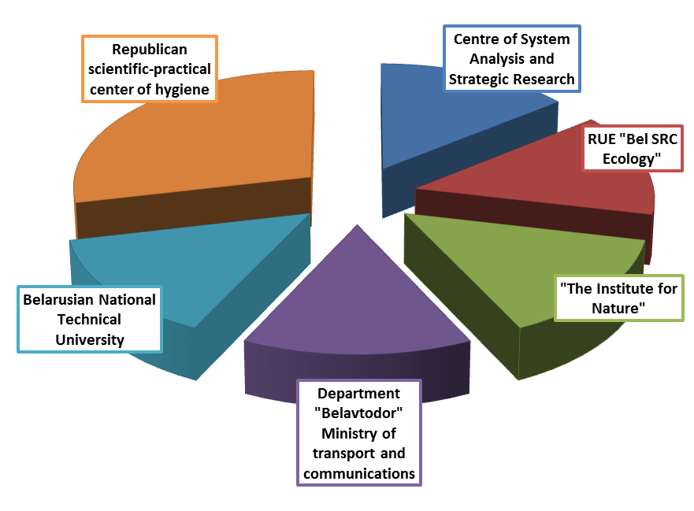
Figure 1 Division of respondents by organisation

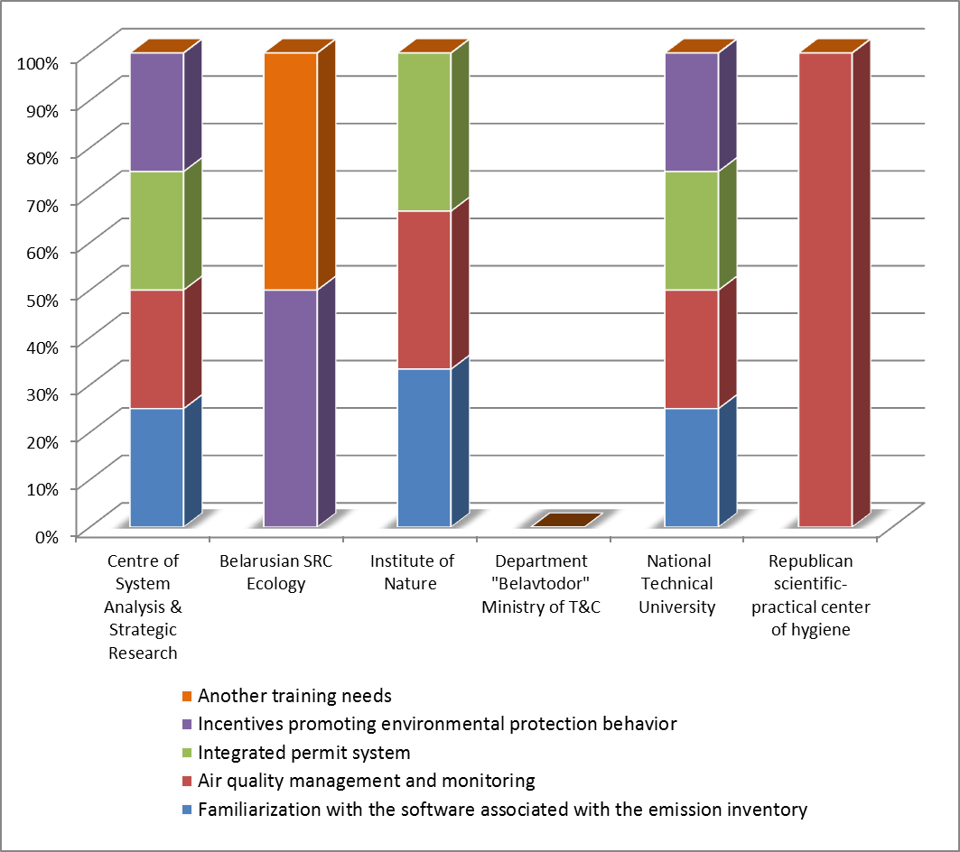
Figure 2 Distribution of training needs

Georgia
All respondents (Figure 3) consider that the country lacks legislation and trained staff and that it has not sufficient funds for the implementation of international agreements. Another identified priority is the preparation of draft laws and regulations as well as fundraising from other donors (Figure 4).
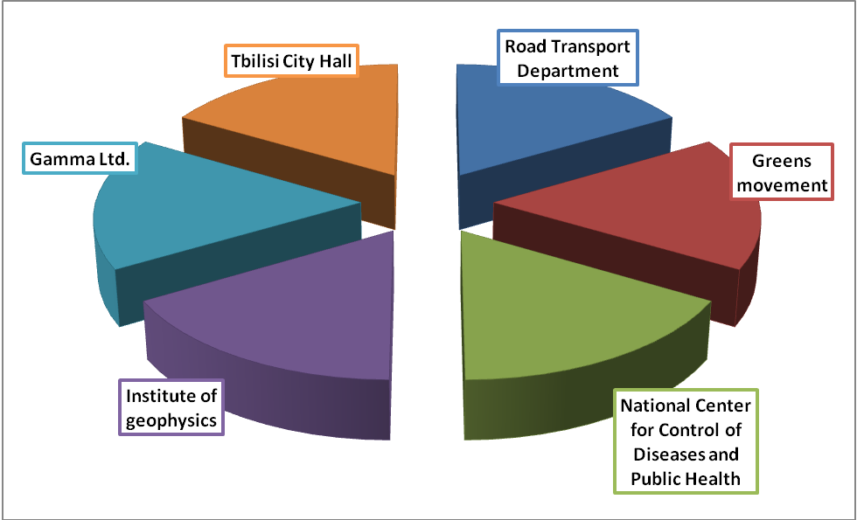
Figure 3 Division of respondents by organisation

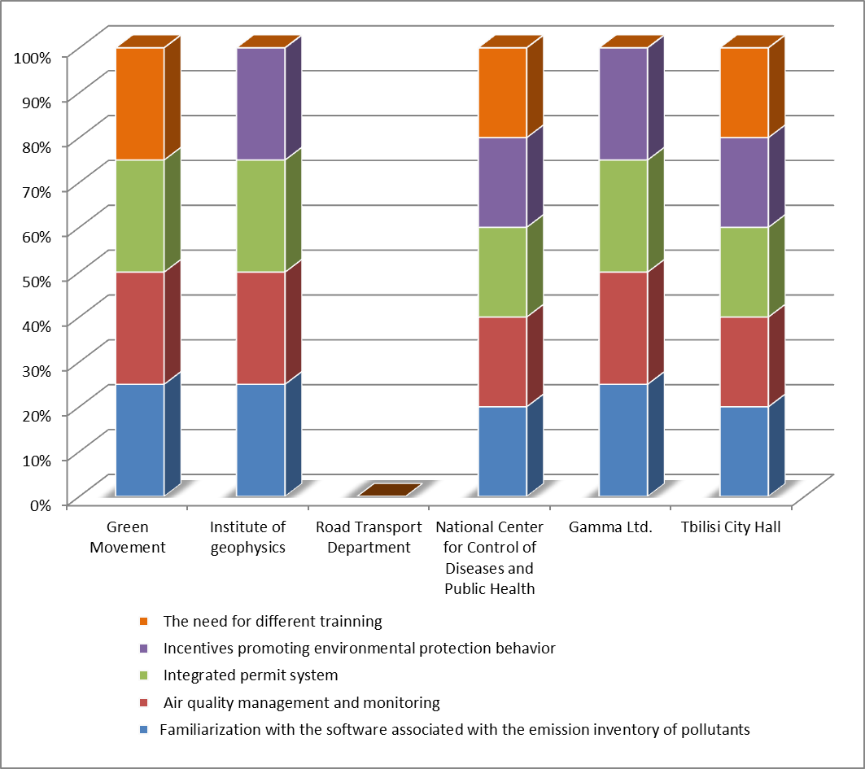
Figure 4 Distribution of training needs

Ukraine
Only one respondent from the State Environmental Investment Agency of Ukraine participated in the survey. According to the answers provided, the country lacks an adequate legal and institutional framework and a qualitative emission inventory system for the implementation of international agreements. All areas included in the questionnaire have been considered to be useful subjects for the trainings. Although the results of the survey are not representative as only one respondent provided feed-back, the need to increase the skills in terms of implementation of air quality management system has been confirmed.

5 Analysis of training needs during the second project year in 2012

5.1 Officials in the Ministries of Environment
All respondents (with exception of Belarus) consider that their countries have not ratified the relevant LRTAP protocols because they cannot produce a high quality emission inventory (Table 2).

5.1.1 Inventory Reporting under CLRTAP Protocols (Table 2)
According to the respondents, the main reasons for the inability to prepare good emissions inventory (EI) generally rely on the need for investments in industry and transport (44.4%) as well as on the lack of resources (33.3%), see Figure 5.
As indicated in Figure 6, 50% of the countries consider that it is hard to transform national formats used to collect emission information in the form of EMEP/EEA technical guide, as indicated, while 33.3% identify also the English language as a barrier.
Note: The Russian version of the technical guide has been published on the website of CLRTAP in March 2012. The answers received from two partner countries indicate that this information was not received by all countries or that Internet is not generally used for obtaining such updates.
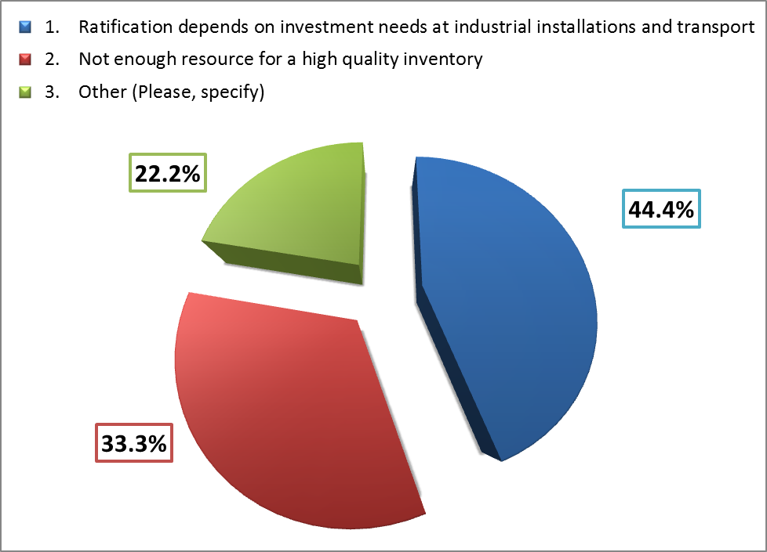 | 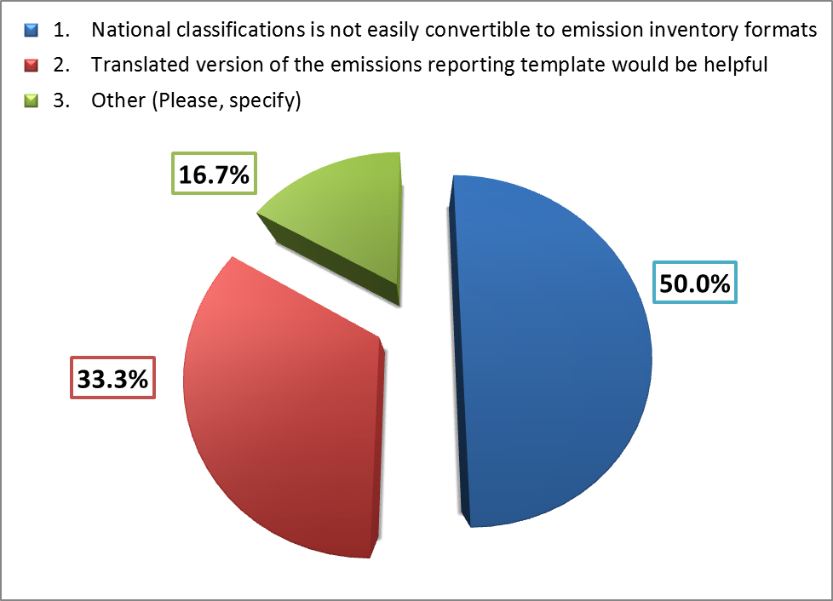
Figure 5 General difficulties in EI preparation | Figure 6 Difficulties with EI format and templates
Under option Other (Please, specify):  Armenia added as problem: the adaptation of the EMEP/EEA guide to national conditions; need to improve the existing inventory of emissions and lack of economic cost-benefit analysis in the case of ratification.  Moldova added the need for transposition of the EU requirements into the national legislation and for establishment of a national system of air quality assessment and management, which will include national system of air quality management and national emission inventories of air pollutants. | Here Belarus and Georgia clearly declare that they have no problem with EMEP/EEA technical guide format and templates for submission of emission inventory report.  Under option Other (Please, specify) Russian Federation added too detailed specification of sources as a problem.

The major expectation from the project is to provide support in implementing software tools such as CollectER and COPERT4, developed in particular for preparation of emission inventory for stationary and mobile sources, respectively. The next expectations are provision of technical trainings and pilot projects with equal weights, as indicated in Figure 7.
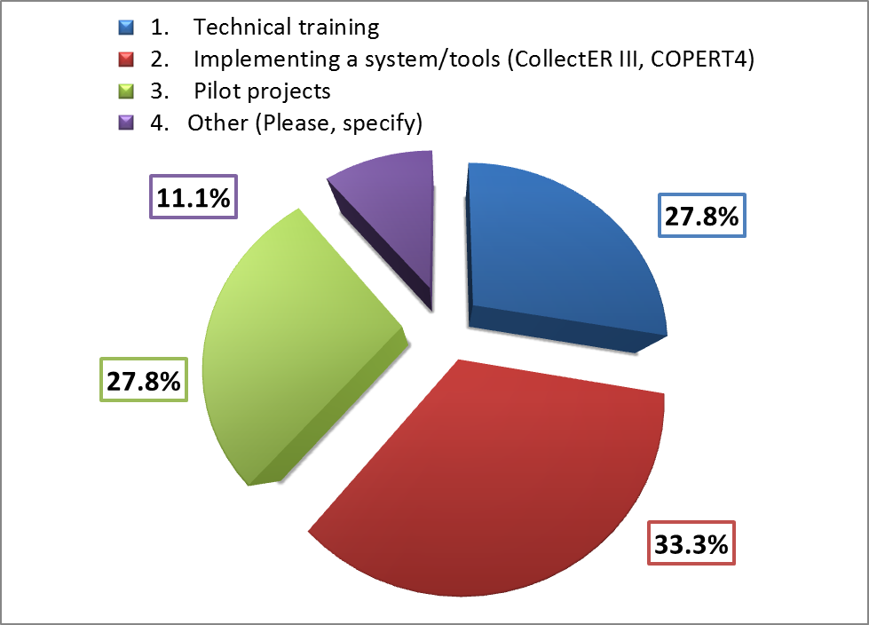
Figure 7 Expectation from Air-Q-Gov project

Under option Other (Please, specify):
- Armenia added the expectation that the project provides the appropriate software.
Note 1: Russian version of mentioned software (CollectAR or COPERT 4) does not exist.
Note 2: The project workplan foresees workshops which aim is to introduce the software and their operation.
- Georgia added the expectation that the project supports the updating of the national methodology for emission inventory.

5.1.2 EMEP/EEA emissions inventory guidebook (Table 3)
All partner countries, which filled in the questionnaires, are aware of the guidebook and its role in helping them to compile emission inventories for air pollutants, however only Belarus, Georgia, Moldova and the Russian Federation use the guidebook to prepare their emissions inventories (EI) for some sectoral sources, as described in Figure 8.
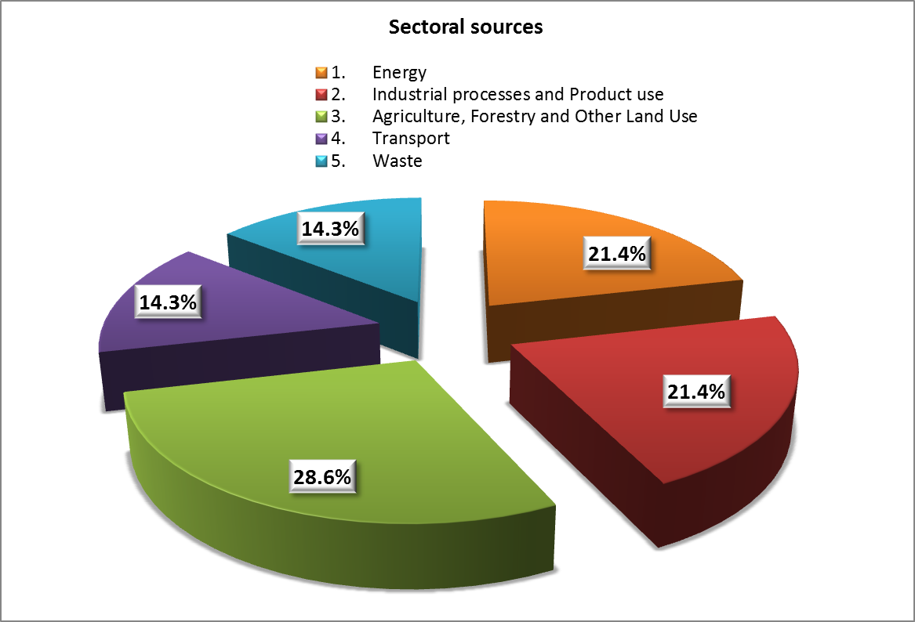
Figure 8 Sectoral sources used for emission inventory
Agriculture is the main source quoted for using the guidebook in emission estimation, which indicates that the partner countries do not have their own methodology to use. Some of the countries apply the guidebook also in the energy and industrial sectors, and few use EMEP/EEA methodology in the transport and waste sectors. Only Belarus uses all sectoral sources – Table 3.

5.1.3 Activity data (Table 4)
Most of the countries, responding to the survey, have the most important activity datasets compiling emission inventory (National Fuel Balance) as well as datasets for transport activity (with exception of the Russian Federation, which answered that it does not have datasets in regards to transport). The weaknesses associated with the activity datasets are shown in Figure 9.
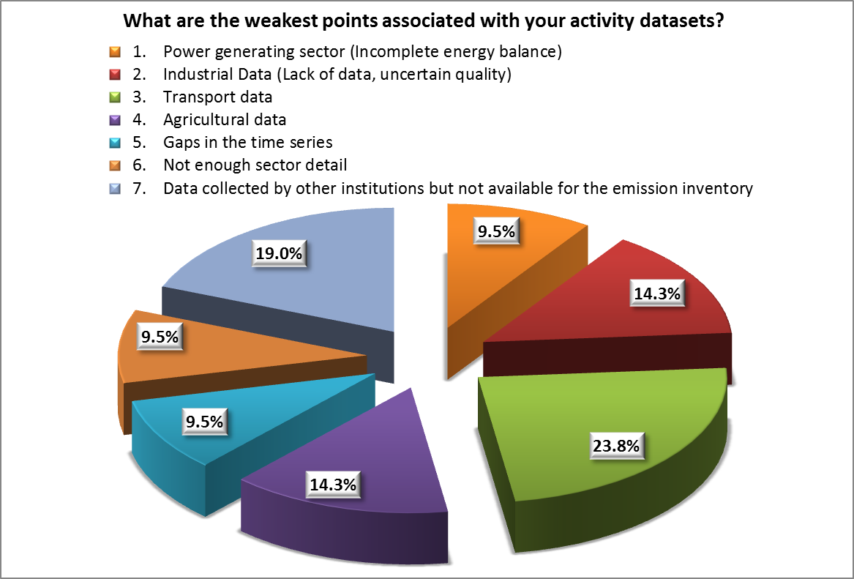
Figure 9 Weaknesses associated with activities datasets
The great part of weaknesses identified focus around the fact that the data for emission inventories is collected by institutions which are remote from the environmental authorities (19%). In general, the major difficulties in collection of dataset are identified in regards to transport data (23.8%), followed by the lack of data or uncertain quality of data from the industry and agricultural sectors (each 14.3%) and the power generating sector (9.5%), as well as the gap in time series (9.5%).

5.1.4 Emission factors (Table 5)
All partner countries have access to appropriate Emission Factors (EFs) needed to compile emission inventory, namely national or default EMEP/EEA ones. No partner country applies Air Pollutant (AP-42) emission factors dataset of the US Environmental Protection Agency (EPA), although they are recommended in the EMEP/EEA technical guide for calculation of dust emissions from diffuse sources in open mines and quarries, VOC emission from storage tanks etc. Moldova declares that it applies other EFs, but did not clarify what type – national or compilation from other countries, as indicated in Figure 10.
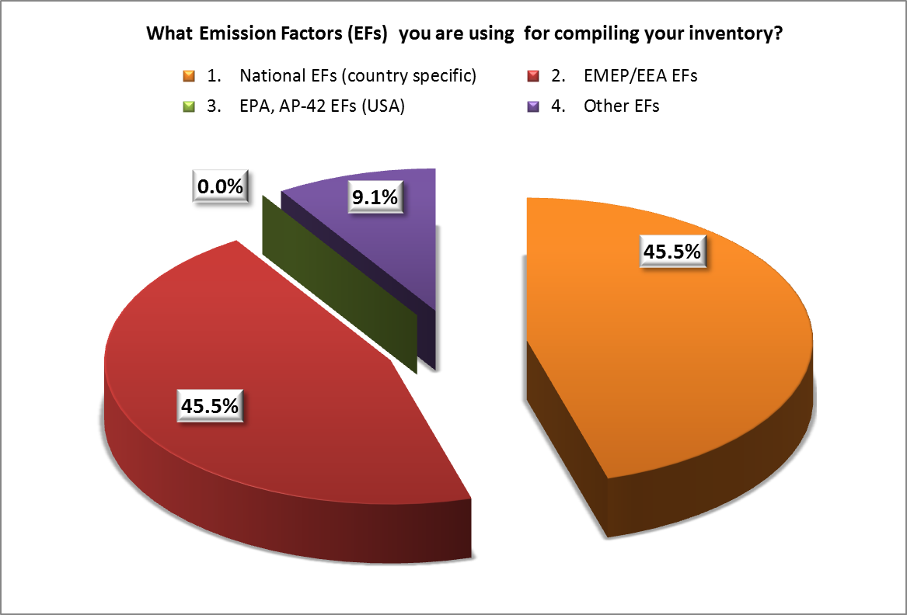
Figure 10 Applied Emission Factors (EFs)

Only Belarus and Russian Federation are aware of EFs from American environmental agency - EPA AP-42 set, but they do not apply them – Table 5.
Armenia declares that compiling emission inventory is based on the annual statistical reports submitted by enterprises; the emission calculations are carried out applying old Soviet methods. That is why it has difficulties with defining EFs for time series - enterprises submit annual reports without specifying the methodology or EFs used, thus there is no possibility of tracing their changes. Accordingly, it is not possible to assess the comparability of figures in the time series. Belarus also notes that there are difficulties with obtaining suitable EFs for the time series (but does not provide further explanation). At the same time Moldova did not provide answer to this question.

5.1.5 Suggested improvements (Table 5)
Assessment of needs for improvement of inventory in connection with particular pollutants is depicted in Figure 11, while in connection with the sources – in Figure 12.
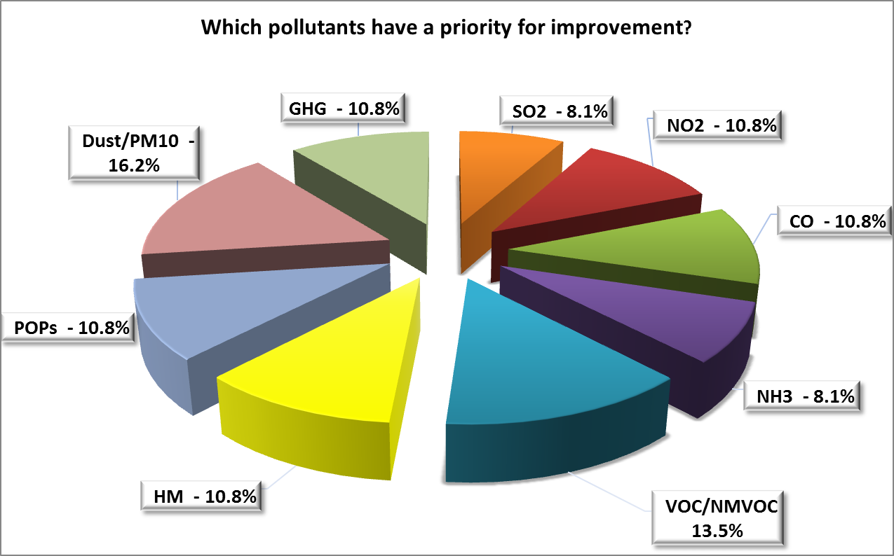
Figure 11 Pollutants, which need improvements

All partner countries note that main pollutants under question are PM₁₀ (16.2%), followed by VOC/NMVOC (13.5%). This result is obvious as above-listed pollutants mainly come from diffuse sources, where specific methodologies and spatial information are widely used for calculations of emission levels.
Application of EPA AP-42 (Chapters “Fugitive Dust Sources” and “Liquid Storage Tanks”) emission factors for mentioned pollutants is recommended in EMEP/EEA technical guide.

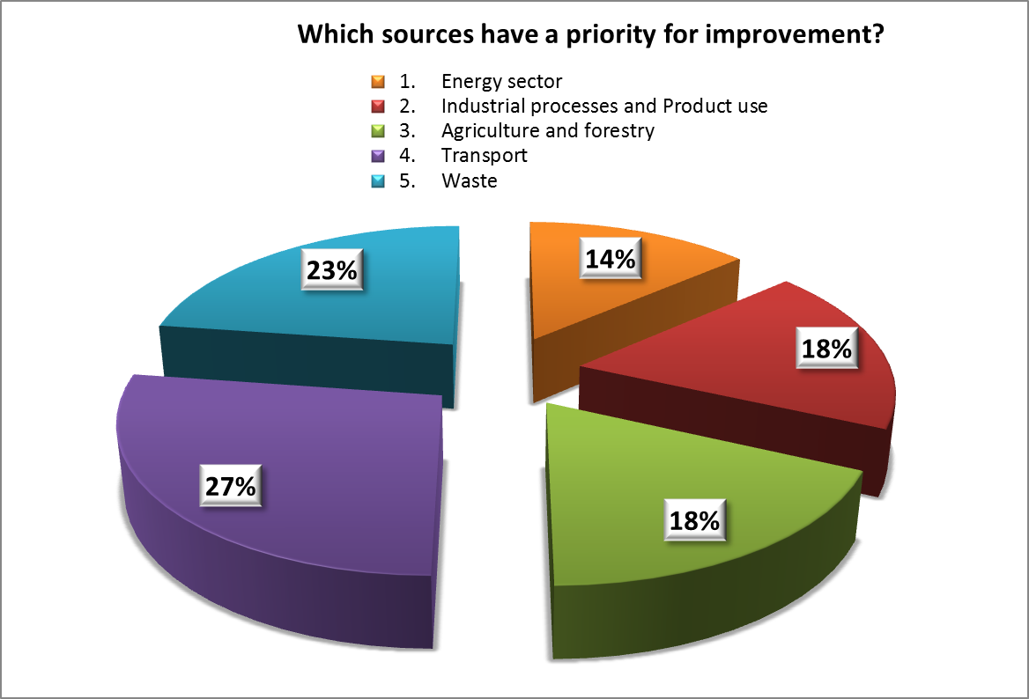
Figure 12 Sources which need improvements

All partner countries (with exception of Ukraine) identify, that the sectoral sources with a priority for improvement are Transport (27%) and Waste (23%).

5.1.6 COPERT4 software (Table 6)
The main reasons, why countries at issue do not use COPERT4 software for calculation of emissions from mobile sources, when preparing their emission inventories, are shown in Figure 13. The partner countries list the insufficient institutional capacity (29.5%) and the lack of financing (23.5%), followed by insufficiently developed statistical data (23.5%), as the major reasons. The lack of professional skills of the national experts is quoted afterwards, due to the fact that the software is in English. In fact, many of the partner countries rely only on the methodologies and software available in the local languages, which a priori triggers a lower possibility to apply international methodologies.
Only Belarus use COPERT4 software for mobile sources during preparation of emission inventory -Table 6.

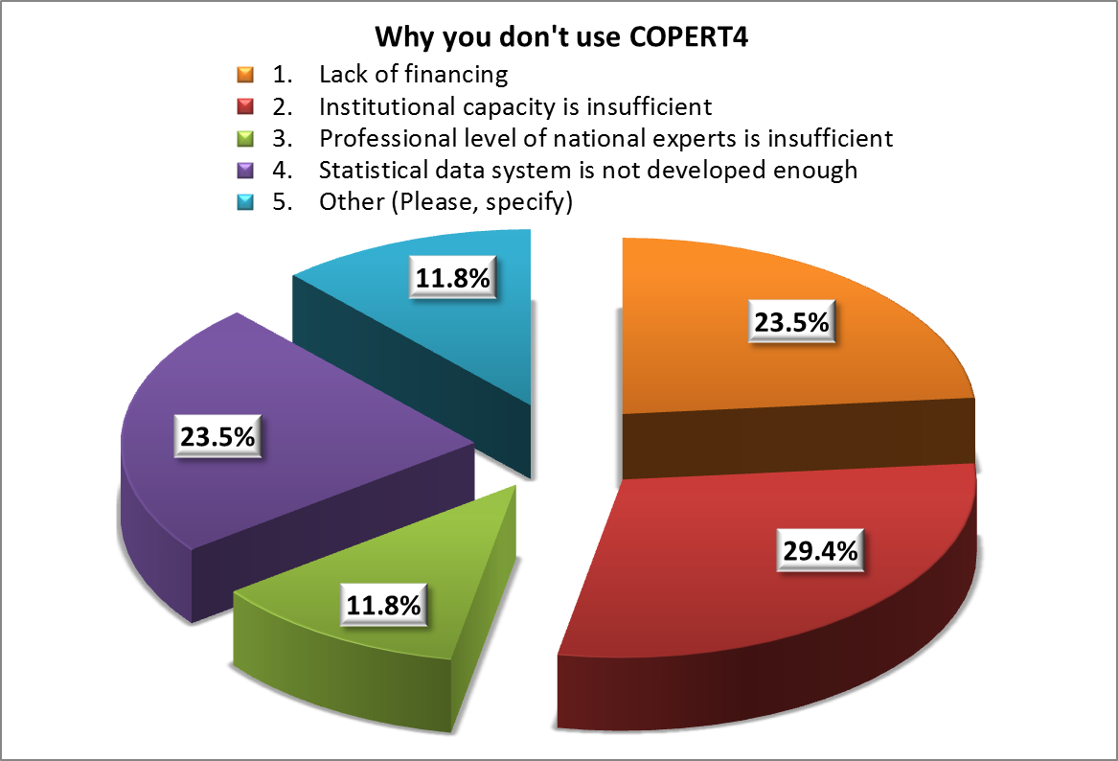
Figure 13 Difficulties in applying COPERT4 software

Under option Other (Please, specify):
- Armenia indicated lack of necessary input data,
- Moldova indicated lack of legal framework for statistical data on transport suitable to apply EFs, depending on mileage for calculation of emissions.

5.1.7 Inventory team (Table 6)
All the partner countries recognize that training on EMEP/EEA emission inventory is necessary, because they do not have enough skilled people and knowledge to compile the emission inventory.
Only Azerbaijan, Belarus and Russian Federation noted that they have necessary human resources to compile the inventory – see Table 6.

Table 2 Reporting under CLRTAP and its protocols in partner countries

Table 3 EMEM/EEA technical guide

Table 4 Activity data

Table 5 Emission factors

Table 6 Software COPERT4 and inventory team

5.2 Local emission inventory and air quality monitoring experts
The following paragraphs encompass the opinions of emission inventory and air quality monitoring experts from countries at issue. The responses mostly focus on indication of particular aspects and provide brief reasoning for delineation of specific fields, where the trainings are especially necessary.

Armenia
One of the main reasons for lack of effectiveness of air quality management system in Armenia is the low level of skills of a large number of public and private organizations and enterprises responsible for air protection. This particularly applies to professionals working in the regional authorities, small businesses and industries located far from the cities.
Training program in emission inventory should consist of following aspects;
  - Training of experts that can afterwards provide training and re-training of the local specialists. This requires involvement of speakers from EU countries with advanced emission inventory system;
  - Organization of periodic courses for specialists from ministries and agencies, regional authorities, freelancer experts;
  - Establishment of information centers, portals and forums where it is possible to (quickly) get acquainted with the methods and examples of calculations, all the news, and get the necessary consultation.
To improve the professional level of specialists involved in the field of air quality management, there is a need for a set of measures, including:
  - Study of the experience of air quality management in transitional economic system, especially those, where adaptation is quite successful;
  - Development of industry manuals, instructions and other procedural documentation;
  - Development of special programs for environmental inspections;
  - Organization of training courses for employees of industrial enterprises, consultancy firms;
  - Organization of seminars and meetings to exchange experiences;
  - Conducting television educational programs.

Azerbaijan
Emission inventory expert
Training and improvement of professional skill of the personnel associated with the inventory of emissions of air pollutants, is carried by the State Educational Institution. It also provides staff training, upon adoption of new technical rules and regulations.
Nevertheless, this training is mainly aimed at the employees in the government system. Therefore, information about what is happening in this area, what are the trends and processes outside the system continues to be absent, insufficient or unidirectional. In this case, there is information gap in regards to independent organizations.
The training will be an important factor in the field related to emission inventory, and it will be particularly effective, if it is not confined to the existing situation in one country, but would also present the experience of neighboring countries, as well as the most advanced countries in this field, i.e. the training would be directed not only vertically but also horizontally.
Organization of training courses for all sectors is important. Several aspects to be considered in the context of training emission inventory experts:
  - Organization of trainings for upgrading the level of experts’ knowledge on climate change and preparation of programs, manuals and additional materials;
  - Providing regular access to information to the public, officials and institutions responsible for decision-making on climate change issues;
  - Examine the current situation and trends in other European countries on the methods of modeling and prevention of air pollution, which may be useful for training in relation to these issues;
  - Training in forecasting, management, planning of emissions and air quality;
  - Staff training is an important factor in the field related to the emission inventory.

Air quality monitoring expert
Several aspects to be considered for training air quality monitoring experts:
  - EU legislation on air quality management;
  - Improving air quality control and monitoring;
  - Methodological and experimental opportunities for the identification and determination of the toxic gases and dust emitted in energy enterprises;
  - Economical mechanisms for the air quality management;
  - Ecological certification and new methodology for the calculation of norms for the pollutant emissions;
  - Inventory of GHG gases;
  - Inventory of ozone depleting substances;
  - Pollutants from transport sector;
  - Modeling methods used to calculate air pollution;
  - Database on air quality management.

Belarus
Emission inventory expert
Inventory of emissions of polluting substances into atmospheric air is carried out under national technical regulatory legal acts.
The international obligations according to the reporting on emissions inventory in the republic is carried out applying methodology using national statistical emissions, additionally in some limited cases using EMEP methodology (with application of factors of both statistical emissions, and calculation of emissions under GAINS model).
Thus, for assessment of the need of training on the management of inventory of atmospheric emissions of EMEP/CORINAIR it is necessary to mark training audience. If it is national level, training is not required. If it is supranational or international level, training is necessary for harmonization of applied and existing methods in the republic and in the European Community.
Air quality management expert
The facts that emission prediction and air quality prediction are developed mainly by scientific-research structures and have singular publications on this topic shows that forecasting processes are not sufficiently familiar to organizations, working with environmental protection technologies. Therefore, a more detailed study on emission prediction and modeling will allow not only to perform evaluation of atmospheric air quality, but also will make a recommended procedure, when performing works of inventory and regulating allowable emissions.
Thus, the necessity of training to predict, regulate, plan emissions and atmospheric air quality is a relevant and required task.
Analyzing the existing model for dispersal of emissions, it is worth noting its shortcomings. Firstly, it is the lack of the ground level emission dispersal concentration of each polluting substance or pollutant groups that have an effect of summarizing hazardous impact on atmospheric air quality, created by stationary emission sources in the portions of average daily maximum allowable concentration. Secondly, the used dispersion model does not consider such environmental characteristics as solar exposure, detailed wind and temperature regime etc. Accordingly, for bigger accuracy of the used model, it needs improving, which can be done on a basis of analysis of other existing dispersal models, which are used in other countries. However, just simple copying of a more accurate model cannot lead to better results. For that reason it is necessary to bring in balance more perfect models with existing system of inventory of emissions, health system and existing norms of environmental protection. It means that more accurate dispersal models will demand a revision of other procedures, associated with prevention of atmospheric air pollution, in particular, with environment impact assessment. Thus, it is recommended to study the existing situation and tendencies in other European countries regarding the methods of modeling and atmospheric air pollution prevention, which may further lead to training on the basis of findings of the study.

Georgia
Emission inventory expert
Existing methodology of air pollutant emission inventory has to be reviewed, simultaneously reviewing national legislation and taking into consideration technologies presented in the country.
To solve problem with shortage of data and ensure better quality of air pollutant emission inventory it is necessary to have reliable statistical data and provision of support to National Statistics Office of Georgia through provision of new methods and instruments of gathering statistical data, and training of personnel.
The need of training in CORINAIR is justified for specific substances (mainly heavy metals, dioxins and furans) for which information on existing reporting is almost entirely absent, because in the national methodology of emission calculations they are connected with a limited number of sectors of production.
It is necessary to organize a training workshop for the task forces on topic “air quality management system”.
The target groups of the workshop are:
• Experts from research institutions, non-governmental organizations and private companies
• Relevant staff of the Ministry of Environment and the Ministry of Labour, Health and Social Protection
• Specialist of transport and industrial infrastructure in the regional and city municipalities.
There are also other programs addressing the citywide air pollution, but the customers of such work should be municipalities of cities at issue. Such programs are a good tool for planning future development of industrial and transport infrastructure of cities and for high-level decision makers.
In this connection it is necessary to organize a training workshop for the target groups on themes: air quality modeling.
Air quality management expert
The most useful would be training related to European experience on establishment of zones and agglomerations, thus providing a knowledge basis on how it should be done in practice.
Due to a very long period of interruption in air quality planning, there is almost no experience in the country in relation to this aspect. Therefore, it is necessary to provide training to appropriate staff, so as to make them aware on existing modern approaches and instruments related to air quality planning. This will ensure better air quality management in future and will increase capacity of country to provide precise air quality planning for those zones and agglomerations, where limit value or target value is exceeded (with reference to EU directives 2008/50/EC and 2004/107/EC).
Target groups for training seminars would be as follows:
  - Staff of Ambient Air Protection Division of MoEP;
  - Staff of Legal Department of MoEP;
  - Staff of Department of Environment Pollution Monitoring of NEA.
General recommendations:
  - To change air quality monitoring principles. This means simultaneous modification of existing air quality standards, methodologies and equipment. Since improvement of these components separately is not reasonable and achievable due to existing circumstances and traditions.
  - To develop strategy for improvement of air quality monitoring system. This means formation of concrete plan for extension of existing air quality monitoring network. That will ensure providing of reliable data from monitoring stations, their accurate analysis and finally high quality data on air pollution, which is essential for making right decisions.
  - To update exiting legislation on air quality standards.
  - To draft a special legal act for air quality monitoring.
  - To adjust existing national legislation on air quality management to principles of establishment of zones and agglomerations and preparation of air quality plans, based on EU directives 2008/50/EC and 2004/107/EC
  - To publish existing air quality monitoring reports on websites of MoEP and NEA (moe.gov.ge; meteo.gov.ge).
  - To improve methods of air quality data analysis and its dissemination, to create sustainable and flexible system. This will ensure timely provision of information in easily understandable form using different media sources.
  - To introduce air quality modeling at local and national level. To enhance amount and quality of basic statistical data, this will ensure sustainable and reliable operation of these models.
  - To establish zones and agglomerations and air quality plans and short-term action plans for those zones and agglomerations where limit value or target value is exceeded based on EU directives 2008/50/EC and 2004/107/EC.
  - To transform existing methodology of air pollutant emission inventory.

Moldova
Emission inventory expert
In Moldova, training and improvement of professional skills of the personnel related to the inventory of emissions of pollutants into the air, is not carried out. Therefore, the need for such training is very high.
Staff training will play an important role in the improvement of emission inventory system. It would be particularly effective if it would describe not only the existing situation in one state, but also refer to the experience of neighboring countries and the more advanced countries in relation to this issue.
The Republic of Moldova has a system of environmental education in pre-school, primary, secondary and higher education institutions.
However, for government officials there are no permanently operating training courses, (according to the second Environmental Performance Review for the Republic of Moldova, 2010, page 8) and there is no training program on environment for adults working in different sectors of the economy, taking into account the features of each of the sectors (industrial, manufacturing, agriculture, energy, transport sector, household sector, etc.).
There is no special environmental education program for judges and officials involved in resolution of disputes entailing application of environmental legislation and regulations. There is no formal or informal environmental education, including education on the rights of citizens.
In view of the fragmented nature of organizations, which carry out analysis on state of the environment, there is a need for a single coordination center, which would accumulate all the current information on the related activities, form a bank of research, store library records and national reports, legislative information, including in electronic form, ensure availability of information on the environmental data banks, which are available in the country and are decentralized. On the basis of such a center it is possible to organize regular courses for training and dissemination of knowledge in the field of environmental protection, licensing procedures, laws, government agreements and commitments.
Training courses and dissemination of knowledge in the field of environmental protection, licensing procedures, laws, government agreements and obligations of the country is recommended for the governmental authorities.
Air quality management expert
It can be concluded that the present legislation of the Republic of Moldova is not sufficient for the implementation of the provisions of the EU Directives connected to air quality management as it does not provide for the major Directive’s instruments (air quality standards, national emission ceilings, technology based emission limit values, best available techniques).
In addition, it has been realized that the human capacity (number of persons) in the environmental protection sector in general and in the air protection sector in particular is extremely undersized. Moreover the main authority, Ministry of Environment, is missing a section responsible for air quality management.
In the framework of the Association Agreement of Republic of Moldova with the EU the particular directives stipulating AQM areas or zones are negotiated:
- Directive 2008/50/EC on ambient air quality and cleaner air for Europe,
- Directive 2004/107/EC relating to arsenic, cadmium, mercury, nickel and polycyclic aromatic hydrocarbons in ambient air.
In order to initiate a first stage, the Terms for implementation after entry into force of the Association Agreement of Republic of Moldova with the EU were established.
In order to transpose the Air Quality Framework Directive into the national legislation, it is necessary to strengthen the institutional capacity. Within this context, the establishment of the necessary technical infrastructure, its operation and inspection and the training of the personnel to be employed in these areas carry great importance for the effective implementation of the directives in the country.
Measurement devices are required for both effective monitoring of the air quality and for reaching the necessary standards. The establishment of the monitoring systems is also considered to be important for full implementation of Air Quality Framework Directive and the other directives on air quality such as the Fuel Quality, the Emissions Arising from the Vehicles and other.
The Republic of Moldova is recommended to update its mechanisms on national emission inventories, mainly to:
- Update the mechanisms to create and operate national emission inventories on a regular basis; these inventories should cover the most important regulated priority pollutants;
- Include the assessment of emissions from mobile sources (mainly road transport, but also non-road mobile machinery) and small stationary sources (mainly decentralized local heating and small businesses) into emission inventories;
- Include into its new/revised legislation provisions for concrete requirements on measurement of emissions (either continuous or periodic measurements depending on the amount and type of emissions generated by particular category of emission sources);
- Apply the EMEP/EEA Air Pollutant Emission Inventory Guidebook as the methodological tool,
- Use, in addition, the GAP Forum’s Air Pollutant Emission Inventory Preparation Manual, together with its associated software (an Excel-based workbook) as a practical tool for preparing emission inventories;
- Arrange for the preparation of emission projections for selected pollutants on a regular basis (these projections should at least cover those priority pollutants which are being regulated or are expected to be regulated by the Gothenburg Protocol);
- Coordinate preparation of emission inventories and projections for “classic” air pollutants (mainly PM, SO₂, NO_{X}, VOCs and NH₃) with the preparation of emission inventories and projections for greenhouse gases (GHGs).
- To include into new or revised legislation provisions on regular preparation of national emission inventories and emission projections (preferably using the internationally recognized methodologies).

Russian Federation
Emission inventory expert
In respect to training conducted to assess emissions, it can be noted that the following target groups needs seminars and extension courses:
  - Enterprise environment protection specialists (on industry, corporation levels, etc.);
  - Specialists of RosPrirodNadzor regional authorities;
  - Users of natural resources on various levels (organized by institutes (including SRI Atmosphere, firm «Integral») and by other organizations, specialized in the area of environmental protection).
When conducting works on emission regulation, front-line scientific and engineering achievements in the area of efficient and complex use of natural resources and nature protection should be taken into consideration. Existing production equipment and plants should be assessed as to the level of their ecological compatibility. With that, it is necessary to ensure implementation of more modern technologies and technical means to reduce pollutant emissions into the atmosphere on the basis of technical norms of emissions that characterize ecological compatibility level of equipment used. However, those works have no corresponding regulatory and methodical foundation, since the documentation regulating the order and requirements for setting technical norms of emissions has not yet been developed in Russia.
It is known, that in the nearest future Russian Federation is planning to implement, stage-by-stage, technological norms of emissions into the system of state regulation of pollutant emissions into the atmospheric air. Meanwhile, it is intended to work out reference books of the best available technologies by industries (types of activities), which will become the basis for setting technological norms of emissions. In particular, such reference books will provide information about the values of specific indexes of pollutant emissions that correspond to the best available technologies.
Besides, when developing the projects on maximum permissible emission norms, an assessment of the conformity degree of technology, production, dust and gas catching equipment used on the front-line scientific and technical level in the country and abroad has to be performed. That assessment is performed by way of comparing values of corresponding indices of specific emissions for production activity under review with the same indices of similar existing productions or with set technological indices of emissions. Those works are of limited character for now due to the absence of necessary recommendations and instructions, adopted in accordance with the applicable procedure.
Until recently, the lack of planning of air quality management in Russia was caused by absence of integrated assessment of all industrial sources and mobile means’ emissions’ influence on atmospheric air in cities (inhabited localities). Presently, because of implementation of emission regulation integrated calculation of atmosphere pollution by industrial and automobile transport emissions in separate cities, AQM plans are developed, including emission regulation (Saint-Petersburg, Krasnoyarsk, Kemerovo and others).
Emission regulation at industrial facilities provides for replacement of used technologies and equipment with more ecologically friendly, equipping sources with gas-purifying technologies, optimizing emissions from low ventilation sources etc. Together with that, it is planned to remove ecologically dangerous facilities from cities, improving automobile transport movement on city roads, etc.
The main criteria for IPPC permit issuance procedure, including volumes of permitted emissions, is the fact that the influence of those emission volumes in atmospheric air should comply with active hygienic criteria of atmospheric air quality without taking into consideration maximum emission values, set in the EU countries for specific technological processes and plants (for example, Directive 2008/1/EU). Presently, Russia does not have any corresponding legislative or regulatory documents, regulating the order of development and implementing technological emission norms with taking into consideration best available technologies (ВАТ).
In regards to training activities, referring to the order of obtaining permission documentation regarding atmospheric emissions, it can be noted that there is no need for training, since seminars and courses on air protection activity for users of natural resources are conducted in Russia. They include interpretations of the procedure of issuing emission permits.
However, it can be worthwhile to conduct one-time seminar for Russian and EECCA specialists, who work in the area of developing regulatory and methodical approaches on air protection activity, where EU specialists will speak on advantages of integrated permits for emissions and the ways of their implementation.
The following actions can be proposed in the framework of this section, directed at adopting emission calculation methods in Russia in accordance with the methods of EMEP/EEA technical guide:
  - conducting comparative assessments of emissions by the methods from EMEP/EEA technical guide and MInR for specific source types (large point sources, unorganized sources);
  - conducting training seminars to assess emissions in accordance with EMEP/EEA technical guide for a wide circle of technique drafters in Russia in order to update and specify Russian active documents, and, possibly, documents of EECCA countries that are interested in this work.
Mathematical models of transfer and fall-out of admixtures (for example, such as EMEP Model), and also models of complex assessment (GAINS Model), allowing to assess the efficiency of measures for limiting emissions in cases of different development scenarios in Russian regions and separate industries are not used in Russia. However, the necessity of performing studies regarding application of such models does not raise any doubts. Recently, the Center of model development for complex assessment (CIAM) conducted the analysis of emission reduction possibilities in the countries that are not part of the EU, including Russia. SRI Atmosphere performs quite a detailed study on using GAINS Model for air-cleaning activities in Russia, conducting scientific research and methodical studies in that direction.
Works on air pollution modeling are performed in some Russian cities on a citywide scale. The results of such works allow performing assessment of efficiency of measures to reduce emissions. These works, to a certain degree, are similar to goals and objectives, realized in the framework of EC4MACS project.
Accordingly, it can be noted that there is a necessity of conducting trainings regarding application of GAINS Model and other models for specialists from Russia and other EECCA countries.
Besides, it might me practical to consider conducting a pilot project in the EECCA countries together with EC4MACS project.

Ukraine
Given the main results of the analysis of EI and AQM the main priorities and recommendations for improvement in the monitoring and management of air quality, as well as some priority measures, are outlined below.
In the area of improving governance in the field of air:
  - Exploring the possibility of harmonization of national environmental legislation in the field of air required by the Directives 2004/107/ES, 2008/50/EC and 2010/75/EU;
  - Exploring the possibility of and the need for amendments to the State Sanitary Rules of atmospheric air pollution from residential areas in terms of accounting requirements of the EU Directive 2010/75/EU (the introduction of the alert threshold, limit pollution to protect human health, information thresholds, expansion rules for evaluating air quality, etc.).
In the area of improving the statistical and departmental reports:
  - Improve accountability for emissions inventory to meet the requirements of the EMEP / EEA.
  - The development of standards and regulations and methodologies.
In the field of modeling and forecasting:
  - Adaptation of pollutant dispersion models and related software products that are recommended in the EU to the conditions of Ukraine;
  - Introduce methods for predicting emissions and air quality, that are approved in the EU countries, in the development of programs for the protection and improvement of air quality at the regional and city level (e.g. modeling methodology EC4MACS).
In the area of collaboration and learning:
  - Coordination of meetings with the representatives of the European countries to implement automated monitoring of air quality, meeting the requirements of the EU;
  - Organization of workshops on methods and tools for modeling and forecasting of emissions and air quality within EU countries;
  - Conduct training on the use of the EMEP / EEA emission inventory methodology for sources that are currently not accounted for in Ukraine.

The opinion of the local non-key experts (NKEs) about training needs is given above in descriptive way. The specificity and level of development of individual partner countries is initially reflected in Air-Q-Gov workplan, but the analytical results of the present survey on concrete issues on emission inventory and air quality monitoring will be incorporated into the routine work of the project.
Following figures categorize the target groups, training tools and training topics according to NKE's responses.
Figure 15 shows that first three target groups: specialists of the ministries and government agencies; territorial government authorities and private organizations and enterprises are represented equally - 25%.
Figure 15 depicts that classical training workshops are determined as the major training tool (28 %), followed by the experience exchange workshops and new/revised legislation provisions and governmental strategic documents with equal percentages. The experience exchange tool has two different aspects – study tour in economic system, especially those where adaptation is quite successful as Czech Republic or ex-soviet Baltic states (Armenia highly appreciates Baltic experience) and workshops where the partner countries with the highest level of progress in the relevant field share their experience – the major example is Belarus.

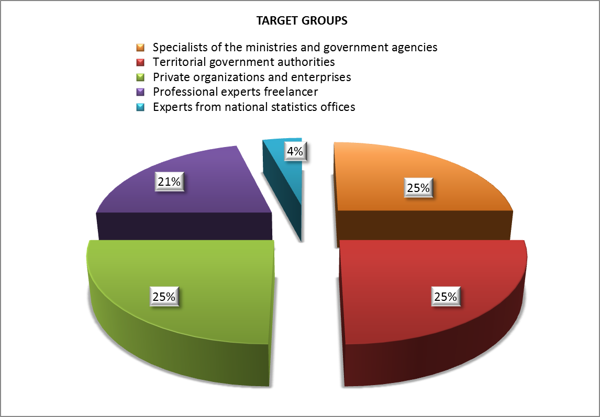
Figure 14 Identified target groups for trainings.

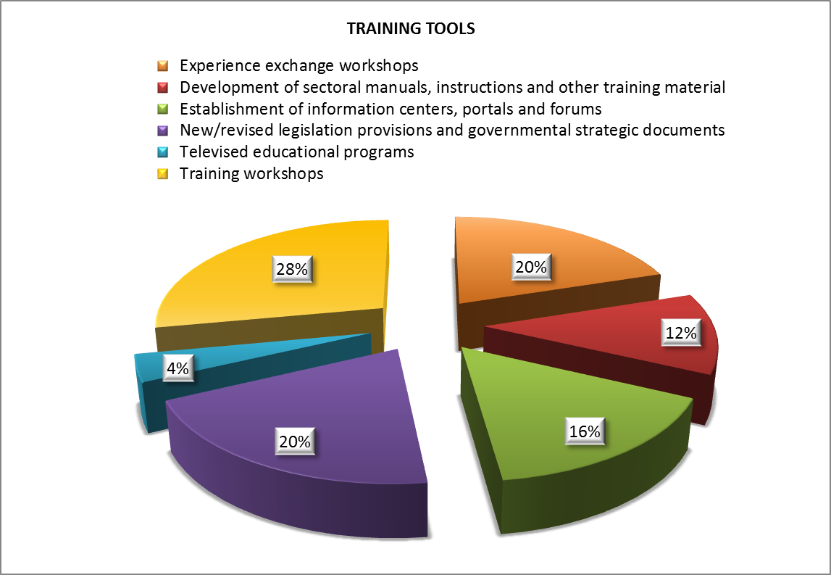
Figure 15 Identified trainings tools.

Figure 16 depicts the training topics identified by the respondents. The major theme for all partner countries is the EMEP/EEA technical guide (29%), because the main requirement of any protocol of the CLRTAP is submission of high level of emission inventory. Next priority topic is air pollution modeling, because diffusion models (any kind - simple or more sophisticated) are the tools used for assessment of air quality where there are insufficient air quality monitoring stations.
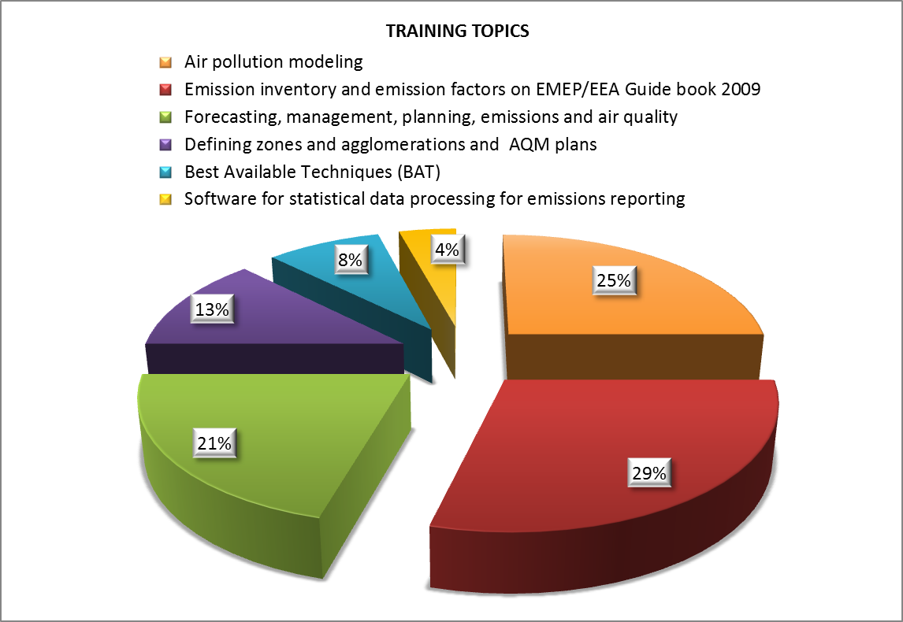
Figure 16 Identified training topics.

6 Final conclusions
The findings and conclusions resulting from training need survey during the period of project implementation may be summarized as follows:

6.1 General view
Many of the respondents both, government officials and technical experts, consider that the country has an inadequate legal framework and lacks the institutional framework to implement international agreements. A general priority here is the preparation of draft laws and regulations.
Note: None of the respondents noted as a solution complying with certain EU directives. Filling gaps in national legislation is expected, only without clear view on what EU directives stipulate. Solely Moldova (in private conversation with the expert from State Hydrometeorological Service) directly expressed the will to adopt the European directives on air quality standards – Directive 2008/50/EC and Directive 2004/107/EC, stipulating the limit and target values for air pollutants.

6.2 Specific view
- All governmental officials’ responses (with exception of Ukraine) indicate that their countries have not ratified the relevant LRTAP protocols because they cannot produce a high quality emission inventory. The main reasons for the inability to prepare good emissions inventory (EI) generally rely in:
  - the need for investments in industry and transport as well as in the lack of resources;
  - the difficulty to transform national formats used to collect emission information to the form required by EMEP/EEA technical guide (too detailed specification of emission sources);
  - the fact that the data for emission inventories is collected by institutions which are remote from the environmental authorities;
  - the difficulties in collection of dataset in transport and the lack or uncertain quality of data from the industry and agricultural sectors, as well as the gap in time series;
  - the difficulties in collection of data from diffuse sources, where calculation of emission levels requires more detailed information and specific methodologies;
  - the compiling of emission inventory is based on the annual statistical reports submitted by enterprises, and emission calculations are carried out with the old Soviet methods;
  - the lack of economic cost-benefit analysis in the case of ratification of certain CLRTAP protocol.
- The major expectations from the Air-Q-Gov project are:
  - conducting technical trainings for implementation of software tools such as CollectER and COPERT4, developed in particular for preparation of emission inventory for stationary and mobile sources, respectively;
  - supporting the updating of the partner country national methodology for emission inventory;
  - development of national and regional pilot projects aimed at specific needs of countries, the results of which would lead to resolving and leaving behind at least one problem of the air quality management.
- Training needs:
  - three target groups - specialists of the ministries and government agencies, territorial government authorities, and private organizations and enterprises – are identified;
  - classical training workshops as the major training tool, followed by the experience exchange workshops, are determined;
Note: One of the experience exchange activities is study tour to economic system, especially to those countries, where adaptation from old Soviet system to the EU one has been carried out quite successfully (as Czech Republic) or in ex-soviet Baltic states (Armenia highly appreciates Baltic experience). The other activity includes workshops where the partner countries with most progress share their experience – the major example is Belarus.
  - major topic for all partner countries is the EMEP/EEA technical guide, because the main requirement of any protocol of the CLRTAP is submission of high level emission inventory. Next priority topic is air pollution modeling, as diffusion models (any kind - simple or more sophisticated) are used for assessment of the air quality where there are insufficient air quality monitoring stations.
The analytical results of the present survey on concrete issues regarding emission inventory and air quality monitoring will be incorporated into the routine work of the project.

7 Project team persuasion

7.1 Specific view
There is a significant difference of opinion between researchers (scientists), experts and government officials about the training needs and expectation from the Air-Q-Gov project:
- The issues in relation to emissions in the context of permitting system, as well as emission limit values (ELV) were not clearly identified, which is not surprizing, due to the fact that the respondents were involved in emission inventory-, not ELV-related work;
- The lack of professional skills of the national experts is mentioned afterwards, due to the fact that many useful software models in air quality management is in English. Many of the partner countries in fact rely only on the methodologies and software available in the local languages, which triggers a priori a lower possibility of applying international methodologies;
- The experts do not use Internet for self-training;
- Only AQM experts from Moldova and Russian Federation with high level of English are familiar with international integrated projection models as GAINS or EC4MACS in the original language of the models;
- Nobody realizes that the air pollution models require meteorological input, which also plays significant part in the assessment of the air quality.

7.2 General view
- The answers received from some partner countries indicate that in some cases not enough attention was paid to the information, spread by the project;
- The project encountered difficulties with receiving (in many cases the requested information is neglected) and in some cases did not receive at all feedback from the beneficiaries. In latter case there is no cooperation with the project, and beneficiaries at issue perceive the project as a sole work of project team, without necessity for mutual efforts;
- In general partner countries are not familiar with the European framework legislation on ambient air quality. They only have a vague impression of certain directives on air quality without logical connection between them and their requirements;
- The partner countries do not use project website, which contains many links to sites that offer useful information in English or in Russian;
- As it can be seen from the training workshops or Steering Committee conferences, there is a lack of cooperation between the partner countries.

8 Project team recommendation for training workshops and study tour events
In order to feel the countries’ commitment in the project, representatives of partner countries, participating in workshops and study tours on exchange of experience, should hand in a report with brief explanation of country’s benefits from participation in a workshop or study tour, conducted in the framework of the project. Reports on benefits would subsequently be published on project’s website. This reporting requirement would ensure that the activities at issue would not be perceived as plain “tourism element”.

EuropeAid/129522/C/SER/Multi
Contract number 2010/232-231
Air Quality Governance in ENPI East Countries
Training Needs Assessment (TNA) - ANNEXES

Date: 15 September 2012

Annex 1 Questionnaire on issues related to air quality management in East ENPI Countries

ARMENIA

Опросник
по вопросам, касающимся управления качеством атмосферного воздуха

Уважаемый респондент!
Просим Вас ответить на вопросы ниже для определения наиболее перспективных путей оказания помощи и повышения эффективности деятельности по проекту.

Раздел 1. Контактная информация

1.1. | ФИО

1.2. | Место работы

1.3. | Должность

1.4. | Телефон

1.5. | E-mail

1.6. Группа | Гос. служащий | Бизнес | Научный работник | Обществен-ная организация | Другое (укажите)

Раздел 2. Национальное законодательство по вопросам охраны атмосферного воздуха
2.1.
Является ли качество воздуха приоритетным направлением государственной политики Армении? | Да | Нет

Если нет, в чем Вы видите причину? | Наличие более насущных приоритетов
 | Недооценка важности проблемы
Другие причины или комментарии
_________________________________________________________

__________________________________________________________

2.2.
Может ли проект оказать помощь? | Да | Нет

Если да, то какую? | Подготовка проектов законодательных и нормативно-правовых актов
 | Обучение
Другой вид помощи
_________________________________________________________

__________________________________________________________

Раздел 3. Международные договоренности

3.1. Армения ратифицировала Конвенцию о трансграничном загрязнении воздуха на большие расстояния.

Обеспечена ли ее имплементация в полном объеме? | Да | Нет

Если нет, что препятствует? | Недостаточность законодательства
 | Несовершенная нормативно-правовая база
 | Недостаточная институциональная база
 | Проблемы с выполнением требований законодательной и нормативно-правовой базы
Другие причины или комментарии
_________________________________________________________

Планируются ли дальнейшие шаги по упрочению ее имплементации? | Да | Нет

Если да, то какие?  Если нет, что препятствует? | Комментарии  __________________________________________________________  __________________________________________________________
Может ли проект оказать помощь? |  | Да | Нет

Если да, то какую? | Подготовка проектов законодательных и нормативно-правовых актов
 | Обучение
Другой вид помощи
_________________________________________________________

__________________________________________________________

3.2. Армения не подписала Протокол о долгосрочном финансировании совместной программы наблюдения и оценки распространения загрязнителей воздуха на большие расстояния в Европе (ЕМЕП).

В чем Вы видите причины? | Недостаточность законодательства
 | Несовершенная нормативно-правовая база
 | Недостаточная институциональная база
 | Проблемы с выполнением обязательств по Протоколу
Другие причины или комментарии
_________________________________________________________

__________________________________________________________

Может ли проект оказать помощь? |  | Да | Нет

Если да, то какую? | Подготовка проектов законодательных и нормативно-правовых актов
 | Обучение
Другой вид помощи
_________________________________________________________

__________________________________________________________

3.3. Армения не подписала Протокол о сокращении выбросов серы или их трансграничных потоков по меньшей мере на 30 процентов.

В чем Вы видите причины? | Недостаточность законодательства
 | Несовершенная нормативно-правовая база
 | Недостаточная институциональная база
 | Проблемы с выполнением обязательств по Протоколу
Другие причины или комментарии
_________________________________________________________

__________________________________________________________

__________________________________________________________

Может ли проект оказать помощь? | Да | Нет

Если да, то какую? | Подготовка проектов законодательных и нормативно-правовых актов
 | Обучение
Другой вид помощи
_________________________________________________________

__________________________________________________________

3.4. Армения не подписала Протокол об ограничении выбросов окислов азота или их трансграничных потоков.

В чем Вы видите причины? | Недостаточность законодательства
 | Несовершенная нормативно-правовая база
 | Недостаточная институциональная база
 | Проблемы с выполнением обязательств по Протоколу
Другие причины или комментарии
_________________________________________________________

__________________________________________________________

__________________________________________________________

Может ли проект оказать помощь? | Да | Нет

Если да, то какую? | Подготовка проектов законодательных и нормативно-правовых актов
 | Обучение
Другой вид помощи
_________________________________________________________

__________________________________________________________

3.5. Армения не подписала Протокол об ограничении выбросов летучих органических соединений или их трансграничных потоков.

В чем Вы видите причины? | Недостаточность законодательства
 | Несовершенная нормативно-правовая база
 | Недостаточная институциональная база
 | Проблемы с выполнением обязательств по Протоколу
Другие причины или комментарии
_________________________________________________________

__________________________________________________________

__________________________________________________________

Может ли проект оказать помощь? | Да | Нет

Если да, то какую? | Подготовка проектов законодательных и нормативно-правовых актов
 | Обучение
Другой вид помощи
_________________________________________________________

__________________________________________________________

3.6. Армения не подписала Протокол относительно дальнейшего сокращения выбросов серы.

В чем Вы видите причины? | Недостаточность законодательства
 | Несовершенная нормативно-правовая база
 | Недостаточная институциональная база
 | Проблемы с выполнением обязательств по Протоколу
Другие причины или комментарии
_________________________________________________________

__________________________________________________________

__________________________________________________________

Может ли проект оказать помощь? | Да | Нет

Если да, то какую? | Подготовка проектов законодательных и нормативно-правовых актов
 | Обучение
Другой вид помощи
_________________________________________________________

__________________________________________________________

3.7. Армения подписала, но не ратифицировала Протокол по тяжелым металлам.

В чем Вы видите причины? | Недостаточность законодательства
 | Несовершенная нормативно-правовая база
 | Недостаточная институциональная база
 | Проблемы с выполнением обязательств по Протоколу
Другие причины или комментарии
_________________________________________________________

__________________________________________________________

__________________________________________________________

Может ли проект оказать помощь? | Да | Нет

Если да, то какую? | Подготовка проектов законодательных и нормативно-правовых актов
 | Обучение
Другой вид помощи
_________________________________________________________

__________________________________________________________

3.8. Армения подписала, но не ратифицировала Протокол по стойким органическим загрязнителям.

В чем Вы видите причины? | Недостаточность законодательства
 | Несовершенная нормативно-правовая база
 | Недостаточная институциональная база
 | Проблемы с выполнением обязательств по Протоколу
Другие причины или комментарии
_________________________________________________________

__________________________________________________________

__________________________________________________________

Может ли проект оказать помощь? | Да | Нет

Если да, то какую? | Подготовка проектов законодательных и нормативно-правовых актов
 | Обучение
Другой вид помощи
_________________________________________________________

__________________________________________________________

__________________________________________________________

3.9. Армения подписала, но не ратифицировала Протокол о борьбе с подкислением, эвтрофикацией и приземным озоном

В чем Вы видите причины? | Недостаточность законодательства
 | Несовершенная нормативно-правовая база
 | Недостаточная институциональная база
 | Проблемы с выполнением обязательств по Протоколу
Другие причины или комментарии
_________________________________________________________

__________________________________________________________

__________________________________________________________

Может ли проект оказать помощь? | Да | Нет

Если да, то какую? | Подготовка проектов законодательных и нормативно-правовых актов
 | Обучение
Другой вид помощи
_________________________________________________________

__________________________________________________________

3.10. Армения ратифицировала Стокгольмскую конвенцию о стойких органических загрязнителях.
Обеспечена ли ее имплементация в полном объеме? | Да | Нет

Если нет, что препятствует? | Недостаточность законодательства
 | Несовершенная нормативно-правовая база
 | Недостаточная институциональная база
 | Проблемы с выполнением требований законодательной и нормативно-правовой базы
Другие причины или комментарии
_________________________________________________________

__________________________________________________________

__________________________________________________________

Планируются ли дальнейшие шаги по упрочению ее имплементации? | Да | Нет

Если да, то какие?  Если нет, что препятствует? | Комментарии  __________________________________________________________  __________________________________________________________

Может ли проект оказать помощь? | Да | Нет

Если да, то какую? | Подготовка проектов законодательных и нормативно-правовых актов
 | Обучение
Другой вид помощи
_________________________________________________________

__________________________________________________________

__________________________________________________________

3.11. Армения ратифицировала Рамочную конвенцию ООН об изменении климата.

Обеспечена ли ее имплементация в полном объеме? | Да | Нет

Если нет, что препятствует? | Недостаточность законодательства
 | Несовершенная нормативно-правовая база
 | Недостаточная институциональная база
 | Проблемы с выполнением требований законодательной и нормативно-правовой базы
Другие причины или комментарии
_________________________________________________________

__________________________________________________________

__________________________________________________________

Планируются ли дальнейшие шаги по упрочению ее имплементации? | Да | Нет

Если да, то какие?  Если нет, что препятствует? | Комментарии  __________________________________________________________  __________________________________________________________

Может ли проект оказать помощь? | Да | Нет

Если да, то какую? | Подготовка проектов законодательных и нормативно-правовых актов
 | Обучение
Другой вид помощи
_________________________________________________________

__________________________________________________________

__________________________________________________________

3.12. Армения ратифицировала Киотский протокол к Рамочной конвенции ООН об изменении климата.

Обеспечена ли его имплементация в полном объеме? | Да | Нет

Если нет, что препятствует? | Недостаточность законодательства
 | Несовершенная нормативно-правовая база
 | Недостаточная институциональная база
 | Проблемы с выполнением требований законодательной и нормативно-правовой базы
Другие причины или комментарии
_________________________________________________________

__________________________________________________________

__________________________________________________________

Планируются ли дальнейшие шаги по упрочению его имплементации? | Да | Нет

Если да, то какие?  Если нет, что препятствует? | Комментарии  __________________________________________________________  __________________________________________________________

Может ли проект оказать помощь? | Да | Нет

Если да, то какую? | Подготовка проектов законодательных и нормативно-правовых актов
 | Обучение
Другой вид помощи
_________________________________________________________

__________________________________________________________

__________________________________________________________

3.13. Армения ратифицировала Венскую конвенцию ООН об охране озонового слоя и протоколы к ней.

Обеспечена ли их имплементация в полном объеме? | Да | Нет

Если нет, что препятствует? | Недостаточность законодательства
 | Несовершенная нормативно-правовая база
 | Недостаточная институциональная база
 | Проблемы с выполнением требований законодательной и нормативно-правовой базы
Другие причины или комментарии
_________________________________________________________

__________________________________________________________

__________________________________________________________

Планируются ли дальнейшие шаги по упрочению их имплементации? | Да | Нет

Если да, то какие?  Если нет, что препятствует? | Комментарии  __________________________________________________________  __________________________________________________________

Может ли проект оказать помощь? | Да | Нет

Если да, то какую? | Подготовка проектов законодательных и нормативно-правовых актов
 | Обучение
Другой вид помощи
_________________________________________________________

__________________________________________________________

__________________________________________________________

3.14. Армения ратифицировала Монреальский протокол и изменения/дополнения к нему.

Обеспечена ли его имплементация в полном объеме? | Да | Нет

Если нет, что препятствует? | Недостаточность законодательства
 | Несовершенная нормативно-правовая база
 | Недостаточная институциональная база
 | Проблемы с выполнением требований законодательной и нормативно-правовой базы
Другие причины или комментарии
_________________________________________________________

__________________________________________________________

__________________________________________________________

Планируются ли дальнейшие шаги по упрочению его имплементации? | Да | Нет

Если да, то какие?  Если нет, что препятствует? | Комментарии  __________________________________________________________  __________________________________________________________

Может ли проект оказать помощь? |  | Да | Нет
Если да, то какую? | Подготовка проектов законодательных и нормативно-правовых актов
 | Обучение
Другой вид помощи
_________________________________________________________

__________________________________________________________

Раздел 4. Вторая национальная программа действий по охране окружающей среды в Армении
Как Вы считаете, выполняется ли данная программа в полном объеме? | Да | Нет

Если нет, что препятствует? | Недостаточность законодательства
 | Несовершенная нормативно-правовая база
 | Недостаточная институциональная база
 | Недостаточность средств
 |  | Недостаток подготовленного персонала
Другие причины или комментарии
_________________________________________________________

__________________________________________________________

__________________________________________________________

Раздел 5. Система мониторинга

Как Вы считаете, уделяется ли этой проблеме должное внимание? | Да | Нет

Если нет, что препятствует? | Недостаточность законодательства
 | Несовершенная нормативно-правовая база
 | Недостаточная институциональная база
 | Недостаточность средств
 |  | Недостаток подготовленного персонала
Другие причины или комментарии
_________________________________________________________

__________________________________________________________

__________________________________________________________

В чем Вы видите пробелы и | Недостаточность законодательства
недостатки в существующей | Несовершенная нормативно-правовая база
системе инвентаризации | Недостаточная институциональная база
выбросов загрязняющих | Недостаточность средств
веществ и отчетности по | Недостаток подготовленного персонала
ним перед международными органами? | Другие причины или комментарии  _________________________________________________________  __________________________________________________________  __________________________________________________________
В чем Вы видите пробелы и | Недостаточность законодательства
недостатки в существующей | Несовершенная нормативно-правовая база
системе моделирования и | Недостаточная институциональная база
прогнозирования загрязнения? | Недостаточность средств
 | Недостаток подготовленного персонала
Другие причины или комментарии
_________________________________________________________

__________________________________________________________

__________________________________________________________

Может ли проект оказать помощь? |  | Да | Нет

Если да, то какую? | Подготовка проектов законодательных и нормативно-правовых актов
 | Обучение
Другой вид помощи
_________________________________________________________

__________________________________________________________

__________________________________________________________

Раздел 6. Система контроля и предотвращения загрязнения
Как Вы считаете, уделяется ли этой проблеме должное внимание? | Да | Нет

Если нет, что препятствует? | Недостаточность законодательства
 | Несовершенная нормативно-правовая база
 | Недостаточная институциональная база
 | Недостаточность средств
 | Недостаток подготовленного персонала
Другие причины или комментарии
_________________________________________________________

__________________________________________________________

__________________________________________________________

В чем Вы видите пробелы и | Неполный перечень загрязняющих веществ
недостатки в существующей | Несовершенная нормативно-правовая база
системе контроля и | Недостаточная институциональная база
предотвращения загрязнения? | Недостаточность средств
 | Недостаток подготовленного персонала
Другие причины или комментарии
_________________________________________________________

__________________________________________________________

__________________________________________________________

В чем Вы видите пробелы и | Недостаточность законодательства
недостатки в существующей | Несовершенная нормативно-правовая база
системе моделирования и | Недостаточная институциональная база
прогнозирования загрязнения? | Недостаточность средств
 | Недостаток подготовленного персонала
Другие причины или комментарии
_________________________________________________________

__________________________________________________________

__________________________________________________________

Может ли проект оказать помощь? | Да | Нет

Если да, то какую? | Подготовка проектов законодательных и нормативно-правовых актов
 | Обучение
Другой вид помощи
_________________________________________________________

__________________________________________________________

__________________________________________________________

Раздел 7. Транспорт

Для Армении транспорт является основным источником загрязняющих выбросов в атмосферу.
Как Вы считаете, уделяется ли этой проблеме должное внимание? | Да | Нет

Если нет, что препятствует? | Недостаточность законодательства
 | Несовершенная нормативно-правовая база
 | Недостаточность средств
 | Недостаточная институциональная база
 | Недостаток подготовленного персонала
Другие причины или комментарии
_________________________________________________________

__________________________________________________________

__________________________________________________________

Планирует ли правительство | Ограничение импорта автомобилей старше _____ лет
Армении предпринимать | Введение экологических стандартов на топливо Euro-______
какие-то шаги в решении этого | Реконструкция дорог
вопроса? | Развитие общественного транспорта
 | Развитие более «чистых» видов транспорта
Другие шаги
_________________________________________________________

__________________________________________________________

__________________________________________________________

Может ли проект оказать помощь? | Да | Нет

Если да, то какую? | Подготовка проектов законодательных и нормативно-правовых актов
 | Обучение
Другой вид помощи
_________________________________________________________

__________________________________________________________

__________________________________________________________

Раздел 8. Обучение

8.1. Ознакомление с программным обеспечением, связанным с инвентаризацией загрязняющих веществ.

Есть ли заинтересованность? | Да | Нет

Целевые группы | Гос. служащий | Бизнес | Научный работник | Обществен-ная организация | Другое (укажите)

Пожелания к программе обучения | ________________________________________________________  __________________________________________________________

8.2. Управление качеством воздуха и мониторинг.

Есть ли заинтересованность? | Да | Нет

Целевые группы | Гос. служащий | Бизнес | Научный работник | Обществен-ная организация | Другое (укажите)

Пожелания к программе обучения | ________________________________________________________  __________________________________________________________

8.3. Система интегрированных разрешений.

Есть ли заинтересованность? | Да | Нет

Целевые группы | Гос. служащий | Бизнес | Научный работник | Обществен-ная организация | Другое (укажите)

Пожелания к программе обучения | __________________________________________________________

8.4. Система стимулирования поведения способствующего охране окружающей среды.

Есть ли заинтересованность? | Да | Нет

Целевые группы | Гос. служащий | Бизнес | Научный работник | Обществен-ная организация | Другое (укажите)

Пожелания к программе обучения | __________________________________________________________
8.5. Потребность в ином обучении.
Есть ли заинтересованность? | Да | Нет

Целевые группы | Гос. служащий | Бизнес | Научный работник | Обществен-ная организация | Другое (укажите)

Пожелания к программе обучения | ________________________________________________________  __________________________________________________________

9. Идентификация приоритетных направлений для проекта

В техническом задании, | Оценка потенциала ратификации и выполнения обязательств в рамках протоколов КТЗВБР
подготовленном ЕК в 2008 г., для Армении были выделены следующие | Передача методологии: адаптация международной методологии инвентаризации выбросов КОРИНАР к национальным условиям, оценка выбросов от транспортного сектора, оценка воздействия на здоровье человека и оценка рисков, экономическая оценка, экономические инструменты
направления. Пометьте те, которые Вы считаете актуальными. | Анализ пробелов и недостатков в существующем экологическом законодательстве

Какие направления Вы предлагаете в качестве приоритетных? В начале таблицы приведены наши предложения на основе Второй национальной программы действий по охране окружающей среды в Армении.

Какие направления Вы предлагаете в | Содействие внедрению наилучших доступных технологических методов
качестве приоритетных? | Содействие внедрению мониторинга твердых частиц 2.5 и 10 в атмосферном воздухе
 | Разработка мероприятий по оптимизации дорожного движения в Ереване
 | Разработка эффективной стратегии для участия Армении в деятельности в рамках РКИК ООН, Киотского протокола и возможных пост-киотских соглашений
 | Другие _______________________________________________

10. Пилотные проекты

10.1. Тип пилотных проектов
Помощь в подготовке проектов законодательных актов | Программное обеспечения для расчетов на уровне принятия решения | Демонстрация измерительной аппарратуры
Другие ________________________________________________________________________

________________________________________________________________________________

10.2. Тематика пилотных проектов
Мониторинг | Система разрешений | Транспорт
Другие ________________________________________________________________________

________________________________________________________________________________

10.3. Наши предложения на основе Второй национальной программы действий по охране окружающей среды в Армении. Пометьте те, которые Вы поддерживаете.

Отметка
Определение картины загрязнения атмосферного воздуха твердыми частицами 2.5 и 10 с помощью мобильных станций мониторинга и разработка рекомендаций по оснащению соответствующими датчиками стационарных мониторинговых станций
Разработка базы данных наилучших доступных технологических методов, адаптированной к условиям Армении
Разработка проектов нормативно-правовых актов для успешной реализации проектов МЧР в Армении

СПАСИБО!

Annex 2 Questionnaires on Inventory Compilation in East ENPI Countries

Inventory Reporting under CLRTAP Protocols
 | Do you think that your countries have not ratified the relevant CLRTAP protocols because they cannot produce an emission inventory report? |  | ☐ - Yes | ☐ - No
 | If YES, explain the reasons | - Ratification depends on investment needs at industrial installations and transport  - Not enough resource for a high quality inventory  - Other (Please, specify) |  | - ☐  - ☐  - ☐
 | Do you have any difficulties with the CLRTAP reporting formats and templates? |  | ☐ - Yes | ☐ - No
 | If YES | - National classifications is not easily convertible to emission inventory formats  - Translated version of the emissions reporting template would be helpful  - Other (Please, specify) |  | - ☐  - ☐  - ☐
 | What would be the best way of using Air-Q-Gov project to improve your inventory?  - Technical training  - Implementing a system/tools (CollectER III, COPERT4)  - Pilot projects  - Other (Please, specify) |  |  | - ☐  - ☐  - ☐  - ☐

EMEP/EEA EMISSIONS INVENTORY GUIDEBOOK
 | Do you know that there is a Guidebook to help you compile emission inventories for air quality pollutants? |  | ☐ - Yes | ☐ - No
 | Do you use the Guidebook to compile national emission inventories? |  | ☐ - Yes | ☐ - No
 | If YES, which sources? | - Energy  - Industrial processes and Product use  - Agriculture, Forestry and Other Land Use  - Transport  - Waste |  | - ☐  - ☐  - ☐  - ☐  - ☐
 | The Guidebook also has information on Quality assurance and control, Uncertainties, Key category analysis and methodological choice, Time series consistency, Projections and Spatial emissions mapping. Do you use any of these sections? |  | ☐ - Yes | ☐ - No
 | If YES, which? | - Quality assurance and control  - Uncertainties  - Key category analysis and methodological choice  - Time series consistency  - Projections, accompanying national inventory  - Spatial emission mapping |  | - ☐  - ☐  - ☐  - ☐  - ☐  - ☐
 | If NO, why? | - Lack of financing  - Institutional capacity is insufficient  - Professional level of national experts is insufficient  - Statistical data system is not developed enough  - Other (Please, specify) |  | - ☐  - ☐  - ☐  - ☐  - ☐

ACTIVITY DATA
 | Do you have the most important activity (National Fuel Balance) datasets needed to compile your inventory? | ☐ - Yes
 |  | ☐ - Yes, but no comprehensive energy balance since independence
 |  | ☐ - Yes, but partial energy balance
 | Do you have datasets for Transport activity to compile your inventory? |  | ☐ - Yes
 |  |  | ☐ - No
 |  |  | ☐ - Partial
 | What are the weakest points associated with your activity datasets?  - Power generating sector (Incomplete energy balance)  - Industrial Data (Lack of data, uncertain quality)  - Transport data  - Agricultural data  - Gaps in the time series  - Not enough sector detail  - Data collected by other institutions but not available for the emission inventory |  | - ☐  - ☐  - ☐  - ☐  - ☐  - ☐  - ☐

EMISSION FACTORS
 | Do you currently have easy access to appropriate default Emission Factors (EFs) that you need to compile your inventory? |  | ☐ - Yes, National EFs
 |  |  | ☐ - Yes, EMEP/EEA Guidebook
 |  |  | ☐ - Yes, EPA, AP-42
 | Do you currently use default Emission Factors (EFs) for compiling your inventory? |  | ☐ - Yes | ☐ - No
 | If YES, which? | - National EFs (country specific)  - EMEP/EEA EFs  - EPA, AP-42 EFs (USA)  - Other EFs |  | - ☐  - ☐  - ☐  - ☐
 | If NO, describe the manner of compiling the emission inventory.
 | Do you have difficulties obtaining suitable EFs for your time series |  | ☐ - Yes | ☐ - No
 | If YES, describe the reasons.

IMPROVEMENTS
 | Which pollutants have a priority for improvement  - SO_{X} (as SO₂)  - NO_{X} (as NO₂)  - CO  - NH₃  - VOC/NMVOC  - HM  - POPs  - Dust/PM₁₀  - Greenhouse gases (GHG) - CO₂, CH₄, N₂O | - ☐  - ☐  - ☐  - ☐  - ☐  - ☐  - ☐  - ☐  - ☐
 | Which sources have a priority for improvement?  - Energy sector  - Industrial processes and Product use  - Agriculture and forestry  - Transport  - Waste | - ☐  - ☐  - ☐  - ☐  - ☐

COPERT4 SOFTWARE
 | Do you use COPERT4 software to compile emission inventory from mobile sources? |  | ☐ - Yes | ☐ - No
 | If NO, why? | - Lack of financing  - Institutional capacity is insufficient  - Professional level of national experts is insufficient  - Statistical data system is not developed enough  - Other (Please, specify) |  | - ☐  - ☐  - ☐  - ☐  - ☐

INVENTORY TEAM
 | Do you have enough people/man time allocated to the inventory compilation? | ☐ - Yes | ☐ - No
 | Do you have the skills/knowledge to compile the inventory? | ☐ - Yes | ☐ - No,  Experts  change often
 | Do you think that training on EME/EEA emission inventory is necessary? | ☐ - Yes | ☐ - No

Only Ukraine has not completed the questionnaire
RosPrirodNadzor - The Federal Service for Supervision of Natural Resources in Russian Federation.
Particularly these models are applicable to selected partner countries

