EuropeAid/129522/C/SER/Multi
Contract number 2010/232-231
Air Quality Governance in the ENPI East Countries
Recommendations for ELVs and other conditions setting for selected installations
31 August 2014

Version |  | Date | Description | Prepared by | Reviewed by
1 |  | 31 August 2014 | Subtask 1.6.5  Recommendations for ELVs and other conditions setting for selected installations | International Non-Key Experts Michael Begak, Monika Přibylová, Valts Vilnītis  Local Non-Key Experts Oleg Bely, Tatiana Guseva, Viktar Khodzin, Dmytro Laznenko | Aiga Kāla, Key Expert 2 – Air Quality Assessment and Management  Vladimir Morozov, Key Expert 3 – Industry/IPPC

SUMMARY
Project Title: Air Quality Governance in ENPI East Countries
Contract Number: 2010/232-231
Countries: Armenia, Azerbaijan, Belarus, Georgia, the Republic of Moldova, the Russian Federation, and Ukraine
Lead Contractor
Name MWH
Address Nysdam Office Park
Avenue Reine Astrid, 92
B-1310 La Hulpe
Belgium
Tel. number +32 2 655 2230
Fax number +32 2 655 2280
Contact person Aïda Yassine, Project Manager
Signature
Date of report: 31 August 2014
Experts:
Michael Begak, International Non-Key IPPC Expert
Monika Přibylová, International Non-Key IPPC Expert
Valts Vilnītis, International Non-Key Permitting Expert
Oleg Bely, Local Non-Key IPPC Expert
Tatiana Guseva, Local Non-Key IPPC Expert
Viktar Khodzin, Local Non-Key IPPC Expert
Dmytro Laznenko, Local Non-Key IPPC Expert
Content
SUMMARY 3
List of abbreviations 5
BACKGROUND 6
1.1 Environmental Issues for Petrol Storage and Handling 7
1.2 European Union requirements for petrol storage and petrol handling 8
1.3 Requirements for petrol storage, petrol handling, and petrol filling stations environmental permits in Great Britain 13
1.4 Requirements for petrol storage, petrol handling, and petrol filling stations environmental permits in Russian Federation 15
1.5 Recommendations for project countries 17
1.recommendations for ELVs, other conditions setting for PETROL STORAGE AND HANDLING 7

2.1 Inventory of fuel combustion installations with a total rated thermal input below 50 MW in EU 25
2.2 Environmental issues for fuel combustion installations with a total rated thermal input below 50 MW 27
2.3 European Union requirements for fuel combustion in installations with a total rated thermal input below 50 MW 31
2 recommendations for ELVs, other conditions setting for small combustion installations 25
2.4 The Russian Federation requirements for fuel combustion in installations with a total rated thermal input below 50 MW 46
2.5 Recommendations for partner countries 47

List of abbreviations
BAT – Best Available Techniques
BREF – BAT Reference document
ELV – Emission Limit Value
ENPI – The European Neighbourhood and Partnership Instrument (ENPI) that supports the European Neighbourhood Policy (ENP)
EU – European Union
GBR – General Binding Rules
IED – Industrial Emissions Directive
IPPC – Integrated Pollution Prevention and Control
VOC – volatile organic compound

BACKGROUND
This report is prepared in the frame of Air Quality Governance project, Component 1 – Common Activities, Task 1.6 Development of a mechanism for accounting for local conditions and technological capacity in the course of setting emission limit values, the current sub-task is focused on development of recommendations for ELVs, other conditions setting for selected installations recommended to be subject to regulation in the partner countries.
The aim of this report is to provide necessary part of comprehensive recommendations for pending reform of the permitting system related to small businesses and installations in countries participating in the Air-Q-Gov project (Armenia, Azerbaijan, Belarus, Georgia, the Republic of Moldova, the Russian Federation, and Ukraine).
The report refers to specific legislation of transitional period ensuring necessary steps for implementation of new instruments and increased efficiency of environmental permitting.
Presented in this report reviewed recommendations for ELVs and other conditions setting for selected activities, and for harmonisation of legislation for the registration and permitting systems (Subtask 1.6.5) are based on review of EU practices (Subtask 1.6.2), prepared list of non-Annex I installations (Subtask 1.6.3), and draft recommendations on harmonisation of the registration system (Subtask 1.6.4).
The recommendations and proposals were developed in the framework of Sub-task 1.6.5 for two previously chosen activities:
- Petrol storage and petrol handling with emphasis on petrol filling stations ELVs and other permit conditions
- Combustion of fuels in installations with a total rated thermal input below 50 MW.
Examples from different EU Member States are examined and recommendations for Project countries given.

recommendations for ELVs, other conditions setting for PETROL STORAGE AND HANDLING

Air Quality Related Issues for Petrol Storage and Handling
The petrol and diesel fuels contain volatile organic compounds (VOCs) that evaporate in storage tanks. When unloading of petrol to an underground storage tank of the petrol filling station, petrol vapour in the tank will be displaced by the incoming petrol. Unless controlled, the petrol vapour will dissipate into the atmosphere.
According to the European Emission Inventory Guidebook 1999, the contribution of the petrol distribution sector to the total man-made non-methane volatile organic compounds emissions ranged from 1.5% to 6.7%.
Results of the investigation made in Canada have shown that in 2009, approximately 58.3 million litres of petrol were evaporated from some 11 200 petrol filling stations across Canada. This is equivalent to the contents of one full tanker truck being evaporating approximately every 8 hours.
Major harmful effects of VOCs from petrol filling stations are:
- Enhancing the formation of ozone and airborne particulate matter (PM) in the ambient air
- Presenting a potential health risk to the public as it contains benzene, a strong carcinogen, and
- Leading to smell nuisance to people in the vicinity.
Ozone is created by chemical reactions between oxides of nitrogen (NOx) and volatile organic compounds (VOC) in the presence of sunlight. Emissions from industrial facilities and electric utilities, motor vehicle exhaust, petrol and vapours of chemical solvents are some major sources of NO_{x} and VOC.
Ozone is a transboundary pollutant so that precursors emitted in one country are dispersed and transported in the atmosphere and contribute to the observed ozone levels in other countries.
Short-term studies show that ozone has adverse effects on pulmonary function, lung inflammation, lung permeability, respiratory symptoms, increased medication usage, morbidity and mortality. Data quality objectives for ambient air quality assessment for ozone and its precursors in EU are presented in Air Quality Directive.
The World Health Organisation recommends a daily maximum 8-hour mean concentration as the principal benchmark for assessing the impact on mortality, with assessment over a full year. Current evidence is insufficient to derive a level for this 8-hour mean below which ozone has no effect on mortality. The Air Quality Directive established a target value for the protection of human health — 120 µg/m³. This value has not to be exceeded on more than 25 days per calendar year averaged over three years.
Benzene is an aromatic hydrocarbon that occurs naturally in crude oil and hence in the petrol.
Among the sources of benzene in ambient air are vapour release during delivery and storage of petrol. This source is estimated as not more than 5% benzene in ambient air.
Benzene is a known human carcinogen and can cause damages to genetic structures in cells in human being. There is no accepted safe level of exposure to benzene. Human exposure comes mainly from tobacco smoke, petrol vapour and from vehicle exhaust emissions.
Mean ambient air concentrations of benzene in rural and urban areas are about 1 µg/m³ and 5–20 µg/m³, respectively. The air quality limit value for benzene is expressed as an annual average concentration of 5 µg/m³. Indoor and outdoor benzene levels are higher in the air near such sources of benzene emission as petrol filling stations.

European Union requirements for petrol storage and petrol handling
The emissions of VOCs during the operations with petrol are regulated by two Directives, namely:
- European Parliament and Council Directive 94/63/EC of 20 December 1994 on the control of volatile organic compound (VOC) emissions resulting from the storage of petrol and its distribution from terminals to service stations
- Directive 2009/126/EC of the European Parliament and of the Council of 21 October 2009 on Stage II petrol vapour recovery during refuelling of motor vehicles at service stations
The Directive 94/63/EC was intended to reduce VOC emissions from the operations, installations, vehicles and vessels used for storage, loading and transport of petrol from one terminal to another or from a terminal to a service station. Over the period 1996-2004 the set of measures were implemented. Among them:
- Painting the above ground tanks in a colour with a total radiant heat reflectance of 70% or more (excluding the cases when it is not possible because of protection of special landscape areas or the tank is equipped by a vapour-recovery unit)
- Tanks with external floating roofs must have primary and secondary seals between the tank wall and the floating roof
- Fixed-roof tanks must either be connected to a vapour-recovery unit or be fitted with an internal floating roof with a primary seal which should be designed to achieve an overall containment of vapours of 90% or more in relation to a comparable fixed-roof tank with no vapour controls
- When loading and unloading at terminals displaced vapours must be returned to a vapour recovery unit for regeneration. If the vapour recovery is unsafe or technically impossible, vapours can be incinerated
- Mobile containers which supply petrol to service stations and terminals shall be designed and operated so as to accept and retain return vapours from the storage installations at the service stations or terminals.
Directive 94/63/EC prescribes the mean concentration of vapours in the exhaust from the vapour recovery (not more than 35 g/Nm³ for any one hour).
The Directive 94/63/EC introduced the definition of “vapour-recovery unit”, mentioned above, which mean equipment for the recovery of petrol from vapours including any buffer reservoir systems at a terminal. This stage of vapour recovering was named Stage I and its simple scheme is presented at the figure 1.
Stage I vapour recovery at petrol filling stations limits the emissions of VOCs that result from unloading petrol from a road tanker into petrol filling station storage tanks.
When petrol is transferred from a delivery tanker to an underground storage tank, a slight pressure build-up occurs in the underground storage tank, which displaces vapour. Stage I systems return displaced vapour back to the delivery tanker by means of a vapour-tight connection line.
To minimise vapour loss from the underground storage tank through the vent during filling, the vent pipes are fitted with a 10-millimetre orifice and a pressure vacuum relief valve to prevent hazardous pressures or vacuums building up.
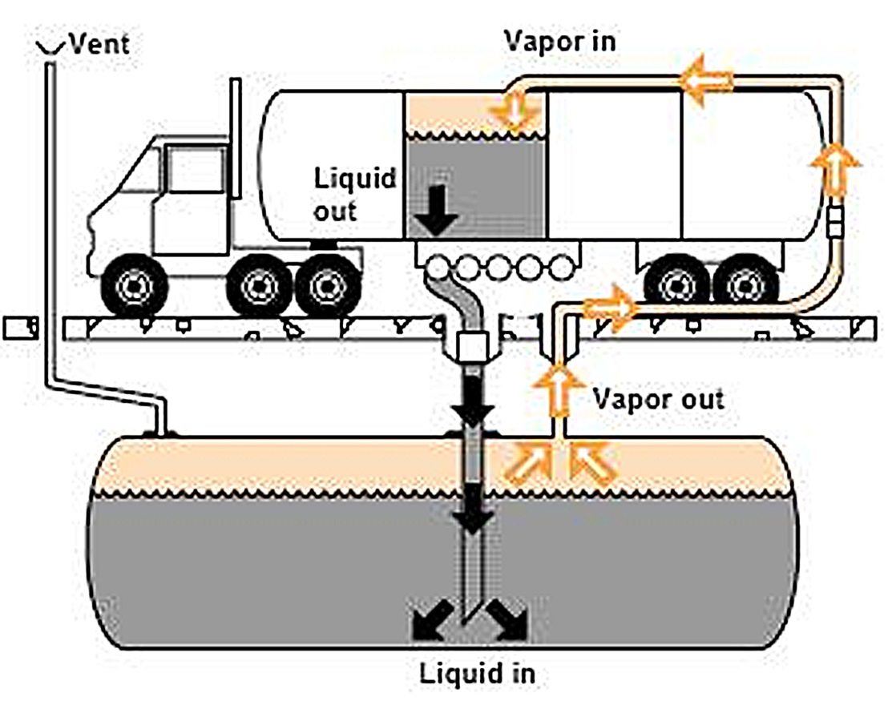
Figure 1 — Stage I vapours recovery
The Directive 2009/126/EC was produced by European Commission in order to fulfil commitments under the Thematic Strategy on Air Pollution. It was a step to further strengthen the requirements for petrol filling station construction and operation. Directive 2009/126/EC lays down measures aimed at reducing the amount of petrol vapour emitted to the atmosphere during the refuelling of motor vehicles at petrol filling stations.
The Directive prescribes such measures as:
- To equip any new petrol filling station or existing service station which undergoes a major refurbishment with a Stage II petrol vapour recovery system if:
(a) Its actual or intended throughput is greater than 500 m³/year; or
(b) Its actual or intended throughput is greater than 100 m³/year and it is situated under permanent living quarters or working areas.
Member States shall ensure that any existing service station with a throughput in excess of 3000 m³/year shall be equipped with a Stage II petrol vapour recovery system by no later than 31 December 2018.
The Stage II vapour recovery system simple scheme is presented at figure 2.
Stage II vapour recovery is the control of petrol vapour emissions that occurs when vehicles are being fuelled at petrol filling stations. Stage II vapour recovery is the system used to capture the petrol vapours at the vehicle fill pipe. The captured vapours are returned to the empty space in the underground storage tank at the filling station.
Usually, the fuel dispenser hose contains both fuel and vapour return lines. The vapour is drawn through the vapour return line by a vacuum pump. Stage II vapour recovery systems are intended to limit the emissions of fuel vapour when vehicles refuel by recovering at least 85% of the displaced vapour.
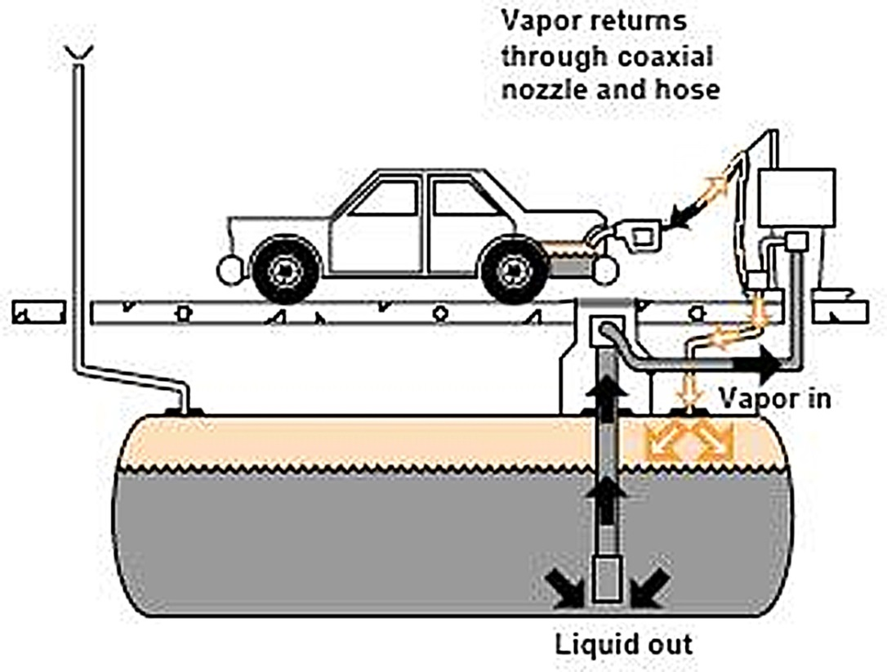
Figure 2 — Stage II vapours recovery
The Stage II vapour recovery systems need special fuel dispenser hoses, equipped with seals to prevent petrol vapours emissions (Figure 3).
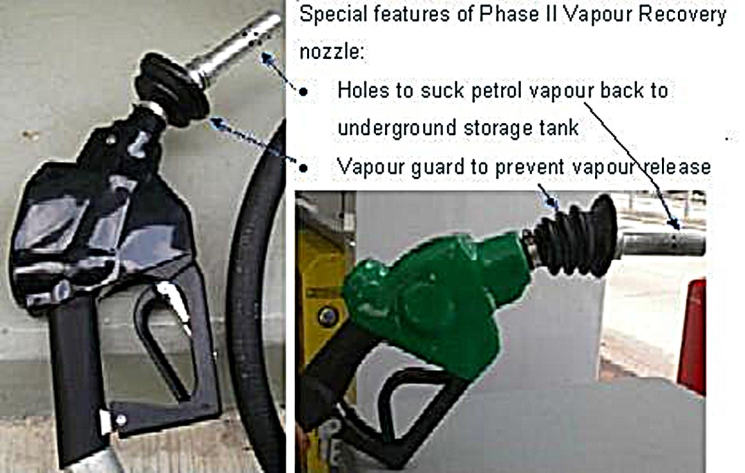
Figure 3 — Stage II vapours recovery fuel dispenser hose design
The Commission shall, by 31 December 2014, review the implementation of the Directive 2009/126/EC and, in particular:
- 100 m³/year threshold referred to in Article 3(1)(b) and (2)(b) of the Directive 2009/126/EC and Article 6(3) of Directive 94/63/EC
- In-service compliance record of Stage II petrol vapour recovery systems; and
- Need for automatic monitoring equipment.
Environmental permits procedures for petrol filling stations differ from one Member State to another. In the next chapter the UK procedure is described. Some general requirements are presented in Irish implementing regulation of the European Union Directive: Stage II Petrol Vapour Recovery during Refuelling of Motor Vehicles at Service Stations (hereinafter — Regulations 2011).
Regulations 2011 summarize all the requirements of Directives 94/63/EC and 2009/126/EC mentioned above. Owners of petrol filling stations are required to apply to their local authority for a certificate of installation after installing the Stage II petrol vapour recovery system and to organise for the system to be tested periodically as appropriate by an assessor, approved by the local authority.
Owners of petrol filling stations must also obtain a certificate of testing from their local authority. Such certificates may be issued following the receipt of a report by an assessor which indicates that the installation is in compliance with the requirement that petrol vapour capture efficiency is not less than 85%.
The forms of Application for Certificate of Installation, Certificate of Installation, Approved Assessor’s Report, and Certificate of Testing are attached to the Regulation 2011. The forms and procedure can be used by the Project countries when developing national procedures, and the templates are in the Annex 1 to the current report.
A person guilty of an offence under these Regulations can be liable on summary conviction (usually for less serious violations, without intervention of a jury) with a fine under the Fines Act 2010 (€5,000 as at 1 January 2012) or imprisonment for a term not exceeding 3 months or both. A person guilty of an offence under these Regulations can also be liable on conviction on indictment (for more serious offenses, may be tried before a judge and jury) to a fine not exceeding €100,000 or to imprisonment for a term not exceeding one year or to both such fine and such imprisonment.
Above mentioned requirements on Stage I and Stage II vapour recovery systems are considered as BAT for petrol filling stations. There is not special reference book on BAT for petrol filling stations, but some provisions of BREF “Emissions from Storage”. Minimum BAT requirements for petrol filling stations are:
- Double-wall underground fuel storage tanks
- Vapour recovery stage I and II systems
- Suitable pavement materials (not asphalt!) for forecourts and fuel filling areas
- Monitoring programmes.
In order to be able to prevent the possible harm to the environment caused by the anthropogenic impacts and to identify best solutions in addition to ones defined as compulsory by the legislation, it is advisable to carry out risk assessment. . The special methodologies of risk assessment are based on the analysis of probabilities of some unfavourable event and harm determination. The worst case corresponds to the high probability of event realization and significant harm caused by it. For risk estimation the matrix methods can be used.
But in practice the risk can be managed by relatively simple analysis of the impact chain: “source — pathway — receptor”. In this case “source” is a potential source of pollution, “receptor” is what could potentially be affected by the pollution, and “pathway” is the path/media source matter or energy can potentially travel through, from source to receptor.
At the figure 4, taken from the Pollution Prevention Guidelines PPG 7 “Safe storage - The safe operation of refuelling facilities” the impact chains: “source — pathway — receptor” are shown for petrol filling station. Here “sources” are leaking pipe and tank, “pathway” is the soil and “receptors” are groundwater and consumers. Also, using next pathway – surface water – the contamination can act harmfully at aquatic biota.
Figure 4 — The impact chains: “source — pathway — receptor” for petrol filling station
The task of the risk management is to break the impact chains. The simplest way is to prevent leakages, but for emergency cases it would be necessary to make appropriate drainage system.
If to make the list of possible sources, consequences of the risk and to find actions for limiting environmental or health damage, it will be a simple way to increase the level of environmental safety of the installation. An example of such a list for petrol filling station can be found at the work Pasi M. Nieminen from Tampere University of Technology. The list of major environmental risks and emission sources at petrol filling stations from the cited work is in Annex 2.

Requirements for petrol storage, petrol handling, and petrol filling stations environmental permits in Great Britain
As an example of implementation of Directives 94/63/EC, 2009/126/EC and Regulations 2011 the UK was chosen. The general issues are presented in the Secretary of State's Guidance for Storage, Unloading and Loading Petrol at Terminals (Process Guidance Note 1/13 (04)) and the Secretary of State’s Guidance for Unloading of Petrol into Storage at Petrol Stations (Process Guidance Note 1/14 (06)).
The first document gives guidance on the conditions appropriate for the control of emissions into the air from storage, unloading and loading petrol at terminals. Some mandatory requirements of the Guidance have their origin in Directive 94/63/EC (Stage I). Recommendations on ELVs were adopted from the “Emissions from Storage” BREF.
ELVs were established for total organic carbon as follows:
- For vapour recovery units installed before 1 January 1993 and operating until now — 50 g/Nm³ as 1 hourly average
- For all other vapour recovery units and vapour incineration units — 35 g/Nm³ as 1 hourly average.
The frequency of monitoring for any unit was established once every 3 years.
The general requirements on control of emissions into the air from unloading of petrol into storage, and from filling of vehicle petrol tanks, at petrol filling stations are presented in Process Guidance Note 1/14 (06). They are in line Stage I Directive and Stage II Regulation. In particular:
- Vapours displaced by the delivery of petrol into storage installations at petrol filling stations must be returned through a vapour tight connection line to the road tanker delivering the petrol
- The vapour tight connection line should be taken to include the hoses and connectors used to return vapour to the road tanker, but not the vent
- The operators should maintain a log book at the permitted installation incorporating details of all maintenance, examination and testing, inventory checking, installation and repair work carried out, along with details of training given to operating staff at the petrol filling station
- Vapours displaced by the filling of petrol into vehicle petrol tanks at petrol filling stations should be recovered through a vapour recovery system to a storage installation, which should include the station’s underground storage tank or other appropriate vessel (for existing stations with a throughput of more than 3500 m³ of petrol per year or 500 m³ of petrol per year for new petrol filling stations)
- At least 85% of the displaced petrol vapours resulting from filling of vehicle petrol tanks in petrol filling stations have to be recovered.
In England, above ground oil storage is regulated by the Control of Pollution (Oil Storage) (England) Regulations 2001, (OSR England). Oils covered by these regulations include petrol, diesel, vegetable, synthetic and mineral oils. They apply to most industrial, commercial and institutional sites storing oil in containers over 200 litres and to private dwellings with containers storing more than 3500 litres.
In Northern Ireland, above ground oil storage is regulated by the Control of Pollution (Oil Storage) Regulations (Northern Ireland) 2011, (OSR NI). These regulations apply to petrol, diesel, vegetable, synthetic and mineral oils. The regulations apply to most industrial, commercial and institutional sites storing oil in containers over 200 litres.
In Scotland, above ground oil storage is regulated by the Water Environment (Oil Storage) (Scotland) Regulations 2006 (OSR Scotland). These regulations apply to any kind of oil including petrol, diesel, mineral oil, heating oil, lubricating oil, agricultural fuel oil, waste oil, and vegetable and plant oil.
In England and Wales the environmental permits (Part A of the list of activities) are granted by DEFRA and Scottish Environmental Agency (SEPA) in Scotland. Permits for activities listed in (Part B) are granted by local authorities in England and Wales and local departments of SEPA in Scotland. All refuelling activities are in the part B:
- The storage of petrol in stationary storage tanks at a terminal, or the loading or unloading at a terminal of petrol into or from road tankers, rail tankers or inland waterway vessels
- The unloading of petrol into stationary storage tanks at a petrol filling station, if the total quantity of petrol unloaded into such tanks at the station in any 12-month period is likely to be 500 m³ or more
- Motor vehicle refuelling activities at an existing petrol filling station after the prescribed date, if the petrol refuelling throughput at the existing station in any 12-month period is, or is likely to be, 3500 m³ or more
- Motor vehicle refuelling activities at a new petrol filling station, if the petrol refuelling throughput at the service station in any 12-month period is likely to be 500 m³ or more.
Outline Pollution Prevention and Control Part B application form for England and Wales is given in Process Guidance Note 1/14 (06).
There is no significant difference between regulation in Scotland, England, Wales, and Northern Ireland but the base documents are separate. Below the procedure for Scotland is described.
At SEPA web site the procedure of getting permits for petrol filling stations owners and operators is given in the form of questions and answers.
The core of permitting procedure is Standard Rules (SR), produced by SEPA. SR is an equivalent of GBR. It is explained at the site that standard rules pollution prevention and control permit contains one condition requiring operator to comply with the standard rules instead of a number of conditions which may vary from site to site.
The new procedure of regulation has started from 01.01.2012. In November 2011, all petrol station operators were contacted in writing to raise awareness of refuelling of motor vehicle petrol vapour recovery, standard rules, on-line permitting and the transfer of permits to standard rules permits.
For existing installations, if annual petrol throughput was 3500 m³ or more the operator or owner had to fit equipment to recover petrol vapour displaced during the refuelling of customer vehicle tanks (Stage II) and apply for a substantial variation of the current permit. The application period was between 9 January and 29 February 2012. The cost of such an application for substantial variation was £151.
For new installations the same requirements of fitting Stage II equipment for petrol recovering are started from the lower threshold: annual petrol throughput 500 m³ or more.
Smaller petrol filling stations with annual petrol throughput less than 500 m³ are not regulated by SEPA. Permits in this case are granted by local (county) authorities.
SEPA inspects petrol filling stations to assess the compliance. Such kind of installation is considered to be a low-risk activity, and that is why the frequency of inspections is low unless SEPA receives complaints regarding the operation.
Failure to comply with permit is a criminal offence and carries a maximum penalty of 5 years imprisonment and an unlimited fine.
Public consultations are not required for applications for activities associated with petrol unloading and motor vehicle refuelling.

Requirements for petrol storage, petrol handling, and petrol filling stations environmental permits in Russian Federation
As it follows from the results of the Russian fuel union investigation, there were somewhat 20-22 thousand petrol filling stations in Russia in 2006. By now no simplified procedures for granting environmental permits for petrol filling stations are in place in Russia. Filling stations have to obtain permits in accordance with the general environmental legislation: on the ambient air quality protection, on water resources protection, and on waste disposal.
The Ordinance of the Russian Federation Chief Sanitary Officer on September 25, 2007 has established the sizes of sanitary protection zones (SPZ) for different sanitary classes of enterprises, ranged in accordance with their potential danger for people’s health.
Cited SanPiN 2.2.1/2.1.1.1200-03 attributes petrol filling stations for filling cars and lorries by liquid and gaseous fuel to class 4 of the sanitary classification. For class 4 the size of SPZ is equal to 100 m. If the number of fuel filling dispensers is not more than 3, the petrol filling station can be attributed as class 5 installation. For class 5 the size of SPZ is equal to 50 m.
Above mentioned sizes are approximate. They have to be legitimated by the project of SPZ with necessary calculations of the expected air pollution and approved by the results of on-site probes analyses. The background levels of ambient air pollution have to be taken into account.
The criterion for the size of SPZ setting is not to exceed PDK (maximum permissible concentrations) of pollutants in ambient air or maximum permissible noise levels at the SPZ boundary and beyond.
The methodology of emissions estimations and ELV calculation from different sources in Russia is worked out and further developed by LLC “NII Atmosphere”. The last edition of the methodology was approved be the Ministry of Natural Resources and Environment (MNR) (letter of the Ministry of 29 March 2012 No. 5-12-47/4521). The software for emissions calculation is produced by “Integral” company in St. Petersburg.
Among the pollutants for ELV determinations are: paraffin hydrocarbons, benzene, toluene, xylene, ethylbenzene.
At the federal level there are no requirements for petrol filling stations in terms of equipping by petrol vapour recovery systems. In February 2011 the issue was discussed at MNR, and it was noted that the emissions of VOC into ambient air in Russia from the processes of handling, storage and selling of oil and petroleum products exceed one million tons annually. It was decided to work out some federal standards aimed to diminish the emissions of petrol vapours at petrol filling stations.
This idea was not realised, but there is such regulation in Moscow, in force from 2002. The Rules on prevention of motor fuel vapours emissions have been in force until now. The Rules establish responsibilities of petrol filling station operators to install vapour recovery systems providing the recovering all the vapours of motor fuel at the stages:
- “Big breathes” during the delivery of petrol into storage installations
- “Small breathes” caused by the daily temperature and pressure fluctuations
- Vapour emissions in the process of motor vehicle refuelling.
The efficiency of fuel vapour recovery has to be not less than 85-90%.
More than 50 petrol filling stations in Moscow were equipped with petrol vapour recovery installations in 2002-2004 at expense of the stations owners.
The usage of petrol vapours’ recovering systems is foreseen in the General Plan of Moscow (Regulation on spatial planning of the City of Moscow). Application of petrol vapours recovering systems at petrol filling stations and oil storages is included into the list of measures on the abatement of the ambient air pollution.
Violation of the requirements regarding installation and operation of petrol vapours recovering systems at petrol filling stations entails an administrative penalty:
- For officials (station management) – 25 000 Roubles;
- For legal entities – 200 000 Roubles.
Air pollution is one of the main environmental problems in many Russian cities. That is why such measures as fuel vapour recovery are included in regional plans of environmental conditions’ improvement of some regions. For example, it is planned to install vapour recovery systems at the petrol filling stations in big cities of the Republic of Tatarstan (Tatneft company) by 2015.
Petrol vapour recovery systems of different modifications are installed at Russian petrol filling stations of Lukoil, Shell, Slavneft and some other companies.
Petrol filling stations have to obtain permits on waste water discharge. If the station sewage system is connected to municipal waste water treatment plant (WWTP), then it is a matter of contract between station and WWTP. Often the installation of some simple local treatment device (oil trap) at the station is the necessary condition of the contract. If the sewage discharges directly into some water body, then the petrol filling station is obliged to treat the sewage by itself and to meet rather severe requirements for the protection and use of water resources.
Also petrol filling station is obliged to have a contract with waste transporting company for disposing solid wastes.

Recommendations for project countries

Overall recommendations
The environmental impact of petrol filling stations is mainly associated with emissions into ambient air. The leaks of fuel from the station equipment can also cause the pollution of underground and surface waters.
The experience of EU countries, USA and Canada confirms the effectiveness of petrol vapour recovery systems for storages’ loading (stage I) and motor vehicles refuelling (stage II). Installation of such systems at petrol filling stations with annual petrol throughput 500 m³ or more can be recommended for Project countries as necessary requirement for operation permit granting.
The efficiency of fuel vapour recovery has to be not less than 85%.
For ELV value 35 g/Nm³ as 1 hourly average for total carbon can be recommended.
All other environmental risks have to be estimated and excluded with the help of environmental risk list. The list of Annex 2 can be used as an example.

Recommendation for environmental control and management of petrol stations
1. Summary of best available techniques
The following table provides a summary of the best available techniques that can be used to control the process in order to meet the emission limits. Provided that it is demonstrated to the satisfaction of the regulator that an equivalent level of control will be achieved, then other techniques may be used.
Table 1: Summary of control techniques
Release source | Substance | Control techniques
Petrol storage | Petrol vapours | Minimise breathing losses  Good seals  Connect to vapour recovery unit (or incinerate or hold vapour)
Loading fixed tanks | Petrol vapours | Connect to vapour recovery unit (or incinerate or hold vapour)
Loading mobile tanks | Petrol vapours | Connect to vapour recovery unit (or incinerate or hold vapour)
2. Ambient air quality management
In areas where air quality standards or objectives are being breached or are in serious risk of breach and it is clear from the detailed review and assessment work under Local Air Quality Management that the petrol storage and loading tanks are significant contributors to the problem, it may be necessary to impose tighter emission limits. If the air quality standard that is in danger of being exceeded is not a national legal requirement, then industry is not expected to go beyond BAT to meet it. Decisions should be taken in the context of a local authority's Local Air Quality Management action plan. For example, where petrol storage and loading tanks process is only responsible to a very small extent for an air quality problem, the authority should not unduly penalise the operator of the process by requiring disproportionate emissions reductions. The following advice can be also applicable:
“The approach from local authorities to tackling air quality should be an integrated one, involving all strands of local authority activity which impact on air quality and underpinned by a series of principles in which local authorities should aim to secure improvements in the most cost-effective manner, with regard to local environmental needs while avoiding unnecessary regulation. Their approach should seek an appropriate balance between controls on emissions from domestic, industrial and transport sources and draw on a combination and interaction of public, private and voluntary effort.”
3. Benzene - Air quality objective and EU limit value
The EU has set a limit value for benzene levels in ambient air of 5 µg/m³ as an annual mean (Directive 2008/50/EC of the European Parliament and of the Council of 21 May 2008 on ambient air quality and cleaner air for Europe).
In case the Ministry of Environmental protection in a project country decides to apply this ELV, it is recommendable to set stepwise requirement, for example:
- 16 mg/m³ as a running annual mean to be achieved by 31 December 2015
- 5 mg/m³ as a running annual mean to be achieved by 31 December 2020
4. Management techniques
Important elements for effective control of emissions include:
- Proper management, supervision and training for process operations;
- Proper use of equipment;
- Effective preventative maintenance on all plant and equipment concerned with the control of emissions to the air; and
- It is good practice to ensure that spares and consumables are available at short notice in order to rectify breakdowns rapidly. This is important with respect to arrestment plant and other necessary environmental controls. It is useful to have an audited list of essential items.
Spares and consumables - in particular, those subject to continual wear - should be held on site, or should be available at short notice from guaranteed local suppliers, so that plant breakdowns can be rectified rapidly.
5. Training
Staff at all levels need the necessary training and instruction in their duties relating to control of the process and emissions to air. In order to minimise risk of emissions, particular emphasis should be given to control procedures during start-up, shut down and abnormal conditions.
Training of all staff with responsibility for operating the process should include:
- Awareness of their responsibilities under the permit;
- Action to minimise emissions during abnormal conditions
The operator should maintain a statement of training requirements for each operational post and keep a record of the training received by each person whose actions may have an impact on the environment. These documents should be made available to the regulator on request.
6. Maintenance
Effective preventative maintenance should be employed on all aspects of the process including all plant, buildings and the equipment concerned with the control of emissions to air. In particular:
- The regulator should be notified 7 days in advance of any planned maintenance of the vapour recovery unit.
- A record of such maintenance should be made available for inspection.

Annex 1
Example of Application for Certificate of Installation
By the owner of a petrol filling station under the Irish implementing regulation of the European Union Directive (Stage II Petrol Vapour Recovery during refuelling of motor vehicles at petrol filling stations) Regulations 2011 further only “Regulations 2011”

1. Name and business address of the owner of the petrol filling station:
2. Address of the petrol filling station if different from above:
3. I am applying for a certificate of installation for the Stage II petrol vapour recovery system installed is in accordance with these Regulations.
4. I enclose the report of the installer and manufacturer’s details for the above installation.

Signature.................................................................. Date..................................

Certificate of Installation Issued
By a competent authority in respect of a petrol filling station under the Regulations 2011

1. Name and business address of the owner of the petrol filling station:
2. Address of the petrol filling station if different from above:
3. Date of receipt of manufacturer’s and installer’s certification which demonstrates that the Stage II petrol vapour recovery system installed is in accordance these Regulations:
4. Register Number:
5. Is the certificate signed by the installer-:
(Name of local authority) today ........................ (date) ..................... hereby certifies that the petrol filling station at ..................... owned by -------------- complies with the provisions to install a Stage II Petrol vapour recovery system in accordance with the Regulations 2011.
Stamp of Local Authority to be affixed here
Signature of Authorised Officer
Date of return of stamped certificate to applicant

Approved Assessor’s Report
Particulars to be included in a report by an approved assessor where a petrol filling station complies with the requirements of the Regulations 2011

1. Name of petrol filling station owner
2. Business address/registered office of owner
3. Address of petrol filling station (if different)
4. Service station throughput (largest total annual quantity loaded/unloaded at petrol filling station in three years preceding this installation of)
5. Date of testing
6. Brief description of tests carried out
7. Is this a first test for the purposes of these regulations- If not, state day, month and year of most recent test.
Declaration
I, ...................................................................., hereby confirm that I have tested the above petrol filling station on .................................... (insert date) .................................... for compliance with the provisions of the Regulations 2011 and to the best of my knowledge and belief this petrol filling station is in compliance with the said provisions.
Signed.
Qualification/Profession and Company
Address
Date
Certificate of Testing Issued
By a competent authority in respect of a compliant service station under the Regulations 2011

1. Date of receipt of approved assessor's report
2. Register Number
3. Fee received (Tick)
4. Is the report signed by an approved assessor-
(Name of local authority) today ...................................... (date) ........................... hereby certifies that the petrol filling station at .......................................... owned by ....................................... complies with the provisions of the Regulations 2011 and this certificate shall be valid for a period of not more than one / three (delete as appropriate) years until .................................................. (date) ................................................. .
Stamp of Local Authority to be affixed here
Signature of Authorised Officer
Date of return of stamped certificate to applicant

Annex 2
Major Environmental Risks and Emission Sources at Petrol Filling Stations
 | Risk or/and release source | Consequence of risk | Recommended action to limit environmental damage.
1. | Wall of underground tank is broken. | Fuel product gets into soil and groundwater → Contamination | - Two-wall storage tanks.  - Impermeable barrier around tanks.  - Real time gauging system.  - Real time alarm system.  - Periodic inspections of tanks and control programme.
2. | Underground pipes leak between the dispenser sump and tank chamber. | Fuel product enters into soil and groundwater → Contamination | - Two-wall petrol pipes.  - Impermeable barrier around pipes.  - Periodic inspections of pipes and monitoring programme.
3. | Underground pipes leak inside unsealed chamber. | Fuel product enters soil and groundwater → Contamination (Danger of explosion) | - Sealed chambers.  - Real time alarm system.  - Periodic inspections and monitoring programme for pipes and chambers.  - Filling chambers with inert materials; e.g. with sand or mineral wool.
4. | Underground pipes leak beneath dispenser. | Fuel product enters soil and groundwater → Contamination (Possible danger of explosion if there are empty spaces beneath pump island or dispenser.) | - Impermeable barrier under the forecourt.  - Sealed sumps.  - Periodic inspections and monitoring programme for pipes, dispensers and sumps.  - Filling empty spaces and/or sump; with inert materials; e.g. with sand or mineral wool.
5. | Dispenser leaks from hydraulic sections. | Fuel product enters soil and groundwater → Contamination | - Impermeable barrier under forecourt.  - Sealed sumps.  - Oil-proof pavement of the forecourt.  - Forecourt rainwater drainage to oil separator.  - Periodic inspections and monitoring programme for the dispenser.
6. | Overflow when storage tank is filling | Fuel product enters soil and groundwater → Contamination | - Overfill prevention.  - Oil-proof pavement of the fuel filling area.  - Filling area's rainwater drainage to oil separator.  - Impermeable barrier under fuel filling area.

 | Risk or/and release source |  | Consequence of risk |  | Recommended action to limit environmental damage.
7. | Overflow when filling motor vehicles. |  | Fuel product enters soil and groundwater → Contamination |  | - Oil-proof pavement of the fuel filling area.  - Forecourt rainwater drainage to oil separator.  - Impermeable barrier under forecourt.
8. | Pavement of fuel filling area is not oil-proof. |  | Fuel product enters soil and groundwater → Contamination |  | - Oil-proof pavement of the fuel filling area.  - Impermeable barrier under fuel filling area.  - Periodic inspections and monitoring programme for the pavement.
9. | Pavement of the forecourt is not oil-proof. |  | Fuel product enters soil and groundwater → Contamination |  | - Oil-proof pavement of the forecourt.  - Impermeable barrier under forecourt.  - Periodic inspections and monitoring programme for the pavement.
10. | No drainage system and oil separator at fuel filling area. |  | Fuel product enters soil and groundwater → Contamination |  | - Drainage system construction.  - Installation of oil separator.
11. | No drainage system and oil separator at forecourt |  | Fuel product enters soil and groundwater → Contamination |  | - Drainage system construction.  - Installation of oil separator.
12. | Absence of overflow prevention system |  | Overflow when filling the storage tank → Fuel product enters soil and groundwater → Contamination |  | - Installation of overflow prevention system  - Periodic inspections and monitoring programme for overflow prevention equipment. Oil-proof pavement of the fuel filling area.  - Impermeable barrier under the fuel filling area.
13. | Improper vapour recovery stage I system (or totally absence) | Vapour enters into the air → Air pollution  Vapour enters into underground spaces →Danger of explosion |  | - Installation of vapour recovery stage I system.  - Periodic inspections and monitoring programme.
14. | Improper vapour recovery stage II system (or totally absence) | Vapour enters into the air → Air pollution  Vapour enters into underground spaces →Danger of explosion |  | - Installation of vapour recovery stage I system.  - Periodic inspections and monitoring programme.
15. | Non-functioning alarm system. | Petrol enters drainage → Danger of explosion |  | - Periodic inspections and monitoring programme.

recommendations for ELVs, other conditions setting for small combustion installations

Inventory of fuel combustion installations with a total rated thermal input below 50 MW in EU
The most recent comprehensive investigation of the environmental role of small combustion installations with a total rated thermal input below 50 MW in EU-27 was fulfilled in 2014 by AMEC Environment and Infrastructure UK Limited (‘AMEC’).
Firstly, the inventory of an existing installation in EU-27 was made. Some results of this work are presented in Table 1. All installations were divided in three categories by their thermal input, in particular: 1-5 MW_{th}, 5-20 MW_{th}, and 20-50 MW_{th}.
Some installations with a rated thermal input less than 50 MW_{th} may already be regulated under IED as part of installations where the aggregated combustion capacity on site is at least 50 MW_{th} or where combustion is a directly associated activity with a technical connection to the IED activity.
The accuracy of the table 1 data cannot be overestimated. There were some gaps in the data and some countries didn’t provide the necessary information. Special approaches, described in the cited Report, were used to fill the gaps. For example, the following EU level assumptions have been made for the Member States who did not provide the information: 5% of plants in 1-5 MW_{th} capacity class, 10% of plants in 5-20 MW_{th} capacity class and 40% of plants in 20-50 MW_{th} capacity class.
Table 1 — Small combustion installations with a total rated thermal input below 50 MW in EU-27
Datum | 1-5 MW_{th} | 5-20 MW_{th} | 20-50 MW_{th}
Number of installations | 113 809 | 23 868 | 5 309
Sectoral distribution: | 1-5 MW_{th} | 5-20 MW_{th} | 20-50 MW_{th}
Public electricity generation | 11% | 8% | 16%
Public heat generation | 25% | 29% | 40%
Tertiary (i.e. non-residential) | 5% | 2% | 0%
Hospitals | 6% | 1% | 2%
Greenhouses | 13% | 40% | 4%
Food industry | 4% | 3% | 6%
Industry | 18% | 14% | 28%
Others (University) | 5% | 0% | 1%
Others (CHP) | 1% | 0% | 0%
Others | 11% | 3% | 3%
Technology type: | 1-5 MW_{th} | 5-20 MW_{th} | 20-50 MW_{th}
Boilers | 80% | 82% | 81%
Engines / turbines / others | 20% | 18% | 19%
Capacity of installations (GW_{th}) | 273 714 | 232 367 | 177 099
Fuel consumption: | 1-5 MW_{th} | 5-20 MW_{th} | 20-50 MW_{th}
Biomass (PJ) | 163 | 160 | 182
Other solid fuel (PJ) | 49 | 46 | 74
Liquid fuel (PJ) | 213 | 290 | 206
Natural gas (PJ) | 1 268 | 1 704 | 844
Other gaseous fuel (PJ) | 277 | 125 | 104
Total fuel consumption (PJ) | 1 971 | 2 325 | 1 410
SO₂ emissions (kt) | 103 | 130 | 68
NO_{X} emissions (kt) | 210 | 227 | 117
Dust emissions (kt) | 17 | 20 | 16
Mainly, the installations are used for heat generation in dwellings and greenhouses; a noticeable number of installations are used in industrial sectors. Nearby 80% of installations are boilers.
Where Reports data have not already been gathered, the total fuel consumption of plants has been estimated by using average load factors together with the capacity data. The average load factors have been calculated separately for each capacity class from those data provided by Member States which were considered complete. Load factors (percent and hours per year) are presented in the table 2.
Table 2 — Average Load Factors for Each Capacity Class
Capacity Class | Load Factor (%) | Load Factor (Hours/Year)
1-5 MW_{th} | 21 | 1847
5-20 MW_{th} | 34 | 2945
20-50 MW_{th} | 22 | 1894

Figure 1 presents the fuel consumption in 2010 for EU-27 by fuel type for each capacity class.
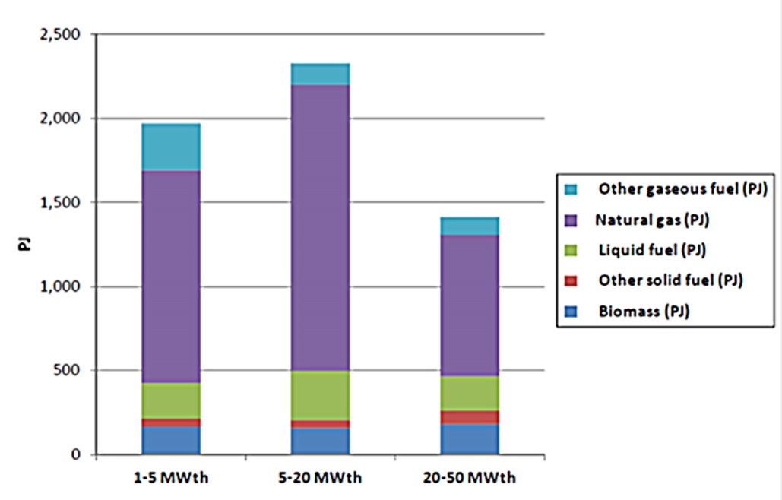
Fig. 1 — EU-27 fuel consumption per capacity class (2010)
The share of natural gas is the biggest, but the current EU tendency of natural gas substitution by other fuels and climate change reasons may lead to biomass share growth in the nearest future.

Environmental issues for fuel combustion installations with a total rated thermal input below 50 MW
Main pollutants related to fossil fuels or biomass combustion are as follows: nitrogen oxides (NO and NO₂, represented as NO_{X}), sulphur dioxide (SO₂), dust or particulate matter (PM), and carbon monoxide (CO). The key combustion related greenhouse gas is carbon dioxide (CO₂).
The most important substances and compounds from the point of public health protection are: NO_{X}, SO₂ and dust. Figure 2 presents the emissions of these pollutants by small combustion plants for EU-27 in 2010.
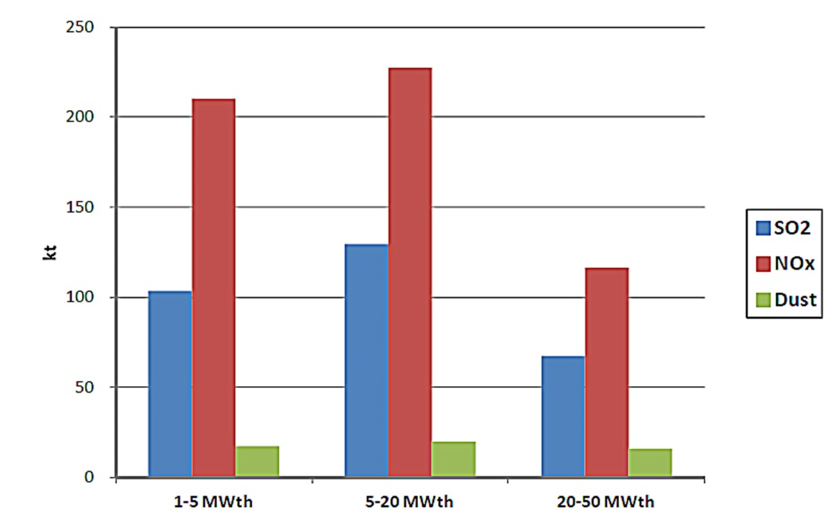
Fig. 2 — EU-27 emissions per capacity class (2010)
Optimal measures for SO₂ reduction deal with the proper choice of fuel. Natural gas and biomass are almost sulphur free fuels. The main sources of SO₂ emissions are the combustion of coal and heavy oil.
Emission of NO_{X} depends on the combustion temperature, on the fuel: air ratio and on the residence time of nitrogen at that temperature. The measures of NO_{X} emissions reduction for large combustion installations are described in the BAT reference document (BREF); some of them can be applied to the smaller units.
NO₂ reacts with volatile organic compounds in the presence of sunlight to form ozone. Ozone can cause adverse effects such as damage to lung tissue and reduction in lung function mostly in susceptible populations (children, elderly, and asthmatics).
The current WHO guidelines for NO_{X}:
- 40 μg/m³ annual mean
- 200 μg/m³ 1-hour mean
At short-term concentrations exceeding 200 µg/m³, NO₂ is a toxic gas which causes significant inflammation of the airways.
Dust or particulate matter (PM) is nowadays considered to be one of the most dangerous substances, which is especially true for the smallest particles. In accordance with US EPA classification, we distinguish:
- “Coarse particles” (PM₁₀) which summarizes all particles with an aerodynamic diameter between 10 and 2.5 microns in size.
- "Fine particles" (or PM_{2.5}) have diameters less than 2.5 microns. PM_{2.5} is referred to as “primary” if it is directly emitted into the air as solid or liquid particles, and is called “secondary” if it is formed by chemical reactions of gases in the atmosphere.
The major components of PM are sulphate, nitrates, ammonia, sodium chloride, black carbon, mineral dust and water. It consists of a complex mixture of solid and liquid particles of organic and inorganic substances suspended in the air.
Long exposures to particulate matter can cause serious health problems such as higher morbidity, affection of lungs and a shorter life expectancy, mainly in subject with pre-existing heart and lung diseases. In accordance with the last WHO report around 7 million people died — one in eight of total global deaths — as a result of air pollution exposure in 2012. Around 3.7 million deaths were attributable to ambient air pollution, and 4,3 million deaths — to household air pollution.
Deaths due to ambient air pollution were mainly fixed in the Western Pacific and South East Asian regions (1.67 million and 936 000 deaths, respectively). But this problem did not leave out the Europe: deaths occur in high-income countries of Europe (279 000 deaths in 2012) and in low- and middle-income countries — 203 000 deaths in 2012. Recalculating these figures per capita, obtain 44 deaths per 100 000 capita in high-income countries of Europe and 75 deaths per 100 000 capita in low- and middle-income countries.
WHO estimates that some 80% of outdoor air pollution-related premature deaths were due to ischaemic heart disease and strokes, while 14% of deaths were due to chronic obstructive pulmonary disease or acute lower respiratory infections; and 6% of deaths were due to lung cancer.
WHO affirms that PM affects more people than any other pollutant. The most health-damaging particles are those with a diameter of 10 microns or less, (≤ PM₁₀), which can penetrate and lodge deep inside the lungs. Chronic exposure to particles contributes to the risk of developing cardiovascular and respiratory diseases, as well as of lung cancer.
WHO Guideline values are:
- For PM_{2.5}
  - 10 µg/m³ annual mean
  - 25 µg/m³ 24-hour mean
- For PM₁₀
  - 20 µg/m³ annual mean
  - 50 µg/m³ 24-hour mean
Air quality standards for EU:
- For PM_{2.5} — 25 µg/m³ annual mean. Target value entered into force 01.01.2010. Limit value enters into force 01.01.2015
- For PM₁₀
  - 40 µg/m³ annual mean
  - 50 µg/m³ 24-hour mean
Limit value entered into force 01.01.2005.
The small and medium combustion installations including those applied for residential heating — fireplaces, stoves, cookers, small boilers (< 50 MW_{th}) - are the noticeable sources of ambient air pollution, especially of PM emissions.
Figure 3 from the report presents PM_{2,5} emissions in the GAINS Europe area for the years 2000, 2005 and projection for 2020. It can be seen that the share of small combustion installations is nearby 25% in total PM_{2.5} emissions and is higher than the share of large combustion plants.
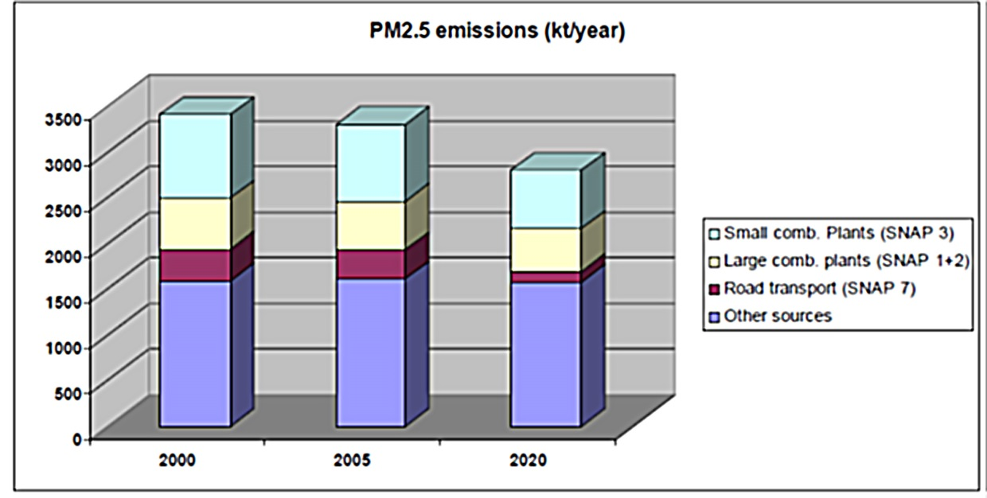
Figure 3 — PM_{2.5} emissions in the GAINS Europe area
Mainly (nearby 80%) PM_{2.5} emissions were due the biofuel combustion. Small and medium combustion installations in domestic sector are responsible for quite significant share of the total PM_{2,5} emissions in EU countries. Estimations made in the Report show that the shares of small and medium combustion installations in PM_{2.5} emissions are as much as 76% in Latvia, 74% in Poland, 57% in Denmark, and 38% in Estonia. But for some countries this share is rather small: Germany – 16%, Sweden – 12% and UK – 9%. The last figure is particularly surprising, and shifts our thinking about the “chimneys country”, but such low emissions are due to the usage of the best available practices and techniques in the sector.
Detailed measurements in residential areas in Denmark show that wood burning can increase local PM_{2.5} and polyaromatic hydrocarbons concentrations to levels similar to those in rush hour traffic in central Copenhagen.
The Danish Centre for Energy, Environment and Health estimates that pollution from Danish residential wood burning causes about 250 premature deaths yearly in Denmark and about 650 premature deaths in the EU (due to transboundary pollution spread to the rest of Europe). This mortality is related to chronic exposure to increased PM concentrations and not to acute exposure to wood smoke. On top of this, tens of thousands of cases of serious diseases (heart, airways and cancer) can be related to the pollution. This estimate does not take into account secondary particles from VOC emissions. The yearly socio-economic health costs related to pollution from Danish wood burning are estimated to be around €500 million per year.
If residential wood burning remains practically unregulated, the sector will by 2025 be responsible for more than 90 per cent of the total Danish PM_{2.5} emissions.

European Union requirements for fuel combustion in installations with a total rated thermal input below 50 MW

Existing EU legislation
At EU level there are several instruments other than IED regulating combustion installations of less than 50 MW_{th}.
At December 18, 2013 new policy package to clean up Europe's air was adopted by European Commission. The package has a number of components. They include:
- A new Clean Air Programme for Europe with measures to ensure that existing targets are met in the short term and new air quality objectives for the period up to 2030. The package also includes support measures to help cut air pollution, with a focus on improving air quality in cities, supporting research and innovation, and promoting international cooperation
- A revised National Emission Ceilings Directive with stricter national emission ceilings for the six main pollutants, and
- A proposal for a new Directive to reduce pollution from medium-sized combustion installations, such as energy plants for street blocks or large buildings, and small industry installations. These proposals will be discussed below in the Report.
By 2030, and compared to business as usual, the clean air policy package is estimated to:
- Avoid 58 000 premature deaths,
- Save 123 000 km² of ecosystems from nitrogen pollution (more than half the area of Romania),
- Save 56 000 km² protected Natura 2000 areas (more than the entire area of Croatia) from nitrogen pollution,
- Save 19 000 km² forest ecosystems from acidification.
The benefits to people's health from implementing the package are around €40 billion a year, over 12 times the costs of pollution abatement, which are estimated to reach € 3.4 billion per year in 2030.
Ecodesign Directive 2009/125/EC provides rules for improving the environmental performance of a wide range of energy related products. Among these products are installations which use, generate, transfer or measure energy, including boilers. Steam boilers below 50 MW_{th} have been included in the working plan of Directive implementation (2012-2014).
Ecodesign Preparatory Study on steam boilers has to provide the European Commission with a technical, environmental and economic analysis of steam boilers as according to Article 15 of the Ecodesign Directive 2009/125/EC. It is based on the Methodology for Ecodesign of Energy-related Products. The study was started in June 2013 and will be finalized in autumn 2014. Draft report “Ecodesign Preparatory Study on Steam Boilers” is already published.
In the framework of the Ecodesign directive and in relation to steam boilers the following preparatory studies will be done:
- Boilers and combi-boilers
- Water heaters
- Solid fuels small combustion installations
- Local room heating products
- Central heating products using hot air to distribute heat
- Domestic and commercial ovens
- Industrial and laboratory furnaces and ovens.
However, there is no relevant legislation based on the Ecodesign directive that directly addresses steam boilers.
Industrial Emissions Directive (IED) 2010/75/EU in the Article 29 establishes “aggregation rules”. The rule is as following: “Where the waste gases of two or more separate combustion plants are discharged through a common stack, the combination formed by such plants shall be considered as a single combustion plant and their capacities added for the purpose of calculating the total rated thermal input”. If two or more combustion plants add up and use or could use a common stack and if the individual rated thermal input power is above 15 MW (and at total more than 50 MW), a combustion plant is considered under the IED. The second case is that a combustion plant of less than 50 MW is directly associated and has a technical connection with Annex I activity IED, operating on the same site. Such cases are quite often at pulp-and-paper plants.
The Emission Trading Directive (2003/87/EC) establishes a scheme for trading greenhouse gas emission within the European Union. The aim of this trading scheme is to reduce greenhouse gas emissions in a cost-effective manner. The directive introduces a system of tradable permits. Operators of certain installations as defined in Annex I of the directive have to hold a sufficient number of permits for operating their installations.
Steam boilers are covered by the directive in two cases: either as combustion installations, if a total rated thermal input of 20 MW, or as part of other production activities.
Directive 2003/87/EC encourage more efficient combustion installations and fuel-switching to natural gas and biomass or other biofuels.
Renewable energy Directive 2009/28/EC establishes a joint framework for the production and promotion of energy from renewable sources. Directive introduces national targets for the share of energy produced from renewable sources. Targets are set for 2020 and include combustion plants < 50 MW_{th}. There are not direct requirements for individual installations in directive, but indirectly its implementation reduces the number of small combustion plants due to encouragement of generation from non-combustion renewable sources.
The Energy Efficiency Directive (2012/27/EU) introduces new instruments to foster energy efficiency in Europe significantly. Among the further development of measures laid down in the Energy Services Directive (2006/32/EC) like the national reporting on energy efficiency efforts in the National Energy Efficiency Action Plans (NEEAP), the Directive introduces some new instruments which are relevant in the context of Energy use and Energy related products.
The Energy Efficiency Directive establishes a common framework of measures for the promotion of energy efficiency within the Union, in order to ensure the achievement of the Union’s 2020 20% headline target on energy efficiency and to pave the way for further energy efficiency improvements beyond that date.
The main new instrument is the (mandatory) introduction of energy saving obligation schemes within the Member States as laid down in Article 7. This instrument is supposed to deliver additional savings equivalent to 1,5% of the annual energy consumption of the member states in a reference period. The Directive includes such measures as monitoring of efficiency levels of new energy generation capacities, national assessments for co-generation and district heating potential and measures for its uptake to be developed by 31 December 2015, including recovery of waste heat, demand side resources to be encouraged.
However there are no regulations in the Energy Efficiency Directive that directly affect steam boilers.
EC Directive on promotion of CHP in the internal energy market (2004/8/EC) aims to promote high-efficiency cogeneration given the potential benefits with regard to saving primary energy, avoiding network losses and reducing emissions, in particular of greenhouse gases. The Directive supports the installation of CHP where there is a significant demand for heat. Its main measures include:
- A single methodology for establishing high efficiency CHP across EU member states
- A “guarantee of origin” for electricity from CHP sources
- Obligations on EU member states to analyse national potentials for high-efficiency CHP and report progress on its development
- Evaluation of the different ways EU member states support CHP
- Ensure equitable or preferential access for CHP on the electricity transmission and distribution networks
- Encouraging EU member states to evaluate their own legislative and regulatory framework with a view to removing barriers to the uptake of CHP.
The share of CHP among combustion plants < 50 MW_{th} is significant and has a tendency to growth. CHP solution is carbon friendly and minimizes specific air emissions, as it will be shown in next chapters.
The Energy Labelling Directive (Directive 92/75/EC) and its revision in 2010 (2010/30/EU) provide a framework for the provision of product information related to energy consumption and use of other essential resources by household products. This should enable consumers to choose more energy efficient appliances. The focus of the Directive is on appliances whose aggregate use of energy is significant and which afford an adequate scope for increased efficiency.
A revised directive expanded the possible introduction of labelling requirements beyond the area of domestic appliances to energy related products with significant direct or indirect impact on the consumption of energy.
Under this directive the Commission has delegated power to set the labelling requirements for specific products. Both directives do not provide any specific regulations for steam boilers or related equipment, but the eco-labelling instruments, foreseen by them, are rather effective.
Investigation of the Danish Centre for Energy, Environment and Health, cited above, affirms that by replacing old wood stoves with Swan labelled stoves and replacing old wood boilers with new boilers the pollution from household wood burning can be halved. Stoves labelled with the Nordic Swan must have total emissions below 5 g/kg wood. The measurement is for average use, and emissions can be higher at certain power levels. Implementation of this standard would reduce the total Danish and EU emission of PM_{2.5} by 35 and 16 per cent, respectively. And if all wood stoves and wood boilers will be replaced with wood pellet, the pollution from residential wood burning could be shrunk to less than a tenth of present emissions. Total Danish and EU emission of PM_{2.5} would be reduced by about 65 and 30 per cent, respectively, and other key pollutants would also be reduced significantly.
The best Swan labelled stoves have emissions below 200 g PM_{2.5}/GJ, some are under 180 g PM_{2.5}/GJ. This is similar to 3 and 2.7 g PM_{2.5}/kg wood.
Besides Directives, there are some standards used within the European Union for wood fired boilers and stoves. Among them:
- EN 14785 — Residential space heating appliances fired by wood pellets – requirements and test methods. The thresholds for CO emissions are established in the standard.
- EN 303-5 —Heating boilers for solid fuels, hand and automatically stoked, nominal heat output of up to 300 kW. In this standard the thresholds for CO and dust are pre-defined.

International legislation
The 1979 Convention on Long-Range Transboundary Air Pollution was established within the framework of the United Nations Economic Commission for Europe (UNECE), it entered into force in 1983 and has since been extended by eight specific protocols. The most recent protocol (1999 Gothenburg Protocol to Abate Acidification, Eutrophication and Ground-level Ozone) has entered into force in 2005. The objective of Protocol was to control and reduce emissions of sulphur, nitrogen oxides, ammonia and volatile organic compounds that are caused by anthropogenic activities and are a result of long-range transboundary atmospheric transport.
Protocol has obliged the Parties to establish emission limit values for new and existing boilers and process heaters with a rated thermal input exceeding 50 MW_{th}. Some of the Project countries signed, but nobody ratified Gothenburg protocol, but its requirements can be used as a guide.
In June 2012, agreement was reached in revising the Gothenburg Protocol. Certain aspects of the revision widen the Protocol’s scope in relation to combustion plants less than 50 MW_{th}. The elements of the newly revised protocol which are relevant to combustion plants between 1 MW_{th} and 50 MW_{th} can be summarised as follows:
Annex II of the Protocol sets national SO₂, NO_{X}, NH₃ and VOC emissions ceilings for 2010 until 2020 and emission reduction commitments (additionally for PM_{2.5}) for 2020 and beyond. These ceilings and reduction commitments are not sector specific but may influence the need to control emissions from combustion plants between 1 MW_{th} and 50 MW_{th}.
In annexes IV, V, VI and X (new) emission limit values of sulphur, nitrogen oxides, VOC and PM from stationary sources were specified. For combustion plants with a rated thermal input between 1 MW_{th} and 50 MW_{th}, the following provisions are relevant:
- Annex IV (SO₂): limit for sulphur content of gas oil at <0.1% by January 2008;
- Annex V (NO_{X}): limit values for new stationary engines which run for more than 500 hours per year, differentiated by fuel, size and combustion type, as follows (table 3):
Table 3 — ELV for gas engines and dual fuel engines greater than 1 MW_{th}, and diesel engines greater than 5 MW_{th}
Engine type | Rated thermal input (MW_{th}) | ELV for NO_{X} (mg/Nm³)
Gas (Otto) engines | >1 | 95-190
Dual-fuel engines (gaseous mode) | >1 | 190
Dual-fuel engines (liquid mode) | 1-20 and >20 | 225
Slow / medium speed (<1 200 rpm) diesel engines (heavy fuel oil and bio-oils) | 5-20 | 225
 | >20 | 190
Slow / medium speed (<1 200 rpm) diesel engines (light fuel oil and natural gas) | >5 | 190
All high speed (>1 200 rpm) diesel engines |  | 190
- Annex X (particulate matter): recommended but not binding dust limit values for solid and liquid fuel-fired boilers and process heaters with rated thermal input from 1 MW_{th} to 50 MW_{th} (table 4).
Table 4 — ELV for solid and liquid fuel-fired boilers and process heaters with rated thermal input from 1 MW_{th} to 50 MW_{th}
Boiler type | Rated thermal input (MW_{th}) | ELV for dust (mg/Nm³)
New solid and liquid fired | >1-50 | 20
Existing solid and liquid fired | >1-5 | 50
Existing solid and liquid fired | >5-50 | 30
There are some recommendations in Annex V of the Protocol for residential small combustion installations with a rated thermal input less 500 kW_{th}:
“Emissions from new residential combustion stoves and boilers with a rated thermal input less 500 kW_{th} can be reduced by the application of:
- Product standards as described in CEN standards (e.g., EN 303–5) and equivalent product standards in the United States and Canada. Countries applying such product standards may define additional national requirements taking into account, in particular, the contribution of emissions of condensable organic compounds to the formation of ambient PM; or
- Ecolabels specifying performance criteria that are typically stricter than the minimum efficiency requirements of the EN product standards or national regulations”
Recommended limit values for dust emissions released from new solid fuel combustion installations with a rated thermal input < 500 kW_{th} to be used with product standards:
Dust (mg/m³)
Open/closed fireplaces and stoves using wood — 75
Log wood boilers (with heat storage tank) — 40
Pellet stoves and boilers — 50
Stoves and boilers using other solid fuels than wood — 50
Automatic combustion installations — 50
The following general recommendations are given for small boilers:
“Emissions from existing residential combustion stoves and boilers can be reduced by the following primary measures:
- Public information and awareness-raising programmes regarding:
  - The proper operation of stoves and boilers;
  - The use of untreated wood only;
  - The correct seasoning of wood for moisture content;
- Establishing a programme to promote the replacement of the oldest existing boilers and stoves by modern appliances; or
- Establishing an obligation to exchange or retrofit old appliances”.
For non-residential combustion installations with a rated thermal input 100 kW_{th} –1 MW_{th} ELVs for dust emissions are recommended:
Dust (mg/m³)
Solid fuels 100 kW_{th} –1 MW_{th}, new installations — 50
Solid fuels 100 kW_{th} –1 MW_{th}, existing installations — 150
No recommendations on ELVs for NO_{X} emissions were given for boilers with rated thermal input from 1 MW_{th} to 50 MW_{th}. But values ELVs for NO_{X} emissions released from combustion plants with thermal input from 50 MW_{th} to 100 MW_{th} can be used as a guide. They are as follows:
  - For solid fuels new plants:
    - coal, lignite and other solid fuels — ELV = 300 mg/Nm³
    - pulverized lignite) — ELV =450 mg/Nm³
    - biomass, peat) — ELV =250 mg/Nm³
  - For solid fuels existing plants:
    - coal, lignite and other solid fuels) — ELV =300 mg/Nm³
    - pulverized lignite) — ELV =450 mg/Nm³
    - biomass, peat — ELV =300 mg/Nm³
  - For liquid fuels new plants — ELV =300 mg/Nm³
  - For liquid fuels existing plants — ELV =450 mg/Nm³
The instrument of ISO International Standards is widely used over the World. The goal of the standards is “to ensure that products and services are safe, reliable and of good quality”. The key ISO standards available for boilers and pressure vessels are as follows:
- ISO 16528-1:2007 Boilers and pressure vessels -- Part 1: Performance requirements
- ISO 16528-2:2007 Boilers and pressure vessels -- Part 2: Procedures for fulfilling the requirements of ISO 16528-1
- ISO 22968:2010 Forced draught oil burners
- ISO 22967:2010 Forced draught gas burners

Main types of boilers
The term “boiler” is generally used for any closed vessel in which water or other fluid is heated. Boilers are used in various processes or heating applications, such as central heating, boiler-based power generation, cooking and sanitation.
Typically used categorization of boilers is based on the way the water-steam medium is flowing through the boiler. Based on this difference, fire-tube and water-tube boilers can be distinguished.
In fire-tube boilers, hot gases pass through the tubes. Boiler feed water in the shell side is converted into steam (Figure 4). Fire tube boilers are competitive for relatively small steam capacities, up to 12 000 kg/hour, and low to medium steam pressures (up to 25 bar).
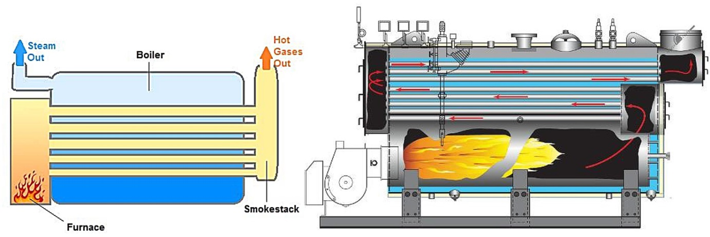
Fig. 4 — Fire tube boiler
In water tube boiler, boiler feed water flows through the tubes and enters the boiler drum (Figure 5). The circulated water is heated by the combustion gases and converted into steam. These boilers are selected when the steam demand as well as steam pressure requirements are high. Most modern water boiler tube designs are within the capacity range 4 500 – 120 000 kg/hour of steam, at very high pressures (supercritical boilers work in pressures above 350 bar).
Superheated steam boiler (superheater) is a variant of water tube boiler. It is used to produce steam above saturation temperature. Much higher temperature of the steam leads to increased overall efficiency of both steam generation and its utilization.
Superheaters can be convective or radiant, depending on the heat transfer from combustion flame or flue to stream method. In radiative superheaters the energy transferred directly from the combustion flame to increase the energy level of the steam while convective superheaters based on the transfer of additional energy from the flue gases to the steam.
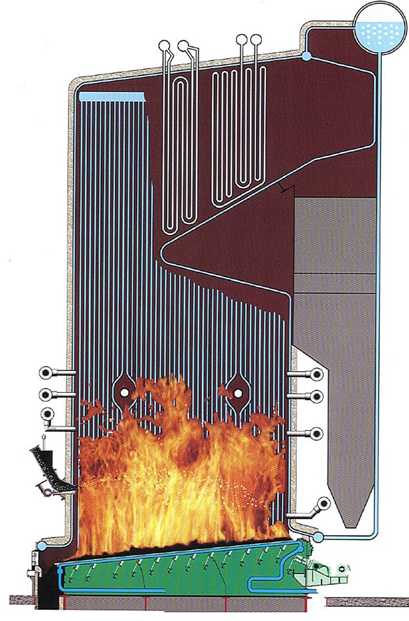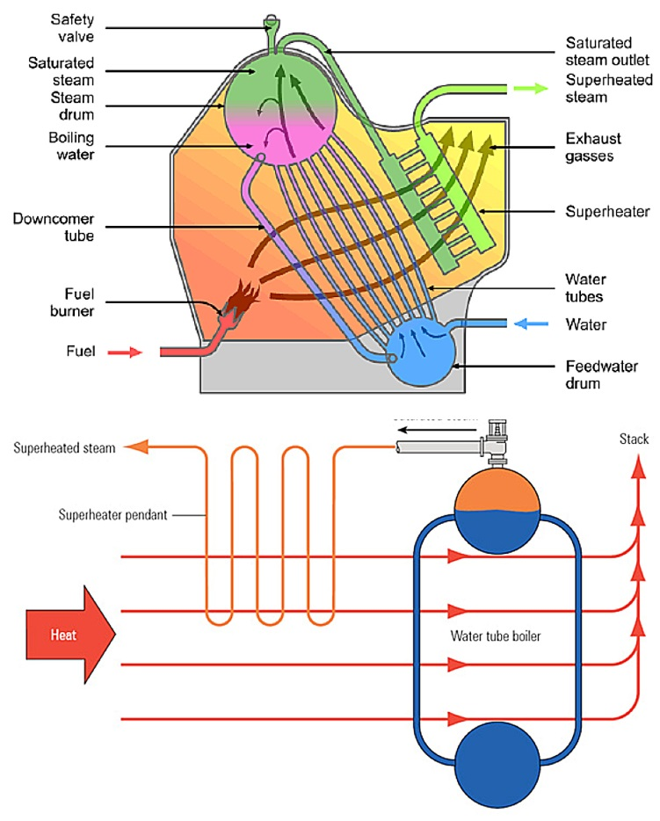
Fig. 5 — Water tube boiler Fig. 6 — Superheated steam boiler

Emitted limit values (ELVs) and emission factors for boilers in EU and Member States

Proposal for the limitation of emissions of certain pollutants into the air from medium combustion plants (MCP)
By now there are not officially approved ELVs for boilers or other heaters at the EU level.
The European Commission published its Clean Air Policy Package on 18 December 2013. Within it, as expected, there is a proposal for a Directive on the limitation of emissions of certain pollutants into the air from medium combustion plants (MCP) .This concerns installations with a capacity between 1 and 50 MW_{th}.
The new directive is to fill a regulatory gap as large combustion as large combustion plants are covered by the Industrial Emissions Directive while small combustion installations (less than 1 MW capacity) may be regulated by specific provisions of the Ecodesign Directive.
These Ecodesign measures do not address industrial or agricultural applications of such capacity, and it is not yet clear what a possible future Ecodesign measure for industrial ovens and furnaces would cover. Moreover, Ecodesign requirements only apply to new installations placed on the market and do not cover existing installations.
Future MCP Directive shall not be applied to the following:
- Plants which are subject to the chapters in the Industrial Emissions Directive dealing with waste incineration or large combustion plants (aggregated to 50 MW and above)
- Plants covered by the Ecodesign Directive (nominally less than 1 MW thermal input)
- Plants whose combustion gases are used for direct heating, drying or other treatment
- Plants used solely to purify waste gases
- Plants used for propulsion/transport.
There are four options being discussed now at EU level and in Member States regarding the “permitting regime” for medium combustion plants:
- Integrated permit similar to the Industrial Emissions Directive regime (covering air, water, soil, waste, etc)
- Air emissions permit: permit covering emissions to air of SO₂, NO_{X} and PM
- Registration on the basis of notification (no permit)
- General binding rules without permit, notification or registration,
It is proposed in the draft of MCP Directive to consider “existing combustion plant” the plant put into operation not later than 1 year after the date of Directive transposition. “New combustion plant” means a combustion plant other than an existing combustion plant.
Emission limit values for medium combustion plants are not published yet. But the dates of its implementation are already indicated in the draft of MCP Directive. From 1 January 2025 emissions into air of sulphur dioxide, nitrogen oxides and particulate matter from an existing medium combustion plant with a rated thermal input above 5 MW shall not exceed the emission limit values, and if a rated thermal input is 5 MW or less, 01.01.2030 is indicated as the date of implementation.
For new combustion plants emissions into air of sulphur dioxide, nitrogen oxides and particulate matter shall not exceed the emission limit values from 1 year after the date of transposition.
Existing plants which do not operate more than 500 hours/year may be exempt from ELV compliance.
Environmental monitoring requirements foresee triennial measurement of compliance with ELVs for plants in the 1 -20 MW_{th} and annual measurement of compliance with ELVs for plants in the 20-50 MW_{th}.
An environmental inspection system for MCPs to be set up, but no frequency specified.
The overview of ELV proposals for medium combustion plants (excluding engines and gas turbines), published in Ecodesign Preparatory Study on Steam Boilers of 28.02.2014 cited above, is presented in table 5
Table 5 — Proposals for ELV for medium combustion plants (excluding engines and gas turbines)
Combustion plants | Existing plants  (for plants > 5 MW from 2025  and other plants from 2030) |  |  | New plants
Pollutant / Fuel | SO₂ | NO_{X} | PM | SO₂ | NO_{X} | PM
Solid biomass | 200 | 650 | 30^{*)} | 200 | 300 | 20^{**)}
Other solid fuels | 400 | 650 | 30 | 400 | 300 | 20
Liquid fuels other  than heavy fuel oil | 170 | 200 | 30 | 170 | 200 | 20
Heavy fuel oil | 350 | 650 | 30 | 350 | 300 | 20
Natural gas | — | 200 | — | — | 100 | —
Gaseous fuels other  than natural gas | 35 | 250 | — | 35 | 200 | —
^{*)} 45 mg/Nm³ for plants with a thermal input below or equal to 5 MW
^{**)} 25 mg/Nm³ for plants with a thermal input below or equal to 5 MW

Proposal for the regulation of emissions of certain pollutants into the air from small combustion plants (EcoDesign Directive)
The last requirements for ambient air emissions can be found in Ecodesign standards. These standards are developed in line with EcoDesign Directive and are applicable for all Member States. Mainly they are developed for mid-term prospect. Commission Regulation (EU) No 813/2013 of 2 August 2013 establishes some standards and requirements for space heaters and combination heaters. In terms of the Regulation “heater” means a space heater or combination heater.
In turn “‘space heater” means a device that:
- provides heat to a water-based central heating system in order to reach and maintain at a desired level the indoor temperature of an enclosed space such as a building, a dwelling or a room;
- and is equipped with one or more heat generators.
“Combination heater” means a space heater that is designed to also provide heat to deliver hot drinking or sanitary water at given temperature levels, quantities and flow rates during given intervals, and is connected to an external supply of drinking or sanitary water.
The Regulation establishes NO_{X} ELV for space heaters and combination heaters with a rated heat output ≤ 400 kW. The values of ELV are as follows:
- fuel boiler space heaters and fuel boiler combination heaters using gaseous fuels: 56 mg/kWh fuel input in terms of gross calorific value (GCV);
- fuel boiler space heaters and fuel boiler combination heaters using liquid fuels: 120 mg/kWh fuel input in terms of GCV;
- cogeneration space heaters equipped with external combustion using gaseous fuels: 70 mg/kWh fuel input in terms of GCV;
- cogeneration space heaters equipped with external combustion using liquid fuels: 120 mg/kWh fuel input in terms of GCV;
- cogeneration space heaters equipped with an internal combustion engine using gaseous fuels: 240 mg/kWh fuel input in terms of GCV;
- cogeneration space heaters equipped with an internal combustion engine using liquid fuels: 420 mg/kWh fuel input in terms of GCV;
- heat pump space heaters and heat pump combination heaters equipped with external combustion using gaseous fuels: 70 mg/kWh fuel input in terms of GCV;
- heat pump space heaters and heat pump combination heaters equipped with external combustion using liquid fuels: 120 mg/kWh fuel input in terms of GCV;
- heat pump space heaters and heat pump combination heaters equipped with an internal combustion engine using gaseous fuels: 240 mg/kWh fuel input in terms of GCV;
- heat pump space heaters and heat pump combination heaters equipped with an internal combustion engine using liquid fuels: 420 mg/kWh fuel input in terms of GCV.

Existing emission limit values for medium combustion plants in Member States and proposals of unification
But mainly, the values of ELV for combustion installation <50 MWth in Member States are established by national legislation. In the table 6 below (AMEC Report, July 2012) the data for other important pollutant NO_{X} for several EU member states are collected.
Table 6 — Emission limit values for NO_{X} in some EU Member States national legislation (from AMEC Report, July 2012)
Member State | Capacity class (MWth) | Fuel | Fuel detail | Notes | ELV for NOx (mg/Nm³)
Austria | 1-5 | Biomass | 13%O₂ | Steam boilers. Average 250-500 range | 375
Austria | 5-20 | Biomass | 13%O₂ | Steam boilers. Average 250-350 range | 275
Austria | 20-50 | Biomass | 13%O₂ | Steam boilers. Average 250-350 range | 275
Austria | 1-5 | Other solid fuels | 6%O₂ | New steam boilers or existing ones from 2018 | 400
Austria | 5-20 | Other solid fuels | 6%O₂ | New steam boilers or existing ones from 2018 | 350
Austria | 20-50 | Other solid fuels | 6%O₂ | New steam boilers or existing ones from 2018 | 350
Austria | 1-5 | Liquid fuels | 11%O₂ | Steam boilers. 150 gasoil | 400
Austria | 5-20 | Liquid fuels | 11%O₂ | Steam boilers. 150 gasoil | 350
Austria | 20-50 | Liquid fuels | 11%O₂ | Steam boilers. 150 gasoil | 350
Austria | 1-5 | Natural gas | 6%O₂ | New steam boilers or existing ones from 2018 | 125
Austria | 5-20 | Natural gas | 6%O₂ | New steam boilers or existing ones from 2018 | 100
Austria | 20-50 | Natural gas | 6%O₂ | New steam boilers or existing ones from 2018 | 100
Czech Republic | 1-50 | Biomass |  | Other furnace, biomass. 400 mg/Nm³ for fluid combustion chamber | 650
Czech Republic | 1-50 | Other solid fuels |  | Other furnace, biomass. 400 mg/Nm³ for fluid combustion chamber | 650
Czech Republic | 1-5 | Liquid fuels |  |  | 500
Czech Republic | 5-20 | Liquid fuels |  |  | 450
Czech Republic | 20-50 | Liquid fuels |  |  | 450
Czech Republic | 1-50 | Natural gas |  |  | 200
Germany | 1-5 | Other solid fuels |  | 300 mg/Nm³ for fluidized bed furnaces | 500
Germany | 5-20 | Other solid fuels |  | 300 mg/Nm³ for fluidized bed furnaces | 400
Germany | 20-50 | Other solid fuels |  | 300 mg/Nm³ for fluidized bed furnaces | 400
Germany | 1-50 | Liquid fuels |  | 180 mg/Nm³ for boiler temperatures <110C and pressure <0,05 MPa; 200 mg/Nm³ for boiler temperatures 110-210C and pressure 0,05-1,8 MPa; 250 mg/Nm³ for boiler temperatures >210C and pressure >1,8 MPa | 200
Germany | 1-50 | Natural gas |  | 180 mg/Nm³ for boiler temperatures <110C and pressure <0,05 MPa; 200 mg/Nm³ for boiler temperatures 110-210C and pressure 0,05-1,8 MPa; 250 mg/Nm³ for boiler temperatures >210C and pressure >1,8 MPa | 110
Finland | 1-50 | Biomass |  | 375 mg/Nm³ for new plants | 450
Finland | 1-50 | Other solid fuels |  | 270 mg/Nm³ for new plants | 420
Finland | 1-5 | Liquid fuels |  | 800 mg/Nm³ for new plants | 900
Finland | 5-20 | Liquid fuels |  | 800 mg/Nm³ for new plants | 900
Finland | 20-50 | Liquid fuels |  | 500 mg/Nm³ for new plants | 600
Finland | 1-5 | Natural gas or other gaseous fuel |  | 340 mg/Nm³ for new plants | 400
Finland | 5-20 | Natural gas or other gaseous fuel |  | 340 mg/Nm³ for new plants | 400
Finland | 20-50 | Natural gas or other gaseous fuel |  | 200 mg/Nm³ for new plants | 300
France | 1-5 | Biomass |  |  | 500
France | 5-20 | Biomass |  |  | 500
France | 20-50 | Biomass |  |  | 600
France | 1-5 | Liquid fuels |  |  | 550
France | 5-20 | Liquid fuels |  |  | 500
France | 20-50 | Liquid fuels |  |  | 600
France | 1-5 | Natural gas |  |  | 200
France | 5-20 | Natural gas |  |  | 150
France | 20-50 | Natural gas |  |  | 225
Latvia | 20-50 | Solid fuels |  |  | 600
Latvia | 20-50 | Liquid fuels |  |  | 450
Latvia | 20-50 | Natural gas |  |  | 350
United Kingdom | 20-50 | Biomass and solid fuels |  | 450 mg/Nm³ for stocker firing; 650 mg/Nm³ for other methods | 550
United Kingdom | 20-50 | Liquid fuels |  | 450 mg/Nm³ for heavy fuel oil; 200 mg/Nm³ for distillates | 325
United Kingdom | 20-50 | Natural gas |  |  | 140
In AMEC report (February 2014), cited above, the data on ELV in different Member States were analysed. Among the countries with the most stringent legislation and low ELV are the Netherlands, Finland, Poland, and Austria. This investigation gives possibility to compare the most stringent emission levels and most “liberal” ones in Member States. Other possible option is to take ELV from Industrial Emissions Directive for next capacity class installations. The ELVs for this option have been set to be equal to those for existing 50-100 MW_{th} combustion plants in the IED.
In table 7 the most stringent ELVs are marked as “min”, maximum existing in Member States ELVs are marked as “max”, and ELVs equal to those for existing 50-100 MW_{th} are marked as “IED”.
Table 7 — Emission limit values for boilers with a rated thermal input from 1 to 50 MW_{th} for Member States
Capacity class | ELV | SO₂ emission levels (mg/Nm³) |  |  |  | NO_{X} emission levels (mg/Nm³) |  |  |  |  | Dust emission levels (mg/Nm³)
Capacity class | ELV | Biomass | Other solid fuel | Liquid fuel | Other gaseous fuel | Biomass | Other solid fuel | Liquid fuel | Natural gas | Other gaseous fuel | Biomass | Other solid fuel | Liquid fuel
1-5 MW_{th} | min | 151 | 200 | 200 | 5 | 200 | 100 | 120 | 70 | 150 | 5 | 5 | 5
1-5 MW_{th} | max | 200 | 3206 | 1700 | 800 | 978 | 1226 | 900 | 400 | 400 | 376 | 376 | 150
1-5 MW_{th} | IED | 200 | 400 | 350 | 35 | 300 | 300 | 450 | 100 | 200 | 30 | 30 | 30
5-20 MW_{th} | min | 151 | 200 | 200 | 5 | 145 | 100 | 120 | 70 | 164 | 5 | 5 | 5
5-20 MW_{th} | max | 200 | 3206 | 1700 | 800 | 978 | 978 | 900 | 400 | 400 | 376 | 376 | 100
5-20 MW_{th} | IED | 200 | 400 | 350 | 35 | 300 | 300 | 450 | 100 | 200 | 30 | 30 | 30
20-50 MW_{th} | min | 151 | 200 | 200 | 5 | 145 | 100 | 120 | 70 | 164 | 5 | 5 | 5
20-50 MW_{th} | max | 200 | 3206 | 1700 | 800 | 978 | 978 | 694 | 694 | 350 | 376 | 376 | 208
20-50 MW_{th} | IED | 200 | 400 | 350 | 35 | 300 | 300 | 450 | 100 | 200 | 30 | 30 | 30
It can be seen that there are big differences between maximum and minimum emission levels. The economic analysis was made in the cited report with the goal to find the “cost of compliance”. It was shown that compliance with the most stringent MS ELVs could cost around 50% more than compliance with the IED ELVs.
In table 8 the examples of the “cost of compliance” are given for most stringent requirements and for IED ELVs. Data a presented in the form of abatement costs (Euro) per tonne of pollutant reduced. The projection is made for the year 2025. ”Damage cost” in the last column of the table was calculated in the work of European Consortium for Modelling of Air Pollution and Climate Strategies— EC4MACS. The quantification of impacts and monetary values using the impact pathway approach was made in relation to human health, mortality, and morbidity due to ambient air pollution.
Table 8 — Abatement cost (Euro) per tonne of pollutant reduced (2025)
Pollutant | ELV options | IED 50-100 MW_{th} | Most stringent in Member States | Damage costs
SO₂ | 1-5 MW_{th} | 1 900 | 4 100 | 7600 — 21200
SO₂ | 5-20 MW_{th} | 1 300 | 2 100 | 7600 — 21200
SO₂ | 20-50 MW_{th} | 800 | 1 300 | 7600 — 21200
NO_{X} | 1-5 MW_{th} | 7 100 | 8 400 | 5500 —13900
NO_{X} | 5-20 MW_{th} | 5 900 | 6 900 | 5500 —13900
NO_{X} | 20-50 MW_{th} | 5 700 | 7 400 | 5500 —13900
Dust (PM) | 1-5 MW_{th} | 4 100 | 5 900 | 14750 — 41650 ^{*)}
Dust (PM) | 5-20 MW_{th} | 2 300 | 4 200 | 14750 — 41650 ^{*)}
Dust (PM) | 20-50 MW_{th} | 2 300 | 5 900 | 14750 — 41650 ^{*)}
^{*)} To allow comparison in this table, damage costs for PM_{2.5} (29500-83300€/t) have been reduced by half to account for the complex relationship between PM and PM_{2.5}
Compliance costs are the cost of installing and operating abatement measures targeted at reducing emissions of the corresponding pollutant. Administrative costs are not included as these costs would be applicable for the three pollutants.
The calculations were made exempting for plants with low operating hours. The recommended threshold can be taken as much as 300-500 hours per year. The aim of this is to exempt back-up and emergency plants from having to make costly upgrades and incurring administrative burden with limited environmental benefit.
As a result of analysis the conclusion was made that the preferred option would set emission limit values in line with those set in Directive 2010/75/EU for plants with capacity between 50-100 MW and in a number of Member States, and complemented with a number of emission limit values set out for new plants in the amended Gothenburg Protocol.

Biomass combustion
The biomass combustion instead of fossil fuels is an important measure in meeting Europe’s 2020 renewable targets and 2050 carbon reduction targets.
One of the growing applications for biomass boiler systems is district heating, especially in countries such as Austria, UK, Denmark, Sweden and other north European countries. Biomass contributes significantly to the global energy supply, especially in heating applications. For some countries, in addition to its positive effect on climate change due to the reduction of CO₂ emissions, it gives energy security by diminishing the dependency on other countries for fossil fuels importation.
Biomass combustion systems are available from a few kW up to more than 100 MW with typical applications as follows:
- Manual wood stoves are most commonly used from 5 kW to 15 kW
- Manual log wood boilers are most commonly used from 20 kW to 70 kW. For typical house heating, heat accumulation tanks with a few 1000 litres of water are used to increase comfort and avoid part-load operation of the boilers at low efficiency and high emissions
- Pellet stoves and boilers for residential heating are common from 15 kW up to 70 kW (in case of boilers). Furthermore, pellet boilers are also applied from 70 kW to 1 MW and in some cases also for applications greater than 1 MW. Due to the higher energy density, pellet storage is less space consuming compared to wood chips, which in some cases is an important advantage
- Automatic wood boilers are most often used from 200 kW to 10 MW heat output, although in some cases wood chips are also used from 20 kW and up to more than 100 MW. For applications greater than 1 MW, grate boilers are most common. Applications with heat output of more than 10 MW to 20 MW are often combined with steam production for combined heat and power production.
Different types of biomass combustion systems are shown at figures 7-8.
The most dangerous for health emission from biomass combustion is particulate matter. Below PM emission factors ³¹ are provided for different types of biomass combustion for some EU countries.
For open fireplaces the range for typical measured emission factors on PM varies between 23 and 265 mg/MJ. The emission factors for Finland and Norway are 860 mg/MJ and 910 mg/MJ, for Germany — 160 mg/MJ.
For closed fireplaces worst results for emission factors range from 180 – 204 mg/MJ, typical results from 47 – 83 mg/MJ and best results from 14 – 26 mg/MJ.
For wood stoves the emission factor for solid particles ranges from 94 mg/MJ (Germany) to 650 mg/MJ (Sweden).
For log wood boilers with forced downdraft combustion (figure 7) the emission factor for PM ranges from 6-10 mg/MJ (Austria) to 135 mg/MJ (Sweden).
For pellet stoves with electronic combustion control the emission factor for PM ranges from 25 mg/MJ (Austria) to 42 mg/MJ (Sweden).
For pellet boiler with electronic combustion control (figure 8) the emission factor for PM ranges from 11 mg/MJ (Austria) to 28 mg/MJ (Sweden). In Denmark and Finland emission factors are 35 mg/MJ and 32 mg/MJ respectively.
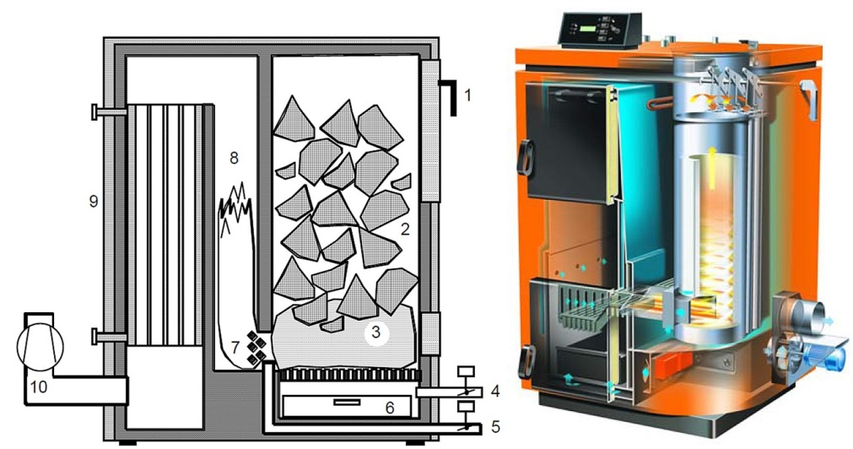
Figure 7 — Downdraft boilers with inverse combustion of log wood and with enforced air flow and air supply with primary and secondary air: [Nussbaumer 2010]
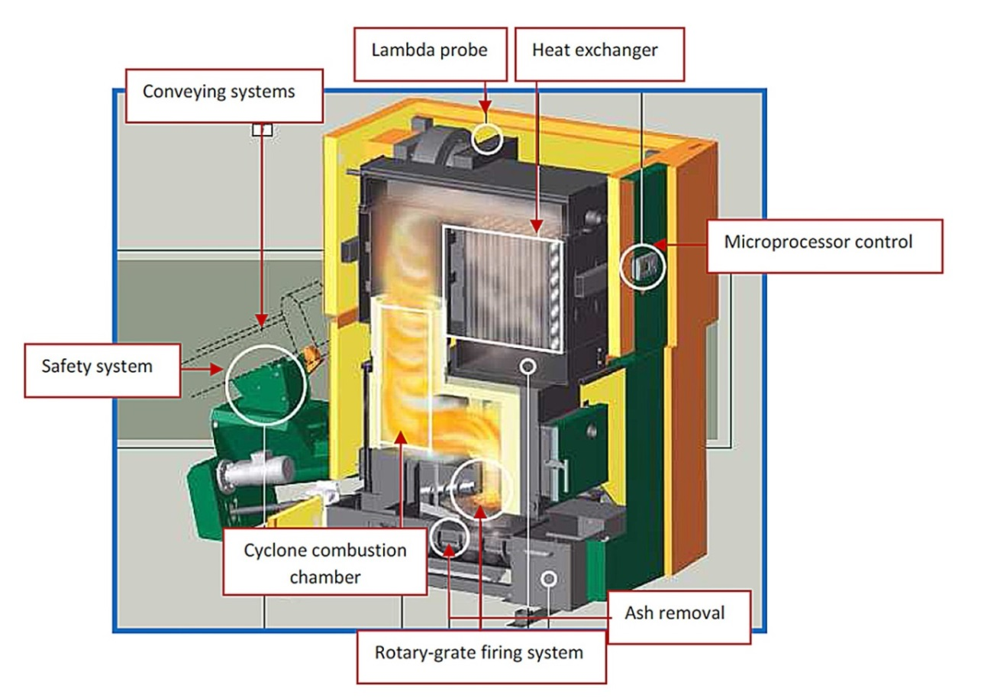
Figure 8 — Austrian KWB pellet combustion automatic installation 150 kW
It can be concluded that pellet combustion and log wood boilers with forced draft achieve relatively low particle emissions with estimated average emission factor of approximately 30 mg/MJ. This is indicated as filterable or solid particles for these categories under typical operation conditions. However, these emission factors are valid for natural, uncontaminated dry wood only, while significantly higher emissions are found for other fuels such as bark, straw pellets, wet log wood and other inappropriate fuels.
For automatic biomass combustion plants from 70 kW to 500 kW average emission factors range from 50 – 100 mg/MJ, which is in line with the typical ELVs valid today (e.g. 150 mg/m³ at 11 or 13 Vol.-% O₂).

The Russian Federation requirements for fuel combustion in installations with a total rated thermal input below 50 MW
By now no simplified procedures for granting environmental permits for small combustion plants are in place in Russia. They have to obtain permits in accordance with the general environmental legislation: on the ambient air quality protection, on water resources protection, and on waste disposal.
The Ordinance of the Russian Federation Chief Sanitary Officer on September 25, 2007 has established the sizes of sanitary protection zones (SPZ) for different sanitary classes of enterprises, ranged in accordance with their potential danger for people’s health.
Cited SanPiN 2.2.1/2.1.1.1200-03 attributes boilers with a rated thermal input not less than 232.6 MWth using coal and heavy oil fuel to class 2 of the sanitary classification. For class 2 the size of SPZ is equal to 500 m. If a boiler with the same thermal input uses natural gas as a fuel, it refers to class 3 and the size of SPZ is equal to 300 m. If a rated thermal input of a boiler is less than 232.6 MWth the size of SPZ is established based on pollutants dispersion calculation. On site measurements also can be used for SPZ size determination.
Above mentioned sizes are approximate. They have to be legitimated by the project of SPZ with necessary calculations of the expected air pollution and approved by the results of on-site probes analyses. The background levels of ambient air pollution have to be taken into account.
The criterion for the size of SPZ setting is not exceeding of PDK (maximum permissible concentrations) of pollutants in ambient air or maximum permissible noise levels at the SPZ boundary and beyond.
The methodology of emissions estimations and ELV calculation from different sources in Russia is established and further developed by LLC “NII Atmosphere”. The last edition of the methodology was approved be the Ministry of Natural Resources and Environment (MNR) and recommended for use (letter of the Ministry of March 29, 2012 N 5-12-47/4521). The software for emissions calculation is produced by “Integral” company in St. Petersburg.
For roof boilers and built-in boilers the size of SPZ is not established. They get environmental permits on a case-by-case basis. Dispersion of pollutions and noise level are calculated or measured on site.
Emission factors for boilers with a rated thermal input less than 36 MW_{th} are estimated on basis of Methodology developed by VTI Institute and LLC “NII Atmosphere” in 1999 and updated in 2001.
Emission factors are determined for NO_{X}, CO, CO₂, dust and benz[a]pyren.

Recommendations for partner countries

Overall recommendations
Attention to the environmental impact of medium and small combustion plants at EU level was caused by high requirements for ambient air quality. Air quality Directive foresees step by step rising of environmental standards for such pollutants as NO_{X}, PM, SO₂, and ground level ozone. Current situation analysis has shown that the measures of impact reduction of “big polluters” (covered by IED) and transport are not enough to meet ambient air standards in 2025 and 2030.
This circumstance has drawn environmentalist’s attention to medium and small combustion plants as noticeable sources of ambient air pollution. The shares of medium and small combustion plants in, for example, PM_{2.5} emissions was as much as 76% in Latvia, 74% in Poland, 57% in Denmark, 38% in Estonia. But for some countries this share is rather small: Germany – 16%, Sweden – 12% and UK – 9%.
So, the general recommendation for Project Countries is at first estimate the environmental impact of medium and small combustion plants and its role in ambient air pollution. If this role will be significant for such pollutants as NO_{X} and PM, then the abatement measures have to be planned.

Recommendation for regulation of medium and small combustion plants environmental impact
It will be reasonable to adopt EU classification of medium and small combustion plants: medium plants are those with a total rated thermal input from 1 MW to 50 MW, small plants are those with a total rated thermal input below 1 MW.
There are four options being discussed now at EU level and in Member States regarding the “permitting regime” for medium combustion plants:
- Integrated permit similar to the Industrial Emissions Directive regime (covering air, water, soil, waste, etc.)
- Air emissions permit: permit covering emissions to air of SO₂, NO_{X} and PM
- Registration on the basis of notification (no permit)
- General binding rules without permit, notification or registration.
The choice of an option depends on the role of medium combustion plants in overall air pollution. It can be recommended to set up an integrated permitting regime or air emissions permit for 1 MW to 50 MW plants in densely populated countries or regions, where medium combustion plant emissions plays significant role. For other project countries such installations can operate on the basis of registration or general binding rules.
In the cases of integrated permitting regime or air emissions permit the following ELVs can be recommended:
Table 9 — Recommended ELVs for an integrated permitting regime or air emissions permit
Capacity class | Plant | SO₂ emission levels (mg/Nm³) |  |  |  | NO_{X} emission levels (mg/Nm³) |  |  |  |  | Dust emission levels (mg/Nm³)
Capacity class | Plant | Biomass | Other solid fuel | Liquid fuel | Other gaseous fuel | Biomass | Other solid fuel | Liquid fuel | Natural gas | Other gaseous fuel | Biomass | Other solid fuel | Liquid fuel
1-5 MW_{th} | new | 200 | 200 | 200 | 5 | 300 | 300 | 350 | 200 | 200 | 25 | 20 | 20
1-5 MW_{th} | old | 200 | 400 | 350 | 35 | 450 | 500 | 500 | 250 | 250 | 45 | 50 | 50
5-20 MW_{th} | new | 200 | 200 | 200 | 5 | 300 | 300 | 300 | 150 | 150 | 20 | 20 | 20
5-20 MW_{th} | old | 200 | 400 | 350 | 35 | 450 | 500 | 450 | 200 | 200 | 30 | 30 | 30
20-50 MW_{th} | new | 200 | 200 | 200 | 5 | 250 | 250 | 200 | 200 | 200 | 20 | 20 | 20
20-50 MW_{th} | old | 200 | 400 | 350 | 35 | 300 | 300 | 450 | 200 | 200 | 30 | 30 | 30
In the table 9 “old plant” means “existing combustion plant” — the plant put into operation not later than 1 year after the date of adopting the correspondent legislation. “New plant” means a combustion plant other than an old (existing) combustion plant.
Other gaseous fuel means gaseous fuel other than natural gas (biogas, synthetic gas, etc.).
Existing plants which do not operate more than 300 hours/year or new plants which do not operate more than 500 hours/year may be exempt from ELV compliance.
Environmental monitoring requirements
It is recommended to carry out annual measurement of compliance with ELVs for plants in the 20-50 MW_{th} and triennial measurement of compliance with ELVs for plants in the 1 -20 MW_{th}.
For small combustion plants with a total rated thermal input below 1 MW it is recommended to use instruments similar to EU Ecodesign Directive, ecolabelling, and some provisions of amended Gothenburg Protocol.
For wood stoves it is recommended to use North countries ecolabelling experience (Swan label). Stoves labelled with the Nordic Swan must have total emissions below 5 g/kg wood.
The following primary measures to reduce emissions from existing residential combustion stoves and boilers can be recommended:
- Use mass-media advertising for provision of new models of stoves and boilers, paying attention to the level of emissions in connection with fuel economy and energy efficiency and about proper kinds of fuel.
- Establishing a programme to promote the replacement of the oldest existing boilers and stoves by modern appliances.
- Establishing an obligation to exchange or retrofit old appliances.
It is reasonable to set ELVs for dust (PM) only, because the abatement NO_{X} measures for small scales are ineffective, and the reduction of SO₂ emissions for small combustion plants it is the question of proper choice of fuel.
In table 10 recommended ELVs for PM and NO_{X} are presented.
Table 10 — Recommended emission levels for small combustion plants
The type of appliance | Dust emission  levels (mg/Nm³) |  | Dust emission  levels (mg/MJ)
The type of appliance | new | existing | new | existing
Open/closed fireplaces and stoves using wood | 40 | 75 | 30 | 50
Log wood boilers (with heat storage tank) | 25 | 40 | 15 | 25
Pellet stoves and boilers | 25 | 50 | 20 | 30
Stoves and boilers using other solid fuels than wood | 25 | 50 | 30 | 45
Automatic combustion installations | 25 | 50 | 10 | 20

Statistics Canada http://www.statcan.gc.ca/pub/16-001-m/2012015/part-partie1-eng.htm
Directive 2008/50/EC of the European Parliament and of the Council of 21 May 2008 on ambient air quality and cleaner air for Europe http://eur-lex.europa.eu/LexUriServ/LexUriServ.do?uri=CELEX:32008L0050:EN:NOT
Air quality guidelines for Europe; second edition (WHO regional publications. European series; No. 91) http://www.euro.who.int/__data/assets/pdf_file/0005/74732/E71922.pdf
http://eur-lex.europa.eu/LexUriServ/LexUriServ.do?uri=CELEX:31994L0063:EN:HTML
http://eur-lex.europa.eu/LexUriServ/LexUriServ.do?uri=OJ:L:2009:285:0036:01:EN:HTML
Service station in the context of Directive means any installation where petrol is dispensed to motor vehicle fuel tanks from stationary storage tanks
Stage II petrol vapour recovery system means equipment aimed at recovering the petrol vapour displaced from the fuel tank of a motor vehicle during refuelling at a service station and which transfers that petrol vapour to a storage tank at the service station or back to the petrol dispenser for resale
European Union (Stage II Petrol Vapour Recovery during Refuelling of Motor Vehicles at Service Stations) Regulations 2011. http://www.irishstatutebook.ie/pdf/2011/en.si.2011.0687.pdf
Reference Document on Best Available Techniques on Emissions from Storage, July 2006 http://eippcb.jrc.ec.europa.eu/reference/BREF/esb_bref_0706.pdf
Pollution Prevention Guidelines PPG 7 “Safe storage - The safe operation of refuelling facilities” http://www.sepa.org.uk/about_us/publications/guidance/ppgs.aspx
Pasi M. Nieminen Environmental protection standards at petrol stations: a comparative study between Finland and other European countries // Tampere University of Technology, 2005 http://dspace.cc.tut.fi/dpub/bitstream/handle/123456789/81/nieminen.pdf?sequence=1
Process Guidance Note 1/13 (04). Secretary of State's Guidance for Storage, Unloading and Loading Petrol at Terminals http://archive.defra.gov.uk/environment/quality/pollution/ppc/localauth/pubs/guidance/notes/pgnotes/documents/pg1-13.pdf
Process Guidance Note 1/14 (06). Secretary of State’s Guidance for Unloading of Petrol into Storage at Petrol Stations http://archive.defra.gov.uk/environment/quality/pollution/ppc/localauth/pubs/guidance/notes/pgnotes/documents/pg1-14.pdf
http://www.sepa.org.uk/air/process_industry_regulation/pollution_prevention__control/petrol_stations/petrol_station_faq.aspx
Compliance Assessment Scheme (CAS), designed in SEPA in 2011, has established a five year inspection cycle for the lowest risk permits, including petrol vapour recovery (petrol filling stations) and solvent-based operations, such as dry cleaners. http://www.sepa.org.uk/about_us/news/2012/businesses_show_improvement_in.aspx
Russian fuel union http://www.rfu.ru/index.asp
The Ordinance of the Russian Federation Chief Sanitary Officer on September 25, 2007 “On enactment of the new revision of the sanitary-epidemiological rules and standards SanPiN 2.2.1/2.1.1.1200-03 Sanitary protection zones and sanitary classification of enterprises, installations, and other objects” (version of 09.09.2010)
Sanitary protection zone – territory between the boundaries of the industrial site, open and indoor storage yards for materials and chemical agents, agricultural enterprises, other sources of hazardous emissions and unfavourable physical effects, and the boundaries of the residential area, as well as other territories used by the population in view of long-term development
"User’s guide on the calculation, standardization and control of emissions of pollutants into ambient air" (LLC “NII Atmosphere”, St. Petersburg, 2012.)
The Ordinance of Moscow Government of 20.08.2002 N 663-PP (version of 25.12.2007) “On the measures of prevention of motor fuel vapours emissions at the objects of the fuel market of Moscow up to the year 2010” (together with “The rules on prevention of motor fuel vapours emissions at the objects of the fuel market of Moscow”)
General Plan of Moscow (Regulation on spatial planning of the City of Moscow) The Law of Moscow of May 5, 2010 No 17
The Law of City of Moscow of 21.11.2007 N 45 (version of 22.01.2014) “The Code of the City of Moscow on administrative violations”
http://www.tatar-inform.ru/news/2014/01/20/391111/
The National Air Quality Strategy (NAQS), 1997 (UK)
“Analysis of the impacts of various options to control emissions from the combustion of fuels in installations with a total rated thermal input below 50 MW” Revised Final Report, February 2014 http://ec.europa.eu/environment/air/pdf/review/Revised%20Final%20Report.pdf
Reference Document on Best Available Techniques for Large Combustion Plants, July 2006 http://eippcb.jrc.ec.europa.eu/reference/BREF/lcp_bref_0706.pdf
http://www.who.int/phe/health_topics/outdoorair/databases/en/
Under EU legislation a limit value is legally binding from the date it enters into force subject to any exceedances permitted by the legislation. A target value is to be attained as far as possible by the attainment date and so is less strict than a limit value
Options for limit values for emissions of dust from small combustion installations < 50 MWth. UNECE Convention on Long-range Transboundary Air Pollution Subgroup on Small Combustion Installations under EGTEI. June 2010 http://www.citepa.org/old/forums/egtei/Options%20for%20PM%20ELVs%20for%20SCI%20%20final.pdf
http://gains.iiasa.ac.at/index.php/gains-europe
Emissions from households and other small combustion sources and their reduction potential. TSAP Report #5, Janusz Cofala, Zbigniew Klimont, IIASA, June 2012 http://gains.iiasa.ac.at/images/stories/reports/TSAP/TSAP-SMALL%20SOURCES-20120612.pdf
Small chimneys – big emissions http://www.airclim.org/acidnews/small-chimneys-%E2%80%93-big-emissions
Directive 2009/125/EC of the European Parliament and of the Council of 21 October 2009 establishing a framework for the setting of eco-design requirements for energy-related products http://eur-lex.europa.eu/legal-content/EN/ALL/?uri=CELEX:32009L0125
Methodology for the Ecodesign of Energy-related Products http://www.meerp.eu/documents.htm
Ecodesign Preparatory Study on Steam Boilers 28.02.2014 Rome/Athens/Karlsruhe http://www.eco-steamboilers.eu/eco-steamboilers-wAssets/docs/DraftReport_Task1-4_Website.pdf
Directive 2010/75/EU of the European Parliament and of the Council of 24 November 2010 on industrial emissions (integrated pollution prevention and control) http://eur-lex.europa.eu/LexUriServ/LexUriServ.do?uri=OJ:L:2010:334:0017:0119:en:PDF
Directive 2003/87/EC of the European Parliament and of the Council of 13 October 2003 establishing a scheme for greenhouse gas emission allowance trading http://eur-lex.europa.eu/legal-content/EN/ALL/?uri=CELEX:32003L0087
Directive 2009/28/EC of the European Parliament and of the Council on the promotion of the use of energy from renewable sources and amending and subsequently repealing Directives 2001/77/EC and 2003/30/EC. http://faolex.fao.org/docs/pdf/eur88009.pdf
Directive 2012/27/EU of the European Parliament and of the Council of 25 October 2012 on energy efficiency, amending Directives 2009/125/EC and 2010/30/EU and repealing Directives 2004/8/EC and 2006/32/EC http://eur-lex.europa.eu/LexUriServ/LexUriServ.do?uri=OJ:L:2012:315:0001:0056:EN:PDF
Directive 2004/8/EC of the European Parliament and of the Council of 11 February 2004 on the promotion of cogeneration based on a useful heat demand in the internal energy market and amending Directive 92/42/EEC http://eur-lex.europa.eu/search.html?type=expert&qid=1397300437010
Council Directive 92/75/EEC of 22 September 1992 on the indication by labelling and standard product information of the consumption of energy and other resources by household appliances http://eur-lex.europa.eu/legal-content/en/ALL/?uri=CELEX:31992L0075
Directive 2010/30/EU of the European Parliament and of the Council of 19 May 2010 on the indication by labelling and standard product information of the consumption of energy and other resources by energy-related products http://eur-lex.europa.eu/LexUriServ/LexUriServ.do?uri=OJ:L:2010:153:0001:0012:en:PDF
The swan is an eco-label established by the Nordic Council of Ministers.
Regulation of air pollution from small biomass combustion Ideas from INFORSE-Europe, December 2010 http://www.inforse.org/europe/pdfs/biomass-pollution-regulation-proposal.pdf
http://www.unece.org/fileadmin/DAM/env/lrtap/full%20text/1999%20Multi.E.Amended.2005.pdf
http://www.unece.org/env/lrtap/status/99multi_st.html
http://www.ceip.at/gothenburg-protocol/amended-gothenburg-protocol/
The International Organization for Standardization http://www.iso.org/iso/home.html
The Clean Air Policy Package http://ec.europa.eu/environment/air/clean_air_policy.htm
Directive of the European Parliament and of the Council on the limitation of emissions of certain pollutants into the air from medium combustion plants Brussels, 18.12.2013 (draft) http://eur-lex.europa.eu/legal-content/EN/TXT/PDF/?uri=CELEX:52013PC0919&from=EN
Commission Regulation (EU) No 813/2013 of 2 August 2013 implementing Directive 2009/125/EC of the European Parliament and of the Council with regard to ecodesign requirements for space heaters and combination heaters. http://eur-lex.europa.eu/LexUriServ/LexUriServ.do?uri=OJ:L:2013:239:0136:0161:EN:PDF
Collection and analysis of data to support the Commission in reporting in line with Articles 73(2)(a) of Directive 2010/75/EU on industrial emissions from the combustion of fuels in installations with a total rated thermal input below 50 MW. European Commission. Final Report. AMEC Environment & Infrastructure, July 2012 http://www.endseurope.com/docs/120723a.pdf
General Guidance Manuals (revised April 2012) for combustion and incineration processes and for other sectors can be found at DEFRA site http://www.defra.gov.uk/industrial-emissions/las-regulations/guidance/
The ALPHA Benefit Assessment Model // European Consortium for Modelling of Air Pollution and Climate Strategies - EC4MACS, January 2013 http://www.ec4macs.eu/content/report/EC4MACS_Publications/MR_Final%20in%20pdf/Alpha_Methodologies_Final.pdf
Thomas Nussbaumer. Overview on Technologies for Biomass Combustion and Emission Levels of Particulate Matter // Swiss Federal Office for the Environment (FOEN), Zürich, June 2010 http://www.citepa.org/old/forums/egtei/Nussbaumer_EGTEI-Report_final.pdf
KWB, 2010. TDS Powerfire 150 kW Technology and Planning, Test Report. Austria.
The Ordinance of the Russian Federation Chief Sanitary Officer on September 25, 2007 “On enactment of the new revision of the sanitary-epidemiological rules and standards SanPiN 2.2.1/2.1.1.1200-03 Sanitary protection zones and sanitary classification of enterprises, installations, and other objects” (version of 09.09.2010)
Sanitary protection zone – territory between the boundaries of the industrial site, open and indoor storage yards for materials and chemical agents, agricultural enterprises, other sources of hazardous emissions and unfavourable physical effects, and the boundaries of the residential area, as well as other territories used by the population in view of long-term development
"User’s guide on the calculation, standardization and control of emissions of pollutants into ambient air" (LLC “NII Atmosphere”, St. Petersburg, 2012.)
Methodology of emissions of pollutants assessment for fuel combustion in boilers with capacity less than 30 tonnes of steam in hour or less than 20 Gcal per hour. М., 1991

