EuropeAid/129522/C/SER/Multi
Contract number 2010/232-231
Air Quality Governance in the ENPI East Countries
Guidance for Integrated Inspection

11 April 2014

Version |  | Date | Description | Prepared by | Reviewed by
2 |  | 3 February 2014 | Report for Task 2.1.1.7 Guidance for integrated inspection | Bjørn Bauer, Michael Begak, Monika Přibylová, International Non-Key IPPC Experts;  Tatiana Guseva, Oleg Bely, Viktar Khodzin, Local Non-Key IPPC Experts | Aiga Kala, Key Expert 2 – Air Quality Assessment and Management  Vladimir Morozov, Key Expert 3 – Industry/IPPC

SUMMARY

Project Title: Air Quality Governance in ENPI East Countries
Contract Number: 2010/232-231
Countries: Armenia, Azerbaijan, Belarus, Georgia, the Republic of Moldova, the Russian Federation, and Ukraine
Lead Contractor
Name MWH
Address Nysdam Office Park
Avenue Reine Astrid, 92
B-1310 La Hulpe
Belgium
Tel. number +32 2 655 2230
Fax number +32 2 655 2280
Contact person Aïda Yassine, Project Manager
Signature
Date of report: 3 February 2014
Experts:
Bjørn Bauer, International Non-Key Expert on Integrated Inspection
Monika Přibylová, International Non-Key IPPC Expert

Michael Begak, International Non-Key IPPC Expert
Oleg Bely, Local Non-Key IPPC Expert
Tatiana Guseva, Local Non-Key IPPC Expert
Viktar Khodzin, Local Non-Key IPPC Expert

Content

Introduction 4
1 Planning inspection 5
1.1 Planning inspection work 5
1.2 Register and categories of facilities 6
1.3 Minimum Inspection Frequencies and Actual Frequencies 8
1.4 Types of inspection 9
1.5 Legislative basis for inspection 10
2 Preparation of site visit 11
2.1 Collection of information 11
2.2 Field Inspection Plan 11
2.3 Announced or unannounced inspections 12
2.4 Necessary equipment and facilities 13
3 Site visit 13
3.1 Inspectors’ code of conduct 13
3.2 Inspection procedures 14
3.3 Emergencies and complaints 18
3.4 Follow-up inspections 20
4 Reporting and follow-up 21
4.1 The inspection report 21
4.2 Sanctions and enforcement 22
4.3 Filling of information 23
Annex 1 – Tool for inspection planning 24
Annex 2 – Tool for facility register 25
Annex 3 – Tool for definition of Complete Inspections 26
Annex 4 – Checklist for collection of data and documents 29
Annex 5 – Template for inspection report 30
Annex 6 – Useful References 34

Introduction
This report is prepared in the frame of Air Quality Governance project, Component 2, Task 2.1.1. Support towards the implementation of integrated permitting, Subtask 2.1.1.7 Development of Guidance for integrated inspection.
The aim of this report is to provide guidance for environmental inspection of installations with focus on integrated inspection based on good EU practice and experience.
Inspection is a key factor to providing environmental protection by assuring compliance by the regulated community with environmental laws and regulations. Unless there is compliance with the requirements that are designed to provide the necessary environmental protection, the promulgation of laws and regulations has little impact.
Compliance does not just happen. Legislation and permits must be supported by introduction of cleaner technologies, robust environmental management procedures, internal and external communications, inspection and enforcement. Environmental inspection can be defined as:
- Checking and promoting the compliance with requirements stated in laws, regulations, ordinances, directives, prohibitions and/or permits etc.
- Monitoring general impacts of specific installations on the environment that might lead to enforcement action or further inspection
- Prevention of the environmental impact.
Inspectors first conduct an investigation where information of verifiable quality is gathered and organized. Information of verifiable quality is usually referred to as documentation. In the next phase, inspectors organize their observations and supporting documentation into a body of data (usually a narrative report) where it is reviewed against standards set forth in law. These investigation and inspection phases are often repeated until enough information is documented to make an adequate evaluation of compliance.
The purpose of this guidance for Environmental Inspection is to support environmental inspectors from countries participating in the Air-Q-Gov project (Armenia, Azerbaijan, Belarus, Georgia, the Republic of Moldova, the Russian Federation, and Ukraine) in providing an effective and efficient service to the society and the installations. The guidance describes procedures and tools for four elements of the inspectors’ functions:
- Planning
- Preparation
- Site visit
- Reporting and follow-up.
The structure of the guidance allows continuous updating and amendment of this document. When new legislation comes into force, the Ministry responsible for Environmental Protection should update the affected sections of the guidance and forward the modified pages to all regional and local environmental inspecting authorities across the country. The practical application of this guidance is expected soon in Belarus; therefore certain parts of this document are focused on Belarusian conditions.
This document should be considered as framework guidance. It is necessary to emphasise that detailed sector specific guidance materials or issues specific manuals should be developed by national inspection authorities themselves depending on national priorities and based on the legal and practical needs. Examples of national and sectoral guides are available both in the EU (in particular, European Union Network for the Implementation and Enforcement of Environmental Law - http://impel.eu/), OECD and the USA.

Planning inspection

Planning inspection work
Planning of the inspection work is necessary to achieve the best environmental results of the existing resources. Inspectorate resources do very seldom correspond to the actual need for control of the environmental situation in the regulated community.
The inspection programme aims at:
- Prioritising resources for the environmentally most important duties
- Offering a benchmark against which inspectorate performance can be measured and reviewed; and
- Serving as a basis for discussion with third parties, for example local business communities or politicians and the general public.
The programme should focus at compliance with legislation, especially for those enterprises constituting a severe risk for the environment. The plan should include the most important activities within a year, but can also include more long-term oriented objectives and actions.
Preparation of the inspection programme involves the following steps:
- Review of the situation
By reviewing the state of the inspectorate and the environment, the requirements and possibilities for the inspection work are clarified.
- Review of the inspectorate situation
- National, regional and local legislation
- Local stakeholders’ priorities – community and enterprises
- Number of enterprises and other inspection objects, divided into categories
- Resources available for inspection activities
- Assessing the state of the environment
An assessment of the environmental conditions within the regulated community is a necessary basic knowledge when prioritising the efforts for environmental protection. The survey should identify particular environmental hotspots that should be taken into consideration when planning the inspection efforts.
The survey should embrace:
- Air quality
- Groundwater quality and resources
- Surface water quality and resources
- Waste problems
- Land/Soil Quality
- Noise
- Public health aspects.
To assess the pollution level, the inspectorate should monitor compliance with international and national priorities, standards, agreements etc.
By repeating the survey within decided intervals the inspectorate will be able to detect trends and establish a basis for setting of goals and objectives.
Information on the state of environment should also be available from national/regional environmental monitoring services/agencies/departments that may be working with the same Ministries as environmental inspection departments. Quite often, survey can be based on analytic reports prepared by these specialised environmental monitoring services/agencies/departments.
- Planning Inspectorate Activities
Having created a qualified overview of the present situation, time has come to prioritise inspection resources in an annual inspection plan. Each inspection unit should prepare an annual inspection plan, based on the register of polluting installations (see section 1.2) and the need for inspection decided according to section 1.3. The inspectorate should set a deadline for the annual inspection plan.
The procedure of preparing the inspection plan is as follows:
- Copy the list of enterprises from the register to a spreadsheet file with the 12 calendar months of the following year
- Note in the plan when the specific inspections should be carried out
- Note the name of the responsible inspector and assisting inspector
The example of a tool for inspection planning is listed in Annex 1.

Register and categories of facilities
All regional and local inspection units should prepare and yearly update a register of the polluting installations within the regulated community. The register should include information on the specified inspection frequency for each installation.
A. Categorisation of installations
Effective inspectors must first and foremost deal with the installations that constitute the largest risk for the environment. Within each environmental jurisdiction, an assessment of the environmental risk of enterprises etc. should form the basis for categorisation of the objects for inspection. Each Environmental Inspectorate should establish a register covering all major polluting installations within the regulated community. One can start simply with a comparative analysis of environmental reporting data: the more emissions and/or incompliance cases the higher the position of a particular installation in the register.
Consider both the environmental risks of the specific entity and the present environmental performance. Enterprises with a good performance history should – other things being equal – have less inspectorate attention than enterprises with a tradition for polluting the environment.
Figure 1. Compliance-enforcement model
B. Register of enterprises
Each inspection unit must establish and maintain a register of the polluting installations within the regulated community.
The register should contain the following information:
- Name of installation
- Unique identification no. e.g. business ID number
- Sector according to the national trade register
- Production (site) address
- Contact person
- Office address (if different from production address)
- Telephone no.
- Fax no.
- Email address
- National Minimum inspection frequency
- Inspectorate fixed inspection frequency.
The register could with advantage be established in a spreadsheet as demonstrated in the Annex 2 of this guidance.
In addition, the register can also contain the information explaining why particular facilities fall under the integrated permitting system.
The register should be updated at least once every year.

Minimum Inspection Frequencies and Actual Frequencies
According to Article 23 in the Industrial Emissions Directive the period between two site visits shall be based on a systematic appraisal of the environmental risks of the installations concerned and shall not exceed 1 year for installations posing the highest risks and 3 years for installations posing the lowest risks. If an inspection has identified an important case of non-compliance with the permit conditions, an additional site visit shall be carried out within 6 months of that inspection.
A specific inspection frequency should be decided for each polluting installation and entered in the Register of polluting installations (refer to section 1.2. and Annex 2). The determined frequencies should be reviewed and updated once per year in light of nationally determined minimum frequencies, the environmental legislation, national and sub-national environmental priorities, and inspection experience from the previous year.
National Minimum Inspection Frequencies
The minimum frequencies express the minimum level of control that all inspection units in the country shall live up to in their planning and accomplishment of inspection duties.
Complete inspection
It is important to note that the minimum inspection frequencies refer to “Complete / Comprehensive Inspections” covering the entire enterprise and all relevant emissions and discharges that can harm the environment. A complete inspection can be carried out through one or several site visits. See Annex 3 for a definition of Complete Inspections.
Performance monitoring
Each inspection unit should once per year inform the Ministry responsible for Environmental Protection about its performance measured against the minimum inspection frequencies and other parameters decided by the Ministry responsible for Environmental Protection.
Specific inspection frequencies
The sub-national inspection unit should decide the specific inspection frequency of each installation. Intensified inspection efforts at individual installations may be necessary due to specific circumstances and conditions such as:
- The specific environmental risk of the individual installation. Different technologies and management approaches may cause differing environmental risk profiles also within the categories
- The environmental performance of the installation, including recent environmental incidents. Enterprises with a good performance history should – other things being equal – have less inspectorate attention than enterprises with a tradition for polluting the environment
- The Environmental Management Systems in the enterprise. Less inspection visits are required at an enterprise with a proper Environmental Management System (especially a certified one) than at an enterprise without any environmental system at all.
The specific inspection frequencies are noted in the register of polluting installations (refer to procedure in section 1.2.).

Types of inspection
Different circumstances require different kinds of inspections. This section provides information about characteristics of planned/unplanned and announced/ unannounced inspections.
Planned inspections
With planned inspections the inspectorate conducts a continuous and systematic control of the enterprises in the region. Planned inspections can be divided into three groups:
- Integrated inspections
- Thematic inspections
- Follow-up inspections and inspections needed to control the execution of orders.
Total, integrated inspections provide a complete picture of emissions and discharges from an enterprise. All important environmental aspects are inspected and/or measured in accordance with permits, orders and legislation, and potential risks of transferring environmental problems from one media to another (for example, from wastewater to solid waste) are dealt with. Large and complicated enterprises require considerable inspectorate resources for preparation, site visit and follow up of a complete integrated inspection. However, carrying out several thematic inspections normally require significantly more resources.
Thematic inspections (or spot inspections) are used when it is needed to inspect a definite kind of activity or emission, for example, storage of hazardous chemicals, or discharge of organic material with the wastewater. Thematic inspections are thus not aimed at providing the full overview of an enterprise’s environmental performance. It is advisable to prepare checklists in advance for such thematic inspections. They can be filled in at the facility hereby recording specific information within a short period of time. After the inspection it is relatively easy to analyze such information.
If the inspectorate prefers thematic inspections, it must make sure that the total overview of the facility’s environmental performance does not crumble. If a thematic inspection exposes significant environmental problems (incompliance), a total inspection visit should be carried out.
Follow-up inspections are used to control compliance with enforcement actions that stipulate modifications of the manufacturing or treatment technologies. Depending upon the character of the modifications required its execution could be documented in written or oral form provided by the responsible person. If non-compliance with the enforcement action implies considerable environmental risks, a follow-up inspection should be carried out. Follow-up inspection can thus only be planned subsequent to integrated or thematic inspection visits.
Unplanned inspections
If the aforementioned inspections are planned and thoroughly prepared in good time, there are unplanned inspections that require immediate action. The unplanned inspections are:
- Investigating accidents resulting in environmental pollution;
- Examining complaints and applications/
Such cases require operative action, which often interrupt the planned activities.
Announced or unannounced inspection
Whether to inform the installation prior to the inspection visit or not is decided from the following considerations:
- By warning the facility prior to the inspection visit, the facility can prepare documents and make sure that the relevant management representative is available during the visit
- The unannounced inspection visit provides the best opportunity to observe the enterprise during normal operation conditions
- If the inspectorate has established a good and trustful relation to an enterprise, an unannounced inspection visit may harm this relation and the future co-operation and prevention of pollution
- Warning of the enterprise may result in covering of severe environmental problems, for example unauthorised storage of chemicals or hazardous waste
- On the other hand, warning of the enterprise may also result in overhauling of the production system with long lasting environmental benefits.
Summarising: The inspector may choose to visit the facility without a prior announcement if:
- The facility has a negative approach towards the inspector
- The facility historically has had many violations of the rules
- The facility has an incomplete Environmental Management System
- Information provided to the inspector indicates that the facility might have reasons to cover up something.
See more on announced and unannounced inspections in section 2.3 of the guidance.

Legislative basis for inspection
Every national legislation contains the basic provisions concerning inspectors’ powers and related sanctions.
The example Belarusian legislation shows the basic provisions related to inspectors’ powers. According to Article 88 in The Belarusian Law on Protection of the Environment, the inspectors have the right to:
- Receive data and documents necessary for the execution of environmental inspections from entrepreneurs etc. without any charge.
- Visit the enterprises etc. without any obstacles at any time and without any preliminary notice in order to carry out the environmental inspection.
In some cases it can be necessary for the inspectors to show their official credentials to the management and explain the legal right of inspecting the facility.
Except the general provisions related to inspection powers, the individual laws related to environmental protection can specify special requirements or powers. It is possible in this way to set special requirements for integrated inspection in installations covered by the integrated environmental permitting system. More information can be found in the report under subtask 2.1.2.3 Recommendations for Law on Environmental permitting.

Preparation of site visit

Collection of information
It is an important task to collect information and data about the facility that is going to be inspected. Annex 4 contains a checklist for the collection of material.
Specific information
The first place to investigate is the file on the facility which should be found in the Inspection Units register of polluting installations. The file should contain:
- Information on the management structure, responsible persons (organogramme)
- Site plan
- Description of technological processes and environmental techniques
- Permits/licences and orders issued by environmental authorities
- Reports from previous inspections
- Environmental hot spots in the facility
- Materials issued by the facility, plans for implementation of new technologies, programme for pollution reduction, technical descriptions, operational rules. Procedures (especially those of environmental significance)
- Information on self-monitoring
- Information on emergency situations
- Copies of complaints, including case handling
- Information delivered by mass media and the public.
If the file in the Inspection Unit register does not contain the information needed, the first on-site visit may function as a preliminary or introductory inspection, the aim of which is to acquire the basic information and knowledge about the facility and its processes.
Additional information about the facility can be searched in the relevant municipality and requested directly from the facility. This information should naturally be filed together with the existing information.
Sector information, cleaner production
Before the site visit, the inspector should acquaint him/herself with the principles of the technologies in the specific sector. This will contribute significantly to professional discussions during the site visit. The inspector should also have knowledge on appropriate BAT solutions (normally described in the sectoral BREF) in order to ensure that the site uses the Best Available Technique, as it is required in the National Law analogous to EU Industrial Emissions Directive.
In addition to BREFs, there are sector and issue specific guides developed in the EU, USA and other countries. Many of them (like Safe Storage and Disposal of Used Oils, Works and Maintenance in or Near Water or Additional Guidance on Compliance with Environmental Permits for Cement Industry, Lime Industry and other sectors) are very useful for preparing site visits.

Field Inspection Plan
The inspector can draw up an inspection plan prior to each inspection visit. The inspection plan ensures that all relevant conditions are taken into consideration during the site visit.
The inspection plan can comprise the following:
- Date of inspection.
- Purpose of inspection.
- Objects to be inspected and controlled.
- Processes where instrumental control or sampling shall be carried out during the inspection.
- Documents to be checked – logbooks, plans, reports/accounts, projects etc. of the enterprise.
- Information to be prepared before the inspection (by the facility).
- Has the inspection visit been announced to the manager (operator) of the enterprise?
- What are the typical problems of this kind of facility, where should the inspector be specifically observant?
- Which (preventive) solutions are known to these problems?
- Which problems are known to exist at this specific facility (the facility’s file in the register)?
- Which solutions appear reasonable?
- When should the problems be solved?

Announced or unannounced inspections
Both planned and unplanned inspections may be announced or unannounced.
Advantages of previously announced inspection
The advantage of announced inspection is that the head of an enterprise (operator) or other executive is informed about the coming inspection and enterprise has sufficient time to produce the relevant materials to submit to the inspector, for example, maintenance report on technical plants prepared by a third party, etc. Announcement shall also allow the operator (management) and inspector to discuss the purpose and other issues concerning the coming inspection freely. Besides, such inspection may be cancelled if it clashes with some extra-ordinary circumstances, e.g., business visit, inventory, etc.
Announced inspection shall be timesaving and shall prevent the necessity for multiple visits in order to obtain the necessary information.
Some enterprise executives could find the unannounced inspections irritating, which may result in less efficient cooperation in comparison with the previously announced inspection.
Advantages of unannounced inspection
The advantage of unannounced inspection is that an inspector may see the site “unadorned” and the enterprise has not had the opportunity to change critical situations (if any), i.e. illegal storage of chemicals, and utilized filters, etc.
Whether a routine site inspection shall be announced or unannounced, shall depend on the type and size of production plants, the purpose of inspection, the occurrence of complaints or incidents, and the history of the occurrence of these complaints or incidents, as well as the amortisation of plants and equipment.
Thus, the inspector shall be aware of the fact that the unannounced inspection will provide more realistic and daily view of the enterprise and its operation.

Necessary equipment and facilities
Prior to the inspection visit the inspector should make sure that the necessary documents and equipment are available and well-functioning. The necessary documents and equipment for inspection visit includes:
- Inspector’s certificate
- Business cards
- Equipment for note taking i.e. notepad and pencils, iPad etc.
- A folder with standard documents, report formats checklists etc.
- The necessary documentation for the inspection visit:
  - Permits and other relevant documents
  - Previous inspection reports
  - Enforcement orders issued to the enterprise from the environmental authority
  - Copies of complaints, reports on accidents etc.
  - Legislative acts
- Sampling / portable environmental monitoring equipment
- Personal protection equipment according to the type of the enterprise (boots, safety spectacles, gloves, helmet, rainwear)
- Camera (photographs and sometimes short videos can be essential for the outcome of a court case).

Site visit

Inspectors’ code of conduct
An environmental inspector is an official representative of the society and must behave accordingly.
The environmental inspector is responsible for an adequate and professional accomplishment of his/her duties in respect for other officials, the representatives of the installations being inspected and the public - and should serve as a role model for increasing the public trust to the state administration.
The inspector controls compliance and provides information on, for example, cleaner technology options or related experience from other installations. But the inspector must avoid advising on alternative technologies and means of compliance as this could place responsibility of the installation’s operation on the inspector.
Principles
- Fairness, equity and integrity are cornerstones of the inspector’s job. An inspector must always strive to report objectively, thoroughly, and without personal bias
- As an agent of the national or sub-national government, the inspector must constantly strive to maintain the highest standards of thoroughness, ethical conduct, and quality assurance.
Inspector’s etiquette
- When paying a site visit, always introduce yourself by showing your inspector’s certificate
- Prior to an inspection visit, prepare the relevant papers and a scheme of action. This will ensure efficient use of your time and provide a good impression to the inspected installation
- Observe agreements and terms
- Bear in mind that all orders have to be based on regulatory acts
- Do not exaggerate your functions, focus at inspecting – not managing – the enterprise
- Also lawbreakers have their rights.
Conflict of interests
- As an inspector, you shall use your official position and information obtained during the accomplishment of your function only in favour of the public
- When carrying out your duties you shall not take into account your own personal interests
- Never try to influence other officials in order to obtain personal advantages
- The inspector knows where to draw the line of his competences and his responsibility. Officials must guarantee secrecy of information that is vulnerable to exploitation by third parties and is given in confidentiality as long as it does not interfere with the compliance and enforcement of its profession
- Avoid using knowledge of the financial situations in companies for own benefit and side jobs that interferes with your professional tasks.

Inspection procedures
The inspection visit can be divided into four stages:
- Preparatory meeting
- Inspection of a territory, facilities, processes and equipment
- Inspection of documentation (self-monitoring, inventories, registration logbooks)
- Summary of inspection.
A. Preparatory meeting
It is the Inspection Unit that takes the lead and decides, what, when and how it will carry out its site visits. Industry must open the gate and let the inspectors check what they deem necessary.
The introductory meeting is your opportunity to let the facility know who you are and what you plan to do. The first introduction is important for the further cooperation between the inspector and the facility. Do not exaggerate the authority role nor become “underdog”, instead seek an open dialogue with mutual respect between the parties.
Especially when dealing with smaller facilities, use of advanced academic and legal terms may create a barrier between the inspector and the manager of the facility.
Practical recommendations:
- Show your official credentials and explain thoroughly to the management the scope of your activities, refer also to your legal right of inspecting the facility
- Learn about the facility operation, plant layout, management structure, the plant processes, plant safety, and other information relevant to your visit
- Ask to new initiatives, productions, changes of processes and plans
- Learn about the safety concerns and policy at the plant
- Discuss the facility’s execution of agreements and enforcement orders of the previous inspection visit
- Ask for copies of self-monitoring reports and other relevant documents
- Provide a brief explanation of the methods that will be used to document the inspection, including making copies of records, taking samples and photographs, talking to employees
- Inform about the expected duration of the visit and make sure that a technical competent person assists you during the complete visit
- Emphasise in your approach that prevention is always better than cure.
If the facility compromises your ability to complete the inspection, take note of the restrictions and inform the facility about the difficulties with carrying out the inspection. If you feel any danger, leave immediately. When you are back at your office, discuss the next steps with the inspection unit manager.
B. Inspection of the facility
Inspection of a territory and visual assessment of the overall situation within the facility must be accomplished on a regular basis. This includes premises and corners, places between waste heaps and behind production buildings, and - if necessary - roofs, ventilators and cyclones.
When performing delimited, thematic inspections, the inspector should record any offence or violation referring to other fields of the enterprise and stated during the inspection visit. If the inspector has not time to thoroughly control such violations during the first visit, he/she must return to the facility as soon as possible and carry out a thorough inspection with regards to these violated spheres or the entire facility.
A walk around at the premises ensures that the inspector has observed all of interest. The pathway may be directed by geographic criteria, process lines or waste streams etc. Log your path on the site map as you complete your observations in each area.
Take notes, photographs, conduct interviews, make diagrams and perhaps take samples or make simple measurements as you tour the plant facilities. Record each site or event with more than one method of documentation and remember that redundancy is important for all critical compliance issues.
The facility staff will quickly identify when you are concerned about something as you increase your emphasis on documentation. Try to maintain a methodical pace and demeanour throughout the inspection so that you do not over-emphasize issues that may be a potential liability to the facility. If you don’t guard against this phenomenon you run the risk of facility paranoia and unpredictable behaviour. However, it is also important to obtain concurrence and confirm critical aspects of your observations with site personnel.
Ask questions
When interviewing officials, employees from an enterprise, or neighbours living in the vicinity of a facility, it is essential to ask objective and neutral questions in order to make a person speak and tell about a concrete problem or occasion. Pay attention to exact words and phrases employed by a person and quote them shortly in the inspection report.
Sampling and measurements
Often it is not sufficient to rely on human sensory organs (ears, eyes, nose). If the inspector suspects incompliance, samples are needed that can be analyzed in a laboratory. The inspector should always bring adequate equipment for sampling (glass or/and plastic bottles), storage and transportation. Record the point of sampling, sampling method, time, weather, storage method until laboratory etc. Observe whether samples from an accredited laboratory specialist are needed.
If the smell of a substance is observed during inspection, but not directly recognized, it should be described by a similar matter or smell, for example, “rotten eggs – H2S-like” or “gas-like odour” (in fact, “ethyl mercaptan line odour”).
Applying robust portable environmental monitoring equipment may also be very useful. Measuring such marker parameters as pH, temperature, conductivity, turbidity, colour, dissolved oxygen, etc. often helps investigating environmental performance variations immediately during the inspection.
While preparing for the inspection, it is reasonable to familiarise yourself with both sector specific BREF and the Reference Document on the General Principles of Monitoring (2003). The latter one contains requirements and suggestions to sampling, sample storage, transport and preservation, selection of marker (surrogate) parameters, etc.
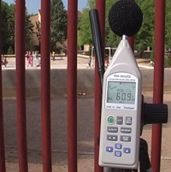  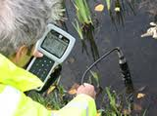 | 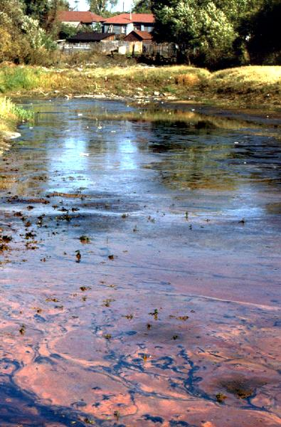
Figure 2. Simple measurements and visual assessments
Other observations
Other, more diffuse observations may also be useful. If, for example, a door leading to a storage room is shut and the key is not found during the inspection visit, you should note this down, as it could serve to hidden storage of chemicals, spill, etc. Pay also attention to whether a person hesitates to answer your questions and the way persons behave during inspection and questioning.
Such observations often indicate whether key procedures within the Quality, Environmental and Health and Safety Management Systems are developed and maintained appropriately.
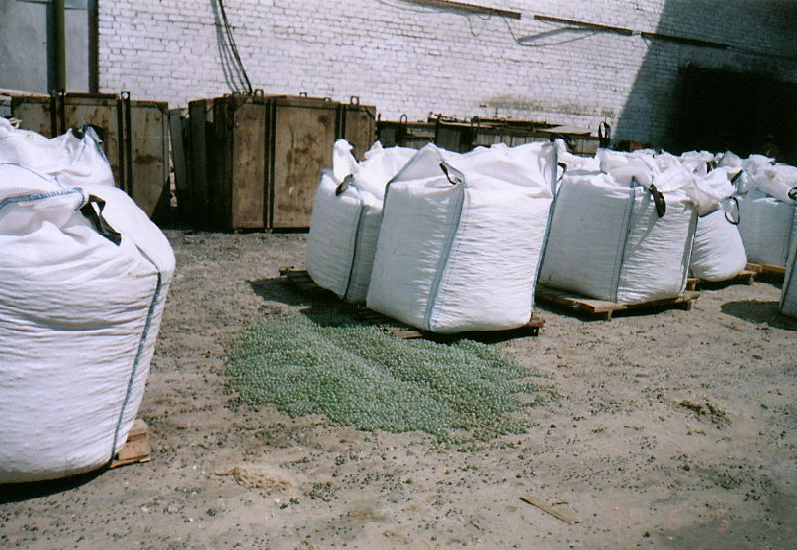
Figure 3. Losses of final product due to inadequate transportation and storage procedures
Manufacturing Installations
A site visit following the process steps often provides the most transparent picture of the facility and its environmental impact. Most processes in manufacturing enterprises follow a flow like:
- Raw materials are gathered and enter the process
- Energy goes into the process
- Manufacturing of a product, energy release, by-products and waste.
C. Inspection of documentation
Inspection of documentation can take place at the office of the facility and be continued at the inspector’s office.
The inspection report must contain references to all data prepared by the facility and used during the inspection visit. Record both:
- The calculated data, e.g. calculated mass and volume of stack gases
- Direct readings from the meters, e.g. readings of water consumption meters.
As this data shall serve as evidence in case of a conflict they should be recorded carefully, thoroughly and accurately.
D. Summary of inspection
Finalising the inspection visit, inform the manager of the facility about inspection results. It is advisable to start with mentioning observed positive elements and appreciation of the (hopefully) constructive cooperation during inspection. Then continue with identified non-compliance situations. Inform about the possible enforcement actions that will be taken and agree on the terms for execution of the enforcement instructions.
The conclusion of the conversation should be focused at the necessary and optional improvements of the facility, including action plans, information sources, good examples etc. If you have not completed the inspection report at the end of inspection, you have to notify the manager about when it will be submitted to the facility.

Emergencies and complaints
When carrying out unplanned inspections, especially in cases of accidents, the inspector’s knowledge about the facility and the involved substances is very important. Immediate action in emergency situation is crucial for the timely prevention of serious pollution. Considering the lack of time for preparation and planning, the background knowledge and inspection routines may be very advantageous.
A. Emergencies
In cases of emergencies and accidents the environmental inspector concentrates on minimizing the risk of immediate and long-term pollution of the environment. It is essential both to stop the pollution and to initiate remedial actions and clean-up activities.
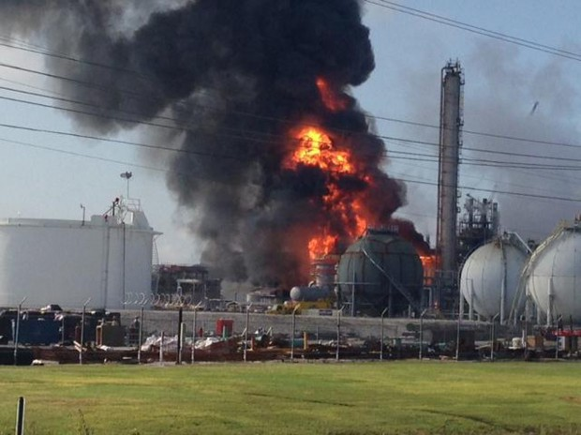
Figure 4. Chemical plant explosion
Inspector’s scheme of action in the case of an accident:
- Visit the place of the incident.
- Identify the responsible person.
- Check the received information and question witnesses and informers.
- Take samples for the purpose of evidence.
- Describe the situation precisely in writing with all available facts.
- Collect further statements from the facility, witnesses and other authorities.
- Take photos to visually record the condition at the time of stating the fact.
- Prepare if possible the inspection report on site.
Recommendations:
- Schematic pictures of the situation should be attached to the inspection report.
- If including hypotheses and other information that cannot be controlled by you, remember to indicate that this is to some extent speculative information and the name of the informer.
- If the accident has taken place within a facility, the first step is to find out whether an emergency scheme exists and whether the relevant authorities and telephone numbers are included.
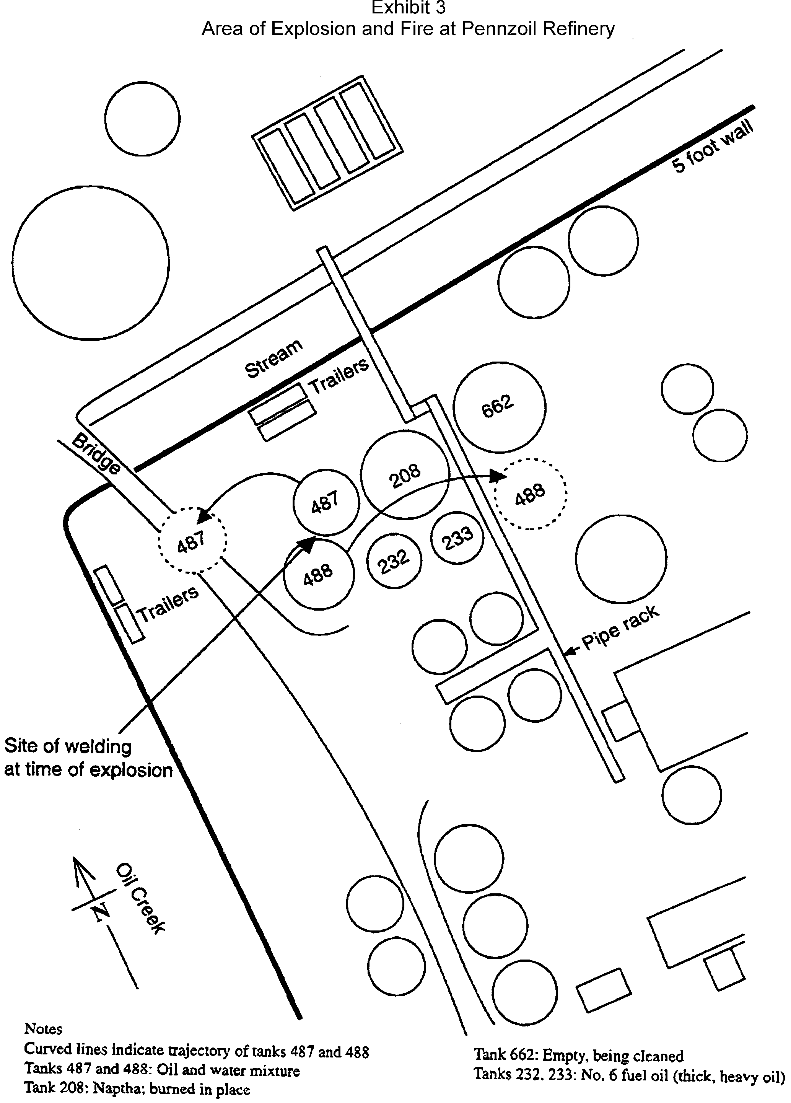
Figure 5. A schematic picture of explosion and fire at Pennzoil Refinery
B. Complaints
The authority that receives complaints must register these with the following information:
- Date, time
- Submitter of the information
- Facts stated in the information
- Information was received by
- Information is checked by
- Further action
- Location of information.
The inspection unit should examine the complaint, take relevant decisions and forward a response to the plaintiff within a reasonable timescale.
It is prohibited to publish information about the plaintiff without his/her approval.

Follow-up inspections
The aim of follow-up inspections is to inspect the execution of orders previously issued to an enterprise.
To reduce the need for follow-up inspections the inspector can instruct the enterprise that it should inform the inspectorate about the execution of orders. Follow-up inspections are carried out only in cases when it is necessary to control if the environmental requirements are fulfilled. Such inspections should be carried out immediately after the expiry of the deadline set for execution.
Data concerning the execution of orders should be recorded in the report of follow-up inspection.
It is advisable in each department of inspectors to draw up “The logbook of control of execution of orders”. It can be produced either in digital or paper form.
Example of such a logbook is provided below.
Registration logbook of orders
Commenced on XX.XX.201X
No. | Date | Name of enterprise | Content of order | Deadline | Inspectors | Need for follow up | Notes about execution
1 | 03.01. 13 | Mountain Asphalt | Injunction: Close leak in waste water discharge #4 | 20.01.13 | BB & CV | Follow up necessary as pollution of nearby village is severe | Manager has accepted the injunction

Reporting and follow-up

The inspection report
The inspection visit must be concluded with an inspection report comprising the impressions and evidence collected during inspection and assessing the level of compliance with legislative environmental requirements.
An inspection report is a permanent record that should be kept in a clear, factual language suitable for the intended audience. The report organises and coordinates all documentation and potential evidence in a comprehensive, understandable and usable manner. The report should be:
Accurate | All information must be factual and based upon sound practices. All observations must be verifiable.
Relevant | Information in the report should be relevant to the subject and objectives of the inspection.
Comprehensive | You should leave nothing out which would contribute to an accurate determination of the facts or support the objective of the inspection. It is better to have too much good evidence than not enough.
Well supported | Inspection reports shall be supported by different material as photographs, video materials and test reports from analyses carried out.
Organized | The report should be well organized and flow in logical sequences as indicated in the Annex 5. Readers with less technical experience or knowledge should be able to reach rational conclusions based upon the narrative and supporting evidence.
Objective | Factual information should be presented objectively without drawing conclusions.
Conclusive | Based on the fact provided, conclusions are presented in a specific section of the report. Explain your logic, calculations and supporting materials.
Professional appearance | This is a permanent record and a professional document subject to scrupulous review. Use acceptable grammar with proper spelling and punctuation. Make the document legible, neat in appearance and organized for easy use.
The report shall be drawn up in at least two copies, of which one is forwarded to the facility and the other filed in the register of the inspection unit. In compliance with Article 23 in the Industrial Emissions Directive the inspection report shall be forwarded to the facility within 2 months after the site visit takes place. The report shall furthermore be made publicly available within 4 months of the site visit in accordance with Directive 2003/4/EC.
In case of emergencies, accidents and complaints, an inspection report shall be prepared immediately after the inspection visit and forwarded to the facility and other stakeholders (plaintiff, neighbours) not later than 10 working days after the site visit.
It is supposed of course that similar provisions will be made in the National Laws analogous to the Industrial Emissions Directive as well as in other (more specific) legislative acts and norms.
Content of inspection reports
The report shall contain a precise description of the facts encountered with focus on changes since the previous inspection report (e.g., production enlargement, change of technologies, use of alternative chemicals, etc.). If the situation has not changed since the previous inspection visit, a reference to the previous inspection report can be given.
The report shall comprise objective statements on the situation encountered:
- Water meter has not been installed;
- Wastewater stream is blue;
- Wrong marking of chemicals.
The statement part shall also contain data about sampling and measurements (if any).
In the Conclusive part the findings are related to legislation, permits, and other relevant documents - and discrepancies described.
The Resolution part of the report shall comprise enforcement orders from the inspector to the facility (the rationale for the orders is provided in the conclusion section). Considering the gravity of the violation, the inspector decides a time frame and whether to further pursue the violation in court. If the violation is significant and causes severe environmental pollution or risks, the inspector may decide that the violation should be eliminated immediately – or cease (part of) the facility.
All persons taking part in the site visit shall sign the inspection report. If a person refuses to sign the inspector notes this next to the other signatures.

Sanctions and enforcement
If a violation is established, most laws provide rights of sanctions of enforcement. These sanctions include:
- Arrest, in accordance with specified procedures, violators of environmental protection regulatory enactments and, if necessary (to ascertain their identity), convey them to the service premises of the police or a local government authority
- In cases when the regulatory enactments regarding environmental protection and the utilisation of natural resources are not observed, stop, suspend or prohibit the activities of natural or legal persons at fault, annul or recommend the annulment of illegally acquired or utilised permits (licences)
- Bringing actions against persons at fault regarding losses, which have been done to the environment.
Overall, there are following liabilities:
1) Civil liability - compensation of losses
2) Administrative liability - pecuniary penalty, annulment of permit, suspension of company`s activity
3) Criminal liability - pecuniary penalty, imprisonment.
Civil liability can be applied for compensation of losses, e.g., as a result of pollution. Due to the fact that only for some kinds of losses there is calculation methodology most certainly a court application shall be filed. If state property has been damaged claim shall be lodged by state environmental institutions. Before filing an application, all possible evidence shall be gathered. Only court has the competence to evaluate circumstances of the case and decide whether there is a loss, how big it is and what are the compensation ways. It is very important to document circumstances and amount of harm (photographs and video materials can be added) when gathering the evidence. Both administrative and criminal liability can only be applied to persons older than a national determined minimum legal age. Till this age an action can be directed against parents or custodian by application of other coercive methods.
In general, administrative penalties can be divided into the following:
1) Warning
2) Fine
3) Confiscation of tools of offence
4) Annulling of special rights (driver`s licence, shooting licence)
5) Annulling of rights to a certain job or entrepreneur activities
6) Administrative arrest.
National legislation will determine penalties that are applicable to different types of violations.

Filling of information
All information concerning an enterprise shall be stored in the relevant Inspection department.
The file of an enterprise shall include:
- General information (address, directors, owners, registration card etc.)
- Permits
- Orders
- Inspection reports
- Correspondence
- Data about monitoring
- Accounts on natural resource tax
- Other relevant information.

Annex 1 – Tool for inspection planning
Planned inspections of polluting industries for the year 20XX of
XXX Department of inspectors
No. | Name of enterprise | 1st Inspector | 2nd inspector | Months
 |  |  |  | J | F | M | A | M | J | J | A | S | O | N | D
Category 1
 | ……………. |  |  |  |  |  | C |  |  |  |  | T
 | ……………. |  |  |  |  |  |  | T |  |  |  |  | C
 | ……………. |  |  |  |  | T |  |  |  |  |  | C
Category 2
 | ……………. |  |  | T |  |  |  |  | C |  |  | T
 | ……………. |  |  |  |  |  |  |  | T |  |  |  |  | C
 | ……………. |  |  |  |  |  | T |  |  |  |  |  | C
 | ……………. |  |  | T |  |  |  |  |  |  | C
 | ……………. |  |  |  |  |  |  | T |  |  |  |  |  | C
 | ……………. |  |  |  |  |  |  | I2
 | ……………. |  |  |  | I2
 | ……………. |  |  |  |  |  |  | I2 |  |  |  |  | T
 | ……………. |  |  |  |  | I2
 | ……………. |  |  |  |  |  |  |  | I2
 | ……………. |  |  |  |  |  |  |  |  |  |  |  |  | I2
Category 3
 | ……………. |  |  |  | I2
 | ……………. |  |  |  | I
 | ……………. |  |  |  |  |  |  |  |  |  |  |  |  |  | I
 | ……………. |  |  |  |  |  |  |  |  |  |  |  |  |  | I
 | ……………. |  |  |  |  |  | I2
 | ……………. |  |  |  |  |  |  |  |  |  | I
 | ……………. |  |  |  |  |  |  |  |  |  |  |  |  | I
 | ……………. |  |  |  |  |  | I2
Category 4
 | ……………. |  |  |  |  |  |  | I
 | ……………. |  |  |  |  |  |  | I
 | ……………. |  |  |  |  |  |  | I
 | ……………. |  |  |  |  | I
 | ……………. |  |  |  |  |  |  |  |  |  |  |  |  | I

Explanations:
I – Integrated inspection by one inspector
I2 - Integrated inspection by two inspectors
T – Thematic inspection
C - Integrated inspection carried out by a group of inspectors (commission).

Annex 2 – Tool for facility register

GUIDANCE for ENVIRONMENTAL INSPECTORS
Chapter: 1. Planning | Document Type: Tool | Status: Compulsory | Edition: 1 | Page: 1 of 2
Chapter: 1. Planning | Document Type: Tool | Status: Compulsory | Valid from:
Section: 1.2 – Tool, Register of facilities |  |  | Responsible:
 |  |  | Controlled by:

Name | ID # | Sector | Sector # | Production address | Contact person | Office address | Phone | Fax | Email | Minimum inspection Frequency | Fixed inspection Frequency

Annex 3 – Tool for definition of Complete Inspections
It is the responsibility of the inspection authority to ensure that the inspection work is carried out correctly. The environmental permit gives the core of inspection of enterprises.
A complete inspection will typically cover the beneath considerations, that – however – are not necessarily adequate or completely relevant for all installations.
General information
- The installation’s categorisation (refer to section 1.2.)
- Kind of enterprise
- Environmental permits and licenses
- Which environmental legislation and rules is relevant for the installation – and which specific requirements?
- Have previous inspection reports and environmental cases been reviewed before the inspection visit?
- Has the installation provided results of self-monitoring?
- Has the authority received complaints since the last inspection visit?
- Has the authority obtained information on processes, activities, raw materials etc. that are not covered by permits and/or the installation’s submitted information?
- Has information on relevant cleaner technologies / end-of-pipe techniques been compiled, are these adopted in the installation?
- Is the installation situated in an area with specific interests for protection of ground water or surface waters, or in (the vicinity of) vulnerable natural areas?
- Does the enterprise have an Environmental Management System?
Arrangement and operation
- Does the installation comply with conditions for arrangement and operation?
- If no environmental requirements for arrangement and operation have been issued, the need for such requirements should be assessed.
Air
- Has an inventory of air emissions and their sources been carried out?
- What substances are emitted – and in which volume and concentration?
- Does the installation self monitor emissions to the air and forward self-monitoring reports to the authority?
- Has self-monitoring reports been evaluated?
- Does the installation emit other substances than included in permits?
- Does the installation comply with emission limits/permit?
- Are all emission points controlled?
- Are wet dust separators filters and other cleaning equipment and maintained according to standards, permits etc.?
- Are new requirements to self-monitoring necessary?
- Are new conditions for air emissions necessary?
Wastewater
- Has an inventory of wastewater discharges and their sources been carried out?
- What substances are discharged – and in which volumes and concentrations?
- Does the installation self monitor wastewater discharges and forward self-monitoring reports to the authority?
- Has self-monitoring reports been evaluated?
- Does the installation discharge other substances than included in permits?
- Does the installation comply with discharge limits/permit?
- Are all discharge points controlled?
- Are treatment plants and filters maintained according to standards, permits etc.?
- Is there a need for sampling wastewater?
- Has the installation undertaken changes of the waste water system that are not reported to the authority, do such changes give reason for reassessment of permits?
- Has oil separators been controlled?
- Are new requirements to self-monitoring necessary?
- Are new conditions for wastewater discharges necessary?
Waste
- Does the installation fulfil all conditions for waste handling?
- Are all waste materials stored correctly?
- Are waste materials sorted out in fractions?
- Are waste materials forwarded to recycling when possible?
- Are special procedures adopted for hazardous waste materials – including storing, handling, packaging, transportation and final treatment?
- Does the installation have documentation for waste transportation and waste treatment – especially regarding hazardous waste materials?
- Does the installation import or export waste materials?
Noise
- Does the installation fulfil all requirements concerning noise?
- Has an inventory of noise emissions and their sources been carried out?
- Has new noisy activities been established since last inspection visit?
- Are noise emissions included in the in permits?
- Does the installation comply with noise emission limits/permit?
- Are measurements of noise emissions necessary?
- Are new conditions for noise emissions necessary?
- Has the installation considered options for installation of noise abatement equipment?
Chemical substances
- Does the installation comply with all requirements concerning handling and storing of chemical substances?
- Does the installation keep records (‘a journal’) of procurement and use of chemical substances?
- Does the installation have buried tanks, piping arrangements etc. – and are these controlled?
- Is the installation placed in the vicinity of vulnerable ground water or surface water resources – if so, does this give reason to specific requirements?
- Does the enterprise analyse the use of chemical substances with regard to substitution?
- Are surfaces of storing facilities controlled?
- Have requirements for handling of chemical substances been issued, are additional requirements necessary?
Smell
- Does the installation cause smell nuisances in the area?
- Does the enterprise aim at smell abatement?
- Does the enterprise fulfil all requirements to prevention of smell?
- Is there a need for (additional) requirements to smell from the enterprise?
Soil and groundwater
- Does the installation cause risk for soil or ground water pollution?
- Does the enterprise fulfil all requirements regarding prevention of risks for pollution of soil and groundwater?
- Is there a need for (additional) requirements to prevent risk for pollution of soil and groundwater?

Annex 4 – Checklist for collection of data and documents
This checklist provides a possibility for the inspector to check whether all relevant information is compiled and relevant institutions contacted.

Facility |  |  | Contact Person
Address |  |  | Phone
Sector |  |  | Email

Date:

 | Yes | No | Comments
Operation permit
Environmental permits
Regulation covering the facility
Organizational structure
Map of location
Description of surroundings, vulnerable areas etc.
Plan of the facility
Description of processes and technologies
Flow charts of processes
List of environmental hot spots
Self monitoring programme
Recent self monitoring data
Inspection reports, records, previous enforcement actions, reports and letters
Time schedule for agreements and deadlines for enforcements actions
Information on the facility’s environmental approach
Recent complaints and reports on action taken
Description of raw and auxiliary materials, intermediate products, by-products
Inventory of chemical substances and products
Waste Management Plan and data about waste handling
Data about hazardous waste
Risk assessment of the facility
Emergency Plan
Information on new production units, objects or technological equipment
Information on environmental accidents or emergency situations
Previous infringements (disobedience to legislative requirements);
Plan for follow up on thematic or spot inspections
Research/special reports or reports on environmental impact
Notification scheme in case of emergency situations
Information from other public authorities
Information about cleaner technologies in the sector
Contact to cleaner technology institutions

Annex 5 – Template for inspection report
Belarus Environmental Inspection

Address ……… Telephone …………. Fax ………….

INSPECTION REPORT No. __________

Day Month Year Place

Inspector ______________________________________________________________________ has
Position, Name
according to law ___________________________________________________________ inspected:
Specify environmental legislation, according to which the inspection was carried out

The facility _______________________________________________________________________
Name, address, telephone number
Legal entity: ______________________________________________________________________
Name/title, address
Registration No.

Responsible contact person ____________________________________________________________
Position and name

_____________________ _____________________________________________________________________________
Direct phone Email-address

Aim of the inspection visit Scope of inspection
Planned integrated inspection
Planned thematic inspection
Examination of complaints
Inspection in case of an accident
Inspection of the execution of orders
Other reason:

The following was observed during the inspection:
Conclusions:

Enforcement
On the basis of law _________________________________________________________________
_________________________________________________________________________________
_________________________________________________________________________________
_________________________________________________________________________________
_________________________________________________________________________________

The facility is instructed to:
No. | Actions to be done | Term of execution
The inspection unit shall be informed in writing about the facility‘s execution of the orders.

IMPORTANT – PLEASE NOTE:

- In case of non-execution of the above-mentioned actions the guilty persons can be called to account according to ________________________________________________________
Specify legislation

- In case of non-execution of actions No. _________________ a decision can be made about suspension of operation of the above-mentioned facility according to _______________________________________________________
Specify legislation

Participants in the inspection visit

Official(s) of the Inspection Unit:
__________________ ___________________________________ _____________________
Position Name Signature
__________________ __________________________________________ _____________________
Position Name Signature
__________________ __________________________________________ _____________________
Position Name Signature

Representative(s) from the facility
__________________ __________________________________________ _____________________
Position Name Signature
__________________ __________________________________________ _____________________
Position Name Signature

Other persons
__________________ __________________________________________ _____________________
Position Name Signature
__________________ __________________________________________ _____________________
Position Name Signature

As representative of the inspected facility, I hereby confirm:

- that I have acquainted myself with the content of the inspection report

- that I have received a copy of the draft report

Day Month Year

______________________ ___________________________________ ________________________
Position Name Signature

Signature of the inspector drawing up the report _____________________________

According to _____________________________________ (specify legislation) the findings and conclusions of this inspection report can be challenged within _________ (specify timeframe) from the day of receipt of the inspection report by ___________________ (specify complainants)

Annex 6 – Useful References
General Guides
- Manual for IPPC Inspections (Croatia ) http://www.mzoip.hr/doc/Inspekcija/Prirucnik_IPPC_2009_EN.pdf
- Conducting Environmental Compliance Inspections. Field Guide (EPA) http://inece.org/manual/English%20Inspectors%20Field%20Manual.pdf
- Environmental Compliance Inspection Manual (EPA) http://www.inece.org/manual/Facilitators%20Manual.pdf
- Environmental Site Inspection Checklist (UK) http://www.epd.gov.hk/epd/misc/env_management_sme/eng/pdf/Construction/EF-EI04-01.pdf
- European Union Network for the Implementation and Enforcement of Environmental Law (EU) http://impel.eu/
- Harmonized Environmental Inspection and Investigation Manual (UNECE, for East Africa) http://www.inece.org/manual/
- Improving the Effectiveness and Efficiency of Environmental Inspections: Risk-based Prioritisation and Planning in Moldova (OECD) http://www.oecd.org/environment/outreach/46960063.pdf
- The National Pollutant Discharge Elimination System (NPDES) Compliance Inspection Manual (USA) http://www.epa.gov/compliance/resources/publications/monitoring/cwa/inspections/npdesinspect/npdesinspect.pdf
- Pollution Prevention Advice and Guidance (UK) http://www.environment-agency.gov.uk/business/topics/pollution/39083.aspx
- General Inspection Procedures (USA) https://www.dnr.mo.gov/env/opsmanual/ch3sec1.htm
Sector and Medium Oriented Guides
- Environment management toolkits to help specific business sectors (UK) http://www.environment-agency.gov.uk/business/144678.aspx
- Portland Cement Industry Inspection Manual (Egypt) http://industry.eeaa.gov.eg/publications/Cemen%20IM-2003.pdf
- Field Surveillance and Enforcement Guide for Primary Metallurgical Industries (USA). National Service Center for Environmental Publications (NSCEP) http://nepis.epa.gov/
- Profile of Inorganic Chemical Industry (USA) http://www.epa.gov/compliance/resources/publications/assistance/sectors/notebooks/inrgchsn.pdf
- Profile of the Organic Chemical Industry (USA) http://www.epa.gov/compliance/resources/publications/assistance/sectors/notebooks/organic.pdf
- Profile of the Agricultural Chemical, Pesticide, and Fertilizer Industry (USA) http://www.epa.gov/compliance/resources/publications/assistance/sectors/notebooks/agchem.pdf
- Profile of the Stone, Clay, Glass, and Concrete Products Industry (USA) http://www.epa.gov/compliance/resources/publications/assistance/sectors/notebooks/stclglsn.pdf
- Profile of the Petroleum Refining Industry (USA) http://www.epa.gov/compliance/resources/publications/assistance/sectors/notebooks/petrefsn.pdf
- Profile of the Textile Industry (USA) http://www.epa.gov/compliance/resources/publications/assistance/sectors/notebooks/textilsn.pdf
- EPR Intensive Farming Pre-Inspection Guide (UK) http://www.environment-agency.gov.uk/static/documents/Business/Factsheet_-_Records_Checklist_for_IPPC_Assurance_Scheme.pdf
- How to comply with your environmental permit for intensive farming (UK) http://cdn.environment-agency.gov.uk/geho0110brsb-e-e.pdf
- EPA Portland Cement Inspection Guide (USA) http://www2.epa.gov/enforcement
- Food and Drink Industry Environmental management Guide (UK) http://cdn.environment-agency.gov.uk/LIT_8422_963b8b.doc
- Above Ground Oil Storage Tanks (UK) http://cdn.environment-agency.gov.uk/pmho0811bucr-e-e.pdf
- Safe Storage and disposal of used oils (UK)http://cdn.environment-agency.gov.uk/pmho0304bhxb-e-e.pdf
Incidents and Accidents
- Major Accidents to the Environment http://v5.books.elsevier.com/bookscat/samples/9780750683890/9780750683890.pdf
- Revised Spill Prevention, Control, and Countermeasure (SPCC) Guidance for Regional Inspectors (USA) http://www.epa.gov/oem/content/spcc/spcc_guidance.htm
- Incident Response Planning (UK) http://cdn.environment-agency.gov.uk/pmho0309bpna-e-e.pdf
- Environmental Incident Report (Canada) http://www.gov.pe.ca/photos/original/tpw_inc_report.pdf
- Notification and Reporting of Environmental Incidents (Australia) http://www.nopsema.gov.au/assets/Guidance-notes/N-03000-GN0926-Notification-and-Reporting-of-Environmental-Incidents-Rev-4-February-2014.pdf

