EuropeAid/129522/C/SER/Multi
Contract number 2010/232-231
Air Quality Governance in the ENPI East Countries
Support towards the implementation of integrated permitting:
Management requirements
25 August 2014
Version |  | Date | Description | Prepared by | Reviewed by
1 |  | 25 August 2014 | Report for Subtasks 2.1.5.1 Prepare phase-in schedule proposals for existing LaPA,  2.1.5.2 Develop reporting requirements for assessment of the new Environmental permitting system implementation, and  2.1.5.3 Prepare phase-in schedule proposals for existing medium polluting installations | Short-term experts of Component 2 | Aiga Kāla, Key Expert 2 – Air Quality Assessment and Management  Vladimir Morozov, Key Expert 3 – Industry/IPPC

SUMMARY
Project Title: Air Quality Governance in ENPI East Countries
Contract Number: 2010/232-231
Countries: Armenia, Azerbaijan, Belarus, Georgia, the Republic of Moldova, the Russian Federation, and Ukraine
Lead Contractor
Name MWH
Address Nysdam Office Park
Avenue Reine Astrid, 92
B-1310 La Hulpe
Belgium
Tel. number +32 2 655 2230
Fax number +32 2 655 2280
Contact person Aïda Yassine, Project Manager
Signature
Date of report: 25 August 2014
Experts:
Monika Přibylová, International Non-Key IPPC Expert
Michael Begak, International Non-Key IPPC Expert
Oleg Bely, Local Non-Key IPPC Expert
Tatiana Guseva, Local Non-Key IPPC Expert
Viktar Khodzin, Local Non-Key IPPC Expert
Content
SUMMARY 3
List of abbreviations 5
1. BACKGROUND 6
2. Summary of management requirements procedure 7
3. Phase-in schedule for the large polluting installations 9
4. Time schedule for medium polluting installations to be regulated by the GBR permitting system 24
5. Reporting requirements for assessment of the new environmental permitting system 26
Annex 1. Example of Questionnaire on the implementation of Directive 2010/75/EU 29

List of abbreviations
BAT – Best Available Techniques
BREF – BAT Reference document
EECCA – Eastern Europe, Caucasus and Central Asia
EIA – Environmental Impact Assessment
ELV – Emission Limit Value
ENPI – The European Neighbourhood and Partnership Instrument (ENPI) that supports the European Neighbourhood Policy (ENP)
EPEP – Environmental Performance Enhancement Programme
EU – European Union
GBR – General Binding Rules
IED – Industrial Emissions Directive
IPPC – Integrated Pollution Prevention and Control
MoE – Ministry of Environment
OECD – Organisation for Economic Cooperation and Development
WG – Working Group

BACKGROUND
This report is prepared in the frame of Air Quality Governance project, Component 2 - Activities addressing the Industrial Sector, including Energy, Task 2.1.5 Management requirements, Subtasks 2.1.5.1 - 2.1.5.3 dealing with phase-in schedules and reporting requirements related to the implementation of the environmental permitting reform.
The aim of this report is twofold – firstly to provide the overview of possibilities and experience with bringing the existing large polluting installations into the integrated permitting regime and how to set up reporting system relevant for monitoring and control of the permitting reform implementation. The second goal of this report is to suggest recommendations for project countries on developing and implementing phase-in schedules for large and medium polluting installation and setting up reporting system on the new environmental regulatory regime implementation.
The proposed options and recommendations for phase-in schedules and reporting are based on the section 7 of the Handbook for Implementation of EU Environmental Legislation. The 7th section covers except the IPPC Directive also related directives such as the Directive on Air Pollution from Industrial Plants, the Large Combustion Plants Directive, and the Seveso Directive.
Furthermore the recommendations are derived from the OECD Integrated Environmental Permitting Guidelines for EECCA countries, chapter VI ‘Strategic approach to the gradual transition to integrated permitting for large industry’ and chapter VII ‘Regulating installation not covered by the integrated permitting system;’ and from the Case study – Approach to the introduction of integrated environmental permitting in Ukraine, 2005.
This report is connected and complementary to other reports developed under this project’s Task 2.1 Support towards the implementation of integrated permitting. General practical recommendations for the project partner countries are presented in reports of the same team for Subtasks 2.1.1.6 Develop Guidance for integrated permitting and 2.1.1.7 Develop Guidance for integrated inspection.

Summary of management requirements procedure
Generally it is possible to define 6 main management requirements related to the environmental permitting reform:
- Planning of legal and institutional transformation
- Planning of implementation of the new legislation and institutional transformation
- Ensuring finances for state administration and industry implementation
- Permitting of all relevant installations and activities
- Implementing BAT and new environmental requirements (GBR) at industry level
- Monitoring of the implementation of the new environmental permitting regime including inspection and reporting.
The experience within EU Member States suggests that the most demanding and time-consuming tasks associated with implementing the integrated permitting regime are:
Phase 1:
- Establishing and developing the institutional structure for integrated permitting of installations, including the enforcement regime
- Surveying and identifying the installations to which the new permitting regime applies
- Establishing a reporting and database system.
Phase 2:
- Establishing technical standards for BAT and determining emission limit values.
- Implementing the authorisation procedures, including preparation of applications, public consultation and issuing permits.
Phase 3:
- Detailed planning, design, permitting and construction of new or upgraded facilities to conform to the new environmental standards.
Majority of the above listed tasks have been elaborated in previous reports under Component 2 of this project, except the practical transitions of existing installations from the old permitting regime into integrated or GBR permitting regimes and reporting requirements. These are the main focus of this report.
A) Phase-in time schedule for the existing large polluting installations to be brought under the integrated permitting regime
In order to accommodate the capacity constraints related to the transition to the integrated permitting system (the development of BAT sectoral technical guidelines, lack of practical experience in the permitting authorities, administrative burden of moving to the new system), it is recommended to prioritize industrial sectors in order to smoothly cope with the new requirements on time. The prioritization can be reflected in the phase-in time schedule for existing plants which would allow sufficient time for determining the integrated permit conditions by the permitting authorities. The phase-in time schedule shall be agreed with relevant industry sectors and approved by a legal act thus making it binding. Alternatively it can be formulated as agreement between industry sectors and permitting authorities.
B) Phase-in time schedule for the plants to be brought under the GBR permitting system
In order to accommodate the capacity constraints related to the transition to the GBR permitting system (the development of GBR, lack of practical experience in the permitting authorities, administrative burden of moving to the new system), it is recommended to prioritize industrial sectors in order to smoothly cope with the new requirements on time. The prioritization can also be reflected in the phase-in time schedule for existing installations which would allow sufficient time for determining the GBR permit by the relevant authorities and institutions. The phase-in time schedule shall be agreed with relevant industry sectors, and if necessary, approved by a legal act thus making it binding.
C) Development of reporting requirements for assessment of the effectiveness of the new environmental permitting regime
In order to ensure effective implementation of the environmental permitting reform, the relevant ministry (e.g. Ministry of Environment) shall develop a set of reporting requirements for the permitting, inspection and registering authorities. These requirements shall be based on the criteria and requirements established by the ministry in the national environmental policy and they can also comply with the EU reporting requirements related to the Industrial Emission Directive, depending on the national plan for cooperation with EU or approximation towards EU.
The regular reporting on these criteria and requirements shall give an overview on environmental, financial and regulatory effectiveness of the new system. The reporting results can be used for adjusting the new regulatory regime.

Phase-in schedule for the large polluting installations
Since the integrated permitting regime was introduced in EU through the IPPC Directive, the possibilities with bringing the existing large polluting installations into the integrated permitting regime is described based on the experience of EU member states with implementation of the IPPC Directive.
As it recommended in OECD-2007 Guiding principles, the first step of the transition to the integrated permitting for LPA is to determine the scope of the integrated permitting system. At this phase a list of industrial sectors to be controlled under the integrated permitting regime has to be established, and correspondent thresholds (capacity, production volume) established. Principles of EU IPPC and IED Directives can be a good starting point for this step. Both the list and thresholds have to be widely discussed with industry and public concerned.
It is not reasonable to introduce integrated permitting instantly. First of all, there is a need to develop a kind of priority list of industrial sectors. The criteria for such prioritisation include environmental impacts, anticipated compliance costs, economic and financial conditions. Administrative capacity constraints of the permitting authorities have also to be taken in account. Different compliance deadlines for new and existing installations should also be established.
The provisions of the IPPC Directive came in force for the new installation in 1999. “Older” (existing) industries had 8 years for obtaining integrated permits and compliance with the BAT. Only in October 2007 all existing installations had to comply with the Directive’s provisions.
Some new EU member states managed to bring the existing installations under the IPPC system within 5 years (e.g. Czech Republic and Slovakia). In many new EU member states the new installations were subject to the IPPC system within one year from the adoption of the national legislation transposing the IPPC Directive.
Transitional period for the new installations or installations undergoing reconstruction has been derived from the IPPC Directive and from availability of the relevant secondary legislation (e.g. application and permit forms). Thus in first few years of implementation there were cases where new or reconstructed installations had to submit the application for integrated permit including BAT assessment and its determination prior to finalization of the relevant BREF. In these cases the operator or investor was encouraged to use the criteria for BAT determination listed in Annex IV of the IPPC Directive and utilize any available sources for BAT or cleaner production guidance.
The phase-in time schedule for existing installations in the EU was usually based on:
- Prioritization based on industrial sectors to be brought in during the same period to eliminate the competition pressures
- The date of expiration of the existing permits, so the renewal was carried out already according to the integrated procedures and IPPC Directive requirements
- The schedule for national BAT guidance or BREFs development
- The capacity of the individual permitting offices, which were given the power to negotiate the regional phase-in time schedule region by region.
In OECD-2007 Guiding principles it is suggested that the preparatory phase of the introduction of the new permitting system may last for up to five years, while the full transition may well take up to 15 years.

Examples of practice in EU member states
- In the United Kingdom, when implementing comparable legislation the government drew up a formal timetable for authorising existing installations, tackling a small number of sectors each year so that all sectors were authorised at the end of a five-year programme. This gave to the authorities an opportunity to develop and issue information on BAT for each sector, gain experience and deal with applications at a rate commensurate with staff capacity, and enabled the site operators to plan effectively against a known deadline.
- In the Czech Republic, there was no officially approved phase-in schedule for the existing installations, but the Ministry of Environment recommended to the regional authorities which were given the function of permitting authorities to negotiate the timetable with individual operators on regional bases. The inventory of existing installations was carried out by the Integrated Prevention Agency which was subordinated to the Ministry of Environment. The list of identified installations was sent to Environmental Inspectorates for verification of the operating capacities during regular inspection visits. Thus the regional authorities received verified list of existing installations on their territory. The practice showed that about 60% of operators agreed with the regional authority on the date of submission of the application for integrated permit more than half a year before the final date when all operators had to have the permit.
Advantages of phase-in schedule
- It allows planning both for the industry and permitting authority
- It enables to spread the work load of permitting authority evenly and with smaller number of officers
- It also enables stepwise planning and training of environmental inspectors on integrated inspections
- Feedback from first years of implementation can be utilized to adjust or improve of the regulatory system during the second half of the implementation period.
Disadvantage of phase-in schedule
- The preparation and approval of the schedule requires cooperation of several ministries and industry, which usually takes long time
- Most of industrial sectors do not want to be at the beginning of the list, therefore some incentives maybe needed to motivate the operators.

Example of proposed phase-in schedule for Ukraine
It is assumed that the implementation in Ukraine needs at least the same or longer period as in the EU member states. Based on this, it is possible to propose the implementation of requirements for the new installations or installations undertaking reconstruction to obtain integrated permit three years after adoption of the new Law on Environmental Permitting. The secondary legislation shall be in place no later than one year before the requirement for the new installations or installations undergoing reconstruction to obtain the integrated permit.
The transitory period of 10 years is proposed for the existing installations. The period is so long due to large number of identified existing installations.
The following table shows the recommended phase-in time schedule based on industrial sectors’ prioritization which was developed within the 2005 Ukraine case study with update related to the Industrial Emissions Directive.
Sectors | IPPC codes | Number of installations | Overall environ-mental score | Submission of application for integrated permits (years from the adoption of the law)
Fuel and energy industry | 1.1-1.4, 6.8 | 132 | 4.43 | 3
Pulp and paper industry | 6.1-6.3 | 35 | 4.23 | 3
Surface treatment by electrolytic or chemical processes | 2.6 | 152 | 4.17 | 4
Waste management | 5.1-5.4 | 502 | 4.12 | 5
Production and processing of metals | 2.1-2.5 | 320 | 3.93 | 6
Chemical and other industry | 4.1-4.6,  6.9-6.10 | 840 | 3.83 | 8
Processing of minerals | 3.1-3.4 | 114 | 3.80 | 9
Food production | 6.4-6.5 | 85 | 3.57 | 9
Surface treatment by organic solvents | 6.7 | 140 | 3.27 | 9
Intensive poultry or pig farming | 6.6 | 190 | 2.97 | 10
Additional sectors brought by the Industrial Emissions Directive | 6.9- 6.11 | Up to 60* | - | 10
* Estimation
Table 1: Prioritization of sectors for transitory phase-in schedule
The proposed time sequence of sectors to become subject to integrated permitting requirements shows that the sectors with high environmental impacts are in the first half of the table, sectors with large number of installations are in the middle, and sectors with the relatively low overall environmental impact are at the end of the table. The presented sequence of sectors makes possible to start with heavily polluting energy sector as well as with relatively small and not the most polluting sector (paper production sector). The food and agricultural sectors are at the end of the priority list. This should allow farming and food industry to prepare well for more robust regulations compared to the current system and for the introduction of BAT.
It is important to understand that the proposed of the OECD Permitting Guidelines environmental scoring procedure is only one approach to sector’s prioritization. To a large extent the scoring depends on the subjective evaluation of selected criteria. Therefore, it is advisable to consult the industry stakeholders on the sequence of industrial sectors in the phase-in time schedule. Ultimately, however, the sectoral prioritization for the introduction of integrated permitting is a political decision that cannot be entirely objective.
In order to adequately plan capacity building activities for the oblast environment regulation offices, it is necessary to take into account the industrial sector distribution across the Ukrainian regions and compare it with the institutional capacity of the respective oblast office to handle the transition from the current permitting practice to the integrated permitting system. From the currently available data it is possible to estimate that about a half of all key sectors are relatively well distributed across the regions (e.g. there is at least one large combustion plant in each region for a total of 66 in the country).
Existing installations will have to comply with the requirements from the 3rd year but no later than after 10 years from the adoption of the Law on Environmental Permitting. To make the transition for existing installations smoother, a regional negotiation approach may be used to better manage the transition of existing installations from a particular sector within the period listed above in the table 1. Under a regional transition scheme, the oblast offices would negotiate with individual installations the date by which each installation would be required to submit the application for an integrated permit. Such negotiations should take place when the operator applies for a modification or renewal of its environmental media-specific permits and be based on an environmental audit of the installation carried out by the operator. The audit would characterize the installation’s technical and financial potential to introduce BAT. By no means, the agreed application date (written as a condition into the installation’s current permit) should go beyond the overall national deadline for the transition to integrated permitting.
The drawback of the regional approach to the transition for existing installations is that it may be hampered by pressure exerted by operators to push ahead the compliance deadline as far as possible, thus leading to corruption.

Timing of industry transition towards integrated permitting regime
In order to ensure smooth transition towards the integrated permitting regime by both the industry and the environmental authorities it is necessary to carry out the three interrelated tasks which are as follows:
- To draft and approve the list of large polluting installations regulated by integrated permits with relevant thresholds
- To carry out inventory of the existing installations falling under the integrated permitting regime and
- After the approval of the list to develop and approve the phase-in time schedule for submitting the applications for integrated permits to the environmental permitting authorities.
The Figure 1 below shows procedure for preparation, consultations and approval of the list of large polluting activities and phase-in time schedule.
Based on the experience in the accession countries, it may require 1 – 1.5 years to carry out the steps indicated in Figure 1 depending on the availability of information for the IPPC installations’ inventory. Within this period it may take 6 – 12 months to carry out the inventory in order to verify the information gathered from various sources.
In order to provide to the sectors, which will be the first ones in the phase-in time schedule, sufficient time for preparation of the integrated permit application and development of a plan for transition to BAT, it is necessary to approve the time schedule by the ministerial decree or other relevant legal act at least one year before the first deadline for submitting the integrated permit application to the permitting authority.
Proposal of LaPA list

Inventory of
existing
installations
Corrections
Consultations with
stakeholders
no
Approval by
Interagency WG
yes
Draft phase-in time
schedule
Corrections
Consultations with
stakeholders
no
yes
Adoption of the LaPA list
by relevant legal act
Adopt the time schedule by
relevant legal act
Publication on
the MoE website
Time
Approval by
Interagency WG
Notes: LaPA = Large Polluting Activities (e.g. as defined by the Annex I of IED)
Interagency WG = group of representatives from relevant ministries, permitting authorities and industry
Figure 1: Preparatory task for transition of industry towards integrated permitting regime

Practical example of integrated permitting legislation implementation (the Russian Federation)
The long history of Russia moving to integrated environmental permits, which started at 1998, has come to its intermediate finish line: the amendments to the Russian Environment Protection Law, providing the legal basis for BAT-oriented integrated permits were adopted on July 21, 2014.
In this regard it would be interesting to take some retrospective view of state administration and management problems which will be solved by the new Environmental Protection law.
Environment protection legislation was always behind the economic and civil legal relations in Russia:
- Low level of environmental liability in industry and agriculture
- High costs of environment protection measures
- Very weak economic incentives for environmental protection
- Absence of the ‘green procurement’ systems at the state and municipal levels
- Weak competitiveness of Russian goods and services at international markets
- Unfavourable reputation of the Russian business
To overcome these gaps the following measures have to be implemented:
- Reformation of the management system in the field of environmental protection
- Sustainable progress of the green economy
- Conversion to integrated environmental permits for major polluters and simplified procedures for small polluters
- Progress of environmental management, ‘green procurements’, environmental reporting
- Implementation of the state support and economic incentive instruments.
Introduction of integrated environmental permits will be important but not the only step of the overall reform of the environmental regulation system in the Russian Federation.
By the new Environmental Protection Law the following issues of the environmental protection are covered:
- All polluters are divided into four categories in accordance with their environmental impacts:
A – significant
B – moderate
C – small
D – negligible
- The state registration of polluters is foreseen. During the registration the above listed categories will be labelled
- BAT paradigm is finally accepted at the national level
- Integrated environmental permits will be granted to category A installations
- The instrument of pollution charges is enforced
- Some measures (economic and administrative) are foreseen to stimulate the environmental modernization of industry and agriculture
- Environmental self-monitoring will be enforced. The data of self-monitoring of category A polluters will be collected in State Monitoring Database and will be made available for the general public
- Timetable of the new system of environmental regulation is worked out.
The measures of the state environmental regulation differ from one category to another. For category D they are the simplest: unscheduled inspection only. Most likely the inspection will be based on some complaint.
Three categories – A, B, C enterprises have to be registered as polluters, and need to prepare and implement self-monitoring programmes. Contents of such programmes depend on the category and are determined by the competent state body.
Also, installations of A, B, C categories have to present their reports on environmental performance and on the implementation of self-monitoring programmes to the competent state bodies. C category installations will present reports in accordance with the notification procedure.
Special consideration is given to category A installations. Permitting procedure for them starts from the environment impact assessment (EIA). In a framework of EIA they have to calculate emitted limit values (ELVs) to be included in the EIA report. The same requirement is built into the law for category B installations.
For category C installations ELVs are calculated only for carcinogenic and mutagenic substances as well as for radioactive materials. ELVs are not calculated for category D installations.
Besides registration, self-monitoring, and reporting mentioned above, the installations of category A will have to pass the procedure of the state environmental review. In case of positive review conclusions the installations will have to get integrated environmental permits based on BAT.
All installations of the category A are subjects to state environmental inspection and have to be equipped with online environmental monitoring devices. These devices have to monitor quantities of pollutants emitted to the air, their concentrations and to transfer the measured data to the State Monitoring Database.
In cases when the environmental permit is granted on the condition that certain environmental improvements or BAT implementation plans should be implemented, the enterprise has to present reports on the fulfilment of such plans annually.
The last requirement is applicable also for category B installations.
For installations of category B environmental permits are based upon the notification principle. So, we can state, that GBR instrument will not be implemented in the Russian Federation, at least in the foreseeable future.
The environmental impact notification has to be presented in written or in digital form, certified by e-signature, to the federal or regional competent body.
The environmental impact notification contains following information:
- Name of the organization, its business form, postal address
- Code of registration in the Registry of Polluters
- The type of main activity and production capacity (goods)
- Information about the realization of a programme of environment protection measures
- Information about accidents, that have led to negative environmental impacts, for the last 7 years
- Declared amounts of emissions
- Information about the program of environmental self-monitoring
Along with the environmental impact notification, calculations of ELVs have to be presented.
If the main technological processes and qualitative and quantitative characteristics of emissions stay unchanged, the environmental impact notification has to be presented every 7 years.
Category B installations will be able to get integrated environmental permit on voluntary basis. Such initiative is limited by existence of corresponding BAT reference documents for a given type of activity.
Installations of B and C categories are the subjects of regional environmental inspections.
In spite of some concrete provisions of the new Environmental Protection Law, in whole it is a framework document. A lot of provisions have to be enacted by the Government in the near future.
These provisions will include criteria of the categorization of installations, which have to be prepared by the Government. It will be the first step of the environmental reform. Then, when category D installations are excluded, the others will have to be registered in the State Pollutants Emissions Register.
A special registration numerical code will be assigned to each installation of A, B, and C categories.
The State Pollutants Emissions Register includes the Federal register, containing information about enterprises which are subjects of the federal environmental inspection, and regional components, containing information about enterprises which are subjects to regional environmental inspections.
Information about quantitative indicators of emissions will be available for public, excluding classified information.
The list of enterprises which are subjects to the federal environmental inspection has to be determined by the Government. Decisions concerning listing particular installations and enterprises will be made based upon specific criteria, which also have to be determined by the Government.
In the period 2015 -2018 all enterprises have to be registered in the State Pollutants Emissions Register. During this period the following activities should be implemented, besides registration:
- Introduction of economic incentives for enterprises
- Adoption of all by-laws
- Publication of Russian BAT reference documents (so called Information and Methodology Reference Documents or Handbooks).
In the period of 2019 - 2022 the following activities should be implemented:
- Foundation of the interdepartmental commission for the consideration of environmental performance enhancement programmes developed by enterprises
- Increase of pollution charges’ rates up to the level comparable with the costs of pollution abatement measures.
In the period 2019 - 2022 Integrated Environmental Permits should be issued to Russian enterprises. At first, Integrated Environmental Permits will be granted to about 300 enterprises, namely to the largest national polluters. These 300 enterprises will be chosen relying on their contribution to the total national emissions of air or water pollutants. It is supposed that these organisations will be responsible for at least 60% of the total national emissions in Russia.
Integrated Environmental Permits will also be granted to all new enterprises and to those who would express their willingness to get Integrated Environmental Permits on the voluntary basis.
In the period of 2022 - 2030 all other category A installations will have to get Integrated Environmental Permits, based on BAT.
The list of the main environmental pollutants will be set by the Russian Government, namely – by the new environmental acts, which have to be determined by Government. The choice of these substances will be made taking into account:
- Toxicity, carcinogenic or mutagenic features of substances, their ability of bioaccumulation and biomagnification in the environment
- Data of environmental and socio-hygienic monitoring
- Existence of reliable and cost-effective measurement techniques.
For operating enterprise the ‘traditional’ procedure of the Integrated Environmental Permitting will be supplemented with the requirement to prepare an Environmental Performance Enhancement Programme (EPEP).
For category A installations EPEP must to be elaborated if the installation is not capable to meet BAT requirements (standards of emissions, other BAT requirements). EPEP has to include a list of measures of renovation, technical upgrading of technological processes and environmental techniques, a schedule for the gradual introduction of such measures, as well as necessary means and funding sources and a list of the managers in charge.
EPEP is a step by step programme. For every step the list of indicators and the measures of environmental impact reduction has to be prepared.
Maximum duration of EPEP programme is 7 years; this term cannot be prolonged.
The procedure of EPEP development has to be established by the competent authority nominated by the Government. It is the statutory requirement.
EPEP has to be approved by the special interdepartmental commission. This Commission has to be created by the competent authority. In the Commission representatives of concerned bodies of the federal power, the State Corporation on nuclear energy ‘Rosatom’, and regional bodies of the executive power have to be included.
In the process of EPEP approval the Commission has to assess the correspondence between the programme and strategic regional development plans. The Commission has a right to demand that some supplementary measures have to be developed by enterprise to fulfil environmental requirements.
Time for EPEP approval cannot exceed 4 months and can be 2 months prolonged if initiated by applicator.
Competent authorities have to publish drafts of EPEP on the official web sites to make these documents publicly available.
Installations have to report annually about EPEP implementation to the federal or regional competent bodies.
Figure 2 below schematically shows integrated environmental permitting procedure for operating and new category A installations.
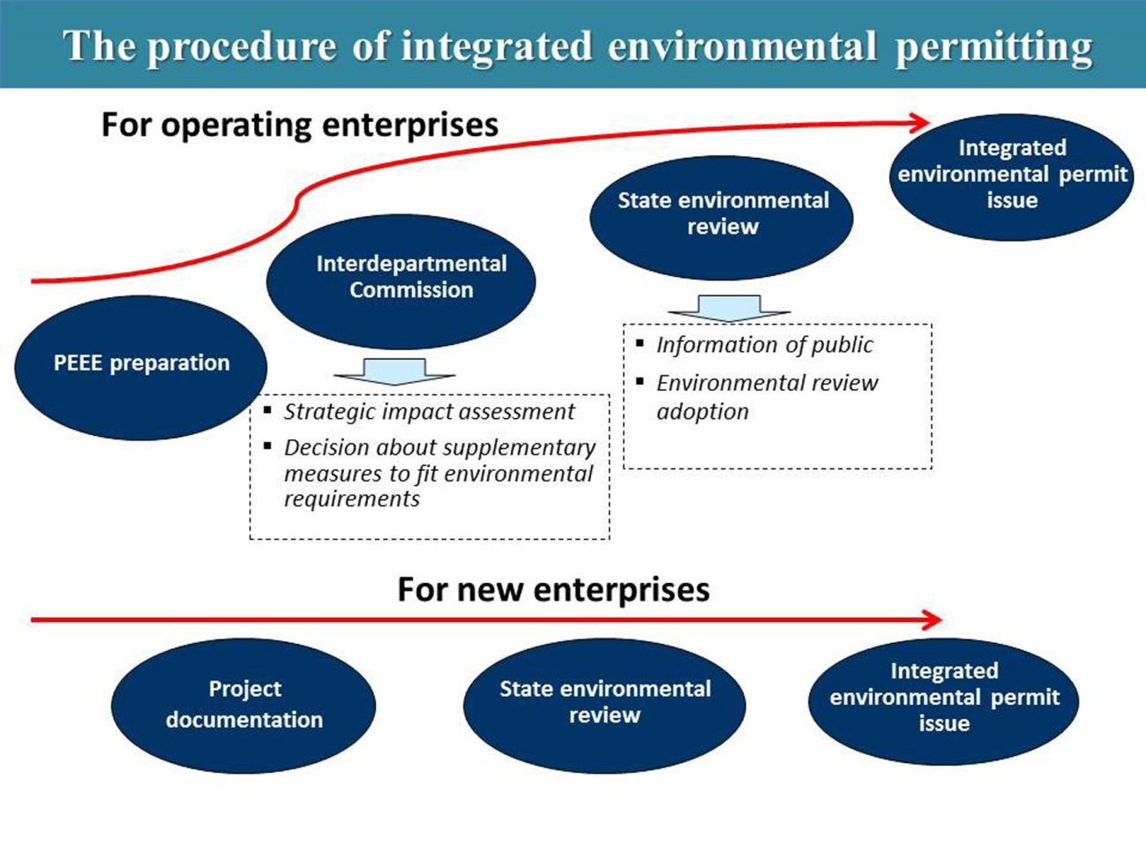
Figure 2 — The integrated environmental permitting procedure for operating and new category A installations
New environmental legislation specifies and enhances the instruments of the state support to environment protection activities. General directions of such activities are as follows:
- support to innovations in the fields of BAT implementation and other activities leading to the reduction of environmental impact
- Support to training (including professional upgrading) activities in the field of environmental protection and providing informational support on measures leading to the reduction of environmental impact.
- Support to the renewable energy sector, secondary resources use, new environmental monitoring techniques.
The state financial support to BAT implementation and other measures leading to the environmental impact reduction can be provided by means of:
- Tax exemptions
- Pollution charges privileges
- Direct state support (subsidies) from the federal and regional budgets
Direct state financial support is granted in a case of realization of some environmental protection measures. The list of these measures and actions is established by the law:
- BAT implementation
- Design, construction and reconstruction of
  - Circulating and closed cycle water supply systems
  - Central sewerage systems, sewerage networks, local waste water treatment plants, including stormwater treatment, liquid household waste treatment and sludge treatment
  - Systems of air emissions treatment, use of associated petroleum gas
- Installation of:
  - Equipment for fuel combustion enhancement
  - Equipment for reuse, transportation, utilisation of waste
  - Automated systems and labs for wastewater monitoring
  - Automated systems and labs (stationary and mobile) for monitoring of ambient air emissions
  - Automated systems and labs (stationary and mobile) for environmental self-monitoring.
Subjects of the Federation are able to define other measures of the state support to environmental protection activities, according to the capacities of regional budgets.
Figure 3 below shows the scheme of economic instruments development. Figure 4 specifies economic instruments supporting BAT implementation.
The Russian Government has adopted a ‘road map’ of BAT implementation (Regulation of the RF Government No. 398-r of 19 April 2014). The main stages of this ‘road map’ are as follows:
- May 2014 — Interdepartmental commission on BAT implementation establishment (fulfilled)
- December 2014 — Procedure for BAT reference documents development prepared and adopted
- May 2015 — Draft concept of BAT implementation in the industrial sector of Russia elaborated
- December 2015 — Proposals on the state support measures for BAT implementation in industrial sector developed
- March 2016 — Measures and indicators for BAT implementation included in the state programs and in the state budget for the next fiscal year
- 2015 – 2018 — BAT reference documents developed
- 2016 – 2018 — Measures to promote production of modern BAT-oriented technological equipment in the Russian Federation developed and implementation started
- 2016 – 2022 — Pilot projects of BAT implementation in the RF regions implemented.
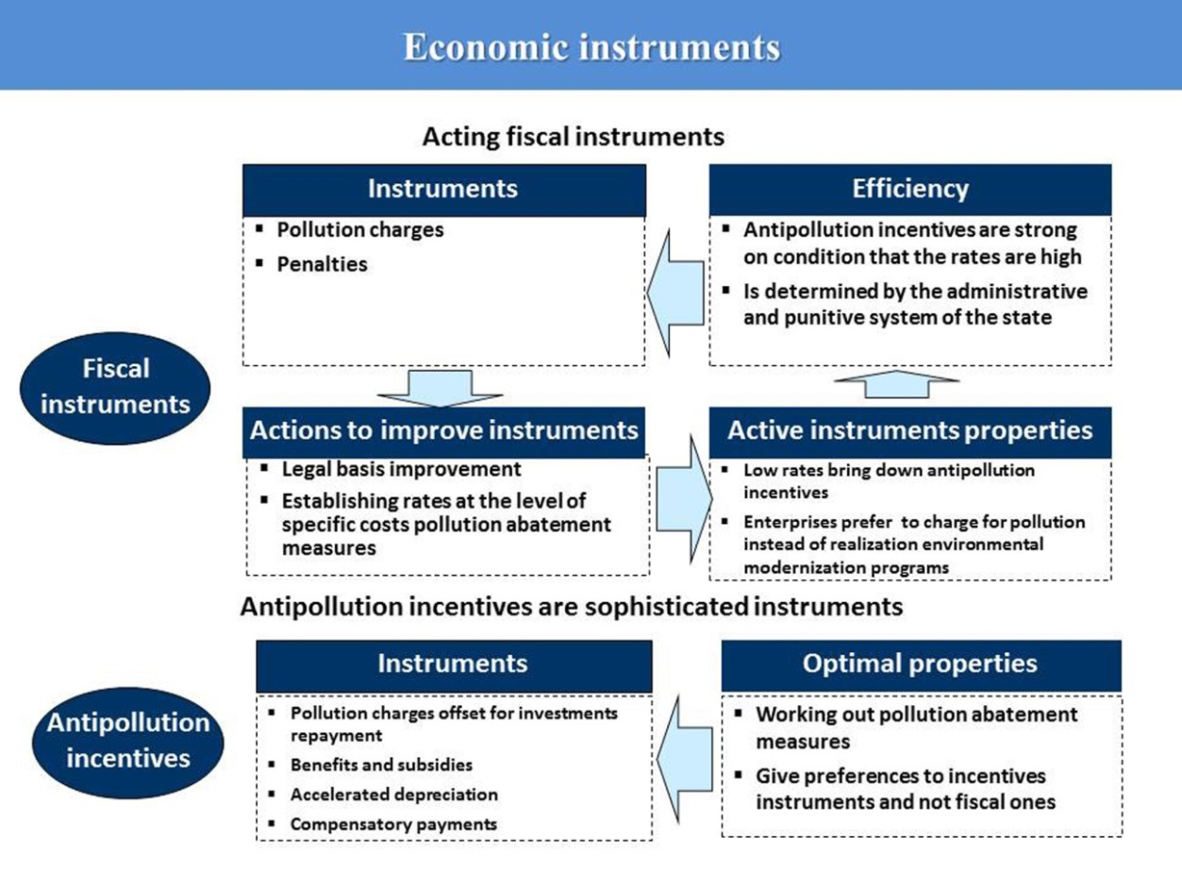
Figure 3 — Economic instruments review
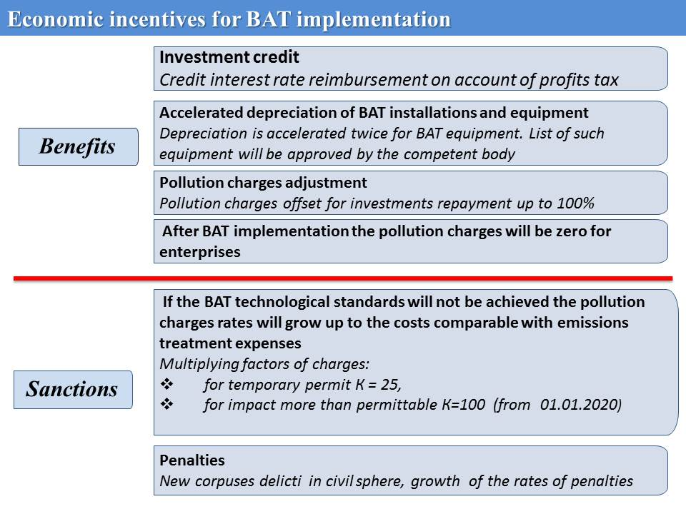
Figure 4 — Economic incentives for BAT implementation
New Russian environmental legislation provides several categories (kinds) of reporting. Annual reporting is obligatory for category A installations. The template of such reporting has not been specified yet, but it is assumed that such reports should include information on self-monitoring programme, self-monitoring data, information on environmental accidents, cases of exceeding of ELVs and information on pollution charges.
Timely presentation of such report is the pre-condition for the prolongation of Integrated Environmental Permit for category A installation for next seven year period.
These reports have to be presented annually to the federal or regional competent bodies.
If a permit was granted with a condition to implement an Environmental Performance Enhancement Programme (EPEP), an installation has to present a report on the implementation of this programme annually.
For category B installations the environmental impact notification plays a role of a report and has to be presented to the competent body only once in 7 years. It is a formal requirement established by the law. Most likely it will be changed by another legal act, and it is expected that the reports on emissions will have to be presented annually.
For category C installations there are requirements to present reports on emissions in ambient air and waste disposal.

- Time schedule for medium polluting installations to be regulated by the GBR permitting system
A transitory period shall be given also for the implementation of the GBR permitting system. Although the number of the enterprises falling under this category is unknown at this stage, the administrative burden of the transition from media based permits to GBR permit shall be smaller or in the most pessimistic scenario it shall not be any bigger than in the current system. The transitory period shall follow the development of GBR. The period needed for the development depends on the number of sectors brought under GBR system and availability of financial resources. The time schedule for the GBR development will set the basis for the time schedule for GBR permits system implementation in different sectors. Operators of the installations shall submit the applications for GBR permit within 2 years after approval of the relevant sector GBR. Furthermore, it would be practical to link the submission of a GBR permit application with the deadline for renewal of existing permit/s during the two years transitory period.
The experience of EU Members States shows that sometimes implementation of GBR requirements can take longer than 2 years, but sometimes – less.
For example, in Germany national general binding rules, developed for several industrial sectors (paper and cardboard production, textile manufacturing and finishing, etc.) have to be implemented in the installation within 4 years after their announcement. The same period is established also for BAT installations.
In Scotland, General Binding Rules have been used to address diffuse water pollution by providing a statutory baseline of good practice, focusing on specific actions, for all landowners. GBR were introduced in 2007 with timetable of implementation in 2008 for low-risk activities which fall within the following areas:
- Activities liable to have an adverse impact on the water environment, including:
  - activities linked to diffuse pollution
  - abstraction of water from the water environment
- Activities liable to impact on flood-risk
- Activities liable to have an adverse impact on soil quality
- Activities liable to have an adverse impact on biodiversity.
An important issue for permits’ management is defining of the GBR revision period. The report “Assessment of the use of general binding rules for the implementation of the IPPC Directive. European Commission – DG Environment”, prepared in 2007, has shown that most of GBR are in line with the BREF conclusions. Almost all Members States indicated that they did not specify revision procedure or revision period in the national legislation. In Austria and Spain, the authorities have recognised this issue and alerted competent authorities of new or upcoming revised BREFs. The French and Flemish GBR are reconsidered after the publication of new BAT information.
However, review processes are complex and do not ensure that the update takes place within a reasonable timeframe. For example, according to the French authorities, the GBR for the pulp and paper industry would be updated 6 years after the publication of the relevant BREF.
For those project countries that will use GBR the time lag between announcement and legal requirements of implementation can be recommended not less than 2 years. Quicker implementation like in Scotland and Welsh can be hardly recommended.

- Reporting requirements for assessment of the new environmental permitting system
The effective implementation of the environmental permitting reform can be achieved through regular reporting and review of the system’s functions and performance. To ensure this, the Ministry of Environment, which is responsible for implementation of the new permitting regime should develop a set of reporting requirements for the permitting, inspection and registering authorities. These requirements should be in line with indicators by the National Environmental Policy and any other strategic document in the field of environmental policy. At the EU level the criteria for the assessment of the IPPC implementation were listed in the EC Decision 2011/631/EU establishing a questionnaire relating to the IPPC Directive. Since IPPC is a part of the Industrial Emission Directive, the EC adopted Decision no. 2012/795/EU establishing the type, format and frequency of information to be made available by the Member States for the purposes of reporting on the implementation of Directive on industrial emissions. The example of the questionnaire contained in this decision is attached to this report as Annex 1.
The indicators or criteria of the new regulatory system effectiveness in the project countries can include the following topics:
- Evaluation of BAT application in sectors regulated by the integrated permitting system through assessment of the BAT criteria compliance based on the Annex III of the IED (e.g. pollution releases reduction waste minimization and energy efficiency enhancement at the national and sectoral levels)
- Assessment of the integrated permit applications’ quality
- Assessment of compliance with the new permit requirements
- The length of permitting procedure in case of integrated and GBR permits
- Number of appeals
- Frequency of public participation in the permitting procedure
- Quality of cooperation with concerned authorities within the integrated permitting procedure
- Cost for carrying out the integrated permitting procedure and inspection.
The regular reporting on these criteria and requirements normally gives a good overview on environmental, financial and regulatory effectiveness of the new permitting system and indicates any required changes or fine tuning the reform.
Since the project countries are just starting implementing their Integrated Permitting Systems, it is reasonable to recommend developing their national effectiveness assessment practices using the EU experience. All indicators listed above can be included into the national lists of criteria.
Possibly, at the first stage, information related to the assessment of the effectiveness could be collected along with data gathered normally during the preparation of national and regional reports on the state of environment. In this case additional positions should be included into questionnaires used by experts working on the reports. Larger polluters regulated by integrated permitting are often responsible for a very significant share of emissions (up to 60-70 % of national/regional emissions); carefully monitoring and assessing environmental performance of such organisations should help to obtain a more realistic environmental footprint at the national level.
One of the most important issues to be considered is the regulated environmental compliance enhancement. The point is that up to now in some countries effectiveness and efficiency of environmental authorities is assessed preliminarily by the quantity of non-compliance response (enforcement) measures. Compliance promotion is rarely addressed, while compliance monitoring is seldom complete. The best approach to compliance and enforcement can be described as a collaborative negotiation. Starting with the permit process, there should be continual dialogue between authorities and regulated facilities. Maintained throughout the permit cycle, this partnership should be supported by the integrated permitting system’s reporting, monitoring, and inspection regime.
It is possible to suggest that assessment of the integrated permit applications’ quality by its nature is similar to the final stage of the Environmental Impact Assessment, at which Environmental Impact reports are assessed and approvals to new industries are granted. An integrated permit is a living document – both reflecting the current performance of a facility and driving continual improvement on the part of the operator. Permit conditions that include implementation of an Environmental Management System and scrutiny of material inputs require operators on an ongoing basis to seek opportunities for performance improvement. This aspect is the core of the permit application quality, but it is not easy to assess. At the first instance, attention should be paid to environmental performance improvement objectives and plans incorporated into applications, while later on it will be reasonable to obtain more data on real achievements of facilities concerned.
Such indicators as the length of permitting procedure in case of integrated and GBR permits, number of appeals or frequency of public participation in the permitting procedure are simpler to assess, though they also require accuracy and help gathering information needed to objectively assess and evaluate administrative burden and public acceptance of the overall Integrated Permitting system.
While assessing the quality of cooperation with concerned authorities within the integrated permitting procedure, it is necessary to consider comments, responses, additional information provided by concerned authorities. Cooperation quality is also partially reflected by the length of permitting procedure.
Information on costs of carrying out the integrated permitting procedures and implementing integrated inspection activities should be collected accurately both at the national/regional and sectoral levels. It is necessary to remember that the key IPPC idea is pollution prevention and environmental performance enhancement. Integrated approach to permitting is more than just a consolidation or ‘stapling together’ of single-media permits. An integrated permit addresses each aspect of an installation’s operation that has an environmental impact, including energy, water, and raw material use. Integrated permits also address pollution prevention, multi-media or cross-media interactions, facility management and long-term effects of facility operation. This is why both the permitting procedure and integrated inspections need more attention and can be more costly that media-based regulatory practices. But this is price of real pollution prevention and environmental improvement rather than simply additional administrative costs. Besides that the UK experience proves that integrated permitting can contribute towards the overall economy modernisation and greening.
In all cases, reporting requirements, indicators and principles of the assessment of the new permitting systems should be set by the competent bodies, preferably – in the form of an official document setting the overall procedure. Step by step these requirements may well be improved, but continual improvement should allow running comparative studies – both nationally and internationally.

Annex 1. Example of Questionnaire on the implementation of Directive 2010/75/EU
General notes:
(a) The replies to this questionnaire shall cover the period from 7 January 2013 to 31 December 2013.
(b) Where a question seeks information on time-variable parameters, the response should indicate the situation as of 31 December 2013.
(c) In the replies to the questions below, information shall only be given on the changes made by Member States in order to implement the provisions of Directive 2010/75/EU mentioned in its Article 80(1).
(d) In this questionnaire, ‘Member State policy or guidance’ shall be understood as having the meaning of any existing implementation measure that is produced or applied at national, regional or local level. Should a Member State wish to include information concerning legislation that transposes Directive 2010/75/EU into national law, this would not negate the need for Member States to meet the requirements of Article 80(2) of Directive 2010/75/EU.
1. Non-compliance (Article 8)
What criteria may be used to decide whether a breach of permit conditions ‘poses an immediate danger to human health or threatens to cause an immediate significant adverse effect upon the environment’?
2. Permit conditions (Article 14)
Provide a summary of any Member State policy or guidance on the following issues and, if published on the internet, a link to where this can be found:
2.1. How is it ensured that BAT conclusions are the reference for setting permit conditions (Article 14(3))?
2.2. How may competent authorities set stricter permit conditions than those achievable by the use of the best available techniques (BAT) as described in BAT conclusions (Article 14(4))?
3. Emission limit values, equivalent parameters and technical measures (Article 15)
Provide a summary of any Member State policy or guidance on the following issues and, if published on the internet, a link to where this can be found:
3.1. How are emission limit values set in relation to the ‘emission levels associated with the best available techniques’ set out in the BAT conclusions (Article 15(3))?
3.2. How are derogations from Article 15(3) granted (Article 15(4))?
3.3. How is the cost-benefit assessment to allow such derogations undertaken and what are considered to be ‘disproportionately higher costs compared to the environmental benefits’? (Article 15(4))?
3.4. Are there any limitations on the magnitude or duration of derogations (Article 15(4))?
3.5. How are temporary derogations granted, from the requirements of Article 11(a) and (b) and from Article 15(2) and (3), for the testing and use of emerging techniques (Article 15(5))?
4. Monitoring requirements (Article 16)
Provide a summary of any Member State policy or guidance on the following issues and, if published on the internet, a link to where this can be found:
4.1. How is it ensured that the BAT conclusions are the basis for defining monitoring requirements in permits (Article 16(1))?
4.2. How is the frequency of periodic monitoring for soil and groundwater determined (Article 16(2))?
4.3. How is a ‘systematic appraisal of risk of contamination’ used to justify the monitoring of soil and groundwater at less than the stipulated frequency (Article 16(2))?
5. General Binding Rules (Article 17)
Where general binding rules are used for implementing Directive 2010/75/EU:
5.1. Which requirements, activities (as listed in Annex I to Directive 2010/75/EU) and pollutants do the general binding rules cover?
5.2. How do general binding rules ‘ensure an integrated approach and a high level of environmental protection equivalent to that achievable with individual permit conditions’ (Article 17(1))?
5.3. How is it ensured that general binding rules are ‘based on the BAT’ (Article 17(2))?
5.4. How are general binding rules ‘updated to take into account developments in BAT’ (Article 17(3))?
5.5. What references are made to Directive 2010/75/EU in the ‘official publication’ of general binding rules (Article 17(4))?
5.6. If the general binding rules are published on the internet, provide a link to where they can be found.
6. Developments in BAT (Article 19)
6.1. How do competent authorities follow, or are informed of, the publication of any new or updated BAT conclusions?
6.2. How do competent authorities make that information available to the public concerned?
7. Reconsideration and updating of permits (Article 21)
Provide a summary of any Member State policy or guidance on the following aspects of the process for reconsidering and updating permit conditions and, if published on the internet, provide a link:
7.1. What information is typically requested from operators for the purposes of permit reconsideration/updating (Article 21(2))?
7.2. How is the ‘main activity’ of an installation defined and/or determined (Article 21(3))?
7.3. How is the permit reconsideration/update triggered in cases of significant pollution, operational safety, or a new/revised environmental quality standard (Article 21(5))?
8. Site closure (Article 22)
8.1. How is it decided which activities require a baseline report, especially?
(a) Which activities listed in Annex I to Directive 2010/75/EU have typically been found to involve the ‘use, production or release of relevant hazardous substances’ (Article 22(2))?
(b) How is regard given to the ‘possibility of soil and groundwater contamination at the site of the installation’ (Article 22(2))?
(c) What information are operators required to include in baseline reports (Article 22(2))?
(d) How has the Commission’s guidance on ‘the content of the baseline report’ been used in this context (Article 22(2))?
8.2. Upon the definitive cessation of activities:
(a) How do operators ‘assess the state of soil and groundwater contamination’ (Article 22(3))?
(b) How is it decided whether an installation has caused ‘significant pollution of soil or groundwater’ (Article 22(3))?
(c) How is it decided whether any contamination of soil or groundwater ‘poses a significant risk to human health or the environment’ (Article 22(3))?
(d) How is it decided what necessary ‘measures’ or ‘actions’ are required of operators (Article 22(3) and (4))?

9. Environmental inspections (Article 23)
9.1. What ‘environmental inspection plans’ have been drawn up? What do they contain? Where are they publicly available? If published on the internet, provide a link (Article 23(2))?
9.2. What ‘programmes for routine environmental inspections’ have been drawn up? What do they contain? Where are they publicly available? If published on the internet, provide a link. (Article 23(4))?
9.3. How are the environmental risks of installations ‘systematically appraised’ for the purposes of deciding the site visit frequency? Provide a summary and reference to any relevant guidance. (Article 23(4))?
9.4. Under what circumstances are ‘non-routine environmental inspections’ carried out (Article 23(5))?
9.5. What information do the site visit reports typically contain? How are these reports notified to the operator? How are they made publicly available? Are there any circumstances under which such reports have not been made publicly available, considering the provisions of Directive 2003/4/EC on public access to environmental information and repealing Directive 90/313/EEC (1) (Article 23(6))?
9.6. What mechanisms exist for ensuring that operators complete the ‘necessary actions’ identified in the site visit report (Article 23(6))?
10. Access to information and public participation (Article 24)
10.1. How is the public given ‘early and effective opportunity’ to participate in decision making on the granting/updating of permit conditions, especially where derogations under Article 15(4) are proposed (Article 24(1))?
10.2. How is information made available to the public (Article 24(2) and (3))?
10.3. Is all relevant information made available on the internet (Article 24(2)(a),(b) and (f) and Article 24(3)(a))?
11. Emerging techniques (Article 27)
How do Member States encourage the development and application of emerging techniques, in particular those identified in BAT reference documents (Article 27(1))?

Guiding Principles of Effective Environmental Permitting Systems. OECD, 2007 http://www.oecd.org/environment/outreach/37311624.pdf
Approach to the Introduction of Integrated Environmental Permitting in Ukraine: Case Study. OECD, 2005
Based on the prioritization criteria specified in Chapter VI of the OECD Permitting Guidelines
https://www.vito.be/Lists/ScientificOutput/Attachments/2235/51353831.PDF
An In-depth Look at the United Kingdom Integrated Permitting System. Exploring Global Environmental Protection Perspectives EPA-100-K-08-003 July 2008 http://www.epa.gov/environmentalinnovation/integrated/pdf/IntPermittingRpt.pdf
See Annex I of Commission Implementing Decision of 12 December 2012 establishing the type, format and frequency of information to be made available by the Member States for the purposes of reporting on the implementation of Directive 2010/75/EU of the European Parliament and of the Council on industrial emissions(notified under document (2012/795/EU) http://eur-lex.europa.eu/LexUriServ/LexUriServ.do?uri=OJ:L:2012:349:0057:0065:EN:PDF

