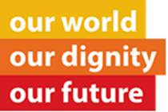
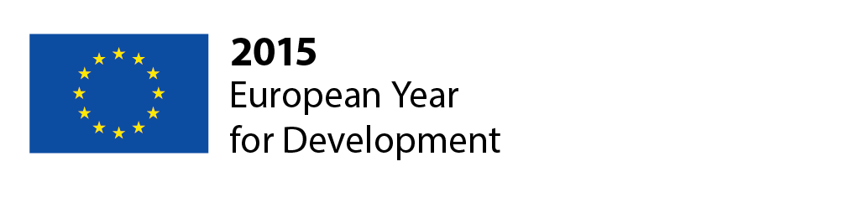

Programme Enlarged Stakeholder Meeting
Brussels, 9 December 2014

8.30 Arrival of participants

9.00 General welcome
Klaus Rudischhauser, Deputy Director General, DG Development and Cooperation - EuropeAid, European Commission

9.15 The Narrative Project – Building public support for global development
Julian Lambertin, Head of Strategy & Analytics at Weber-Shandwick

10.00 Food and Agriculture Organization of the United Nations (FAO)
Maarten Roest, Communications coordinator, Liaison Office with the European Union and Belgium

10.20 Confederation for Cooperation of Relief and Development NGOs (CONCORD)
Seamus Jeffreson, Director

10.40 Committee of the Regions (CoR)
Bernard Chane Kune, Administrator
Tom De Smedt, Administrator

10.50 European Economic and Social Committee (EESC)
Andris Gobiņš, Member of the European Economic and Social Committee

11.00 Private Sector Representative
Christine Bosse, Advocate for the Millennium Development Goals by the UN Secretary General

11.20 Coffee Break

11.40 EYD2015 what’s next?
Stina Soewarta, Head of Unit 05 Communication and Transparency DG Development and Cooperation - EuropeAid, European Commission
Dörte Bosse, Team Leader EYD Unit 05 Communication and Transparency, DG Development and Cooperation - EuropeAid, European Commission

12.00 Communication Campaign: Promoting the EYD 2015
Yasmin Love, Account Director Media Consulta

12.20 Q&A

12.45 Lunch Break

13.30 European Parliament
Charles Goerens, Member of the European Parliament

13.40 EYD2015: An EU corporate communication campaign
Directorate-General of Communication

14.00 United Nations Regional Information Centre (UNRIC)
Caroline Petit, Brussels Deputy Director

14.05 Q&A

14.30 Wrap-up

15.00 Coffee Break

15.15 Optional programme
- Speed networking sessions fostering synergies between stakeholders
- Training EYD WEB
- Training EYD Social Media
- Training Information – Evaluation session – Measuring the success of the EYD 2015 campaign

16.45 End of optional programme

