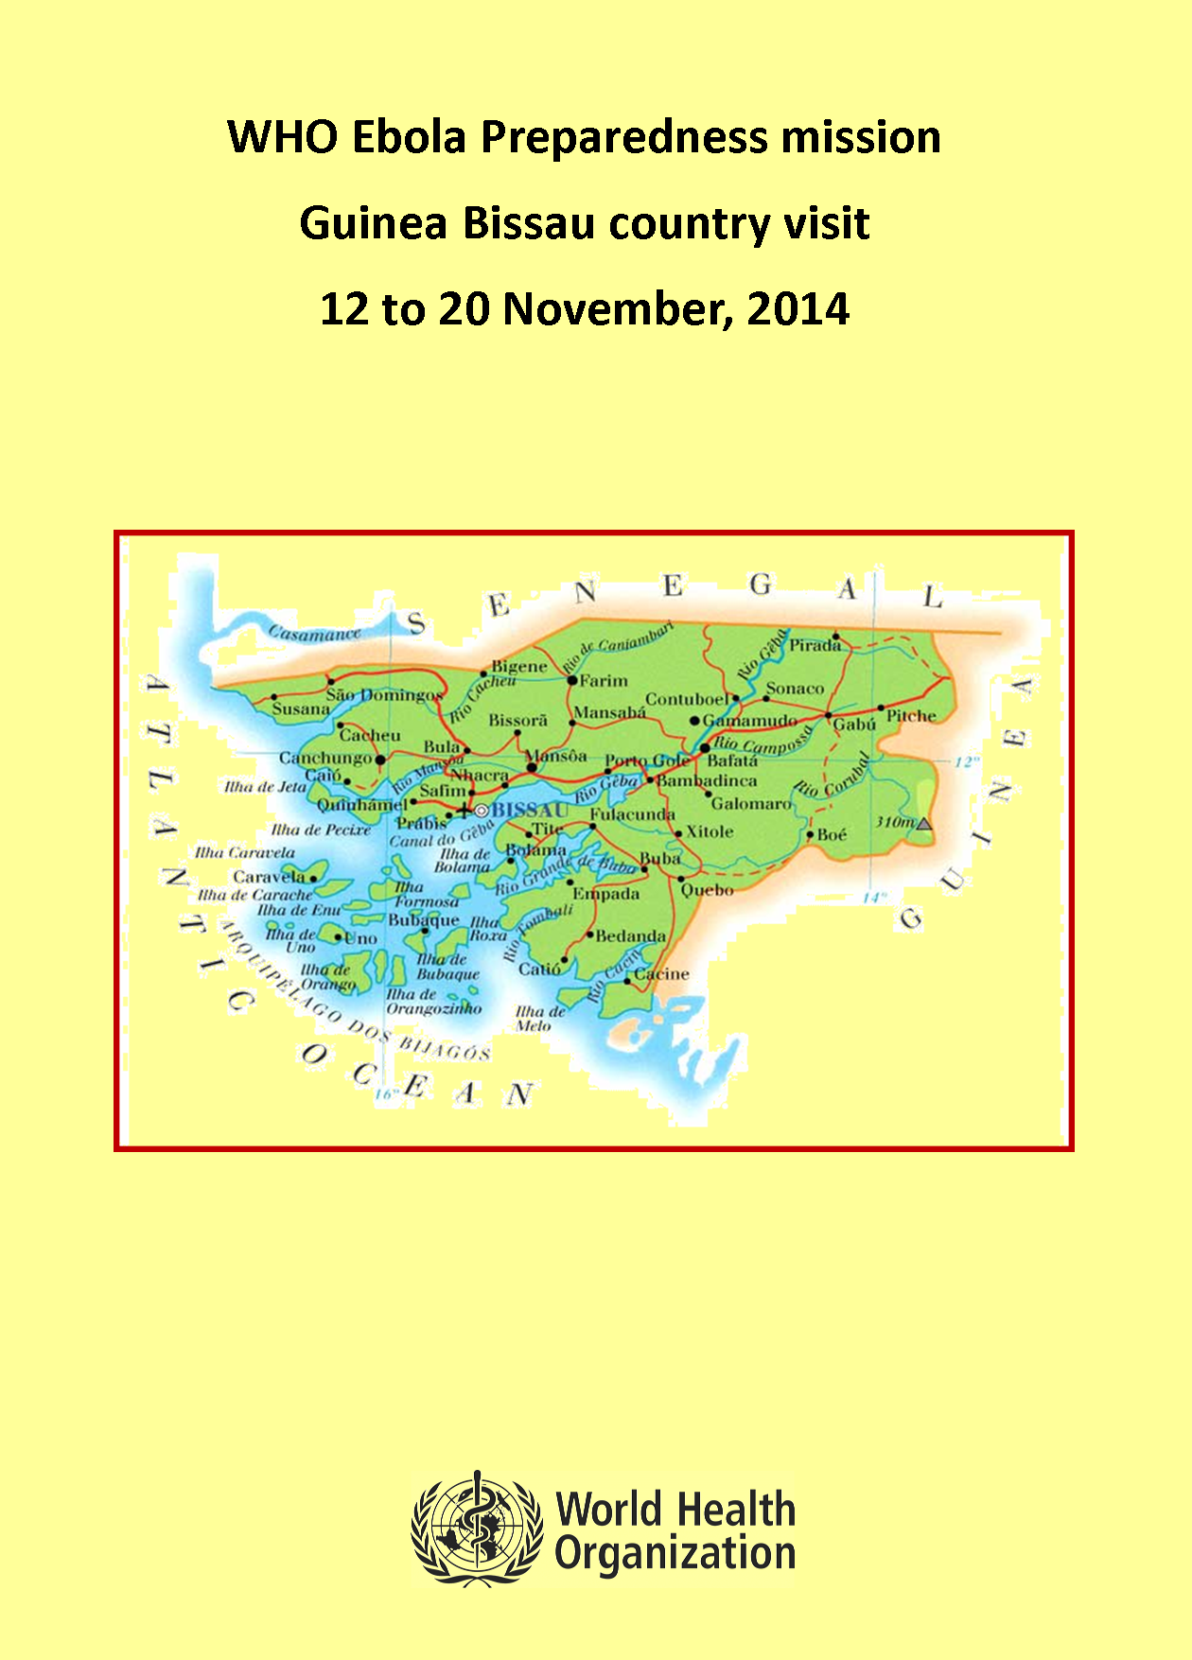
Contents

Contents ………………………………………………………………………………………..………………………..... Page 2
Executive Summary …………………………………………………………………………………..…………....... Page 3
Introduction ……………………………………………………………………………………………………..….….... Page 5
WHO Missions to assess countries’ preparedness for an Ebola outbreak …………...…….. Page 6
Guinea Bissau - Objectives of this mission ……………………………………………………………...... Page 7
Overview……………………………………………………………………………………………………………......... Page 9
Screening at the airport ………………………………………………………………………………………....... Page 10
Discussion of the Consolidated Checklist ……………………………………………………………........ Page 11
Table Top Exercise (TTX) ……………………………………………………………………………….………..... Page 12
Main Findings …………………………………………………………………………………..…………..……........ Page 13
Identified Priorities. ………………………………………………………………………………………….…....... Page 15
Checklist Components in Graphics ………………………………..……………………………………........ Page 17
Photos ………………………………………………………………………………………………………..………........ Page 18
Annex 1: Discussion of the Consolidated Checklist per group ………….…………….............. Page 20
Annex 2: Capacity Building Training Programme ………….……………................................... Page 43
Annex 3: Estrutura de Comando de Incidentes e Comité de Gestão de Emergências …. Page 44
Annex 4: National Preparedness Plan (in French) ………….……………................................... Page 45
Summary of Budget ………….……………................................................................................ Page 50
Executive Summary
The Republic of Guinea-Bissau is a small country with an area of 36.125 km² and a population of 1.664.000 inhabitants on the west coast of Africa. (World Health Statistics, 2014).
The country has borders to the north with the Republic of Senegal, to the east and south with the Republic of Guinea and the Atlantic Ocean to the west.
Guinea-Bissau has suffered several outbreaks of infectious diseases in the past, including: cholera, measles and meningitis. Sporadic human and animal cases of anthrax were reported during the past 10 years. Malaria, tuberculosis and cholera are the main health concerns. In 2010, there were reported cases of avian influenza in the Biombo region.
The country has never experienced an outbreak of Ebola Virus Disease but due to its vicinity to Guinea and the mobility of people, the Ministry of Public Health in collaboration with cooperation partners launched in February 2014, a contingency plan for the prevention and response to a possible outbreak of Ebola in the country.
The Ministry of Public Health has also created an Emergency Task Force Committee to develop strategies for the preparation of an emergency plan for a possible Ebola outbreak. This committee meets every week to assess the situation with partners and to discuss next steps.
All regional health authorities are on alert to identify suspected cases of the disease, identify isolation sites if needed, and the regional officers have surveyed the stocks of medications and available resources.
All partners are mobilized and are ready to work on the prevention and response in face of a possible Ebola outbreak.
Prime Minister appointed a High Commissioner to Coordinate the Ebola Response and to be the political liaison between all Ministries and most of all to supervise donor funds.
Country has engaged in social mobilization campaigns in the radio, TV and newspapers to raise awareness of the population about the risks of the EVD with the support from UNICEF.
The airport is performing entry screening of all passengers arriving through the international terminal, and there are several points in the city to implement hand hygiene with chlorinated water or alcohol based hand rub distributed in public places (hotels, restaurants, WHO Country Office, public buildings).
Considering that the main objective of this mission was to use a Consolidated Checklist for Ebola Virus Disease Preparedness, the team met for the first time at WHO Country Office in Bissau to discuss with the WR Kossi Akla Ayigan and his team, the objectives and expected results of the visit.
The main concern for Guinea Bissau, at the moment, is the lack of laboratory capability to perform a diagnosis for Ebola virus.
The National Laboratory of Public Health (LNSP) does not have the required biosafety/biosecurity level or human or structural resources to perform an Ebola diagnosis. Guinea Bissau has not yet established a formal agreement with the Institute Pasteur in Dakar for laboratory diagnosis of Ebola, and has not identified carriers that could transport the samples by air and is still exploring the possibilities to transport samples by road.
On the other hand, MSF has renovated an entire ward at the National Hospital to be the Ebola Treatment Centre, as needed and has trained six medical doctor and 2 nurse technicians for the Rapid Response Team.
In summary, although Guinea Bissau struggles with a fragile health system, the country has already implemented a number of Ebola preparedness related activities during the last 10 months.
Partners are very active in the country and supporting the Ministry of Health in its efforts.
The main constraints are:
- Lab diagnosis. Taking into consideration that the Institute Pasteur in Dakar is, for the moment, the best option for Ebola laboratory diagnosis; it is critical to establish a formal agreement between the Ministry of Health of Guinea Bissau through the National Institute of Health (INASA) and the Institute Pasteur in Dakar.
- Identify a route for transportation of samples. Authorities need to urgently identify the most timely and safe route (by air or by road) for transportation of samples for testing in Dakar.
- Training for gravediggers for safe and dignified burials.
- Training and development of social communication in border areas.
- Define roles and responsibilities among Ministry of Health, UN agencies and partners.
- Monitor all actions already in place.
Introduction

The Republic of Guinea-Bissau is a small country with an area of 36.125 km² and a population of 1.664.000 inhabitants on the west coast of Africa. (World Health Statistics, 2014). According to the Human Development Index (UNDP, 2013), Guinea Bissau is ranked at 177th place among 187 countries.
The country has borders to the north with the Republic of Senegal, to the east and south with the Republic of Guinea and the Atlantic Ocean to the west. Guinea Bissau is a member of the African Union (AU), United Nations (UN), Economic Community of West African States (ECOWAS), West African Economic and Monetary Union (UEMOA), Organisation of Islamic Cooperation (OIC), Community of Sahel-Saharan States (CEN-SAD) and the Community of Portuguese-speaking Countries (CPLP).
From an administrative point of view, Guinea-Bissau is divided into 8 regions: Bafatá, Biombo, Bolama-Bijagos, Cacheu, Gabu, Oio and Tombali Quínara. The regions are divided into 36 sectors plus an autonomous sector (Capital city of Bissau).
The health sector is divided into 11 health regions, including Bissau and these 11 health regions are divided into 114 health zones, the closest level to the communities. However over 40% of the population still lives 5 km away from the nearest primary health care facility.
Guinea Bissau has five main ethnic groups and more than 20 native languages but Portuguese is the only official language. 45% of the population lives in urban areas and between 50 to 80% of the population proclaims to be muslin. 42% of the population is less than 15 years old and life expectancy for men is 53, for women is 56 and 55% of the population is literate. (World Health Statistics, 2014). 2.8% of the population has access to the internet and there are 63 cells per 100 people.
Guinea-Bissau has suffered several outbreaks of infectious diseases in the past, including cholera, measles and meningitis. Sporadic human and animal cases of Anthrax were reported during the past 10 years. Malaria, tuberculosis and cholera are the main health concerns.
According to the information provided in their contingency plan, in 2010, there were reported cases of influenza A (H1N1) in the Biombo region (page 48).
The country has never experienced an outbreak of Ebola Virus Disease, however because of its vicinity to Guinea and the mobility of people, the Ministry of Public Health in collaboration with national stakeholders and international partners launched in February 2014, a contingency plan for the prevention and response to a possible outbreak of Ebola in the country.
The Ministry of Public Health has also created an Emergency Task Force with partners to develop strategies for preparation of an emergency plan for a possible Ebola outbreak.
All regional health authorities are on alert to identify suspected cases of the disease, identify isolation sites if needed, and the regional officers have surveyed the stocks of medications and available resources.
All partners are mobilized and are ready to work on the prevention and response in face of a possible Ebola outbreak.
WHO Missions to assess countries’ preparedness for an Ebola outbreak

In October 2014, WHO developed a “Consolidated Ebola Virus Disease Preparedness Checklist” considering the unprecedented scale of the Ebola virus disease (EVD) in West Africa. WHO has identified 4 groups of countries to facilitate more effective implementation of preparedness actions.
1. Guinea Bissau, Mali, Senegal and Cote d’Ivoire because they directly border currently affected countries.
2. Benin, Burkina Faso, Cameroon, Central African Republic, Democratic Republic of Congo, Gambia, Ghana, Mauritania, Nigeria, Togo and South Sudan were also considered for various reasons.
3. All other countries in Africa.
4. Countries in other regions.
It is considered that with adequate levels of preparation, any cases entering one of these countries can be contained before they develop into large outbreaks.
WHO is coordinating the deployment of international Preparedness Strengthening Teams (PST) to help unaffected countries build upon their existing preparedness work and planning. The PST visits will support countries in developing their operational readiness for EVD to the greatest degree possible. The PST will be part of a larger group of activities to prepare all countries for the potential introduction of EVD.

Guinea Bissau - Team Members of the mission

- Regina Ungerer (Team Lead, ePORTUGUESe Programme), WHO Headquarters, Switzerland
- Ana Paula Coutinho Rehse (Team Lead and Infection Prevention and Control), WHO Regional Office for Europe (EURO), Denmark
- Yacoub Ahmedou, WHO Regional Office for Africa (AFRO), Republic of Congo
- Abdou Moha, WHO AFRO/WHO Country Office Mozambique
- Manuela Gonzalez, United Nations Office for the Coordination of Humanitarian Affairs (OCHA), Senegal
- Paulo Campos, National Institute of Medical Emergencies of Portugal, (Rapid Response Team), Portugal
- Rodolfo Soares, Anthropologist, (Safe burials), Portugal
- Renata Rodrigues Santos, Psychologist, (Social mobilization), Brazil
- Igor Damiani, Molecular biologist, (Laboratory), Brazil
- Jessica Marcinkevage, Epidemiologist Centers for Disease Control and Prevention (CDC), United States of America
- Amelia Maria Kasper, Epidemiologist, Centers for Disease Control and Prevention (CDC), United States of America
Objectives of this mission

The main objective of this mission was to assess the level of preparedness of Guinea Bissau using the WHO Consolidated Checklist for Ebola Virus Disease Preparedness. The checklist is instrumental to help countries to assess and test their level of readiness, and it is being used as a tool for identifying concrete action to be taken, and how countries will be supported by the partners to close potentially existing gaps.
The Consolidated Checklist for Ebola Virus Disease Preparedness was developed and based on efforts by various national and international institutions, including WHO, CDC and UNOCHA.
It identifies 10 key components and tasks for both countries and the international community that should be completed within 30 days, 60 and 90 days respectively from the date of issuing this list. There is a minimal requirement of equipment and material as well as human resources.
There are key reference documents such as guidelines, training manuals and guidance notes to help the technical experts to implement the required action in each key components.

Key components are:
Component | What this component is about | Why this needs to be in place and ready
Overall coordination | These are all efforts to clarify roles and responsibilities of national authorities and international partners in preparedness activities under a shared set of objectives. | This will allow to minimise duplication of efforts and ensure maximum impact from limited resources that are currently available.
Rapid Response Team (RRT) | RRT is a group of experienced experts that are on stand-by and can reach any part of the country within 24 hours. Their actions will help to contain/stop an outbreak early on. They will investigate the first case(s), support epidemiologic surveillance and contact tracing, provide health care, engage with the community and carry out infection, prevention and control measures. | As countries will not know exactly in which geographical area a first case will emerge, a fully operational RRT is critical to be able to act immediately once a suspicious case is reported. They will act as an initial stabilising resource in the earliest phase of the outbreak.
Public awareness and community engagement | These are efforts to promote the understanding of at risk communities on Ebola and address any stigma hampering EVD emergency healthcare and effective surveillance. Instead, the community has a crucial role in the alert. | In currently affected countries, health centres have been attacked as people were highly afraid and false rumours about the disease spread.
Infection Prevention and Control | This is to develop optimum IPC capacity and support facilities to ensure safe working conditions within healthcare facilities and Public awareness and community engagement. | The ongoing epidemic in West Africa have caused considerable fatality of healthcare workers (average rate of infections 5-6%). IPC and safe working conditions are critical components to deliver emergency healthcare.
Case management  a) Ebola Treatment Centre (ETC) | These are all efforts to develop or repurpose an existing facility as EVD ETC to treat 15 patients and have them fully operational. It includes the physical infrastructure as well as the capacities of staff to manage EVD cases. | The lack of functional ETCs in the beginning of an outbreak can lead to a small outbreak getting out of control. Therefore, having at least one fully operational ETC facility before a first case occurs is important to contain an outbreak early on.
Case management  b) Safe burials | These are efforts to ensure safe burial with due regard to local custom and religion while safe handling of deceased is necessary to prevent wider transmission to communities. | Unsafe burial of Ebola victims has caused considerable community infection during burial ceremonies and is one of the main risk factors.
Epidemiological Surveillance | This is a country wide effective alerting/notification system to immediately investigate potential EVD cases. | The key to success in controlling EVD is largely dependent on timely and accurate community based surveillance.
Contact Tracing | These are all efforts that need to be in place to identify and track the chain of transmission within the first 72 hours of reporting a confirmed/probable/suspected case. | Rapid contact tracing and immediate monitoring is essential to stop/limit the transmission to other people. .
Laboratory | These are all efforts to ensure that samples are safely taken and transported to laboratories which are ready to swiftly analyse them. | Rapid confirmation of cases is crucial to contain an outbreak, trace contacts and provide emergency healthcare.
Capacities at Points of Entry | Efforts to get Points of Entry ready to deal with an Ebola case crossing the border. This includes the preparation of facilities as well as increasing staff capacity. | An effective targeted screening at Point of Entries will help to prevent cross border transportation of infections.

Overview

It was a week-long mission to assess the level of preparedness of Guinea Bissau in case Ebola Virus Disease is diagnosed in the country.
The team met for the first time at WHO Country Office in Bissau to discuss with the Dr Kossi Akla Ayigan (WHO Representative in Guinea Bissau), and his team, the objectives and expected results of the mission. They were all very keen to host the mission as they are faced with the responsibility to lead the Ebola response in additional to their core functions at country level.

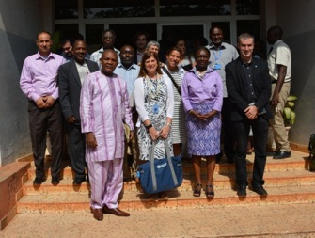  WR Aygan Kossi Akla and Minister of Health, Dr Valentina Mendes | According to the WR, the country needs support to meet the expectations for Ebola preparedness, and this mission should be an opportunity for strengthening their preparedness not only for Ebola but to build capacity and strengthen the health system to deal with this and other possible outbreaks.  Nevertheless, a contingency plan has been developed since February 2014, and is being adapted accordingly.  Minister of Health has created a Task Force Committee that meets every week to assess the situation and to discuss next steps.  Prime Minister appointed a High Commissioner to Coordinate Ebola Response and to be the political liaison between all Ministries and most of all to supervise donor funds.  A number of awareness campaigns about Ebola prevention and control are being broadcast on the radio, TV and newspapers.  The airport is performing temperature screening of all passengers.
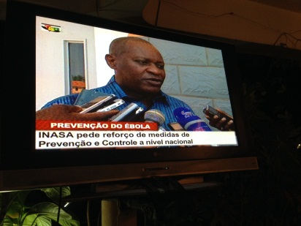
President of the National Institute of Health, Dr Plácido Cardoso

Screening at the airport

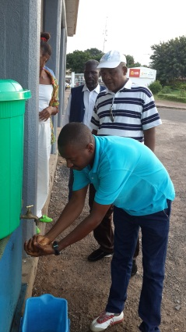  Hand washing with chlorinated water | 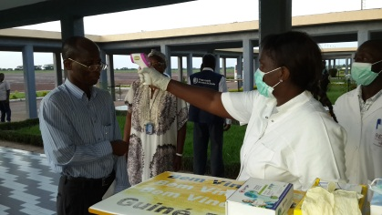 | 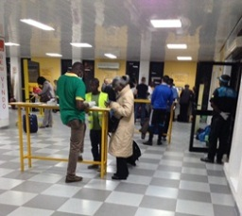  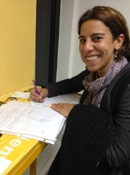 | 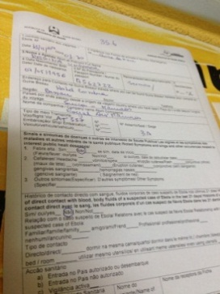  Surveillance form
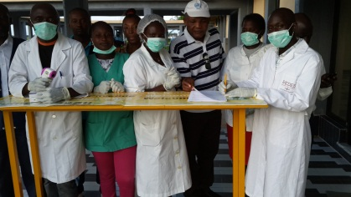
Temperature checking
At the airport, before entering the terminal, every passenger has to clean their hand with chlorinated water and undertake an electronic temperature check as well as fill up a form that is then sent to the surveillance team at the National Institute of Public Health (INASA).
It should be highlighted that there are several points for hand hygiene with chlorinated water or alcohol based hand rub in public places (hotels, restaurants, WHO Country Office, public buildings).
The team had the opportunity to meet several times with partners and other Organizations already working in the country, to understand their roles and responsibilities and how are they supporting the Ministry of Health in their Ebola preparedness.
During the meeting with the UN Resident Coordinator,  Dr Maria do Valle Ribeiro and the other UN agencies working in Guinea Bissau (UNICEF, UNHCR (UN Refugee Agency), UNFPA (UN Population Fund), OCHA (Office for the Coordination of Humanitarian Affairs), UNIOGBIS (Integrated Peace-Building Office in Guinea Bissau), CDC (Centers for Disease Control and Prevention), EU (European Union), among others, the UN Resident Coordinator highlighted that there is an inter-ministerial meeting every week with the Prime Minister, UN agencies, partners and foreign missions to discuss latest developments, news and designate roles. | 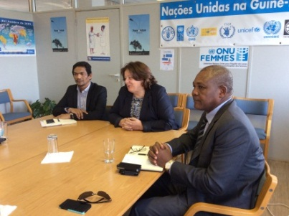  Unicef Representative, UN Resident Coodinator and WHO Representative  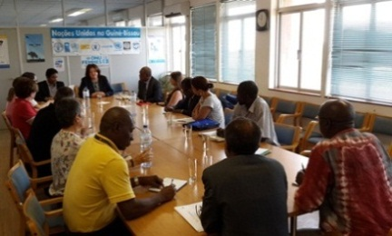
Discussion of the Consolidated Checklist

Coordinated by WHO, the checklist was extensively discussed with Ministry of Health, National Institute of Health (INASA), partners and members of the mission.
Participants were selected into four groups according to their expertise.
The results were presented to the Ministry of Health and UN sister organizations and it is expected to be a document to support implementation actions by the Ministry of Health and partners in 30 days, 60, 90 days and beyond.
Details can be seen in Annex 1, page 20.

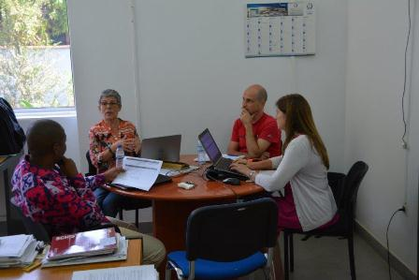  Coordination group | 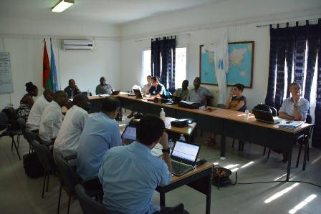  RRT, epidemiological surveillance, laboratory group
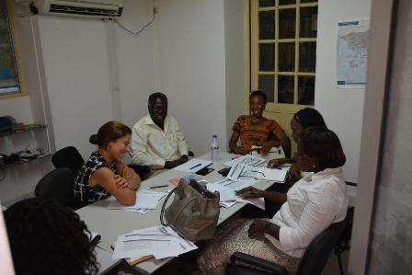  Cases management, points of entry,  infection control group | 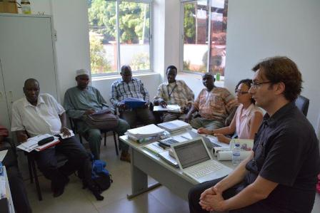  Public awareness and community engagement,  burials safe and dignified group

Table Top Exercise (TTX)

The EVD Table-Top Exercise (TTX) is a simulation package which uses a progressive scenario to enable participants to consider the potential impact of an outbreak in terms of existing plans, procedures and capacities.
The aim of the TTX is to strengthen national levels of readiness against the virus through a series of facilitated group discussions. The key outcomes are to identify gaps and therefore strengthen preparedness. It is not a test of country’s preparedness.
The objectives of the EVD TTX simulation were to:
- Share information on the progress of the preparation and response measures against Ebola
- Identify areas of interdependence between health professionals and their interaction with other sectors
- Identify lines of accountability as well as roles and responsibilities
- Review the operation management process for a suspected Ebola case
- Make sure that arrangements for notification, coordination and internal communications are in place before and after the confirmation of an Ebola case
- Validate aspects related to personal protection and other logistical needs (disinfection, burial, etc...) and the management of suspected cases of contamination before and after laboratory confirmation
- Review the requirements of public health laboratories, coordination, funding
- Review public and media communications and strengthen team building for managing an emergency response
This exercise should benefit wider national preparedness measures as a whole, not only for Ebola.

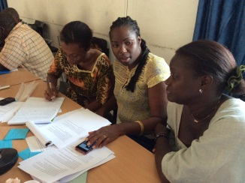 | 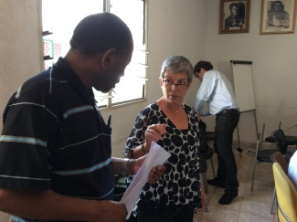
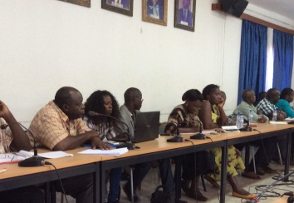 | 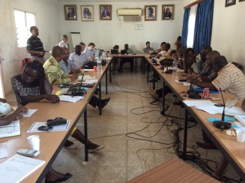
Main Findings

Area | Mission main findings
Overall coordination | - Since February, the country has a contingency plan for EVD.  - Ministry of Health has created a Technical Task Force Group to coordinate the Ebola Preparedness for the country.  - The former emergency and epidemiological committee became the Technical Task Force Group.  - Prime Minister has appointed a High Commissioner for Ebola to politically coordinate the action among all the Ministries and to supervise donor funds.  - INASA is the focal point for IHR.  - INASA can be the Emergency Operational Centre working 14/7. It needs only to organize with the staff.
Rapid Response Team (RRT) | - MSF has provided training for six medical doctors and two nurses technicians for Rapid Response Team (RRT).
Public awareness and community engagement | - A number of awareness campaigns about Ebola prevention and control are being broadcast on the radio, TV and newspapers.  - Religious and community leaders to be involved in the awareness.  - UNICEF has been responsible for the public social mobilization. It has sponsored local artists and shows to raise awareness for the disease.
Infection Prevention and Control | - Numerous hand hygiene points are available at most public places
Case management  a) Ebola Treatment Centre (ETC) | - MSF renovated a ward at the National Hospital to be used as an ETC (Ebola Treatment Centre). Key structural aspects like electricity and hospital bed were not available on the day of the visit. MSF is quite confident that the ECT can be activated anytime if need be.  - New incinerator and autoclave are available, however still need to be installed.  - The same 8 health professionals trained by MSF will be responsible for the ETC.  - Sufficient quantities of Personal Protective Equipment (PPE) are available at the Hospital, WHO Country Office, MSF Office, Ministry of Health.  - 5000 kits were donated by WHO during the Influenza Pandemic 2009. These kits were distributed to the 11 health districts and leading stakeholders, such as: National Hospital, INASA. UNICEF has helped the distribution to risk areas (Gabu, Tombali and Quinara).
Case management  b) Safe burials | - None of the key activities to ensure safe burials had been initiated.
Epidemiological Surveillance | - 2 hotlines for information and notification are available 24 hours (Orange and MTN providers).  - National Institute of Health (INASA) has also a line for notification but only operational during working hours (Monday to Friday from 08.00 to 17.00).  - Hotline operators need to be trained.
Contact Tracing | - As of 19 November 2014, a total of 16 rumours were reported and assessed by national authorities and MSF.  - 8 out 16 fulfilled the criteria of a case under investigation (travellers from Guinea with a variety of symptoms).  - Some of those cases under investigation were quarantined or isolated.  - None of those cases had clinical specimens collected for further EVD test.  - All cases under investigation were discharged based on clinical judgments (1 case had a laboratory confirmation of malaria infection, one gastric ulcer with vomit and blood, and one case with fever had a miscarriage).
Laboratory | - As of 19 November Guinea Bissau did not have local capacity to perform diagnosis of Ebola virus disease.  - During the mission, we learnt that the National Public Health Laboratory (LNSP) in Guinea Bissau had not yet formalized any agreement with Institute Pasteur in Dakar for EVD diagnosis.  - Agreements between the Public Health Laboratory and Institute Pasteur in Dakar for laboratory confirmation of cholera and polio virus are in place.  - The situation is known by concerned health authorities and partners on site.  - On 3 December, 2014, the President of INASA contacted the Institute Pasteur in Dakar to discuss the possibility to send samples of suspected cases.  - There is also an offer from Lyon to perform diagnose, if needed.  - The National Laboratory of Public Health (LNSP) is not equipped to perform an Ebola diagnosis. It is necessary to train technician and improve structural conditions of the laboratory including purchasing of reagents.  - Portugal has offered to support the training of one lab technician in a course for shipment of biological samples begun on 24th November (details of the course please see annex 2, page 43).  - Shipment of EVD samples by air are not guaranteed by local air carriers.  - During the time of the mission, national authorities were exploring options to transport the sample by road, which takes around 12 to 15 hours’ drive.  - Agreements and clearance with border authorities from both Senegal and Guinea Bissau still need to be discussed.  - After the end of the mission, CDC has located a chartered flight that accepted to transport an Ebola sample from Bissau to Dakar, if needed. It will costs around US$ 3,000. Ministry of Health and INASA need to explore this option.  - WHO Country Office has supported the renovation of 2 vehicles for transport of samples. WHO Country office is also securing financial resources for fuel and perdiens of the drivers, if needed.  - There are 4 X 4 vehicles available in case of a Ebola case. One at the Ministry of Health, one at INASA (recovered by WHO); one at the border with Guinea one with MSF.
Capacities at Points of Entry | - 48 ground borders with Guinea were closed in early August 2014, following the advice of the Prime Minister of Guinea Bissau. It was reported that local communities living near the border are suffering financial and social disruption since then.  - At the airport, before entering the terminal, every passenger has to perform hand washing with chlorinated water solution, has their body temperature measured with infrared scan and has to fill in a surveillance form for travellers. The results of the body temperature and the surveillance form are evaluated on site and then sent to the surveillance team at the National Institute of Public Health (INASA).  - Minister of Health informed that they have made the decision to open one humanitarian and one commercial corridor however no specific dates have been set.

Identified Priorities

Area | Identified priorities
Overall coordination | - Define responsibilities (government, partners, UN agencies, NGOs, Civil Society) - ASAP  - Establish clear protocols to receive international aid, and make sure that strategies are in place and coordinated by the Government, UN agencies, donors, NGOs, etc.  - It is necessary to strengthen the relationship between the Government and partners, so everyone knows their roles and responsibilities.
Rapid Response Team (RRT) | - Full implementation of the key tasks of the preparedness checklist
Public awareness and community engagement | - Ensure that all messages to the community are clear and validated by the Ministry of Health to avoid misconceptions and misunderstandings.  - Strengthen and develop social communication especially in border areas.  - Strengthen communication strategies between civil society, religious leaders, traditional healers and Government.
Infection Prevention and Control | - Full implementation of the key tasks of the preparedness checklist.
Case management  a) Ebola Treatment Centre (ETC) | - Monitor safe messages to technicians.  - Need to train health technicians in the regions for contact tracing. if needed.
Case management  b) Safe and dignified burials | - Important to provide training for those who are responsible for burials.  - So far no training provided.  - Most of the burials are conducted by family members.  - There are 194 body bags available for safe burials. (144 donated by the Government of the People’s Republic of China and 50 by MSF).  - Need to have operational procedures for safe and dignified burials translated into Portuguese. At the moment it is being revised by the ePORTUGUESe Programme.  - It is important to map and identify all the resources (who is doing what).
Epidemiological Surveillance | - Full implementation of the key tasks of the preparedness checklist
Contact Tracing | - Full implementation of the key tasks of the preparedness checklist
Laboratory | - Need to train more health professionals (not only lab technicians) to prepare, fill and sign forms for samples to be sent to Dakar, if needed according to IATA rules for infections samples class A (UN2814). To date, only 2 professionals are qualified to do so.  - Minister of Health, Minister of Transportation and Minister of Immigration have to contact their counterpart in Senegal to guarantee safe passage of samples.  - It is necessary to run a simulation exercise to identify gaps with transportation of samples from different parts of the country to make sure that all the necessary safe measures are in place and being followed. This needs to be well coordinated and well informed to the population to avoid panic.  - Monitor all actions already in place.
Capacities at Points of Entry | - Full implementation of the key tasks of the preparedness checklist

Checklist Components in Graphics

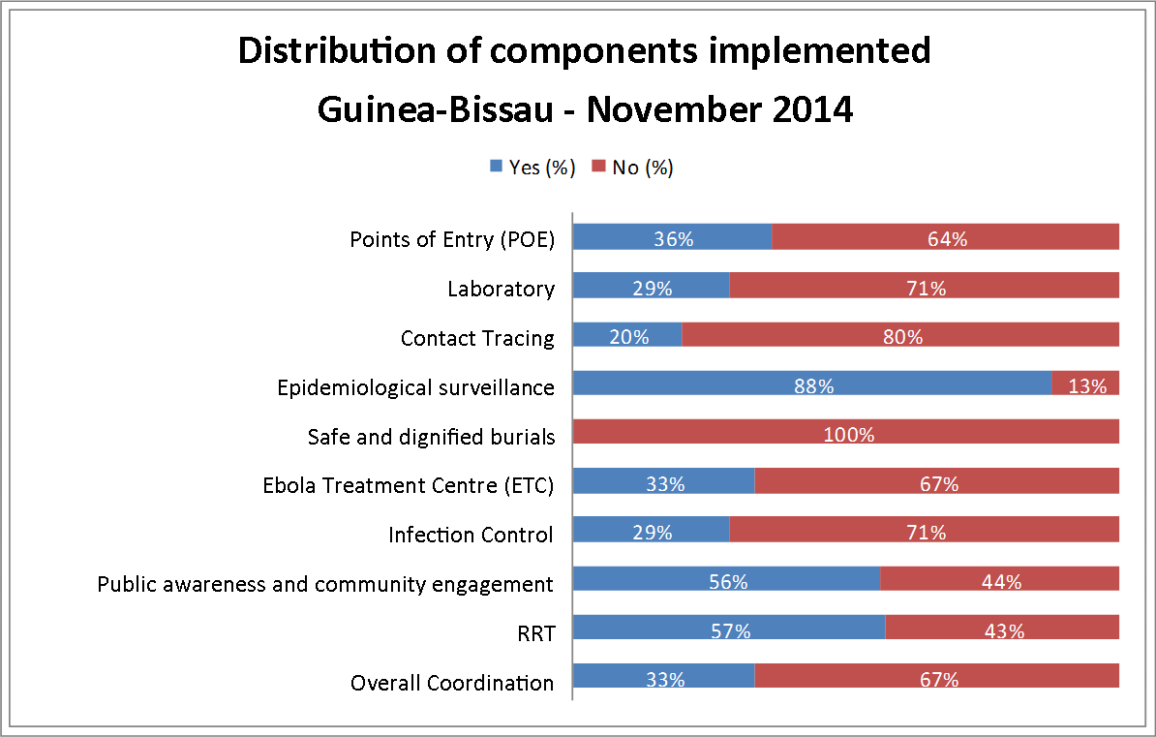
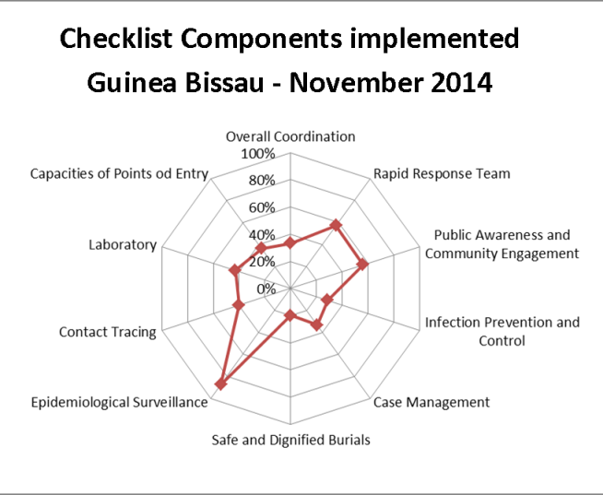

Photos

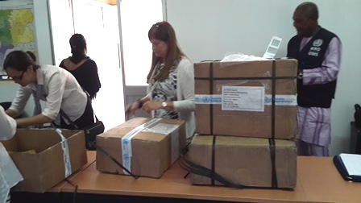  WHO materials brought to the country to be distributed to the health centres and units | 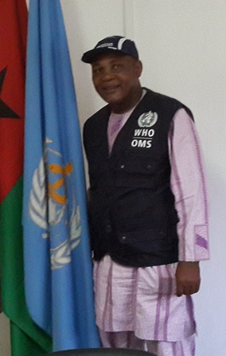  WR Kossi Akla Ayigan
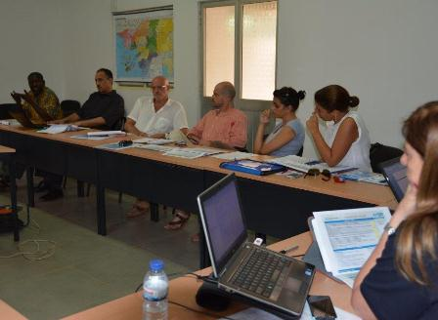  Meeting with partners at the WCO | 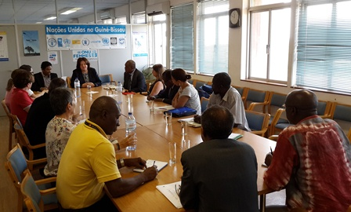  Meeting with the UN Resident Coordinator
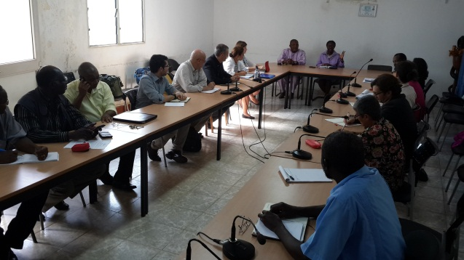  Meeting with the Minister of Health | 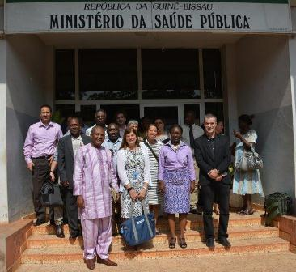  Meeting with the Minister of Health

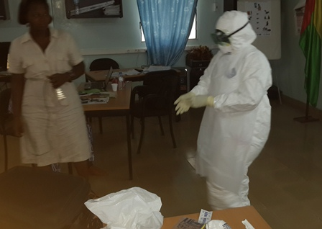  Training exercise (learning how to use PPE) |  | 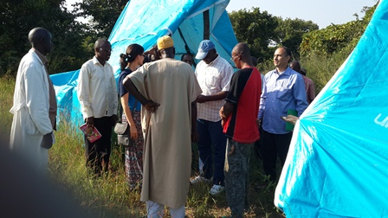  Border region of Gabu (east of the country)
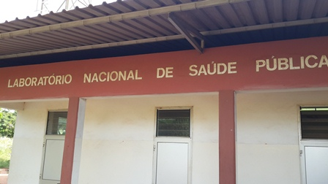  National Public Health Laboratory |  | 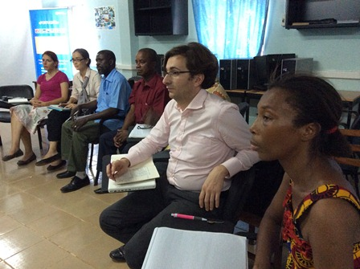  Meeting at INASA
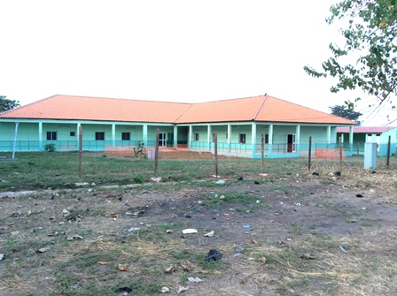  Ebola Treatment Centre renovated by MSF |  | 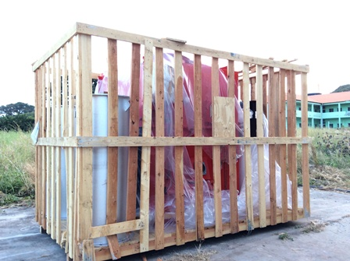  Incinerator to be installed
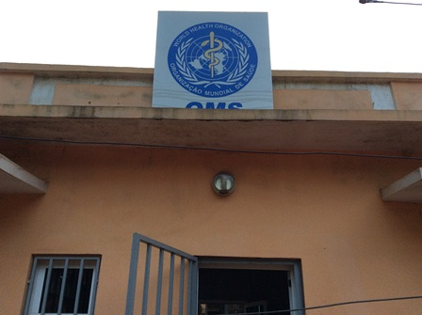  WHO Country Office | 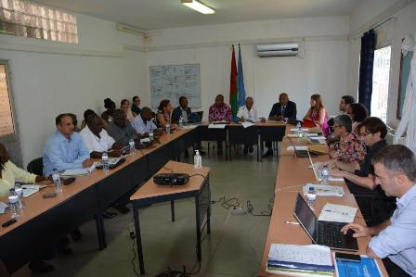  Debriefing with the WR and officials from the Ministry of Health

Annex 1: Discussion of the Consolidated Checklist per group

Overall coordination

Tasks | Component | Implemented | Responsible | National | Regional | Local | Commentaries | Time | Actions to begin after
High-level Emergency & epidemic committees / Ebola Task Force (ETF)  1.1.1. Implementation of a multisectoral and functional committee /Ebola Task Force (ETF) at the national and subnational / district levels. | Overall coordination | YES | Ministry of Health | Yes | n/a | n/a | ETF at National level is operational.  At regional level is necessary to reactivate outbreak committees. | Delivered | 1/12/2014
1.1.2. Pre-existent Emergency Committee transformed into ETF. | Overall coordination | NO | Ministry of Health | NO | n/a | n/a | Minister of Health is responsible for convening the meeting with Region Governors.  At regional level is necessary to reactivate outbreak committees. | 30 days | 1/12/2014
1.1.3. Membership to the Committee / ETF at national and in “at risk” districts level reviewed and updated  All members informed on their tasks and responsibilities | Overall coordination | NO | Minister of Health and Region Governors | NO | n/a | n/a | There is a ToR in place for the national and regional multisectoral committees.  Sharing of documents with all partners. | 30 days | 1/12/2014
1.1.4. Membership to the sub-Committee / ETF with focal points and a clear mandate | Overall coordination | NO | Ministry of Health | NO | n/a | n/a | There is a ToR in place for the national and regional multisectoral committees.  Sharing of documents with all partners. | 30 days | 1/12/2014
1.1.5. Existence of clear TOR of Committee / ETF | Overall coordination | YES | Ministry of Health | YES | n/a | n/a |  | 30 days | 1/12/2014
1.1.6. Mechanisms are in place for coordinating donor support at the country level | Overall coordination | NO | High-Commissioner for Ebola Coordination | NO | n/a | n/a | Need clear ToR for the work of the High-Commissioner  (currently under discussion). | 30 days | 1/12/2014
1.1.7. Review of current policy and legislative frameworks to ensure that they will provide the authorization for the preparedness measures are proposed | Overall coordination | NO | Prime Minister | NO | n/a | n/a | There is a Health Emergency Declaration in place. | 30 days | 1/12/2014
1.1.8. Contingency or emergency plans exist and are fully budgeted for fund identification | Overall coordination | YES | World Bank  ADB | YES | n/a | n/a | Contingency plan is budgeted but not totally covered.  According to WHO, only some of the activities in the contingency plan is budgeted.  For example: The ETC was not included in the plan, as this activity is being fully covered by MSF.  Total Budget: US$ 1,785.942.  WB has made US$ 250,000 available to the Ministry of Health and US$ 500.000 to WHO.  African Development Bank has offered US$ 124.000 to the MINSAP to be used for the Contingency Plan.  There is a GAP of US$ 1,000.000. | 30 days | 1/12/2014
1.2.1. Establish EOC/IMS personnel at the subnational / district level for localized EOC/IMS coordination and management | Overall coordination | YES | Ministry of Health.  Emergency Management Team operational | YES | NO |  | Some Professionals have received training.  ToR should be adapted for team capacity building. (Technical Committee). | 30 days | 1/12/2014
1.2.2. Identify, train and designate Incident Manager and Operations Manager who is empowered to take operational decisions | Overall coordination | NO | Dr Cristovão Manjuba | NO | n/a |  | Dr Cristovão Manjuba (Director of Communicable Diseases Programme) to be appointed as Incident Manager. | 30 days | 1/12/2014
1.2.3. Clearly assign communication responsibilities to specific EOC/IMS roles | Overall coordination | NO | Director General  Dr Nicolau Almeida | NO | n/a |  | Communications with the media (radio, TV and newspaper) are made by the Director General.  Communications with the High Commissioner will be made by the Director General.  All messages and information on EBOLA should be agreed, reviewed and validated by the Technical Committee before disseminated. | 30 days | 1/12/2014
1.2.4. Develop plans for communication channels within EOC/IMS and between EOC/IMS, partners and the public | Overall coordination | YES | Ministry of Health  INASA | YES | YES |  | Campaigns on radio, TV, newspapers and Public awareness and community engagement already in place. | 30 days | 1/12/2014
1.2.5. Established procedures for command & control, coordination mechanisms, clearance of key technical and information products | Overall coordination | NO | Ministry of Health  INASA | NO | n/a |  | There is no assess and evaluation of the information collected.  There is need to follow up on all measures. | 30 days | 1/12/2014
1.2.6. Test coordination and operations through table top exercises and drills | Overall coordination | NO | Ministry of Health with the support from partners | NO | n/a |  |  | 30 days | 1/12/2014
1.2.7. Identify a physical location for the EOC | Overall coordination | NO | INASA | NO | n/a |  | National Institute of Health is the natural choice. | 30 days | 1/12/2014

Rapid Response Team

Tasks | Component | Implemented | Responsible | National | Regional | Local | Commentaries | Time | Actions to begin after
2.1. Identify and assign team leader(s) and multidisciplinary members under the framework of the EOC/IMS | RRT | YES | MINSAP and MSF | YES |  |  | There are 6 out of 11 teams needed | 30 days | 1/12/2014
2.2. Ensure that there is a rapid communication system in place to alert the RRT | RRT | YES | MINSAP | YES |  |  |  | 30 days | 1/12/2014
2.3. Train all clinical staff on the RRT in case management using international standards and the use of a mock ETC | RRT | YES | MSF | YES |  |  |  | 30 days | 1/12/2014
2.4. Train the RRTs on sampling procedures for suspect EVD cases and on the transport of category A pathogens | RRT | YES | MSF | YES |  |  |  | 30 days | 1/12/2014
2.5. Train the subnational RRT in surveillance and contact tracing | RRT | NO | CDC | n/a |  |  |  | 30 days | 1/12/2014
2.6. Map potential health facilities at the district level that are ready to receive suspect EVD cases | RRT | NO | MINSAP | n/a |  |  |  | 60 days | 1/12/2014
2.7. In the absence of an EVD case in the country after 60 days, conduct at least one simulation exercise to maintain the capacity of the RRTs to respond quickly | RRT | NO | MINSAP | NO |  |  |  | 90 days | 1/12/2014

Public awareness and community engagement

Tasks | Component | Implemented | Responsible | National | Regional | Local | Commentaries | Time | Actions to begin after
3.1. Develop or adapt, review, translate into local languages and disseminate targeted messages for media, health care workers, local and traditional leaders, churches, schools, traditional healers and other community stakeholders | Public awareness and community engagement | YES | INASA (Estevão da Silva e Jean Pierre Mendes Umpeça)  UNICEF | YES |  |  |  | 30 days | 1/12/2014
3.2. Identify and engage influential/key actors/mobilisers, such as religious leaders, politicians, traditional healers, and media in urban and rural areas. | Public awareness and community engagement | YES | INASA (Estevão da Silva) | YES | YES | YES | Within 30 days and beyond | 30 days | 1/12/2014
3.3. Map out public communication capacities and expertise within health and other sectors | Public awareness and community engagement | YES | INASA (Jean Pierre Mendes Umpeça) | YES | YES | YES | Within 30 days and beyond | 30 days | 1/12/2014
3.4. Identify and establish mechanisms for engagement with national networks for social mobilization | Public awareness and community engagement | YES | Director of the Multimedia Communication Centre do (Malamane e Mohammed Djicó) | YES |  |  |  | 30 days | 1/12/2014
3.5. Identify established functional communication coordination mechanism involving all government sectors and other stakeholders (including civil society organisations and communities). | Public awareness and community engagement | YES | INASA (Estevão da Silva) | YES |  |  | Difficulty to meet partners for sub-committee meetings | 30 days | 1/12/2014
3.6. Establish coordination mechanism for engaging with the community (involving the traditional leaders, relevant sectors in a bottom-up approach) | Public awareness and community engagement | NO | INASA  President Dr Plácido Cardoso | NO |  |  | Not yet being done.  Plans exists but lack resources and transportation to reach remote areas | 30 days | 1/12/2014
3.7. Establish coordination mechanism for engaging with partners (e.g. NGOs). | Public awareness and community engagement | YES | INASA (Estevão da Silva) | YES | YES | YES |  | 30 days | 1/12/2014
3.8. Draw up a roster with clear roles and responsibilities for internal and external communications and spokespersons. | Public awareness and community engagement | NO | INASA (Estevão da Silva e Jean Pierre Mendes Umpeça) | NO |  |  | These two professionals were designated to the task but their responsibilities are not clear. | 30 days | 1/12/2014
3.9. Establish functional and timely procedures for review, validation and clearance of information products | Public awareness and community engagement | YES | INASA (Estevão da Silva) | YES |  |  |  | 30 days | 1/12/2014
3.10. Identify and train spokespersons and communication team and provide with talking points as needed | Public awareness and community engagement | NO | INASA (Estevão da Silva) | YES | YES | YES | Teams have been identified.  At the beginning of November 2014, there was capacity building sessions the high risk regions (border with Guinea).  Still 6 health regions to be trained.  National: Coordination Committee of Social Mobilization (Estevão da Silva e Jean Pierre Mendes Umpeça)  The Associated Regional Directors are the focal points for social mobilization.  At local level, the health areas are the responsible for social mobilization. | 30 days | 1/12/2014
3.11. Develop a comprehensive strategy, plan and budget for engaging with the media and public (including a scaled-up approach) | Public awareness and community engagement | YES | INASA  UNICEF  WHO | YES | YES | YES | Strategy already approved.  Need financial resources.  UNICEF is leading radio Ebola campaigns and messages.  WHO collaborates with the community radios.  Some radios have agreed to give 30 days minutes of air for campaign.  However, more time on the air is needed.. | 30 days | 1/12/2014
3.12. Establish a system for rumour monitoring, investigation and response | Public awareness and community engagement | NO | INASA (Estevão da Silva e Jean Pierre Mendes Umpeça) | NO |  |  | Contact telephone is the private phone of each of them.  Need to improve structure to increase coverage. | 30 days | 1/12/2014
3.13. Establish a plan for reviewing, revising and monitoring impact of communication strategy | Public awareness and community engagement | NO | INASA  UNICEF | NO |  |  | There is a plan.  NGO Palmerinha has na agreement with UNCIEF to assess, follow up and monitor the impact of communication. | 60 days | 1/12/2014
3.14. Identify critical communication networks and plan for the use of materials in appropriate languages (TV, radio, social media, SMS, story tellers, theatre, and other appropriate communication means) | Public awareness and community engagement | YES | INASA (Estevão da Silva) | YES | YES | YES |  | 30 days | 1/12/2014
3.15. Establish media monitoring mechanisms with appropriate tools | Public awareness and community engagement | NO | INASA  UNICEF | NO |  |  | Not yet exist | 60 days | 1/12/2014
3.16. Map psychological and social assistance capacity and train teams to assist those affected by Ebola. | Public awareness and community engagement | NO | Ministry of Health (Nedilé & Red Cross)  Francisco Mendes e Ione | YES | YES | YES | The Red Cross has a contingency plan that includes the psychosocial aspects of the teams who are in the process of training.  MINSAP will be responsible for identifying teams within the public health sector.  MINSAP and Red Cross will disseminate a list to the communication sub-commission (Estevão da Silva). | 30 days | 1/12/2014

Infection Prevention and Control

Tasks | Component | Implemented | Responsible | National | Regional | Local | Commentaries | Time | Actions to begin after
4.1. Provide health facilities with basic hygiene, sanitation, disinfection, protective equipment and posters.  Priority should be given to hospitals; then health centres in high risk areas (started in 30 days and to cover priority districts in 60 days) | Infection Prevention and Control | YES | Subcommittee CCIH  (Comissão de controle de infecção hospitalar) | YES | YES | YES |  | 15 days | 1/12/2014
4.2. Increase the general awareness about hygiene and how to effectively implement infection prevention and control (started in 30 days and completed in 60 days for priority districts) | Infection Prevention and Control | NO | Subcommittee CCIH  (Comissão de controle de infecção hospitalar) | YES | YES | YES |  | 30 days | 1/12/2014
4.3. Identify health facilities for setting up basic isolation units (2 beds) for suspected cases in all major hospitals and all border points (ideally regional and district hospitals). | Infection Prevention and Control | NO | Subcommittee CCIH  (Comissão de controle de infecção hospitalar) | YES | YES | YES |  | 15 days | 1/12/2014
4.4. Equip and adequately train health care workers including environmental health personnel, cleaners etc. on IPC measures, including waste management, with priority for those at first contact with patients and at basic isolation unit. | Infection Prevention and Control | NO | Subcommittee CCIH  (Comissão de controle de infecção hospitalar) | YES | YES | YES |  | 60 days | 1/12/2014
4.5. Establish a compensation and benefits package for health care workers (HCWs) for: remuneration and motivation for high-risk assignment; in case of infection and death | Infection Prevention and Control | NO | Trade union of medical doctors and nurses | YES |  |  |  | 30 days | 1/12/2014
4.6. Map availability of hospital supplies | Infection Prevention and Control | YES | Subcommittee of logistics | YES | YES | YES | Central de Compras de Medicamentos (CECOME)  URGENT | 7 days | 1/12/2014
4.7. Introduce good practices of Infection Prevention and Control | Infection Prevention and Control | NO | Subcommittee CCIH  (Comissão de controle de infecção hospitalar) | YES | YES | YES |  | 60 days | 1/12/2014

Case management - Ebola Treatment Centre (ETC)

Tasks | Components | Implemented | Responsible | National | Regional | Local | Commentaries | Time | Actions to begin after
5.1. Set up at least one facility with trained staff, adequate supplies, ready to provide care to a patient or cluster of patients with suspected EVD.  This facility should cater for 15 patients initially | Ebola Treatment Centre (ETC) | YES | Subcommittee for general practitioner  MSF | YES | YES | n/a | MSF has renovated an entire ward of the National Hospital to be used as a ETC.  However, it needs to be finalized and needs a generator. | delivered | 1/12/2014
5.2 Identify double cap vehicle to be used as ambulances in the regions | Ebola Treatment Centre (ETC) | NO | Subcommittee for general practitioner  MSF | NO | YES | n/a | URGENT | 7 days | 1/12/2014
5.3 Equip and adequately train ambulance teams to transport suspect EVD cases | Ebola Treatment Centre (ETC) | YES | Subcommittee for general practitioner  MSF | YES | YES | n/a | MSF has trained 6 medical doctors and 2 nurses practitioners to be RRT and transport of EVD cases | delivered | 1/12/2014
5.4. Identify health facilities at district level that can be turned into an ETC at short notice.  (map facilities that have running water, sanitation, bathroom nearby and incinerator).  Have protective equipment; disinfection supplies and awareness posters. | Ebola Treatment Centre (ETC) | NO | Subcommittee for general practitioner  MSF | n/a | YES | n/a |  | 30 days | 1/12/2014
5.5. Identify health facilities at local level that can be turned into an ETC at short notice.  (map facilities that have running water, sanitation, bathroom nearby and incinerator).  Have protective equipment; disinfection supplies and awareness posters. | Ebola Treatment Centre (ETC) | NO | Subcommittee for general practitioner  MSF | n/a | n/a | YES |  | 30 days | 1/12/2014
5.6. Train trainers at the Subcommittee for general practitioner to help build capacity of the teams trained by the MSF | Ebola Treatment Centre (ETC) | NO | MSF | n/a | n/a | YES |  | 30 days | 1/12/2014

Case management – Safe and Dignified Burials

Tasks | Components | Implemented | Responsible | National | Regional | Local | Commentaries | Time | Actions to begin after
5.b.1. Develop SOPs for safe burials and decontamination | Safe and Dignified Burials | NO | Dr Isis Julieta Pina Ferreira Gomes Ferreira  (Outbreak control) | NO |  |  |  | 30 days | 1/12/2014
5.b.2 Identify appropriate secured burial ground with agreement of the community | Safe and Dignified Burials | NO | It was suggested that the Red Cross could be responsible | YES |  |  | It is necessary to identify land, prepare plan A,  Plan B and eventually plan C and D, to cover all eventualities in a country with more than 30 days ethnic groups (Muslins, Christians and animists.  The current idea is to build a new cemetery in Bissau for Ebola cases.  If Ebola is to enter Guinea-Bissau, most likely it will be in the border with Guinea.  Therefore, it is necessary to discuss with the near communities to identify areas for possible victims. | 30 days | 1/12/2014
5.b.3 Equip and adequately train burial teams (8 people). | Safe and Dignified Burials | NO | It was suggested the Red Cross and  PROMETRA (promoção da medicina tradicional) | NO |  |  | Red Cross claims that already takes this into consideration in its contingency plan.  However, people ignore it. | 30 days | 1/12/2014
5.b.4. Ensure that a dedicated transportation process is in place to bury human remains safely and dignified | Safe and Dignified Burials | NO | INASA | NO |  |  | A proposal exists to purchase a hearse.  However it is important to define what is a "safe transportation" of a Ebola dead patient.  It is not possible to put a coffin in the back of a car. | 30 days | 1/12/2014
5.b.5 Ensure burials teams have access to support services such as drivers, grave diggers, and potential security support during the burial process | Safe and Dignified Burials | NO | Subcommittee of logistics  (Mrs Olga Campos) | NO |  |  |  | 30 days | 1/12/2014

Epidemiological Surveillance

Tasks |  | Component | Implemented | Responsible | National | Regional | Local |  | Commentaries | Time |  | Actions to begin after
 | 6.1. Establish a 24/7 hotline with escalation facilities with medically trained staff. | Epidemiological Surveillance | YES | To be defined by INASA  (Responsible + substitute) | YES |  |  |  |  | 30 days | 1/12/2014
 | 6.2. Train the hotline staff on case identification and management of communication with potential cases. | Epidemiological Surveillance | YES | MINSAP – Dr Cristovão Manjuba  + substitute | YES | YES |  | YES |  | 30 days | 1/12/2014
 | 6.3. Provide guidance (case definition and investigation forms to all sub-national / district levels and healthcare facilities);, standard case definitions to all countries). | Epidemiological Surveillance | YES | MINSAP  WHO | YES | YES |  | YES |  | 30 days | 1/12/2014
 | 6.4. Provide training on the case definition and investigation for all health workers in the country. | Epidemiological Surveillance | YES | MINSAP  partners | YES | YES |  | YES |  | 30 days | 1/12/2014
 | 6.5. Test existing Surveillance/IDSR systems for Ebola, identify gaps and start implementation of corrective actions where necessary. | Epidemiological Surveillance | YES | INASA | YES | YES |  | YES |  | 30 days | 1/12/2014
 | 6.6. Establish immediate lines of reporting for suspect cases, clear responsibility for such actions. | Epidemiological Surveillance | YES | INASA | YES |  |  |  |  | 30 days | 1/12/2014
 | 6.7. Identify human resources for community surveillance (community HCWs, Red Cross/Crescent volunteers, NGOs, healer, leaders etc.) | Epidemiological Surveillance | NO | MINSAP  partners | NO |  |  | YES |  | 30 days | 1/12/2014
 | 6.8. Disseminate simplified case-definitions for community use | Epidemiological Surveillance | YES | MINSAP  WHO  UNICEF | YES |  |  |  |  | 60 days | 1/12/2014

Contact Tracing

Tasks | Component | Implemented | Responsible | National | Regional | Local | Commentaries | Time | Actions to begin after
7.1. Train the teams at both national and subnational / district levels including on contact tracing and data management (with a ToT strategy). | Contact Tracing | YES | MINSAP, INASA e CDC | YES | n/a | n/a |  | 30 days |  | 1/12/2014
7.2. Provide UNMEER with list of required equipment and materials for contact tracing at National and sub-national levels. | Contact Tracing | NO | MINSAP, INASA e CDC | NO | n/a | n/a |  | 30 days |  | 1/12/2014
7.3. Train staff at district level on contact tracing. | Contact Tracing | YES | MINSAP, INASA e CDC | NO | YES | n/a |  | 30 days |  | 1/12/2014
7.4. Train staff at sub district and community level on contact tracing. | Contact Tracing | NO | MINSAP, INASA e CDC | NO | n/a | n/a |  | 60 days |  | 1/12/2014
7.5 Develop a plan to guarantee data quality. | Contact Tracing | NO | MINSAP, INASA e CDC | NO | n/a | n/a |  | 90 days |  | 1/12/2014

Laboratory

Tasks | Components | Implemented | Responsible | National | Regional | Local | Commentaries | Time | Actions to begin after
8.1. For each district, identify laboratory responsible for analysis or specimen handling of biological samples and mode of transport for samples.  To date, samples have to reach Pasteur Institute in Dakar, Senegal. | Laboratory | NO | MINSAP  INASA  WHO | NO |  |  | Regional Laboratories should be identified and lab technicians trained for handling samples independently from the National Laboratory.  It means that regional Labs should be capable to handle samples. | 30 days | 1/12/2014
8.2. Stand-by arrangements and agreements with WHO Collaborating Centres for confirmatory testing in place. | Laboratory | NO | MINSAP  INASA  WHO | NO |  |  | Urgent | 7 days | 1/12/2014
8.3. Stand-by arrangements and agreements with relevant air-lines to ship samples from suspected cases to WHO collaborating Centres in place. | Laboratory | NO | MINSAP  INASA  WHO | NO |  |  |  | 30 days | 1/12/2014
8.4. Availability of resources to facilitate transportation and shipment of specimens. | Laboratory | YES | MINSAP  WHO  CDC | YES |  |  |  | 30 days | 1/12/2014
8.5. Existence of protocol for:  - Sample collection;  - Referral and shipment of specimens from suspect EVD cases to designated laboratory for confirmation at national and sub-national public health laboratories. | Laboratory | YES | MINSAP  WHO  CDC | YES |  |  |  | 30 days | 1/12/2014
8.6. Laboratory personnel trained on procedures for specimen collection, packaging, labelling, referral & shipment, including handling of infectious substances. | Laboratory | NO | MINSAP  WHO  CDC | NO |  |  |  | 30 days | 1/12/2014
8.7 Build Capacity of the molecular virology laboratory at LNSP/INASA to diagnose Ebola samples.  Have mobile laboratory available. | Laboratory | NO | MINSAP  INASA  WHO  CDC  others | NO |  |  | WHO could be responsible for training a trainer lab technician in Guinea. This professional could support the virology lab at LNSP.  Portugal has offered to bring mobile laboratories to the country. (explore this possibility). | 90 days | 1/12/2014

Capacities at Points of Entry (POE)

Tasks | Components | Implemented | Responsible | National | Regional | Local | Commentaries | Time | Actions to begin after
9.1. Ensure that a health emergency contingency plan is in place at high risk PoE (ports, airports, and ground crossings). | Capacities at Points of Entry (POE) | YES | IHR Focal Point | YES | n/a | YES |  | delivered | 1/12/2014
9.2. Deliver identified supplies (9 PPE full sets at each PoE medical equipment to survey cases; 3 Infrared hand held thermometers, 1 scanner, 2 observation room/ 2 Health facilities and supplies for safe isolation and observation of suspect cases if possible separation room, if not, a separated area.  Depending on the geographical location, 1 Ambulance to PoEs.  Every PoE needs to have either a separation room of a dedicated area for holding suspected cases | Capacities at Points of Entry (POE) | Partially implemented | IHR Focal Point | YES | n/a | YES | Screening performed at the airport.  Ground borders with Guinea are closed (no control yet). | 30 days | 1/12/2014
9.3. Identify PoE teams to cover 24/7, to assist travellers and ensure correct isolation if required, including through a “holding” centre/area for any suspect cases. | Capacities at Points of Entry (POE) | Partially implemented | IHR Focal Point | YES | n/a | YES | At the airport  Ground borders with Guinea are closed (no control yet). | delivered | 1/12/2014
9.4. Review and test current communication system between health authorities and conveyance operators at PoE, and national health surveillance system | Capacities at Points of Entry (POE) | NO | IHR Focal Point | YES | n/a | YES | Urgent | 7 days | 1/12/2014
9.5. Use standard operating procedures to identify, manage and direct the POE suspects patients to designated hospitals / isolation facilities. | Capacities at Points of Entry (POE) | YES | IHR Focal Point | YES | n/a | YES |  | delivered | 1/12/2014
9.6. Use standard operating procedures to implement exit case tracing in the case of a confirmed outbreak of Ebola virus disease | Capacities at Points of Entry (POE) | NO | IHR Focal Point | YES | n/a | YES |  | 30 days | 1/12/2014
9.7. Build capacity of health technicians on the procedures if a case of Ebola is identified.  (material for training already available). | Capacities at Points of Entry (POE) | NO | Commission | YES | YES | YES |  | 15 days | 1/12/2014
9.8. Identify contact person for each entry point of ground borders with Guinea. | Capacities at Points of Entry (POE) | NO | High Commissioner | YES | NO | YES | Urgent | 7 days | 1/12/2014
9.9. Establish a coordination mechanism between officials at PoE (border control officer, immigration, tourism, etc.) | Capacities at Points of Entry (POE) | NO | IHR Focal Point | YES | NO | NO | Urgent | 7 days | 1/12/2014
9.10. Identify facilities to ensure 24/7 coverage in PoE | Capacities at Points of Entry (POE) | NO | High Commissioner | YES | NO | YES | Urgent | 7 days | 1/12/2014
9.11. Map stock of supplies and equipment in PoE | Capacities at Points of Entry (POE) | NO | IHR Focal Point | YES | NO | NO | Urgent | 7 days | 1/12/2014

Annex 2 –Capacity Building Training Programme offered by Portugal attended by a Lab technician.

Apoio Militar e da Polícia
- Se necessário para Segurança
- Especialidade clínica, hospitalar
- Logística
Annex 3: Estrutura de Comando de Incidentes e Comité de Gestão de Emergências (CGE)/ COE

Presidente

Autoriza
Primeiro-ministro
- Autoriza um Comité de Gestão de Emergência (CGE/COE) a supervisionar:
  - Preparação
  - Resposta a Emergências de Saúde Pública
Ativação de Equipe de resposta rápida (ERR)
  - Acesso a fundos adequados, com controlos apropriados, para proteção da saúde pública

Aconselhamento
Em Caso de Ébola,
o CGE ativa uma “Estrutura de comando de Incidente”, Notifica OMS
OMS
Autoriza
Comité de Gestão de Emergências (CGE/COE), incluindo Ministério da Saúde, Laboratórios de Referência e Outras Agências para a Saúde (Gado, Ambiente, Vida Selvagem)
Grupo Técnico Consultivo (TAG):
- Especialistas
- Faculdade da Universidade
- Sector Privado

Ação Imediata
Comando de Incidente (Qualificações):
- Profissional de saúde
- Experiência na gestão de surtos
- Competências de liderança, Capacidade de tomada de decisões
- Compreende a prevenção e controlo da doença
- Capacidade para trabalhar em ambientes de elevado stress

Comités/Sub-comités
Epidemiologia
Oficial de ligação / Relações públicas
Segurança
Planejamento
Finanças Administração

Gestão de casos (médicos)
Laboratórios
Logística
Antropologia
Comunicação
Annex 4 – National Preparedness Plan

REPUBLIQUE DE  LA GUINÉE-BISSAU
MINISTERE DE LA SANTÉ PUBLIQUE
Direção Geral de Prevenção e Promoção de Saúde

Direction de Services des Maladies Transmissibles et Non Transmissibles
Comité National Multi-sectoriel de Gestion des Épidémies et Catastrophes

Plan de prévention et de réponse à l’Epidémie de la maladie à Ebola (Mai à Décembre 2014)

Bissau, 26 Mai 2014

Introduction
La République de Guinée-Bissau est située sur la côte ouest du continent africain. Le pays possède des frontières au nord avec la République du Sénégal, à l'est et au sud-est avec la République de Guinée et l'océan Atlantique à l'Ouest. Du point de vue administratif, la Guinée-Bissau est divisée en 8 régions : Bafatá, Biombo, Bolama-Bijagós, Cacheu, Gabu, Oio, Quínara et Tombali. Les régions sont subdivisées en 36 secteurs et un secteur autonome (ville de Bissau), capitale politique, économique et administratif du pays. La carte sanitaire se présente avec 11 régions sanitaires, y compris le secteur autonome de Bissau. 11 régions sanitaires ont été divisées en 114 zones sanitaires (niveau le plus proche aux communautés), définis sur la base de critères géographiques, couvrant une population comprise entre 5 000 et 12 000 habitants. Plus de 40 % de la population vit encore, à une distance supérieure à 5 km, structures de prestation de soins de santé primaires, plus proche.
La Guinée-Bissau a subi plusieurs épidémies de maladies/contagieuse au cours des années, à savoir : choléra, rougeole, méningites et charbon. En 2010, il y a des cas notifiés de l'influenza aviaire dans la région de Biombo. Les régions transfrontalières et la communication aérienne avec la République de Guinée Conakry, notamment, Quinara, Tombali, Gabu, Bolama-Bijagós et SAB respectivement constituent des zones d`entrée et potentiel de propagation de maladies.
Récemment, le pays a été tenu au courant de l'existence d'une fièvre hémorragique épidémique du virus Ebola en cours depuis février dans la République voisine de Guinée-Conakry. On sait que la maladie est virale et à l'origine de taux de létalité élevé et a été enregistrée pour la première fois en 1976 dans la République démocratique du Congo (anciennement Zaire).
Le pays n'a jamais connu l'épidémie de fièvre hémorragique à virus Ebola et en raison de la situation géographique et la mobilité des personnes, le ministère de la santé publique en collaboration avec ses partenaires traditionnels de la coopération a lancé la préparation d'un plan de prévention et de réponse à une possible propagation de l'épidémie dans le pays, une plan qui couvre la période de mai à décembre de l'année en cours (2014).
Réponse Nationale:
Compte tenu de la situation actuelle, le MINSAP a convoqué une réunion technique avec ses partenaires pour la préparation des stratégies possibles de prévention de cette épidémie qui figureront dans le plan d'urgence. Aussi toutes les directions régionales ont été informées de l'existence de l'épidémie de fièvre hémorragique à virus Ebola en Guinée-Conakry et il été donc demandé aux responsables sanitaires d'identifier les sites possibles pour l'isolement des cas suspects de la maladie. Outre ces directives, les directions régionales ont également procédé à la mise à jour la liste des stocks de médicaments et des intrants disponibles.
Partenaires impliqués:
Tous les partenaires au développement sanitaire en Guinée Bissau ont été sensibilisés et sont intéressés à appuyer dans la prévention et de réponse à une éventuelle épidémie du virus Ebola dans le pays.
Population vulnérable ou à risque :
Toute la population résidente et notamment des régions frontalières avec la République voisine de Guinée-Conakry sont à risque. Les scénarios pour les sources possibles de contamination les plus probables sont l’entrée du virus par des points d'entrée dans les zones frontalières, campements des pécheurs dans les régions de Quinara,Tombali, Bijagós et ville de Bissau par le biais de l'aéroport de Bissau.
Objectif général:
Prévenir et répondre à temps et efficacement à une éventuelle épidémie de fièvre hémorragique à virus Ebola dans le pays.
Objectifs spécifiques:
1 – Réactiver et opérationnaliser les épidémies, les comités de gestion à tous les niveaux en améliorant la coordination des activités.
2 – Renforcer les capacités techniques des équipes pour répondre efficacement à la prise en charge de la maladie à Virus Ebola et réduire la mortalité et la morbidité liées à cette maladie.
3 – Pré positionner des médicaments et équipements médicaux pour l’organisation d’une préparation et d’une réponse adéquate aux cas notifiés.
4 – Fournir des mesures de bonne pratique d’hygiène y compris lavage des mains auprès des ménages pour réduire le risque de contamination des les maladies (Ébola et autres. Choléra, etc).
5 – Créer des conditions favorables pour la collecte et le transport des échantillons.
Résultats attendus pour l'objectif spécifique 1
- Les comités de gestion des épidémies réactivés et fonctionnels à tous les niveaux.
Résultats attendus pour l`objectif spécifique 2
I – Les capacités des techniciens de santé dans la surveillance et la prise en charge clinique des cas sont renforcées.
Résultats attendus pour l'objectif spécifique 3
I – Les sites de l'isolement des cas suspects équipés adéquatement à tous les niveaux et y compris les points d'entrée.
Résultats attendus pour l'objectif spécifique 4
I - La connaissance des populations sur l'épidémie d'Ebola est renforcée.
5 - Résultats attendus pour l'objectif spécifique 5
I – Les conditions pour la collecte et le transport des échantillons sont créés.
Stratégies pour l'objectif spécifique 1
Réactiver et opérationnaliser les comités de gestion des épidémies à tous les niveaux en améliorant la coordination des activités.
A – Coordination des comités de gestion des épidémies pour le monitorage de l'évolution de la situation hebdomadaire d'épidémie, la communication et la concertation quotidienne entre les différents niveaux.
B- Mobilisation et gestion des ressources à différents niveaux.
Stratégies pour l'objectif spécifique 2
Renforcer la capacité des techniciens de santé à répondre efficacement à une éventuelle épidémie pour réduire la mortalité et la morbidité attribuée à cette maladie.
A – Disposer des techniciens de santé ayant de très bonnes connaissances sur la détection précoce et la notification des cas.
Stratégies pour objectif spécifique 3
Fournir des mesures de prévention et des conditions de service appropriées pour la prise en charge adéquate des cas suspects.
A – Renforcement et équipement des points d'entrée pour la détection et la prise en charge des cas suspects possibles.
B - Fournir aux structures de santé des outils de surveillance et de gestion de cas cliniques.
Stratégias pour objectif spécifique 4
Promouvoir l'adoption de bonnes pratiques d'hygiène, y compris le lavage des mains auprés des familles afin de réduire le risque de contamination par d’autres maladies infectieuses (Ebola, choléra, etc.)
A – Renforcement des capacités des acteurs (personnels de santé, les professionnels des médias, chefs religieux et traditionnels, volontaires communautaires (ASC).
B – Sensibilisation des populations à adopter les meilleures pratiques d’hygiène individuelle et collective et prévenir ainsi la maladie.
Stratégies pour objectif spécifique 5
Créer des conditions propices à la collecte et le transport des échantillons.
A – Renforcement des capacités techniques pour la collecte, le conditionement et le transport des échantillons.
Activités relatives à l'objectif spécifique 1
- Organiser des réunions du Comité de gestion à tous les niveaux
- Organiser des supervisions à tous les niveaux
- Soutenir les équipes régionales de la santé par le biais de missions techniques ad hoc
- Doter l`INASA des fonds pour le transport d'échantillons de DRS à LNSP
Activités relatives à l'objectif spécifique 2
- Former les professionnels de la santé, les agents de santé communautaire et volontaires des ONG.
- Soutenir la reproduction des supports de formation, manuels, dépliants, cartes, etc.
- Organiser des réunions techniques transfrontalières.
Activités relatives à l'objectif spécifique 3
- Acheter et pré-positioner les matériels médicaux et autres intrants.
- Soutenir en moyen logistique les activités des régions et assurer la maintenance
Activités relatives à l'objectif spécifique 4
- Produire des supports de communication (spots, affiches et dépliants)
- Organiser l'orientation de sessions courtes au niveau des aires sanitaires à l’intention des ONG, des animateurs des radios et des chefs traditionnels et religieux.
- Effectuer des missions de suivi et de supervision.
Activités relatives à l'objectif spécifique 5
- Achat des matériels & équipements pour le laboratoire
- Adapter les règles de procédure standard
Suivi et évaluation
Le suivi et l'évaluation des actions programmées se fera sur une base hebdomadaire pendant les réunions du Comité régional de gestion des épidémies comme instance identique de coordination au niveau régional. Les rapports de mise en œuvre de ce plan doivent reposer sur les indicateurs inclus dans ce tableau.
Résultats attendus | Indicateurs
Les comités de gestion des épidémies réactivées et fonctionnelles à tous les niveaux | % des comités de gestion des épidémies réactivées et fonctionnelles
Capacités des techniciens de santé dans la prise en charge clinique des cas et de la surveillance renforcée | % des techniciens de santé formés
Les sites d'isolement des cas suspects équipés adéquatement à tous les niveaux et y compris les points d'entrée | % des sites d'isolement des cas/suspects équipés de manière adéquate
La connaissance des populations au sujet de l'épidémie d'Ebola renforcée | Nombre des séances de sensibilisation organisées
Conditions pour la collecte et le transport des échantillons créées | % d'échantillons reçus dans des conditions acceptables au LNSP

RÉSUMÉ DU PLAN (voir détails en Excel)
Stratégies | Activités | Budget
Stratégies | Activités | FCFA | USD
- Coordination des comités de gestion des épidémies pour le monitorage de l'évolution hebdomadaire de la situation d'épidémie, et concertation entre les différents niveaux  - Mobilisation et gestion des ressources à différents niveaux. | - Organiser des réunions du Comité de gestion de l`épidémie à tous les niveaux  - Monitorage et évaluation de l`épidémie  - Conduire les supervisions à tous les niveaux  - Soutenir des équipes régionales de la santé par le biais de missions techniques ad hoc  - Doter l`INASA des moyens pour le transport d'échantillons de DRS à LNSP | 23 234 482 | 48 905
- Disposer des techniciens de santé ayant des connaissances solides sur la détection précoce et de notification des cas | - Former les professionnels de la santé, les agents de santé communautaire et les bénévoles, les ONG  - Appuyer avec le matériel de bureau pour l’organisation des réunions.  - Organiser des réunions techniques transfrontalières | 82 645 502 | 172 178
- Renforcement et l'équipement des points d'entrée pour la prise en charge des cas suspects possibles  - Fournir aux structures de santé des outils de surveillance et de gestion de cas | - Acheter et pré-positionner les matériels médicaux et autres intrants  - Soutenir en moyens logistique et maintenance | 98 150 431 | 204 480
- Renforcement de la surveillance active au niveau des points d`entrée | - Per diem pour les agents de santé  - Per diem pour les agents de garde-frontière  - Carburant pour les motos  - Crédit pour les portables | 45 824 970 | 95 506
- Renforcement des capacités des acteurs (personnels de santé, les professionnels des médias, chefs religieux et traditionnels, bénévoles de la collectivité et ASC) sur le CIP Sensibilisation des populations à adopter les meilleures pratiques d’hygiène individuelle pour la prévention de la maladie | - Produire des supports de communication (spots, affiches et dépliants)  - Organiser l'orientation de sessions courtes au niveau des aires sanitaires, pour les ONG, les animateurs de radio et les chefs traditionnels et religieux  - Effectuer des missions de suivi et de supervision | 82 578 000 | 172 038
- Renforcer les capacités des équipes techniques à l’utilisation des équipements et à la récolte des données. | - Acheter les matériaux & équipements pour le laboratoire  - Adapter les règles de procédure et standard de collecte des données | 32 107 000 | 66 890
Assistance technique |  | 18 453 120 | 38 444
TOTAL |  | 364 540 385 | 759 459

USD = 480 FCFA

