The objectives of the Regional Pilot Project 3 (RPP3) are in close collaboration with local authorities, staff experts and civil servants to build/implement an air pollution assessment system in the ENPI East countries which can be used for
1. high resolution urban air quality modelling,
2. urban assessment,
3. estimating effects of different urban planning and transportation schemes,
4. etc.
and teach local staff in the ENPI East counties to operate the system and setup the system in other cities in their countries.
As air pollution assessment system was the THOR model system chosen (Brandt et al., 2001a,b; 2003; 2012). The reason for this choice was that it includes several meteorological and air pollution models capable of operating for different applications and scales. The system is unique with respect to the integration of scales and capable of estimating accurate and high resolution simulations of weather and air pollution from regional scale over urban background scale and down to individual street canyons in cities - on both sides of the streets.
The goals of RPP3 were achieve though the following steps:
- Selection of one pilot city in each of the ENPI East countries (see Figure 4.1)
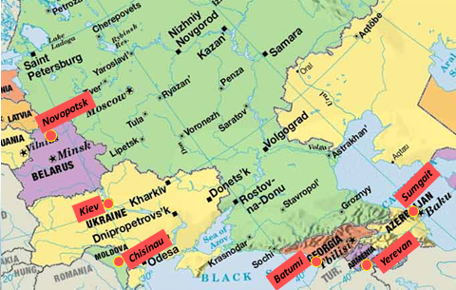
Figure 4.1: The selected pilot cities by the ENPI East countries.
- Collection of data by local experts in the pilot cities (point sources, areal sources, traffic data, graphical data, air pollution measurements data, meteorological data, etc.).
- Development of high resolution emission data for the pilot cities by AU (examples see figure 4.2).

Figure 4.2: Yearly NOx emission inventories for Batumi (Georgia), Novopolotsk (Belarus) and Chisinau (Moldova) calculated by AU.
- Teaching local staff in operating the THOR system during two training workshops one in June in Yerevan and one in July in Chisinau (se Picture 4.1).
Picture 4.1: Pictures of the participants of the three RPP3 training workshops.
- From June/July until October the local experts from the ENPI east countries worked with the THOR system:
  - Armenia; modelling of the EMEP station of Armenia, the urban background air pollution of Yerevan, and the air pollution of one street in Yerevan.
  - Azerbaijan; modelling of the urban background air pollution of Sumgait, and the air pollution of two streets in Sumgait.
  - Moldova; modelling the urban background air pollution of Chisinau, and the air pollution of one street in Chisinau.
  - Belarus, Georgia, and Ukraine; the urban background air pollution of Novopotsk, Batumi and Kiev, respectively.
- A follow up training workshop in October in Copenhagen (see Picture 4.1) where the local staff presented their results first modelling results from their pilot cities from the THOR system. In Figures 4.3 are presented a few examples of the urban background simulations from the local staff.
Figure 4.3: Yearly average concentration of NOx form Yerevan (middle plot), and of NO2 from Chisinau (left plot) and Batumi (right plot).
As round off the project; the Danish team made different simple verifications of the model results of the pilot cities, and the EMEP station in Armenia and Moldova. In general most of the simulations were in good agreement with observations, but for some of the modelling results the differences with observations were rather different. These differences could for most of the cases be explained by unrealistic measurements.
Realising the objectives of RPP3 were very challenging, because many challenging tasks from data collection locally in the pilot cities to setup the THOR system for the pilot cities and training local staff should be realised during a very short project period (14 months). Examples of these challenges are (i) collection of emission data from the pilot cities necessary to make emission inventories for the pilot cities, (ii) collection of detailed traffic information and building information for the street of interests required by the street canyon model in THOR, data which are not available from many of the pilot cities.
Even though the RPP3 project faced many challenges during the project period the overall output from the project is in the line with the overall objectives of the RPP3 project, and all the ENPI East have future plans with the THOR system: (i) apply THOR for other cities, (ii) apply THOR for to air pollution assessment according to the Directive 2008/50/EC: ”Pure air for Europe”, (iii) apply THOR for AQ forecasts, (iv) add extra pollutants in to THOR.
The local staff, who have been trained in running the THOR system, have demonstrated through the model results presented during the RPP3 project that they are able to operate the system, and a manual (Jensen et al, 2014a,b) for the model system has been written to support the local staff in the future. In conclusion, the local staff that has been trained should have enough knowledge and experience with the model system in order to fulfill the overall goal of the RPP3 project.

