TWG Performance Review: Survey Scoring Summary (December 2014)

TWG Chairs and Lead DP Facilitators were asked 8 questions related to TWG performance and support. Responses were provided confidentially but the following charts show the averages and the range of responses across the 14 TWGs for which both RGC and DPs data was provided.

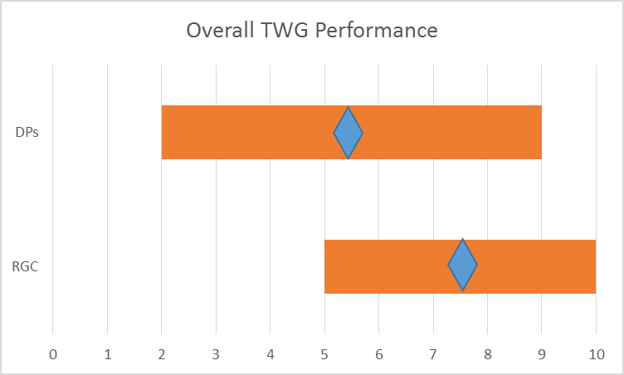 | 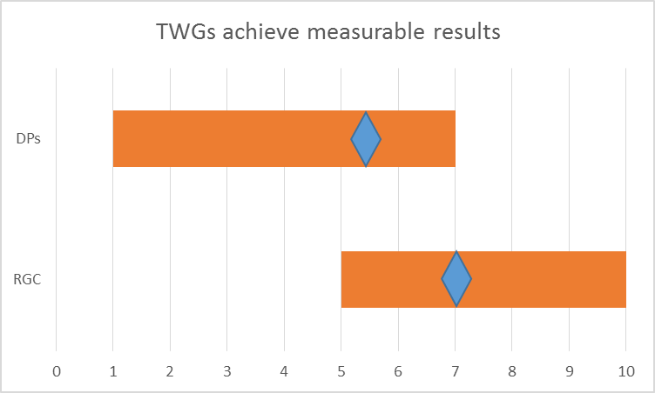
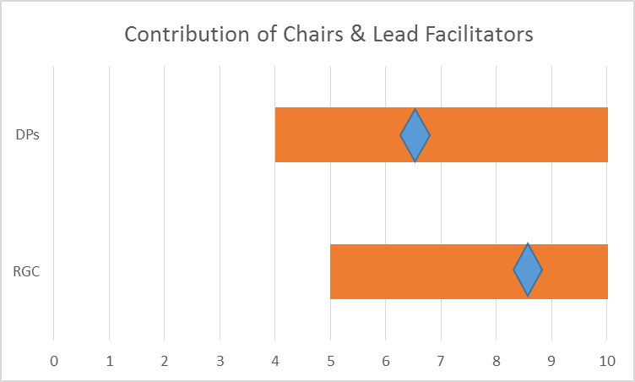 | 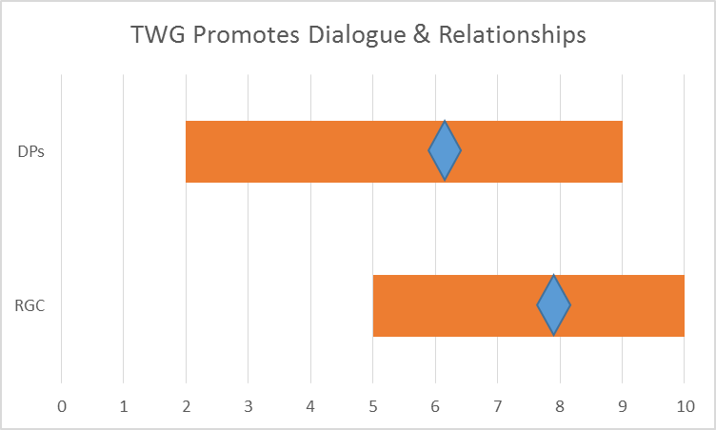
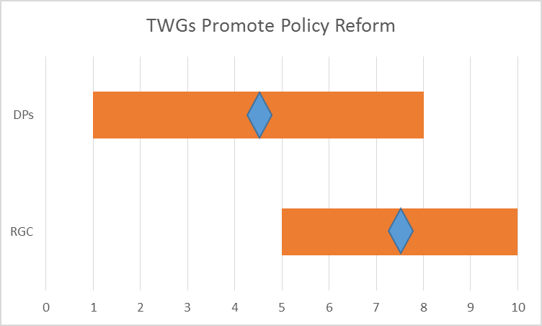 | 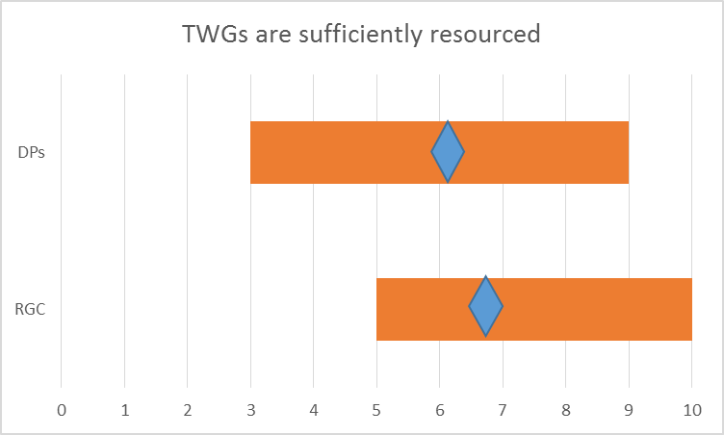
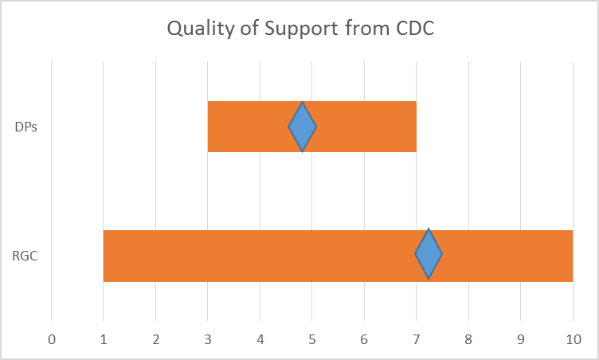 | 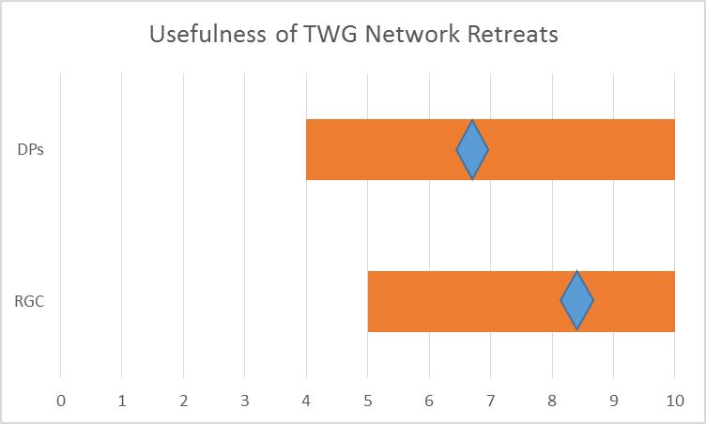

Quantitative analysis shows that: (i) based on averages across 14 TWGs, RGC tends to rate TWG performance higher on all criteria; (ii) the range is quite high across all questions, meaning that TWGs have diverse perceptions and experience; and (iii) RGC perceptions generally fall in the upper half of the range (i.e. 5-10) while the variance for DPs is larger and more often extending to the lower half of the scoring range.

