

Catalina Amihaiesi
Consultant at Spherik Accelerator

$246 million for what?
Feb 5, 2015
Indiegogo and Kickstarter have an impressive portfolio of successful projects. According to Kickstarter’s stats from last year, donations come from everywhere, with USA, Japan, UK, Australia, Germany, Singapore or Sweden in top 10. And while roughly 80% of the projects raised $10.000 from 100 backers (details here), 114 projects from both platforms raised more than $1 mil.
These ‘super’ projects account for a very small percentage of the total successful projects, but they made people from all over the world step in and contribute. Some got viral due to their technological breakthrough, like Oculus Rift, while others got attention because they were challenging a mind-set, like Amanda Palmer.
So I asked myself: what is out there besides Oculus and Amanda? What have we accomplished so far?
I decided to take a closer look at all these successfully ended campaigns in search of a general picture of what went viral in the first 6 years of crowdfunding. These projects tell the story of big common ambitions and cravings across the globe.
The total? $246 mil. Let’s see how we spent it.
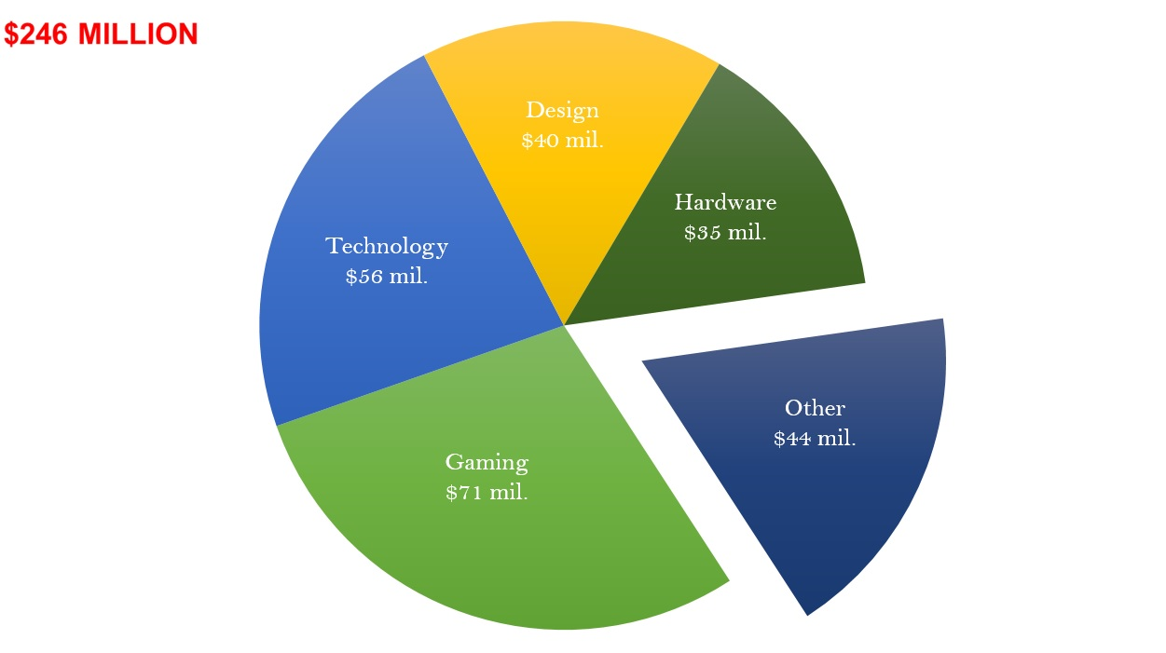
80% of the money went for projects in Gaming, Hardware, Technology and Design. Both platforms have a very broad definition of these categories, but it’s best to look at them together because they generally have to do with games and technology for our phone or computer.
In more details, Technology projects are a mix of more games, more hardware (sometimes for games), apps, 3D printing and some drones. The solar roads are worth mentioning here.
Design projects deal with objects we transformed to include latest technologies in an innovative design, like the smallest, the thinnest, touchless, sensor based, etc. The coolest cooler is the most funded project from this category.
Gaming means…well, games. Computer and video games are leading the way, but board games start to gain popularity, with monsters already funded and exploding kittens on their way.
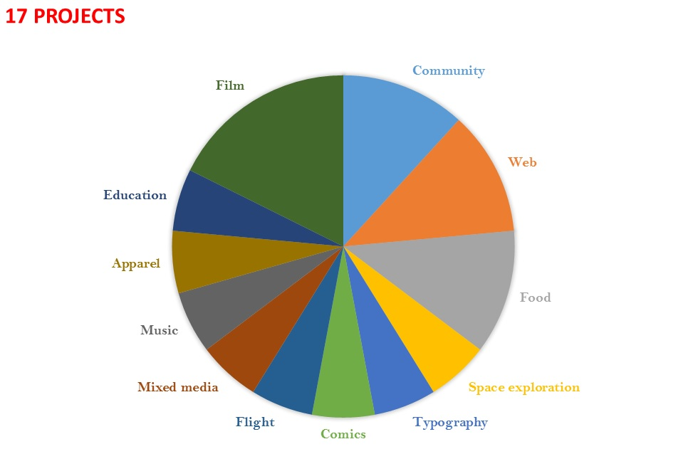
The 17 other projects over $1 mil. cover various categories, but a closer look at them offers an interesting perspective. Apart from playing games and getting a new gadget around the house, which we surely love, we managed to fund the following:
- a simplified version of the Bible as a pure literary art, ‘free of all numbers, notes, etc.’
- a pressurized growler to keep our beer fresh and cold
- Boil an egg with the help of our phone and a kitchen appliance that allows us to cook sous vide
- A 10-year hoodie that is guaranteed to last 10 years of intense video gaming
- A mini museum that fits up to 33 specimens into our pocket in acrylic
- One hour of computer science for 100 mil students worldwide
- A space telescope to send pictures of ourselves into space and take the alien search into our own hands.
- A ‘zipperless luggage with GPS’. We funded this one just two weeks ago, I guess the history repeats itself – we put a man on the Moon in the ‘60s before we put wheels on luggage in the ‘70s.
The projects that got our attention via Kickstarter and Indiegogo for the past 6 years are a good predictor of what will get our money in the years to come. These projects stroke a chord with many of us all around the world and encapsulate some of our biggest desires, fears and hopes.
Stay tuned for a follow-up article on what these projects have in common and stories that raise the most money.

