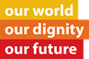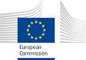

**Brussels, 17 January 2015**

**Belgian launch of the European Year for Development 2015**

**Debate:" Culture as Pillar of Development Cooperation"**

***Investing in culture is equivalent to investing in human development…is essential as a basis for mutual respect, tolerance and, in my opinion, even for stability and peace…it is very important for young people to have the opportunity to discover culture at a very early age…***

**Her Majesty Mathilde, Queen of the Belgians, 2015.**

***…culture and development cooperation are two areas that are not only closely interlinked, but that also mutually influence each other.***

**Alexander de Croo, Minister of Development of Belgian, 2015**

***Culture is an expected powerful tool to uphold human dignity, combat poverty, defend equality and prevent conflict.***

**Klaus Rudishauser, Deputy Directorate General on Commission's DG for International Cooperation and Development, 2015**

After the official opening in Riga of the *European Year for Development 2015* in the beginning of the year under the slogan *"Our world, our dignity, our future",* another flagship initiative took place: it was launched in Belgium‬‬‬!‬‬

As the first ever European Year to focus on external relations, "this European Year for Development provides us with a unique opportunity to explore new horizons". Aiming to stimulate the active interest of European citizens and to raise awareness of the benefits of the Union's and the Member States' in development cooperation, not only for beneficiaries of the Union's development assistance but also for Union citizens, and to foster among citizens in Europe and developing countries a sense of joint responsibility, solidarity and opportunity as regards participation in policy formulation and implementation in a changing and increasingly interdependent world, [1] 2015 will be a crucial year for the global development agenda. It is an opportunity to showcase the strong commitment of the EU and its Member States to eradicating poverty worldwide and promoting human development. The event was organised in January, month with a focus on Europe’s position in the world/ Global citizenship in the EYD thematic agenda.

*The Belgian Foreign Ministry, with the support of European Union, worked with Africalia and BOZAR* in this year’s launch that was held on the 17 of January and had two strands: the Afropean+ event and, a debate on the role of culture at the heart of ‎development‬‬‬‬ cooperation, at the SQUARE [2]. Before an audience of hundreds of invited participants, themselves very engaged with the theme, the debate brought together representatives of the Belgian and African governments representatives, European Union and culture professionals, around the major issues that frame Culture as an (underestimated) pillar in development cooperation. ‬‬

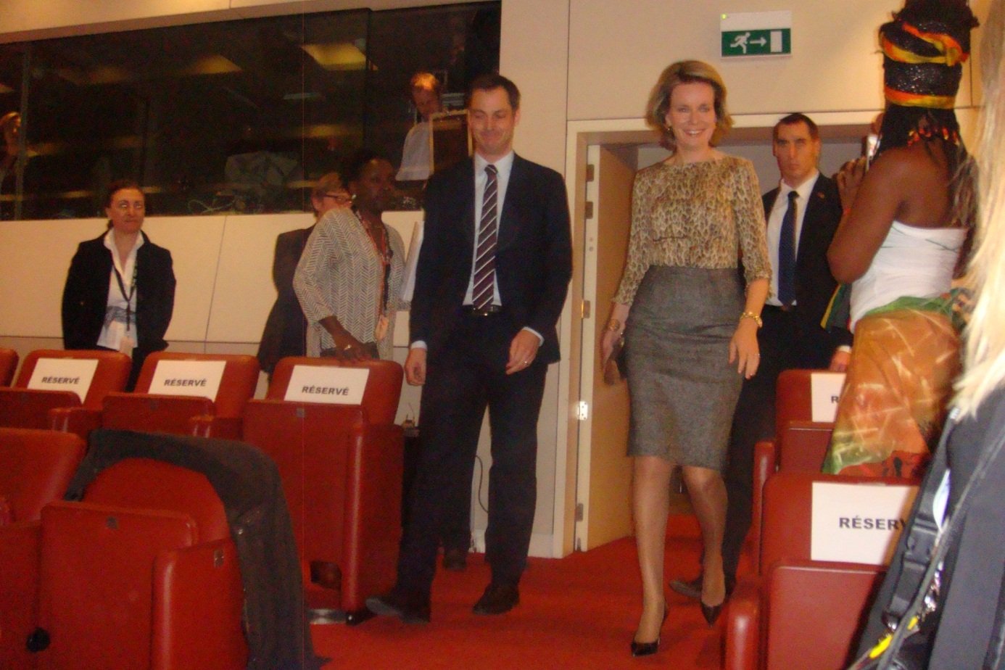

The Opening Ceremony counted on the attendance of *Her Majesty Mathilde, the Queen of the Belgians*, whose presence confirms and stresses the importance of this European Year for Development. *Queen Mathilde* also privileged this event with a magnificent elocution highlighting the sense of Culture as *«bildung»*, i.e. as education and training " visant à stimuler et à valoriser les talents des jeunes en créant un contexte qui leur permette de s’épanouir. L’art et la musique font partie intégrante de ce processus". Moreover, Her Majesty underlined as "very important for young people to have the opportunity to discover culture at a very early age. This exposure will arouse their interest and make them more aware of it later on". She also emphasised that culture is a valuable ally in the fight against poverty as Development assistance programs in this area contribute to the promotion and protection of freedom of artistic expression and democratic dialogue.

*Mr. Alexander De Croo, Deputy Prime Minister and Minister for Development Cooperation, Digital Agenda, Postal Services and Telecommunications* focussed his speech on the importance of coherence on European development policy, highlighting the approach to integrate Belgium’s development cooperation policy as much as possible in the European policy framework. "Our focus on the least developed and fragile states is only one example of similar outlook and vision." Also His Excellency added as common vision that "culture and development cooperation are two areas that are not only closely interlinked, but that also mutually influence each other ". Cultural diversity and interculturalism where mentioned as cornerstone of development as "a development policy that is “fit for purpose” per definition needs to be sufficiently culturally blended". Still in line with the EU vision the Prime Minister referred that a Human Rights based approach will constitute one of major axes in the Belgian Development Cooperation Policy as in certain countries rights are being contested and violated by the false use of religion or culture as a pretext and " in almost all cases have signed the main HR instruments. Mr. Alexander De Croo gave as an example the downgrading of women’s rights like sexual and reproductive rights, inheritance rights, equal access to education and work for women.

**Overview on the panels**

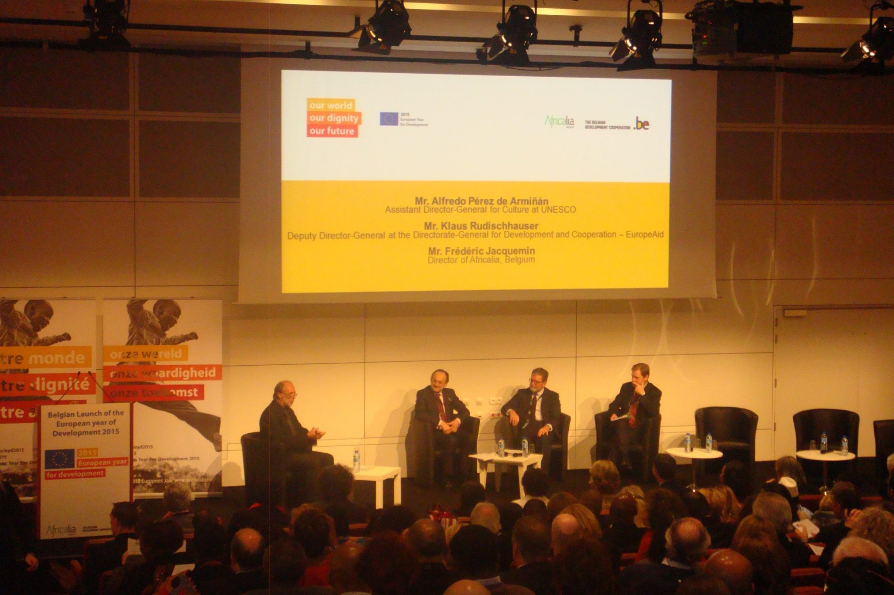

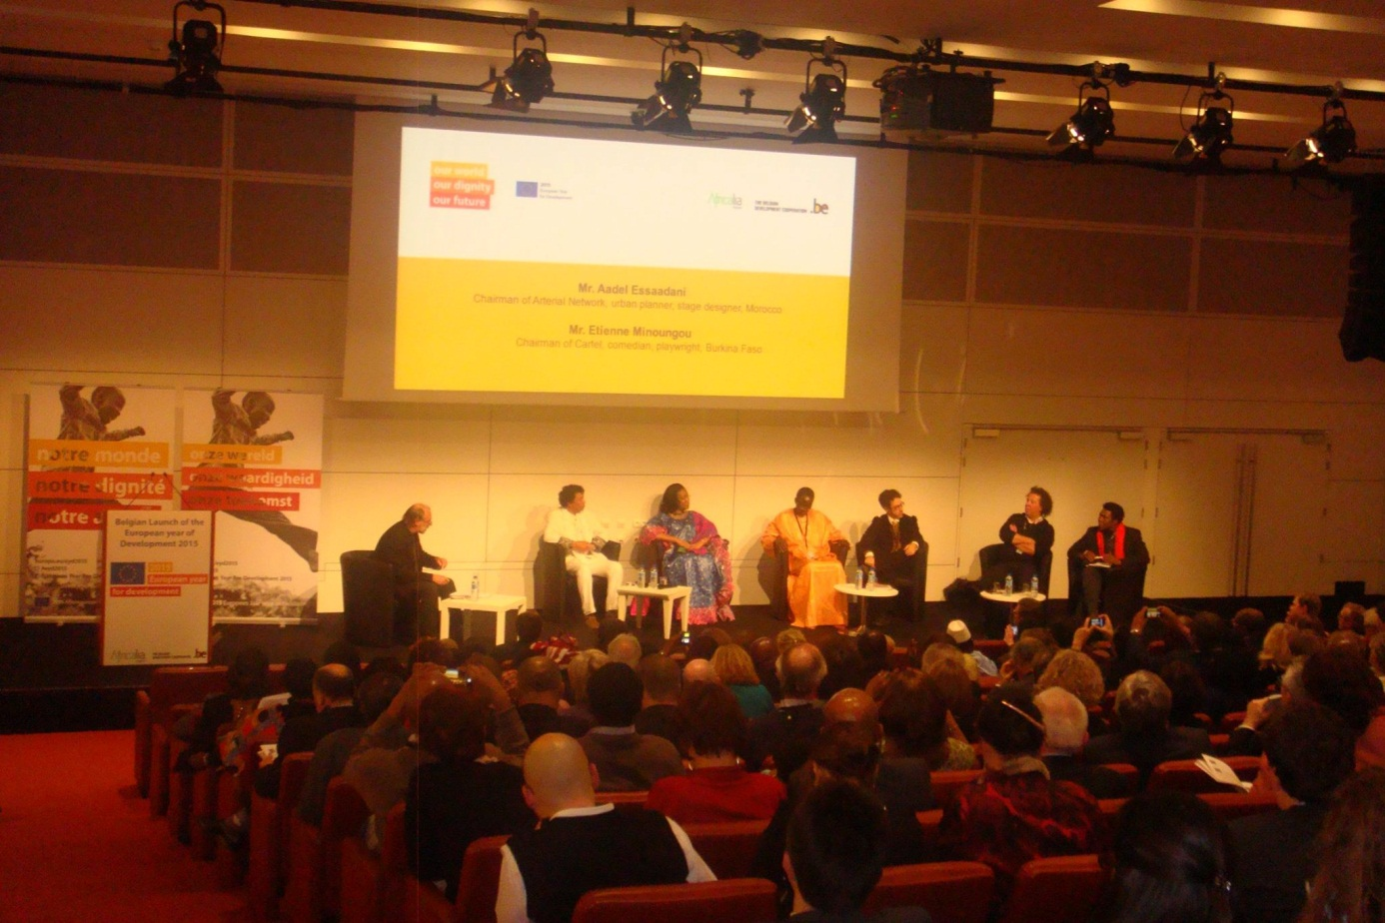

At the heart of this exceptional multidisciplinary event was the Debate: "Culture, pillar of Development Cooperation". This topic was discussed by a panel of experts, including: Mr. Mário Lúcio Matias de Sousa Mendes (Minister of Culture of Cape Verde), Ms. N’diaye Ramatoulaye Diallo (Minister of Culture of Mali), Mr. Klaus Rudischhauser (Deputy Director-General at the Directorate-General for Development and Cooperation – EuropeAid), Mr. Alfredo Pérez de Armiñán (Assistant Director-General for Culture at UNESCO), Mr. Aadel Essaadani (Chairman of the Arterial Network / MA), Mr. Frédéric Jacquemin (Director of Africalia / BE), Mr. Etienne Minoungou (Artistic Director of the festival Récréatrales / BurkinaFaso), Mr. Babacar Sarr (Chairman of FESFOP / SN) and Mr. Jordi Pascual (Coordinator, Agenda 21 for Culture / SP), and moderated by M. Gie Goris, rédacteur en chef de MO* Magazine/ Modérateur (Belgique) . The debate aimed to frame the role of Culture in the heart of Cooperation and Development "and was bound to feature this well-Known figures from the political or cultural world".

Following the panels, European Commission representative of International Cooperation and Development (DEVCO*), Deputy Director-General Klaus Rudischhauser* [3], on behalf of Commissioner Neven Mimica, open the first one *" Cultural diversity: a benchmark for better way of living tomorrow"*.

In reply to the question of the moderator, about what vision the EU would have on culture and development, KR stressed Democracy and Human Rights like Freedom of Expression as European Union’s guiding principles that the EU promotes vigorously in international cooperation, culture being a powerful tool to uphold human dignity, combat poverty, and defend equality and prevent conflict."

He recalled that under the EU development policy Agenda for Change (2014-2020)), Culture is recognized as an essential contribution to two specific objectives agreed with partner countries: Strengthening Human Rights and Democracy as essential elements of Good Governance, and Promoting inclusive and sustainable growth.

Then he explained that the European Union provides over 50% of all global development aid, is the world's leading donor, is present and active in most countries in the world. With 139 EU Delegations, spread around the globe the EU contributes to building solid and lasting partnerships on the ground: EU development aid goes to around 150 countries, ranging from Afghanistan to Zimbabwe. Having championed the UN Millennium Development Goals, the EU is now contributing to shape a global development agenda that will deliver lasting change and take us closer to the ultimate aim: a decent life for all. The EU is providing support to cultural and creative sectors in developing countries around the world, facilitating the development of sustainable cultural industries, helping to preserve the diversity of tangible and intangible heritage, providing support and training to professionals of Culture and prioritizing strong connection to Education .

Also the dialogue with civil society was highlighted by KR in this process as a very important factor not least because one of the main focus is on fragile countries. On the issue on how is Europe managing diversity/identity KR said: "we need increased dialogue and there are some issues in this area, as linked to tradition and religions, that are oppressive, eg female genital mutilation. We have to do this dialogue in a differentiated way" .

*Gie Goris* a donc introduit l'élément de discussion Emploi / Économie : en Europe, 7 millions de personnes ont un emploi dans les secteurs des industries culturelles et créatives, la culture etant le 3eme employeur européen. De nombreux instruments de soutien à la créativité européens en plus des politiques des Etats membres ont largement contribué à cette situation positive en soutenant l’offre (des artistes et de petits et moyens entrepreneurs culturelles) et la demande (accessibilité de la culture, subventions aux centres culturels, à la diffusion du cinéma, enseignement artistiques). Pourquoi cette logique gagnante face au chômage et à la crise, ne pourrait-elle pas être appliquée ailleurs alors qu’elle est gagnante en Europe? Pourquoi est-elle de manière générale sous employée dans les programmes de réduction de la pauvreté de l’Europe en direction des pays ACP."

KR reiterated that Europe is ready to engage in Culture. The Culture and Creative Sectors make a major contribution to social cohesion, job creation, and have a pivotal role in innovation, and they were taken as a priority namely in ACP countries. In developing countries, it is a sector with high potential, and issues such as education and training, or the promotion of mutual knowledge and skills transfer are all the more important.

The Economy of Culture is to transform the culture in a development strategy that supports the cultural heritage (built, mobile or performative) as memory, as constituent element of identity. It is essential to rethink the role of the EU in the challenges faced by different sectors in their contributions to the economy in particular taking into account the emerging markets, where demand for cultural products is growing.

The European Commission – EuropeAid in particular has an important role to play in ensuring that the EU is effectively represented internationally in this specific development policy matter.

*Le sous- Directeur général pour la culture de l'UNESCO, Alfredo Pérez de Armiñan,* a mis en évidence que l'Unesco et l'EU ont le même fin social, économique, écologique et humain: Le Développent Durable et la Culture comme vecteur, moteur, précondition du Développent Durable. " On ne peut pas avoir Développement sans Culture et ceci est valide pour tous les pays, c'est global ainsi que, l'Unesco comme Plateforme, Africalia comme représentant la Société Civile et l'EU comme le pilier institutionnel, les trois présents à ce panel on le même objectif , le Développent Durable a travers de la Culture".

Quand a la Diversité Culturelle ici soulignée il faut tenir en compte qu'il y a beaucoup de concepts associés à la" Culture" mais en ce qui concerne l'Economie de la Culture, c'est l' economie de partage. Il faut former des acteurs culturels, artistes, techniciens pour s'adapter a cette réalité et investir à la formation pour la gestion culturelle.

Africalia is an association supported by the Belgium Development Cooperation wich implements programmes supporting civil society operators involved in culture activities in Africa. About Africalia's policy framework, Director Fréderic Jacqmain, denoted the Africalia's philosophy is in line with the Cotonou Agreement; the UNESCO Convention on cultural diversity; the Millenium Development Goals and the Paris Declaration on aid effectiveness. Poverty is not just economic. Africalia considers art and culture as powerful tools to fight poverty in its various forms: social, educational, spiritual and economical."

**Conclusion**

This debate counted with an involved audience, including EU and African Ministers, Ambassadors, representatives from international organisations, NGOs, professionals working in Cooperation and Development in the European institutions, etc.

It showcased and highlighted the opportunities of the EYD2015 activities in terms of Culture, and showed how culture raises passionate debates.

2015 is the target date for achieving the Millennium Development Goals and the year in which the ongoing global post-2015 debate will converge into a single framework for poverty eradication and sustainable development at September’s United Nations General Assembly.

In this context, over the last 30 years, EU citizens have consistently shown strong support for development aid and cooperation: positive opinions range from 82% in 1984 to 83% in 2013. Despite the economic crisis, a recent survey by Eurobarometer[4] shows that 61% of respondents think that aid to developing countries should be increased. A majority also believes that international cooperation and development deliver benefits for them too so: 69% of EU citizens believe that tackling poverty in developing countries has a positive influence on EU citizens as well. Second National Expert

The European Year for Development 2015, foreseeing the organisation of conferences, events and initiatives with all relevant stakeholders, to promote active participation and debate, also highlights Culture as the lever for collective dignity we all want to build as "Culture is both a bridge between people and a means to challenge the status quo" as stated Gie Goris in closing remarks.

Article for Capacity4dev

**Olinda Martinho Rio**

**Seconded National Expert in Professional Training**

European Commission

International Cooperation and Development

Unit B.4 – Education, Health, Research, Culture

**Reviewer: Inês Alves**

**Responsible for Sector Culture**

European Commission

International Cooperation and Development

Unit B.4 – Education, Health, Research, Culture

1. Decision No 472/2014/Eu of the European Parliament and of the Council

   of 16 April 2014
2. Find out more in [www.africalia.be](http://www.africalia.be)

   Find out more at <http://www.bozar.be/afropean.html>
3. The Commission's Directorate-General for International Cooperation and Development is responsible for designing European development policy and delivering aid throughout the world.
4. Special Eurobarometer 405, November 2013