The Campaign FaGoW on the 3rd UN World Conference on Disaster Risk Reduction

We want to celebrate the success of the Campaign FaGoW .
We want to celebrate the success of the Campaign FaGoW on the 3rd UN World Conference on Disaster Risk Reduction UNISDR that took place in Japan from 14 to 18 March with more 8,000 participants.
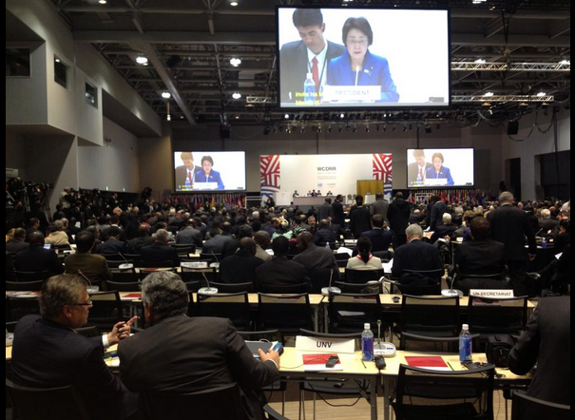
Among many projects submitted, they have selected FaGoW as one of the best experiences of using technology, innovation and good practice in disaster risk reduction.

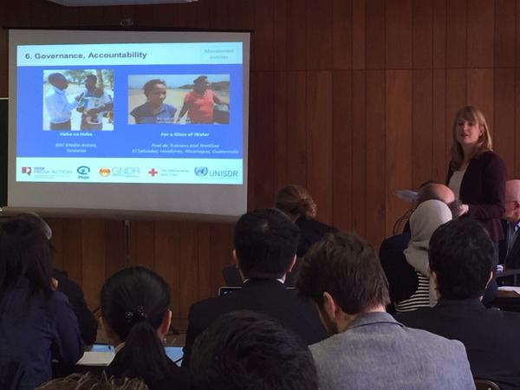
Also FaGoW has been selected in the official website of the UN Conference on Knowledge and Education section. It is an example of a campaign that has been successful in implementing the Hyogo Framework for Action (International Strategy for Disaster Reduction).
For a Glass of Water!

