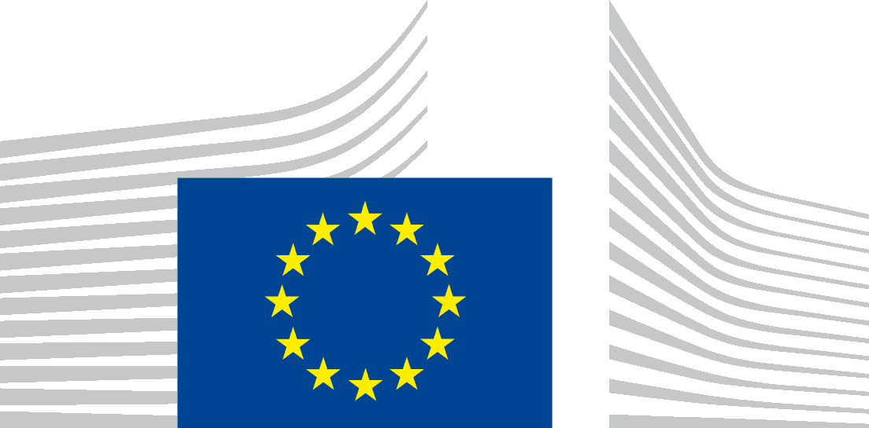 | EUROPEAN COMMISSION  Directorate-General for Development and Cooperation — EuropeAid
New operational information system – updated list of user group members
1. Members from HQ
 | Directorate | name | Unit of origin
1 | A | Virginia Manzitti, Lino Molteni  As back up of Ellen Kelly | A2
2 | B | Rui Costa/Edouard Van Vlasselaer | B5/B6
3 | C | Luca Busetto / Guglielmo Zanarelli | C5/C1
4 | D | Luigi Brusa | D3
5 | E | Grégoire Lacoin / Denise Richert | E3
6 | NEAR (ex F) | Ingrid Schwaiger (Neighbourhood South)  Rob De Lobel (Neighbourhood East) | C2  B2
7 | G | Sebastien Mairesse / Sebastian Molina Munoz | G3/G1
8 | H | Hans Juergen Scheck on behalf of J von Kirchman | H3
9 | R | Anne-Catherine Gridelet, Jean Yves Poncelet, Fabian Verhoeven | R1
10 | R | Fernando Centurione, Michel Martin | R6
11 |  | Thierry Vanden Bossche | 02
12 |  | Chris Korakas/Emilios Efthymiadis | 06
2. Members from EU Delegations
 |  | Delegation | name | function
 | 1 | Ethiopia | Fasika Kelemework | Op. section
 | 2 | Tanzania | Serena Bertaina | Op. section
 | 3 | Mali | Abdoulaye Kabdaogo | Op. section
 | 4 | Cote d'Ivoire | Geza Strammer | Head of Coop.
 | 5 | Malawi | Trijntje Talen | FC section
 | 6 | Bangladesh | Pierre-Yves Lambert | Op. section
 | 7 | Afghanistan | Cecilia Costa (Milko Van Gool, 05) | Op section
 | 8 | Cambodia | Georges Dehoux | Op. section
 | 9 | Peru | Denis Zanotti | Head of FC
 | 10 | Paraguay | Deisy Acevedo | Op. section
 | 11 | Georgia | Oliver Reisner  Mikolaj Bekasiak | Op. section
 | 12 | Morocco | Philip Mikos | Head of Coop.
3. Members from other DGs and service
 | DG/Serv. | User | unit
1 | NEAR | Farid Rahmi, Judith Novak, Carlo Battiston | E1/C/E3
2 | ECHO | V. Jonet | C2
3 | FPI | B Nieuwenhuis, J Rosa, A Sulola, Nona Deprez, E Troya Blanco (back up A Debongnie), | FPI/5, FPI/1, FPI/2, FPI/4

