Component 5
Results management
High level business requirements

V0.2 of 23/03/2015
Author: TF/P Riembault

Context and summary:

Managing, measuring and aggregating results is one of the biggest challenges for the OpSys. DEVCO misses the practical experience of a result Framework with lessons gathered over some years, which could have guided us for designing the system.
Therefore, the proposed approach has been prototyped (see annex). This makes it more robust, however, further feeding the prototype with real programmes would be necessary in order to stress test the approach and to assess user behaviour and needs.
The proposed requirements are supported by the new logic based on the notion of Programme. The Programme is the key entity to monitor and measure achieved results during implementation.
The proposed requirements aim at:
- managing the results from Programming to implementation
- monitoring the Programmes around an online logframe. This relies on the assumption that Action Documents (as well as the related contract documents when necessary) should not only indicate envisaged results, but also their baselines and targets.
- matching local Programme indicators with the EU result framework indicators
- letting the implementing partners/entities enter the achieved results into the OpSys, in order to make the proposed approach manageable, and to avoid double encoding. To achieve that, contracts should include a clearer obligation for the contractor to contribute to the results of the Programme and to encode them in the system.
- introducing a level of flexibility in so far that the system should allow users to create other Matching indicators for aggregating results according to their needs, in particular: for other DGs which priorities are not reflected in the (DEVCO) EU result framework indicators, for centrally managed programmes for which key objectives are not also not reflected by EU RF indicators, similarly for countries in which an important objective is also not covered in the EU RF.
- aggregate achieved results along 2 dimensions (1) by EU result indicators or Other Matching Indicators, and (2) by country.
Result management will also allow substantiating KPI 6 on achieving programme objectives.

1 Context/References 3
2 Concepts 3
3 Actors 3
4 Description of the requirements 3
4.1 Business need: results management 3
4.1.1 Business process: Prior to all phases 3
4.1.1.1 AS IS 3
4.1.1.2 TO BE Requirements 3
4.1.2 Business process: Programming 4
4.1.2.1 AS IS 4
4.1.2.2 TO BE Requirements 4
4.1.3 Business process: Identification & Formulation 4
4.1.3.1 AS IS 4
4.1.3.2 TO BE Requirements 4
4.1.4 Business process: Implementation and end-of-Programme reporting 4
4.1.4.1 AS IS 4
4.1.4.2 TO BE Requirements 4
4.1.5 Results: data structure (valid through all phases of the PCM) 6
4.1.6 Results: permissions (valid through all phases of the PCM) 6
4.1.7 Results: Dashboarding and aggregation 6
Annex 1 – Results management in the prototype 8

Context/References
- EU results framework
- Methodological guidance (PCM, SPSP, BS guidelines)
- Instructions notes (Unified Action Document, Programming instructions..)

Concepts

Local Indicator | An indicator used in EC external relations operations (not aggregatable)
EU Indicator | A predefined aggregatable indicator, which is listed in the EU result framework (level 2).
Other Matching Indicator | A user defined aggregatable indicator

Actors

Programming phase:
- Programming manager
Identification and formulation phase:
- Action manager
Implementation phase:
- EC Programme Manager
- EC Contract Manager (when a Programme is multi-contract)
- EC Lead Programme manager (for centrally managed calls for proposals, etc.)

- Implementing Entity Programme Manager
- Partner country Programme Manager
- Partner country Aid Coordination Manager

- ROM contractor Results reporting expert (end of Programme result reporting)
All phases:
- Process coordinator: HQ Result support coordinator

Description of the requirements

Business need: results management

Business process: Prior to all phases

AS IS
Manually consolidated Excel files.

TO BE Requirements

HQ Result support coordinator needs to:
  - trigger: enter a list of EU Indicators –CUD-Must
  - trigger: validate the matching relations between Local Indicators and EU Indicators
  - trigger: when updating an EU Indicator, he/she needs to retrieve all matching relations created between the existing EU Indicator and Local Indicators, and he/she needs to be able to update these relations (either individually or by clusters) –CUD-Must

Business process: Programming

AS IS
Tables written on Word files

TO BE Requirements

Programming manager needs to:
  - trigger: enter a structured sector intervention framework describing the anticipated results and indicators for a given sector of concentration –CUD-Must
  - trigger: enter a structured list of matching relations between Local Indicators and EU Indicators –CUD-Must
HQ Result support coordinator needs to:
  - trigger: update and validate the above structured list of matching relations – CUD - must

Business process: Identification & Formulation

AS IS
Unified Action Document drafted on word files.
Currently no consolidation, the Result Framework needs a system to be implemented.

TO BE Requirements
Action manager needs to:
  - trigger: enter an online logframe (or result indicators list for Budget support) including intervention logic (result), Local Indicators and related matching indicators, baseline, intermediary and final targets, and their related sex-disaggregated values – CUD – must
  - trigger: create new Local Indicators and propose matching relations with EU Indicators – CUD - must

HQ Result support coordinator needs to:
  - trigger: update and validate the newly proposed matching relations between Local Indicators and matching indicators (the ones which have not yet been validated at an earlier stage) – CUD - must

Business process: Implementation and end-of-Programme reporting

AS IS
Manual processes, no consolidation.

TO BE Requirements

Implementing Entity Programme Manager needs to:
  - trigger: enter result indicators final and intermediary achieved gross values, as well as final and intermediary net values (in case the Local Indicator is referencing an EU Indicator or an Other Matching Indicator) – CUD - must
Implementing Entity Programme Manager needs to (baseline and targets):
  - trigger: submit/launch a process of updating baseline and target values – CUD - could

Partner country Programme Manager needs to (achieved values):
  - trigger: edit, accept or reject result indicators final and intermediary achieved gross values, as well as final and intermediary net values (in case the Local Indicator is referencing an EU Indicator or an Other Matching Indicator) – validation is explicit or by silent approval - CUD – should
Partner country Programme Manager needs to (baseline and targets):
  - trigger: edit, accept or reject result indicators baseline and targets– validation is explicit or by silent approval - CUD – should

EC Programme Manager needs to (achieved values):
  - trigger: edit, accept or reject result indicators final and intermediary achieved gross values, as well as final and intermediary net values (in case the Local Indicator is referencing an EU Indicator or an Other Matching Indicator) – validation is explicit through the “Conforme aux faits” visa - CUD – must
EC Programme Manager needs to (baseline and targets):
  - trigger: edit, accept or reject result indicators baseline and targets– validation is explicit or by silent approval - CUD – should
Validation/rejection by partner country Programme manager and EC Programme manager are parallel (not sequential).
Partner country Aid Coordination Manager needs to:
  - trigger: access complete result file (included draft data) in his/her country - R – should
  - trigger: access result file (without draft data) across the system - R – could

ROM contractor Results reporting expert (end of Programme result reporting) need to:
  - trigger: access complete result file for the Programmes he/she is in charge - R – should
  - trigger: access result file (without draft data) across the system - R – should
  - trigger: for the purpose of the “end of Programme result reporting” and provided the implementing entity Programme manager has left the Programme, the ROM contractor Results reporting expert needs the same rights as the implementing entity Programme manager: he/she needs to edit and create result indicators values which are submitted to validation of the Partner and EC Programme managers – CUD - should

Supplementary requirement for Budget Support programmes:
HQ Budget Support Programme Manager needs to (baseline and targets):
  - trigger: edit, accept or reject result indicators baseline and targets– validation is explicit - CUD – must
Validation/rejection of baseline/targets updates by partner country Programme manager, EC Programme manager, HQ Budget support Programme manager are parallel (not sequential).
HQ Director needs to (baseline and targets):
  - trigger: edit, accept or reject result indicators baseline and targets– validation is explicit - CUD – must
Validation/rejection of baseline/targets updates by Director can be included in a batch approval – CUD - could
Supplementary requirement when the Programme is at contract level (typically a call for proposals):
Implementing Entity Programme Manager needs to:
  - trigger: enter an online logframe including intervention logic (result), Local Indicators and related matching indicators, baseline, intermediary and final targets, and their related sex-disaggregated values – CUD – must for the successful Programme proposal, could for the Programme proposals during call for proposals phase.
  - trigger: create new Local Indicators and propose matching relations with EU Indicators – CUD - must
HQ Result support coordinator needs to:
  - trigger: - For the successful Programme proposal only - update and validate the newly proposed matching relations between Local Indicators and matching indicators (the ones which have not yet been validated at an earlier stage) – CUD - must

Results: data structure (valid through all phases of the PCM)

  - An intervention logic (a result) can be referenced by several Local Indicators
  - A Local Indicator can refer (match) to an EU Indicator
  - A Local Indicator can refer (match) to an Other Matching Indicator
  - A Local Indicator (referencing a result) is referenced by several result indicator values such as:
    - A baseline
    - Final and intermediary target
    - Final and intermediary achieved gross values
    - Final and intermediary net values (in case the Local Indicator is referencing an EU Indicator or an Other Matching Indicator)
  - Each result indicator value (baseline, target, achieved gross value, net value) has a reference year
  - Each result indicator value (baseline, target, achieved gross value, net value) can be split in value for women/girls, value for men/boys

Results: permissions (valid through all phases of the PCM)

EU Indicators:
  - An HQ Result support coordinator needs to create-update-delete an EU Indicator
  - An EC process manager cannot create an EU Indicator

Local Indicators and Other Matching Indicators (OMI)
  - An EC process manager needs to create a new Local Indicator and a new OMI
  - An EC process manager needs to update-delete a Local Indicator (and a new OMI), provided he/she is the only EC process manager to use it.
  - An EC process manager needs to launch/submit a process of update-delete a Local Indicator (and a new OMI)
  - An HQ Result support coordinator needs to create-update-delete a Local Indicator (and a new OMI)

Results: Dashboarding and aggregation

The main Programme dashboard should include a “result quadrant” with:
  - the list of indicators
  - the achieved values
  - the “progress to target” as a percentage representing the achieved progress compared to target
  - a colour coding (traffic light style) indicating whether the “progress to target” is satisfactory compared to the time elapsed: All 4 bullets are “R-should”

As the online logframe will serve as a Programme monitoring tool, it should be automatically updated.

For an EU Indicator or an Other Matching Indicators, it should be possible to display:
  - the list of Programmes contributing to this indicator (R-must)
  - the achieved values over time or year by year (R-must)
  - the aggregated value overall or year by year (R-must)
  - the aggregated value overall or country by country (R-should)

For a given country or region, it should be possible to display:
  - the list of Programmes contributing to EU Indicators or Other Matching Indicators (R-must)
  - the achieved values over time or year by year (R-must)
  - the list of “unmatched” Local Indicators and there values (R-could)
It should be possible to tag a number of those indicators as “key country result” for a given reference year (C-U-D should).

The “key country results” will be highlighted in country fiches, and the internet website (R should).

Annex 1 – Results management in the prototype

The purpose of this annex is to illustrate the above requirements.
The prototype represents the beginning of a possible implementation of the results management component. However – as its purpose was to support reflection and the below screens and workflows have been developed in a short time - it should not constrain the design of the future system. The main characteristics of the current prototype are:
- Online logframe for every programme (called "project" in the prototype)

- Values of indicators are being actualised by the implementing partner as the Programme is being implemented

- Aggregation of results according to the EU results framework

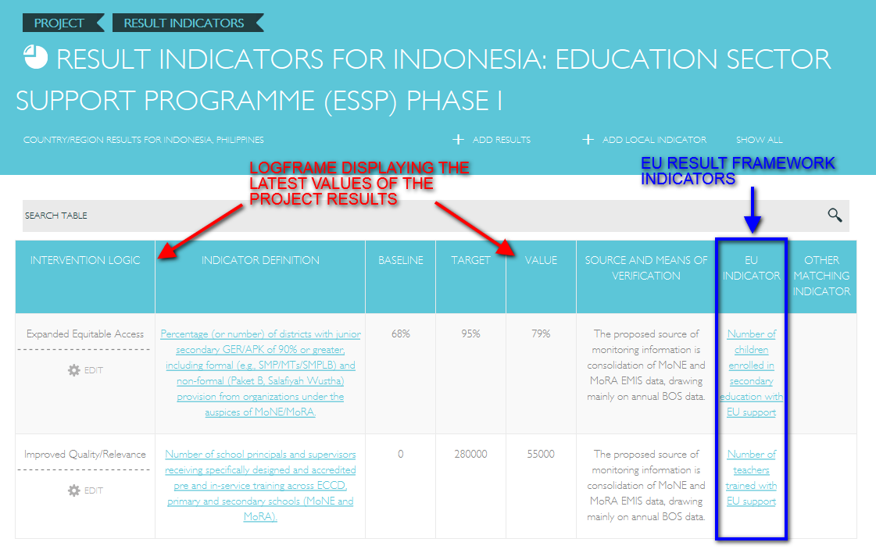
At this stage, the coherence of the result cycle is insured by:
- use of the indicators validated at the programming phase
- use of the Action Document logframe
- correspondence of Local Indicators with EU or Other Matching Indicators, which allows to aggregate the results at different levels.
The Programme entity is the foundation for managing the results at implementation stage.

Results are managed through 4 data bases:
- 1. results
- 2. Local Indicators (possibly more than one per result)
- 3. result indicator values (yearly values of baseline, targets, achieved values and net values)
- 4.a. EU Indicators (matching with Local Indicators)
- 4.b. Other Matching Indicators (same db as the EU Indicators: matching with Local Indicators)
Step by step guide for implementing the results cycle in the system:

1) During the formulation phase, the user enters the logframe including the baselines and targets
The system keeps track of the link between Local Indicator and EU results indicator (or Other Matching Indicators).

Therefore the system proposes the user to apply Local Indicators which have already been linked to EU result indicators.

Alternatively the user may create its own Local Indicator.

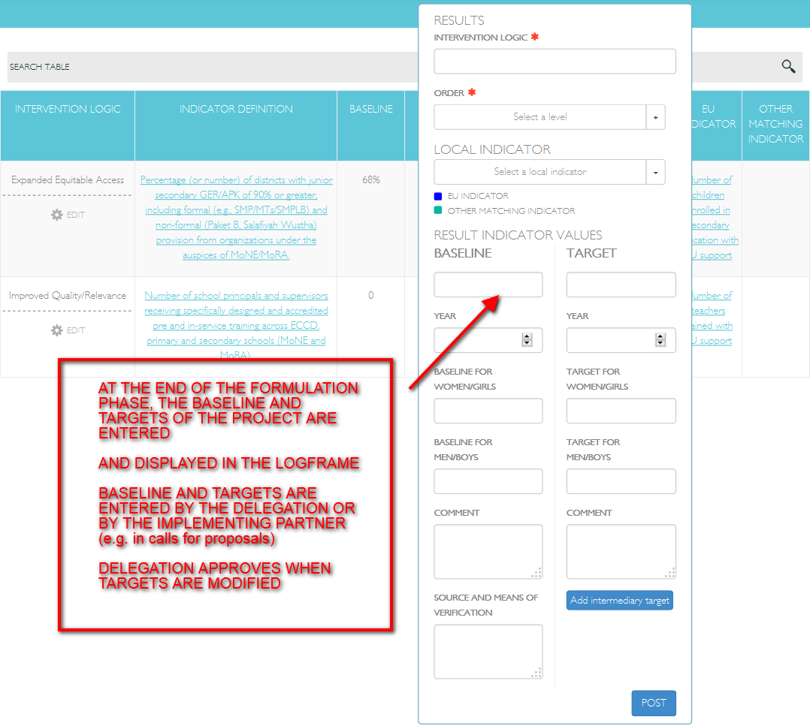

A form allows the user to enter values in the 4 different databases of the system in one go.

2) If necessary, intermediary targets can be added

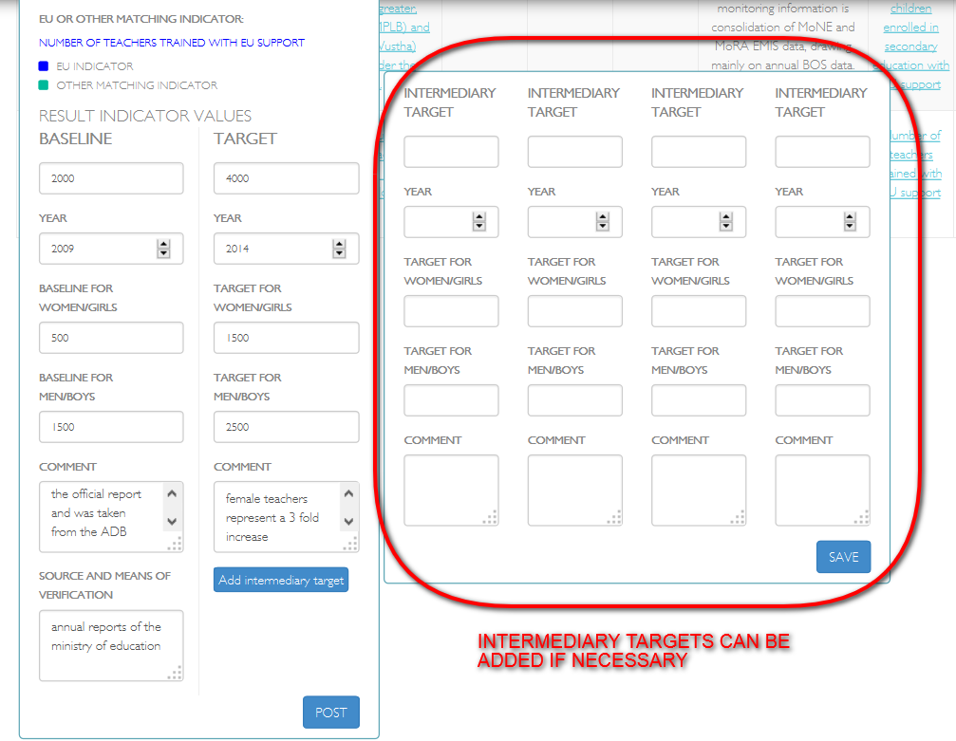

The baseline and targets can also be edited.

3) During the implementation phase, the implementing entity enters the achieved values
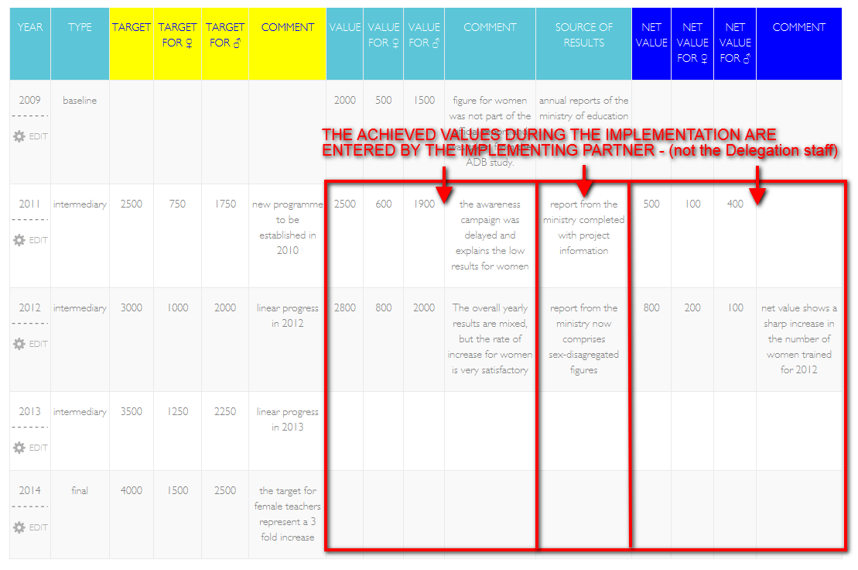
The latest achieved values are actualised in the online logframe
The targets can be edited by the Operational managers

A differentiated access could be easily implemented, for restricting the "write access" of implementing contractors/entities to the red square of the table.

4) Aggregation and display of results:
Given the sophistication of the data structure, a high number of aggregations is possible. For the time being, the system allows only the main types of aggregation: By EU Indicators, or By country/region.

- display by EU Indicator:

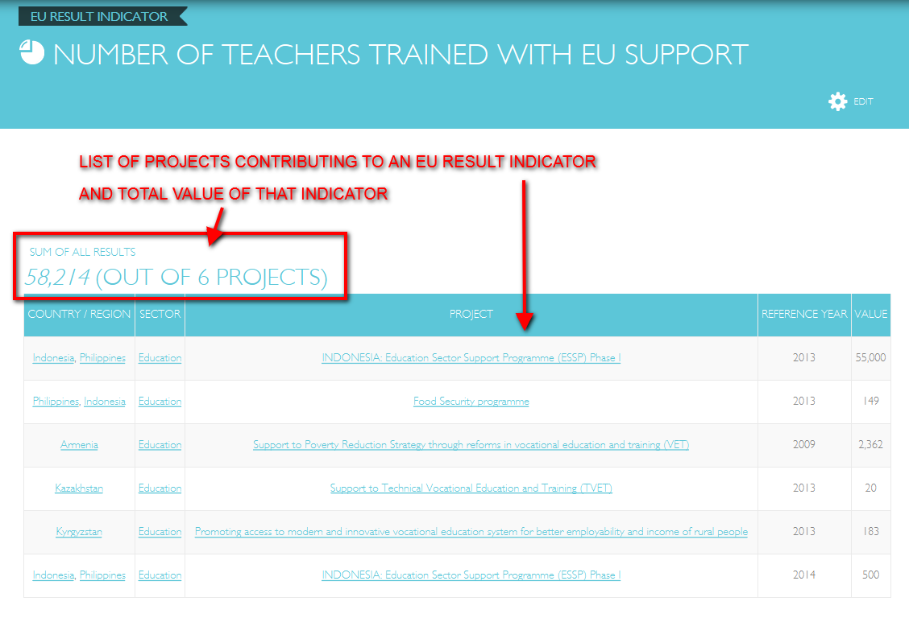

- display by country/region:

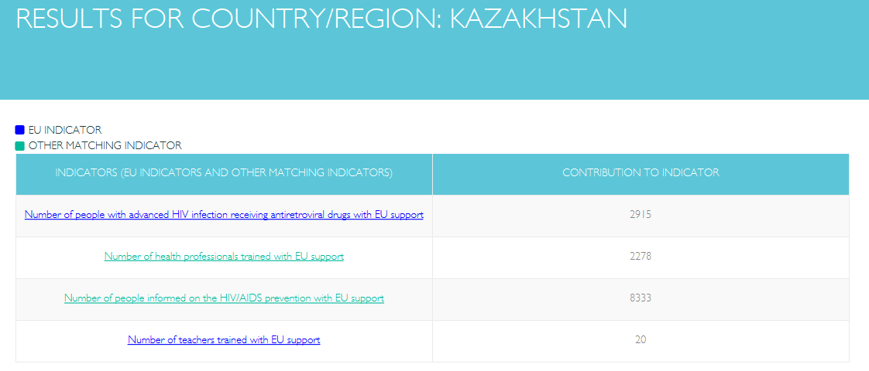

Given the fact that the EU result framework indicators cannot cover the full extent of our cooperation, it is necessary to offer the user the possibility to aggregate other important results for example at country level.

Such possibility has been implemented in the system as "Other Matching Indicator". It will allow to manage a "key country result" on which a Delegation would like to report at country level, but which does not belong to the list of EU RF indicators.

Similarly, the "Other Matching Indicator" could be used by other DGs which would like to implement specific Non-DEVCO results indicators.

