Youth4Foresight Toolkit

JANUARY 2024

2

Detectives of the Future

Purpose: Learning how to identify and understand emerging signals of the future in the present.

Time taken: 90 - 120 minutes

Participants: For the whole youth advisory structure in the first uses of the tool and later, in each thematic committee.

Difficulty level: Medium

What comes before: It can be done as a standalone tool or after “Images of the Future”.

What comes after: Start practicing this skill regularly in each thematic committee, scanning the horizon to better understand the present and identify what’s emerging. The trends identified can be then used to feed the “Futures Wheel” exercise.

Videos: Introduction to Foresight, Introduction to Detectives of the Future

Group sizes: Groups of 3-5 people based on thematic committees or randomly allocated.

Facilitation: The exercise should be facilitated by a Youth Focal Point or experts/technical assistants (in which case the “Why use this tool?” and “Instructions” parts can be shared with the participants beforehand). Later, youth advisory structure members can self-facilitate the further use of this tool in their own committee groups if they have read this whole document.

Why use this tool?

For the second step of this foresight process, we move from understanding ourselves as individuals and as a group, reflecting about images of the future, towards understanding the greater context of the world around us.
“Detectives of the Future” is a game-style exercise that consists in acting as detectives to find trends, patterns and useful insights, among the “noise” of the world around us. This process is often known as Horizon Scanning, and it is a powerful tool for making sense of the underlying complexity around us.
This tool helps us learn a skill through hands-on exercises in a fun and engaging setting, as we become “Detectives of the Future”.
Using the metaphor of the detective, we reinforce the importance of the detective skills, like objectivism, curiosity, openness and awareness of one's own bias when exploring our contexts.

EU Definitions
Horizon Scanning: Systematic seeking and spotting early signs of potentially important emerging trends in the present with potential future impacts. Its purpose is to provide timely awareness of what is new or changing – to identify risks, as well as opportunities, that emerging trends can create.

Sign of new: Information (factual, sourced) about developments around us, which might indicate something new, different (i.e., “emerging issue”) that may have a significant impact on the system under consideration.

Signal of change: A piece of potential evidence for a trend. This can be a small or local innovation or disruption that has the potential to grow in scale and geographic distribution. A signal can be a new practice, a new policy, or innovative technology. It can be an event, a local trend, or an organisation. It can also be a recently revealed problem or state of affairs. Often signals are derived from signs of new.

Trends: A general direction in which something is developing or changing. A trend may be strong or weak, increasing or decreasing in intensity, or stable. Trends represent gradual but long-term change in factors that will define the future of an organisation, region, country or topic.

The main outcome of this tool is not that much identifying trends per se, but instead practicing the art of the horizon scanning process and gaining the skills of:
- Identifying patterns
- Surfacing underlying insights from the signs of news
- Reflecting on our own bias and assumptions when identifying trends that are already known for us or that we are interested in.
- The importance of being open to discover “unknown - unknowns” and to listen to others interpretations of the signs of news and trends.
- Learning to identify what is emerging at a global, regional and local level and having a better and deeper understanding of their context, may help participants to better articulate the challenges and opportunities around their own work.

Instructions

Step 1: Individual reading of the signs of new (15 minutes)
Each individual spends 15 minutes quietly reading the headlines of the Signs of new.
While reading, the participants are encouraged to start reflecting following these questions:
- Are there any patterns that they identify?
- What could be the driving forces of these news, policies or innovations? Why are they happening now?
Step 2: Sharing and reflecting within groups (15-20 minutes)
In groups (3-8 people), each one should share what they have identified and what caught their attention.
Participants are reminded that we are detectives! Our subjectivity is not a good companion for this exercise. We should keep our minds open to others' ideas and reflections. No one has the right answer. The group is trying to find patterns and trends, to make sense of the present and more easily identify potential opportunities and threats that emerge from these changes.
Step 3: Clustering (20-25 minutes)
Each group clusters the signs of new according to any patterns and trends they see emerging. Groups should try to cluster at least three articles into each trend.
When they have a cluster of related signs of new, groups should create a post-it note to name each emerging signal of change/trend that they have spotted. Each group should try to find at least 3 emerging signals of changes or trends.
As detectives, we need more than one clue to make a valid conclusion, we cannot base ourselves just on one or two clues (one or two signs of new). Groups should go beyond the surface. When naming the trends, remember to name them based on what is changing, what is different, what is emerging (e.g. Instead of just naming the trend “Artificial Intelligence”, we should reinforce what is changing: “Increase awareness of ethical challenges of AI”)
Step 4: Sharing the findings with the bigger group (20 minutes)
All groups share the trends that they have identified along with the main insights from their discussions. Groups can share what trends were the most surprising, or what trends could be the most impactful (in terms of both opportunities and threats)?
NB: When this tool is used independently in thematic committees, this step can be skipped.
Step 5: Reflections and learnings (10-15 minutes)
The groups discuss in plenary to reflect on the main learnings of the exercise. Each group presents what they have learned from the activity. The following questions may be useful:
- Do you think you are now more capable of finding emerging signals of change?
- How can you start applying the skills learned in your youth advisory work?

What next ?

After the first training of the detectives of the future skills, helping them to better identify and even anticipate change, youth advisory structure members can continue practicing so it becomes a habit and informs their thematic committees’ work. Critical and systems thinking, attention to details and to what is not at plain sight are critical competencies to understand our complex context and to start making sense of it.
The trends and signals of change identified can be explored in depth in the next exercise: Futures Wheel
How to take action:
- If the participants feel ready to start their own Horizon Scanning process in their thematic committees, looking for signs of new and identifying signals of change and emerging trends in their area of interest, they can use these sources as a starting point. You may want to explore and add regional and local news agencies for more stories.
- Encourage participants to create a plan to run horizon scanning exercises periodically (every two weeks, every two months, twice a year…). The important thing is to create the habit and train the gaze to constantly scan the horizon so we can anticipate early signals of change before it becomes mainstream. In this way, we become proactive instead of reactive agents!
- All the signals of change and emerging trends that thematic committees identify could serve as inputs for their Three Horizons exercise, giving them a deeper understanding of their context and more clarity on what potential recommendations they can articulate.

Preparing for the workshop

For a virtual workshop:
- Prepare a digital whiteboard with the “Detectives of the Future” template. You can copy the Miro board template here, making sure each group has a separate space to work.
- Add in the Board the signs of new identified in this document (the first time by the YFP and/or experts/technical assistants, and later by the youth advisory structure members in their own thematic committees), by copy pasting the links on the Miro Board. You can find a useful list of signs of new prepared for this toolkit here. Do not hesitate to add more local, national, and regional signs. Members can also use this document to add their own signs of new for their thematic committees’ workshops.
- Define the groups based on the thematic committees or select groups at random.
- Make sure the participants have knowledge on how to use digital whiteboards like Miro. If not, dedicate some time to using the tool beforehand (navigating the whiteboard, zooming in and out, creating post-its, etc.). You might want to create an icebreaker activity to teach people how to use the platform.
For an in person workshop:
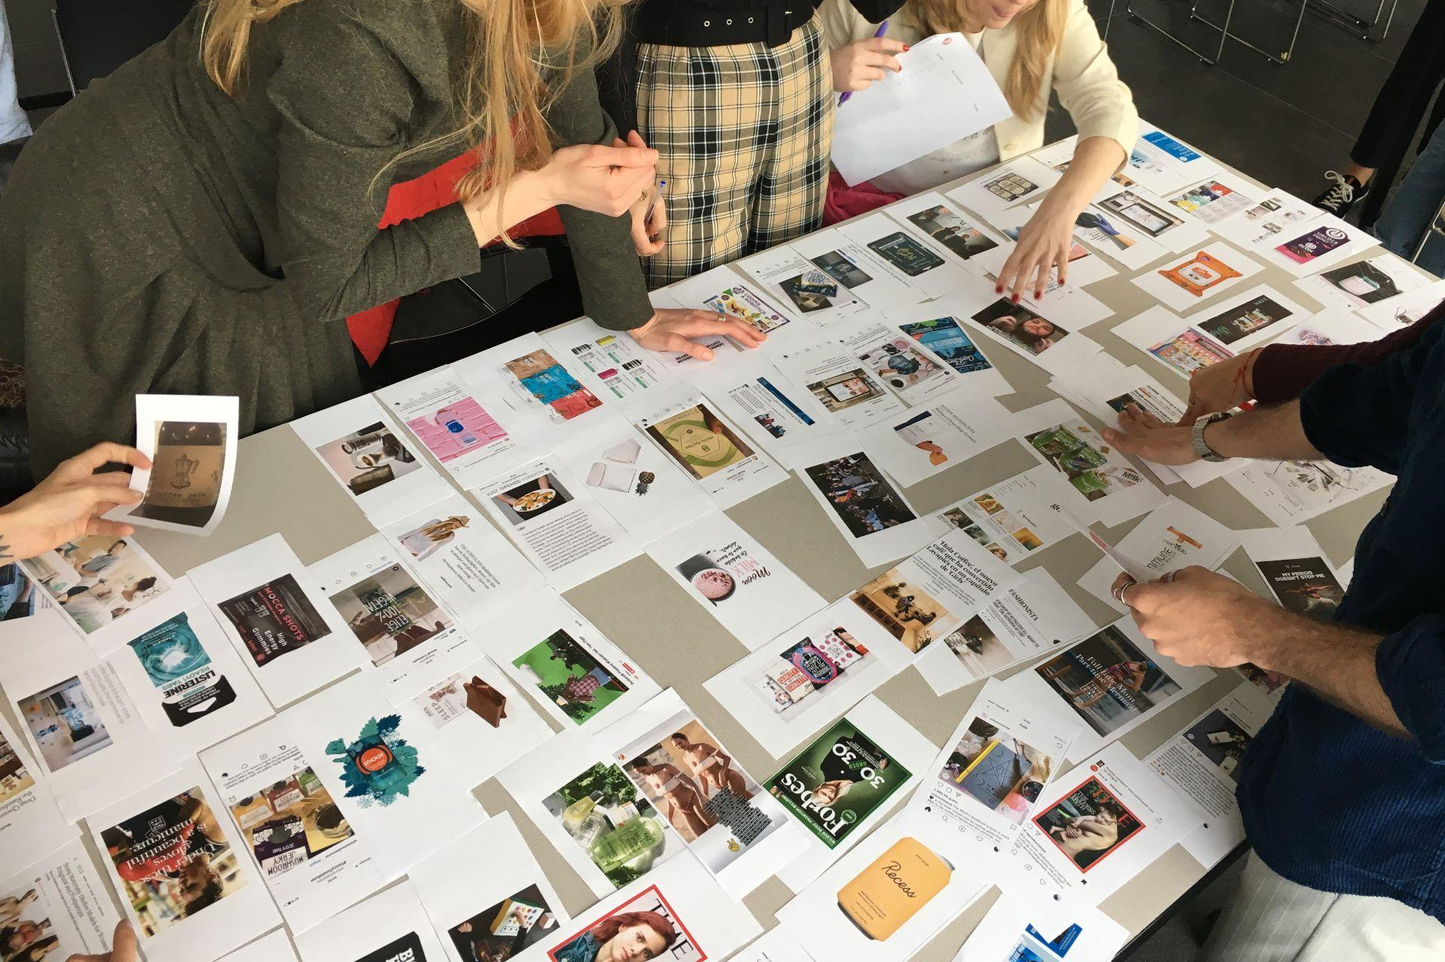
- Add the signs of new identified in this document (the first time by the YFP and/or experts/technical assistants, and later by the youth advisory structure members in their own thematic committees) and print them. An easy way of doing it is first including the links of the articles (signs of new) in Miro, then doing a screenshot of each one of them and including them on the template. Print and cut the individual signs of news. Remember you should print copies for all the groups participating.
- Make sure the room has enough tables for each of the groups.
- Make sure each table is big enough to spread out 50 or 60 small pieces of paper. See picture ➡️

Facilitator tips

- Make sure all the members of each group are participating and being heard.
- When participants are working in groups, make sure everyone understands the assignment and is following it.
- Reinforce the idea that there are not right or wrong answers. The main objective is to learn to make sense out of the complexity that surrounds us, so we can better identify and anticipate potential opportunities and challenges that emerge from the changes.
- Try to encourage and challenge the participants to become real detectives, reminding them to stay curious, open and objective. They are trying to find clues of the future in the present!
We acknowledge that YFPs are busy with many responsibilities and may not be able to identify further local, national, and regional signs of new. This does not need to be a problem, as the main outcome is not to discover new trends, but to learn skills on how to find relevant insights and patterns from the ongoing flux of news that we receive every day. Youth advisory structures members can later on find their own signals of change and trends in their own topic or committee groups.

Suggested exercise timings

Please note that you can expand the timings to suit your group but always try to keep your session less than 3 hrs.
Introducing the activity | 15 minutes
Step 1: Individual reading of signs of new | 15 minutes
Step 2: Sharing and reflecting within the group  Step 3: Clustering | 15 - 20 minutes  20 - 25 minutes
Step 4: Sharing the findings  Step 5: Reflections and learnings | 20 minutes  10 - 15 minutes

Case studies
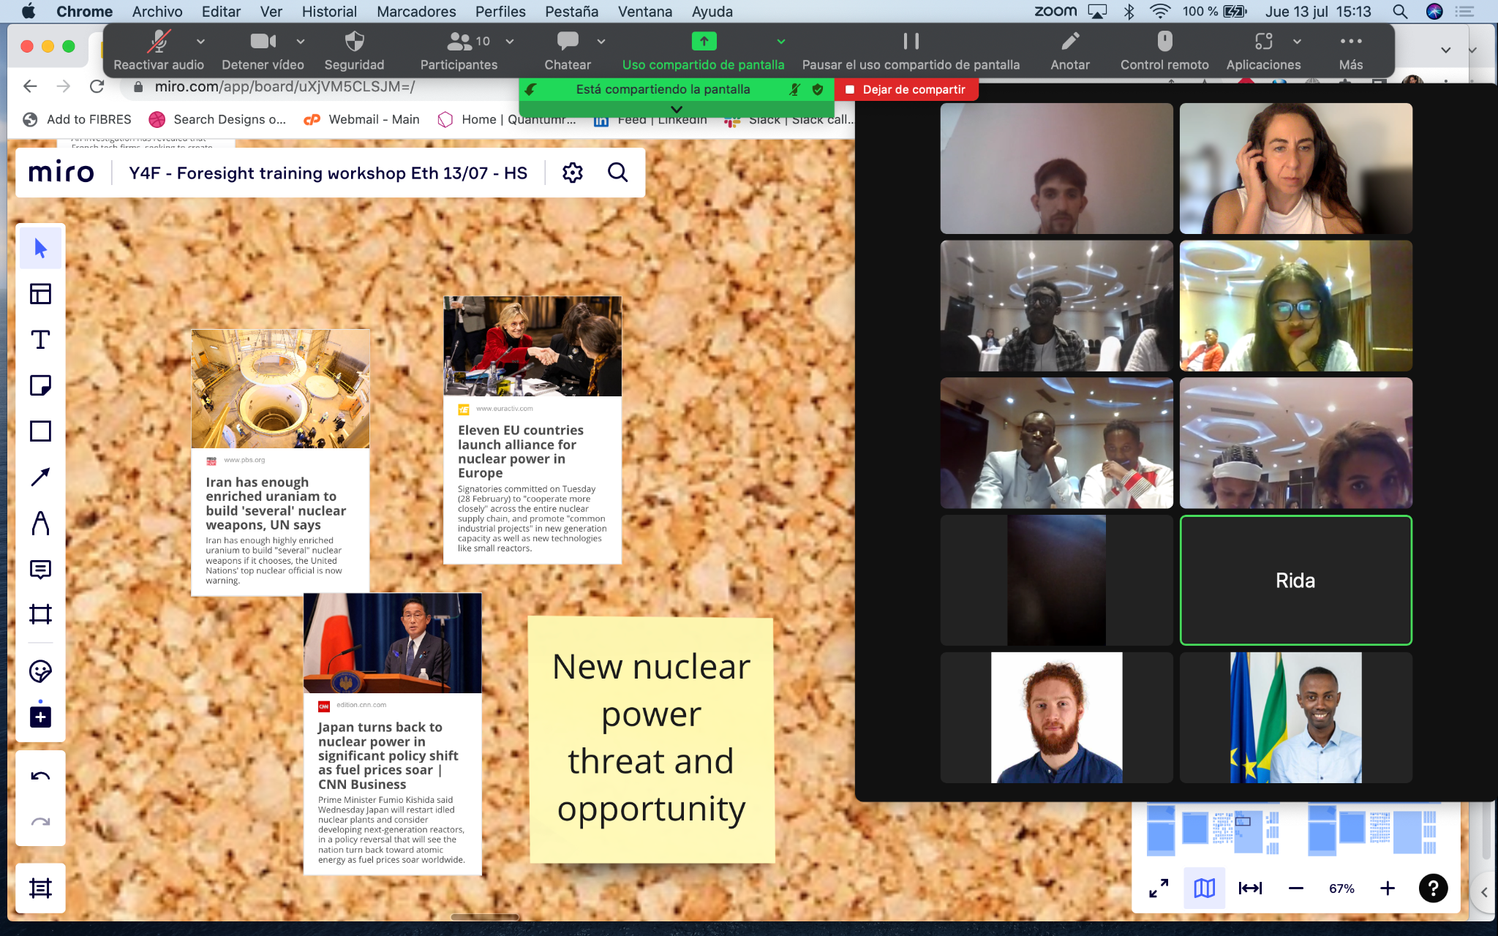

Ethiopia

The YSB of Ethiopia experienced the “Detectives of the Future” tool in a hybrid setting. All their members were together in the same room with the Technical Assistants and from an online Zoom call, they received the support from the consultants hired to develop the toolkit. The exercise itself was conducted through a digital whiteboard (Miro).

Here are some of their anonymous comments after the exercise:
“As a learning experience, this introduction training was very
interesting to me. I have got a chance to discuss what's happening
around us and how this would signal the new change.”

“It was an amazing experience. I learned a lot by reading articles
and making sense of the weak signals about what's going on
around us and how this would signal something which could be
the driver of change.”

“Since the workshop combines presentations with group discussions, practical exercises, and guided sessions. It inspires me to question my assumptions, consider alternate outcomes, and think critically. Also I learned to appreciate different viewpoints and work together to develop innovative solutions.”

Even though most of their comments were positive, the hybrid format brought some technical difficulties due to loss of internet connections and lack of previous knowledge in using the digital whiteboard. For that, we encourage you to use this tool as any other to a 100% physical or virtual setting.

Useful links

- Template for printing signs of new
- Document where signs of new can be added and signs of new are ready to be used
- Template Miro Board
- Video Introduction to foresight
- Video Detectives of the Future

Additional resources

- Competence Centre on Foresight
- European Strategy And Policy Analysis System
- Video: Horizon Scanning from “Systems Innovation”
- Feedly - An online tool to collect urls, which facilitate the monitoring and early detection of signs of new

