Youth4Foresight Toolkit

JANUARY 2024

3

Futures Wheel

Purpose: This exercise is designed to generate new ideas and spark interesting discussions about the future of a topic

Time taken: 90 minutes

Participants: For the whole youth advisory group or in specific thematic committees.

Difficulty level: Easy

What comes before: The exercise uses the signals of change or trends identified, and helps to ‘flesh out’ into ideas about future worlds.

What comes after: The ideas generated will help to complete the Three Horizons exercise.

Videos: Introduction to foresight, Video Futures Wheel

Group sizes: Groups of 3-8 people

Facilitation: The exercise can be facilitated by YFP and/or experts/technical assistants (in which case the “Why use this tool?” and “Instructions” parts can be shared with the participants beforehand).However, it is a good exercise for members to start engaging the self-facilitation of an easy Foresight exercise by reading this whole document.

Why use this tool?

This is the moment when you get to remove your training wheels and launch yourself into an exploration of future possibilities. Buckle up!
The futures wheel takes you from the starting point of a present day signal trend or initiative and propels you into the future. The purpose is to spark creativity, excitement and to explore further and further into the future.
By the end of the exercise, you will have some new ideas about the future, and thanks to a set of reflective questions you will be well on your way to developing a future vision and policy recommendations.
The Futures Wheel builds off the Detectives of the Future tool by stretching the trends you identified into the future. However the Futures Wheel can also be run on its own, by picking any three trends or signals of change you agree on as a starting point.

Instructions

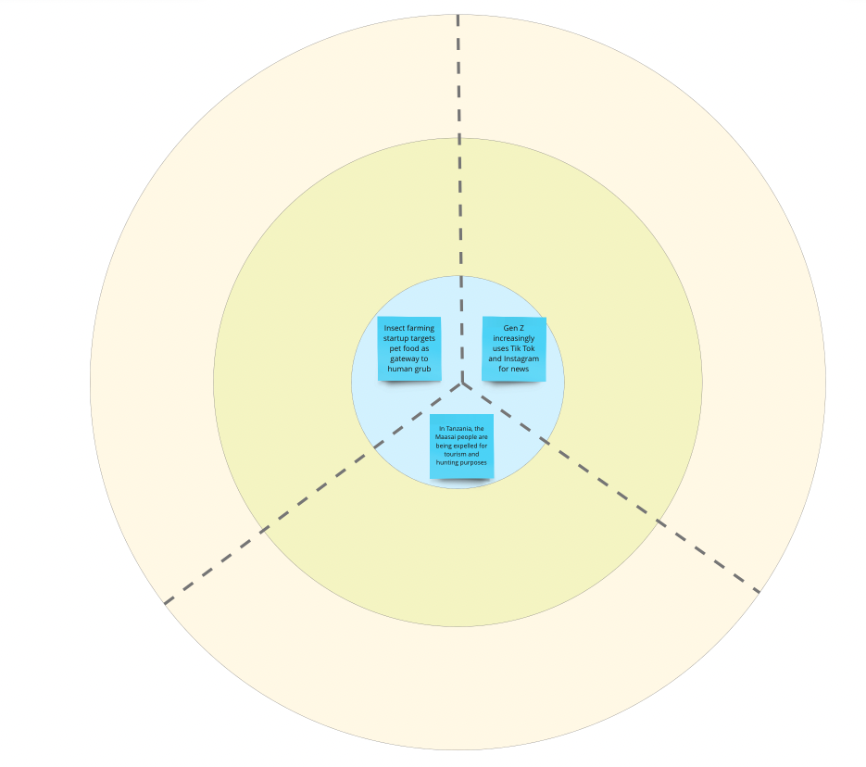
Step 1: Choose three signals of change (10 minutes)
The group or each group picks three signals of change to go into the centre of the futures wheel. These could be signals of change or trends that were identified in the Detectives of the Future exercise, or ones agreed based on an initial discussion on signals of change and trends they believe might be impactful.
When choosing signals of change to work, the group(s) think about:
- Which of these feels most new and surprising?
- Which of these are most relevant to their group/committee topic?
- Which of these are moving towards a future they want?
The group(s) need to make sure the signals are all quite different! For example, they should choose two signals that are both about the economy. The signals of change are put in the centre of the futures wheel, with one in each slice of the wheel.
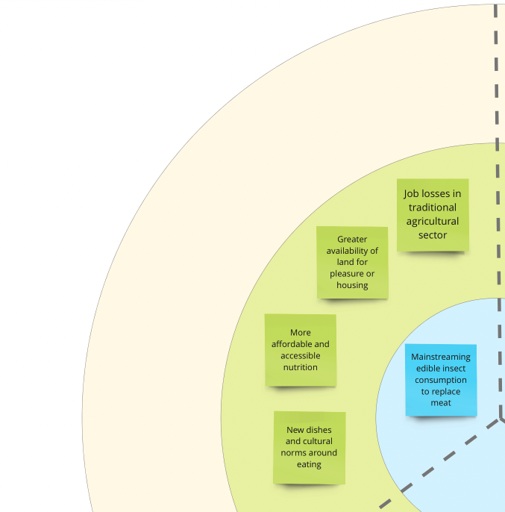
Step 2: Imagine initial impacts (10 minutes)
Starting with one signal of change, each group explores the following questions: What could happen if this signal becomes mainstream and becomes the status quo? What impact would that have on the country and local people?
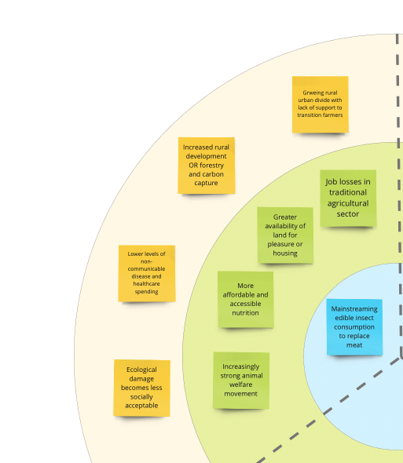
The group(s) should make note of their ideas on post-it notes in the middle ring of the futures wheel. The social, technological, environmental, economic, legal, ethical or political dimensions of this change need to be taken into account! Each group should try to come up with at least four ideas.
Step 3: Imagine secondary impacts (10 minutes)
The group(s) look at the post-its in their middle ring and for each green post it ask themselves: What could happen if this idea becomes mainstream and becomes the status quo? What could happen if this existed in your area? What impact would that have on the country and local people?
Groups make a note of these ideas in the outermost ring of the futures wheel. Every time they go out a ring, participants are imagining more and more distant consequences and implications of the ideas in the middle of their futures wheel.
Step 4: Repeat for two other seeds (20 minutes)
Once the group(s) have completed all the rings for the first signal of change, they should complete the same process for the other two signals of change that they selected in step 1. The other signals should be quicker as groups will have practice, and a better understanding of what they are meant to be doing. Some ideas might start intertwining with the previous ones. That is a good sign! The group(s) should also think about deeper connections
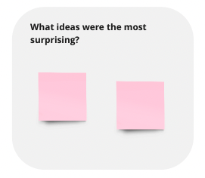
Step 5: Review the futures wheel (20 minutes)
By this point, each group should have a completed futures wheel.
Now ask each group review their futures wheel and discuss:
- What ideas were the most surprising?
- What ideas would be the most impactful on your topic (in terms of both threats and opportunities)?
- What ideas were most hopeful, and represent a positive future?
Groups can make notes in the box to the right of your futures wheel template.
Session close
A final reflection on the main learnings of the exercise as a whole group is always encouraged.

What next ?

The contents of each futures wheel and reflections from each group in step 5 can be used as the inputs to the next tool - the Three Horizons. The content of these discussions may also be enough for groups to develop initial thoughts on policy recommendations that they can build on through informal meetings and conversations.

Preparing for the workshop

For an in person workshop:
- Print the Futures Wheel template no smaller than A2, so there is one for each group. If you prefer you can also draw the template on flip charts or print it, if it’s possible, on A1/A0
- Colored post it notes and pens (or the digital whiteboard equivalent).
- A list of signals of change or trends. You can use those identified in the Detectives of the Future exercise and/or prepare some of them beforehand based on discussions or those below.
For a virtual workshop:
- Prepare a digital whiteboard with the futures wheel template. You can copy the Miro template here. Make sure each group has a separate space to work.
- Collect a list of signals of change or trends in a work document. You can use those identified in the Detectives of the Future exercise and/or prepare some of them beforehand based on discussions or those below.

Facilitator tips

- Take care in how participants pick the trends or signals of change to work with in stage 1. The goal is to find ideas about the future that are diverse enough to stretch the thinking about the topic while still relevant to the broader systems of the youth advisory position in an EU Delegation.
- In the primary and secondary consequences, invite participants to try to imagine what would happen if the seeds at the center of the circle grow to their full potential.
- The three signals can be separate brainstorms and do not have to describe one coherent world. Ideas in the brainstorm might connect to one another but might also be contradictory - this is fine as we don’t know how the future will play out.
- Prompt participants to think about many different types of impact that can arise from a signal or trend. For example, a technological trend could have political, social, technological, economic, or even environmental impacts!

Suggested exercise timings

Please note that you can expand the timings to suit your group but always try to keep your session less than 3 hrs.
Introducing the activity | 10 minutes
Step 1: Choose the signals of change | 10 minutes
Steps 2-4:  Signal 1  Signal 2  Signal 3 | 20 minutes  10 minutes  10 minutes
Step 5: Review your Futures Wheel!  Session close | 20 minutes  10 minutes

Signals of change

- Decolonising thoughts and models – Dominant narratives (male, white, capitalist) are pushed back by grassroot cultural and social movements reclaiming heritage, history and are expressing alternative aspirations for the future. Decoloniality (vs. decolonisation) aims to ‘delink’ from the structure of knowledge imposed by the West, and then to ‘reconstitute’ other ways of thinking and living, Pluriversality, diversality are terms that challenge the idea of a heteronomous standard of reference.
- Multilateralism 3.0 – Regional powers (India, African Union) are calling for a fair seat at the table. Russia’s aggression against Ukraine revealed the changing dynamics of multipolarity. Many “non-aligned” countries are refusing to be pushed into a perceived confrontation between opposing political systems and are taking a more interest-based, transactional approach to alternative offers of support, moving beyond the on-going ‘battle of narratives’ into a ‘battle of offers’. Meanwhile, resources-rich countries are gaining leverage. Alternative set-ups (e.g. BRICS) are gaining momentum.
- No Climate justice, no peace! – The climate challenge (and biodiversity loss) is catalysing tensions at multiple levels: individual, generational, national, and international. Despite a political consensus to fight climate change, the how - and who pays for it - questions remains unsolved. Calls from those who did very little to trigger the crisis but who are/will be most affected are increasing, with Youth at the front. Intergenerational justice is at play. Risks to shift from non-violent to violent (ecoterrorist) actions exist.
- Debt Reverse narrative (the futures of sustainable finance) –The global debt crisis, especially in developing economies, is leading to a new narrative unfolding where the South claims back its debt from the North with a focus on loss and damage, in relation to climate change, colonisation and environmental degradation related to resources extraction. There is a strong call for innovative finance mechanisms and push back against various forms of debt servitude to the financial institutions of “the North” (because not fit for the century’s challenge and West/North overrepresented) – but also increasingly to China.
- Polarisation, the call for the extremes –Trust in democracy, institutions, and mainstream media has been declining in parallel with increasing authoritarianism and nationalism. The trust crisis is strong amongst young people (opting out of the system). Spaces for public deliberation are shrinking. With social stereotypes challenged, conservatism, sometimes violent, is also growing. Algorithms are shaping how individuals and societies consume information. Content creation algorithms could significatively multiply disinformation content. Hybrid warfare (trolling, hate campaigns) are increasing.
- Mental Health and Social Fabric at risk - Uncertainties are undermining people’s mental wellbeing: pandemics, continuing regional and local conflicts, record-breaking temperatures, fires and storms, food/energy volatility in prices. Feelings of distress are on the rise. Climate change is causing distress and anger in young people, worldwide. Eco anxiety is the chronic fear of environmental cataclysm that comes from observing the seemingly irrevocable impact of climate change. Solastalgia affects people who have already suffered the consequences of a natural disaster.
- Human-Nature: From exploitation to symbiosis - There is a surge in calls for a reconsideration of our relationship to nature, a regenerative worldview where human activity no longer competes with the environment but serves people, their prosperity, and the planet as a whole. If the view that humans are at the apex of the natural world is typically “Western”, for many societies, the concept of nature as a sentient equal to humans is nothing new, and they now make their voices louder. Virtual reality, and new industrial philosophies (biomimicry) are feeding such reconsideration.
- Law for Nature – There is a global, indigenous-led campaign, echoing the rights of nature movement, shaping new ways to look at human-nature relationships and a shift in global values while defending an extension of rights, including nature. Rivers and forests have opened the way in Ecuador, Canada, and New Zealand; there is now a growing momentum for “ecocide” to be included as an international crime under the International Criminal Court; and pioneer companies are giving nature a legal say in their business strategy by amending their constitution.
- Trade patterns under reconfiguration – Global trade patterns are being reshaped following cascading disruptions due to lockdowns, the Russian invasion of Ukraine, and climate extreme events. Many regions, to secure their strategic autonomy, are regionalising critical value-chains (“nearshoring”) and/or are moving production to countries where they are not caught in the geopolitical line of fire (“friendshoring”). In the digital world, more fragmentation is expected (China internet ‘great firewall’, China and Russia alternatives to the SWIFT payment system, etc.).

- The race for minerals speeds up – what next? – The green and digital transition will require the use of huge amounts of minerals (lithium, nickel, cobalt, manganese and palladium). While its extraction might lead to renewed local socio-environmental tensions, the strategic nature of these minerals is likely to accelerate a shift in economic weight and influence towards resources-rich countries. Arctic, deep-ocean and space are being explored, without regulatoy frameworks. Batteries are the fastest growing storage technology – new innovations could lead to new scarcities (sand, water).
- Global values: a new definition of progress? – Younger generations value a better work-life balance and are more sensitive to the impacts of our actions on generations to come and to collective responsibilities. They value their role as stewards with a responsibility to the community and the planet. In parallel, calls for a “pluriversality” of values are increasingly heard, driven notably by movements of indigenous people. A pluriversal understanding of time could open new ways to face the social and ecological crisis and to consider goals such as wellbeing and environmental preservation.
- Shifting from Capitalism to longer-term economic models – There is an increase of dissatisfaction toward capitalism mostly nourished by growing inequalities and failure to respond to environmental issues. There are more references about de-growth or frugality (“sobriété”). Other alternative economic models are being explored by economists, longer term models assuming that future individuals are just as important as those living today, regenerative models assuming that the same laws that govern health and development in ecosystems are applicable to human economies and societies.
- Virtuality: emotions at play, ethics at risk – Digitalisation, social networks, artificial intelligence, and the metaverse are changing what it means to be human and live in a democracy: blended boundaries between reality and virtuality, new battles for attention, and biased issues raised in public arenas. While society has invested trillions in building digital platforms and tools, we have invested a small amount in understanding the ethics, values, social dynamics, identities, and biases of digital communities (i.e. digital anthropology).
- Who am I? towards multiple identities – In virtual spaces we are able to craft diverse identities and avatars as digital representations of ourselves, opening the abysmal question of the very definition of “self”. It also opens new ways to experience gender (gender fluidity describes the way some people feel they fit outside the gender binary). An imagined self can do virtual harm to others, while the promise of neurotechnology to improve lives and to gain insight into the human brain is growing: questions about anonymity, transparency, data privacy and personal freedom are raising.
- Navigating the trade-offs of the twin transition without compromising ethics – Climate change is requiring tough decisions and trade-offs between short-term economic benefits and longer-term impacts. Many dilemmas are rising, and tough decisions are to be made in relation to energy, critical raw materials, water scarcity, etc. Enough financing is not easily mobilised. The race for critical materials raises concerns over the environmental and social implications of their extraction and processing. Varying approaches to change are observed, from preserving the status quo longer “at all costs” to opting for drastic adaptation.
- Reimagining how we are “feeding (our) Humanity” – The pressing global concerns are reshaping attitudes towards food, while the fight against hunger remains an imperative. Evolving perceptions and demands for sustainability are reshaping consumption patterns. However, this shift can create tensions. Acceptance and affordability of alternative food sources impact their adoption, while cultural, religious, gender, and generational factors influence food choices. Food goes beyond sustenance, serving as a cornerstone of social connections and intergenerational bonds. Many cultural and religious traditions and social gatherings revolve around food, expressing and preserving a shared identity. Shifts will transform social and cultural practices, customs, and drive new food-related rituals.
- Younger generations rising for a just and sustainable future – Youth are advocating for collective action on climate change, inequality, and discrimination. They demand nature-friendly habits, work-life balance, and social equality, while struggling with difficult trade-offs between present urgencies and future interests, and with contradictions between discourse and consumption patterns. An intergenerational trust crisis, coupled with mistrust in traditional institutions and media poses challenges. If disillusionment persists, some could choose to opt-out or turn to violence.
- Gender landscape in flux: While there is progress in the release of women’s speech, in addressing women's health issues, and changing attitudes towards taboos albeit mainly in the West, gender equality progress remains inconsistent, with challenges including the erosion of reproductive rights and online harassment. Setbacks in certain regions highlight the vulnerability of these and possibly other women’s rights. Furthermore, the recognition of non-binary genders emphasises the need for modern societies to embrace gender diversity for gender equality and human rights.

- Imminent massive jobs market disruption in the face of the AI era – Generative AI will have far reaching implications across most sectors: healthcare, education, finance, public administration, justice and legislation, agriculture, energy, or culture. A massive impact on jobs market, especially for knowledge workers (“white collars”) and creatives is expected. Some anticipate a structural labour market churn of 23% of jobs in the next five years. Reskilling and upskilling become an urgent imperative, equipping workers to use generative AI systems, understand their capabilities, and leverage their potential. Societal consequences will follow: How major IT economies, and/or public-sector led economies will cope is still to be seen.
- Democracy and Rule of Law in the generative AI era – The increased use of large language models has sparked concerns about their effects on democratic engagement and, ultimately, democracy itself. While these models could aid communication between citizens and policymakers, they could undermine traditional forms of democratic engagement too. They may flood public consultations with automated submissions, drowning out authentic responses and distorting the governments’ understanding of public preferences, potentially twisting the legislative agenda. The AI could also give governments and companies unprecedented surveillance power over citizens. On the positive side, AI can increase efficiency in government policy decisions, improve public services, and be used within citizen assemblies for consensus building and idea generation. Implications to explore include AI’s effect on disinformation (scale-up), increase in automated decisions (and “machine drift”), and how transparent it will all be.
- Your personal co-pilot for “anything anywhere all at once” – Generative AI will rapidly revolutionise basic education by personalising learning materials and improving access to knowledge. Higher education will need to reinvent itself, review curriculums, foster human qualities such as entrepreneurship. Lifelong learning becomes even more essential to meet quickly changing professional needs. Access to health or legal services (or even to spiritual guidance!) will be reshaped too, when anyone, anywhere, can access personalised advice, in his/her own language. AI can offer guidance to people for their daily lives, with a level of knowledge that goes beyond that of most humans, and this could lead many to trust it more than humans. Questions also arise in relation to creativity.

Useful links

- Template for printing
- Miro Board
- Video Introduction to foresight
- Video Futures Wheel

