# Youth4Foresight Toolkit

# JANUARY 2024

4

# Three Horizons

**Purpose:** This exercise is designed to generate new ideas and spark interesting discussions about the future of a topic

**Time taken:** 90 minutes

**Participants:** For the whole youth advisory group or in specific thematic committees.

**Difficulty level:** Easy

**What comes before:** The exercise uses the signals of change or trends identified, and helps to ‘flesh out’ into ideas about future worlds.

**What comes after:** The ideas generated will help to complete the Three Horizons exercise.

**Videos**: [Introduction to foresight](https://www.youtube.com/watch?v=MZbez2NVmP8&feature=youtu.be), [Video Three Horizons](https://www.youtube.com/watch?v=768jc_HMltc)

**Group sizes:** Groups of 3-8 people

**Facilitation:** The exercise can be facilitated by YFP and/or experts/technical assistants (in which case the “Why use this tool?” and “Instructions” parts can be shared with the participants beforehand).However, it is a good exercise for members to start engaging the self-facilitation of an easy Foresight exercise by reading this whole document.

# Why use this tool?

Three horizons has the power to shape not only a workshop, but also how you see the world!

It helps to develop a holistic systems perspective of a topic (e.g. peace and security, fight against climate change, digital revolution, etc.), exploring both the present and the future in the same exercise. The tool offers a simple and applicable model to describe how systems change happens, how a transition could occur in a specific system of interest, as well as what actions are needed to support that transition. The tool can also be used with the youth advisory group to align around a preferred future vision for the group (e.g. on the future of the cooperation between the EU and the country, on the future of the country, etc.).

By the end of this exercise, the group(s) should be better able to explain both the change they want to see in the world, as well as the key points of intervention needed to get there, especially those that can be influenced as members of the youth advisory structure!

# Instructions

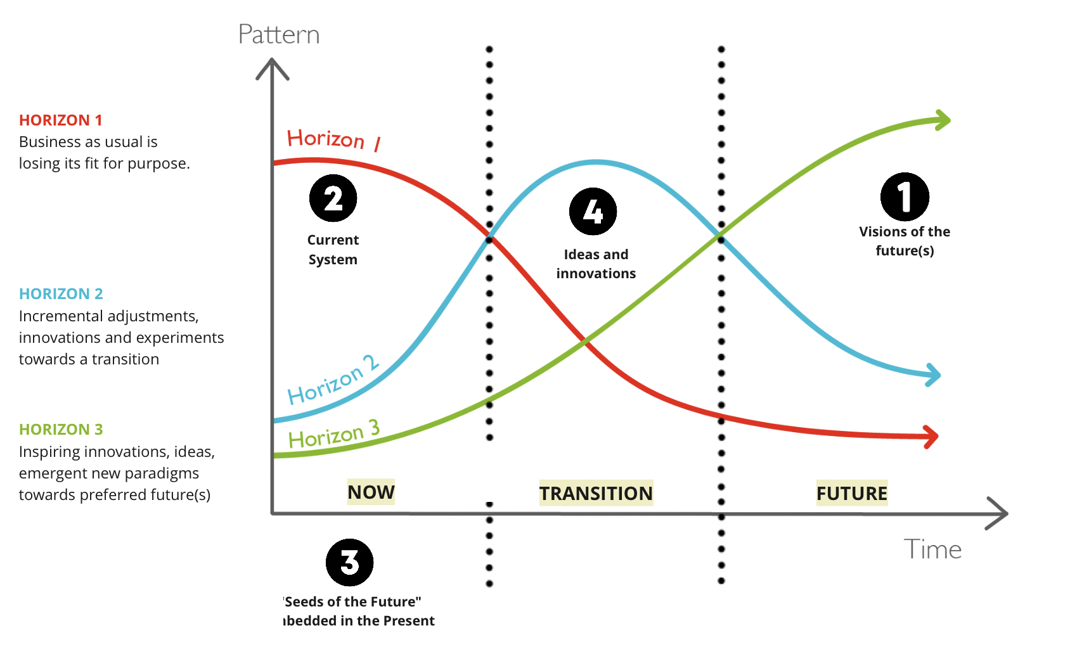This activity focuses on three different periods – the present, the future, and the time in between them (transition). We call each of these one the three horizons and the tool uses the three horizons diagram to help groups structure a discussion to explore the system surrounding committees’ topics or the youth advisory structure as a whole:

**Step 1: Imagine your preferred future (15-20 minutes)**

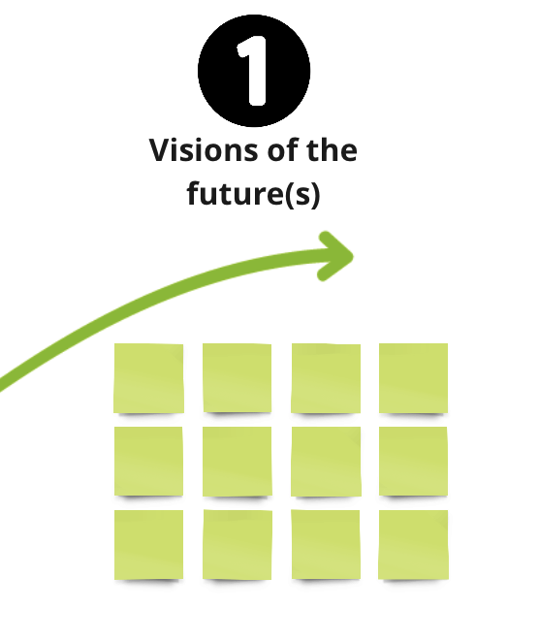Each group (3-8 people) starts by exploring the future they want - **the third Horizon**. In the three horizons diagram, the present is on the left hand side, and the future is on the right. The green line, which is barely visible in the present, represents our preferred future but will one day (hopefully) become the norm.

Thinking about their preferred future, each group(s) should consider:

* What are the characteristics of our preferred future? (Different aspects related to Politics, Economy, Society, Technology,  Legality and Environment (PESTLE) should be taken into account)
* What are the values of this preferred future are they different from today?
* What are the foundations for this preferred future?

The group(s) make notes under the bulge of the green third horizon. The notes should be as specific as possible. A post-it saying “better healthcare” is not as useful as one saying “health care that anticipates solving problems upstream”.

Once the group(s) have discussed their preferred future, they write one statement on a large post-it note, a summary that captures the group’s hopes for their ideal future.

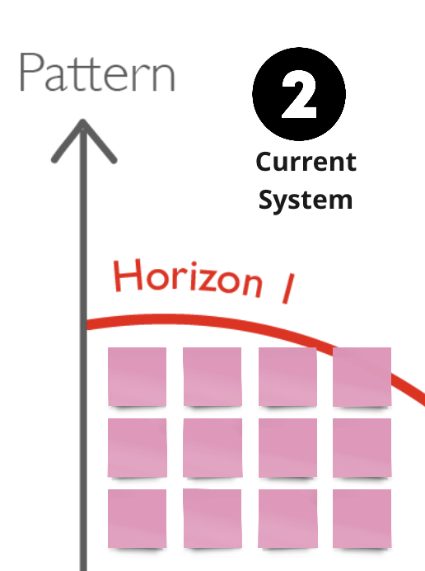**Step 2: Explore the current system (15-20 minutes)**

The next two steps travel back from the future to explore the present. To examine the current context of the topic and the ‘dominant’ system – **the first horizon**, ask each group(s) to discuss:

* What is happening today in the topic of interest that is not working? What is losing it fits for purpose?
* How would we define "Business as Usual"?
* What is assumed or taken for granted?
* What are the weaknesses of the current system?

Groups can make notes on the diagram, on top of the red horizon 1.

**Step 3: Find ‘seeds of the future’ in the present (10-15 minutes)**

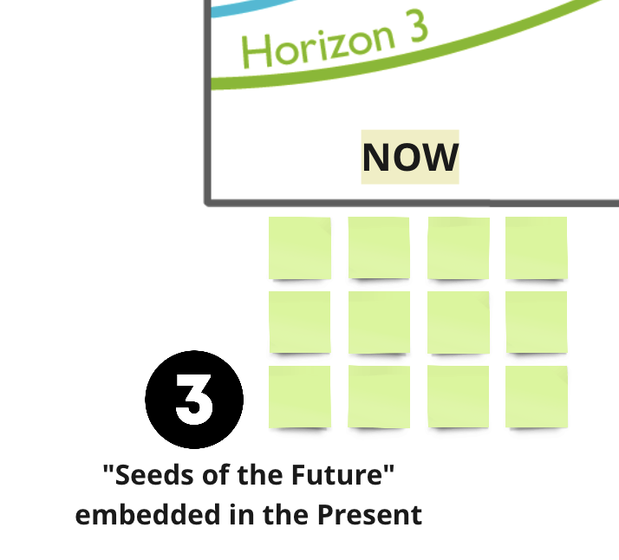Step 3 remains in the present but rather than exploring the ‘dominant’ system, groups look for pieces of their preferred future that are already beginning to happen today. They likely operate outside of the mainstream and might have been spotted during the Detectives of the Future exercise. Groups should try to think of:

* Any small-scale pilots or initiatives that are already trying to bring our preferred future to life?
* Or any existing capabilities in the system that will help to bring our future into being?

Groups should make note of these ‘seeds’ on the diagram under the left hand side of the green third horizon.

**Step 4: Come up with ideas and Innovations (20 - 25 minutes)**

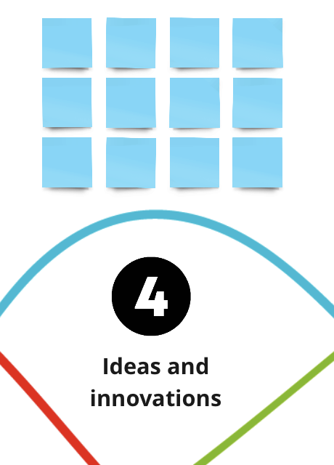For step 4, group(s) explore the space in between past and present -this is represented by the blue line -**the second horizon**. This horizon contains the gaps, obstacles and innovations that might help to transition between horizon 1 and 3.

For this section, each group should discuss:

* What new ideas or innovations do we need?
* What are the main barriers we need to overcome to create change?
* How can we overcome these barriers?
* What do we need to know that we currently do not?
* What kind of actors need to arise in this space?
* Are there some signals of change in today’s world that might be an opportunity?
* Are there some signals of change in today’s world that might be a challenge?

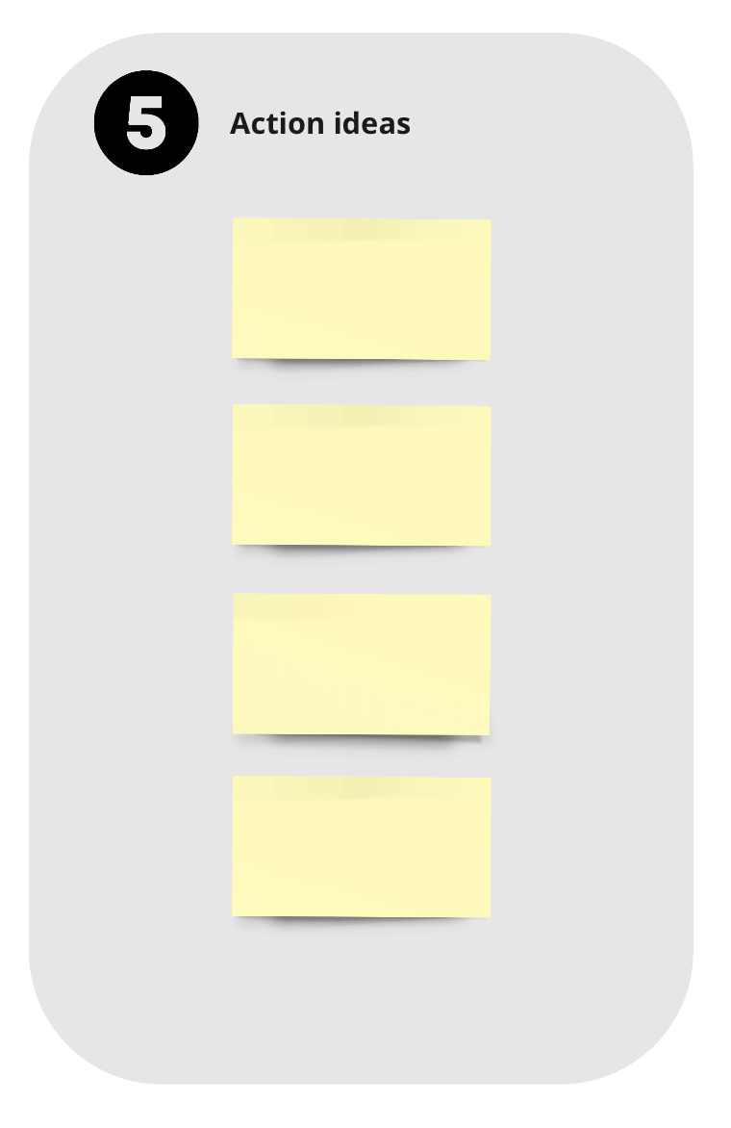**Step 5: Action statements (10 - 15 minutes)**

Each group drafts a list of ideas that are needed to transition the system towards their preferred future. Each group then reflects on their diagram and decides at least five action ideas that are the most important from their discussion based on the possibilities offered by the youth advisory mandate.

These ideas can be very precise in terms of what the youth advisory structure can do at their own level, but some of them might also form the beginning of a set of recommendations for the delegation and the EU to think about moving forward.

Groups should write each action idea as a single, simple and specific sentence.

**Session close (5-10 minutes)**

The whole group can reflect on the learning experiences of the session and set the tone for the next step in the Foresight journey.

# What next ?

* **Share main insights:** Groups may need some additional discussion time in a separate session to transform their insights from the exercise to clear recommendations for action within the youth advisory structure and/or the delegation and the EU.
* **Designing for transitions:** Groups can further explore how their innovation ideas can help to make the system change and transition from the current state to their preferred vision of the future!

# Preparing for the workshop

**For an in person workshop:**

* Print the Three Horizons [template](https://capacity4dev.europa.eu/library/template-three-horizons_en?listing=group_library&refgid=250063) no smaller than A2, so there is one for each group. If you prefer you can also draw the template on flip charts.
* Bring coloured post-it notes and pens (or the digital whiteboard equivalent).
* If you did the [Detectives of the Future](https://capacity4dev.europa.eu/resources/INTPA-Foresight/info/tool-2-detectives-future_en) exercise beforehand, bring the group’s signals of change and trends.
* If you did the [Futures Wheel](https://capacity4dev.europa.eu/resources/INTPA-Foresight/info/tool-3-futures-wheel_en) exercise beforehand, bring the groups’ ideas for what futures they preferred.

**For a virtual workshop:**

* Prepare a digital whiteboard with the three horizons template. You can copy the Miro template from [here](https://miro.com/app/board/uXjVM3Wk9pg=/?moveToWidget=3458764564905506512&cot=14). Make sure each group has a separate space to work.
* If you did the [Detectives of the Future](https://capacity4dev.europa.eu/resources/INTPA-Foresight/info/tool-2-detectives-future_en) exercise beforehand, bring the group’s signals of change and trends.
* If you did the [Futures Wheel](https://capacity4dev.europa.eu/resources/INTPA-Foresight/info/tool-3-futures-wheel_en) exercise beforehand, bring your group’s ideas for what futures they preferred.

# Facilitator tips

* In each horizon, be responsive to the energy of the group. You do not have to stick perfectly to timings, but stick to one horizon until the flow of ideas dries up, or the energy of the group seems to drop.
* Try to make sure comments are focused and specific as possible. These will lead to a richer discussion.
* Try to see value in ambiguity and people taking different perspectives. Different group members might have a different understanding of the system you are exploring and it is fantastic if you can surface that.

# Suggested exercise timings

| Please note that you can expand the timings to suit your group but always try to keep your session less than 3 hrs. | |
| --- | --- |
| **Introduce** the Three horizons exercise | 10 minutes |
| **Step 1**: Imagine your preferred future | 15 – 20 minutes |
| **Step 2**: Explore the current system | 15 – 20 minutes |
| **Step 3**: Find seeds of the future in the present | 10 – 15 minutes |
| **Step 4:** Ideas and innovations | 20 – 25 minutes |
| **Step 5:** Action statements | 10 – 15 minutes |

# Case studies

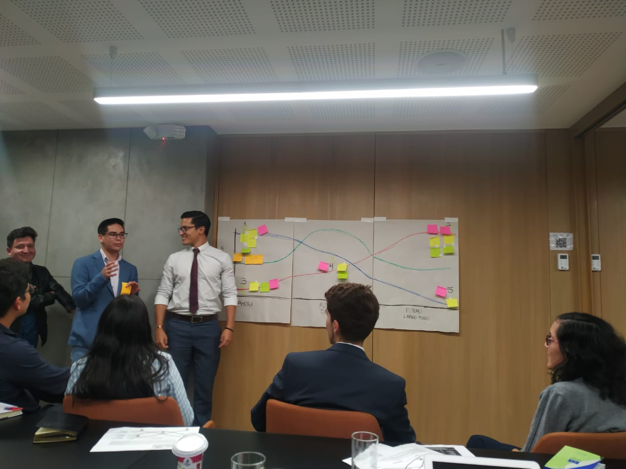

**Ecuador**

Ecuador’s YFP Michaela Zelenanska organized a two-day meeting with their YSB (CoCoECU) to:

* Explain the purpose of CoCoECU and have a clear vision of its work with the Delegation.
* Approve subcommittee work plans so that they can organize to have a real impact.
* **Create a sense of unity among members to improve their functioning as a group.**

She programmed 3 hours for the foresight activities, including the Three Horizons exercise.

*“They were grouped by the subcommittees. They   
got 40 minutes to answer the questions and did   
a presentation at the end. We drew the three   
horizons timeline on the wall and they had   
post its of different colours by subcommittee.”*

“*I think it was a good bridge for them before we   
started the actual planning the day after. From  
the feedback I received, they all claimed that it  
is now much clearer for them what is expected   
and what can be achieved with YSB. They all   
agreed it was important to meet and have such   
an honest discussion*. “ Michaela Zelenanska,   
YFP Ecuador (CoCoECU)

*“I think it was a good bridge for them before we started the actual planning the day after. From the feedback I received, they all claimed that it is now much clearer for them what is expected and what can be achieved with YSB. They all agreed it was important to meet and have such an honest discussion. “ Michaela Zelenanska, YFP Ecuador (CoCoECU)*

ifficulties due to loss of internet connections and lack of previous knowledge in using the digital whiteboard. For that, **we encourage you to use this tool as any other to a 100% physical or virtual setting.**

# Useful links

# Useful links

* [Template for printing](https://capacity4dev.europa.eu/library/template-three-horizons_en?listing=group_library&refgid=250063)
* [Miro Board](https://miro.com/app/board/uXjVM3Wk9pg=/?moveToWidget=3458764564905506512&cot=14)
* [Video Introduction to foresight](https://www.youtube.com/watch?v=MZbez2NVmP8&feature=youtu.be)
* [Video Three horizons](https://www.youtube.com/watch?v=768jc_HMltc)

# Additional resources

This tool is based on the Three Horizons process created by Bill Sharpe. There is an excellent set of resources with more information about the tool and how to use it at <https://www.h3uni.org/>

**Licensing and copyright**:

Three horizons framework by Bill Sharpe, 2003, under CC BY-SA 4.0

License Three horizons framework visuals by Curry and Hudson, 2008, under Attribution, Noncommercial, No Derivatives 4.0 International License