**The Grim Legacy of War: Mines and Explosives on Ukraine’s Road to Reconstruction** – Alejandro Nievas

The shadows of war stretch far beyond the echoes of gunfire; they leave a toxic legacy embedded in the very ground, presenting a silent but deadly threat: landmines and unexploded ordnance (UXO). In Ukraine, this reality takes on a particularly urgent dimension, transforming vast areas of its landscape into lethal minefields where each step could be the last.

The issue of mines and UXO in Ukraine is not only a hurdle in the physical reconstruction of the nation; it stands as a barrier to the revival of lives, the flourishing of its youth, and the emergence of a future in peace. Statistics paint a bleak picture: as of 2024, an estimated 30% of Ukrainian territory is contaminated with landmines or UXO, placing Ukraine at the top of a grim global list. This reality fosters an environment of uncertainty and peril for millions, with hundreds of civilians, including children, falling victim to these lethal remnants each year.

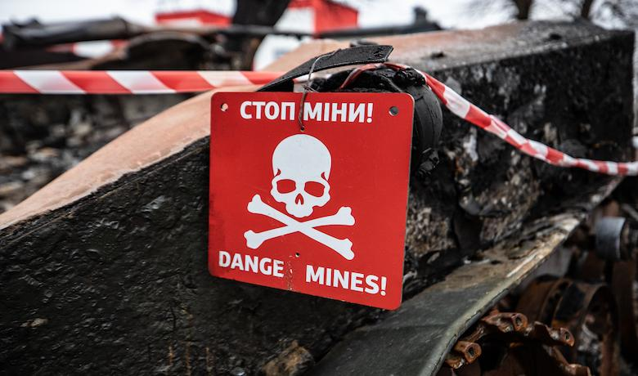

**The Role of Demining and Risk Education**

Clearing mines and implementing Explosive Ordnance Risk Education are not only urgent safety measures but also long-term investments in Ukraine's future. Mozambique’s experience serves as a powerful example: in 2015, the country declared itself free from known landmines, transforming former death fields into productive farmland, generating over $800 million in agricultural production alone. This revival, achieved through international cooperation, community commitment, and technological innovation, provides a beacon of hope for Ukraine.

In Ukraine, the journey toward mine clearance is complex and unprecedented. The scale of contamination and the variety of explosive devices ranging from Soviet-era ammunition to modern improvised explosive devices and cluster munitions with a failure rate as high as 40% make this mission especially challenging. This urgent task impacts essential areas, including agriculture, food security, access to vital services, and the nation’s overall post-conflict reconstruction.

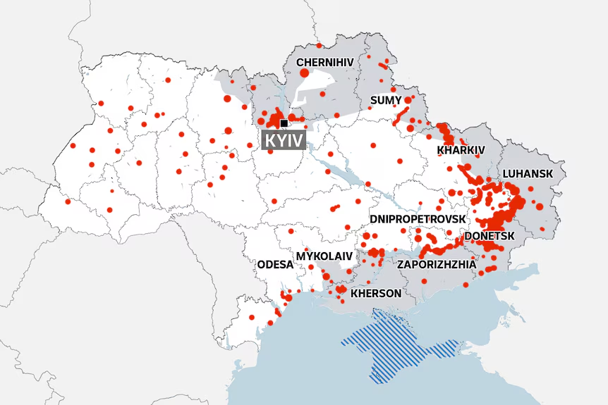

**Human Aspect of Demining Efforts**

Demining and EORE are more than technical undertakings; they are deeply human efforts aimed at protecting and restoring communities scarred by conflict. The mission goes beyond clearing land of deadly explosives it’s about safeguarding the people who live there. Each mine removed, each person educated on the risks of UXO, represents a step toward rebuilding a nation torn apart by war. It’s a journey toward a future where Ukraine’s people can walk freely, dream boldly, and thrive in safety.

**International and Local Collaborations**

Ukraine’s demining initiatives represent a powerful, united front of international and local partnerships. Organizations like SafeLane Global, The HALO Trust, MAG , and FSD work alongside critical support from agencies like UNDP, UNICEF, and the U.S. Department of State’s Office of Weapons Removal and Abatement. This coalition of expertise and resources highlights a global commitment to reducing human suffering and restoring dignity to communities trapped under the shadow of war.

Within Ukraine, the national government, supported by institutions like the State Emergency Service (SESU) and the Ministry of Defense, joins forces with local organizations like the Ukrainian Deminers Association and Demining Solutions. This unified effort is relentless, working to mitigate the dangers of every mined inch of land. Together, these local and global alliances embody a shared responsibility to help Ukraine reclaim its land and rebuild its future.

**﻿**

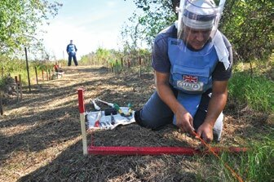

**Ukraine’s Determination and Forward Vision**

Supported by a network of international allies, Ukraine is resolute in facing the monumental task of demining. The combined efforts of clearing landmines, conducting awareness campaigns, and assisting victims form a triad of actions aimed at not only restoring land but also healing the soul of the nation. Ukraine’s determination to overcome these challenges underscores a resilience that’s both inspiring and transformative.

The focus on EORE and mine clearance goes beyond safety it lays a foundation for the nation’s recovery, ensuring that future generations inherit a country free from the scars of past conflicts. This vision illuminates a pathway for Ukraine’s youth to grow in a society that embodies safety, hope, and prosperity.

**Conclusion: Global Responsibility and Collective Action**

The struggle to clear Ukraine of landmines and unexploded ordnance is not just a national challenge it’s a call to the global community. As observers, and perhaps participants, in this process, we are faced with a question similar to the one posed at the beginning of this journey: Will we stand by as passive witnesses to this prolonged tragedy, or will we actively contribute to creating a safer, more prosperous future for Ukraine? The responsibility to address this legacy of war does not rest solely on political leaders and international organizations but on each of us, as members of a connected global community.

At the current pace, it is estimated that clearing Ukraine of these hidden dangers could take over 700 years. This staggering timeline serves as a reminder of the vast scale of the challenge ahead and the urgent need to accelerate demining efforts. Ukraine cannot face this task alone; it requires a unified global response, bringing together international expertise, resources, and a shared commitment to lift this burden of war from Ukrainian soil.

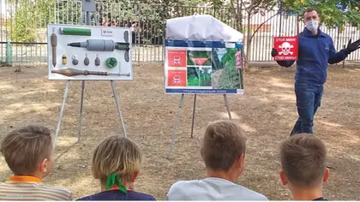

Clearing mines and advancing Explosive Ordnance Risk Education are more than technical procedures; they are acts of global solidarity. Each mine removed, each piece of land reclaimed, and each individual educated on these risks represents a declaration of resilience and hope against the shadows of war. This is not just a story of Ukraine it is a testament to humanity’s collective will to transform war-torn landscapes into places of safety, opportunity, and life. Together, we can illuminate the path toward a brighter future, where Ukraine and its people can flourish free from the remnants of conflict.