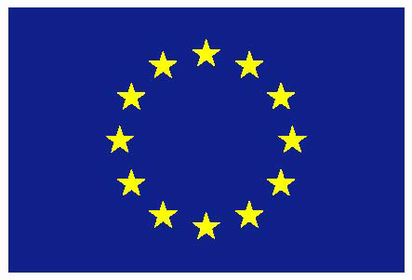
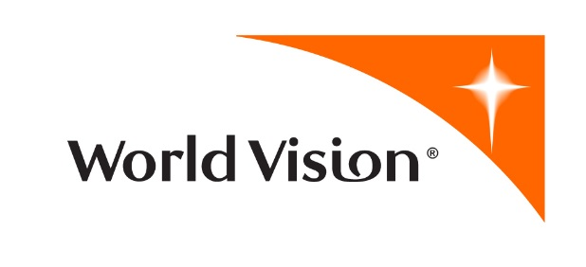

Communication and Visibility Plan

Nugal Empowerment for Better Livelihood Project
(DCI-HUM/2014/339-988)

This document has been produced with the financial assistance of the European Union. The contents of this document are the sole responsibility of World Vision and can under no circumstances be regarded as reflecting the position of the European Union.
GENERAL COMMUNICATION STRATEGY

Objectives
- Overall communication objectives

The overall objective of the planned activities outlined within this communication and visibility plan is ensuring beneficiaries are aware of the roles of the partner and of the EU in funding and supporting the action. An additional objective is to raise awareness among the host country population (Nugal region, Puntland, Somalia) of the role the EU is playing in supporting development in Nugal region.

The specific objectives of the communication and visibility plan are:

- To raise awareness amongst the local government and project beneficiaries about the project, including their roles and responsibilities
- To raise awareness amongst local government and project beneficiaries regarding support extended from European Union
- To make known the benefits of non-formal education and technical vocational education and training in reducing unemployment in youth and vulnerable populations
- To make known possible synergies between education, training, employment, mental health and social inclusion

- Target groups

The communication and visibility activities outlined within this plan have two target groups. The first group is located within the region of Somalia where the action is implemented, Puntland:
- Beneficiaries benefitting from vocation skills training
- Beneficiaries benefitting from non-formal education activities
- Small business owners
- Children being registered
- Community based organizations

The second group includes European Union member countries and EU affiliated emergency and developmental agencies together with other opinion-formers and “elite” audiences involved in the field of international cooperation.

- Specific objectives for each target group, related to the action’s objectives and the phases of the project cycle

Specific communication objective for each target audience:

Beneficiaries benefitting from vocation skills training
Objective: Inform skills graduates of the employment opportunities after acquiring skills for sustainable economic growth
Message: EU supports the Somali youths to acquire vocational skill training for better livelihood

Beneficiaries benefitting from non-formal education activities
Objective: Improve the ability of beneficiaries in the informal sector
Message: The skills acquired through NFE will support the continuation of beneficiaries’ career path for enhanced livelihood

Small business owners
Objective: Promote awareness raising on the importance of small business in the local economy, in particular among vulnerable women business owners.
Message: The business skills training will equip the beneficiaries to identify suitable business that can improve their income and livelihood.

Children being registered
Objective: To strengthen social cohesion and inclusion of the children of marginalized groups through child registration
Message: Equal opportunity for all the children to access the limited basic social services within Puntland and beyond

Community based organizations
Objective: Promote community dialogue aimed at prioritizing day to day issues
Message: Sincere community engagement and sharing of ideas strengthens active citizenship and mutual co-existence

European Union member countries, etc.
Objective: Promote awareness of EU support of NFE and TVET in Nugal region, Puntland
Message: Capacity building for the marginalized groups through TVET skills training to create employment opportunities

COMMUNICATION ACTIVITIES

- Main activities that will take place during the period covered by the communication and visibility plan

The main activities that will take place during the period covered by the communication and visibility plan include the following:

S/N | Nugal Empowerment for Better Livelihood Project activities | Proposed Visibility | Explanation |  | Time Frame
1 | 6.3 Provision of equipment and supplies for NFE Centres in the communities or at TVET centres | EU &WV logos on all equipment | Printing EU & WV logos on all equipment (Putting EU logo first) |  | As per the DIP
2 | 6.6 Provision of equipment and supplies for TVET Centres | EU &WV logos on all equipment | Printing EU & WV logos on all equipment (Putting EU logo first) |  | As per the DIP
3 | 6.7 Curriculum review workshops | Banner | EU, WV, and line ministry logos and other workshop related information on the banner (Putting EU logo first of the three) |  | As per the DIP
4 | 6.8 Training of TVET Trainers on curriculum implementation, management of training safety standards and lesson planning | Banner | EU, WV, and line ministry logos and other workshop related information on the banner (Putting EU logo first of the three) |  | As per the DIP
5 | 6.9 Refresher training for TVET trainers on revised curriculum | Banner | EU, WV, and line ministry logos and other workshop related information on the banner (Putting EU logo first of the three) |  | As per the DIP
6 | 6.10 Training on management and supervision within TVET | Banner | EU, WV, and line ministry logos and other workshop related information on the banner (Putting EU logo first of the three) |  | As per the DIP
7 | 6.13 Business development training | Banner | EU & WV logos and other workshop related information on the banner (Putting EU logo first) |  | As per the DIP
8 | 6.15 Training on basic technical and value addition practices | Banner | EU & WV logos and other workshop related information on the banner (Putting EU logo first) |  | As per the DIP
9 | 6.17 Awareness campaign on social protection and inclusion | Banners, T-shirts & Hats | EU & WV logos and other campaign related information on all visibility materials (Putting EU logo first of the two) |  | As per the DIP
10 | 6.18 Child protection training | Banner | EU & WV logos and other workshop related information on the banner (Putting EU logo first of the two) |  | As per the DIP
11 | 6.20 Gender training | Banners, T-shirts & Hats | EU & WV logos and other workshop related information on all visibility materials (Putting EU logo first of the two) |  | As per the DIP
12 | 6.22 Action plan development workshop | Banner | EU & WV logos and other workshop related information on the banner (Putting EU logo first of the two) |  | As per the DIP
13 | 6.23 Community dialogue forum | Banner | EU, WV, and line ministry logos and other meeting related information on the banner (Putting EU logo first of the three) |  | As per the DIP
14 | 6.25 Self Advocacy and Rights Training | Banner | EU &WV logos and other workshop related information on the banner (Putting EU logo first) |  | As per the DIP
15 | 6.26 Conflict resolution training | Banner | EU & WV logos and other workshop related information on the banner (Putting EU logo first of the two) |  | As per the DIP
16 | 6.27 Coordinating community activities for peaceful coexistence: Sports, peace clubs, cultural forums, drama and poetry | Banners, T-shirts & Hats | EU, WV and line ministry logos and other information related to the event on all visibility materials (Putting EU logo first) |  | As per the DIP
17 | 6.28 Training of trainers on psychological first aid | Banner | EU & WV logos and other workshop related information on the banner (Putting EU logo first) |  | As per the DIP
18 | 6.29 Training on psychological first aid (Business facilitators, NFE and TVET trainers) | Banner | EU & WV logos and other workshop related information on the banner (Putting EU logo first) |  | As per the DIP
19 | 6.30 Training on psychological first aid (community leaders and marginalised groups) | Banner | EU &WV logos and other workshop related information on the banner (Putting EU logo first) |  | As per the DIP
20 | 6.33 Review meeting of livelihood and TVET policy | Banner | EU, WV, and line ministry logos and other meeting related information on the banner (Putting EU logo first of the three) |  | As per the DIP
21 | 6.34 Stakeholder workshop for policy review | Banner | EU, WV, and line ministry logos and other workshop related information on the banner (Putting EU logo first of the three) |  | As per the DIP
22 | 6.35 Community session on livelihood policies and standard that affect them | Banner | EU & WV logos and other session related information on the banner (Putting EU logo first) |  | As per the DIP
23 | 6.36 Group Management Training | Banner | EU & WV logos and other workshop related information on the banner (Putting EU logo first) |  | As per the DIP
24 | 6.37 Advocacy Training | Banner | EU & WV logos and other workshop related information on the banner (Putting EU logo first) |  | As per the DIP
25 | 6.39 Active citizenship, conflict resolution and basic advocacy skills training | Banner | EU & WV logos and other training related information on the banner (Putting EU logo first) |  | As per the DIP
26 | 6.40 Conferences on the need for Standardized TVET and Certification | Banner | EU, WV and line ministry logos and other information related to the meeting on the banner (Putting EU logo first of the three) |  | As per the DIP
27 | 6.44 Provision of start-up kits | EU &WV logs on all equipment | Printing EU & WV logos on all equipment (Putting EU logo first) |  | As per the DIP
General visibility Materials
S/N | Proposed visibility | Specification |  | Quantity | Timeframe
1 | Brochures | Brochures written in both English and Somali languages to be distributed in the middle of project period to give details of project activities and at the end of project period to indicate project achievements to all stakeholders |  | 100 pieces | Within first year of project and end of project
2 | Standing banners | Standing banners giving details of all project activities with logos of EU, WV and line ministry to be placed at line ministries offices and WV offices in all project target districts |  | 10 pieces | within the first 2 year of the project
3 | Hats | Normal hats with EU, WV and line ministry logos to be distributed to project beneficiaries, staff and line ministries (Putting EU logo first) |  | 500 pieces | within the first 2 year of the project
4 | T-shirts | Normal T-shirts with EU, WV and line ministry logos to be distributed to project beneficiaries, staff and line ministries (Putting EU logo first) |  | 500 pieces | within the first 2 year of the project
5 | Head scarves and shawls for women | Women scarves with EU, WV and line ministry logos to be distributed to female project beneficiaries, staff and line ministries (Putting EU logo first) |  | 500 pieces of each | within the first 2 year of the project
6. | Video clips and project photos | Share with the EU Delegation, and to be presented during EU and other partner meetings (One such video was produced and presented during July, 2015 EU sponsored seminar in Brussels) |  | One clip per quarter @$1,300 | Each quarter
7. | Display panels | Display panels in all the TVET and NFE centres with visible EU logo |  | All the 30 centres | By the fourth quarter of 2015.
8. | Press release | Target local government, and local media on the project implementation. |  | Once per year | By the end of each year.

- Communication tools chosen

The communication tools chosen for this action include:

- Use of advertisement during different project events

Advertisement tools include the preparation and use of T-shirts, caps, banners, display panels, and video clips with both donor and implementing partner logo. Banners will be used during workshops and during project events such as the project launch and project closing event. Sign boards indicating the name of the activity, the name of the village, the implementer and the donor will also be used.

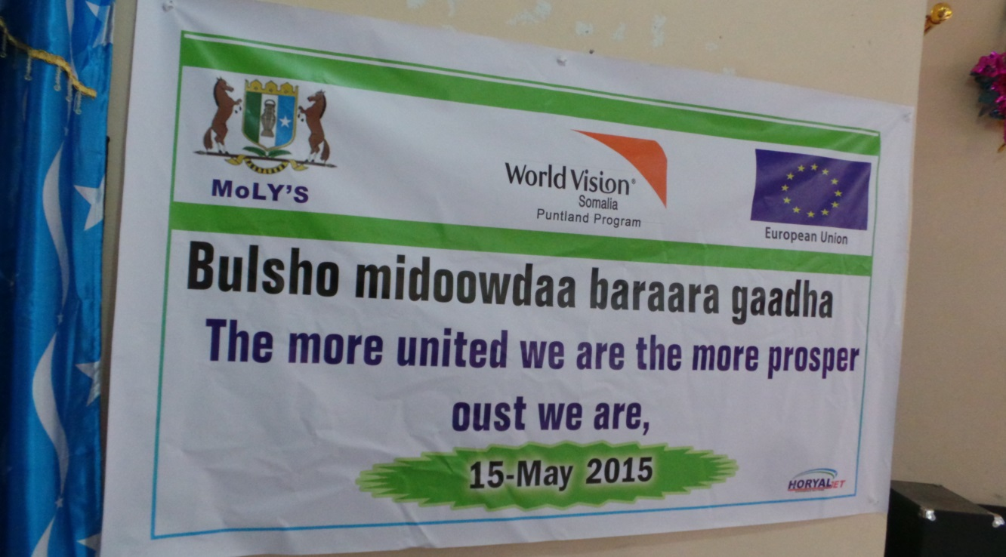

Fig.1: One of the banners prepared during Somali Youth Day celebration emphasizing the importance of unity among all the communities for prosperous future.

Whenever possible, both English and Somali will be used for properly communicating both to the project area audience and the international community.

- Use of media for communication

Since the possibility of getting both local and foreign media coverage is lower, the action will focus to get more coverage on local media especially with Puntland TV stations and radio. Local media teams will be invited to different project events such as the project launch event and closing workshop in Garowe, five sessions of project review meetings which will be conducted in the five target districts (Garowe, Dangorayo, Burtinle, Eyl and Godobjiran) together with community dialogues around inclusion, and TVET activities.

INDICATORS OF ACHIEVEMENT

- Completion of the communication objectives

Quantitative:
- 80 % beneficiaries reached
- 50 Stickers, 30 display panels, 10 banners, 500 t-shirts, 500 caps, 200 photos and 6 video clips produced
- 3 press releases, pieces in the media
- 5 case studies generated and picked up by media in Puntland and/ or the EU

Qualitative:
- Observation (field visits)
- Interactive interviews with the beneficiaries

- Provisions for feedback (when applicable)
- Through project monitoring reports
- Field visits/observation
- Quarterly review meetings

RESOURCES

- Human Resources

The project team will oversee the implementation of the project communication and visibility plan. The project manager is the one responsible for ensuring this plan is implemented as per the policy and guidelines of EU, World Vision and the Puntland State of Somalia. In addition, the project staff will be supported by a local communication consultant, line ministry staff, and the World Vision Communications Manager.

- Financial resources
The total budget planned for visibility and communications in this action is 30,000 EUR for three years. Its allocation per year is 10,000 EUR in the first, second and third year. The financial resources for communication and visibility activities constitute 1% of the overall budget for the action.

