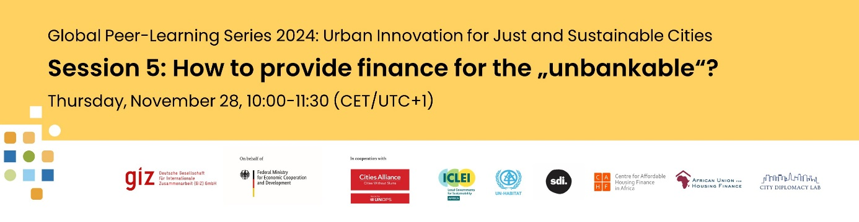

Dear participant,

We are pleased to invite you to the fifth and final event of our peer learning series “[**Urban Innovation for Just and Sustainable Cities**](https://www.citiesalliance.org/newsroom/news/cities-alliance-news/global-peer-learning-series-urban-innovation-just-and)”:

[**How to provide finance for the “unbankable”?**](https://www.citiesalliance.org/newsroom/events/global-peer-learning-series-event-5-how-provide-finance-unbankable)

**Thursday, November 28, 2024**

**10:00-11:30 CET/UTC+1**

**English (with subtitles in French and Spanish in the recording)**

**Calendar Entry:**



Housing is recognized by Article 25 of the Universal Declaration of Human Rights as an essential right. Yet, an estimated 2.8 billion people today live in inadequate housing conditions, without access to basic services, and struggling to afford housing costs. The housing crisis will only be exacerbated with an additional 2.5 billion people estimated to be living in African and Asian cities by 2050. Thus, realizing improved access to adequate and affordable housing is central to just and sustainable development. However, formal housing delivery systems are failing to meet this ever-growing demand. Formal markets usually do not cater for low-income communities and policy interventions for increased affordability often fall short of their objectives. With access to housing-related finance also extremely limited for low-income households in the Global South, these often need to rely on informal and incremental approaches, with their own savings and their own labor.

So what is needed to improve access to affordable housing and housing finance at scale? In this session, co-organized by GIZ and the Centre for Affordable Housing Finance in Africa (CAHF), we will discuss what mechanisms can meet the lived realities of low-income households and explore good practices that improve access to finance for the “un-bankable” communities that do not qualify for commercial loans.

**Speakers**

|  |  |
| --- | --- |
| • | Illana Melzer, Engagement Manager,71point4 |
| • | Kecia Rust, Executive Director and Founder of CAHF |
| • | Girlie Lopez, Philippines Country Program Manager, Build Change |
| • | Joy Wachira, Program Lead - Green Affordable Housing, REALL |

**Moderator**  
Lorenzo Kihlgren, Founding Director, City Diplomacy Lab

The session is part of a peer learning series hosted by GIZ – on behalf of BMZ – and Cities Alliance to strengthen local actors in their ability to act for socially just and climate-friendly urban transformation. Together with our partners from ICLEI, UN-Habitat, Slum Dwellers International, the Centre for Affordable Housing Finance in Africa, the African Union for Housing Finance, and the City Diplomacy Lab, we have conducted five events across 2024. Click [here](https://eur01.safelinks.protection.outlook.com/?url=https%3A%2F%2Fmail.invitario.com%2Flnk%2FCAAABdjA8xoAAcsCWXgAAL-cPYYAAYC9y10AAAAAAAbAYABmq0iHXBjV69bGTp6fp7hdaSRglwAGdKg%2F1%2FcvOuf9LgOKto4wKX2S4-hw%2FaHR0cHM6Ly93d3cuY2l0aWVzYWxsaWFuY2Uub3JnL25ld3Nyb29tL25ld3MvY2l0aWVzLWFsbGlhbmNlLW5ld3MvZ2xvYmFsLXBlZXItbGVhcm5pbmctc2VyaWVzLXVyYmFuLWlubm92YXRpb24tanVzdC1hbmQ&data=05%7C02%7Cclemens.heukrodt%40giz.de%7Ca29be27e0b3946a227f208dcb204bad3%7C5bbab28cdef3460488225e707da8dba8%7C0%7C0%7C638580980587822654%7CUnknown%7CTWFpbGZsb3d8eyJWIjoiMC4wLjAwMDAiLCJQIjoiV2luMzIiLCJBTiI6Ik1haWwiLCJXVCI6Mn0%3D%7C0%7C%7C%7C&sdata=Wqn3dw5dBXnUw7BP3%2BBoYPTuR8f07unjYpFfI0wImYE%3D&reserved=0) to learn about our past and future events. Watch the recording of our latest event “***Leaving No Women and No One Behind in Sustainable Urban Development***.”, [here](https://www.youtube.com/watch?v=aVonIHy8g7M).

We look forward to seeing you at our fifth event!

|  |
| --- |
|  |

Kind regards,

The Urban Innovation made in Africa Team

*Please be aware that this session will be recorded.*

*Please message* [*efia.faschina@giz.de*](mailto:efia.faschina@giz.de) *if you do not want to receive emails about this Peer Learning anymore.*