# Youth4Foresight Toolkit

# OCTOBER 2024

0

# Diving into the Futures Mindset

**Purpose:** This series of short exercises is designed to get participants to be creative, and to think about the future in a low-pressure way, usually before their first experience in a Foresight activity.

**Time taken:** 30-45 minutes

**Difficulty level:** Easy

# Exercise #1. The Time Machine (10 - 15 min)

Understanding our own expectations and aspirations for what lies ahead is a crucial first step in futures thinking. This exercise will help you clarify how you perceive the future and how that aligns with the future you want to see. By exploring these perspectives, you will be better equipped to engage in meaningful discussions and strategic planning.

In this exercise, participants will be asked to reflect on two key questions:

* **How do you think the future will look in 2050?**
* **How do you want the future to look in 2050?**

Each participant will then share their thoughts by writing them on post-its, which will be placed on a Miro board. This approach allows for a visual representation of everyone{s perspectives and contributes to a collective exploration of future possibilities.

# Exercise #2. Images of the future (10 - 15 min)

In this exercise, we will reflect on how people imagined the future in the past and how this influenced our present. Emphasising and analysing current mainstreams visions of the future, who is driving them and how we could bring alternative images forward.

The participants will reflect on the following questions:

1. **PAST IMAGES OF THE FUTURE**

**Why do you think the author imagined the future in this way?** Participants will discuss the depictions of retro-futuristic visions from the past, exploring the reasons and contexts that may have influenced these portrayals and how these images influenced our present.

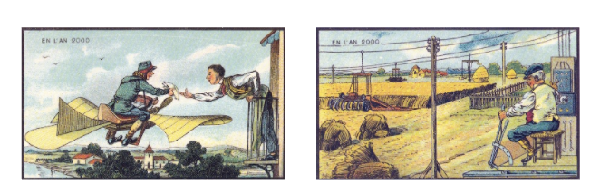

Jean-Marc Côté (1901)

1. **CURRENT MAINSTREAM IMAGES OF THE FUTURE**

**What are the most common images you see today of the future? Who do you think has the most influence in driving these images forward?** Participants will examine the provided images and discuss the type of future they represent, considering who may hold the most influence in promoting these visions.

**What are the most common images you see today of the future of your region or country?** Participants will identify and discuss contemporary portraits of the future relevant to their own region or country.

1. **ALTERNATIVE IMAGES OF THE FUTURE**

**Have you ever reflected on how different countries, cultures, religions, and minorities imagine the future?** Participants will consider the motivations and contexts that led to these depictions of the future and reflect on how our visions shape what the future becomes. They will also discuss whether diverse voices are being included in the process of imagining the future and how this inclusion, or lack thereof, can impact the future we create.

# Exercise #3. Unveiling uncertainties (10 - 15 min)

In this exercise, participants will reflect on their assumptions about the future by assessing the probability of various events (5-7 examples) that may or may not occur, rooted in ongoing trends. They will consider how these potential events could manifest in their region and/or country. Expertise is not required. Participants are encouraged to draw from their own experiences and contribute their unique perspectives. The exercise aims to uncover uncertainties and challenge different or very similar (group thinking) preconceived notions about the future.

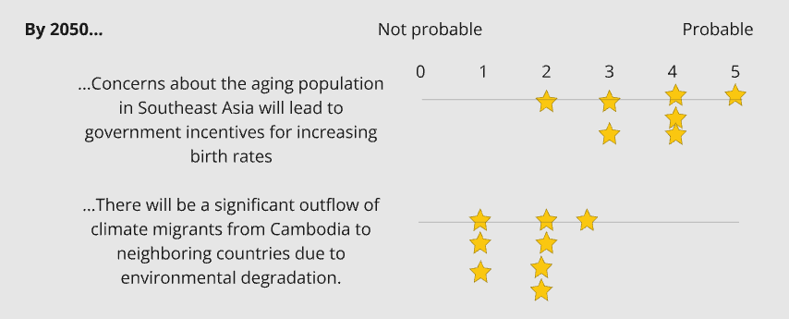

# Useful links

* [Miro Board](https://miro.com/app/board/uXjVM3Wk9pg=/?moveToWidget=3458764564905506512&cot=14)
* [Video Introduction to foresight](https://www.youtube.com/watch?v=MZbez2NVmP8&feature=youtu.be)