# Youth4Foresight Toolkit

# OCTOBER 2024

8

# Empower Landing

**Purpose:** This exercise is designed as a short final activity to develop clear recommendations, action, or next steps, so everyone can see how their work leads to change, after an event, meeting and/or workshop.

**Time taken:** 30-45 minutes

**Difficulty level:** Easy

# Exercise (20 - 30 min)

Prepare the Quadrant Framework: Use the provided quadrant template below as a source for inspiration and adjust it to the specificities of your youth engagement context.

You can ask participants:

* What should we do differently as young people and/or a youth advisory structure?
* What actions do we recommend for our EU delegation?
* What can we do on a local level and through our own networks?
* What can we communicate with the outside world?

Facilitate Brainstorming: Participants should work through each quadrant in whatever order they prefer. They should identify and propose concrete actions or next steps within each section, keeping in mind that certain actions may be more feasible than others, depending on the context.

Actionable Outcomes: After the brainstorming session, ask participants to review their proposals and select a set of actions that they feel most committed to taking forward. This will help in prioritizing efforts based on feasibility and impact.

Wrap-Up: Conclude by discussing the ideas generated, highlighting the importance of each route to action, and encouraging collaboration on the chosen next steps.

Note: The activity is designed to be adaptable. Depending on the time available, you can either focus on one specific quadrant or explore all four in detail.

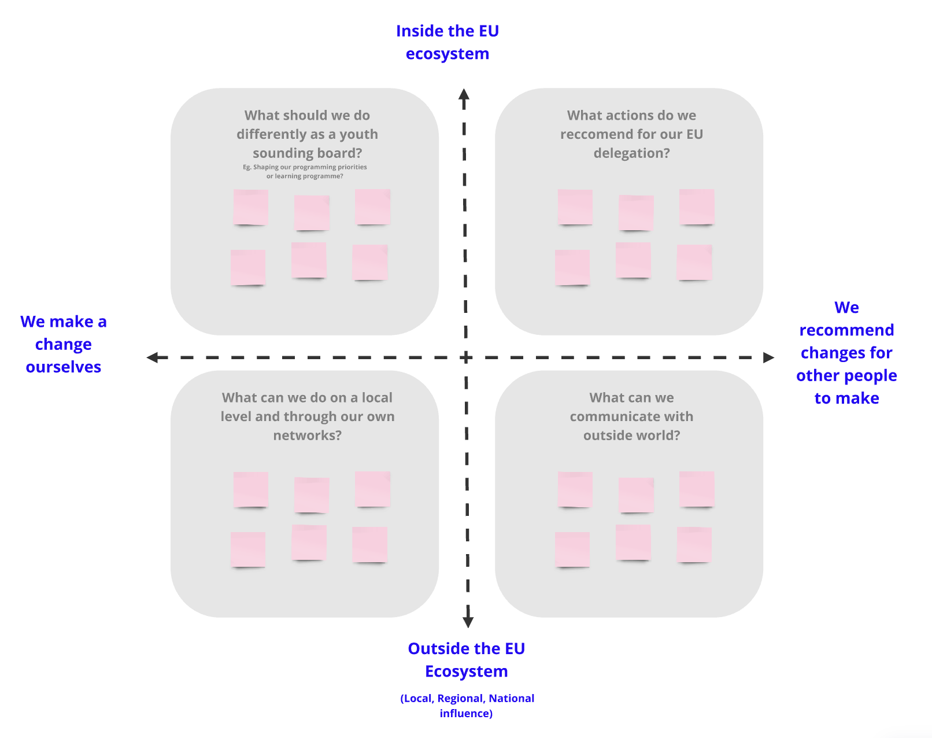

# Useful links

* [Miro Board](https://miro.com/app/board/uXjVM3Wk9pg=/?moveToWidget=3458764564905506512&cot=14)
* [Video Introduction to foresight](https://www.youtube.com/watch?v=MZbez2NVmP8&feature=youtu.be)