**Youth Futures in Lesotho**

**Summary:** Lesotho’s young people often feel excluded from decision-making. Using foresight in the Youth Power Hub equipped young leaders with tools to imagine and shape their futures and fosters dialogue and systemic thinking in governance.

### **Building youth-led foresight**

Lesotho faces some of the highest inequality levels in the world, leaving young people vulnerable to poverty, unemployment, and forced migration. Nearly a third of the population is under 24, yet youth voices can stay absent from decision-making. Cultural norms discourage open deliberation between young people and adults, leaving many — especially young herders, returnees from South Africa, and young women and girls — without opportunities to shape their futures.

The European Union (EU), UNICEF, and the International Organization for Migration (IOM) launched the Youth Power Hub Programme in September 2024, with the goal of empowering young people as key players in governance and development at both local and national levels. To make the activities also future facing, the [Youth4Foresight toolkit](https://capacity4dev.europa.eu/resources/INTPA-Foresight/info/youth4foresight-toolkit_en) was used at the launch event.

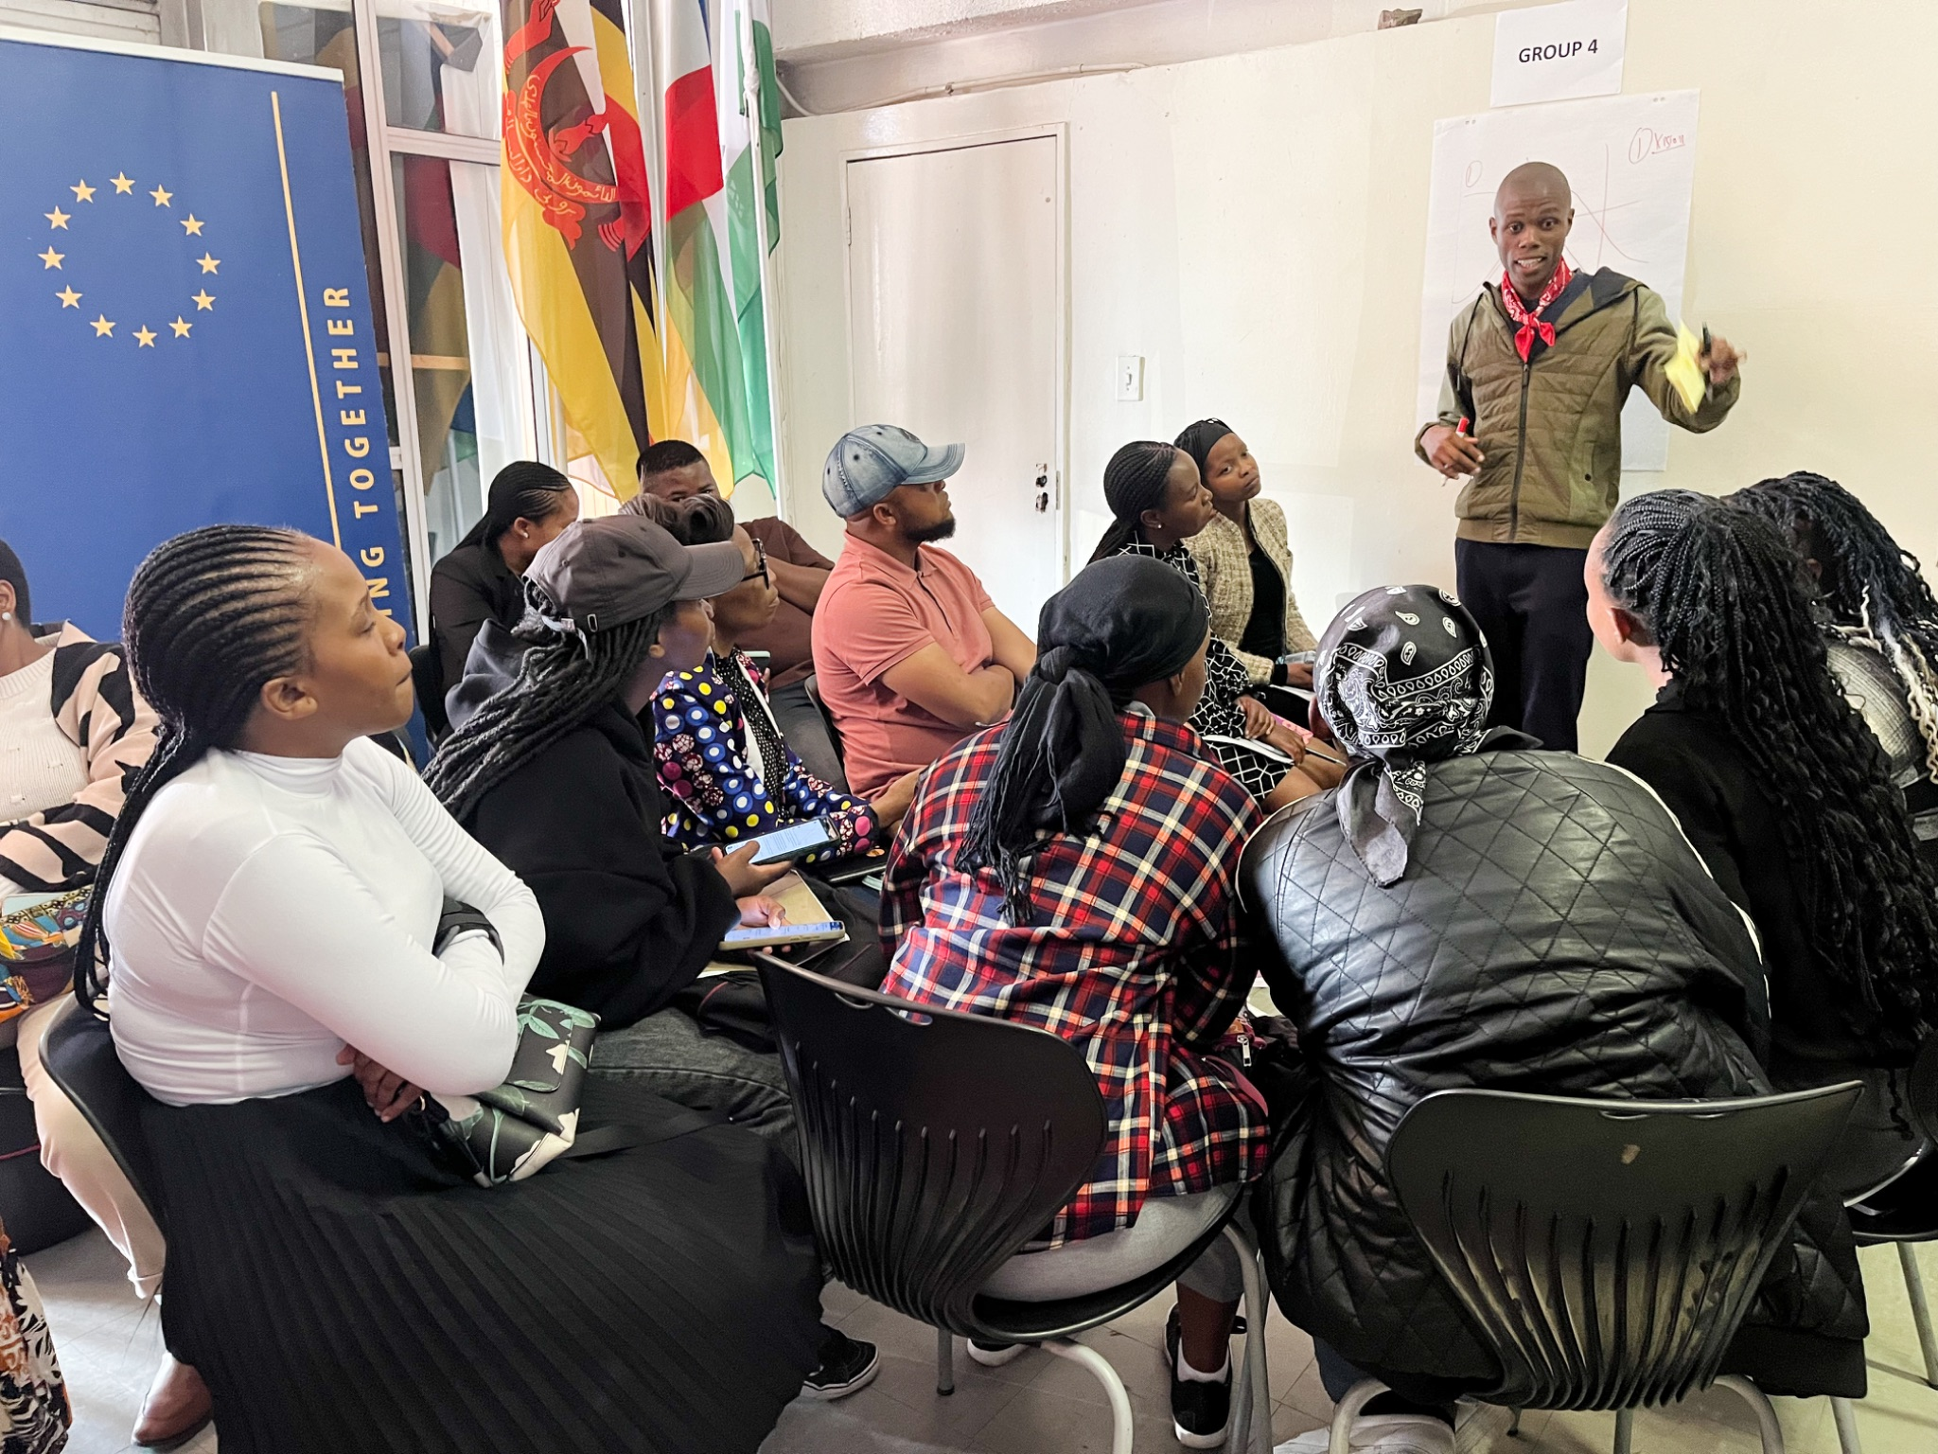

### **Training foresight facilitators**

The toolkit, produced by European Commission, foresight experts and young people worldwide, offers a set of foresight techniques tailored for young people. Rather than relying on external foresight experts for a one-off workshop at the launch event, the EU and partners focused on embedding foresight within the Youth Power Hub itself. Local youth leaders participated in hybrid training on foresight fundamentals, specific tools, and facilitation skills.

These facilitators then led a futures workshop for 100 participants, exploring ‘The Future of Youth Advocacy in Lesotho.’ A key tool used, part of the Youth4Foresight toolkit, was Three Horizons, a structured approach to understanding systems change and transitions.

### **Shifting mindsets, creating space for new ideas**

For many participants, this was the first time they had been invited to systematically and critically think about the future — not as something distant and abstract, but as something they could actively shape. One facilitator described the experience as “a permission slip to imagine beyond the immediate struggles we are navigating.” Others found clarity in seeing how interconnected issues like climate resilience, youth unemployment, and political participation required systemic solutions. By framing discussions in terms of possible futures rather than fixed positions, it created space for conversations that might otherwise have been constrained by political or institutional barriers.

The workshop also empowered the young participants collectively convey their views on the Lesotho of the future to the decision makers present at the launch event, as a practical example of the dialogue that the Power Hub seeks to encourage.

### **What’s next for foresight in the Youth Power Hub?**

Foresight is not a one-off intervention; it is a capability that grows over time. In a world where youth engagement is often reduced to consultation rather than real agency, the Youth4Foresight Toolkit offers young people a way to navigate uncertainty and define alternative futures they can build towards.

Spanning from 2024 to 2029, the Youth Power Hub in Lesotho will actively involve young people in decision-making to strengthen citizen participation and build stronger, more inclusive communities.  The project supports the [**Youth Action Plan**](https://international-partnerships.ec.europa.eu/policies/youth/youth-action-plan_en) in European Union external action for 2022-2027, the first ever policy framework for a **strategic partnership with young people around the world**.

[Youth4Foresight Toolkit | Capacity4dev](https://capacity4dev.europa.eu/resources/INTPA-Foresight/info/youth4foresight-toolkit_en)