BENEFICIARY STORY- YOUNG AFRICA
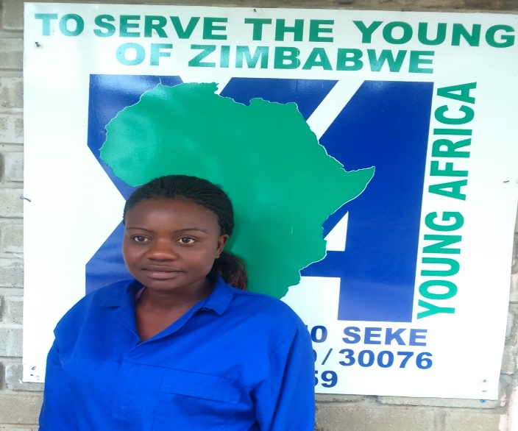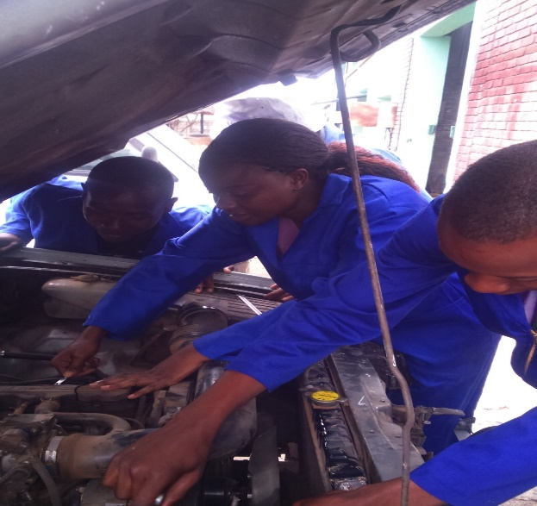

NAME : ISABEL KAPUYA
AGE : 24 YEARS
PROJECT SECTOR : VOCATIONAL SKILLS TRAINING
IMPLEMENTING PARTNER : YOUNG AFRICA
LOCATION : CHITUNGWIZA, ZIMBABWE

Isabel Kapuya (24) a single mother of one grew up in the Chiweshe rural areas with her paternal grandparents. Orphaned at a tender age (both parents deceased) Isabel grew up in a challenging environment, with her grandmother as the sole breadwinner in the family. She did her O’ level at Kakora Secondary in Chiweshe and passed 5 subjects. Her grandparents were overburdened with the responsibility of taking care of 7 other grandchildren, Isabel’s orphaned cousins. Isabel recalls bitterly her past life, “We survived on farming. Being the eldest in the family, a normal day for me would start at 4am. I had to attend to all household chores or go to the fields before I went to school. In those harsh circumstances, I soldiered on and I managed to pass 5 subjects at Ordinary level. Unfortunately, there was no money for me to proceed to advanced level.”

After an unfruitful search for employment, Isabel then opted to work as a domestic worker at the house of one of Young Africa’s lecturers. Her income was only USD80 per month. She later learnt of YA’s youth empowerment programmes through the lecturer who encouraged her to enroll for a course of her choice. In June 2015 she defied all odds and enrolled in the male dominated Motor Vehicle Mechanics (MVM) course. Now she has a story to tell from the theory and practicals she is undertaking. She is able to do engine servicing and braking systems maintenance with minimal assistance. Isabel is also a beneficiary of YA halfway home hostel for girls, where she is currently staying as she pursues her studies at YA. Through the encouragement that she is getting from YA she is motivated to keep learning and finish her course. Isabel derives her inspiration from her female MVM lecturer.

She has this to say,

“YA empowerment courses have made me change my attitude for the better. I am now a more determined and more focused young lady. I used to be very slow in whatever l did, for example going to school very late but Life skills training transformed me. At home, my guardians are very proud of me. l used to be rude and had no control over my emotions but it is all in the past now.”

