If you have trouble reading this e-mail, please click here.

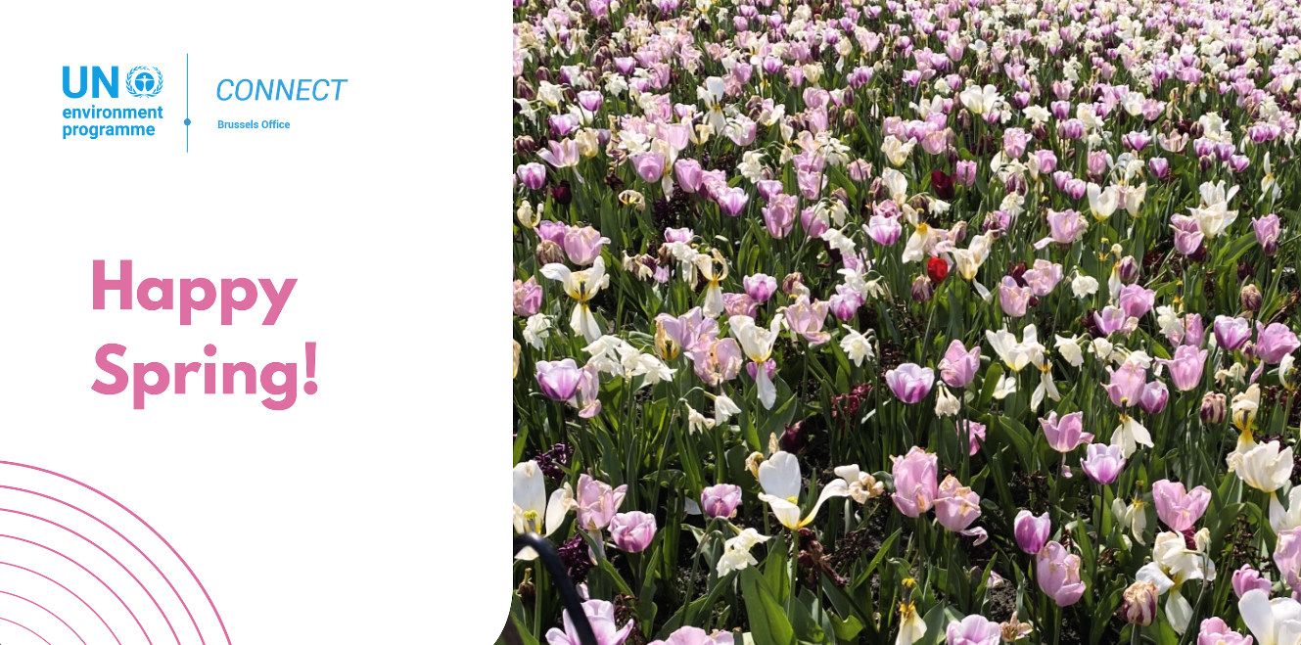

Dear Reader,
This issue of our newsletter covers the main activities of the UNEP Brussels Office in the months of January, February and March 2024 and includes a selection of recently released UNEP reports.

Throughout this period, our Office has been raising awareness on the sixth session of the United Nations Environment Assembly (UNEA-6) that took place from 26 February to 1 March 2024 at our headquarters in Nairobi, Kenya. UNEA-6 concluded with the adoption of 15 resolutions to advance collaborative action on the triple planetary crisis, and focused on how multilateralism can help tackle the triple planetary crisis of climate change, nature and biodiversity loss, and pollution and waste.
The 'In Focus' section highlights some important policy dialogues at which the UNEP Brussels Office played an important role, in specific on human rights related subjects.

Several of the 'recent events in Brussels' aimed at publicizing and discussing with EU policymakers and stakeholders the findings from two flagship Outlook reports with regards to natural resources and waste management. You will find these reports under the Key reports section at the end.

Enjoy the read!

Cordially,
Veronika Hunt Safrankova
Head of UNEP Brussels Office

Table of Content
- In Focus
- Recent events in Brussels
- Key Reports

In Focus
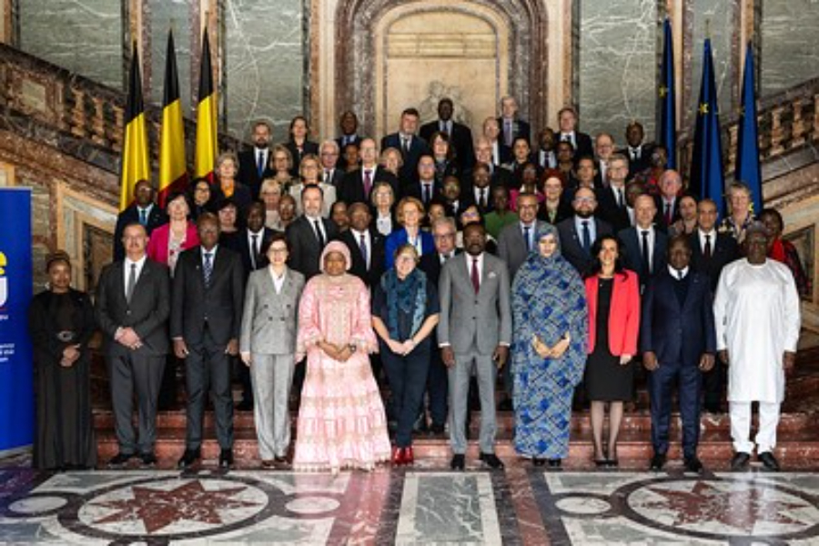

EU and African Union High-level event on Health

On 20 March, during the Belgian Presidency of the Council of the EU, the Belgian Ministry of Foreign Affairs, in collaboration with the European Commission, the African Union (AU), and the Africa Africa Centres for Disease Control and Prevention (Africa CDC), organized a high-level event at Egmont Palace. This event gathered EU Member States, African health ministers, and leaders from international and African health and financial institutions to expand the strategic EU-AU health partnership. The goal was to foster collaboration to improve health outcomes in Africa and Europe, enhance global pandemic prevention and response, and achieve SDG 3 targets. At a roundtable on One Health, Veronika Hunt Safrankova, Head of UNEP Brussels Office, emphasized the urgent need for joint efforts to strengthen an integrated One Health approach that promotes the health of people, animals, and ecosystems.
Learn more

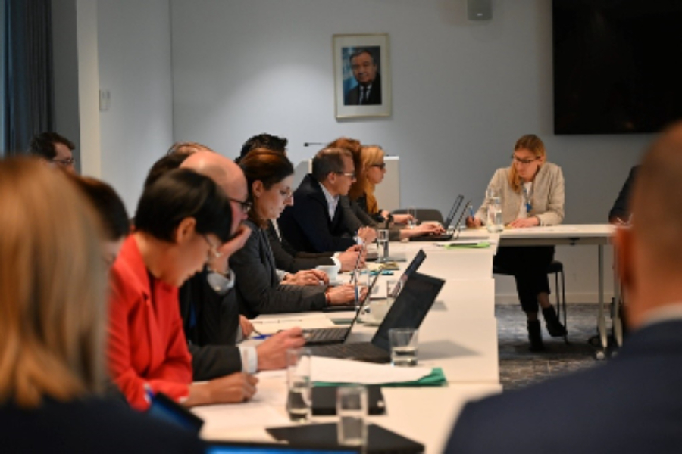

EU-UN Dialogue on Business and Human Rights

On 20 March, the second edition of the EU-UN Dialogue on Business and Human Rights took place at the UN House in Brussels. The event brought together senior experts from the EU and the UN with the objective of advancing the global business and human rights agenda. They discussed the UN Guiding Principles on Business and Human Rights, highlighting trends, challenges, and opportunities of its implementation. Speakers, which included Janyl Moldalieva, Policy Officer at UNEP Brussels Office, talked about the current EU and UN policies, lessons learned, and best practices to ensure greater levels of responsible business conduct.
Learn more

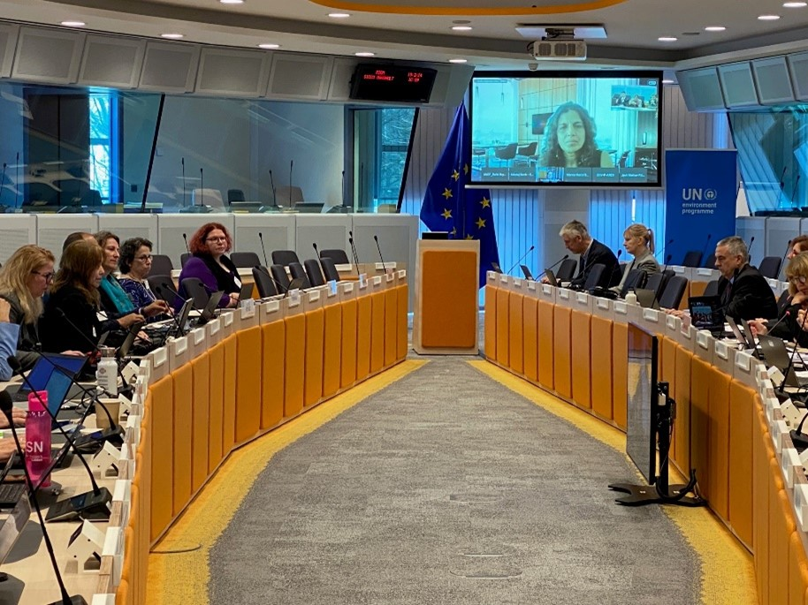

UNEP - EC Policy Dialogue on Chemicals, Waste and Pollution

On 19 March 2024, UNEP and the European Commission held a Policy Dialogue on Chemicals, Waste, and Pollution in Brussels, under the EC-UNEP Memorandum of Understanding. The dialogue aimed to drive system-wide changes for sound chemicals and waste management and zero pollution. It built on global efforts like the Global Framework on Chemicals, relevant UNEA resolutions and Decisions of the Conference of the Parties of the Multilateral Environmental Agreements (MEAs). High-level participants included Sheila Aggarwal-Khan, Director of UNEP Industry and Economy Division, and Rolph Payet, Executive Secretary for the Basel, Rotterdam and Stockholm Convention, and Astrid Schomaker from the European Commission.

Recent events in Brussels

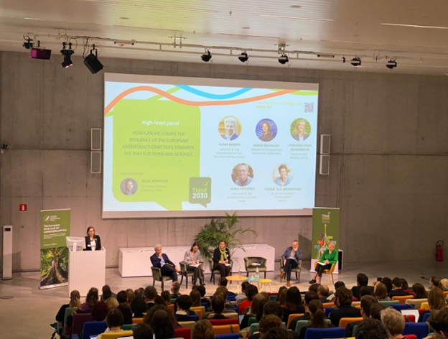

The EU Green Deal: challenges and next steps, an international perspective
At the Think 2030 Conference on 27 March 2024, Veronika Hunt Safrankova, Head of UNEP Brussels Office, praised the EU's contributions to environmental multilateralism over the past five years. She highlighted the achievements of the EU Green Deal and emphasized the need to consider socio-economic realities and measure economic prosperity beyond GDP. She pleaded for a social approach to green policies, engaging all economic actors to ensure resilience towards the 2024 elections and beyond.
Learn more

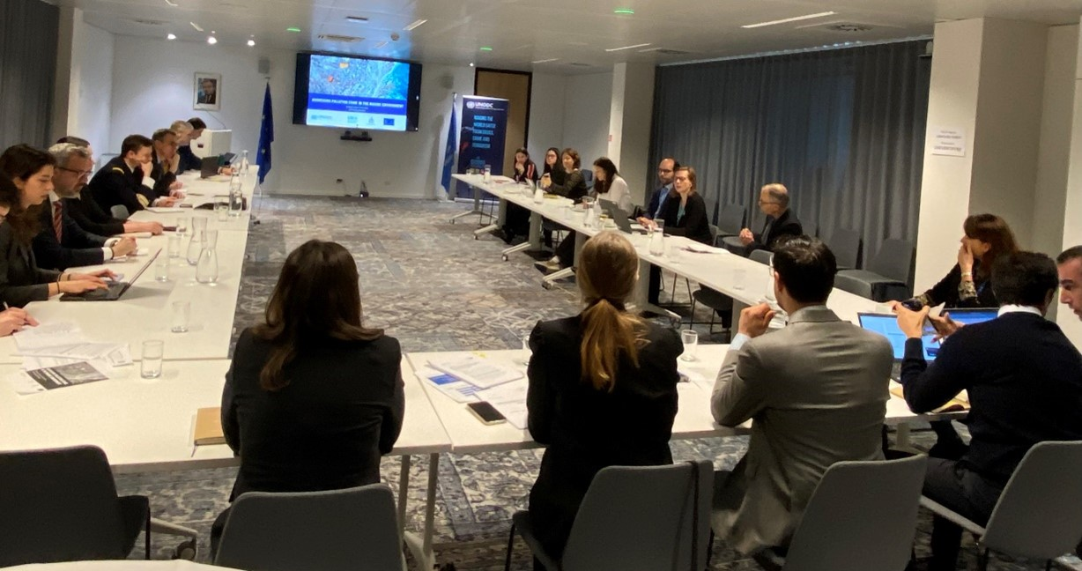

Addressing pollution crime in the marine environment
UNODC together with INTERPOL and UNEP hosted an event at the UN House in Brussels on 21 March on addressing pollution crime in the marine environment. With the objective to enhance the understanding, collaboration, and use of technologies in addressing pollution crimes in the marine environment, the participants discussed the intrinsic link between marine pollution, environmental degradation and climate change.
Learn more

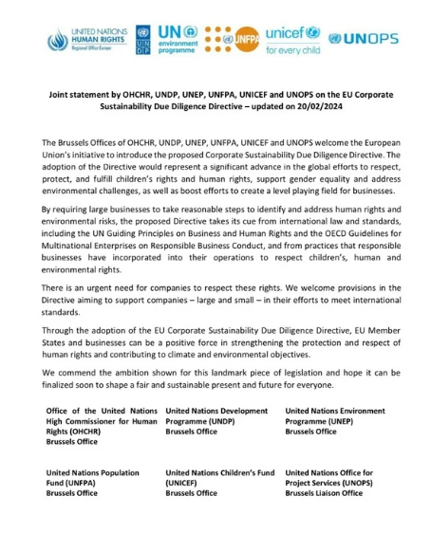

Joint statement on EU Sustainable Corporate Responsibility Due Diligence
On 19 February, the Brussels Offices of UNDP, UNEP, UNICEF and OHCHR published a joint statement on the EU Corporate Sustainability Due Diligence Directive, welcoming the European Union’s initiative. The statement highlights that the adoption of the Directive would represent a significant advance in the global efforts to protect children’s rights, human rights and address environmental challenges. By requiring businesses to take reasonable steps to identify, understand and mitigate against risks to human rights, as well as risks to the environment, this legislation also boots efforts to create level playing field for responsible businesses.
Learn more

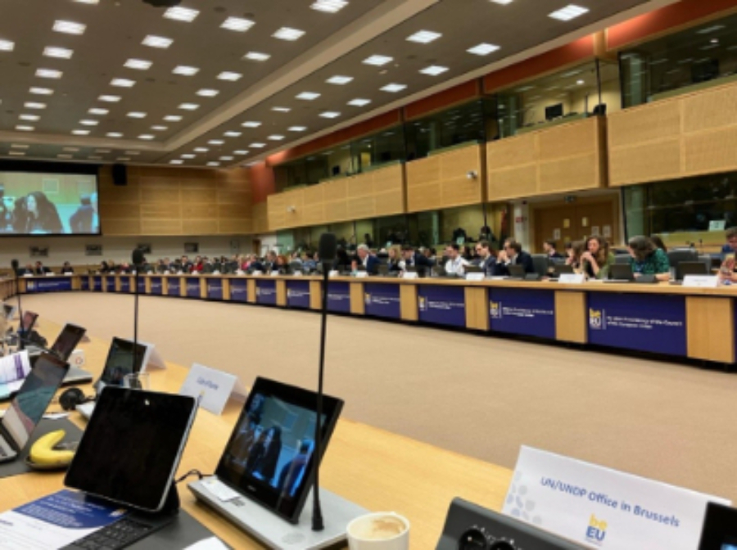

Belgian EU Presidency Conference on Just Transition
The European Conference for a Just Transition on 4 and 5 March in Brussels, convened by the Belgian Presidency of the EU Council, saw representatives from Member States and EU institutions, from civil society and other stakeholders, coming together to discuss the social dimensions of the EU Green Deal. Taking place on the eve of European elections and the appointment of the future European Commission, these substantive discussions aimed to ensure progress towards a greener and more sustainable Europe where no one is left behind. Veronika Hunt Safrankova, Head of UNEP Brussels Office, highlighted the importance of adopting an inclusive and people-centered approach when it comes to tackling the interconnected planetary crises of climate change, biodiversity loss and pollution.
Learn more

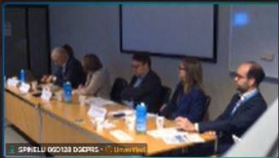

“Charting the Path to Sustainable Resource Management: Unveiling the 2024 Global Resources Outlook Report (GRO24)”
On 5 March, Janez Potočnik, co-chair of the UNEP International Resource Panel (IRP), presented the key findings from the Global Resources Outlook 2024 during an event organized by GLOBE EU at the European Parliament. The Global Resources Outlook 2024 findings are key to recognise the environmental and social costs of extraction of Earth's resources. The report shows how demand for resources is expected to continue increasing in the coming decades. The report also describes the potential to turn negative trends around and put humanity on a trajectory towards sustainability. Nicolas Galudec, Senior Policy Advisor at the UNEP Brussels Office, joined the discussions and the panel on Equity and Justice, emphasizing the critical need to adopt a social perspective to effectively address the triple planetary crisis.
Learn more

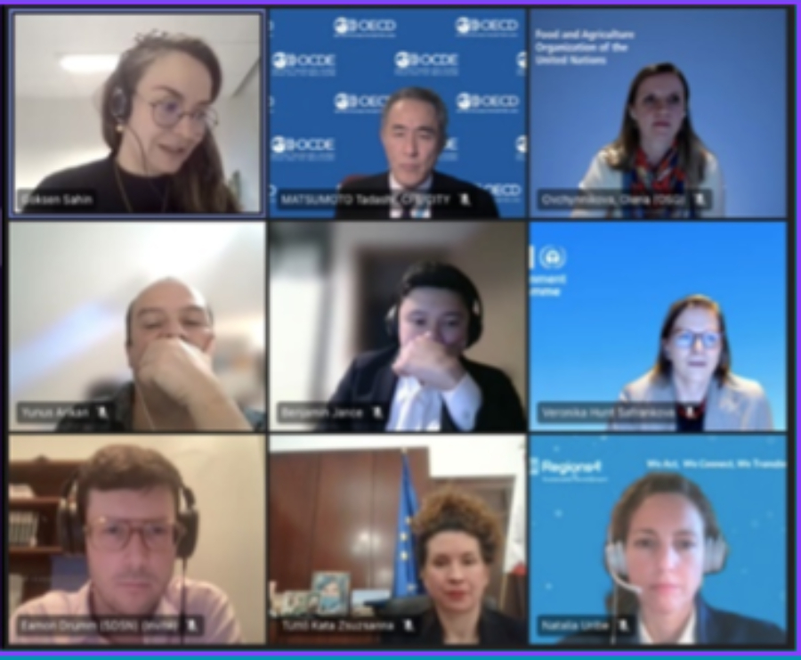

European Committee of the Regions: Opinion on a Global Green Deal
Veronika Hunt Safrankova, Head of the UNEP Brussels Office, provided feedback on the European Committee of the Regions' draft Opinion, "Towards a Global Green Deal: aligning climate and biodiversity goals with SDGs from bottom-up." This Opinion outlines the EU cities' and regions' recommendations for key international conferences this year. At a Brussels event on 21 February, Ms Hunt Safrankova highlighted pivotal achievements like the Global Framework on Chemicals and the right to a clean environment in the Universal Declaration of Human Rights. She stressed the need for global cooperation and the importance of the upcoming Summit of the Future (September 2024) in shaping environmental sustainability.

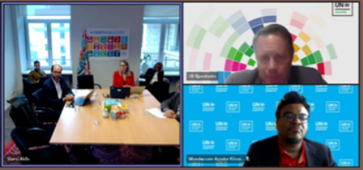

Pre-UNEA Press Briefing
On 7 February, the UNEP Brussels Office held a press briefing at the Residence Palace in Brussels, ahead of the United Nations Environment Assembly (UNEA-6) scheduled from 19 February to 1 March 2024 in Nairobi, Kenya. Senior UNEP officials updated journalists on UNEA preparations, its operational dynamics, stakes, and potential outcomes. They underscored UNEA's critical role as the world’s top decision-making body on the environment and highlighted its importance as a platform for exchanging ideas and fostering effective, inclusive, and sustainable multilateral actions to tackle the triple planetary crisis.
Learn more

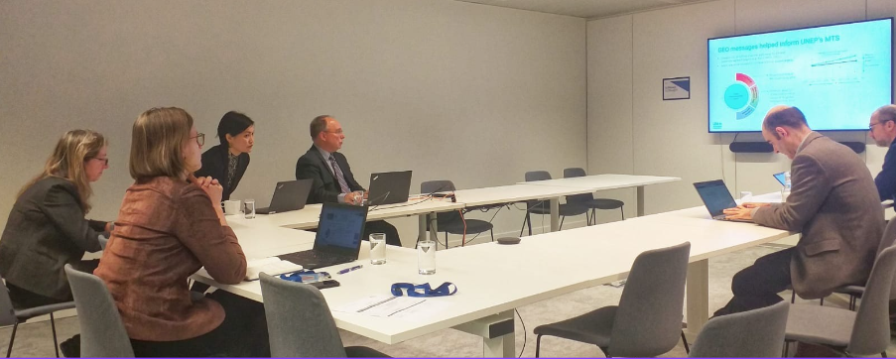

UNEP-EC dialogue on the upcoming Global Environment Outlook
On 22 and 23 January, the UNEP Brussels Office hosted a presentation on the upcoming Global Environment Outlook 7 (GEO-7), sharing insights with European Commission officials and discussing its key policy topics. The GEO-7 will address the drivers and pressures causing environmental degradation, the status and trends of climate, biodiversity loss, pollution, and land degradation, and their impact on energy, food, and waste systems, as well as health and security. The GEO-7 is expected to initiate a new era in environmental assessments, actively seeking solutions while identifying challenges.
Read more

Key Reports

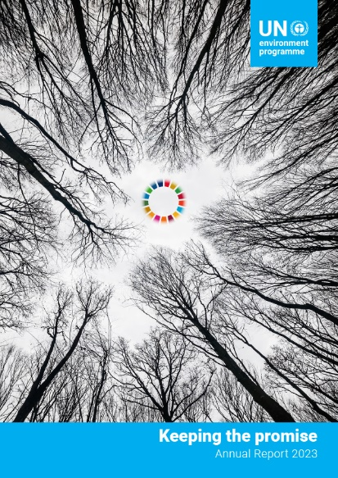

UNEP Annual Report 2023

The recently launched UNEP Annual Report for the year 2023 offers a sobering yet hopeful reflection on the state of our planet. Last year witnessed a troubling trend of broken records and broken promises. From soaring greenhouse gas emissions to unprecedented temperature highs, the impacts of climate change are becoming increasingly undeniable and urgent. Amidst these alarming developments, however, there is reason for cautious optimism. The global response to the triple planetary crisis of climate change, nature and biodiversity loss, and pollution and waste has intensified. Efforts to combat pollution and waste received a significant boost with the agreement of the Global Framework on Chemicals, while progress was made on the global instrument to address plastic pollution, slated for completion by 2024. Nations also took crucial steps to protect biodiversity in the ocean and released key guidelines to help the private sector reduce its impact on nature. Explore the progress achieved and the path forward outlined in UNEP's 2023 Annual Report.
Download the full report
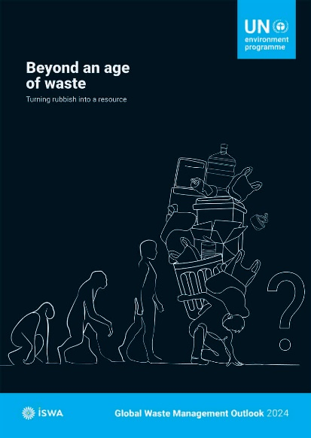

Global Waste Management Outlook 2024

The Global Waste Management Outlook 2024: Beyond an age of waste report, a collaborative effort with the International Solid Waste Association (ISWA), delves into the critical realm of global waste generation and management. Released as an update since 2018, this report not only sheds light on the figures of waste production but also uncovers the profound costs associated with its management. Using innovative life cycle assessments, we navigate potential futures: from continuing down the familiar path of business-as-usual, to adopting intermediary measures, all the way to envisioning a world committed to zero waste and circular economy principles. The report lays out three distinct scenarios of municipal waste generation and management, each meticulously evaluated for their societal, environmental, and economic impacts.
Download the full report
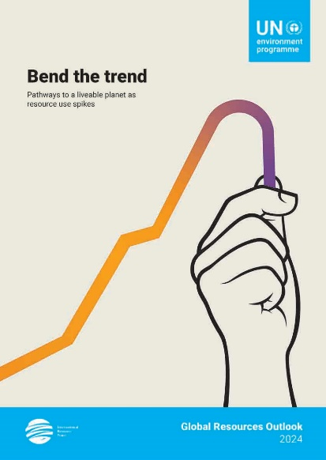

Global Resources Outlook 2024: Bend the trend

The world is in the midst of a triple planetary crisis of climate change, biodiversity loss and pollution and waste. The global economy is consuming ever more natural resources, while the world is not on track to meet the Sustainable Development Goals. This 2024 edition of the Global Resources Outlook sheds light on how resources are essential to the effective implementation of the Agenda 2030 and multilateral environmental agreements to tackle the triple planetary crisis. The report brings together the best available data, modelling and assessments to analyse trends, impacts and distributional effects of resource use. It builds on more than 15 years of work by the International Resource Panel, including scientific assessments and inputs from countries, a vast network of stakeholders in the field and regional experts.

Download the full report
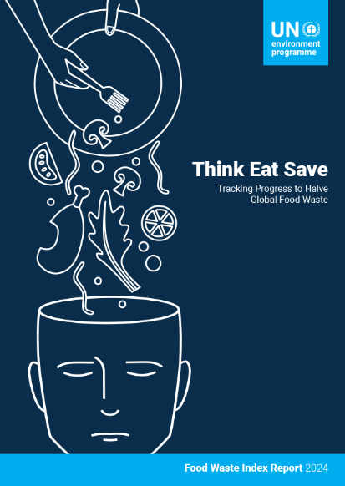

Food Waste Index Report 2024

Measuring food waste allows countries to comprehend the magnitude of the issue, thereby revealing the size of the opportunity, while establishing a baseline for tracking progress.
The Food Waste Index Report 2024 incorporates vastly expanded data points from around the world, providing significantly more robust global and national estimates. It expands on the SDG 12.3 food waste measurement methodology offering enhanced guidance on measurement across retail, food service, and household sectors. Lastly, the report transitions from focusing solely on food waste measurement to exploring solutions for food waste reduction.
Download the full report



Join UNEP Brussels' Group 'Environment for Development' on Capacity4dev
for more news and for previous UNEP Brussels Connect editions
Copyright © 2024, UNEP Brussels Office. All rights reserved.
For questions related to this newsletter please contact unep-brussels@un.org

