If you have trouble reading this e-mail, please click here.

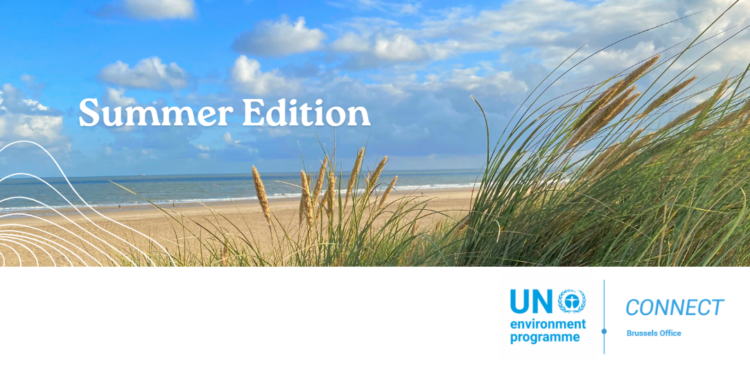

Dear Reader,

This newsletter highlights main activities of the UNEP Brussels Office from April to mid-July 2024, and features recently released UNEP reports.

It follows the launch on 15 July of UNEP and the International Science Council’s Global Foresight Report which explores future scenarios for planetary and human health and potential solutions. The report emphasizes shifting from polycrisis to polystability, focusing on intergenerational equity and a new social contract, requiring transformative change across technological, economic, and social factors.

The need for transformative change was also the focus of the high-level event on sustainable textiles, we co-hosted with the Belgian Presidency of the Council of the European Union (EU) in May. This event heard perspectives from across the textile value chain on the systemic changes needed to tackle the industry’s significant environmental footprint.
Amongst our recent events on the ground, we zoom in on UNEP participation in the World Circular Economy Forum. Amongst recent events, we feature Brussels celebrations of the World Environment Day focusing on land degradation, desertification and drought resilience, and which culminated this year in a major film screening event just days after EU Green Week and ahead of the European elections.
Let me end by wishing you a relaxing summer. Take good care and travel sustainably.
Veronika Hunt Safrankova
Head of UNEP Brussels Office

Table of Content
- In Focus
- Recent events in Brussels
- Announcements
- Key Reports

In Focus

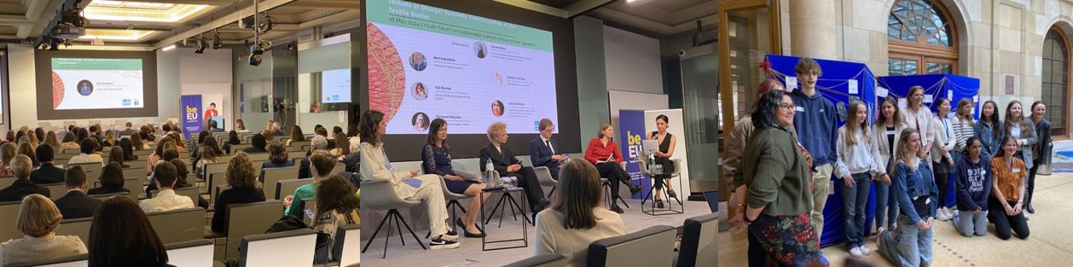

Systemic change of the textiles industry: “Threads of change”
Some 100 policymakers, representatives from Industry and associations, civil society, youth and academics assembled in Brussels on 16 May to reflect on how to shift the textile sector towards sustainability and circularity.

The high-level event, co-hosted by UNEP and the Belgian Presidency of the Council of the EU, heard perspectives from across the textile value chain on the systemic changes needed to tackle the industry’s significant environmental footprint.

The textiles sector is responsible for 2-8% of global greenhouse gas emissions every year, substantial water use, and 9% of ocean microplastic pollution.

Panel discussions covered policy priorities, the importance of capacity-building for producers, and the need for global traceability and collective action against microplastics. The event underscored the necessity of global collaboration, policy coherence, and the need to support vulnerable workers.

A youth forum closed the event, highlighting the role of young consumers and industry collaboration in driving systemic change toward sustainability. An exhibition by students of the British School in Brussels underscored the importance of youth action by showing fashion upcycling projects.
Learn more

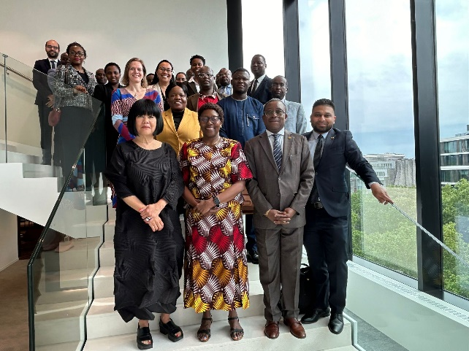

UNEP Deputy Executive Director on mission in Brussels
Just days ahead of the European elections, UNEP Deputy Executive Director (DED) Elizabeth Mrema was in Brussels from 22 to 24 May, to engage with key partners in Brussels, including the European Commission, the European External Action Service, and diplomats from the African, Caribbean and Pacific States (ACP). The main objective of her visit was to stress the importance of maintaining the highest level of ambition for continued strategic political and financial investment in environmental multilateralism.

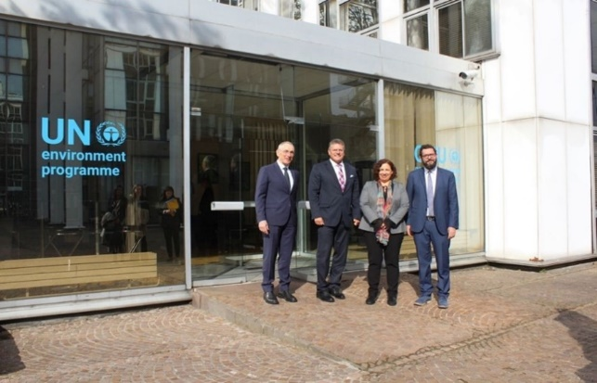

EU Commission Executive Vice-President visits International Methane Emissions Observatory
On April 26, European Commission Executive Vice-President Maroš Šefčovič visited Paris for a briefing on methane reduction with the International Methane Emissions Observatory. IMEO, a key implementing partner of the Global Methane Pledge to reduce emissions by 30% by 2030, and co-funded by the EU, is turning data into action with initiatives like the Methane Alert and Response System (MARS), which uses satellite data to help governments and companies quickly reduce emissions. The visit was co-facilitated by UNEP Brussels Office.

Recent events in Brussels

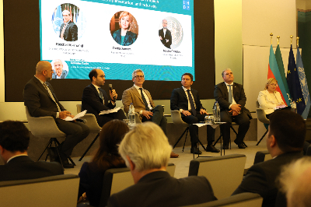

On the Road to the UN Climate COP29
The UN Climate Change Conference (COP29) in Baku, Azerbaijan (11-22 November 2024) will be a key moment to drive global climate action. At an event in Brussels on 10 July, leaders, policymakers, and experts discussed ambitious climate goals, practical implementation of climate actions, and meaningful engagement of underrepresented groups. In a panel discussion with H.E. Yalchin Rafiyev, Deputy Foreign Minister of the Republic of Azerbaijan and Chief Negotiator for COP29, and Jacob Werksman, Principal Advisor at the European Commission, Nicolas Galudec, Senior Policy Advisor at the UNEP Brussels Office, emphasized the need for integrative collaboration and coherence with other international processes. He further reiterated messages from Inger Andersen, UNEP Executive Director's recent mission to Azerbaijan. The event was co-organized by the Embassy of Azerbaijan in Brussels and the United Nations Development Programme.

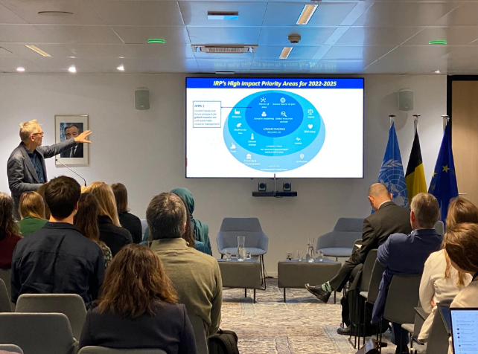

Brussels Debate: Global Resources Outlook 2024
On 25 April UNEP organized at the UN House in Brussels an event with presentation of Janez Potocnik, Co-Chair of the International Resource Panel, on the key findings of the Global Resources Outlook 2024. This event gathered civil society representatives and key EU partners in Brussels to discuss the findings of the report.
The 2024 edition of the Global Resources Outlook sheds light on the crucial role of resources for the effective implementation of Agenda 2030 and multilateral environmental agreements to tackle the triple planetary crisis of climate change, biodiversity loss and pollution.

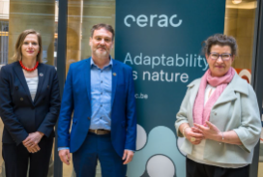

Supporting EU Climate Resilience
On 22 April, Veronika Hunt Safrankova, Head of the UNEP Brussels Office, participated in a panel discussion with Leena Ylä-Monone, Executive Director of the European Environment Agency, Barbara Dewulf, Director General at Brussels Environment, and Diane Simiu, Director of Climate, Energy Efficiency, and Air. The event, “Unlocking Resilience through Climate and Environment Risk Assessments,” was organized by the Belgian Presidency of the Council of the EU to enhance climate change adaptation and preparedness. It also marked the inauguration of the Belgian Climate and Environment Risk Assessment Center.
Learn more

UNEP was actively involved in the annual World Circular Economy Forum (WCEF) that took place in Brussels from 15 to 18 April (see overview below). The Forum was organised by the International Resource Panel (UNEP-IRP), Circle Economy Foundation and Sitra, and partners.
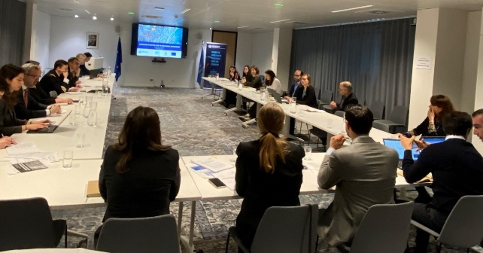

UNEP hosts forum on solutions for minimising food waste
On 18 April, the UNEP Brussels Office hosted the World Circular Economy Forum Accelerator Session titled "Circular Food Systems: Enabling Policies and Successful Business Cases in the Agri-Food Sector." At this event, organised by UNECE and WRI, Janyl Moldalieva, UNEP Senior Policy Officer presented findings from the 2024 UNEP Food Waste Index Report, and proposed solutions for minimising food waste. She also shared insights from the 2024 Global Resources Outlook.
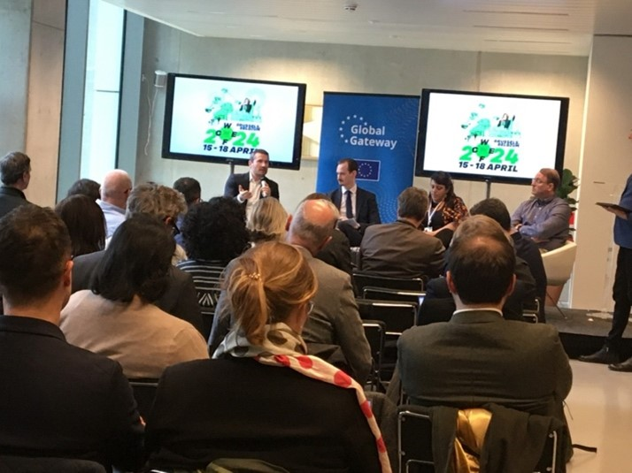

2024 SWITCH to Green Coordination Meeting
On the sidelines of the 2024 World Circular Economy Forum, the SWITCH to Green Coordination Meeting took place on 18 April. The meeting offered an opportunity to EU-supported green/circular economy initiatives at all geographic levels to improve their coherence and coordination, and to strengthen related synergies across the world. UNEP, a co-founder of the « Green Growth Knowledge Partnership » is partnering with the partnership on this matter. During the meeting, the EU-funded partnership highlighted the need to develop concrete market leverages and incentives to support the transition towards a circular economy. This will be facilitated by the new Circular Economy Resource Centre announced by the EU Directorate-General for International Partnerships on 16 April.
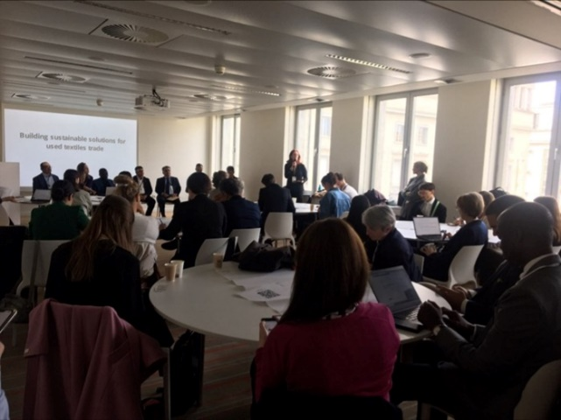

Launch of the 'Circularity and used textiles trade' project
In response to the pressing need for a sustainable and circular textile value chain, UNEP announced the launch of the EC-funded ‘Circularity and Used Textiles Trade’ project on 15 April. This initiative seeks to pinpoint essential policy, investment, and regulatory priorities to drive trade and policy reforms, while also identifying financing options to support this transformative shift.
Learn more
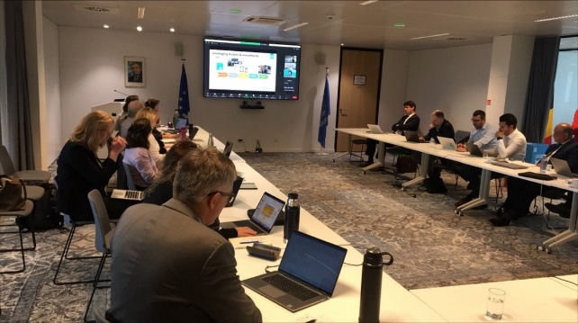

Presentation of Global Waste Management Outlook: A call for action for zero waste
Preceding the World Circular Economy Forum 2024, UNEP presented the Global Waste Management Outlook 2024 in Brussels, on 12 April to underscore the urgency of tackling the escalating waste crisis. With global waste expected to triple by 2025, effective waste management is imperative for environmental conservation. The event was attended by representatives from the European Commission and Brussels-based NGO’s. It highlighted the call for action on zero waste, echoing resolutions from UNEA6 and the UN General Assembly on prioritising waste reduction efforts.

UNEP Brussels on the Ground
On Wednesday, June 5, World Environment Day was marked worldwide with a focus on land degradation, desertification, and drought resilience. The celebrations highlighted the importance of ecosystem restoration, urging everyone to join #GenerationRestoration in tackling environmental degradation. Highlights of the Brussels celebrations include:

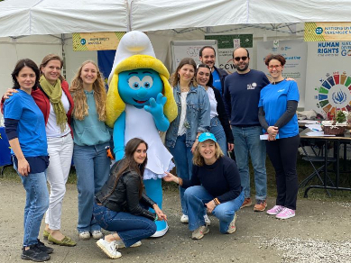

Fête de l’Environnement
The Brussels celebrations began with the bi-annual Fête de l’Environnement on Sunday, 2 June, organized by Brussels Environment. Thousands gathered in a large park to celebrate environmental action. Smurfette, a UN SDG Ambassador, joined the UNEP Brussels Office at the UN Stand to promote #GenerationRestoration. Alongside colleagues from UNODC and OHCHR, they raised awareness about issues like land restoration, wildlife trafficking, endangered species, environmental crime and the Right to a Healthy Environment.
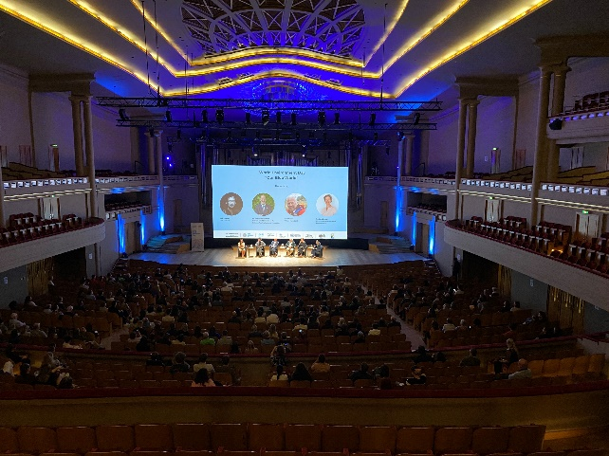

European Premiere of ‘Our Blue World’
Ahead of the European parliamentary elections, the UNEP Brussels Office premiered ‘Our Blue World’ on 4 June at Bozar Cultural Centre. This CineONU event raised awareness on land degradation and water scarcity, inspiring action by highlighting solutions. The public event marked World Environment Day and connected to the 2024 EU Green Week,'s theme of water resilience, attracting 800 participants, including EU representatives, diplomats, civil society, and students.
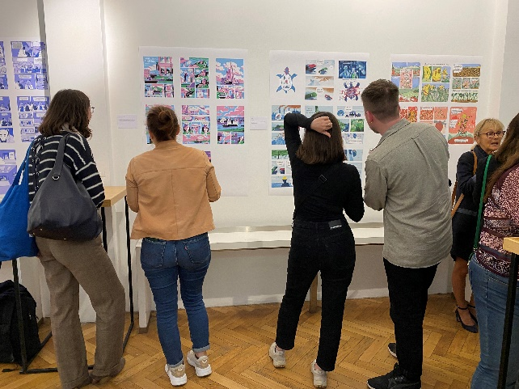

The film was followed by a panel discussion with the director, the Chief Scientist of the UN Convention to Combat Desertification, a UK farmer, and a Brussels Capital region representative. After a Q&A, attendees enjoyed a reception and explored a comic art exhibition promoting environmental action. The event was organized by UNEP and UNRIC, with OHCHR, FAO, UNDRR, UNESCO, and the UK Mission to the EU, funded by the EU, and under the auspices of the Belgian Presidency of the Council of the EU.
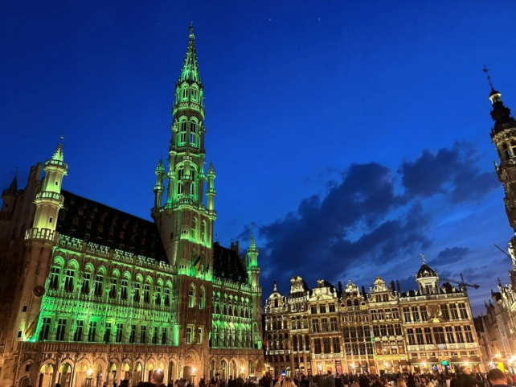

Brussels City Hall illuminated in green
On World Environment Day, 5 June, the Brussels City Hall was illuminated in green as a tribute to World Environment Day. This symbolic action highlighted the City's support for #GenerationRestoration and its commitment to preserving and revitalizing ecosystems in urban areas.
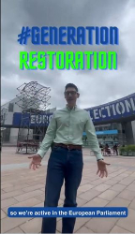

EP Intergroup participates in social media challenge
Supporting #GenerationRestoration, the EP Intergroup on Climate Change, Biodiversity, and Sustainable Development contributed a brief video to the World Environment Day campaign, encouraging people of all ages to share why they identify with #GenerationRestoration.

Learn more about World Environment Day in Brussels here.

The next editions of World Environment Day will be hosted by the Republic of Korea in 2025 with a focus on ending plastic pollution globally, followed by Azerbaijan in 2026 around the topic of climate change.

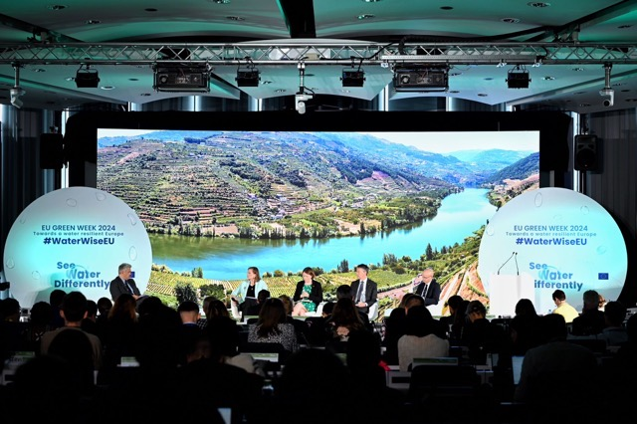

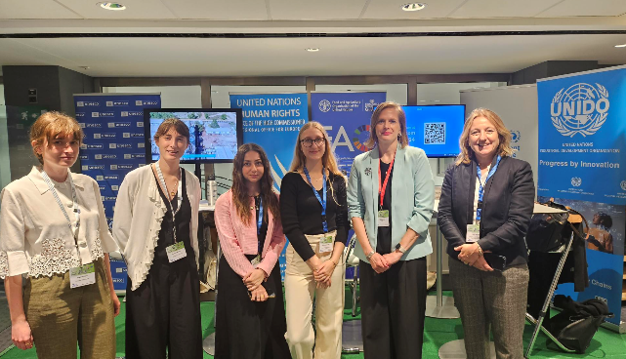

EU Green Week 2024
The 2024 edition of the EU Green Week looked into what was needed to make the EU more water resilient. The UNEP Brussels Office was actively involved in the annual conference organised by the European Commission in Brussels on 29 and 30 May. On the first day, the Head of the UNEP Brussels Office, Veronika Hunt Safrankova, spoke in a panel discussion “From growing global crisis to global opportunity.”
UNEP also coordinated a joint UN Stand at the conference site, bringing together seven UN agencies (OHCHR, UNDP, UNDRR, UNEP, UNESCO, UNIDO, UN FAO) to share respective insights on the topic of water resilience in an interactive manner with the conference participants, and connecting to the EU Water Wise campaign launched at EU Green Week.
Learn more



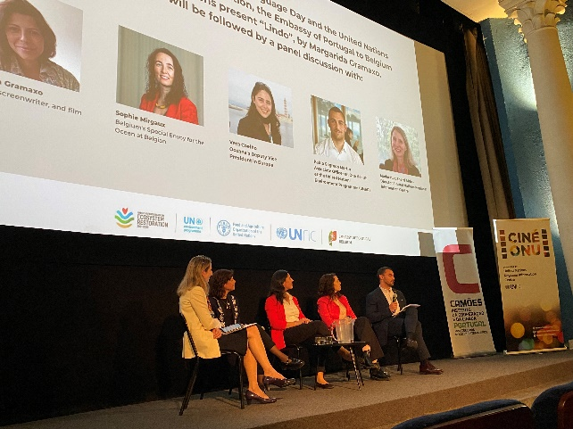

Cine-ONU event in Brussels marks UN Decade on Ecosystem Restoration
On 7 May, Cine-ONU (UNRIC Desk for Portugual) and the Portuguese Embassy to Belgium screened “Lindo” in Brussels to mark World Portuguese Language Day and the UN Decade on Ecosystem Restoration. The documentary by Margarida Gramaxo follows Lindo, a sea turtle hunter on Principe Island, who after 20 years decides to change his life and start protecting these animals from other predators.

The screening was followed by a panel discussion with the film director, Belgium’s Special Envoy for the Oceans, Oceana's vice president and Pablo Sagredo Martin, Associate Officer for One Health at UNEP. Pablo brought context to the UN Decade on Ecosytem Restoration, and spoke about marine ecosystems restoration, ocean governance and ocean pollution. Some 200 people attended the event.

Announcements
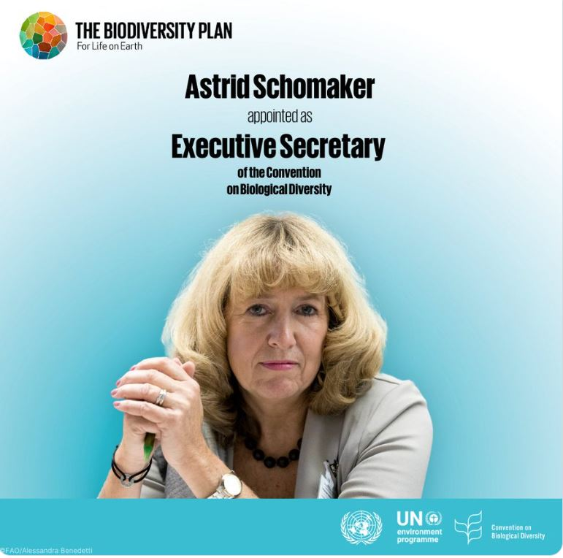

Appointment
On 1 July 2024, Ms Astrid Schomaker of Germany has officially taken up her appointment as Executive Secretary of the Convention on Biological Diversity (CBD). UN Secretary-General António Guterres made the appointment in April. The Acting Executive Secretary, David Cooper of the United Kingdom now resumes his role as Deputy Executive Secretary. Before taking up her new function, Ms Schomaker was Director for Green Diplomacy and Multilateralism with the European Commission in Brussels.
Learn more

Mark your calendars

7 September International Day of Clean Air for blue skies (global)
7 September 'The Summit of the Future and challenges ahead: How can the EP drive the EU-UN partnership forward?' Welcome event offered by the UN Director in Brussels and the UN Brussels Team (European Parliament, Strasbourg)
16 September World Ozone Day (global)
20 September World Cleanup Day (Global)
29 September International Day of Awareness of Food Loss and Waste (global)

Recent Reports

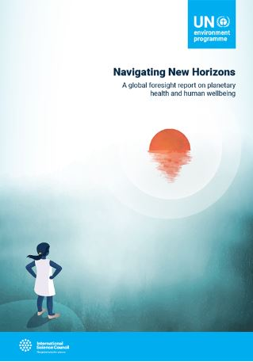

A global foresight report on planetary health and human wellbeing

This report from the United Nations Environment Programme and the International Science Council, calls for the world to pay heed and respond to a range of emerging challenges that could disrupt planetary health and wellbeing. The report presents insights on eight critical global shifts that are accelerating the triple planetary crisis of climate change, biodiversity and nature loss and pollution and waste.
Download the report

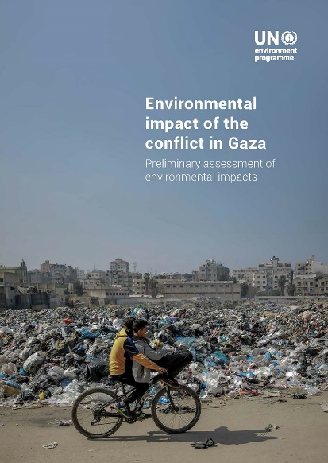

Environmental Impact of the Conflict in Gaza: Preliminary Assessment of Environmental Impacts

UNEP prepared this Preliminary Assessment in response to a request from the State of Palestine to evaluate the environmental impacts of the conflict in the Gaza Strip. The assessment summarizes known impacts on environmental management and waste disposal systems, energy and fuel infrastructure, building destruction, marine and terrestrial environments, and air quality. It also highlights serious conflict-related environmental issues, about which the United Nations has however limited information at this stage.
Download the report

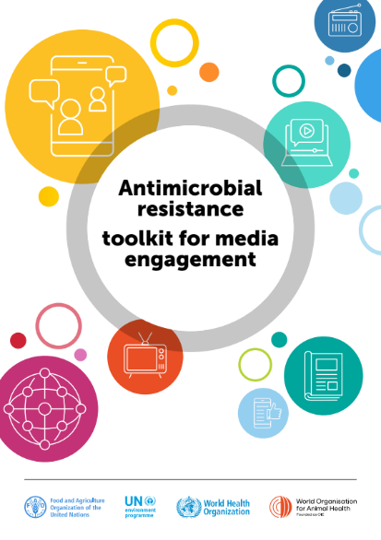

Antimicrobial resistance toolkit for media engagement

The Quadripartite organizations, Food and Agriculture Organization of the United Nations (FAO), United Nations Environment Programme (UNEP), World Health Organization (WHO) and World Organisation for Animal Health (WOAH). has developed this practical toolkit for engaging media in AMR. The aim is to equip individuals, organizations and networks with tools for media engagement on AMR at subnational, national, regional and global levels to increase public awareness of AMR, including policy-makers, civil society and communities.
Download the report

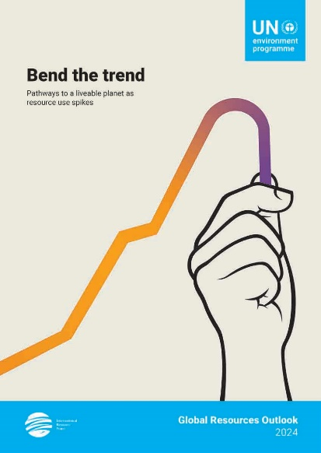

Global Resources Outlook 2024

The scientific community has never before been more aligned or more resolute on the need for urgent global transformation towards the sustainable use of resources. This 2024 edition of the Global Resources Outlook sheds light on how resources are essential to the effective implementation of the Agenda 2030 and multilateral environmental agreements to tackle the triple planetary crisis. The report brings together the best available data, modelling and assessments to analyse trends, impacts and distributional effects of resource use. It builds on more than 15 years of work by the International Resource Panel, including scientific assessments and inputs from countries, a vast network of stakeholders in the field and regional experts.
Download the report
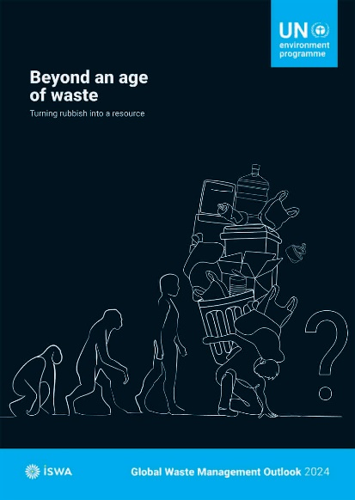

Global Waste Management Outlook 2024

Jointly published with the International Solid Waste Association (ISWA), the report provides an update on global waste generation and the cost of waste and its management since 2018. The analysis uses life cycle assessments to explore what the world could gain or lose through continuing business-as-usual, adopting halfway measures, or committing fully to zero waste and circular economy societies. The report also evaluates three potential scenarios of municipal waste generation and management, examining their impacts on society, the environment, and the global economy. Furthermore, it presents potential strategies for waste reduction and enhanced management, following the waste hierarchy, to treat all waste materials as valuable resources.
Download the report

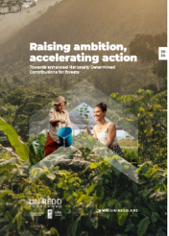

Raising ambition, accelerating action: Towards enhanced Nationally Determined Contribution for Forests
Pledges to reduce deforestation and pledges to financially support this transition from developed countries, are insufficient to halt deforestation by 2030. This report finds that commitments within the Nationally Determined Contributions (NDCs) from the twenty countries with the highest emissions from tropical deforestation are not enough to meet the goal. Only eight countries include explicit, quantified targets to reduce deforestation. All fall short of the global ambition to halt deforestation by 2030. The report provides recommendations to strengthen and enhance forest-based targets in NDCs and other policies and scale up immediate and substantive financial and technical support for forest-rich countries.
Download the report
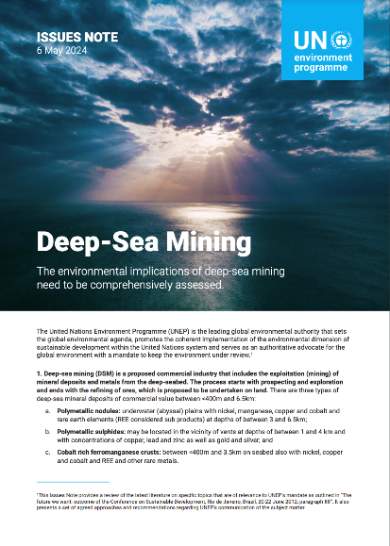

Issue Note on Deep-Sea Mining

This Issues Note outlines a summary review of literature on Deep Sea Mining (DSM) and recommends a comprehensive assessment of the environmental impacts of DSM across the globe. UNEP is mandated to keep the environment under review and has been monitoring proposals for deep-seabed mining, both within and beyond national jurisdictions. While no commercial activities currently exist, several countries have signaled their intention to assess the environmental impacts of the activity in their national waters or apply to the International Seabed Authority for approval to extract minerals and metals from the deep-seabed.
Download the report




Join UNEP Brussels' Group 'Environment for Development' on Capacity4dev
for more news and for previous UNEP Brussels Connect editions
Copyright © 2024, UNEP Brussels Office. All rights reserved.
For questions related to this newsletter please contact unep-brussels@un.org
Photos by UNEP except photos 'On the Roal to Cop29' by FAO and UNDP,
and Supporting EU Climate Resilience' by CERAC; or when indicated otherwise.

